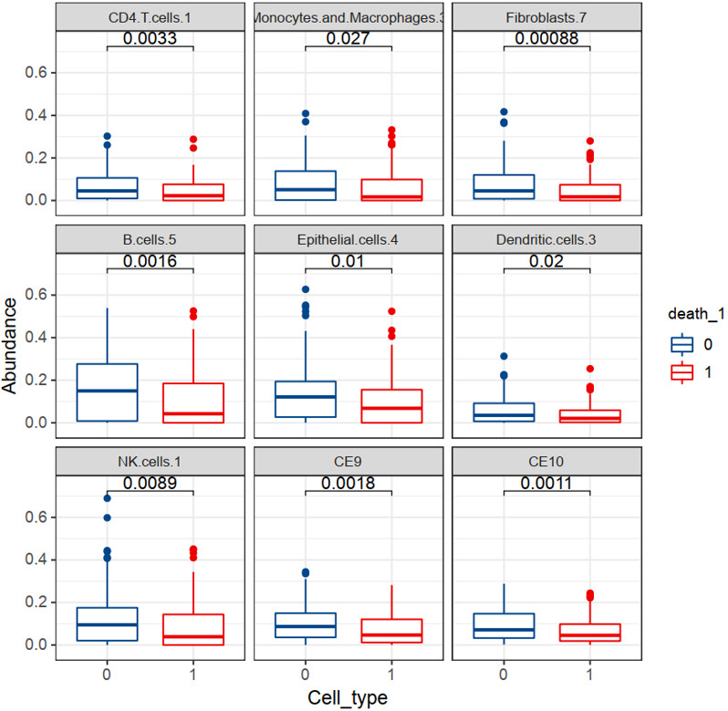
Figure S1 Box plots showing the differential expression of nine cell states between died and survived HGSOC patients. 1: died, 0: survived.

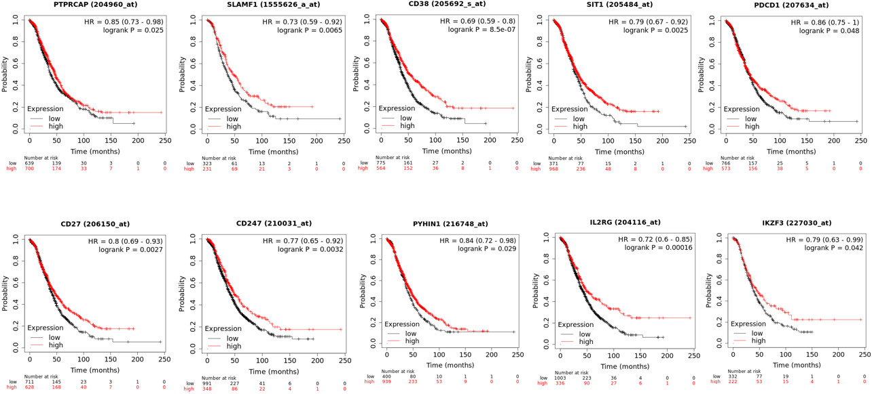
Figure S2 The top 10 most significant DEGs Ptprcap, Slamf1, Cd38, Sit1, Pdcd1, Cd27, Cd247, Pyhin1, Il2rg, and Ikzf3 are all predictive of ovarian cancer overall survival in an independent dataset in Kaplan-Meier Plotter database.

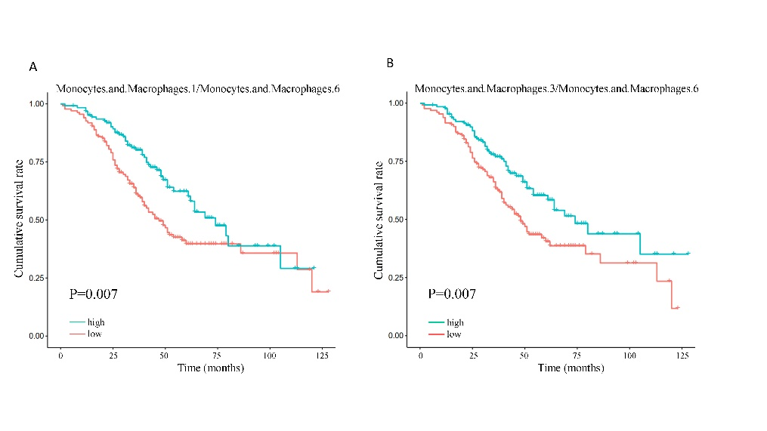
Figure S3 Cell state ratios of (A) macrophages (MCs) S1/S6 and (B) MCs S3/S6 are predictive of HGSOC survival.

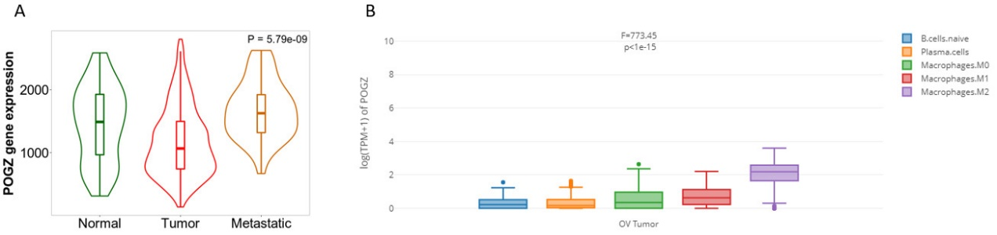
Figure S4 Pogz expression in ovarian cancer. (B) Pogz is differentially expressed in TCGA ovarian cancer dataset during the disease development. Pogz shows significant differential expression between macrophages M2 and other tumor microenvironment cells.

