Supporting information

Selective Recovery of Pyrolyzates of Biodegradable (PLA, PHBH) and Common Plastics (HDPE, PP, PS) During Co-pyrolysis Under Slow Heating
Wakana Adachi¹, Shogo Kumagai^{1,2 *}, Zhuze Shao¹, Yuko Saito¹, Toshiaki Yoshioka¹

¹ Graduate School of Environmental Studies, Tohoku University, 6-6-07 Aoba, Aramaki-aza, Aoba-ku, Sendai, Miyagi 980-8579, Japan
² Graduate School of Engineering, Tohoku University, 6-6-07 Aoba, Aramaki-aza, Aoba-ku, Sendai, Miyagi 980-8579, Japan

*Corresponding author. E-mail address: kumagai@tohoku.ac.jp (S. Kumagai).

Table S1 The summary of start, end, and peak-top temperatures of all the samples obtained by DTG
Plastics | Temperature [°C]
Plastics | T_{s}^{*1} | T_{f}^{*2} | T_{p}^{*3}
PLA | 325 | 378 | 368
PHBH | 273 | 298 | 294
HDPE | 458 | 499 | 484
PP | 422 | 478 | 465
PS | 386 | 444 | 417
^{*1} Temperature at DTG = 5 wt%/min after weight loss start, ^{*2} Temperature at DTG = 5 wt%/min before weight loss finish, ^{*3} Temperature at the maximum DTG

Table S2 The peak-top temperatures of all the samples obtained by EGA-MS (TIC)
Samples | 1st peak temperature [°C] | 2nd peak temperature [°C]
PLA | 364
PHBH | 293
HDPE | 478
PP | 457
PS | 411
PLA10HDPE90 | 362 | 479
PLA20HDPE80 | 357 | 476
PLA50HDPE50 | 363 | 478
PLA10PP90 | 356 | 457
PLA20PP80 | 361 | 458
PLA50PP50 | 362 | 457
PLA10PS90 | 370 | 413
PLA20PS80 | 370 | 414
PLA50PS50 | 363 | 414
PHBH10HDPE90 | 289 | 479
PHBH20HDPE80 | 290 | 477
PHBH50HDPE50 | 289 | 477
PHBH10PP90 | 290 | 455
PHBH20PP80 | 289 | 459
PHBH50PP50 | 288 | 456
PHBH10PS90 | 290 | 413
PHBH20PS80 | 286 | 411
PHBH50PS50 | 293 | 411

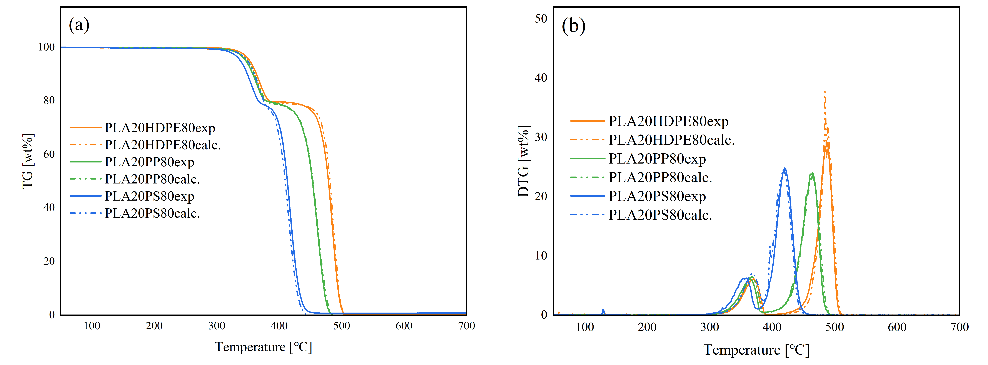
Figure S1 TG (a) and DTG (b) curves of PLA20HDPE80, PLA20PP80, and PLA20PS80.
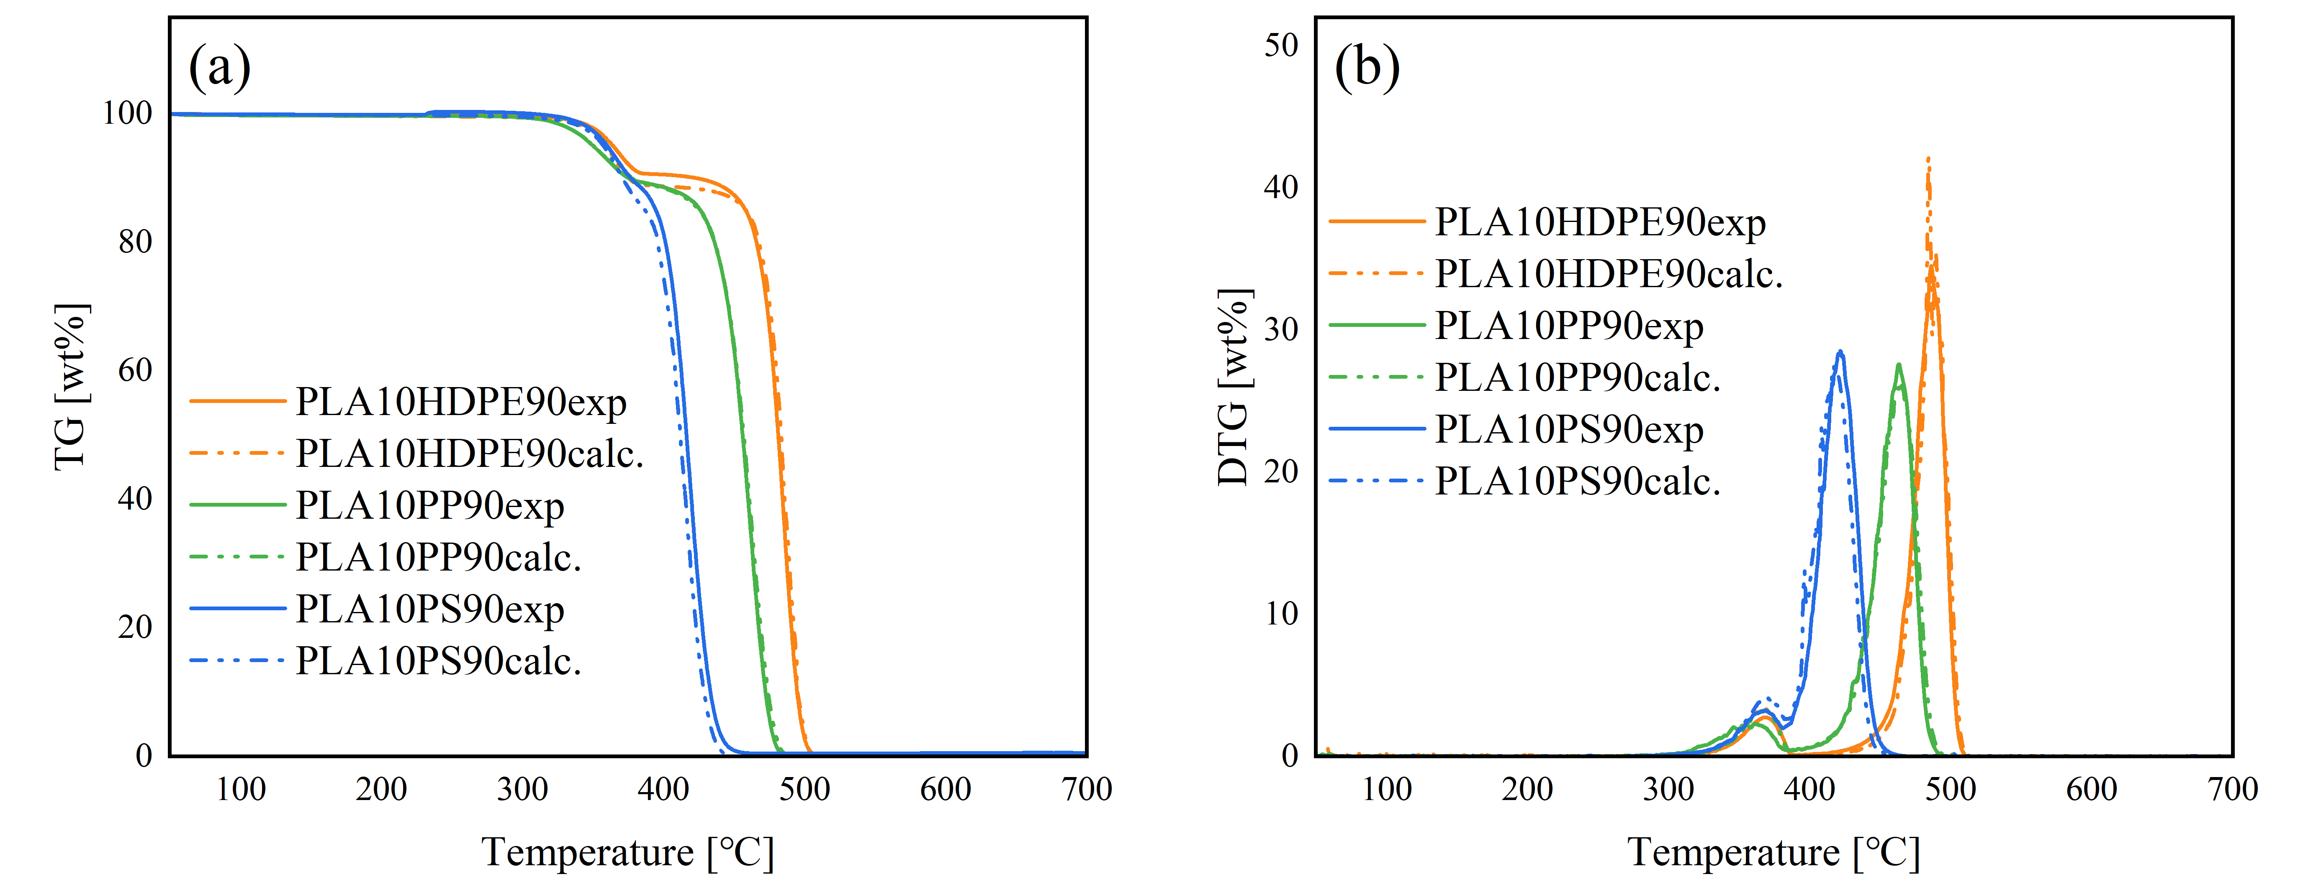
Figure S2 TG (a) and DTG (b) curves of PLA10HDPE90, PLA10PP90, PLA10PS90

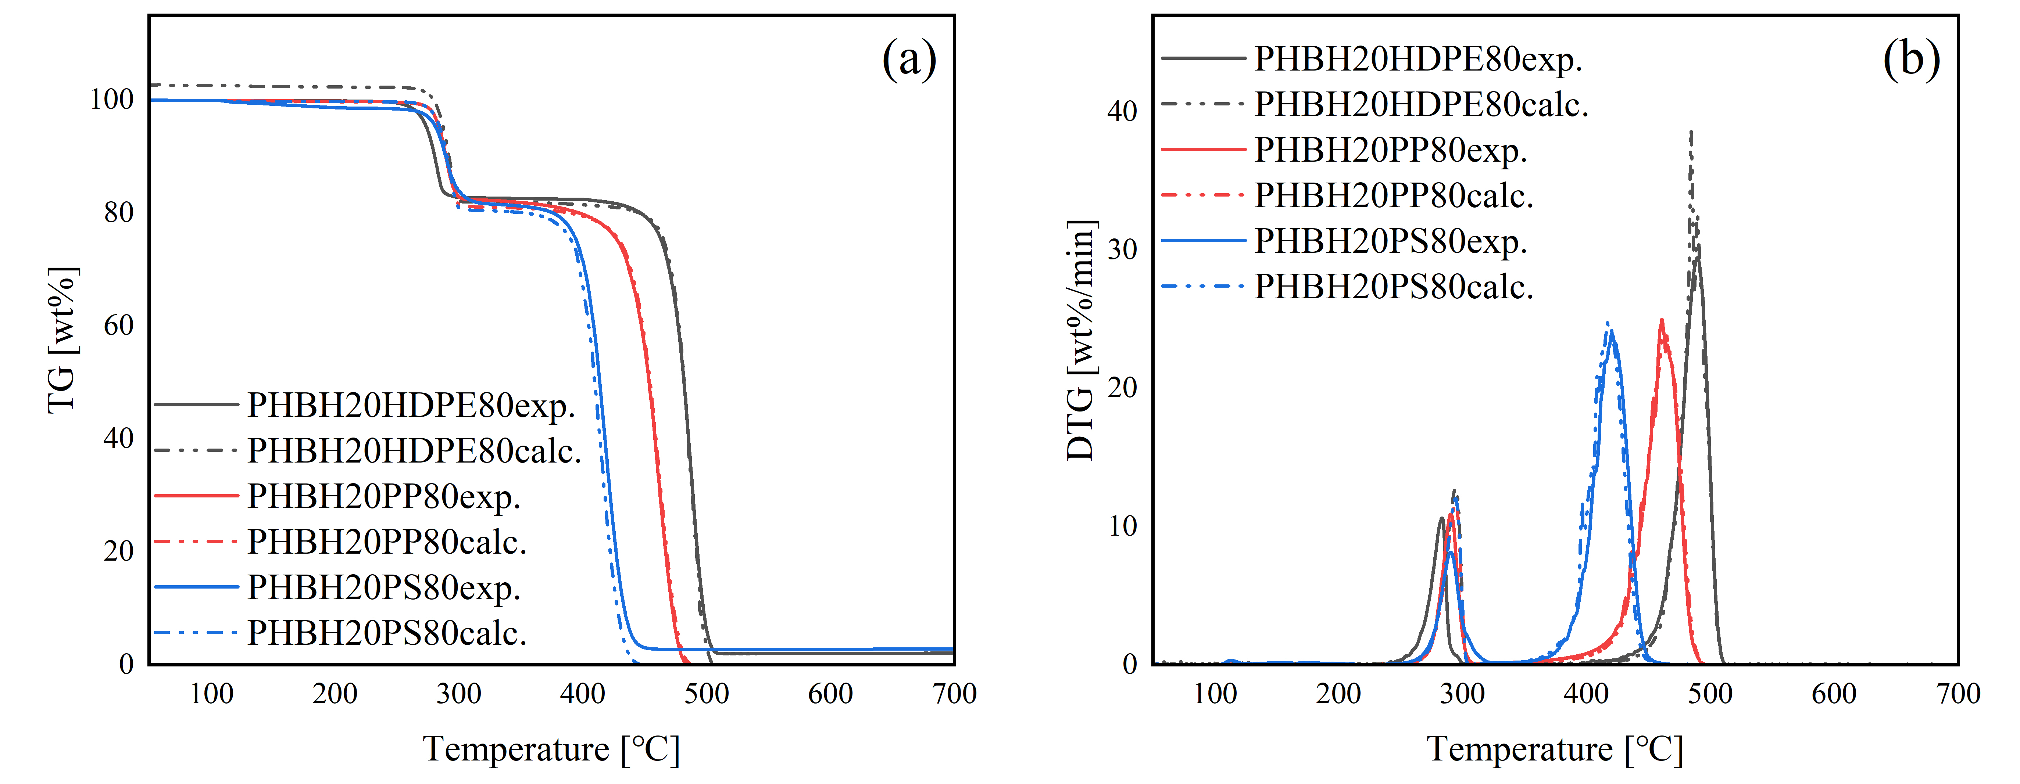
Figure S3 TG (a) and DTG (b) curves of PHBH20HDPE80, PHBH20PP80, PHBH20PS80
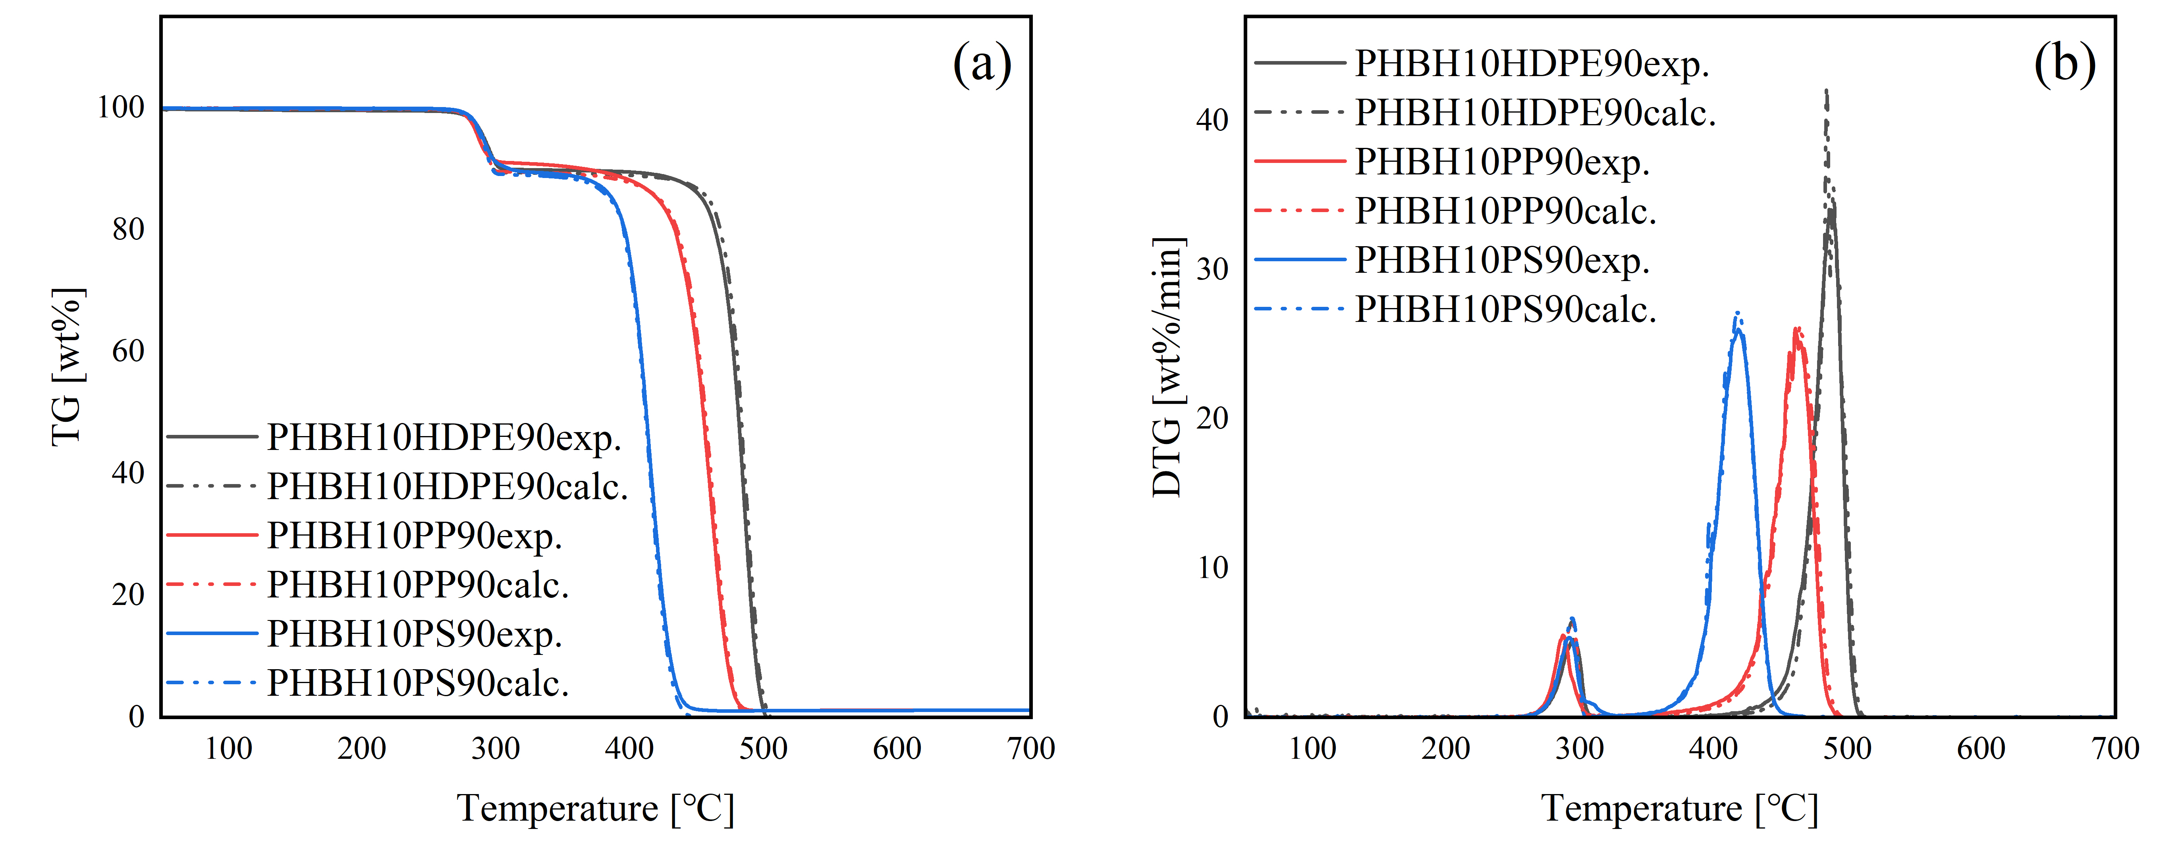
Figure S4 TG (a) and DTG (b) curves··of PHBH10HDPE90, PHBH10PP90, PHBH10PS90
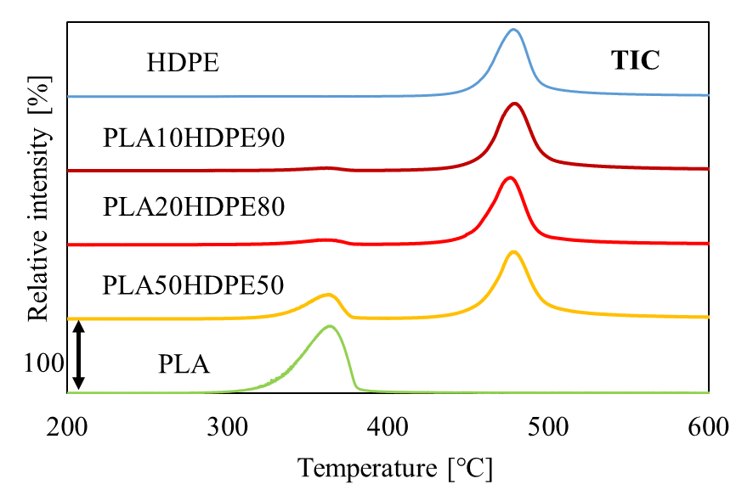
Figure S5 TIC and EICs of PLA+HDPE
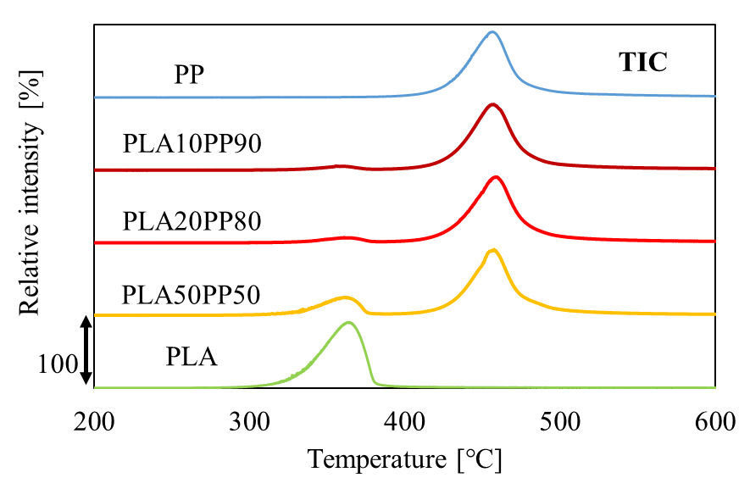
Figure S6 TIC and EICs of PLA+PP
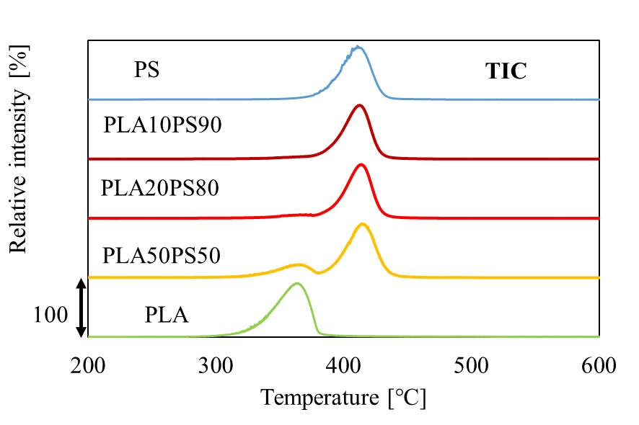
Figure S7 TIC and EICs of PLA+PS
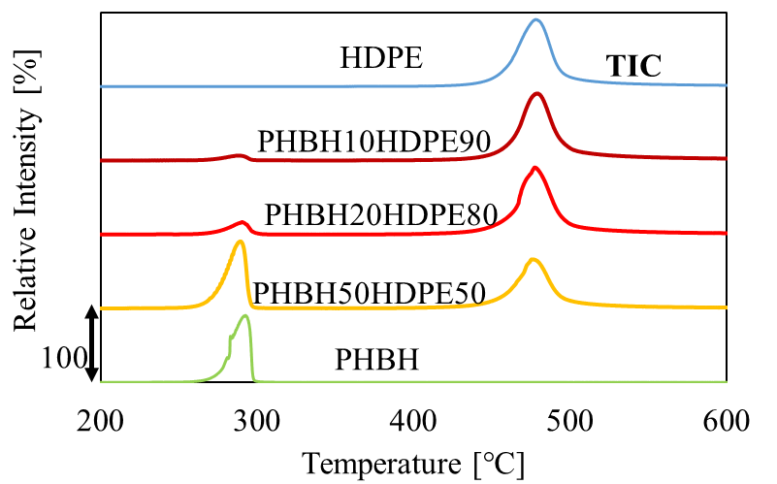
Figure S8 TIC and EICs of PHBH+HDPE
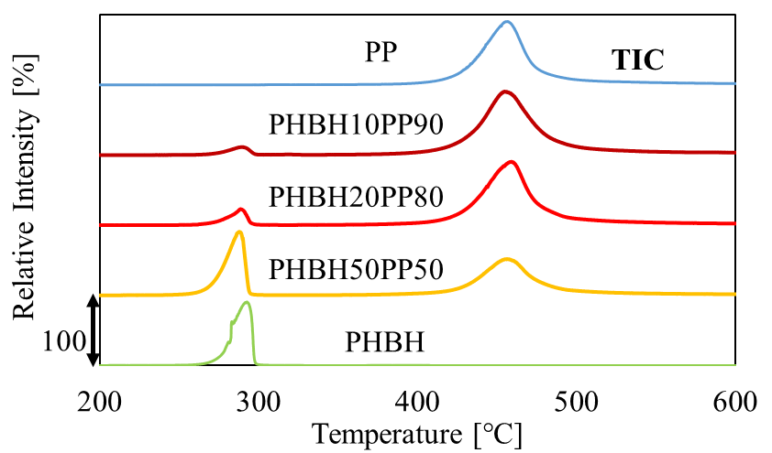
Figure S9 TIC and EICs of PHBH+PP
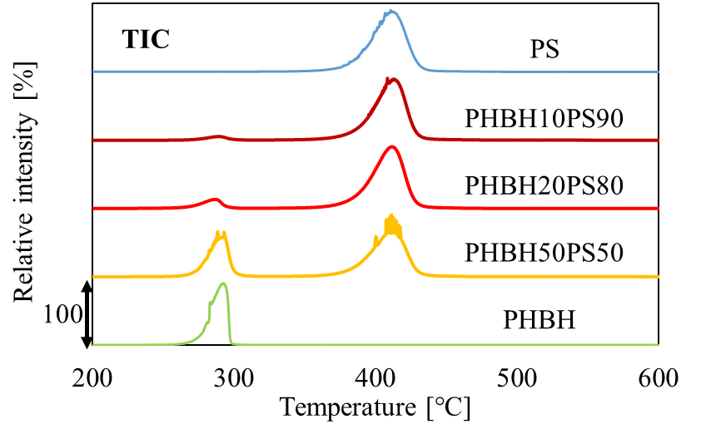
Figure S10 TIC and EICs of PHBH+PS

