Mechanical Characterization of Spectrin at the Molecular Level

Md Nahian Bin Hossain¹, Ashfaq Adnan¹
¹ Department of Mechanical and Aerospace Engineering, The University of Texas at Arlington (UTA), Arlington, TX, USA.

Appendix A: Estimation of Average Diameter of Spectrin Coil
For simplicity, we have considered one type of spectrin filament for the helical spring. We need to find out the average diameter of a spectrin filament which we can use to calculate the $C$ value for the detail mechanics calculation. For this analysis, we have chosen one simple type of spectrin filament 1CUN, which is chicken brain alpha spectrin. This spectrin has been chosen because while explaining the compact biological form of spectrin previous works[1] had made the illustration with this spectrin (along with other filaments). This is also very similar with the pdb file 1aj3 which we have used to show our representations, which is also a common type of spectrin. The average diameter of any spectrin filaments always almost remain same. So, we have just analyzed 1CUN here. Details pdb file of the 1CUN has taken from RCSB Protein Data Bank. This alpha spectrin has below fundamental details:
Classification: Structural Protein
Organism: Gallus gallus
Expression System: Escherichia coli BL21(DE3)
Total no of atoms: 5824
The pdb file had visualized using OVITO-basic 3.8.2. Ovito is a visualization and analysis software for the generated data in Molecular Dynamics[2].
As this single spectrin filament remains in a three folded form, average diameter analysis has been done for certain five ranges of x-direction. From $30 Å$ to $80 Å$, five segments have analyzed with equal limit of $10 Å$ range. For each segment all atoms have been considered through an ascending order. Then average diameter has been calculated for the segment. After separate calculation for average diameter of each segment then the final average diameter has been calculated for the whole mentioned range and this has been considered as the average diameter of spectrin filament 1CUN. To validate the date, arbitrarily any segment has taken while visualizing the pdb file through OVITO and manually minimum and maximum Z coordinate data has taken for the point along with X-direction. Almost all of the cases this arbitrary analysis has given the average diameter of the filament same as like detail segment wise analysis.
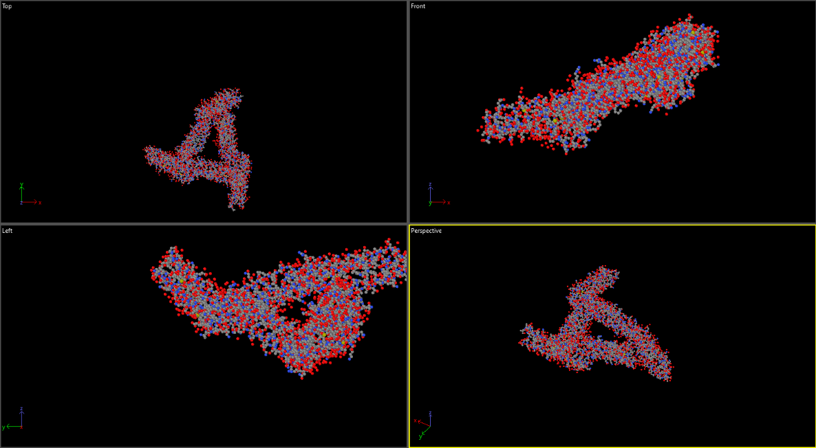
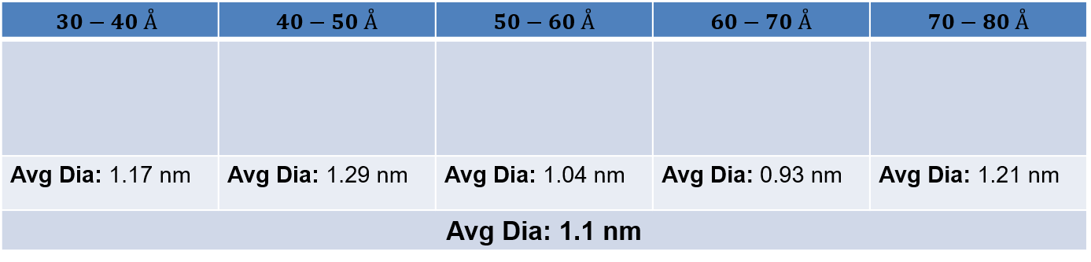
Figure S1: Visualization of spectrin filament strand (PDB:1CUN)
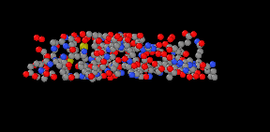
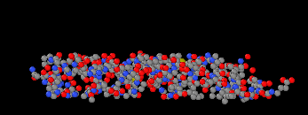
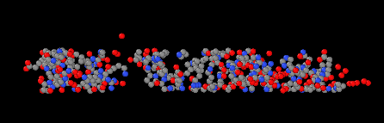
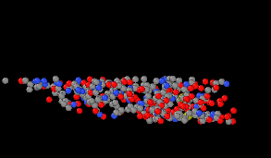
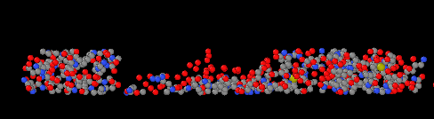

Figure S2: Segment-wise visualization of spectrin filament strand and average diameter.
Appendix B: G Value Estimation Method for Helical Spring Model
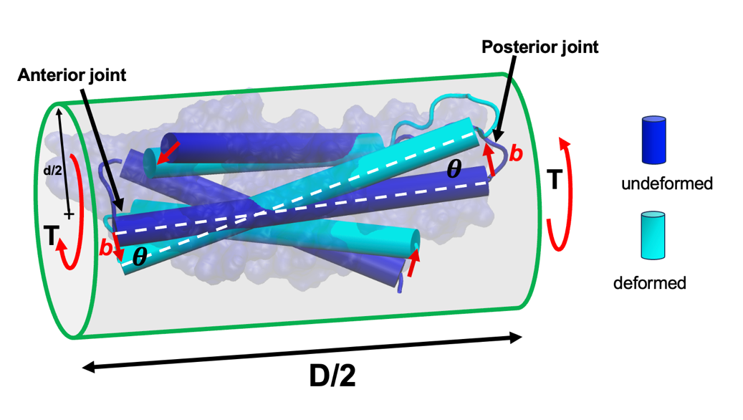
(a)
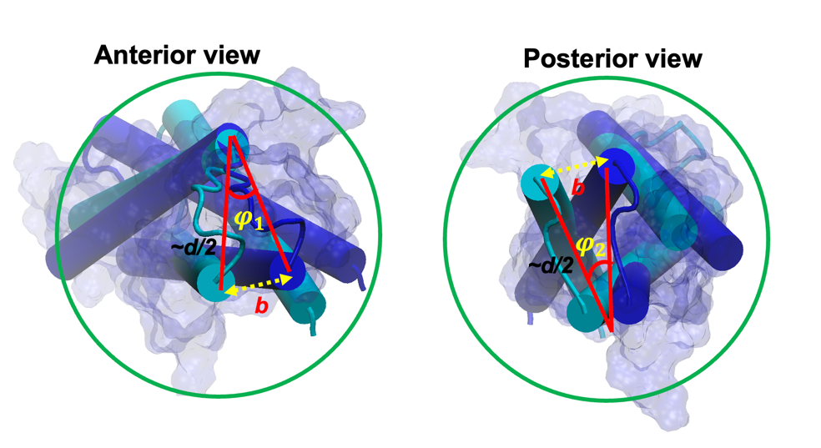
(b)
Figure S3. (a) Schematic showing how torque applied to one spectrin repeat twists the internal configuration. We assume an arbitrary value to torque T yields angle of twist = $2θ$ per length of the repeat (i.e D/2) and moves a material point on the surface of the coil by “2b” (b + b) per length. (b) The cross-sectional view of spectrin molecular from the anterior and posterior side. We argue the twist changes the molecular level dihedral angle of spectrin at its two joint angles by $φ_{1}$ and $φ_{2}$. Considering the torsional strain energy is associated with the spectrin’s molecular-level dihedral energy difference before and after deformation, the torsional rigidity of spectrin coil can estimated. The blue cartoon refers to the original configuration and the cyan cartoon represents the configuration of the spectrin repeat after deformation.

Consider a torque T is applied across the length of one spectrin repeat of length = D/2. This torque produces total angle of twist = $2θ$., as shown in Fig. 5a. Note that coil diameter of the repeat is d. The strain energy associated with this torque can be estimated as

$$U_{twist}=\frac{1}{2}T\left(2θ\right)=\frac{1}{2}\frac{\left(2θ\right)GJ}{\frac{D}{2}}\left(2θ\right)=\frac{{\left(2θ\right)}^{2}G}{D}\frac{πd^{4}}{32}=\frac{θ^{2}Gπd^{4}}{8D}$$
Using $\left(2θ\right)=\frac{TD}{2GJ}$ and $J=\frac{πd^{4}}{32}$, we get
$U_{twist}=\frac{θ^{2}Gπd^{4}}{8D}$ (1)
Now, from the schematic shown in Fig. 5b and 5a, we can establish the relation between the arbitrary arc length, b with the angle $θ$ and $φ_{1} and φ_{2}$
$${b=\sim \frac{d}{2}φ}_{1}{=\sim \frac{d}{2}φ}_{2}=\frac{D}{4}θ$$
From this, we find,
$φ_{1}=φ_{2}=φ=\frac{D}{2d}θ$ (2)
We argue that the rotation of the spectrin repeat by angle $θ$ results in total dihedral angle change of spectrin repeat by $φ_{1}+φ_{2}=$2$φ$. Using AMBER force field [3]parameters, the total dihedral energy can be estimated as
$$U_{dih}=\frac{V_{n}}{2}\left[1+cos⁡(nφ_{1}-γ)\right]+ \frac{V_{n}}{2}\left[1+cos⁡(nφ_{2}-γ)\right]$$
The values of $V_{n}$, n and $γ$ vary by the atom-atom interactions. Since majority of the amino acids in spectrin is linked by X-CA-CB-X atom sequence, we consider the following values for $V_{n}$, n and $γ$.
$$V_{n}=0.1\frac{kcal}{mole}$$
$n=3,and γ=180$. We admit the choice of these values [4]are still somewhat arbitrary and details analysis and computation is needed for accurate determination of these parameters. In this study, we wish to obtain a first order approximation of the torsion modulus and we feel the chosen parameters will provide a reasonable estimation of G.
Using these parameters and after simplifications, we obtain
$U_{dih}=V_{n}\left[1+cos⁡(2φ-180)\right]=V_{n}\left[1-cos⁡2φ\right]=\sim V_{n}\frac{9}{2}φ^{2}$ (3)
Here, we use the Taylor series expansion of the cosine term and retain the first two terms.
Equating Eqns, (1) and (3) and using the relation shown in (5), we obtain
$\frac{θ^{2}Gπd^{4}}{8D}=V_{n}\frac{9}{2}φ^{2}=V_{n}\frac{9}{2}{\left(\frac{D}{2d}\right)}^{2}θ^{2}$
$$G=\frac{9{V_{n}D}^{3}}{πd^{6}}=1.127 GP$$
Appendix C: Detail Chemical Composition for Spectrin Filament:
As previously mentioned, each repeat segment of any spectrin filament consists of 106 amino acids, so the detail about the amino acids is necessary for the calculation of spring constant for a compact form of spectrin. Many types of amino acid sequences had been reported for diverse types of spectrin. Here we have considered the repeat sequence for erythrocyte $α$ spectrin for which the structural domain begins with serine[5]. For the simplicity of analysis and analogous conditions, $β$ spectrin has also considered with same sequence of amino acid repeats. The details of amino acids are important to consider the probable long chain for each amino acid for which individual spring constant will be calculated for the assigned bond parameter data as per the closest match with amber force field.
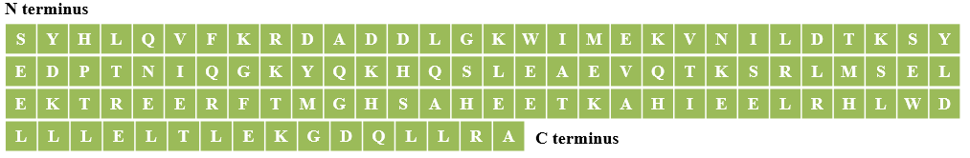
Table S1: Amino acid sequence[5]
Code | Amino Acid | No | Code | Amino Acid | No
S | Serine | 6 | V | Valine | 3
Y | Tyrosine | 3 | F | Phenylalamine | 2
H | Histidine | 6 | K | Lysine | 10
L | Leucine | 15 | R | Arginine | 6
Q | Glutamine | 6 | D | Asparatate | 7
A | Alanine | 5 | E | Glutamate | 14
G | Glycine | 4 | N | Asparagine | 2
w | Tryptophan | 2 | T | Threonine | 7
I | Isoleucine | 4 | P | Proline | 1
M | Metheonine | 3

Table S2: Amino acid types and numbers[5]
Chemical structure for each type of amino acid has been well known[6]. From this chemical structure the probable long chain has defined for every amino acid. It has been considered that, while the filament will be subjected to be stretched the unfolding of each amino acid will mostly take place towards the direction of probable long chain. This long chain consideration is based upon the chemical structure.

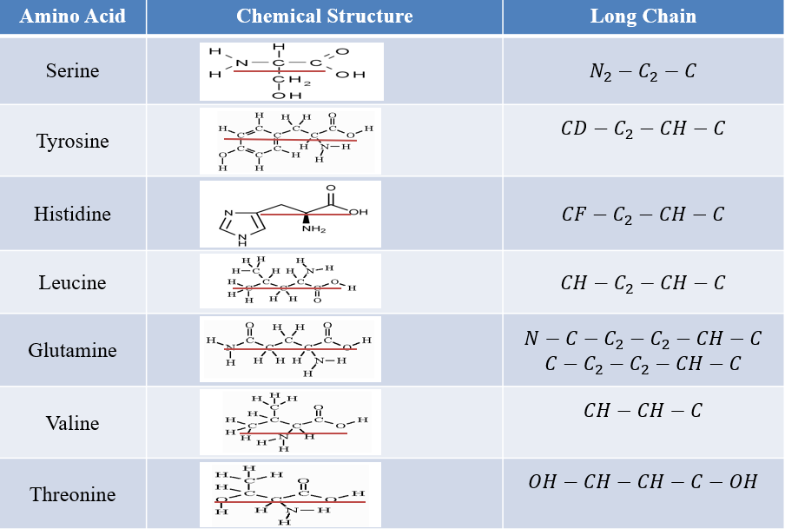
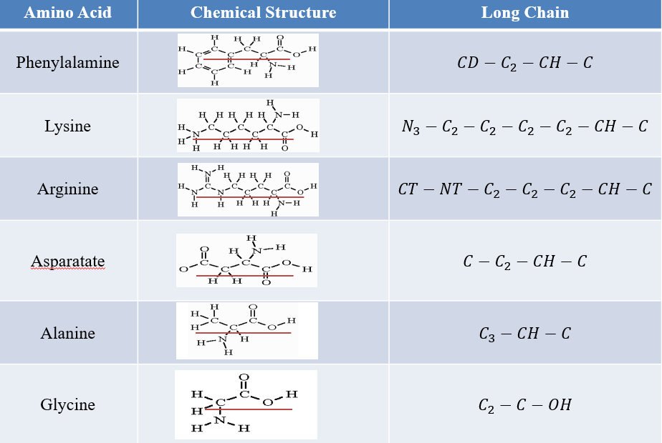
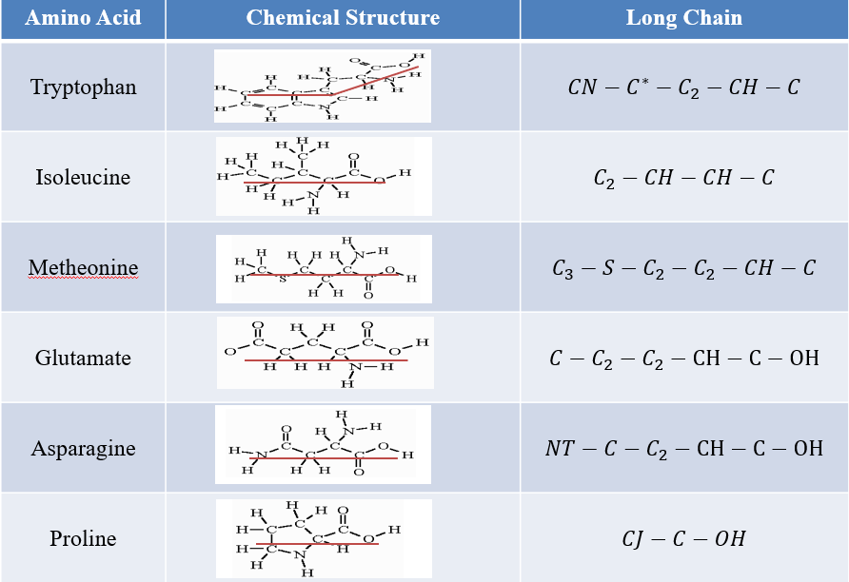
Table S3: Probable long chain of amino acids as per the chemical structure
Appendix D: Spring Constant $\left(K_{b}\right)$ For One Repeat of Spectrin Filament:
As each repeat of spectrin filament consists of 106 amino acids, so the spring constant of each amino acid through the probable long chain has been calculated. Then these 106 amino acids (19 types) are considered to be connected in series while stretched. The probable long chains have already been presented in the previously mentioned Table S3. For each long chain the best possible matched bond parameter had taken from [4] .
Serine:
Long chain: $N_{2}-C_{2}-C$
Spring Constant: $\frac{1}{K_{serine}}=\frac{1}{K_{1}}+\frac{1}{K_{2}}=\frac{1}{337}+\frac{1}{317}$
$$K_{serine}=163.35\frac{kcal}{molÅ^{2} }$$
Tyrosine:
Long chain: $CD-C_{2}-CH-C$
Spring Constant: $\frac{1}{K_{tyronine}}=\frac{1}{K_{1}}+\frac{1}{K_{2}}+\frac{1}{K_{3}}=\frac{1}{469}+\frac{1}{260}+\frac{1}{317}$
$$K_{tyrosine}=109.494\frac{kcal}{molÅ^{2} }$$
Histidine:
Long chain: $CF-C_{2}-CH-C$
Spring Constant: $\frac{1}{K_{histidine}}=\frac{1}{K_{1}}+\frac{1}{K_{2}}+\frac{1}{K_{3}}=\frac{1}{317}+\frac{1}{260}+\frac{1}{317}$
$$K_{histidine}=98.471\frac{kcal}{molÅ^{2} }$$
Leucine:
Long chain: $CH-C_{2}-CH-C$
Spring Constant: $\frac{1}{K_{leucine}}=\frac{1}{K_{1}}+\frac{1}{K_{2}}+\frac{1}{K_{3}}=\frac{1}{260}+\frac{1}{260}+\frac{1}{317}$
$$K_{leucine}=92.19\frac{kcal}{molÅ^{2} }$$
Glutamine:
Long chain: $N-C-C_{2}-C_{2}-CH-C$
Spring Constant: $\frac{1}{K_{glutamine}}=\frac{1}{K_{1}}+\frac{1}{K_{2}}+\frac{1}{K_{3}}+\frac{1}{K_{4}}+\frac{1}{k_{5}}=\frac{1}{490}+\frac{1}{317}+\frac{1}{260}$+$\frac{1}{260}+\frac{1}{317}$
$$K_{glutamine}=62.34\frac{kcal}{molÅ^{2} }$$
Valine:
Long chain: $CH-CH-C$
Spring Constant: $\frac{1}{K_{valine}}=\frac{1}{K_{1}}+\frac{1}{K_{2}}=\frac{1}{260}+\frac{1}{317}$
$$K_{valine}=142.84\frac{kcal}{molÅ^{2} }$$
Phenylalanine:
Long chain: $CD-C_{2}-CH-C$
Spring Constant: $\frac{1}{K_{phenylalamine}}=\frac{1}{K_{1}}+\frac{1}{K_{2}}+\frac{1}{K_{3}}=\frac{1}{469}+\frac{1}{260}+\frac{1}{317}$
$$K_{phenylalamine}=109.49\frac{kcal}{molÅ^{2} }$$
Lysine:
Long chain: $N_{3}-C_{2}-C_{2}-C_{2}-C_{2}-CH-C$
Spring Constant: $\frac{1}{K_{lysine}}=\frac{1}{K_{1}}+\frac{1}{K_{2}}+\frac{1}{K_{3}}+\frac{1}{K_{4}}+\frac{1}{K_{5}}+\frac{1}{K_{6}}=\frac{1}{367}+\frac{1}{260}+\frac{1}{260}+\frac{1}{260}+\frac{1}{260}+\frac{1}{317}$
$$K_{lysine}=47.03\frac{kcal}{molÅ^{2} }$$
Arginine:
Long chain: $CT-NT-C_{2}-C_{2}-C_{2}-CH-C$
Spring Constant: $\frac{1}{K_{arginine}}=\frac{1}{K_{1}}+\frac{1}{K_{2}}+\frac{1}{K_{3}}+\frac{1}{K_{4}}+\frac{1}{K_{5}}+\frac{1}{K_{6}}=\frac{1}{337}+\frac{1}{367}+\frac{1}{260}+\frac{1}{260}+\frac{1}{260}+\frac{1}{317}$
$$K_{arginine}=49.055\frac{kcal}{molÅ^{2} }$$
Asparatate:
Long chain: $C-C_{2}-CH-C_{2}$
Spring Constant: $\frac{1}{K_{asparatate}}=\frac{1}{K_{1}}+\frac{1}{K_{2}}+\frac{1}{K_{3}}=\frac{1}{317}+\frac{1}{260}+\frac{1}{260}$
$$K_{asaparatate}=92.19\frac{kcal}{molÅ^{2} }$$
Alanine:
Long chain: $C_{3}-CH-C$
Spring Constant: $\frac{1}{K_{alanine}}=\frac{1}{K_{1}}+\frac{1}{K_{2}}=\frac{1}{260}+\frac{1}{317}$
$$K_{alanine}=142.84\frac{kcal}{molÅ^{2} }$$
Glycine:
Long chain: $C_{2}-C-OH$
Spring Constant: $\frac{1}{K_{glycine}}=\frac{1}{K_{1}}+\frac{1}{K_{2}}=\frac{1}{317}+\frac{1}{450}$
$$K_{glycine}=185.98\frac{kcal}{molÅ^{2} }$$
Tryptophan:
Long chain: $CN-C^{*}-C_{2}-CH-C$
Spring Constant: $\frac{1}{K_{tryptophan}}=\frac{1}{K_{1}}+\frac{1}{K_{2}}+\frac{1}{K_{3}}+\frac{1}{K_{4}}=\frac{1}{388}+\frac{1}{317}+\frac{1}{260}+\frac{1}{317}$
$$K_{tryptophan}=78.538\frac{kcal}{molÅ^{2} }$$
Isoleucine:
Long chain: $C_{2}-CH-CH-C$
Spring Constant: $\frac{1}{K_{isoleucine}}=\frac{1}{K_{1}}+\frac{1}{K_{2}}+\frac{1}{K_{3}}=\frac{1}{260}+\frac{1}{260}+\frac{1}{317}$
$$K_{isoleucine}=92.192\frac{kcal}{molÅ^{2} }$$
Methionine:
Long chain: $C_{3}-S-C_{2}-C_{2}-CH-C$
Spring Constant: $\frac{1}{K_{methionine}}=\frac{1}{K_{1}}+\frac{1}{K_{2}}+\frac{1}{K_{3}}+\frac{1}{K_{4}}+\frac{1}{k_{5}}=\frac{1}{222}+\frac{1}{222}+\frac{1}{260}$+$\frac{1}{260}+\frac{1}{317}$
$$K_{methionine}=50.37\frac{kcal}{molÅ^{2} }$$
Glutamate:
Long chain: $C-C_{2}-C_{2}-CH-C-OH$
Spring Constant: $\frac{1}{K_{glutamate}}=\frac{1}{K_{1}}+\frac{1}{K_{2}}+\frac{1}{K_{3}}+\frac{1}{K_{4}}+\frac{1}{k_{5}}=\frac{1}{317}+\frac{1}{260}+\frac{1}{260}$+$\frac{1}{317}+\frac{1}{450}$
$$K_{glutamate}=61.638\frac{kcal}{molÅ^{2} }$$
Asparagine:
Long chain: $NT-C-C_{2}-CH-C-OH$
Spring Constant: $\frac{1}{K_{asparagine}}=\frac{1}{K_{1}}+\frac{1}{K_{2}}+\frac{1}{K_{3}}+\frac{1}{K_{4}}+\frac{1}{k_{5}}=\frac{1}{490}+\frac{1}{317}+\frac{1}{260}$+$\frac{1}{317}+\frac{1}{450}$
$$K_{asparagine}=69.36\frac{kcal}{molÅ^{2} }$$
Threonine:
Long chain: $OH-CH-CH-C-OH$
Spring Constant: $\frac{1}{K_{threonine}}=\frac{1}{K_{1}}+\frac{1}{K_{2}}+\frac{1}{K_{3}}+\frac{1}{K_{4}}=\frac{1}{386}+\frac{1}{260}+\frac{1}{317}$+$\frac{1}{450}$
$$K_{threonine}=84.65\frac{kcal}{molÅ^{2} }$$
Proline:
Long chain: $CJ-C-OH$
Spring Constant: $\frac{1}{K_{proline}}=\frac{1}{K_{1}}+\frac{1}{K_{2}}=\frac{1}{410}+\frac{1}{450}$
$$K_{proline}=214.53\frac{kcal}{molÅ^{2} }$$

For One Repeat of $α$Spectrin
$$\frac{1}{K_{1}}=\frac{6}{K_{serine}}+\frac{3}{K_{tyrosine}}+\frac{6}{K_{histodine}}+\frac{15}{K_{leucine}}+\frac{6}{K_{glutamine}}+\frac{5}{K_{alanine}}+\frac{4}{K_{glycine}}+\frac{2}{K_{tryptophan}}+\frac{4}{K_{isoleucine}}+\frac{3}{K_{methionine}}+\frac{3}{K_{valine}}+\frac{2}{K_{phenylalamine}}+\frac{10}{K_{lysine}}+\frac{6}{K_{arginine}}+\frac{7}{K_{asparatate}}+\frac{14}{K_{glutamate}}+\frac{2}{K_{asparagine}}+\frac{7}{K_{threonine}}+\frac{1}{K_{proline}}$$
$$K_{1}=0.734\frac{kcal}{molÅ^{2} }$$
So, This $K_{1}=K_{repeat}=0.734\frac{kcal}{molÅ^{2} }=0.511837\frac{N}{m}$
Now $K_{b}=\frac{1}{3}K_{repeat}=.1706\frac{N}{m}$
$K_{b}$is on average$\frac{1}{3}$ of the $K_{repeat}$ .This is because it is a fair assumption that each portion of the Z shaped structure (Figure 7) is almost same in length, so the value of $K_{b}$ will be about $\frac{1}{3}$ of the total value of $K_{repeat}$ .

Considering $K_{θ}$ is taken as the average value for bond from amber force field parameters [4].
$$K_{θ}=50\frac{kcal}{mole}=3.488×{10}^{-19}Nm$$

Appendix E: Spring constant for fully unfolded Spectrin
As outlined in Eqn (9) in the main manuscript, the tensile deformation of the fully unfolded spectrin is determined by the parameters K_{s} and K_{LJ.} From, Eqn (7) and (8) in the main manuscript,
$K_{s}=\frac{AE_{tension}}{L}$ and $E_{tension}=\frac{4}{{πd}^{2}D}\left(K_{b}+\frac{K_{θ}}{m^{2}{\left(m+n\right)}^{2}}\right)$
${ K}_{IN} and δ_{max}$ Calculation
$K_{LJ} and δ_{max_LJ}$ Calculation:
To get the $K_{LJ}$ value, the expression for LJ potential[7] is
$$U(r)=4ε\left[\frac{σ^{12}}{r^{12}}-\frac{σ^{6}}{r^{6}}\right]$$
The equilibrium point is located at: $r=σ$
Expanding the LJ potential around the equilibrium point
$$U(r)≈U(σ)+\frac{dU(σ)}{dr}(r-σ)+\frac{1}{2}\frac{d^{2}U(σ)}{dr^{2}}{(r-σ)}^{2}+ . . . . .$$
Where,
$$U(σ)=-4ε$$
$$\frac{dU(σ)}{dr}=0$$
$$\frac{d^{2}U(σ)}{dr^{2}}=\frac{288ε}{σ^{2}}$$
$$U(r)≈-4ε+\frac{1}{2}\frac{288ε}{σ^{2}}{(r-σ)}^{2}$$
The corresponding force is: $F(r)≈-\frac{288ε}{σ^{2}}(r-σ)$
The force expression for a harmonic oscillator is $F(r)≈-K_{LJ}(r-σ)$
$K_{LJ}=\frac{288ε}{σ^{2}}$ (4)
With the Lennard Jones Potential analysis, we have calculated the maximum stretchable length in each interface. This will finally lead to predict a failure force for spectrin filament. As previously described, we can fairly assume the interface of connected repeats of spectrin as carbon-nitrogen bonds due to the presence of amino acids, so we need to know the $K$ value and $δ$ value for these interfaces. We can obtain these from the Lennard Jones potential analysis of C-N bond.
$δ_{max}=$maximum stretching allowed after the coils of spring of Spectrin is fully stretched.
As such, $δ_{max}=36×(bond seperation lentgh-equivalent length)$ (5)
We need to obtain the bond separation length and equivalent length for carbon-nitrogen (C-N) bond. A simple Lennard Jones potential plotting is used to estimate $δ_{max}.$ The LJ potential equation for C-N bond is,
$U_{LJ}{=4ε\left(\frac{σ_{C-N}}{r}\right)}^{12}-{\left(\frac{σ_{C-N}}{r}\right)}^{6}$(6)
where,
$$σ_{C-N}=\frac{σ_{C-C}+σ_{N-N}}{2} (7)$$
$$ε_{C-N}=\sqrt{ε_{C-C}×ε_{C-N}} (8)$$
$$σ_{C-C}=3.805 Å$$
$$ε_{C-C}=0.0692 kcal/mole$$
$$σ_{N-N}=3.12 Å$$
$$ε_{N-N}=0.16 kcal/mole$$
These values have taken from the previously reported data[8], [9] . Plugging these values in equation (7) and equation (8) will generate the LJ potential plot through equation (6). For plotting all of the graphs here, we have used MATLAB[10].
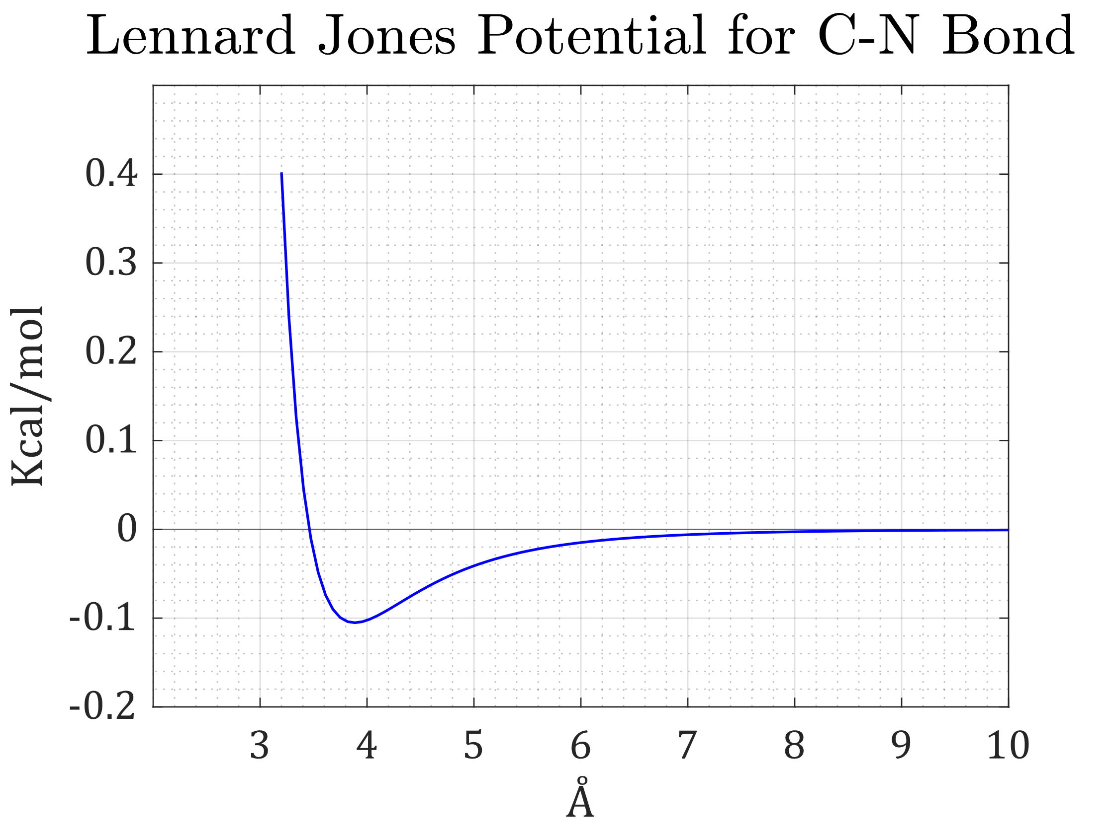
Figure S4: Lennard Jones potential plot for Carbon-Nitrogen bond.

$$σ_{C-N}=3.46 Å ≅0.347 nm$$
$$ε_{C-N}=0.1052 kcal/mole$$
Putting these values in equation (4) will give $K_{LJ}=1.765\frac{N}{m}$
From the Lennard Jones potential, we are seeing that the bond separation length=0.7 nm
Equivalent length$≅$0.347 nm
So, the $δ_{max}=36×\left(0.7-0.347\right)=12.71 nm$ , using equation (5).
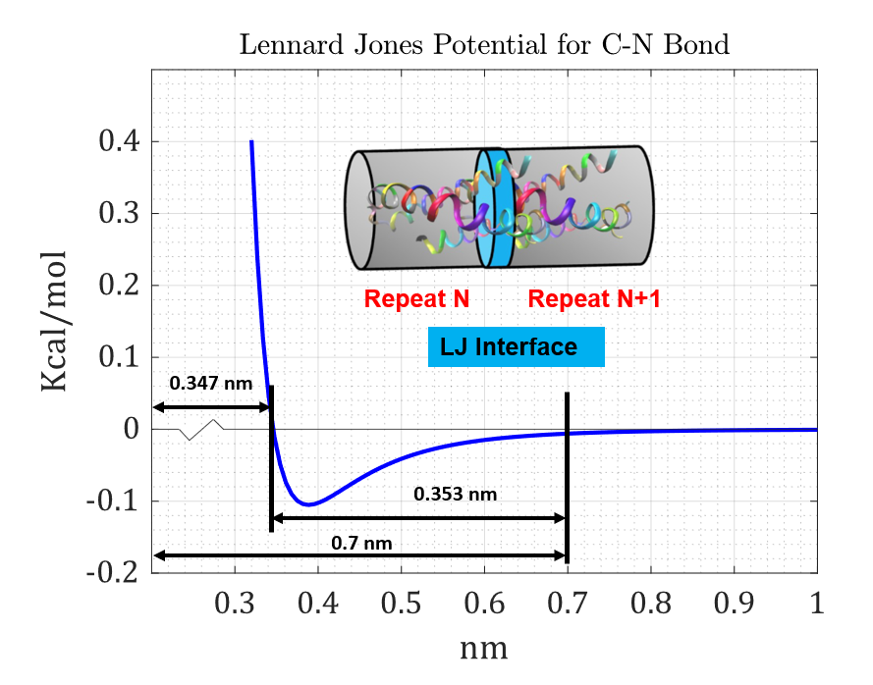
Figure S5: Schematic of failure length of one interface.

$K_{Morse} and δ_{max_Morse}$ Calculation:
Now, the parameters have been calculated through the Morse potential analysis for a comparative result in the main manuscript, and details are as follows.
The Mores potential equation and associated terms[11], [12]
$U=D{\left[1-e^{-α\left(r-r_{e}\right)}\right]}^{2}$ (9)
Here, $D=Well depth or energy (\frac{kcal}{mol})$
$$r_{e}=Equilibrium bond length \left(Å\right)$$
$$α=Width parameter (Å^{-1})$$
$D_{ij}=\sqrt{D_{i}×D_{j}}$ (10)
$α_{ij}=\sqrt{α_{i}×α_{j}}$ (11)
$r_{e}=\frac{1}{2}\left(r_{i}+r_{j}\right)$ (12)
Now, the reported morse parameters for C-C and N-N bonds[13], [14] have some variations in various sources but we have taken the most common values to calculate the C-N morse parameters.
For C-C bonds,
$$D_{c-c}=0.0028437 ev=0.0658 kcal/mol$$
$$r_{c-c}=3.8164 Å$$
$$α_{c-c}=1.5722 Å^{-1}$$
For N-N bonds,
$$D_{N-N}=9.904 ev=228.4 kcal/mol$$
$$r_{N-N}=1.10 Å$$
$$α_{N-N}=1.875 Å^{-1}$$
Thus, using the equations (10) & (11) and (12) we get the values of C-N bonds,
$$D_{C-N}=3.865 kcal/mol$$
$$r_{C-N}=2.45 Å$$
$$α_{C-N}=1.72 Å^{-1}$$
Now, plotting these values using equation (9) we get the figure S6.
Here we see that the equivalent length $≅$0.3 nm, separation length, $≅$0.38 nm,
So, the maximum separation length for all the repeats, $δ_{max⁡_Morse }=36×0.38=13.68 nm$
Now for the $K_{Morse}$ value analysis of interface, the derivation will be as follows for Morse potential,
Expanding the Morse potential around the equilibrium point using the equation (9),
$$U(r)≈U(α)+\frac{dU\left(α\right)}{dr}(r-α)+\frac{d^{2}U(α)}{dr^{2}}{(r-α)}^{2}+ . . . .$$
Where, $U\left(α\right)=D$
$$\frac{dU\left(α\right)}{dr}=0$$
$$\frac{d^{2}U(α)}{dr^{2}}=Dα^{2}$$
The corresponding force is: $F(r)≈ 2Dα^{2}(r-α)$
The force expression is $F(r)≈K_{Morse}(r-σ)$
So, $K_{Morse}=2Dα^{2}$ (13)
Now, putting the values of Carbon-Nitrogen bonds in equation (13) we get,
$$K_{Morse}=1.8\frac{N}{m}$$
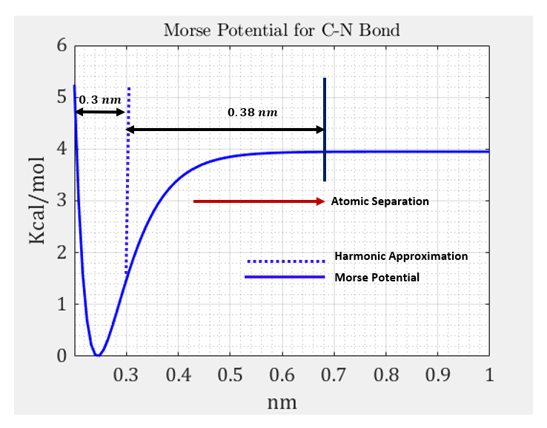
Figure S6: Morse potential plot for Carbon-Nitrogen bond

[1] J. W. Brown, E. Bullitt, S. Sriswasdi, S. Harper, D. W. Speicher, and C. J. McKnight, “The Physiological Molecular Shape of Spectrin: A Compact Supercoil Resembling a Chinese Finger Trap,” PLoS Comput Biol, vol. 11, no. 6, p. e1004302, Jun. 2015, doi: 10.1371/journal.pcbi.1004302.
[2] A. Stukowski, “Visualization and analysis of atomistic simulation data with OVITO–the Open Visualization Tool,” Model Simul Mat Sci Eng, vol. 18, no. 1, p. 015012, Jan. 2010, doi: 10.1088/0965-0393/18/1/015012.
[3] D. A. Case et al., “AmberTools,” J Chem Inf Model, vol. 63, no. 20, pp. 6183–6191, Oct. 2023, doi: 10.1021/acs.jcim.3c01153.
[4] S. J. Weiner et al., “A new force field for molecular mechanical simulation of nucleic acids and proteins,” J Am Chem Soc, vol. 106, no. 3, pp. 765–784, Feb. 1984, doi: 10.1021/ja00315a051.
[5] D. M. Lusitani et al., “The first human alpha-spectrin structural domain begins with serine,” Journal of Biological Chemistry, vol. 269, no. 42, pp. 25955–25958, Oct. 1994, doi: 10.1016/S0021-9258(18)47141-4.
[6] “Purdue Chemistry.” Accessed: Aug. 09, 2023. [Online]. Available: https://www.chem.purdue.edu/jmol/molecules/glycine.html
[7] J. K. Johnson, J. A. Zollweg, and K. E. Gubbins, “The Lennard-Jones equation of state revisited,” Mol Phys, vol. 78, no. 3, pp. 591–618, Feb. 1993, doi: 10.1080/00268979300100411.
[8] K. Kholmurodov, M. Abasheva, and K. Yasuoka, “Molecular dynamics simulations of valinomycin interactions with potassium and sodium ions in water solvent,” Advances in Bioscience and Biotechnology, vol. 01, no. 03, pp. 216–223, 2010, doi: 10.4236/abb.2010.13030.
[9] J. Che, T. Çağın, and W. A. Goddard III, “Generalized extended empirical bond-order dependent force fields including nonbond interactions,” Theoretical Chemistry Accounts: Theory, Computation, and Modeling (Theoretica Chimica Acta), vol. 102, no. 1–6, pp. 346–354, Jun. 1999, doi: 10.1007/s002140050506.
[10] “MATLAB version: 9.13.0 (R2022b).” The MathWorks Inc., 2022.
[11] R.Amiri, “Supersymmetry Quantum Mechanics and Exact Solutions of the Effective Mass of Schrodinger Equations with Rosen-Morse Potential,” GJSFR, vol. 14, no. A5, pp. 25–30, Mar. 2014.
[12] A. C. van Duin and S. R. Larter, “A computational chemical study of penetration and displacement of water films near mineral surfaces,” Geochem Trans, vol. 2, no. 1, p. 35, Dec. 2001, doi: 10.1186/1467-4866-2-35.
[13] T. C. O’Connor, J. Andzelm, and M. O. Robbins, “AIREBO-M: A reactive model for hydrocarbons at extreme pressures,” J Chem Phys, vol. 142, no. 2, Jan. 2015, doi: 10.1063/1.4905549.
[14] D. D. Konowalow and J. O. Hirschfelder, “Morse Potential Parameters for O–O, N–N, and N–O Interactions,” Phys Fluids, vol. 4, no. 5, pp. 637–642, May 1961, doi: 10.1063/1.1706374.

