Autistic adults have insight into their relative face recognition ability

Bayparvah Kaur Gehdu, Clare Press, Katie L. H. Gray, Richard Cook

Supplementary Material

In the main text, we describe a Matrix Reasoning Task (MRT) that was used to estimate individual differences in participants’ non-verbal intelligence. The MRT consisted of forty items, with scores ranging from 0 to 40 (chance performance = 10). Participants were given 30 seconds to complete each puzzle by selecting the correct answer from 4 options. Participants responded using keyboard number keys (1-4), were given a 5-second warning before the end of each trial, and received no feedback. Each participant attempted all forty items. Participants had to complete 3 practice trials correctly before beginning the test.

To assess the test-retest reliability of this measure, 100 non-autistic participants (M_{age} = 34.90 years, SD_{age} = 10.16 years; 27 males, 73 females) were recruited through www.prolific.co and asked to complete the test twice. The average interval between the first and second attempt was 170.2 days (range: 75 days to 297 days), during which time participants were given no feedback regarding their level of performance. The scores seen at the first attempt (M = 26.07, SD = 5.714) and second attempt (M = 26.13, SD = 6.530) did not differ significantly [t(99) = .131, p = .896]. We observed strong positive correlation (Pearson’s r) between the two sets of scores [N = 100, r_{p} = .727, p < .001] (Figure S1).

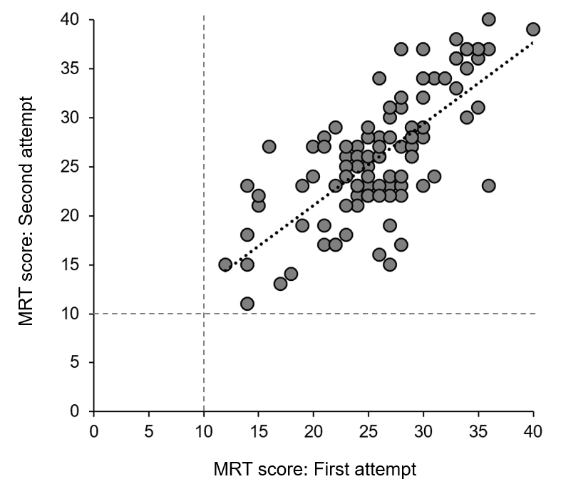
Figure S1. Scatterplot illustrating participants’ scores on the Matrix Reasoning Task (MRT) at the first and second attempt.
Table S1. The statements comprising the PI20.

1. My face recognition ability is worse than most people
2. I have always had a bad memory for faces
3. I find it notably easier to recognize people who have distinctive facial features
4. I often mistake people I have met before for strangers
5. When I was at school, I struggled to recognize my classmates
6. When people change their hairstyle or wear hats, I have problems recognizing them
7. I sometimes have to warn new people I meet that I am ‘bad with faces’
8. I find it easy to picture individual faces in my mind*
9. I am better than most people at putting a ‘name to a face’*
10. Without hearing people's voices, I struggle to recognize them
11. Anxiety about face recognition has led me to avoid certain social or professional situations
12. I have to try harder than other people to memorize faces
13. I am very confident in my ability to recognize myself in photographs*
14. I sometimes find movies hard to follow because of difficulties recognizing characters
15. My friends and family think I have bad face recognition or bad face memory
16. I feel like I frequently offend people by not recognizing who they are
17. It is easy for me to recognize individuals in situations that require people to wear similar clothes (e.g. suits, uniforms and swimwear)*
18. At family gatherings, I sometimes confuse individual family members
19. I find it easy to recognize celebrities in ‘before-they-were-famous’ photos, even if they have changed considerably*
20. It is hard to recognize familiar people when I meet them out of context (e.g. meeting a work colleague unexpectedly while shopping)
N.B. Asterisks indicate items that are reverse scored.

