Legionella colonization and 3D spatial location within a Pseudomonas biofilm

Ana Rosa Silva^{1,2}, Luis F. Melo^{1,2}, C. William Keevil³, Ana Pereira^{1,2*}

¹LEPABE - Laboratory for Process Engineering, Environment, Biotechnology and Energy, Faculty of Engineering, University of Porto, Rua Dr. Roberto Frias, 4200-465 Porto, Portugal
²ALiCE - Associate Laboratory in Chemical Engineering, Faculty of Engineering, University of Porto, Rua Dr. Roberto Frias, 4200-465 Porto, Portugal
³School of Biological Sciences, University of Southampton, Southampton, United Kingdom

Supplementary Material

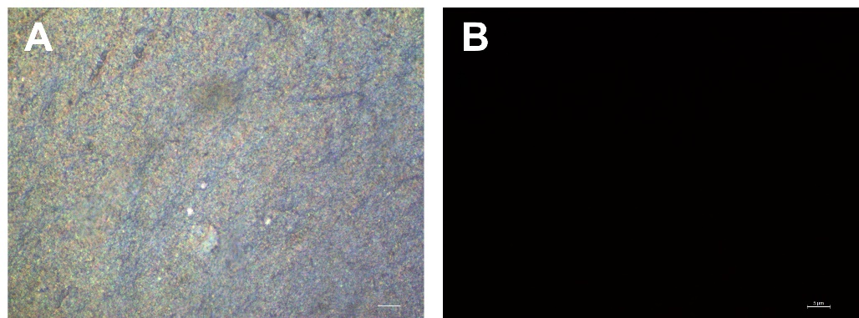
Figure S1. Representative EDIC/EF image of 14-days P. fluorescens biofilms (control – without L. pneumophila); the control biofilms were hybridized with the PNA probe PLPNE620 (red stain; specific for L. pneumophila). Biofilms were visualized using the EDIC channel (image A) and using a TRITC filter for fluorescence (image B). Bars represent 5 µm. Magnification ×1000.

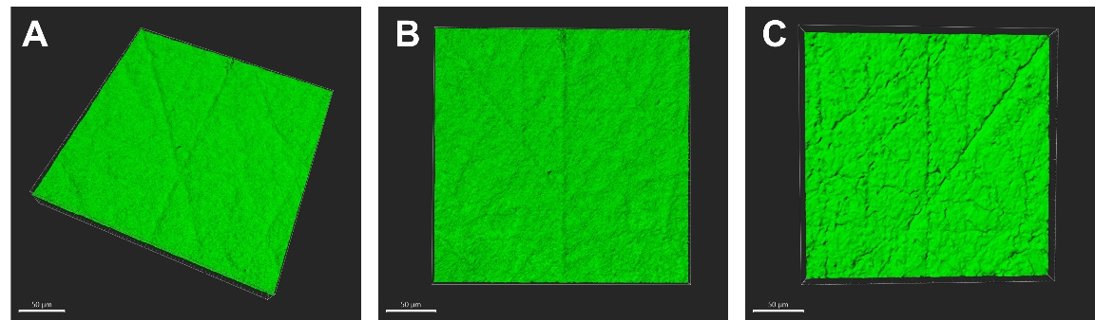
Figure S2. Representative CLSM image of 14-day P. fluorescens biofilms (control – without L. pneumophila); the control biofilms were hybridized with the PNA probe PLPNE620 (red stain; specific for L. pneumophila). The confocal images are 3D projections obtained using IMARIS (A – rotational view, B – top view and C – bottom view), and the white scale bars are 50 µm.

