The predictive value of ultrasound markers for subsequent pregnancy outcomes in recurrent pregnancy loss：a retrospective study

Cai Liu¹, Xue Wei², Fang Wang²*
1 Lan Zhou University,Lanzhou City, Gansu Province,China.
2 Lan Zhou University Second Hospital,Lanzhou City, Gansu Province,China.
*Correspondence to: Fang Wang, Department of Reproductive Medicine, Lan Zhou University Second Hospital, Lanzhou City, Gansu Province,China. 730030. E-mail:ery_fwang@lzu.edu.cn. Telephone:13919302888

S Table 1 Logistic regression of variables in 5th gestational week(sensitive analysis)
5w | B | S.E. | Wald | df | p-value | Exp(B) | 95% CI
age  BMI  PL  hCG  P  E2  mGSD  YSD  Constant | .134 | .037 | 13.207 | 1 | .000 | 1.144 | 1.064 | 1.230
age  BMI  PL  hCG  P  E2  mGSD  YSD  Constant | -.035 | .048 | .528 | 1 | .468 | .966 | .880 | 1.060
age  BMI  PL  hCG  P  E2  mGSD  YSD  Constant | .037 | .138 | .072 | 1 | .789 | 1.038 | .792 | 1.359
age  BMI  PL  hCG  P  E2  mGSD  YSD  Constant | -.002 | .004 | .328 | 1 | .567 | .998 | .990 | 1.005
age  BMI  PL  hCG  P  E2  mGSD  YSD  Constant | -.036 | .014 | 6.245 | 1 | .012 | .965 | .938 | .992
age  BMI  PL  hCG  P  E2  mGSD  YSD  Constant | .003 | .004 | .568 | 1 | .451 | 1.003 | .995 | 1.011
age  BMI  PL  hCG  P  E2  mGSD  YSD  Constant | -.043 | .090 | .232 | 1 | .630 | .958 | .803 | 1.142
age  BMI  PL  hCG  P  E2  mGSD  YSD  Constant | .112 | .162 | .479 | 1 | .489 | 1.119 | .814 | 1.538
age  BMI  PL  hCG  P  E2  mGSD  YSD  Constant | -3.806 | 1.646 | 5.345 | 1 | .021 | .022
a. Variable(s) entered on step 1: age, BMI, PL, hCG, P, E2, mGSD, YSD.
P: progesterone; E2: estrogen; mGSD: mean gestational sac diameter; YSD: yolk sac diameter; CRL: crown rump length.

S Table 2 Logistic regression of variables in 6th gestational week(sensitive analysis)
6w | B | S.E. | Wald | df | p-value | Exp(B) | 95% CI
age  BMI  PL  hCG  P  E2  mGSD  YSD  CRL  Constant | .118 | .037 | 10.312 | 1 | .001 | 1.125 | 1.047 | 1.210
age  BMI  PL  hCG  P  E2  mGSD  YSD  CRL  Constant | .002 | .048 | .002 | 1 | .961 | 1.002 | .912 | 1.101
age  BMI  PL  hCG  P  E2  mGSD  YSD  CRL  Constant | -.038 | .146 | .068 | 1 | .794 | .963 | .723 | 1.281
age  BMI  PL  hCG  P  E2  mGSD  YSD  CRL  Constant | .000 | .001 | .027 | 1 | .869 | 1.000 | .999 | 1.001
age  BMI  PL  hCG  P  E2  mGSD  YSD  CRL  Constant | -.018 | .014 | 1.737 | 1 | .187 | .982 | .956 | 1.009
age  BMI  PL  hCG  P  E2  mGSD  YSD  CRL  Constant | -.005 | .004 | 1.615 | 1 | .204 | .995 | .988 | 1.003
age  BMI  PL  hCG  P  E2  mGSD  YSD  CRL  Constant | -.112 | .048 | 5.369 | 1 | .020 | .894 | .813 | .983
age  BMI  PL  hCG  P  E2  mGSD  YSD  CRL  Constant | -.235 | .174 | 1.827 | 1 | .177 | .790 | .562 | 1.112
age  BMI  PL  hCG  P  E2  mGSD  YSD  CRL  Constant | -.256 | .075 | 11.536 | 1 | .001 | .774 | .668 | .897
age  BMI  PL  hCG  P  E2  mGSD  YSD  CRL  Constant | -.675 | 1.749 | .149 | 1 | .700 | .509
a. Variable(s) entered on step 1: age, BMI, PL, hCG, P, E2, mGSD, YSD, CRL.
P: progesterone; E2: estrogen; mGSD: mean gestational sac diameter; YSD: yolk sac diameter; CRL: crown rump length.

S Table 3 Logistic regression of variables in 7th gestational week(sensitive analysis)
7w |  | B | S.E. | Wald | df | p-value | Exp(B) | 95% CI
 | age | .137 | .051 | 7.366 | 1 | .007 | 1.147 | 1.039 | 1.267
 | BMI | -.109 | .058 | 3.479 | 1 | .062 | .897 | .800 | 1.006
 | PL | -.138 | .187 | .546 | 1 | .460 | .871 | .603 | 1.257
 | hCG | -.003 | .001 | 7.531 | 1 | .006 | .997 | .995 | .999
 | P | -.030 | .018 | 2.768 | 1 | .096 | .971 | .937 | 1.005
 | E2 | -.002 | .004 | .346 | 1 | .556 | .998 | .990 | 1.005
 | mGSD | .057 | .052 | 1.194 | 1 | .274 | 1.059 | .956 | 1.172
 | YSD | -.101 | .271 | .139 | 1 | .709 | .904 | .532 | 1.537
 | CRL | -.385 | .070 | 30.505 | 1 | .000 | .680 | .593 | .780
 | Constant | 1.647 | 2.383 | .478 | 1 | .490 | 5.189
a. Variable(s) entered on step 1: age, BMI, PL, hCG, P, E2, mGSD, YSD, CRL.
P: progesterone; E2: estrogen; mGSD: mean gestational sac diameter; YSD: yolk sac diameter; CRL: crown rump length.

S Table 4 Logistic regression of variables in 8th gestational week(sensitive analysis)
8w | B | S.E. | Wald | df | p-value | Exp(B) | 95%CI
age  hCG  P  E2  mGSD  YSD  CRL  PL  BMI  Constant | .167 | .080 | 4.390 | 1 | .036 | 1.181 | 1.011 | 1.381
age  hCG  P  E2  mGSD  YSD  CRL  PL  BMI  Constant | -.002 | .001 | 2.942 | 1 | .086 | .998 | .997 | 1.000
age  hCG  P  E2  mGSD  YSD  CRL  PL  BMI  Constant | -.040 | .032 | 1.532 | 1 | .216 | .961 | .902 | 1.024
age  hCG  P  E2  mGSD  YSD  CRL  PL  BMI  Constant | -.006 | .004 | 2.166 | 1 | .141 | .994 | .986 | 1.002
age  hCG  P  E2  mGSD  YSD  CRL  PL  BMI  Constant | .012 | .073 | .027 | 1 | .870 | 1.012 | .876 | 1.169
age  hCG  P  E2  mGSD  YSD  CRL  PL  BMI  Constant | .547 | .377 | 2.100 | 1 | .147 | 1.728 | .825 | 3.620
age  hCG  P  E2  mGSD  YSD  CRL  PL  BMI  Constant | -.382 | .071 | 28.990 | 1 | .000 | .682 | .594 | .784
age  hCG  P  E2  mGSD  YSD  CRL  PL  BMI  Constant | -.272 | .346 | .618 | 1 | .432 | .762 | .387 | 1.501
age  hCG  P  E2  mGSD  YSD  CRL  PL  BMI  Constant | -.034 | .089 | .149 | 1 | .700 | .966 | .813 | 1.150
age  hCG  P  E2  mGSD  YSD  CRL  PL  BMI  Constant | .070 | 3.781 | .000 | 1 | .985 | 1.072
a. Variable(s) entered on step 1: age, hCG, P, E2, mGSD, YSD, CRL, PL, BMI.
P: progesterone; E2: estrogen; mGSD: mean gestational sac diameter; YSD: yolk sac diameter; CRL: crown rump length.

S Table 5 Logistic regression of variables in 9th gestational week(sensitive analysis)
9w | B | S.E. | Wald | df | p-value | Exp(B) | 95% C.I.for EXP(B)
age  BMI  PL  hCG  P  E2  mGSD  YSD  CRL  Constant | .110 | .097 | 1.291 | 1 | .256 | 1.116 | .924 | 1.348
age  BMI  PL  hCG  P  E2  mGSD  YSD  CRL  Constant | -.103 | .116 | .791 | 1 | .374 | .902 | .718 | 1.133
age  BMI  PL  hCG  P  E2  mGSD  YSD  CRL  Constant | -.142 | .303 | .220 | 1 | .639 | .867 | .479 | 1.571
age  BMI  PL  hCG  P  E2  mGSD  YSD  CRL  Constant | -.002 | .001 | 3.101 | 1 | .078 | .998 | .996 | 1.000
age  BMI  PL  hCG  P  E2  mGSD  YSD  CRL  Constant | .005 | .031 | .025 | 1 | .876 | 1.005 | .945 | 1.069
age  BMI  PL  hCG  P  E2  mGSD  YSD  CRL  Constant | -.004 | .004 | .682 | 1 | .409 | .997 | .988 | 1.005
age  BMI  PL  hCG  P  E2  mGSD  YSD  CRL  Constant | .214 | .077 | 7.811 | 1 | .005 | 1.239 | 1.066 | 1.440
age  BMI  PL  hCG  P  E2  mGSD  YSD  CRL  Constant | .291 | .434 | .450 | 1 | .502 | 1.338 | .572 | 3.132
age  BMI  PL  hCG  P  E2  mGSD  YSD  CRL  Constant | -.411 | .094 | 19.067 | 1 | .000 | .663 | .551 | .797
age  BMI  PL  hCG  P  E2  mGSD  YSD  CRL  Constant | -1.971 | 4.362 | .204 | 1 | .651 | .139
a. Variable(s) entered on step 1: age, BMI, PL, hCG, P, E2, mGSD, YSD, CRL.
P: progesterone; E2: estrogen; mGSD: mean gestational sac diameter; YSD: yolk sac diameter; CRL: crown rump length.

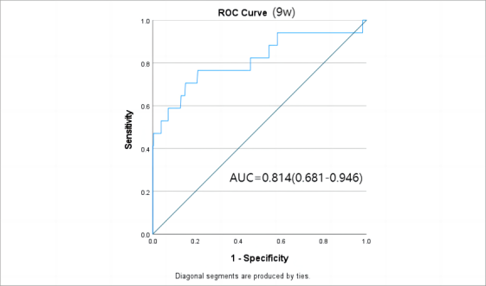
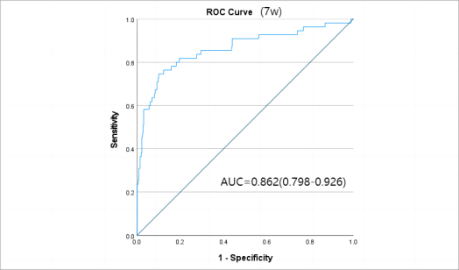
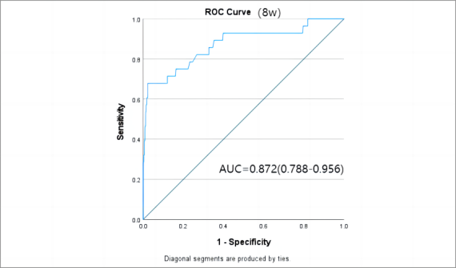
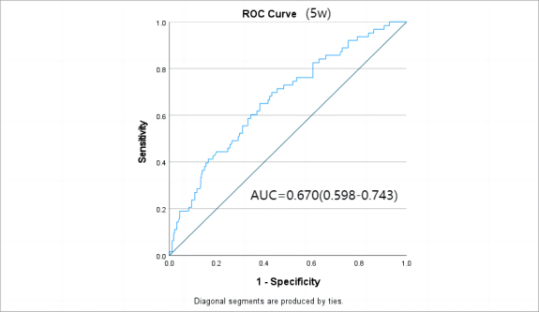
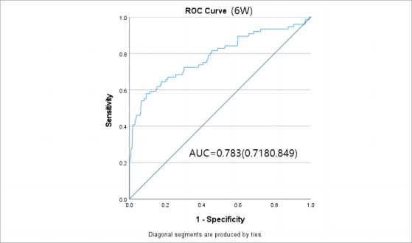

S Figure 1 The AUC of predictors for pregnancy loss in different gestational weeks(sensitive analysis).

S Table 6. The AUC of predictors for pregnancy loss in different gestational weeks(sensitive analysis).
Week | Variable | AUC | 95%CI
5th | Age  P | 0.670 | 0.598-0.743
6th | Age  mmGSD  CRL | 0.783 | 0.718-0.849
7th | Age  hCG  CRL | 0.862 | 0.7984-0.926
8th | Age  CRL | 0.872 | 0.788-0.956
9th | mmGSD  CRL | 0.814 | 0.681-0.946
P: progesterone; mGSD:mean of the gestational sac diameter; CRL:Crown-rump length; HR: hazard ratio. BMI:body mass index.

