Supplemental Figures and Tables

Supplemental Table 1: Olink Categorical Analysis by Sex. Organized by significance.

Full Cohort: Male vs Female |  |  | RRMS: Male vs Female |  |  | PMS: Male vs Female
Protein | p value | Adjusted p | Protein | p value | Adjusted p | Protein | p value | Adjusted p
FGF-19 | 2.80E-06 | 0.00025719 | FGF-19 | 0.00046585 | 0.01797766 | FGF-19 | 0.00081898 | 0.07147978
FGF-5 | 0.00404071 | 0.125815 | IL-10RA | 0.00058271 | 0.01797766 | CD244 | 0.00228381 | 0.07147978
CXCL1 | 0.00410266 | 0.125815 | IL-20 | 0.00058623 | 0.01797766 | Flt3L | 0.00233086 | 0.07147978
IL8 | 0.01073489 | 0.21453353 | ARTN | 0.01033243 | 0.20018028 | TNF | 0.00536381 | 0.12336757
OPG | 0.01369277 | 0.21453353 | IL-20RA | 0.01334585 | 0.20018028 | SIRT2 | 0.02773563 | 0.36056123
ADA | 0.01547374 | 0.21453353 | ADA | 0.01377211 | 0.20018028 | IL8 | 0.02919963 | 0.36056123
MMP-10 | 0.01767676 | 0.21453353 | IL18 | 0.01523111 | 0.20018028 | MCP-1 | 0.02961362 | 0.36056123
DNER | 0.01865509 | 0.21453353 | MCP-3 | 0.03894689 | 0.44788927 | MCP-2 | 0.03135315 | 0.36056123
CSF-1 | 0.02721102 | 0.21911712 | IL2 | 0.04777966 | 0.48841433 | CXCL1 | 0.05683345 | 0.38268318
CST5 | 0.02839802 | 0.21911712 | FGF-5 | 0.05447665 | 0.50118517 | SCF | 0.05713528 | 0.38268318
ARTN | 0.02856895 | 0.21911712 | DNER | 0.07123233 | 0.54746833 | IL-18R1 | 0.06268513 | 0.38268318
TGF-alpha | 0.02858049 | 0.21911712 | CD244 | 0.10277748 | 0.54746833 | FGF-5 | 0.06819046 | 0.38268318
IL18 | 0.04076437 | 0.28848628 | SIRT2 | 0.10321257 | 0.54746833 | CCL11 | 0.06893137 | 0.38268318
VEGFA | 0.04796051 | 0.31516905 | NRTN | 0.11751913 | 0.54746833 | TGF-alpha | 0.07275274 | 0.38268318
MMP-1 | 0.05355225 | 0.32845382 | CXCL1 | 0.12159061 | 0.54746833 | CST5 | 0.07422274 | 0.38268318
IL-10RA | 0.05742759 | 0.33020866 | STAMBP | 0.12276516 | 0.54746833 | HGF | 0.08152864 | 0.38268318
Flt3L | 0.06571813 | 0.35565107 | OPG | 0.12307724 | 0.54746833 | ADA | 0.08536852 | 0.38268318
SCF | 0.08562984 | 0.40804769 | FGF-23 | 0.12477359 | 0.54746833 | OPG | 0.10059563 | 0.38268318
uPA | 0.08822227 | 0.40804769 | IL8 | 0.12829182 | 0.54746833 | IL33 | 0.10145146 | 0.38268318
TWEAK | 0.08870602 | 0.40804769 | CCL25 | 0.13405078 | 0.54746833 | CCL28 | 0.10223165 | 0.38268318
HGF | 0.10154854 | 0.41335823 | MMP-10 | 0.13531744 | 0.54746833 | CXCL9 | 0.10852971 | 0.38268318
CD8A | 0.10340728 | 0.41335823 | CSF-1 | 0.13809453 | 0.54746833 | VEGFA | 0.10887152 | 0.38268318
CCL19 | 0.10464491 | 0.41335823 | CD40 | 0.138607 | 0.54746833 | IL4 | 0.10984888 | 0.38268318
IL-10RB | 0.11088486 | 0.41335823 | NT-3 | 0.14470455 | 0.54746833 | CCL3 | 0.115241 | 0.38268318
IL-18R1 | 0.11232561 | 0.41335823 | CCL19 | 0.14876857 | 0.54746833 | MCP-4 | 0.11660248 | 0.38268318
MCP-4 | 0.13238777 | 0.44340911 | IL-15RA | 0.15635886 | 0.55326982 | CCL23 | 0.11939153 | 0.38268318
CD40 | 0.13963647 | 0.44340911 | IL33 | 0.19381595 | 0.65639855 | TNFRSF9 | 0.12021878 | 0.38268318
TNF | 0.14006342 | 0.44340911 | CST5 | 0.19977347 | 0.65639855 | SLAMF1 | 0.1214104 | 0.38268318
MCP-3 | 0.14203305 | 0.44340911 | IL6 | 0.21083103 | 0.66884327 | IL18 | 0.12717318 | 0.38268318
FGF-23 | 0.14513176 | 0.44340911 | ST1A1 | 0.21879447 | 0.67096971 | CD8A | 0.12746816 | 0.38268318
IL-20 | 0.15287622 | 0.44340911 | IL-22 RA1 | 0.24568272 | 0.67471075 | TWEAK | 0.12894759 | 0.38268318
NRTN | 0.15813731 | 0.44340911 | OSM | 0.25033033 | 0.67471075 | PD-L1 | 0.14910959 | 0.42869006
CXCL6 | 0.15904892 | 0.44340911 | VEGFA | 0.25113076 | 0.67471075 | CCL4 | 0.17495527 | 0.48775407
LIF-R | 0.17365582 | 0.45046885 | Flt3L | 0.25724336 | 0.67471075 | MMP-10 | 0.19226771 | 0.49199074
PD-L1 | 0.1747283 | 0.45046885 | IL4 | 0.25733093 | 0.67471075 | CSF-1 | 0.19243836 | 0.49199074
IL-15RA | 0.1827432 | 0.45046885 | TNF | 0.27019461 | 0.67471075 | LIF-R | 0.19251812 | 0.49199074
IL2 | 0.1909043 | 0.45046885 | uPA | 0.28491635 | 0.67471075 | CXCL5 | 0.20882465 | 0.51103083
LIF | 0.19358369 | 0.45046885 | MMP-1 | 0.29093655 | 0.67471075 | IL-10RB | 0.21107795 | 0.51103083
IL-22 RA1 | 0.19372775 | 0.45046885 | TNFB | 0.29828057 | 0.67471075 | CD40 | 0.22799866 | 0.51391449
MCP-1 | 0.19736208 | 0.45046885 | TGF-alpha | 0.30157831 | 0.67471075 | MMP-1 | 0.22878603 | 0.51391449
CCL3 | 0.20075242 | 0.45046885 | CXCL5 | 0.31204264 | 0.67471075 | NT-3 | 0.22902711 | 0.51391449
CCL23 | 0.22266777 | 0.47785252 | CCL23 | 0.31754269 | 0.67471075 | CDCP1 | 0.23811849 | 0.52159289
IL-17A | 0.22334411 | 0.47785252 | SCF | 0.3217022 | 0.67471075 | CD5 | 0.24963189 | 0.52293388
CXCL5 | 0.2396499 | 0.50108616 | IL-17A | 0.32580234 | 0.67471075 | DNER | 0.25009881 | 0.52293388
MCP-2 | 0.27707018 | 0.56274643 | GDNF | 0.33002156 | 0.67471075 | 4E-BP1 | 0.27517267 | 0.55663565
4E-BP1 | 0.28137321 | 0.56274643 | CXCL6 | 0.35666853 | 0.70548608 | CX3CL1 | 0.28103929 | 0.55663565
CX3CL1 | 0.29019103 | 0.56803351 | AXIN1 | 0.36411602 | 0.70548608 | uPA | 0.28436821 | 0.55663565
AXIN1 | 0.31555099 | 0.59595812 | HGF | 0.36807969 | 0.70548608 | LIF | 0.2961394 | 0.56760053
IL-24 | 0.31741248 | 0.59595812 | CCL28 | 0.37638609 | 0.70639582 | IL10 | 0.31639105 | 0.59087851
IL5 | 0.33916273 | 0.60793444 | IL5 | 0.38391077 | 0.70639582 | CASP-8 | 0.32112962 | 0.59087851
CCL11 | 0.34129413 | 0.60793444 | IL-10RB | 0.41233213 | 0.71742417 | CXCL6 | 0.34027203 | 0.61382406
OSM | 0.34361512 | 0.60793444 | TNFRSF9 | 0.41393621 | 0.71742417 | TSLP | 0.35839037 | 0.63407526
CD5 | 0.38984146 | 0.67670593 | CXCL10 | 0.41523909 | 0.71742417 | CXCL10 | 0.37322736 | 0.64786635
IFN-gamma | 0.40068578 | 0.68264985 | IL-1 alpha | 0.43950218 | 0.71742417 | IL-20RA | 0.39422153 | 0.66730431
CD6 | 0.43799757 | 0.713589 | CCL3 | 0.45386865 | 0.71742417 | CCL25 | 0.39893193 | 0.66730431
CCL4 | 0.4399207 | 0.713589 | CD8A | 0.45519901 | 0.71742417 | IL6 | 0.42098663 | 0.6916209
CXCL10 | 0.44211492 | 0.713589 | TWEAK | 0.46241427 | 0.71742417 | CCL19 | 0.46606271 | 0.75224157
TSLP | 0.44991245 | 0.71365423 | IL-24 | 0.46871203 | 0.71742417 | IL-12B | 0.50334101 | 0.77625203
Beta-NGF | 0.4824713 | 0.75232813 | 4E-BP1 | 0.47789665 | 0.71742417 | GDNF | 0.5057553 | 0.77625203
IL-12B | 0.50029337 | 0.76711649 | CD5 | 0.47904962 | 0.71742417 | EN-RAGE | 0.50625133 | 0.77625203
CXCL11 | 0.51312445 | 0.77389262 | IL-18R1 | 0.48587979 | 0.71742417 | IFN-gamma | 0.51764275 | 0.7807071
ST1A1 | 0.55466483 | 0.80421863 | MCP-2 | 0.48705831 | 0.71742417 | ARTN | 0.5430865 | 0.80587029
STAMBP | 0.5629352 | 0.80421863 | IL-2RB | 0.49549766 | 0.71742417 | IL-24 | 0.55435239 | 0.80953047
CCL25 | 0.56806753 | 0.80421863 | MCP-1 | 0.50599028 | 0.71742417 | CXCL11 | 0.56798422 | 0.81647732
NT-3 | 0.56819794 | 0.80421863 | CD6 | 0.50687577 | 0.71742417 | IL5 | 0.60062935 | 0.83323751
FGF-21 | 0.57860853 | 0.80654522 | CXCL11 | 0.53679848 | 0.74826454 | ST1A1 | 0.60466901 | 0.83323751
TRAIL | 0.60870644 | 0.83583571 | SLAMF1 | 0.56669881 | 0.77110964 | FGF-21 | 0.60681427 | 0.83323751
IL10 | 0.62451824 | 0.84028971 | EN-RAGE | 0.5699506 | 0.77110964 | Beta-NGF | 0.62691366 | 0.8481773
IL6 | 0.63021728 | 0.84028971 | LIF | 0.61825049 | 0.82433399 | IL2 | 0.63634644 | 0.84846192
CD244 | 0.64405087 | 0.84646686 | IL-17C | 0.62931966 | 0.82710583 | LAP TGF-beta-1 | 0.65364514 | 0.85907647
TNFSF14 | 0.68260881 | 0.88450719 | PD-L1 | 0.65027562 | 0.83474578 | TNFSF14 | 0.67002456 | 0.86820083
CCL28 | 0.709257 | 0.8931397 | LIF-R | 0.65327931 | 0.83474578 | IL-17A | 0.68857715 | 0.87356586
IL-2RB | 0.71384103 | 0.8931397 | FGF-21 | 0.70839252 | 0.89276866 | IL13 | 0.69315552 | 0.87356586
IL-20RA | 0.71839498 | 0.8931397 | CASP-8 | 0.72788836 | 0.90494228 | MCP-3 | 0.73605894 | 0.90504564
TNFB | 0.73565164 | 0.90239935 | MCP-4 | 0.76518123 | 0.93862231 | IL-1 alpha | 0.74440784 | 0.90504564
IL13 | 0.76020462 | 0.9202477 | CCL4 | 0.78255397 | 0.94730217 | OSM | 0.75250982 | 0.90504564
IL33 | 0.79877187 | 0.93773073 | LAP TGF-beta-1 | 0.79942445 | 0.95007963 | IL-17C | 0.75748385 | 0.90504564
CASP-8 | 0.82517612 | 0.93773073 | CCL20 | 0.80550229 | 0.95007963 | IL-22 RA1 | 0.79921198 | 0.92661343
TRANCE | 0.83119454 | 0.93773073 | CX3CL1 | 0.81650719 | 0.95086913 | IL-20 | 0.82512015 | 0.92661343
IL-1 alpha | 0.8338942 | 0.93773073 | TRAIL | 0.84439916 | 0.95760455 | CD6 | 0.82573415 | 0.92661343
GDNF | 0.84263331 | 0.93773073 | TSLP | 0.85159789 | 0.95760455 | TRANCE | 0.82703162 | 0.92661343
IL4 | 0.84469603 | 0.93773073 | IL13 | 0.87046082 | 0.95760455 | FGF-23 | 0.83030309 | 0.92661343
LAP TGF-beta-1 | 0.84601898 | 0.93773073 | Beta-NGF | 0.87637057 | 0.95760455 | IL7 | 0.8476127 | 0.92661343
TNFRSF9 | 0.86140595 | 0.93773073 | TRANCE | 0.88175861 | 0.95760455 | TNFB | 0.85196844 | 0.92661343
CCL20 | 0.86638165 | 0.93773073 | CCL11 | 0.88474334 | 0.95760455 | TRAIL | 0.85611023 | 0.92661343
IL7 | 0.88181822 | 0.94334043 | TNFSF14 | 0.90302633 | 0.96602816 | IL-10RA | 0.88940184 | 0.94391466
CDCP1 | 0.91143244 | 0.96381361 | IL7 | 0.92624287 | 0.97332323 | NRTN | 0.89261495 | 0.94391466
SIRT2 | 0.96260762 | 0.98349875 | CDCP1 | 0.94628514 | 0.97332323 | CCL20 | 0.92326367 | 0.95918921
IL-17C | 0.96486878 | 0.98349875 | IFN-gamma | 0.94642078 | 0.97332323 | AXIN1 | 0.93181814 | 0.95918921
CXCL9 | 0.97665615 | 0.98349875 | IL10 | 0.9525451 | 0.97332323 | STAMBP | 0.93833727 | 0.95918921
SLAMF1 | 0.97959694 | 0.98349875 | CXCL9 | 0.96274363 | 0.97332323 | IL-2RB | 0.96344623 | 0.96663312
EN-RAGE | 0.98349875 | 0.98349875 | IL-12B | 0.98080479 | 0.98080479 | IL-15RA | 0.96663312 | 0.96663312

Supplemental Table 2: Olink Categorical Analysis by MS Subtype. Organized by significance.

RRMS vs PMS |  |  | Tumefactive vs Other |  |  | RRMS vs Other
Protein | p value | Adjusted p | Protein | p value | Adjusted p | Protein | p value | Adjusted p
SLAMF1 | 0.01083071 | 0.96598024 | CCL4 | 0.00023794 | 0.02189027 | IL-17C | 0.05735807 | 0.935511901
IL-17C | 0.1135171 | 0.96598024 | IL-22 RA1 | 0.00214436 | 0.09864035 | SLAMF1 | 0.08774402 | 0.935511901
IL2 | 0.14890411 | 0.96598024 | CXCL6 | 0.00411362 | 0.126151 | CCL20 | 0.09349148 | 0.935511901
CCL20 | 0.15420604 | 0.96598024 | NRTN | 0.05747613 | 0.98540449 | CASP-8 | 0.15877936 | 0.935511901
TRAIL | 0.16702311 | 0.96598024 | IL-24 | 0.08032864 | 0.98540449 | IL-24 | 0.1617596 | 0.935511901
TNFB | 0.17004287 | 0.96598024 | IL5 | 0.08911141 | 0.98540449 | TRAIL | 0.18812592 | 0.935511901
CD5 | 0.20593688 | 0.96598024 | CD6 | 0.14487275 | 0.98540449 | CXCL5 | 0.18817481 | 0.935511901
IL-24 | 0.29334403 | 0.96598024 | CCL20 | 0.17839423 | 0.98540449 | ADA | 0.2179983 | 0.935511901
IL13 | 0.30429194 | 0.96598024 | CXCL5 | 0.18901673 | 0.98540449 | IL33 | 0.22273036 | 0.935511901
CST5 | 0.31558075 | 0.96598024 | CCL19 | 0.19679104 | 0.98540449 | CXCL6 | 0.26468594 | 0.935511901
CASP-8 | 0.32251073 | 0.96598024 | TSLP | 0.2039136 | 0.98540449 | CCL23 | 0.26973662 | 0.935511901
IL18 | 0.32760681 | 0.96598024 | IL8 | 0.20617234 | 0.98540449 | Flt3L | 0.27385734 | 0.935511901
SIRT2 | 0.35056516 | 0.96598024 | FGF-19 | 0.23455647 | 0.98540449 | IL13 | 0.30228961 | 0.935511901
ADA | 0.36945649 | 0.96598024 | IL-2RB | 0.24920929 | 0.98540449 | FGF-21 | 0.30661506 | 0.935511901
CX3CL1 | 0.37488883 | 0.96598024 | CASP-8 | 0.25589599 | 0.98540449 | CCL19 | 0.30891375 | 0.935511901
LIF | 0.37929835 | 0.96598024 | STAMBP | 0.26329647 | 0.98540449 | CD6 | 0.33758261 | 0.935511901
IFN-gamma | 0.38295417 | 0.96598024 | DNER | 0.26666281 | 0.98540449 | IL-20RA | 0.35477169 | 0.935511901
AXIN1 | 0.39789976 | 0.96598024 | IL33 | 0.28170763 | 0.98540449 | CD8A | 0.37054273 | 0.935511901
IL33 | 0.4012136 | 0.96598024 | IL-1 alpha | 0.30633533 | 0.98540449 | OPG | 0.37744829 | 0.935511901
FGF-21 | 0.40297319 | 0.96598024 | IL18 | 0.34497176 | 0.98540449 | MCP-1 | 0.37969532 | 0.935511901
Beta-NGF | 0.42442994 | 0.96598024 | CD8A | 0.3539453 | 0.98540449 | IL-17A | 0.38786657 | 0.935511901
OPG | 0.43276807 | 0.96598024 | VEGFA | 0.40405809 | 0.98540449 | CSF-1 | 0.40133845 | 0.935511901
IL-20RA | 0.4384949 | 0.96598024 | TNFSF14 | 0.42197111 | 0.98540449 | CXCL10 | 0.40270827 | 0.935511901
STAMBP | 0.45475966 | 0.96598024 | TRANCE | 0.42620994 | 0.98540449 | TNFSF14 | 0.40452562 | 0.935511901
IL-10RA | 0.45753628 | 0.96598024 | ARTN | 0.42986602 | 0.98540449 | CX3CL1 | 0.40521342 | 0.935511901
IL-1 alpha | 0.46019193 | 0.96598024 | IL4 | 0.43598529 | 0.98540449 | CCL4 | 0.4095145 | 0.935511901
EN-RAGE | 0.47908158 | 0.96598024 | CCL11 | 0.49619141 | 0.98540449 | VEGFA | 0.41846942 | 0.935511901
CD8A | 0.48293229 | 0.96598024 | IL-17C | 0.50539983 | 0.98540449 | MCP-2 | 0.41894562 | 0.935511901
CCL23 | 0.50390769 | 0.96598024 | Beta-NGF | 0.506323 | 0.98540449 | NRTN | 0.42233333 | 0.935511901
CSF-1 | 0.5064953 | 0.96598024 | MCP-2 | 0.51127236 | 0.98540449 | 4E-BP1 | 0.43960403 | 0.935511901
IL-2RB | 0.51452042 | 0.96598024 | IL-18R1 | 0.51824182 | 0.98540449 | Beta-NGF | 0.44657402 | 0.935511901
TNFSF14 | 0.52157454 | 0.96598024 | CXCL10 | 0.52306896 | 0.98540449 | IL2 | 0.4535646 | 0.935511901
LAP TGF-beta-1 | 0.52803764 | 0.96598024 | Flt3L | 0.52914539 | 0.98540449 | CST5 | 0.4576956 | 0.935511901
VEGFA | 0.53277453 | 0.96598024 | CCL23 | 0.54238772 | 0.98540449 | IFN-gamma | 0.45885594 | 0.935511901
TNF | 0.53304041 | 0.96598024 | CD244 | 0.54258767 | 0.98540449 | IL6 | 0.46670269 | 0.935511901
SCF | 0.54776404 | 0.96598024 | IL-17A | 0.55574932 | 0.98540449 | LIF | 0.46721737 | 0.935511901
CXCL1 | 0.55318004 | 0.96598024 | TNFRSF9 | 0.57004582 | 0.98540449 | SIRT2 | 0.46870306 | 0.935511901
LIF-R | 0.55832208 | 0.96598024 | MCP-1 | 0.57174245 | 0.98540449 | SCF | 0.47094194 | 0.935511901
Flt3L | 0.55920791 | 0.96598024 | 4E-BP1 | 0.57453122 | 0.98540449 | IL10 | 0.49017757 | 0.935511901
IL6 | 0.58733005 | 0.96598024 | IL10 | 0.58251235 | 0.98540449 | CXCL9 | 0.49910147 | 0.935511901
IL4 | 0.59400053 | 0.96598024 | CDCP1 | 0.58665784 | 0.98540449 | PD-L1 | 0.5040756 | 0.935511901
IL-17A | 0.59689235 | 0.96598024 | ADA | 0.58747984 | 0.98540449 | CCL28 | 0.50848799 | 0.935511901
ST1A1 | 0.60517061 | 0.96598024 | CXCL9 | 0.59289276 | 0.98540449 | IL-22 RA1 | 0.50997409 | 0.935511901
TNFRSF9 | 0.61724536 | 0.96598024 | CXCL11 | 0.59863032 | 0.98540449 | LIF-R | 0.51920441 | 0.935511901
CCL28 | 0.62131676 | 0.96598024 | TNFB | 0.61755157 | 0.98540449 | GDNF | 0.52063461 | 0.935511901
CCL19 | 0.62168705 | 0.96598024 | FGF-21 | 0.61792423 | 0.98540449 | TNFRSF9 | 0.52702611 | 0.935511901
PD-L1 | 0.63164325 | 0.96598024 | CCL3 | 0.62055503 | 0.98540449 | IL-10RA | 0.52786031 | 0.935511901
NT-3 | 0.64215035 | 0.96598024 | IL-15RA | 0.6287884 | 0.98540449 | CXCL1 | 0.52803135 | 0.935511901
CD6 | 0.65689137 | 0.96598024 | OPG | 0.63721181 | 0.98540449 | LAP TGF-beta-1 | 0.52962284 | 0.935511901
IL5 | 0.65800981 | 0.96598024 | LIF | 0.64584757 | 0.98540449 | MMP-1 | 0.54340954 | 0.935511901
IL10 | 0.65811535 | 0.96598024 | CD40 | 0.64731734 | 0.98540449 | AXIN1 | 0.55002787 | 0.935511901
CXCL5 | 0.65879691 | 0.96598024 | CSF-1 | 0.64792719 | 0.98540449 | ARTN | 0.56025213 | 0.935511901
GDNF | 0.66069687 | 0.96598024 | IL2 | 0.65300597 | 0.98540449 | IL-18R1 | 0.56291365 | 0.935511901
CXCL6 | 0.66149671 | 0.96598024 | SIRT2 | 0.66285801 | 0.98540449 | NT-3 | 0.57134453 | 0.935511901
IL-10RB | 0.66406814 | 0.96598024 | IL7 | 0.66507084 | 0.98540449 | IL-10RB | 0.58671944 | 0.935511901
HGF | 0.67517682 | 0.96598024 | IL-12B | 0.67380935 | 0.98540449 | TSLP | 0.59687737 | 0.935511901
CD244 | 0.69309283 | 0.96598024 | CCL25 | 0.68367199 | 0.98540449 | CD5 | 0.60028474 | 0.935511901
TWEAK | 0.69738688 | 0.96598024 | TNF | 0.70281721 | 0.98540449 | CD40 | 0.60140735 | 0.935511901
TRANCE | 0.71055469 | 0.96598024 | TGF-alpha | 0.70365501 | 0.98540449 | ST1A1 | 0.61473521 | 0.935511901
IL-12B | 0.71569464 | 0.96598024 | IL6 | 0.72176337 | 0.98540449 | TWEAK | 0.63893377 | 0.935511901
FGF-5 | 0.71730705 | 0.96598024 | CD5 | 0.73700173 | 0.98540449 | CDCP1 | 0.65220546 | 0.935511901
MMP-1 | 0.71753759 | 0.96598024 | MMP-10 | 0.74855854 | 0.98540449 | HGF | 0.65638989 | 0.935511901
MCP-1 | 0.72333878 | 0.96598024 | MMP-1 | 0.75213759 | 0.98540449 | FGF-5 | 0.66204917 | 0.935511901
CCL3 | 0.73331132 | 0.96598024 | CST5 | 0.75237479 | 0.98540449 | IL-1 alpha | 0.6775951 | 0.935511901
DNER | 0.74535558 | 0.96598024 | GDNF | 0.75567256 | 0.98540449 | uPA | 0.68890177 | 0.935511901
ARTN | 0.76678176 | 0.96598024 | OSM | 0.75957174 | 0.98540449 | STAMBP | 0.68984412 | 0.935511901
TSLP | 0.77443341 | 0.96598024 | SCF | 0.77775891 | 0.98540449 | IL7 | 0.70050608 | 0.935511901
CXCL11 | 0.77912345 | 0.96598024 | IL-20RA | 0.77937941 | 0.98540449 | IL-2RB | 0.70253397 | 0.935511901
NRTN | 0.80429724 | 0.96598024 | FGF-23 | 0.78120473 | 0.98540449 | IL-15RA | 0.73200364 | 0.935511901
CCL11 | 0.80902853 | 0.96598024 | MCP-4 | 0.79466662 | 0.98540449 | IL-20 | 0.7350118 | 0.935511901
uPA | 0.81609229 | 0.96598024 | IL-20 | 0.79515998 | 0.98540449 | EN-RAGE | 0.75361629 | 0.935511901
CCL25 | 0.82109363 | 0.96598024 | CCL28 | 0.79542048 | 0.98540449 | CXCL11 | 0.76736032 | 0.935511901
IL-20 | 0.8389641 | 0.96598024 | PD-L1 | 0.80037555 | 0.98540449 | CCL11 | 0.78043971 | 0.935511901
4E-BP1 | 0.83964903 | 0.96598024 | uPA | 0.81006342 | 0.98540449 | FGF-19 | 0.7828553 | 0.935511901
FGF-23 | 0.83997788 | 0.96598024 | MCP-3 | 0.82671994 | 0.98540449 | IL4 | 0.78967422 | 0.935511901
CXCL10 | 0.84614338 | 0.96598024 | NT-3 | 0.83412297 | 0.98540449 | IL8 | 0.79316689 | 0.935511901
IL-15RA | 0.86879503 | 0.96598024 | IL-10RB | 0.85523719 | 0.98540449 | CCL3 | 0.8071479 | 0.935511901
CDCP1 | 0.86914811 | 0.96598024 | TWEAK | 0.85813043 | 0.98540449 | MCP-4 | 0.80810668 | 0.935511901
MCP-4 | 0.88869801 | 0.96598024 | FGF-5 | 0.86540356 | 0.98540449 | TNF | 0.81319931 | 0.935511901
TGF-alpha | 0.89976621 | 0.96598024 | EN-RAGE | 0.87847852 | 0.98540449 | MCP-3 | 0.81348861 | 0.935511901
MMP-10 | 0.90634142 | 0.96598024 | LAP TGF-beta-1 | 0.87908263 | 0.98540449 | DNER | 0.87199648 | 0.990415755
CCL4 | 0.91196379 | 0.96598024 | AXIN1 | 0.88495534 | 0.98540449 | CD244 | 0.90422859 | 0.996927301
IL-22 RA1 | 0.91417843 | 0.96598024 | IFN-gamma | 0.89344589 | 0.98540449 | IL-12B | 0.91793681 | 0.996927301
MCP-3 | 0.91455334 | 0.96598024 | IL-10RA | 0.90149491 | 0.98540449 | OSM | 0.92698198 | 0.996927301
CD40 | 0.92337974 | 0.96598024 | HGF | 0.91279764 | 0.98540449 | TGF-alpha | 0.93345069 | 0.996927301
FGF-19 | 0.93866149 | 0.96598024 | ST1A1 | 0.92420063 | 0.98540449 | FGF-23 | 0.96670915 | 0.996927301
MCP-2 | 0.93973387 | 0.96598024 | TRAIL | 0.93632632 | 0.98540449 | MMP-10 | 0.97164156 | 0.996927301
IL7 | 0.95745299 | 0.96598024 | LIF-R | 0.95421716 | 0.98540449 | TRANCE | 0.97628407 | 0.996927301
CXCL9 | 0.96385778 | 0.96598024 | SLAMF1 | 0.96825697 | 0.98540449 | TNFB | 0.98375607 | 0.996927301
IL8 | 0.96429351 | 0.96598024 | CXCL1 | 0.97660684 | 0.98540449 | CCL25 | 0.98479342 | 0.996927301
IL-18R1 | 0.96581563 | 0.96598024 | CX3CL1 | 0.9789562 | 0.98540449 | IL18 | 0.9951494 | 0.996927301
OSM | 0.96598024 | 0.96598024 | IL13 | 0.98540449 | 0.98540449 | IL5 | 0.9969273 | 0.996927301

 | Variable | Estimate | Standard error | 95% CI (asymptotic) | |t| | P value | P value summary
  Parameter estimates
β0 | Intercept | -3.137 | 8.780 | -21.97 to 15.69 | 0.3573 | 0.7262 | ns
β1 | age | 0.3930 | 0.1860 | -0.005825 to 0.7919 | 2.113 | 0.0530 | ns
β2 | T2LV (cube root) | 19.13 | 5.976 | 6.318 to 31.95 | 3.202 | 0.0064 | **
Supplemental Table 3: Multiple Linear Regression reveals Total T2 Lesion Volume is an independent predictor of larger Ventricular CSF when accounting for age.
Independent variables: Total T2 Lesion Volume (cube root taken across all analyses in this study to promote data linearity), Age. Dependent variable: vCSF. N=17 patients (excluding patients K, L, and M who did not have MRIs available for segmental analysis).

Supplemental Table 4a: Multiple linear regression reveals that male sex is still a significant predictor of FGF-19 in all patients (n=20) after accounting for age. The same finding persists when comparing amongst only RRMS patients (p=0.03; not shown).

 | Variable | Estimate | Standard error | 95% CI (asymptotic) | |t| | P value | P value summary
  Parameter estimates
β0 | Intercept | 4.338 | 0.2342 | 3.843 to 4.832 | 18.52 | <0.0001 | ****
β1 | Age at LP | -0.00696 | 0.005363 | -0.01827 to 0.004357 | 1.297 | 0.2118 | ns
β2 | Sex[Male] | 0.7361 | 0.1653 | 0.3873 to 1.085 | 4.453 | 0.0003 | ***

Supplemental Table 4b: Multiple Linear Regression reveals that female sex is still a significant predictor of IL-10RA after accounting for age in 13 RRMS patients. This is also true when performing the analysis amongst all patients (n=20, p=0.045; not shown).

 | Variable | Estimate | Standard error | 95% CI (asymptotic) | |t| | P value | P value summary
  Parameter estimates
β0 | Intercept | 0.7401 | 0.1082 | 0.4989 to 0.9813 | 6.838 | <0.0001 | ****
β1 | Age at LP | -0.001388 | 0.002449 | -0.006845 to 0.004068 | 0.5669 | 0.5833 | ns
β2 | Sex[Female] | 0.2139 | 0.07932 | 0.03715 to 0.3906 | 2.697 | 0.0224 | *
Supplemental Table 4c: Multiple Linear Regression reveals that female sex is still a significant predictor of IL-20 after accounting for age in 13 RRMS patients.

 | Variable | Estimate | Standard error | 95% CI (asymptotic) | |t| | P value | P value summary
  Parameter estimates
β0 | Intercept | 0.9089 | 0.1671 | 0.5367 to 1.281 | 5.440 | 0.0003 | ***
β1 | Age at LP | -0.003531 | 0.003780 | -0.01195 to 0.004892 | 0.9340 | 0.3723 | ns
β2 | Sex[Female] | 0.4048 | 0.1224 | 0.1320 to 0.6776 | 3.306 | 0.0079 | **

Supplemental Table 5: A comprehensive list of other protein analytes which negatively correlated with brain volumes in our analyses.

CCL11 | (cortical gray matter p=0.03; total gray matter p=0.03)
TNFSF14 | (cortical gray p=0.046; total gray 0.04)
FGF-21 | (cortical gray p=0.046, total gray p=0.045)
GDNF | (white matter p=0.03; total brain matter p=0.047)
CD244 | (caudate p=0.04; thalamus p=0.006; ventricular volume p=0.047 and total lesion volume p=0.008)
OPG | (caudate p=0.02; thalamus p=0.02; total lesion volume p=0.04)
IL-17C | (caudate p=0.03; thalamus p=0.049)
TRAIL | (caudate p=0.04)
TGF-alpha | (caudate p=0.03; thalamus p=0.03)
MMP-1 | (caudate p=0.02)
LIF-R | (caudate p=0.04)
CXCL5 | (caudate p=0.03)
MMP-10 | (caudate p=0.02)
CXCL6 | (caudate p=0.01)
CCL28 | (caudate p=0.04)
SCF | (thalamus p=0.006; total lesion volume p=0.04)
TWEAK | (thalamus p=0.048)

TRANCE was negatively correlated with ventricular volume (p=0.02), suggesting an inverse relationship with brain atrophy.

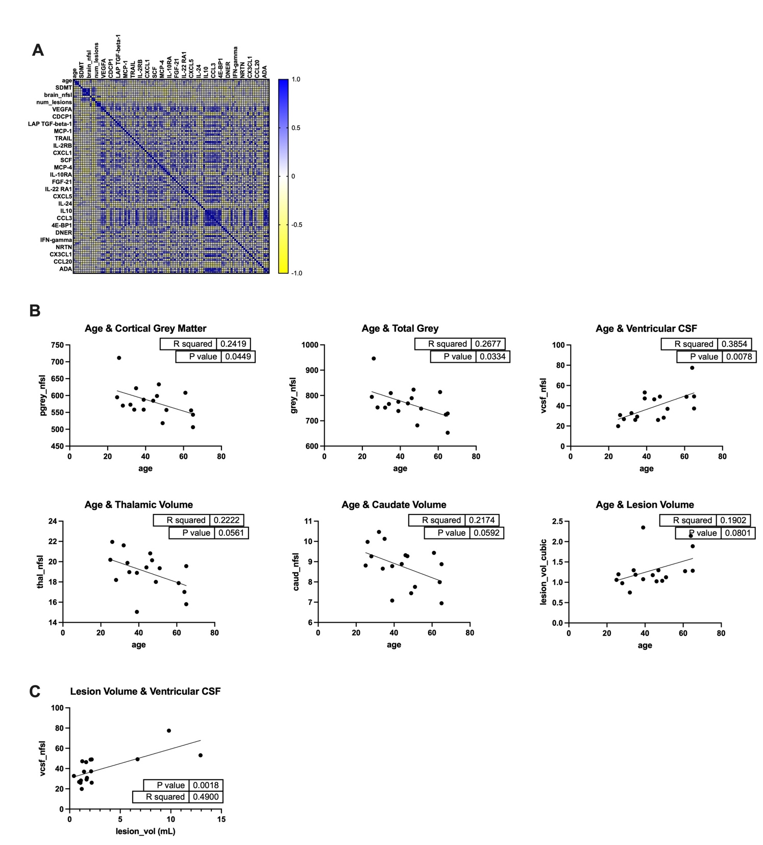

Supplemental Figure 1. Additional MRI correlation matrix findings. A. Multiple correlation matrix of MRI brain matter segmental volumes, intrathecal inflammatory analytes, and clinical disability metrics. B. Negative correlation between age and various segmental brain volumes. C. Positive correlation between lesion volume and ventricular size.

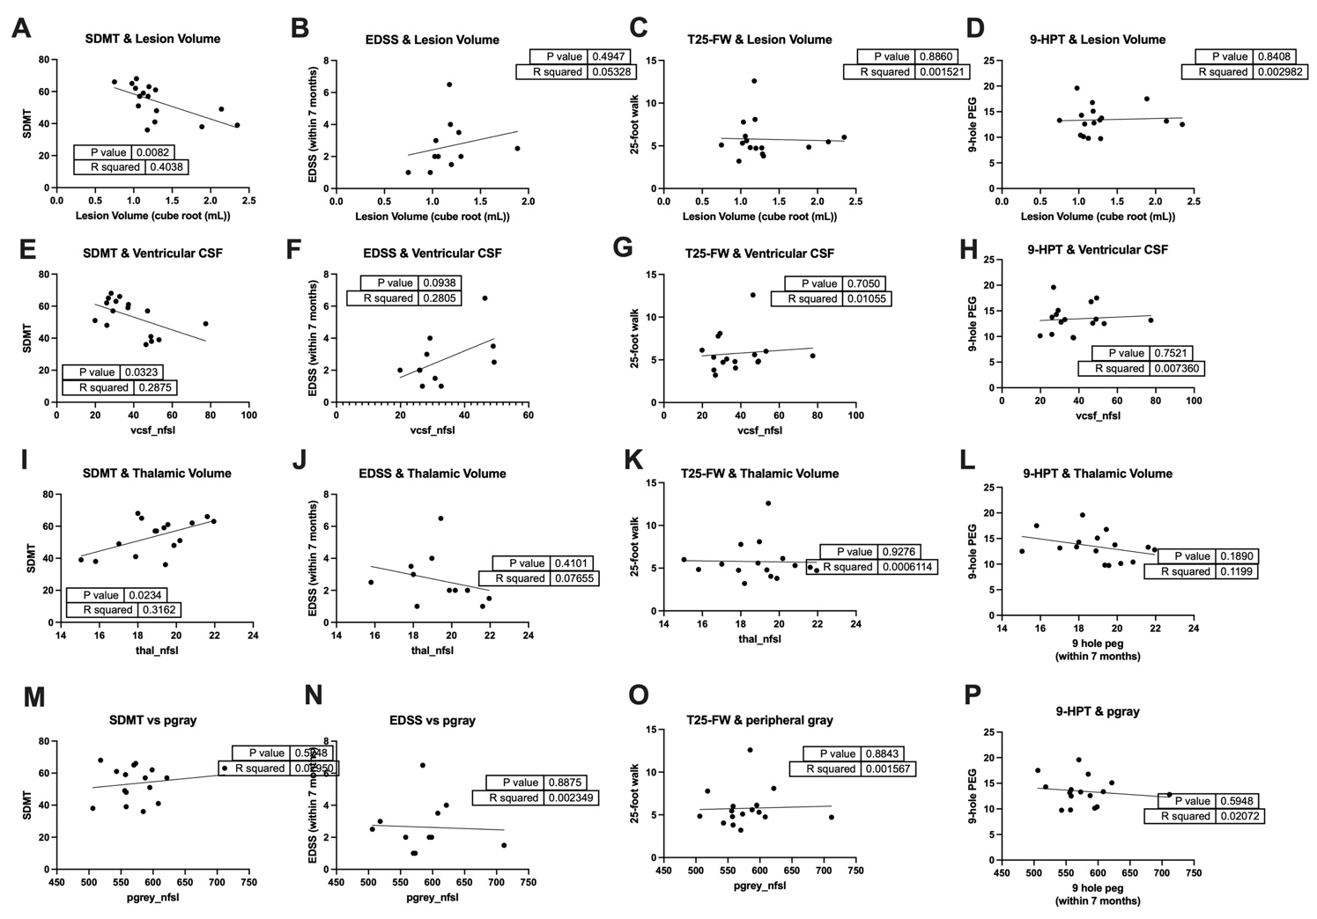

Supplemental Figure 2. Clinical metrics of disability versus MRI segmental brain volumes. SDMT: Single Digit Modalities Test. EDSS: Expanded Disability Status Scale. T25-FW: Timed 25-foot walk. 9-HPT: 9-hole peg test.

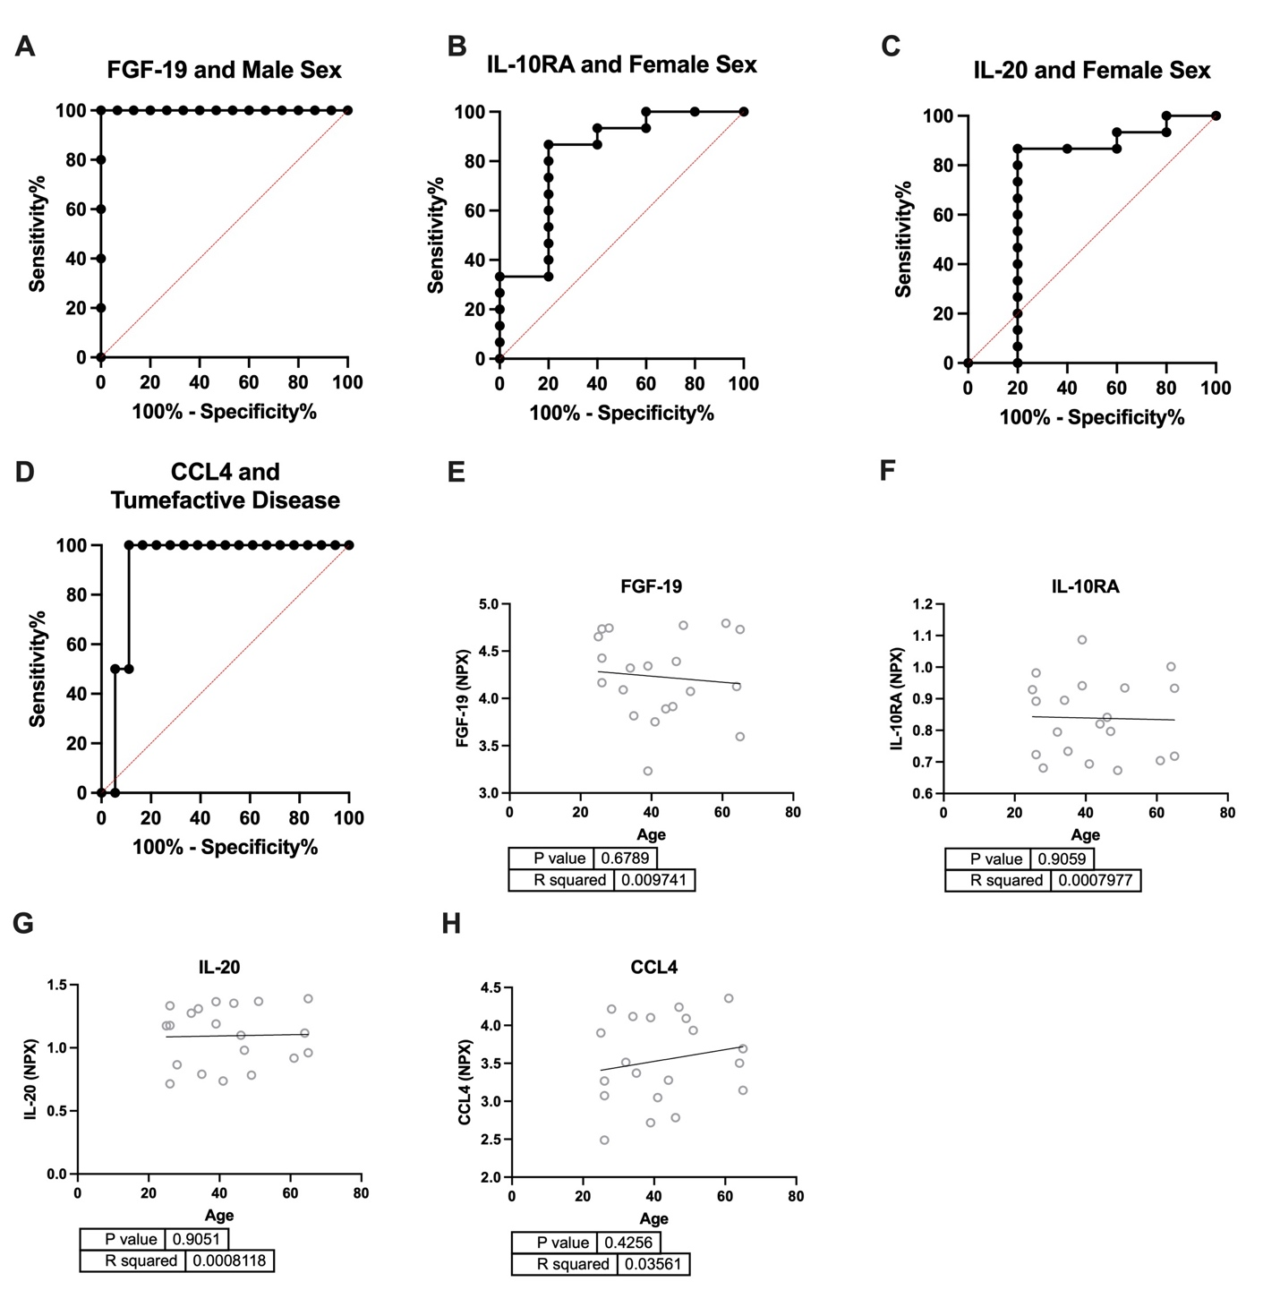

Supplemental Figure 3. ROC curves delineating the sensitivity and specificity of FGF-19 as a predictor of male sex (A), IL-10RA and IL-20 as independent predictors of female sex (B) and CCL4 as a predictor of Tumefactive Disease (D). Age was not significantly correlated with either of the four markers (E-H).

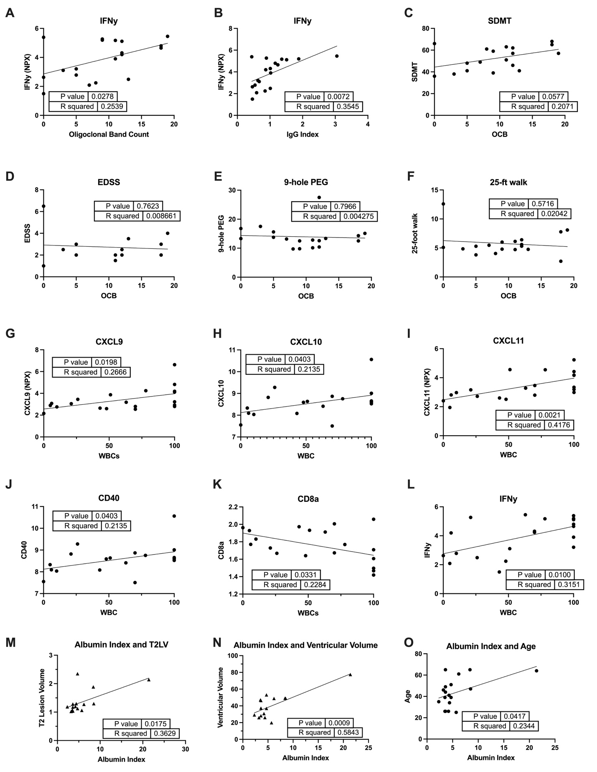

Supplemental Figure 4. Comparison of routinely collected cerebrospinal fluid tests and select immune proteins or clinical disability measures.

