First report of recurrent parthenogenesis as an adaptive reproductive strategy in the endangered common smooth-hound shark Mustelus mustelus
Giuseppe Esposito^{1,}*, Arianna Meletiadis¹, Simona Sciuto¹, Marino Prearo¹, Flavio Gagliardi², Ilaria Corrias², Angela Pira², Alessandro Dondo¹, Paolo Briguglio³, Claudio Ghittino¹, Daniele Dedola⁴, Elena Bozzetta¹, Pier Luigi Acutis¹, Paolo Pastorino^{1,}* and Silvia Colussi¹
¹ Istituto Zooprofilattico Sperimentale del Piemonte, Liguria e Valle d’Aosta, Via Bologna 148, 10154 Turin, Italy.
² Panaque S.r.l. - Acquario di Cala Gonone, Via La Favorita snc, 08022 Cala Gonone - Dorgali, Italy.
³ Clinica Veterinaria Duemari, Via Cagliari 313, 09170 Oristano, Italy.
⁴ Istituto Zooprofilattico Sperimentale della Sardegna, Via Duca degli Abruzzi 8, 07100 Sassari – Italy.

Supplementary materials

Supplementary Table S1. Seasonal chemical-physical parameters and daylight hours.

Season | Temperature (°C) | Salinity ¹ | pH | Day hours of artificial light ²
Winter | 17.3 ± 0.3 | 36.7 ± 1.2 | 8.1 ± 0.1 | 8
Summer | 27.5 ± 0.4 | 37.3 ± 0.8 | 8.2 ± 0.1 | 12
¹ Seasonal variable (e.g., winter rains) and based on the number of hours/day of use of the ozone gas disinfection system.
² Natural light varies seasonally and daily due to the skylight over the tank.

Supplementary Table S2. Microsatellite loci, technical features and primers.
Locus | Fluorophores | Size | Primer sequence (5’-3’) | Repeat size
McaB5 | VIC | 186 - 209 | F: TAATCGACACGCAGTCATCG  R: AAGCTCCAATTCTCACTGTGC | 2
Mh25 | FAM | 141 - 154 | F: TGCAATAACCGTTCTGCGTC  R: TCACACCCGCAGTTAGATCC | 2
McaB35 | NED | 206 - 221 | F: AGTGCGTGCCAGTGTATGAG  R: GTTCTGCATGGGACGTGAC | 2
MaD2X | FAM | 179 - 185 | F: ACCTGGCCCAAGAACTCTC  R: ACTGGTGATGTGTGGACCC | 2
McaB26 | FAM | 224 - 229 | F: ACTGTGGCACTGCATTCTGC  R: TGCATTTCAAAACCACTGGA | 5
Gg20 | PET | 280 - 282 | F: GACCAAGGGTCATCCAGAC  R: TCAGCTTGGGCAATTCCAG | 2
MaTJ5 | FAM | 157 - 159 | F: TGCCTCTGTTATGCCCCTC  R: GGGGTCGAGAAGCATGTTG | 2
Gg4 | PET | 198 - 199 | F: CTGGAATACATGCCGAGCAC  R: CCCGAAAGGTCTTAGTTCGC | 2
Mca33 | FAM | 194 - 200 | F: CATTTGAACCCCGACAGAAC  R: TCCAAGTAAGGATGAGTGACACC | 3
Mh1 | VIC | 201 - 203 | F: GGAGGAGGGAAGCCTATGG  R: TCTCTGGCTCCATTCAGGG | 2
MaFYP | FAM | 238 - 251 | F: TGGTTGCCGATACAGCAGG  R: CAAGCGCATGCACACTCAC | 2
Gg22 | VIC | 209 - 249 | F: TCCTGGGATGGCAACTTCG  R: AGGCCACCCAACTATCCTG | 2
Mh9 | NED | 325 - 336 | F: CAACCATCTTTACTACACTG  R: GATGGACCTCACATTTAACAC | 2

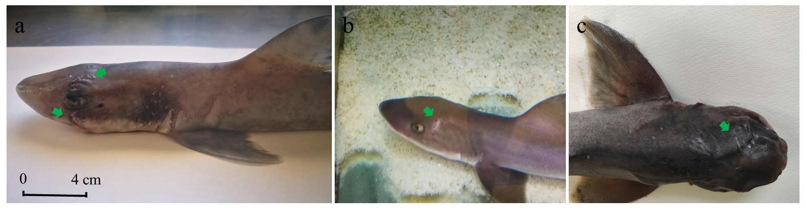
Supplementary Figure S1. Detail of bites (green arrow) on common smooth-hound Mustelus mustelus specimens during and/or after birth in 2020, 2021, and 2023 (photos a, b, and c, respectively). All photography copyrights are exclusively held by Giuseppe Esposito, co-author of this manuscript.

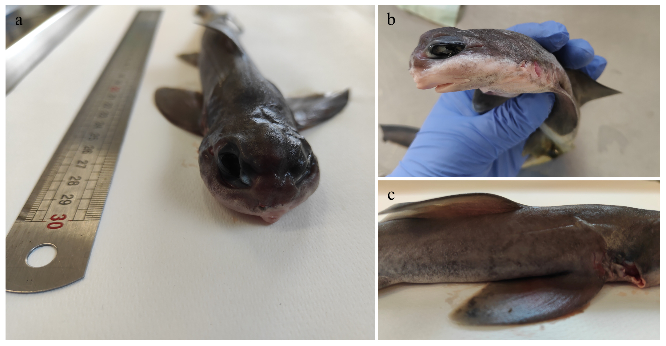
Supplementary Figure S2. Anatomical deformities in the female specimen of common smooth-hound Mustelus mustelus born prematurely and by parthenogenesis in 2023: (a) skull and eyes, (b) snout and mouth, (c) gill lamellae. Photography copyright held exclusively by Giuseppe Esposito, co-author of this manuscript.

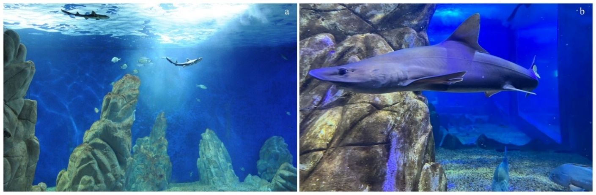
Supplementary Figure S3. (a) Juvenile female specimens of common smooth-hound Mustelus mustelus introduced in 2010. (b) One of the adult female specimens to date. All photography copyrights are exclusively held by Cala Gonone Aquarium.

Supplementary Video 1. Common smooth-hound Mustelus mustelus born in 2021 at Cala Gonone Aquarium in Sardinia, Italy.
Supplementary Video 2. Common smooth-hound Mustelus mustelus in 2024 at Cala Gonone Aquarium in Sardinia, Italy.

