Adaptation of Indoor Ornamental Plants to Various Lighting Levels in Growth Chambers Simulating Workplace Environments

Soma Sugano ^{1*}, Masahisa Ishii ², and Shin-ichi Tanabe ³
¹ Waseda Research Institute for Science and Engineering, Waseda University, Tokyo, Japan
² Institute for Rural Engineering, National Agriculture and Food Research Organization, Tsukuba, Japan
³ Department of Architecture, Waseda University, Tokyo, Japan

*Corresponding Author: Soma Sugano
Email: s.sugano@aoni.waseda.jp
Postal adress: Room 701, Building N55, 3-4-1 Okubo, Shinjuku-ku, Tokyo 169-8555, Japan.

Supplementary Table S1. Initial physiological parameters of three plant species.
Supplementary Table S2. Details of statistical analysis for total fresh weight, total dry weight, dry weight increase, and relative growth rate.
Supplementary Table S3. Details of statistical analysis for number of leaves, leaf area, specific leaf area, and leaf weight ratio.
Supplementary Table S4. Details of statistical analysis for SPAD values.
Supplementary Table S5. Details of statistical analysis for an area-based photosynthetic rate of P. aquatica for each photosynthetic photon flux density level.
Supplementary Table S6. Details of statistical analysis for estimated maximum net photosynthetic rate and dark respiration rate of P. aquatica.
Supplementary Table S7. Stomatal conductance of P. aquatica for each photosynthetic photon flux density level under the three experimental conditions.
Supplementary Table S8. Intercellular carbon dioxide concentration of P. aquatica for each photosynthetic photon flux density level under the three experimental conditions.
Supplementary Table S9. Transpiration rate of P. aquatica for each photosynthetic photon flux density level under the three experimental conditions.
Supplementary Fig. S1. Proportion of leaves, stems, and roots in the total dry weight of plant materials. The number shows the ratio of dry weight for each part of the plants.
Supplementary Fig. S2. Measured spectral irradiance at the canopy height of plants under the three different experimental conditions.
Table S1. Initial physiological parameters of three plant species: total fresh and dry weight, number of leaves, leaf area, specific leaf area, and leaf weight ratio (Mean ± SD; n = 6, except for R. tetrasperma where n = 5)
 | E. aureum  (n = 6) | P. aquatica  (n = 6) | R. tetrasperma  (n = 5)
Fresh weight (g) | 27.21 ± 5.17 | 166.24 ± 31.54 | 66.1 ± 16.07
Dry weight (g) | 3.14 ± 0.48 | 30.78 ± 6.75 | 7.52 ± 1.78
Number of leaves | 20.8 ± 2.6 | 8.8 ± 2.7 | 10.6 ± 3.3
Leaf area (cm²) | 342 ± 40 | 266 ± 86 | 740 ± 263
Specific leaf area (cm² g⁻¹) | 245 ± 16 | 241 ± 28 | 265 ± 36
Leaf weight ratio | 0.45 ± 0.03 | 0.04 ± 0.01 | 0.37 ± 0.09

Table S2. Total fresh weight, total dry weight, dry weight increase, and relative growth rate for the three species of plant materials after 190 days of cultivation under the three different experimental conditions (Mean ± SD; n = 6, except for Case 1 of P. aquatica where n = 5). Includes One-Way ANOVA and Tukey’s Test Results.
 |  | Case 1  (6.8 µmol m⁻² s⁻¹  ×9 h d⁻¹) | Case 2  (6.7 µmol m⁻² s⁻¹  ×18 h d⁻¹) | Case 3  (20.1 µmol m⁻² s⁻¹  ×18 h d⁻¹) | ANOVA |  |  | Tukey HSD
 |  |  |  |  | F | p | η² | p
E. aureum | Final Fwt (g) | 47.08 ± 10.56 | 52.16 ± 7.82 | 88.35 ± 5.66 | 37.094 | < 0.001 | 0.832 | C1-C2: 0.606  C1-C3: < 0.001  C2-C3: < 0.001
 | Final Dwt (g) | 3.31 ± 0.70 | 3.81 ± 0.55 | 7.55 ± 0.65 | 66.936 | < 0.001 | 0.899 | C1-C2: 0.440  C1-C3: < 0.001  C2-C3: < 0.001
 | Dwt increase (g) | 0.17 ± 0.70 | 0.67 ± 0.55 | 4.41 ± 0.65 | 66.936 | < 0.001 | 0.899 | C1-C2: 0.440  C1-C3: < 0.001  C2-C3: < 0.001
 | RGR (mg g⁻¹ d⁻¹) | 0.15 ± 1.17 | 0.97 ± 0.73 | 4.60 ± 0.46 | 39.715 | < 0.001 | 0.841 | C1-C2: 0.300  C1-C3: < 0.001  C2-C3: < 0.001
P. aquatica | Final Fwt (g) | 204.03 ± 31.00 | 221.80 ± 27.16 | 210.92 ± 31.73 | 0.409 | 0.672 | 0.055 | C1-C2: 0.656  C1-C3: 0.937  C2-C3: 0.838
 | Final Dwt (g) | 31.76 ± 6.13 | 35.46 ± 5.19 | 38.67 ± 8.04 | 1.235 | 0.321 | 0.150 | C1-C2: 0.684  C1-C3: 0.290  C2-C3: 0.729
 | Dwt increase (g) | 0.99 ± 6.13 | 4.68 ± 5.19 | 7.89 ± 8.04 | 1.235 | 0.321 | 0.150 | C1-C2: 0.684  C1-C3: 0.290  C2-C3: 0.729
 | RGR (mg g⁻¹ d⁻¹) | 0.08 ± 0.94 | 0.69 ± 0.81 | 1.07 ± 1.21 | 1.115 | 0.355 | 0.137 | C1-C2: 0.688  C1-C3: 0.496  C2-C3: 0.939
R. tetrasperma | Final Fwt (g) | 83.05 ± 18.74 | 103.48 ± 12.69 | 135.36 ± 23.81 | 9.662 | 0.002 | 0.563 | C1-C2: 0.236  C1-C3: 0.002  C2-C3: 0.045
 | Final Dwt (g) | 7.19 ± 1.67 | 9.24 ± 1.66 | 13.77 ± 1.47 | 22.149 | < 0.001 | 0.747 | C1-C2: 0.139  C1-C3: < 0.001  C2-C3: 0.001
 | Dwt increase (g) | -0.34 ± 1.67 | 1.72 ± 1.66 | 6.25 ± 1.47 | 22.149 | < 0.001 | 0.747 | C1-C2: 0.139  C1-C3: < 0.001  C2-C3: 0.001
 | RGR (mg g⁻¹ d⁻¹) | -0.42 ± 1.42 | 0.99 ± 0.98 | 3.15 ± 0.57 | 14.653 | < 0.001 | 0.661 | C1-C2: 0.118  C1-C3: < 0.001  C2-C3: 0.014
Fwt = fresh weight; Dwt = dry weight; RGR = relative growth rate, C1 = Case 1, C2 = Case 2, C3 = Case3
Note: Significant results (p < 0.05) are in bold.
Table S3. Number of leaves, leaf area, specific leaf area, and leaf weight ratio for the three species of plant materials after 190 days of cultivation under the three different experimental conditions (Mean ± SD; n = 6, except for Case 1 of P. aquatica where n = 5). Includes One-Way ANOVA and Tukey’s Test Results.
 |  | Case 1  (6.8 µmol m⁻² s⁻¹  ×9 h d⁻¹) | Case 2  (6.7 µmol m⁻² s⁻¹  ×18 h d⁻¹) | Case 3  (20.1 µmol m⁻² s⁻¹  ×18 h d⁻¹) | ANOVA |  |  | Tuley HSD
 |  |  |  |  | F | p | η² | p
E. aureum | Number of leaves | 28.5 ± 4.0 | 35.5 ± 3.2 | 48.2 ± 3.5 | 38.912 | < 0.001 | 0.838 | C1-C2: 0.019  C1-C3: < 0.001  C2-C3: < 0.001
 | Leaf area (cm²) | 601 ± 141 | 716 ± 95 | 1192 ± 107 | 36.537 | < 0.001 | 0.830 | C1-C2: 0.290  C1-C3: < 0.001  C2-C3: < 0.001
 | SLA (cm² g⁻¹) | 305 ± 12 | 297 ± 9 | 271 ± 9 | 15.361 | < 0.001 | 0.672 | C1-C2: 0.464  C1-C3: < 0.001  C2-C3: 0.003
 | LWR | 0.60 ± 0.03 | 0.63 ± 0.02 | 0.58 ± 0.02 | 6.807 | 0.008 | 0.476 | C1-C2: 0.042  C1-C3: 0.687  C2-C3: 0.008
P. aquatica | Number of leaves | 12.2 ± 1.6 | 13.5 ± 2.2 | 14.0 ± 2.9 | 0.700 | 0.513 | 0.091 | C1-C2: 0.688  C1-C3: 0.496  C2-C3: 0.939
 | Leaf area (cm²) | 1103 ± 78 | 1180 ± 169 | 1393 ± 243 | 3.184 | 0.072 | 0.313 | C1-C2: 0.804  C1-C3: 0.075  C2-C3: 0.191
 | SLA (cm² g⁻¹) | 330 ± 29 | 303 ± 25 | 253 ± 25 | 10.070 | 0.002 | 0.590 | C1-C2: 0.324  C1-C3: 0.002  C2-C3: 0.024
 | LWR | 0.11 ± 0.01 | 0.11 ± 0.02 | 0.15 ± 0.02 | 5.473 | 0.018 | 0.439 | C1-C2: 0.950  C1-C3: 0.028  C2-C3: 0.039
R. tetrasperma | Number of leaves | 12.5 ± 3.4 | 14.7 ± 2.4 | 12.0 ± 2.8 | 1.199 | 0.329 | 0.138 | C1-C2: 0.481  C1-C3: 0.960  C2-C3: 0.339
 | Leaf area (cm²) | 964 ± 289 | 1133 ± 197 | 1028 ± 177 | 0.703 | 0.511 | 0.086 | C1-C2: 0.486  C1-C3: 0.897  C2-C3: 0.750
 | SLA (cm² g⁻¹) | 278 ± 20 | 274 ± 19 | 218 ± 27 | 11.202 | 0.001 | 0.599 | C1-C2: 0.966  C1-C3: 0.002  C2-C3: 0.003
 | LWR | 0.48 ± 0.09 | 0.45 ± 0.03 | 0.34 ± 0.03 | 7.381 | 0.006 | 0.496 | C1-C2: 0.722  C1-C3: 0.006  C2-C3: 0.030
SLA = specific leaf area; LWR = leaf wight ratio, C1 = Case 1, C2 = Case 2, C3 = Case3
Note: Significant results (p < 0.05) are in bold.

Table S4. SPAD values for the three species of plant materials after 190 days of cultivation under the three different experimental conditions. Includes Kruskal-Wallis H test and Dunn-Bonferroni test Results.
 |  | SPAD value |  |  |  | Kruskal-Wallis H test | Pairwise comparison  (Dunn-Bonferroni test)
 |  | Min | Mean | Median | Max | p-value | p-value
E. aureum | Case 1 (n=60) | 40.4 | 54.9 | 56.7 | 65.7 | < 0.001 | Case 1-2: 1.000
 | Case 2 (n=60) | 37.5 | 55.6 | 55.8 | 71.8 |  | Case 1-3: 0.001
 | Case 3 (n=60) | 46.5 | 59.8 | 59.4 | 73.2 |  | Case 2-3: 0.001
P. aquatica | Case 1 (n=60) | 27.1 | 36.6 | 35.0 | 52.1 | < 0.001 | Case 1-2: 0.023
 | Case 2 (n=60) | 20.0 | 38.3 | 39.0 | 50.9 |  | Case 1-3: 0.001
 | Case 3 (n=60) | 26.4 | 40.8 | 41.8 | 51.4 |  | Case 2-3: 0.026
R. tetrasperma | Case 1 (n=60) | 27.8 | 49.0 | 48.9 | 64.8 | < 0.001 | Case 1-2: 0.746
 | Case 2 (n=60) | 32.9 | 50.7 | 50.9 | 61.8 |  | Case 1-3: <0.001
 | Case 3 (n=60) | 39.1 | 55.2 | 56.1 | 65.4 |  | Case 2-3: 0.001
Note: Significant results (p < 0.05) are in bold.

Table S5. The area-based photosynthetic rate of P. aquatica for each photosynthetic photon flux density level under the three experimental conditions (Mean ± SE). Includes One-Way ANOVA and Tukey’s Test Results.
PPFD  (µmol m⁻² s⁻¹) | Case 1  (6.8 µmol m⁻² s⁻¹  ×9 h d⁻¹, n=7) | Case 2  (6.7 µmol m⁻² s⁻¹  ×18 h d⁻¹, n=6) | Case 3  (20.1 µmol m⁻² s⁻¹  ×18 h d⁻¹, n=7) | ANOVA |  |  | Tuley HSD
 |  |  |  | F | p | η² | p
0 | -0.11 ± 0.02 | -0.18 ± 0.07 | -0.07 ± 0.04 | 1.78 | 0.199 | 0.173 | Cace 1-2: 0.421  Case 1-3: 0.826  Case 2-3: 0.182
2 | 0.03 ± 0.04 | -0.04 ± 0.04 | 0.02 ± 0.03 | 1.024 | 0.38 | 0.108 | Cace 1-2: 0.384  Case 1-3: 0.964  Case 2-3: 0.521
5 | 0.23 ± 0.02 | 0.18 ± 0.03 | 0.26 ± 0.04 | 0.812 | 0.461 | 0.087 | Cace 1-2: 0.779  Case 1-3: 0.811  Case 2-3: 0.428
10 | 0.47 ± 0.03 | 0.44 ± 0.03 | 0.41 ± 0.05 | 0.49 | 0.621 | 0.054 | Cace 1-2: 0.833  Case 1-3: 0.598  Case 2-3: 0.930
20 | 0.81 ± 0.04 | 0.73 ± 0.06 | 0.63 ± 0.06 | 3.323 | 0.061 | 0.281 | Cace 1-2: 0.938  Case 1-3: 0.068  Case 2-3: 0.150
50 | 1.17 ± 0.11 | 1.12 ± 0.08 | 1.05 ± 0.09 | 0.49 | 0.621 | 0.054 | Cace 1-2: 0.999  Case 1-3: 0.699  Case 2-3: 0.658
100 | 1.49 ± 0.14 | 1.42 ± 0.09 | 1.64 ± 0.08 | 0.584 | 0.568 | 0.064 | Cace 1-2: 0.999  Case 1-3: 0.629  Case 2-3: 0.630
250 | 1.82 ± 0.17 | 1.78 ± 0.10 | 2.14 ± 0.08 | 1.766 | 0.201 | 0.172 | Cace 1-2: 0.996  Case 1-3: 0.238  Case 2-3: 0.301
500 | 2.10 ± 0.18 | 2.02 ± 0.12 | 2.64 ± 0.12 | 4.103 | 0.035 | 0.326 | Cace 1-2: 1.000  Case 1-3: 0.055  Case 2-3: 0.067
1000 | 2.23 ± 0.19 | 2.31 ± 0.11 | 2.93 ± 0.11 | 5.822 | 0.012 | 0.406 | Cace 1-2: 0.827  Case 1-3: 0.013  Case 2-3: 0.055
2000 | 2.28 ± 0.19 | 2.51 ± 0.13 | 3.10 ± 0.12 | 6.577 | 0.008 | 0.436 | Cace 1-2: 0.449  Case 1-3: 0.006  Case 2-3: 0.099
Note: Significant results (p < 0.05) are in bold.
Table S6. Estimated maximum net photosynthetic rate and dark respiration rate of P. aquatica for each condition. Mean ± SE for each condition
 | Case 1  (6.8 µmol m⁻² s⁻¹  ×9 h d⁻¹, n=7) | Case 2  (6.7 µmol m⁻² s⁻¹  ×18 h d⁻¹, n=6) | Case 3  (20.1 µmol m⁻² s⁻¹  ×18 h d⁻¹, n=7) | ANOVA |  |  | Tukey HSD
 |  |  |  | F | p | η² | p
Estimated maximum net photosynthetic rate  (µmol m⁻² s⁻¹) | 2.48 ± 0.20 | 2.85 ± 0.17 | 3.42 ± 0.11 | 7.379 | 0.005 | 0.465 | Case1-2: 0.341  Case1-3: 0.004  Case2-3: 0.096
Estimated dark respiration rate  (µmol m⁻² s⁻¹) | -0.12 ± 0.03 | -0.23± 0.07 | -0.06 ± 0.03 | 3.155 | 0.068 | 0.271 | Case1-2: 0.290  Case1-3: 0.600  Case2-3: 0.057
Estimated light compensation point  (µmol m⁻² s⁻¹) | 1.14 ± 0.28 | 1.71 ± 0.42 | 0.79 ± 0.48 | 1.082 | 0.361 | 0.113 | Case1-2: 0.642  Case1-3: 0.834  Case2-3: 0.332
Note: Significant results (p < 0.05) are in bold.

Table S7. Stomatal conductance of P. aquatica for each photosynthetic photon flux density level under the three experimental conditions (Mean ± SE).
PPFD  (µmol m⁻² s⁻¹) | Case 1  (6.8 µmol m⁻² s⁻¹ ×9 h d⁻¹, n=7)  [mol H₂O m⁻² s⁻¹] | Case 2  (6.7 µmol m⁻² s⁻¹ ×18 h d⁻¹, n=6)  [mol H₂O m⁻² s⁻¹] | Case 3  (20.1 µmol m⁻² s⁻¹ ×18 h d⁻¹, n=7)  [mol H₂O m⁻² s⁻¹]
0 | 0.0013 ± 0.0003 | 0.0038 ± 0.0007 | 0.0041 ± 0.0021
2 | 0.0015 ± 0.0002 | 0.0044 ± 0.0007 | 0.0041 ± 0.0020
5 | 0.0018 ± 0.0001 | 0.0049 ± 0.0008 | 0.0044 ± 0.0021
10 | 0.0026 ± 0.0002 | 0.0053 ± 0.0009 | 0.0049 ± 0.0020
20 | 0.0042 ± 0.0004 | 0.0064 ± 0.0009 | 0.0057 ± 0.0020
50 | 0.0064 ± 0.0006 | 0.0083 ± 0.0010 | 0.0073 ± 0.0019
100 | 0.0087 ± 0.0010 | 0.0108 ± 0.0013 | 0.0098 ± 0.0018
250 | 0.0106 ± 0.0012 | 0.0132 ± 0.0016 | 0.0127 ± 0.0017
500 | 0.0125 ± 0.0014 | 0.0159 ± 0.0021 | 0.0153 ± 0.0016
1000 | 0.0139 ± 0.0016 | 0.0183 ± 0.0025 | 0.0172 ± 0.0016
2000 | 0.0146 ± 0.0017 | 0.0205 ± 0.0031 | 0.0181 ± 0.0016

Table S8. Intercellular carbon dioxide concentration of P. aquatica for each photosynthetic photon flux density level under the three experimental conditions (Mean ± SE).
PPFD  (µmol m⁻² s⁻¹) | Case 1  (6.8 µmol m⁻² s⁻¹ ×9 h d⁻¹, n=7)  [µmol CO₂ mol⁻¹] | Case 2  (6.7 µmol m⁻² s⁻¹ ×18 h d⁻¹, n=6)  [µmol CO₂ mol⁻¹] | Case 3  (20.1 µmol m⁻² s⁻¹ ×18 h d⁻¹, n=7)  [µmol CO₂ mol⁻¹]
0 | 633 ± 36 | 598 ± 37 | 587 ± 52
2 | 444 ± 51 | 482 ± 24 | 457 ± 53
5 | 275 ± 32 | 395 ± 33 | 315 ± 33
10 | 189 ± 32 | 334 ± 24 | 276 ± 32
20 | 170 ± 29 | 271 ± 29 | 247 ± 29
50 | 192 ± 17 | 243 ± 24 | 207 ± 30
100 | 205 ± 14 | 249 ± 28 | 185 ± 29
250 | 205 ± 15 | 246 ± 27 | 196 ± 24
500 | 209 ± 14 | 254 ± 30 | 196 ± 22
1000 | 219 ± 13 | 258 ± 26 | 203 ± 18
2000 | 225 ± 15 | 257 ± 29 | 201 ± 15

Table S9. Transpiration rate of P. aquatica for each photosynthetic photon flux density level under the three experimental conditions (Mean ± SE).
PPFD  (µmol m⁻² s⁻¹) | Case 1  (6.8 µmol m⁻² s⁻¹ ×9 h d⁻¹, n=7)  [mmol H₂O m⁻² s⁻¹] | Case 2  (6.7 µmol m⁻² s⁻¹ ×18 h d⁻¹, n=6)  [mmol H₂O m⁻² s⁻¹] | Case 3  (20.1 µmol m⁻² s⁻¹ ×18 h d⁻¹, n=7)  [mmol H₂O m⁻² s⁻¹]
0 | 0.018 ± 0.003 | 0.050 ± 0.010 | 0.055 ± 0.029
2 | 0.021 ± 0.002 | 0.058 ± 0.010 | 0.055 ± 0.027
5 | 0.025 ± 0.002 | 0.065 ± 0.011 | 0.060 ± 0.028
10 | 0.036 ± 0.004 | 0.070 ± 0.012 | 0.066 ± 0.028
20 | 0.059 ± 0.006 | 0.085 ± 0.012 | 0.077 ± 0.027
50 | 0.088 ± 0.009 | 0.110 ± 0.014 | 0.100 ± 0.026
100 | 0.120 ± 0.014 | 0.144 ± 0.018 | 0.135 ± 0.026
250 | 0.151 ± 0.018 | 0.182 ± 0.023 | 0.180 ± 0.025
500 | 0.187 ± 0.022 | 0.233 ± 0.031 | 0.228 ± 0.027
1000 | 0.231 ± 0.027 | 0.300 ± 0.039 | 0.286 ± 0.030
2000 | 0.296 ± 0.035 | 0.418 ± 0.059 | 0.371 ± 0.039

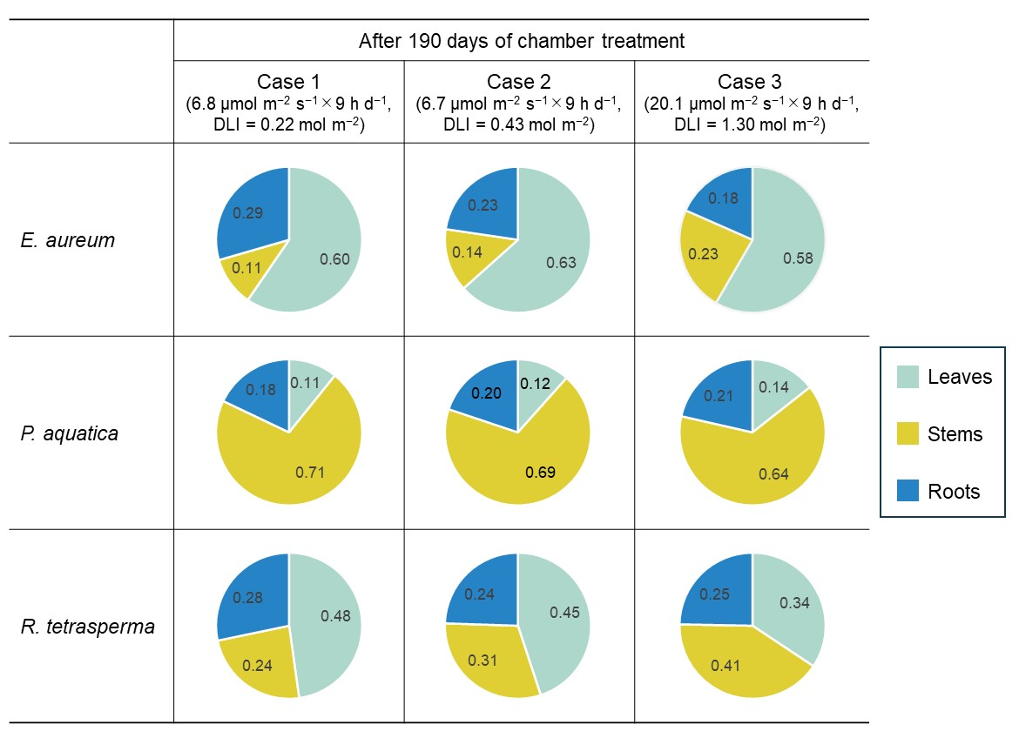
Fig. S1. Proportion of leaves, stems, and roots in the total dry weight of plant materials. The number shows the ratio of dry weight for each part of the plants (Mean; n = 6, except for Case 1 of P. aquatica where n = 5).

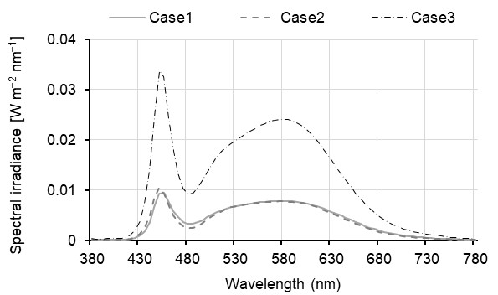
Fig. S2. Measured spectral irradiance at the canopy height of plants under the three different experimental conditions.

