Supplementary material

The following content is supplementary material for the study "Influenza Severity Scale (ISS): Predicting major clinical events among Canadian adults with laboratory-confirmed influenza infection." This supplementary material includes additional data, figures, and detailed information that provide a more comprehensive view of the research conducted in the main study.

Table of Contents

Figure 1. Scale development workflow scheme. 2
Table 1. The characteristics of the train, test, and validation set populations. 3
Figure 2. (A) Overall distribution of the Influenza Severity Scale scores and by sex (B); the solid line represents the fitted density plot of the scores. 4
Figure 3. A Random Forest model generated a list of importance rankings based on the Gini index observed for the predicting variables. 5
Figure 4. 10-fold cross-validation cumulatively estimating the AU-ROC by iterating over the input variables. The blue line represents the highest rank until reaching a saturation threshold for two consecutive iterations. 6
Figure 5. (A) ROC and (B) gain curves for the Penalized Logistic Regression (PLR) model on the train set. 7
Figure 6. (A) ROC and (B) gain curve for the Classification and Regression Trees (CART) model. 8
Figure 7. (A) ROC and (B) gain curve for the Random Forest (RF) model. 9
Figure 8. (A) ROC and (B) gain curve for the eXtreme Gradient Boosting (XGBoost) model. 10
Table 2. Conversion table mapping pre-specified score cutoffs to their predicted risks. 11
Table 3. The sociodemographic and clinical characteristics of the entire study population. 12

Figure 1. Scale development workflow scheme.

Table 1. The characteristics of the train, test, and validation set populations.

Parameter | Level | Train set | Test set | Validation set | Balance by dataset pair: Standard difference*
Parameter | Level | (N=7,773) | (N=3,886) | (N=1,295) | Test vs. Train | Test vs. Validation | Train vs. Validation
Age | Years | 74 [59 84] | 74 [59, 85] | 75 [61, 86] | -0.0190 | 0.0237 | 0.0427
Sex | Female | 4163 (53.6) | 2110 (54.3) | 698 (53.9) | 0.0074 | 0.0040 | -0.0034
Sex | Male | 3610 (46.4) | 1776 (45.7) | 597 (46.1) | 0.0074 | 0.0040 | -0.0034
Health history | Current smoker | 2045 (26.3) | 1034 (26.6) | 348 (26.9) | -0.0030 | 0.0026 | 0.0056
Health history | Former smoker | 2255 (29.0) | 1077 (27.7) | 370 (28.6) | 0.0130 | 0.0086 | -0.0044
Health history | Never smoked | 2940 (37.8) | 1479 (38.1) | 498 (38.5) | -0.0024 | 0.0040 | 0.0063
Health history | Smoking status unknown | 533 (6.9) | 296 (7.6) | 79 (6.1) | -0.0076 | -0.0152 | -0.0076
Health history | Chronic Pulmonary Diseases | 1846 (23.7) | 891 (22.9) | 265 (20.5) | 0.0082 | -0.0247 | -0.0329
Health history | Diabetes mellitus | 2143 (27.6) | 1070 (27.5) | 341 (26.3) | 0.0004 | -0.0120 | -0.0124
Health history | Vaccination in the current influenza season | 2849 (36.7) | 1382 (35.6) | 463 (35.8) | 0.0109 | 0.0019 | -0.0090
Clinical presentation | Cough | 5814 (74.8) | 2939 (75.6) | 955 (73.7) | -0.0083 | -0.0189 | -0.0105
Clinical presentation | Sputum production | 2918 (37.5) | 1549 (39.9) | 507 (39.2) | -0.0232 | -0.0071 | 0.0161
Clinical presentation | Shortness of breath | 2817 (36.2) | 1388 (35.7) | 440 (34.0) | 0.0052 | -0.0174 | -0.0226
Function | Require regular support for activities of daily living | 3490 (44.9) | 1722 (44.3) | 595 (45.9) | 0.0072 | 0.0117 | 0.0045
Outcomes | Major Clinical Events | 4508 (58.0) | 2151 (55.4) | 744 (57.5) | 0.0264 | 0.0210 | -0.0054
* Standardized mean difference (for continuous variables) and difference in proportions (for categorical variables).

Figure 2. (A) Overall distribution of the Influenza Severity Scale scores and by sex (B); the solid line represents the fitted density plot of the scores.
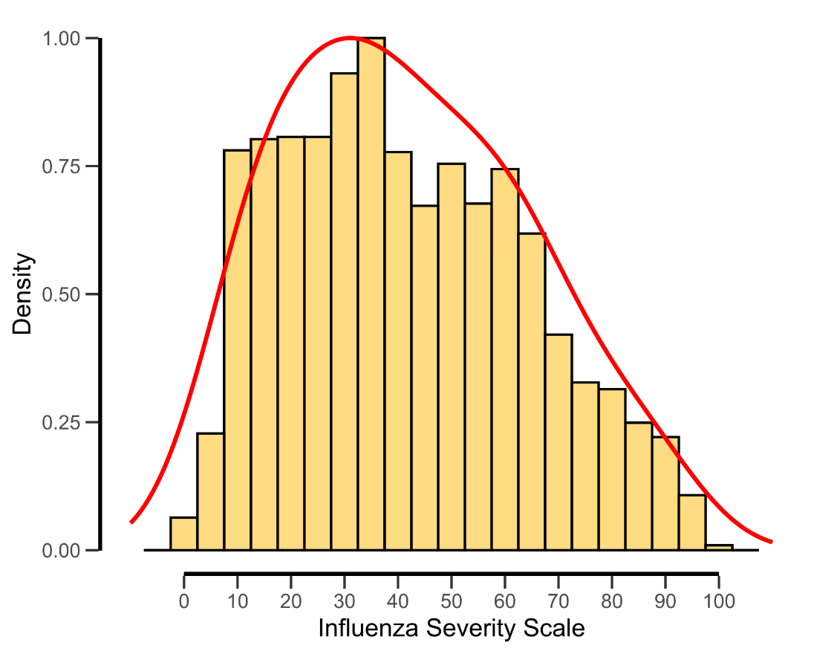
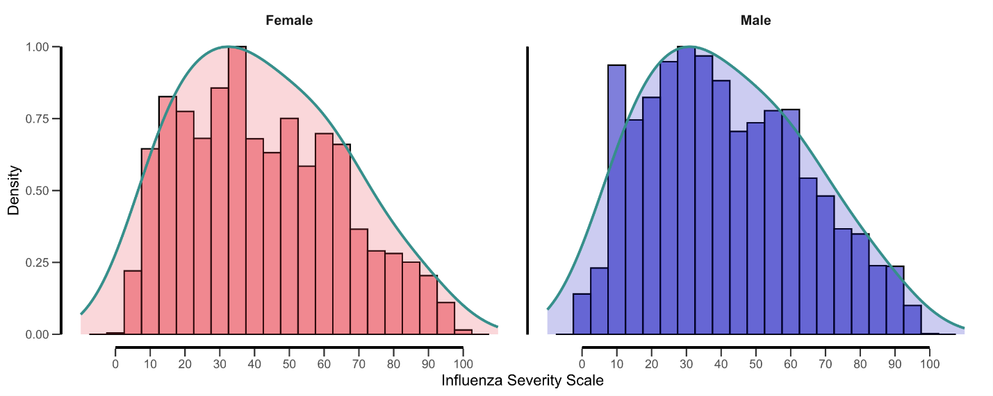

Figure 3. A Random Forest model generated a list of importance rankings based on the Gini index observed for the predicting variables.

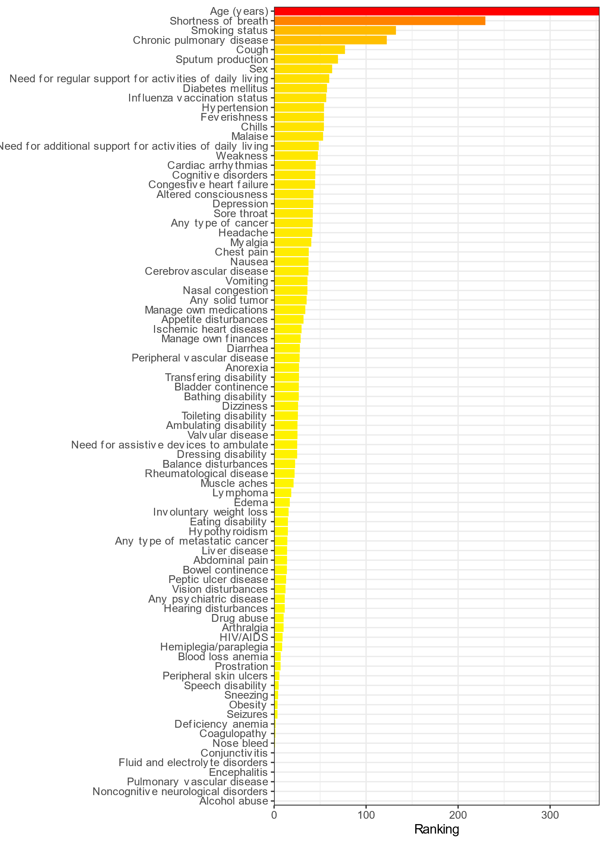

Figure 4. 10-fold cross-validation cumulatively estimating the AU-ROC by iterating over the input variables. The blue line represents the highest rank until reaching a saturation threshold for two consecutive iterations.

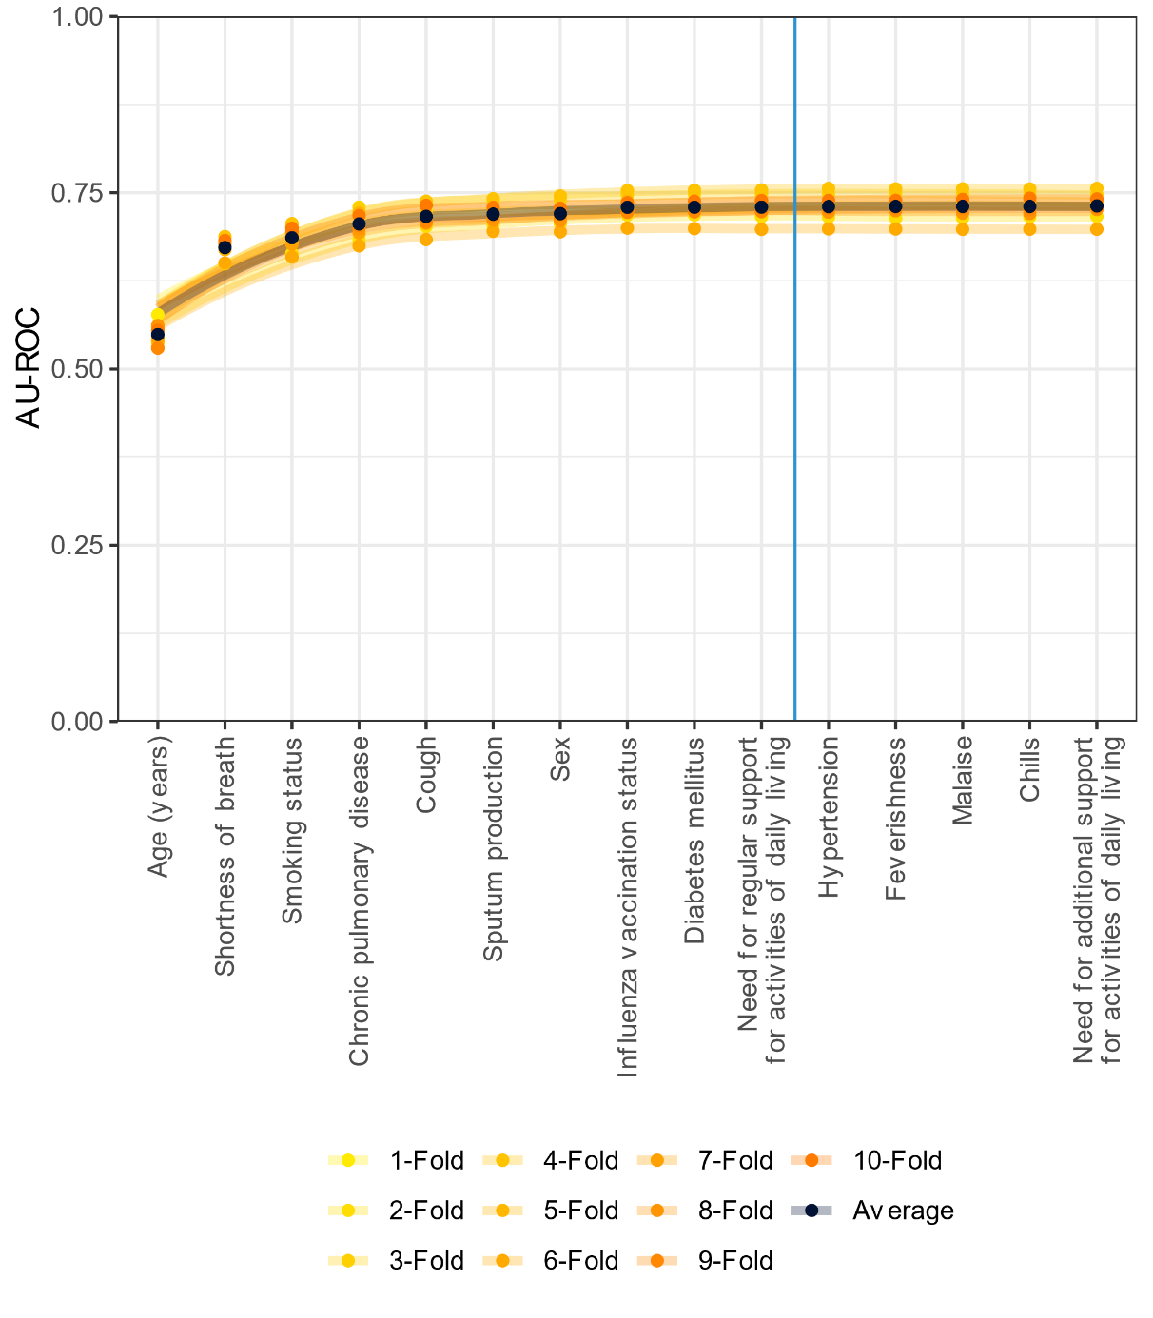

Figure 5. (A) ROC and (B) gain curves for the Penalized Logistic Regression (PLR) model on the train set.

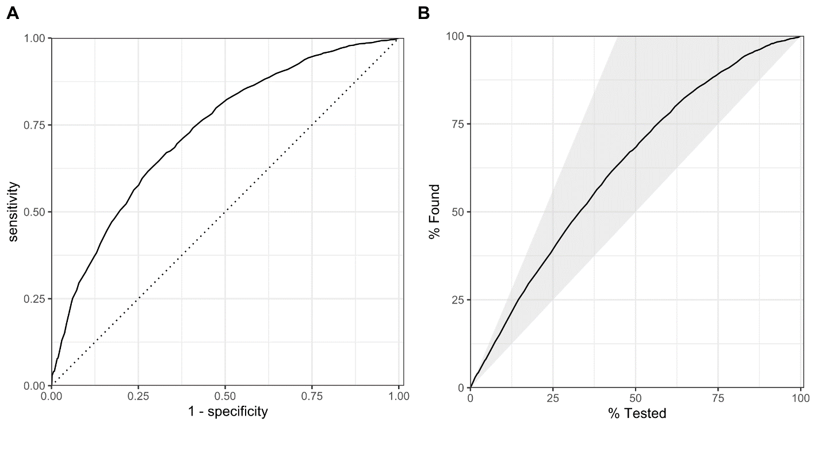

Figure 6. (A) ROC and (B) gain curve for the Classification and Regression Trees (CART) model.

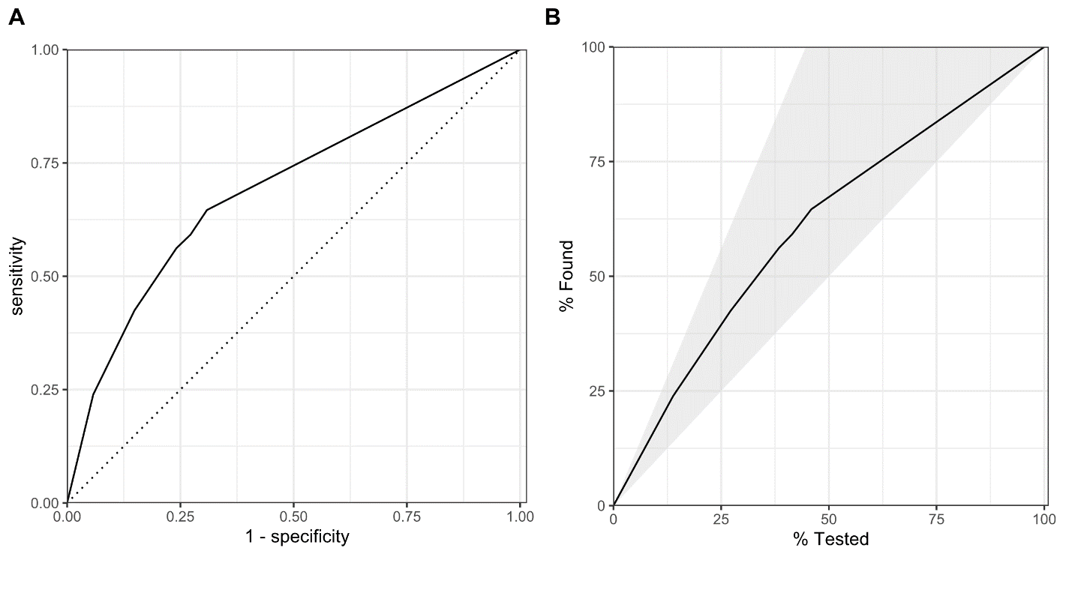

Figure 7. (A) ROC and (B) gain curve for the Random Forest (RF) model.

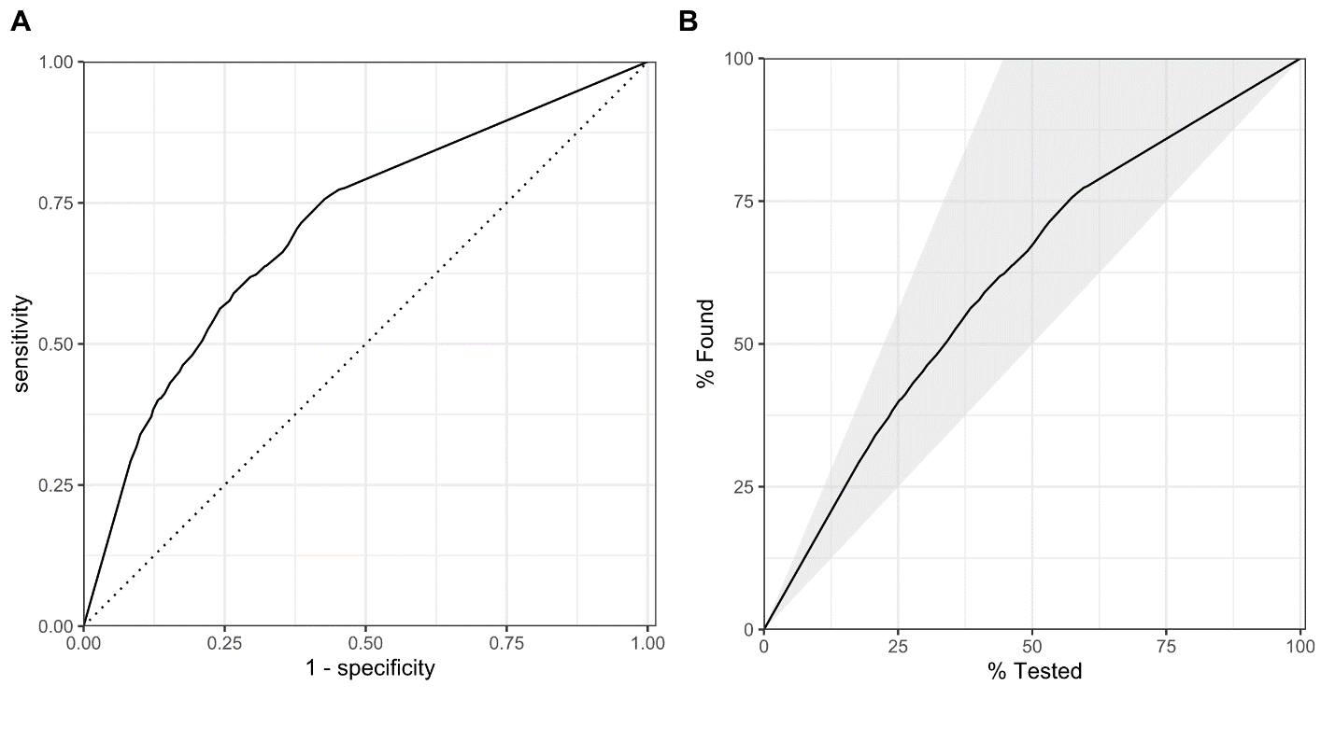

Figure 8. (A) ROC and (B) gain curve for the eXtreme Gradient Boosting (XGBoost) model.

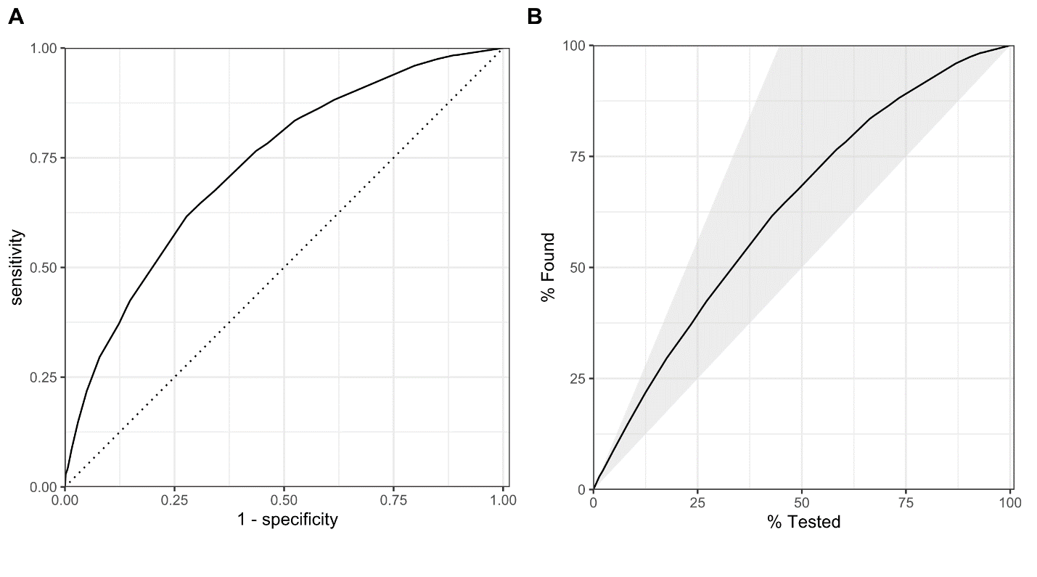

Table 2. Conversion table mapping pre-specified score cutoffs to their predicted risks.

Score  cutoff (≥) | Predicted risk (≥) | Percentage of patients (%) | Sensitivity  (95% CI) | Specificity  (95% CI) | Risk classification
18 | 33.10% | 84 | 92.9% (91.8-94.0%) | 26.7% (24.7-28.8%) | Low risk
20 | 34.90% | 80 | 90.6% (89.3-91.8%) | 32.3% (30.1-34.5%) | Low risk
22 | 36.80% | 77 | 88.2% (86.8-89.6%) | 36.6% (34.3-38.8%) | Low risk
24 | 38.60% | 75 | 86.6% (85.0-88.0%) | 39.8% (37.5-42.1%) | Low risk
26 | 40.50% | 72 | 84.8% (83.4-86.3%) | 43.7% (41.6-46.2%) | Low risk
28 | 42.50% | 69 | 82.4% (80.8-84.1%) | 47.2% (45.0-49.6%) | Low risk
30 | 44.50% | 66 | 79.9% (78.0-81.7%) | 51.0% (48.6-53.3%) | Low risk
32 | 46.40% | 62 | 76.5% (74.7-78.2%) | 55.9% (53.7-58.3%) | Moderate risk
34 | 48.40% | 60 | 74.8% (72.9-76.7%) | 57.8% (55.4-60.1%) | Moderate risk
36 | 50.40% | 57 | 72.5% (70.6-74.3%) | 61.1% (58.8-63.3%) | Moderate risk
38 | 52.40% | 54 | 69.3% (67.3-71.1%) | 64.3% (62.1-66.6%) | Moderate risk
40 | 54.40% | 51 | 66.1% (64.1-68.1%) | 67.3% (65.1-69.4%) | Moderate risk
42 | 56.40% | 49 | 63.5% (61.5-65.6%) | 69.2% (67.1-71.4%) | Moderate risk
44 | 58.40% | 45 | 59.8% (57.7-61.8%) | 73.3% (71.3-75.3%) | Moderate risk
46 | 60.30% | 42 | 57.3% (55.1-59.4%) | 76.0% (74.1-78.0%) | Moderate risk
48 | 62.20% | 40 | 54.5% (52.4-56.5%) | 77.7% (75.7-79.6%) | Moderate risk
50 | 64.00% | 37 | 51.4% (49.3-53.6%) | 80.5% (78.7-82.4%) | High risk
52 | 65.90% | 34 | 48.0% (46.0-50.2%) | 83.3% (81.6-85.0%) | High risk
54 | 67.60% | 32 | 45.7% (43.7-47.8%) | 84.6% (82.8-86.3%) | High risk
56 | 69.40% | 30 | 42.9% (40.8-45.0%) | 85.8% (84.1-87.4%) | High risk
58 | 71.00% | 28 | 39.7% (37.7-41.8%) | 87.4% (85.9-89.0%) | High risk

Table 3. The sociodemographic and clinical characteristics of the entire study population.

Parameter | Level | Study population
Parameter | Level | (N=12,954)
Age | Years | 74 [59, 85]
Sex | Female | 6,971 (53.8)
Sex | Male | 5,983 (46.2)
Health history | Smoking status
Health history | Current smoker | 3,427 (26.5)
Health history | Former smoker | 3,702 (28.6)
Health history | Never smoked | 4,917 (38.0)
Health history | Smoking status unknown | 908 (7.0)
Health history | Comorbidities
Health history | Chronic Pulmonary Diseases | 3,002 (23.2)
Health history | Pulmonary circulation disorders | 0 (0)
Health history | Diabetes mellitus | 3,554 (27.4)
Health history | Hypothyroidism | 339 (2.6)
Health history | Hypertension | 3,673 (28.4)
Health history | Myocardial infarction | 1,175 (9.1)
Health history | Congestive heart failure | 1,485 (11.5)
Health history | Cardiac arrhythmias | 2,534 (19.6)
Health history | Valvular disease | 771 (6.0)
Health history | Peripheral vascular disease | 868 (6.7)
Health history | Cerebrovascular disease | 1,505 (11.6)
Health history | Rheumatoid disease | 481 (3.7)
Health history | Peptic ulcer disease | 227 (1.8)
Health history | Cancer (any malignancy) | 2,409 (18.6)
Health history | Solid tumour, without metastasis | 1,630 (12.6)
Health history | Metastatic solid tumour | 278 (2.1)
Health history | AIDS/HIV | 77 (0.6)
Health history | Drug abuse | 186 (1.4)
Health history | Psychoses | 166 (1.3)
Health history | Depression | 1,244 (9.6)
Health history | Vaccination in the current influenza season
Health history | Unvaccinated | 8,260 (63.8)
Health history | Vaccinated | 4,694 (36.2)
Clinical presentation | Feverishness | 3,022 (23.3)
Clinical presentation | Nasal congestion | 1,313 (10.1)
Clinical presentation | Headache | 1,435 (11.1)
Clinical presentation | Abdominal pain | 321 (2.5)
Clinical presentation | Malaise | 2,622 (20.2)
Clinical presentation | Cough | 9,708 (74.9)
Clinical presentation | Diarrhea | 857 (6.6)
Clinical presentation | Weakness | 2,619 (20.2)
Clinical presentation | Shortness of breath | 4,645 (35.9)
Clinical presentation | Vomiting | 1,358 (10.5)
Clinical presentation | Dizziness | 702 (5.4)
Clinical presentation | Sore throat | 1,591 (12.3)
Clinical presentation | Nausea | 1,360 (10.5)
Clinical presentation | Muscle aches | 605 (4.7)
Clinical presentation | Arthralgia | 203 (1.6)
Clinical presentation | Prostration | 118 (0.9)
Clinical presentation | Seizures | 41 (0.3)
Clinical presentation | Myalgia | 1,630 (12.6)
Clinical presentation | Sneezing | 70 (0.5)
Clinical presentation | Conjunctivitis | 20 (0.2)
Clinical presentation | Sputum production | 4,974 (38.4)
Clinical presentation | Chest pain | 1,230 (9.5)
Clinical presentation | Encephalitis | 5 (0.0)
Clinical presentation | Nose bleed | 27 (0.2)
Clinical presentation | Altered consciousness | 1,636 (12.6)
Clinical presentation | Chills | 2,719 (21.0)
Clinical presentation | Anorexia | 999 (7.7)
Support for activities of daily living | Require regular support | 5,807 (44.8)
Support for activities of daily living | Need for additional support | 2,325 (17.9)
Outcomes | Major Clinical Events | 7,403 (57.1)
Outcomes | Supplemental oxygen therapy | 6,705 (51.8)
Outcomes | Non-invasive ventilation | 882 (6.8)
Outcomes | Invasive ventilation | 921 (7.1)
Outcomes | Intermediate Care Unit | 404 (3.1)
Outcomes | Intensive Care Unit | 1,805 (13.9)
Outcomes | Death | 916 (7.1)

