Supplementary material
Supplementary Figure 1.

Borderline personality score counts in the whole sample (left), the non-creative subset (middle), and the creative subset (right).

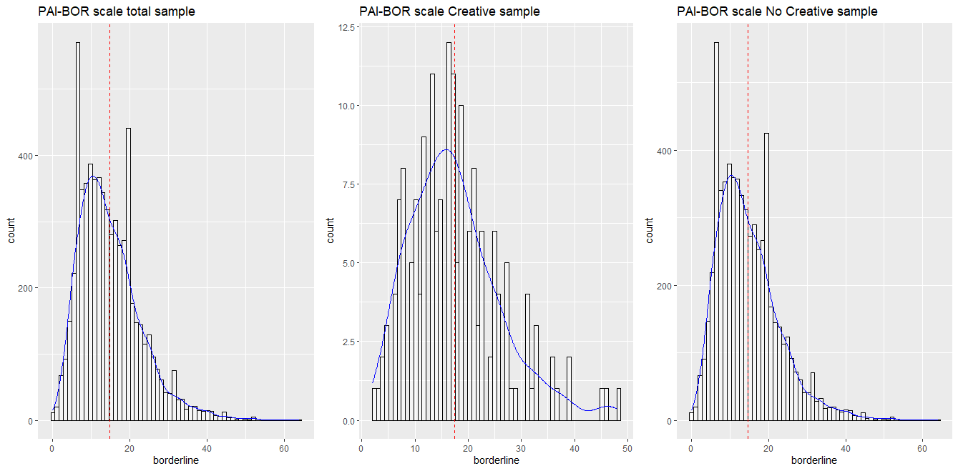
Note. Borderline personality score counts in the whole twin sample (left), the non-creative subset (middle), and the creative subset (right). The mean of each group is shown in red, and the distribution is shown in blue.

Supplementary Figure 2.

Cholesky decomposition of the best fitting model (AE).

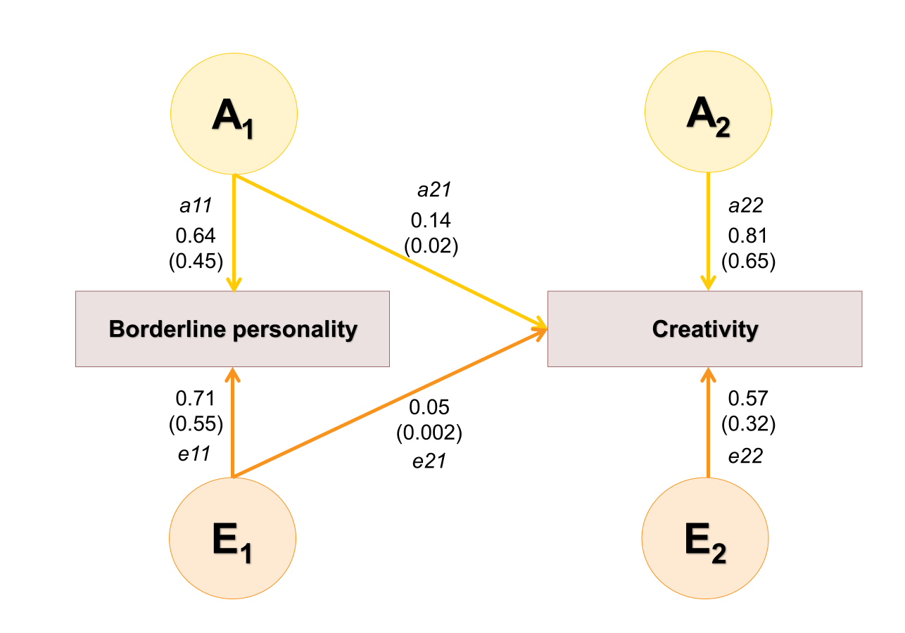
Note. The parameters are shown as: Path coefficients (variance values in parenthesis). A₁ is the additive genetic factor and E₁ is the non-shared environment factor that influences borderline personality and creativity; A₂ is the additive genetic factor and E₂ is the non-shared environment factor which influences creativity. a11, a21, a22 , e11, e21 and e22 are path coefficients that represent the influence of the latent factors on the phenotype. The total variance for a phenotype is obtained by summing the squares of these coefficients, e.g. the variance of BPD scores is (a11*a11) + (e11*e11) and heritability is 0.45.For a detailed description of how to calculate the parameters of the common twin model from these, see ¹.

Supplementary Table I.
Estimates under the AE bivariate Cholesky decomposition.
Standardized matrices
h² matrix | e² matrix
   | Borderline | Creativity
  Borderline | 0.45 | 0.72
  Creativity | 0.72 | 0.67
   | Borderline | Creativity
  Borderline | 0.55 | 0.28
  Creativity | 0.28 | 0.33
phenotypic and genetic correlation matrices
R phenotype matrix | Rg matrix
   | Borderline | Creativity
  Borderline | 1 | 0.13
  Creativity | 0.13 | 1
   | Borderline | Creativity
  Borderline | 1 | 0.17
  Creativity | 0.17 | 1
environmental correlation matrix
 | Borderline | Creativity
Borderline | 1 | 0.09
Creativity | 0.09 | 1

Supplementary table II.

Details of -2LL tests in the bivariate Cholesky decomposition.

Fitting model | Compared with | -2LL⁽¹⁾ | df⁽²⁾ | AIC⁽³⁾ | Χ² ⁽⁴⁾ | ∆df⁽⁵⁾ | P⁽⁶⁾
ACE | - | 20017.20 | 13612 | 20041.20 | NA | NA | NA
AE | ACE | 20015.73 | 13615 | 20033.73 | -1.475079 | 3 | 1
a11, a21 = 0 | AE | 20334.42 | 13617 | 20348.42 | 318.6906 | 2 | 6.269371e-70
a21=0 | AE | 20020.29 | 13616 | 20036.29 | 4.558087 | 1 | 0.03276365
a22=0 | AE | 20060.36 | 13616 | 20076.36 | 44.63523 | 1 | 2.37382e-11
e22=0 | AE | 20204.25 | 13616 | 20220.25 | 188.5204 | 1 | 6.688116e-43
1. Likelihood ratio test (-2LL): likelihood ratio test statistic calculated by -2 (log likelihood sub-nested model – log likelihood full model). 2. Degrees of freedom (df) of the model. 3. The Akaike information criterion (AIC) is an estimator of prediction error and thereby relative quality of statistical models for a given set of data. 4. Χ² test given in the -2LL test. 5. Difference of degrees of freedom equal to the difference in the number of estimated parameters in the two models. 6. P represents the p-value of the chi-squared test. In bold are the models with no difference from the original model.

Supplementary twin model information.
If the MZ correlation was less than twice the DZ correlations (2*rDZ > rMZ), an ACE starting model was evaluated; otherwise an ADE starting model was used. In a series of nested models, we tested whether we could constrain parameters at zero by likelihood ratio tests and derived the most parsimonious model.
In bivariate models, the within-twin cross-trait covariances show whether there are common etiological A, E or C influences in the traits. The influence of genes and environment on the correlation between BPD and creativity is deduced from the correlation between borderline personality score in twin 1 and creativity in twin 2, and vice versa. When this ‘cross-correlation’ is higher in MZ than in DZ twin pairs, a genetic correlation is implied. When the MZ cross-correlation is lower than the correlation between creativity and borderline personality score in one person, an influence of E is implied.
The genetic and environmental correlations were estimated in a bivariate model ². The ACE model included 9 free parameters: one threshold, one estimated mean and the six Cholesky parameters of the bivariate model estimating the path coefficients. In a series of nested models, we tested constraints to analyze the significance of different parameters and derived the most parsimonious model. The fit of submodels was evaluated with Loglikelihood ratio tests, which involves subtracting the log-likelihood for the more general model from the log-likelihood of the more restricted model. Twice this difference gives a Χ² test with the degrees of freedom (df) equal to the difference in the number of estimated parameters in two nested models. A significant Χ² (P < 0.05) indicates that the constrained model fits significantly worse than the previous model. As a result, the previous model is kept as the most parsimonious model, to which a new model can be compared. Thus, those models that are the most parsimonious and efficient representations of the data are selected.
A saturated bivariate model was fitted specifying a threshold, a mean and 3 correlations for each zygosity group. To allow for a better model fitting, we set some constrains in nested models on means and threshold based on the output (models not shown). As no effect of sex was reported in previous studies for creativity a constraint for the bivariate models was an equal thresholds for men and women for creativity (1 threshold). For the liability scale, the total variance was constrained at unity.

Supplementary analyses.
 | Creativity |  | Borderline
 | Correlation | CI | Correlation | CI
Sex | 0.05 | −0.033/0.136 | 0.08* | 0.06/0.10
Age | -0.09* | -0.12/-0.06 | -0.05* | -0.07/-0.02
Educational Attainment | 0.02 | -0.005/0.05 | -0.13* | -0.16/-0.10
IQ | 0.04 | -0.05/0.13 | -0.23* | -0.31/-0.14
Neuroticism | 0.07* | 0.04/0.10 | 0.65* | 0.64/0.67
Extroversion | -0.01 | -0.04/0.02 | -0.26* | -0.29/-0.23
Openness | 0.17* | 0.14/0.20 | 0.09* | 0.06/0.11
Agreeableness | -0.01 | -0.04/0.02 | -0.32* | -0.34/-0.29
Conscientiousness | -0.05* | -0.08/-0.02 | -0.31* | -0.34/-0.29
Phenotypic correlation and confidence intervals (CI) for creativity (left) and borderline (right).
* indicates a significant correlation (not corrected for multiple testing).

 | Creativity |  |  | Borderline
 | OR | CI | p-value | β | se | p-value
Sex | 1.23 | 0.87/1.74 | 0.249 | 0.17 | 0.03 | 1.025e-10*
Age | 0.50 | 0.38/0.67 | 1.867e-06* | -0.04 | 0.01 | 0.002*
Educational Attainment | 1.14 | 0.97/1.34 | 0.117 | -0.12 | 0.01 | 2.024e-19*
IQ | 1.36 | 1.00/1.85 | 0.051 | -0.20 | 0.04 | 3.752e-06*
Neuroticism | 1.42 | 1.24/1.62 | 1.729e-07* | 0.63 | 0.01 | 0*
Extroversion | 0.95 | 0.81/1.11 | 0.514 | -0.25 | 0.02 | 8.620e-58*
Openness | 2.42 | 2.07/2.83 | 2.869e-28* | 0.08 | 0.02 | 1.023e-07*
Agreeableness | 0.93 | 0.80/1.08 | 0.361 | -0.30 | 0.01 | 9.533e-96*
Conscientiousness | 0.77 | 0.66/0.91 | 0.001* | -0.30 | 0.01 | 2.410e-91*
Odds ratio (OR), confidence interval (CI) and p-value parameters from the GEE models corrected for each significant confounder for creativity (on the left). β, standard error (se) and p-value parameters from the GEE model for each possible confounder for borderline (on the right).
* indicates a significant correlation (not corrected for multiple testing).

For the confounders with a significant effect, we performed the regression between creativity and borderline corrected by the confounders, as illustrated in the table below.
Dependent variable | Independent variable | OR | CI | p-value
Creativity | Borderline | 1.33 | 1.18/1.50 | 4.005e-06*
Creativity | Sex | 1.16 | 0.82/1.64 | 0.393
Creativity | Borderline | 1.41 | 1.25/1.60 | 4.394e-08*
Creativity | Age | 0.52 | 0.40/0.59 | 3.161e-06*
Creativity | Borderline | 1.39 | 1.21/1.60 | 3.512e-06*
Creativity | Educational Attainment | 1.19 | 1.01/1.40 | 0.034*
Creativity | Borderline | 0.65 | 0.30/1.41 | 0.275
Creativity | IQ | 1.27 | 0.94/1.72 | 0.121
Creativity | Borderline | 1.36 | 1.14/1.62 | 0.0005*
Creativity | Neuroticism | 1.14 | 0.96/1.35 | 0.127
Creativity | Borderline | 1.51 | 1.32/1.73 | 3.156e-09*
Creativity | Extraversion | 1.07 | 0.91/1.25 | 0.427
Creativity | Borderline | 1.36 | 1.20/1.55 | 3.235e-06*
Creativity | Openness | 2.34 | 1.99/2.74 | 7.109e-26*
Creativity | Borderline | 1.51 | 1.32/1.73 | 1.692e-09*
Creativity | Agreeableness | 1.07 | 0.91/1.25 | 0.402
Creativity | Borderline | 1.42 | 1.24/1.64 | 9.076e-07*
Creativity | Conscientiousness | 0.88 | 0.74/1.04 | 0.122
Dependent variable | Independent variable | β | se | p-value
Borderline | Creativity | 0.40 | 0.08 | 1.945e-06*
Borderline | Age | -0.04 | 0.01 | 0.008*
Borderline | Creativity | 0.21 | 0.06 | 0.0007*
Borderline | Neuroticism | 0.63 | 0.01 | 0*
Borderline | Creativity | 0.38 | 0.09 | 1.359e-05*
Borderline | Openness | 0.07 | 0.02 | 6.686e-06*
Borderline | Creativity | 0.36 | 0.08 | 1.318e-05*
Borderline | Conscientiousness | -0.30 | 0.01 | 1.361e-89*
Odds ratio (OR), confidence interval (CI) and p-value parameters from the GEE models corrected for each significant confounder for creativity (on yellow). β, standard error (se) and p-value parameters from the GEE models corrected for each significant confounder for borderline (on orange). If creativity needed to be corrected, the dependent variable was borderline and vice versa.
* indicates a significant correlation (not corrected for multiple testing)

After these analyses, we found that only IQ confounded the relationship between BPD and creativity at the phenotypic level. Therefore, we controlled the bivariate twin model by IQ resulting in a still significant genetic correlation between BPD and creativity. (Note that IQ itself is a heritable trait, so adding it as a covariate also controls for genetic components associated with intelligence.)
These results indicate that the genetic correlation between the proxy of creative profession and the PAI-BOR score seems unconfounded by sex, age, educational attainment, intelligence and personality.

1. Falconer, D. S. Introduction to Quantitative Genetics. (Pearson Education, 1996).
2. Treur, J. L. et al. Smoking and caffeine consumption: a genetic analysis of their association. Addict. Biol. 22, 1090–1102 (2017).

