Evaluating the impact of evolving green and grey urban infrastructure on local particular pollution around city square parks

Meng-Yi Jin^{1,2}, Kiran Apsunde², Brian Broderick², Zhong-Ren Peng^{3,4}, Hong-Di He¹, John Gallagher^{2,*}

¹ Center for Intelligent Transportation Systems and Unmanned Aerial Systems Applications Research, State-Key Laboratory of Ocean Engineering, School of Naval Architecture, Ocean and Civil Engineering, Shanghai Jiao Tong University, Shanghai, 200240, China.
² Department of Civil, Structural & Environmental Engineering, Trinity College Dublin, the University of Dublin, Ireland.
³ iAdapt: International Center for Adaptation Planning and Design, College of Design, Construction and Planning, University of Florida, Florida 32611-5706, USA.
⁴ Healthy Building Research Center, Ajman University, Ajman, UAE.
*Corresponding author: j.gallagher@tcd.ie

Table S1. Description of the characteristics of Fitzwilliam Square Park and surrounding urban form.
Characteristics
Area | 12,300 m²
Estimated percentage of grass cover | 26%
Estimated percentage of tree cover | 49%
Distance between the park boundary and the surrounding buildings | 17-26 m
Average height of surrounding buildings | 14 m

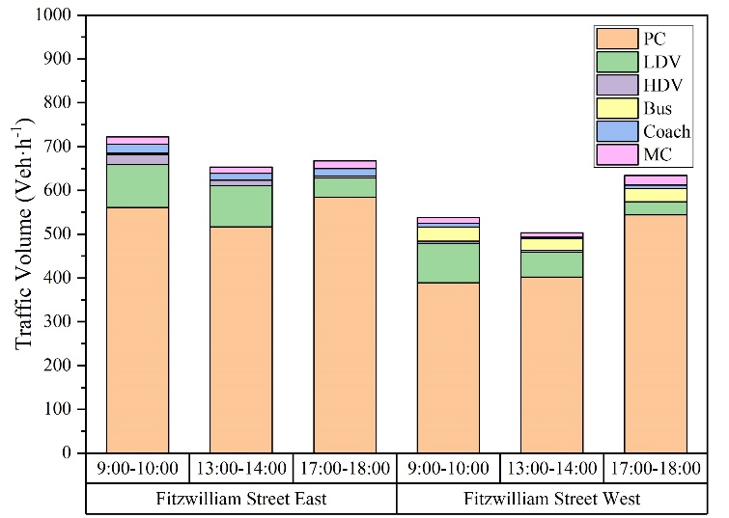
Figure S1. Hourly traffic volume of Fitzwilliam Street East and Fitzwilliam Street East obtained from traffic surveys in three time periods.

Table S2. Results of Pearson correlation coefficient analysis for hourly PM concentrations from the four eLos air quality stations and background monitoring station (Rathmines) during the monitor correction periods (represented as Phase 1 / Phase 2 results).
Pollutant | Location | Outside |  |  | Inside |  |  | Background  (Rathmines)
Pollutant | Location | O-W | O-E |  | I-W | I-E |  | Background  (Rathmines)
PM_{2.5} | O-W | 1.000 |  |  |  |  |  | 0.853 / 0.827
PM_{2.5} | O-E | 0.990 / 0.968 |  | 1.000 |  |  |  | 0.839 / 0.824
PM_{2.5} | I-W | 0.987 / 0.983 |  | 0.988 / 0.967 | 1.000 |  |  | 0.821 / 0.813
PM_{2.5} | I-E | 0.988 / 0.983 |  | 0.989 / 0.969 | 0.986 / 0.970 |  | 1.000 | 0.829 / 0.824
PM₁₀ | O-W | 1.000 |  |  |  |  |  | 0.791 / 0.638
PM₁₀ | O-E | 0.984 / 0.941 |  | 1.000 |  |  |  | 0.779 / 0.560
PM₁₀ | I-W | 0.982 / 0.966 |  | 0.984 / 0.967 | 1.000 |  |  | 0.761 / 0.598
PM₁₀ | I-E | 0.986 / 0.960 |  | 0.983 / 0.922 | 0.982 / 0.941 |  | 1.000 | 0.778 / 0.627
Note: The value before and after “/” means the coefficients of the Phase 1 and Phase 2, respectively.
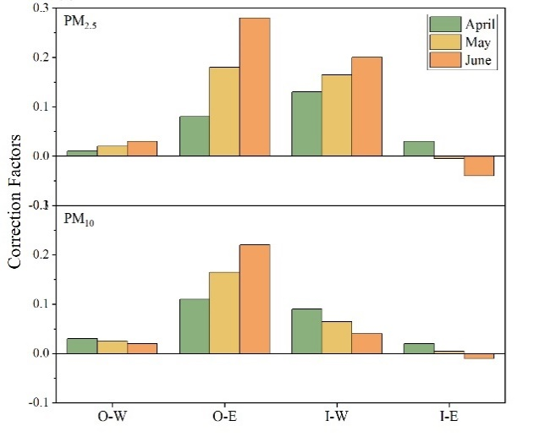
Figure S2. The correction factors of the measured PM data between the fixed stations.

Table S3. The parameter values of the ENVI - met configuration.
Parameter type | Parameter name | Value
Geographical Location | City | Dublin
Geographical Location | Reference time zone | GMT + 0
Geographical Location | Latitude, Longitude | 53.33, -6.25
Model Geometry | Spatial resolution | 2 m × 2 m × 1 m
Model Geometry | Grid (x,y,z) | 265 × 229 × 50
 | Telescoping factor | 5% (starting after 20m height)
 | Domain size | 530 m × 458 m × 89.76 m
 | Vertical grid generation | Lowest grid is split into 5 subcells
 | Nesting grid | 10
 | Roughness length | 0.01m
 | Wall and roof | Concrete hollow block (Thickness: 0.3, Absorption: 0.7, Reflection: 0.3, Emissivity: 0.9)
` | Roads and pavements | Concrete grey pavement (Roughness Length: 0.01, Albedo: 0.5, Emissivity: 0.9)
Boundary condition | Wind Direction | Parallel (Predominant, 210°)  Perpendicular (300°)
 | Wind Speed | 3.47 m/s
 | Air Temperature | 11 ℃
 | Relative Humidity | 64 %
Pollution Source | Species | PM_{2.5,} PM₁₀
 | Source geometry | Line
 | Source height | 0.15 m
Vegetation | Leaf type | Deciduous
 | Albedo | 0.2
 | Transmittance | 0.3
 | LAD  (From bottom to top) | 2.180/2.180/2.180/2.180/2.180/2.180/2.180/  1.720/1.720/0.000 (m²/m³)

Table S4. Pearson Correlation for measured PM concentrations and the influence factors (background concentrations, traffic volume, and meteorological parameters).
Pearson Correlation | 1. | 2. | Meteorological Parameter |  |  |  |  |  | Measured PM
Pearson Correlation | 1. | 2. | 3. | 4. | 5. | 6. | 7. |  | PM_{2.5} | PM₁₀
1. Background | 1 |  |  |  |  |  |  |  | .809** | .658**
2. Traffic Volume | -.113** | 1 |  |  |  |  |  |  | -0.002 | .101**
3. Air Temperature | -.288** | .468** | 1 |  |  |  |  |  | -.127** | 0.022
4. Relative Humidity | .150** | -.502** | -.506** | 1 |  |  |  |  | .105** | -.103**
5. Surface Pressure | .278** | -.093** | -.045* | -.050* | 1 |  |  |  | .260** | .242**
6. Wind Direction | -.336** | 0.017 | -.065** | .074** | -.169** | 1 |  |  | -.326** | -.265**
7. Wind Speed | -.233** | .265** | .103** | -.283** | -.517** | .101** | 1 |  | -.387** | -.309**

Table S5. Summary of Stepwise Regression Model.
 |  |  |  |  |  | ANOVA |  |  | Change Statistics
 | Model | R | R² | Adj R² | Std. Error of the Estimate | F | Sig. |  | R² Change | F  Change | Sig. F Change
PM_{2.5} | 1 | .817ª | 0.668 | 0.667 | 3.52663 | 2149.345 | .000 |  | 0.668 | 2149.345 | 0.000
PM_{2.5} | 2 | .826^{b} | 0.682 | 0.681 | 3.45237 | 1145.167 | .000 |  | 0.014 | 47.528 | 0.000
PM_{2.5} | 3 | .832^{c} | 0.692 | 0.691 | 3.39912 | 799.14 | .000 |  | 0.010 | 34.758 | 0.000
PM_{2.5} | 4 | .833^{d} | 0.694 | 0.693 | 3.38651 | 606.065 | .000 |  | 0.003 | 8.964 | 0.003
PM_{2.5} | 5 | .835e | 0.698 | 0.696 | 3.36995 | 491.934 | .000 |  | 0.003 | 11.516 | 0.001
PM₁₀ | 1 | .685ª | 0.469 | 0.469 | 3.97247 | 935.200 | .000 |  | 0.469 | 935.200 | 0.000
PM₁₀ | 2 | .708^{b} | 0.501 | 0.500 | 3.85549 | 529.459 | .000^{b} |  | 0.031 | 66.110 | 0.000
PM₁₀ | 3 | .722^{c} | 0.521 | 0.519 | 3.77952 | 381.931 | .000^{c} |  | 0.020 | 43.879 | 0.000
PM₁₀ | 4 | .724^{f} | 0.525 | 0.523 | 3.76507 | 290.931 | .000^{d} |  | 0.004 | 9.115 | 0.003
PM₁₀ | 5 | .726^{g} | 0.527 | 0.525 | 3.75593 | 235.106 | .000e |  | 0.003 | 6.135 | 0.013
 | 6 | .728^{h} | 0.530 | 0.527 | 3.74767 | 197.728 |  |  | 0.003 | 5.650 | 0.018
ªPredictors: (constant), Background
^{b}Predictors: (constant), Background, Wind Speed
^{c}Predictors: (constant), Background, Wind Speed, Temperature
^{d}Predictors: (constant), Background, Wind Speed, Temperature, Traffic Volume
^{e}Predictors: (constant), Background, Wind Speed, Temperature, Traffic Volume, Relative Humidity
^{f}Predictors: (constant), Background, Wind Speed, Temperature, Wind Direction
^{g}Predictors: (constant), Background, Wind Speed, Temperature, Wind Direction, Traffic Volume
^{h}Predictors: (constant), Background, Wind Speed, Temperature, Wind Direction, Traffic Volume, Pressure

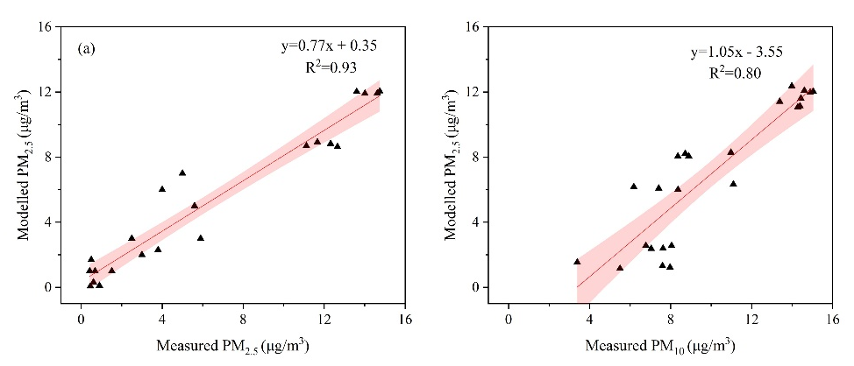
Figure S3 Pearson’s correlation analysis between measured and modelled PM concentration data: (a) PM_{2.5}, (b) PM₁₀. Shaded areas indicate the 95% confidence intervals.

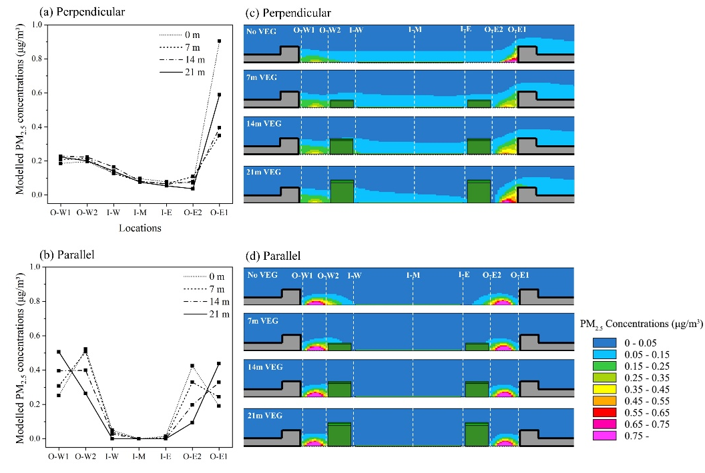
Figure S4. ENVI-met modeled PM_{2.5} concentrations at the seven receptor locations with different vegetation heights (0 m, 7 m, 14 m, 21 m) in (a) perpendicular and (b) parallel wind conditions respectively; Vertical planes along the central axis of the park with different tree heights (0 m, 7 m, 14 m, 21 m) in (c) perpendicular and (d) parallel wind conditions.

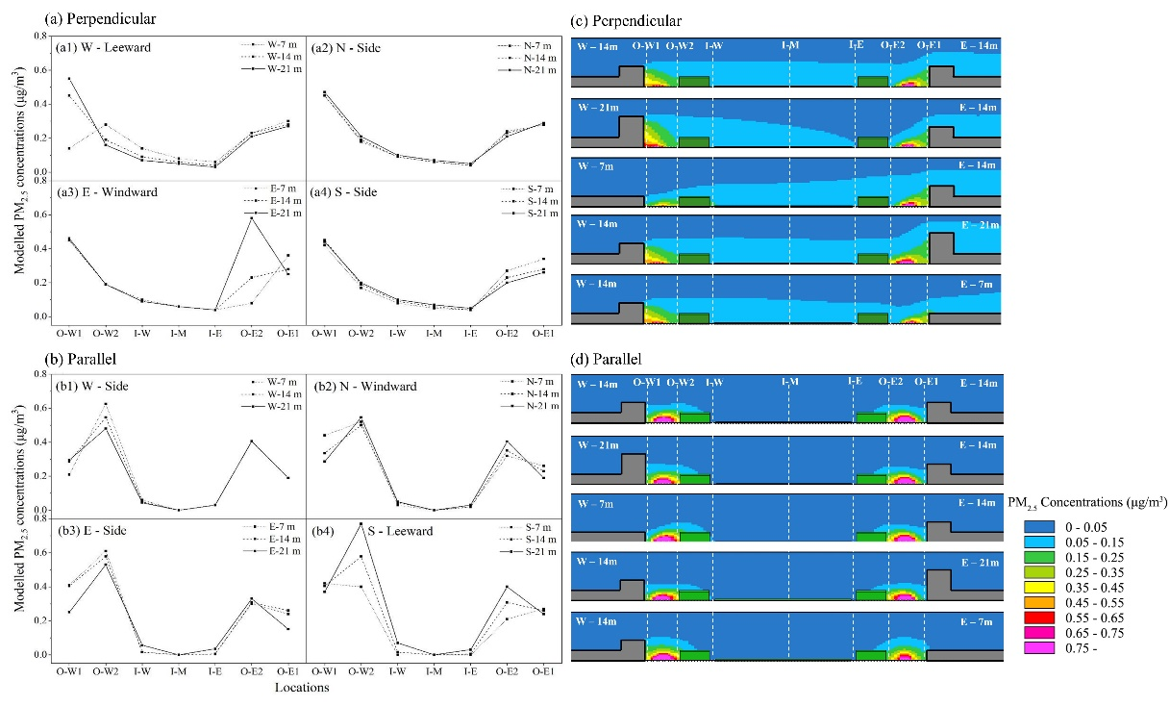
Figure S5. Modelled distribution of PM_{2.5} concentrations at the seven receptor locations with varying building heights in (a) perpendicular and (b) parallel wind conditions, respectively. Vertical plane along the park’s central axis with corresponding building heights in (c) perpendicular and (d) parallel wind conditions.

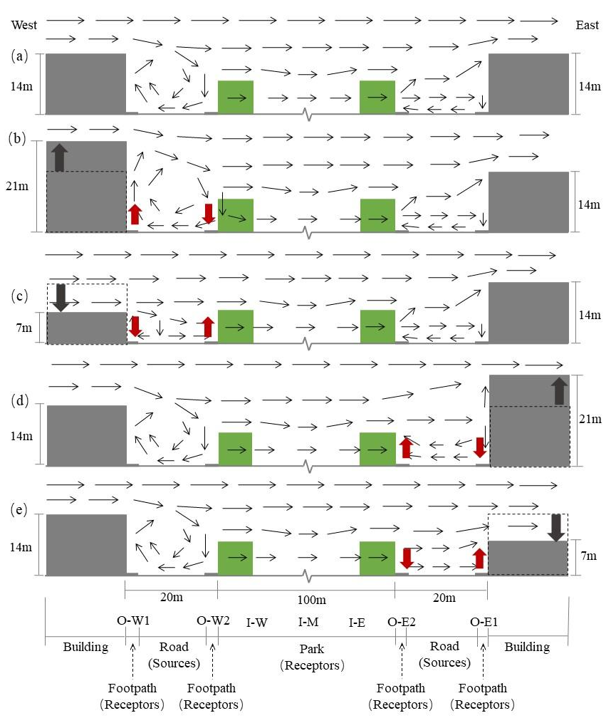
Figure S6. Modelled wind conditions along the central West-East cross-section of the study area under varying building height for wind perpendicular to the roads (The length of the arrow represents the wind speed).

