Appendix B Supplementary Data

Supplementary Tables

 | MTX Responders (n=12) | MTX non-responders  (n=13) | p*
TJC (/28) | 7.3 (4.5) | 5.0 (6.5) | 0.32
SJC (/28) | 7.8 (5.0) | 4.2 (4.5) | 0.08
VAS pain (/100) | 44.7 (30.3) | 53.1 (18.3) | 0.53
ESR (mm) | 38.8 (33.3) | 31.0 (34.9) | 0.61
CRP (mg/L) | 14.4 (13.6) | 14.0 (13.0) | 0.93
DAS28-CRP | 4.6 (1.1) | 3.8 (1.5) | 0.17
Oral steroid dose (mg)** | 5.17 (5.8) | 5.7 (6.7) | 0.84
Supplementary Table S1. Baseline disease activity (M0) in MTX responders and non-responders RA patients.
Data are expressed in mean (sd)
* student test
** prednisone equivalent
Abbreviation : TJC, tender joint count ; SJC, swollen joint count ; VAS, visual analogue scale ; ESR, erythrocyte sedimentation rate ; CRP, C-reactive protein
Metabolite  name | KEGG ID¤ | Class¤ | Subclass¤ | Pathway¤ | Pvalue* | FDR-Qvalue* | RA/HC ratio
Inosine -monophosphate | C00130 | Purine nucleosides | Purine ribonucleotides | Purine metabolism | <0.001 | 0.013 | 0.66
Ergothioneine | C05570 | Carboxylic acids and derivatives | Amino acids, peptides, and analogues | Histidine metabolism | 0.040 | 0.18 | 0.70
Proline | C16435 | Carboxylic acids and derivatives | Amino acids, peptides, and analogues | Arginine and Proline metabolism | 0.047 | 0.18 | 0.83
L-Citrulline | C00327 | Carboxylic acids and derivatives | Amino acids, peptides, and analogues | Arginine and proline metabolism | 0.027 | 0.15 | 0.83
aminovaleric acid | C00431 | Carboxylic acids and derivatives | Amino acids, peptides, and analogues | Arginine and Proline metabolism | 0.013 | 0.11 | 1.21
Creatine | C00300 | Carboxylic acids and derivatives | Amino acids, peptides, and analogues | Arginine and Proline metabolism | 0.002 | 0.42 | 1.25
Spermidine | C00315 | Organonitrogen compounds | Amines | Arginine and Proline metabolism | 0.005 | 0.52 | 1.41
Spermine | C00750 | Organonitrogen compounds | Amines | Arginine and Proline metabolism | 0.043 | 0.18 | 1.53
Stachydrine | C10172 | Carboxylic acids and derivatives | Amino acids, peptides, and analogues | Arginine and Proline metabolism | 0.017 | 0.11 | 1.67
Supplementary Table S2. RBC metabolites associated with RA (C18(+) dataset), ranked lowest to highest RA/HC ratio
* Significant changes in metabolite levels were tested using the t-test, and False Discovery Rate (FDR)-q value were determined according to Storey and Tibshirani
¤ Metabolite ID, class, subclass and pathway were provided by the Human Metabolome Database (HMDB)

Metabolite  name | KEGG ID¤ | Class¤ | Subclass¤ | Pathway¤ | Pvalue* | RA/HC ratio
DHEA sulfate | C04555 | Steroids | Sulfated Steroids | Steroid hormone biosynthesis | 0.027 | 0.48
Hydroxydecanoic acid | C02774 | Hydroxy acids and derivatives | Medium-chain hydroxy acids and derivatives | Fatty acids biosynthesis | 0.011 | 0.69
Alanine | C00041 | Carboxylic acids and derivatives | Amino acids, peptides, and analogues | Alanine metabolism | 0.038 | 0.87
Threonine | C00188 | Carboxylic acids and derivatives | Amino acids, peptides, and analogues | Glycine and Serine Metabolism | 0.030 | 0.87
Succinic acid | C00042 | Carboxylic acids and derivatives | Dicarboxylic acids and derivatives | Arginine and Proline metabolism | 0.012 | 1.22
Hexoses | C00031/C00095/C00124/C00159/C00738/C01381/C01383 | Organooxygen compounds | Carbohydrates and carbohydrate conjugates | Starch and sucrose metabolism | 0.012 | 1.30
O-Acetyl-homoserine | C01077 | Carboxylic acids and derivatives | Amino acids, peptides, and analogues | Cysteine and methionine metabolism | 0.006 | 1.30
Hydroxyproline | C01157 | Carboxylic acids and derivatives | Amino acids, peptides, and analogues | Arginine and Proline metabolism | 0.015 | 1.37
Methylbutyric acid | C18319 | Fatty acyls | Fatty acids and conjugates | Fatty acid metabolism | 0.038 | 1.46
Supplementary Table S3. Plasma metabolites associated with RA (HILIC(-) dataset) (FDR<0.3 only)
* Between-group comparisons as described in supplementary statistical methods
¤ Metabolite ID, class, subclass and pathway were provided by the Human Metabolome Database (HMDB)

Metabolite  name | HMDB ID¤ | Class¤ | Subclass¤ | Pathway¤ | Pvalue* | RA/HC ratio
Theophylline | C07130 | Purines and purine derivatives | Xanthines | Caffeine metabolism | 0.001 | 0.37
Trigonelline | C01004 | Nicotinic acid alkaloids | Pyridine alkaloids | Tropane, piperidine and pyridine alkaloid biosynthesis | 0.044 | 0.73
Ornithine | C01602 | Carboxylic acids and derivatives | Amino acids, peptides, and analogues | Arginine and Proline metabolism | 0.012 | 0.80
Threonine | C00188 | Carboxylic acids and derivatives | Amino acids, peptides, and analogues | Glycine, serine and threonine metabolism | 0.002 | 0.81
Alanine | C00041 | Carboxylic acids and derivatives | Amino acids, peptides, and analogues | Alanine metabolism | 0.011 | 0.84
Acetominophen glucuronide | NA | Phenols | 1-hydroxy-2-unsubstituted benzenoids | Acetaminophen Metabolism Pathway | 0.023 | 22.32
Supplementary Table S4. Plasma metabolites associated with RA (C18(+) dataset) (FDR<0.3 only)
* Between-group comparisons as described in supplementary statistical methods
¤ Metabolite ID, class, subclass and pathway were provided by the Human Metabolome Database (HMDB)

Supplementary Figure
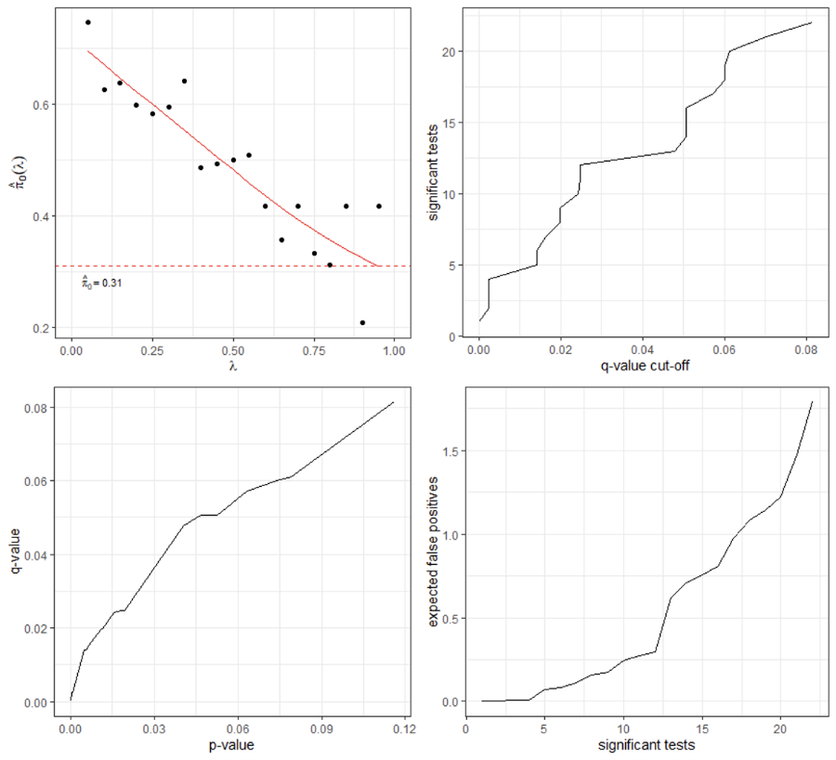
Supplementary Figure S1. Estimation of false discovery rate (FDR) in the comparisons of RBC metabolite levels (using the HILIC(-) dataset) in RA patients relative to HCs. False Discovery Rate (FDR)-q value were determined according to Storey and Tibshirani. With a q-value cut-off of 0.05 and 14 positive tests, there is less than 1 expected to be false positive.

