Supplementary materials
Novel Enzymatic Route to the Synthesis of C-8 Hydroxyflavonoids Including Flavonols and Isoflavones..
Kinga Dulakª, Sandra Sordonª, Agata Matera ª, Aleksandra Wilczak^{b}, Ewa Huszczaª, Jarosław Popłoński*ª
ªDepartment of Food Chemistry and Biocatalysis, Wroclaw University of Environmental and Life Sciences, Wroclaw, Poland (agata.matera@upwr.edu.pl), (sandra.sordon@upwr.edu.pl), (ewa.huszcza@upwr.edu.pl)
^{b}Hirszfeld Institute of Immunology and Experimental Therapy, Polish Academy of Sciences, Wroclaw, Poland (aleksadnra.wilczak@gmail.com)

List of content
Supplementary Figure S1. Predicted 3D models 2
Supplementary Figure S2. SDS-PAGE gel electrophoresis of recombinant hydroxylases 2
Supplementary Figure S3. Oxidation of cosubstrate 2
Supplementary Figure S4. UV-Vis absorbance spectra 3
Supplementary Figure S5. In vitro analysis of the biochemical properties 3
Supplementary Figure S6. Relative enzymatic activity measured for NADPH consumption in reaction 4
Supplementary Figure S7. LC-MS analysis of hydroxyl products. 9
Supplementary Figure S8. Degradation of C-8 hydroxylation products over time in vivo reaction – culture colour after 24 hours. 9
Supplementary Figure S9. Level of degradation of substrates over time in vivo reaction. 9
Supplementary Figure S10. Formation of C-8 hydroxylation products over time in vivo reaction 10
Supplementary Figure S11. Effect of reducing agents on the stability of hydroxy derivatives 11
Supplementary Figure S12. (a) Scheme of the chrysin hydroxylation reaction. (b) Scheme of the wogonin demethylation reaction. (c) UPLC-DAD analysis. (d) UV-Vis absorption spectrum. 11
Supplementary Figure S13. Formation curve of 8-hydroxy derivatives. 12
Supplementary Figure S14. ¹H-NMR (600 MHz, DMSO-d₆) spectrum of 8-hydroxyquercetin. 12
Supplementary Figure S15. ¹³C-NMR (600 MHz, DMSO-d₆) spectrum of 8-hydroxyquercetin. 13
Supplementary Figure S16. ¹H-¹³C NMR (HSQC) (600 MHz, DMSO-d₆) spectrum of 8-hydroxyquercetin. 13
Supplementary Figure S17. ¹H-¹³C NMR (HMBC) (600 MHz, DMSO-d₆) spectrum of 8-hydroxyquercetin. 14
Supplementary Table S1. Calculated parameters of substrate binding pocket volume for the predicted 3D models 14
Supplementary Table S2. Accession numbers and origin of amino acid sequences used in the phylogenetic analysis. 14
Supplementary Table S3. Primer sequences and description of transcription units. 15
Supplementary Table S4. Structures of substrates used in this work. 16
Supplementary Table S5. Reaction yield and purification efficiencies. 18
Products identification 19

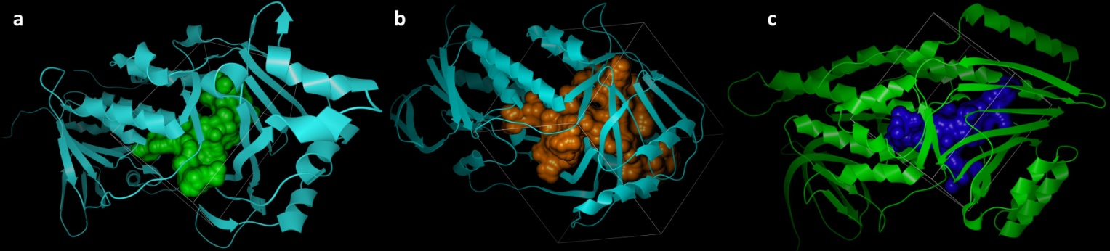

Supplementary Figure S1. Predicted 3D models of (a) – RgF8H, (b) – fdeE and (c) – LjF8H constructed with Caver Analyst 2.0 software¹ with cavities detected using default software cavity calculation (Probe 1.4, Large probe 3.0).
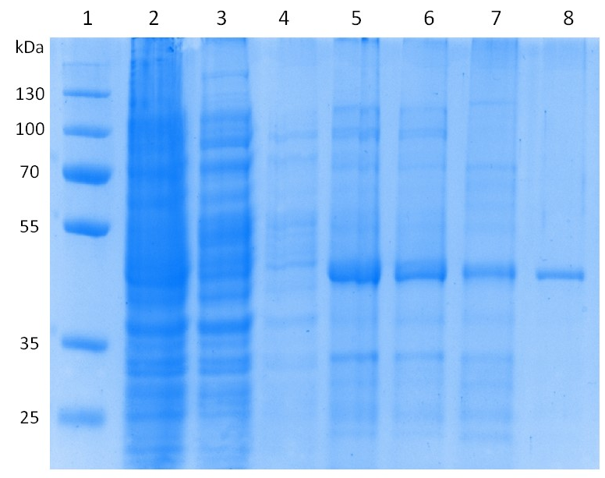

Supplementary Figure S2. SDS-PAGE gel electrophoresis of recombinant hydroxylases: marker (line 1), crude (line 2), filtrate (line 3), wash (line4) collected fraction of enzyme (line 5-7), purified 2x HisTrap enzyme fraction (line 8). Expected mass of purified fdeE fraction: 41.1 kDa.
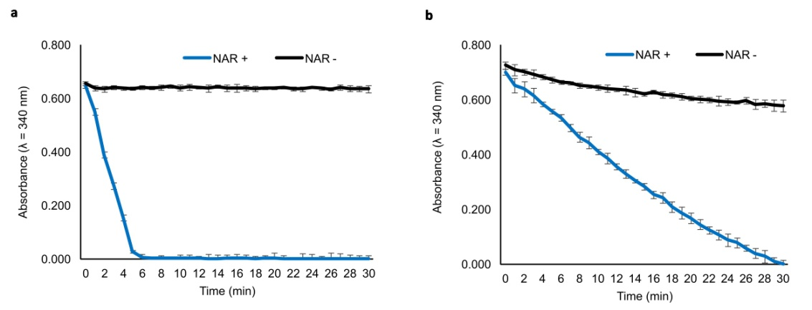

Supplementary Figure S3. Oxidation of cosubstrate (a) NADPH and (b) NADH by fdeE with and without naringenin addition in an in vitro reaction. The initial cosubstrate concentration was 1 mM.
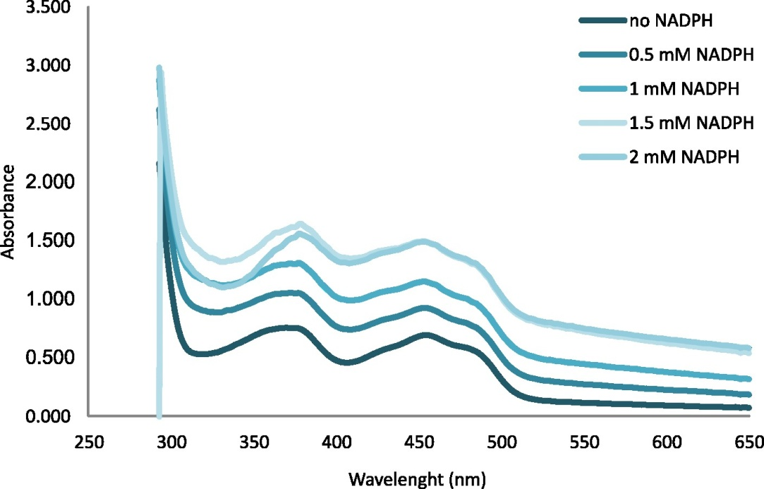

Supplementary Figure S4. UV-Vis absorbance spectra of purified and desalted enzyme without and with addition of NADPH coenzyme (after each 0.5 mM rise in NADPH concentration made in 5 min intervals corresponding blank measurement was performed). The reaction mixture 50 µL enzyme (1.8 mg/mL), 25 mM sodium phosphate buffer, pH 7.5.
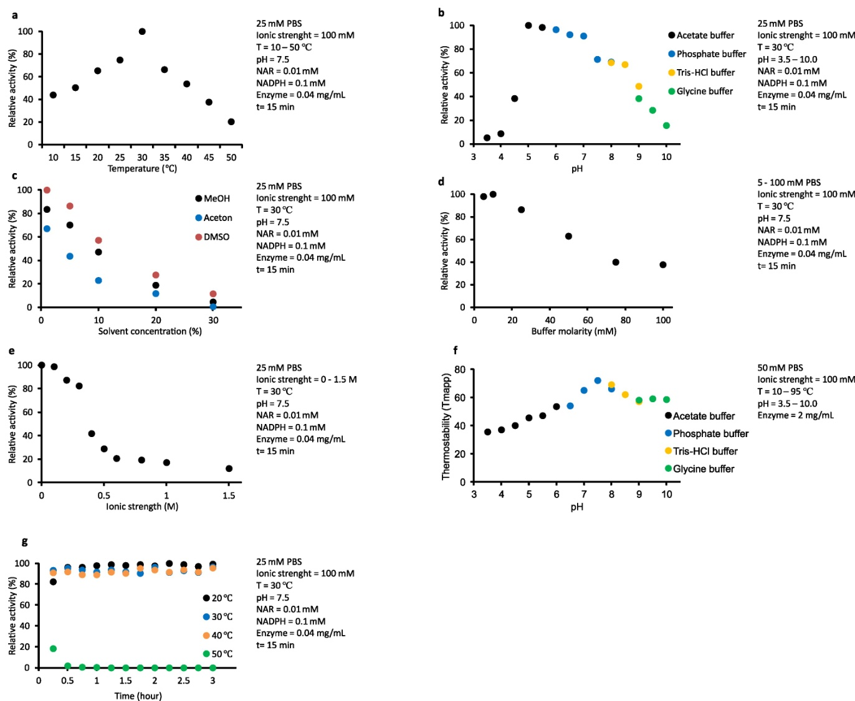

Supplementary Figure S5. In vitro analysis of the biochemical properties of fdeE. Data in all panels represent averages over three replicates. The standard deviations obtained were <3% of relative activity and were not included in the point markers. Effect of (a) temperature, (b) pH, (c) solvent concentration, (d) buffer molarity, (e) ionic strength of fdeE activity. (f) Stability of fdeE analyzed via ThermoFAD under different conditions, (g) thermo stability of fdeE.
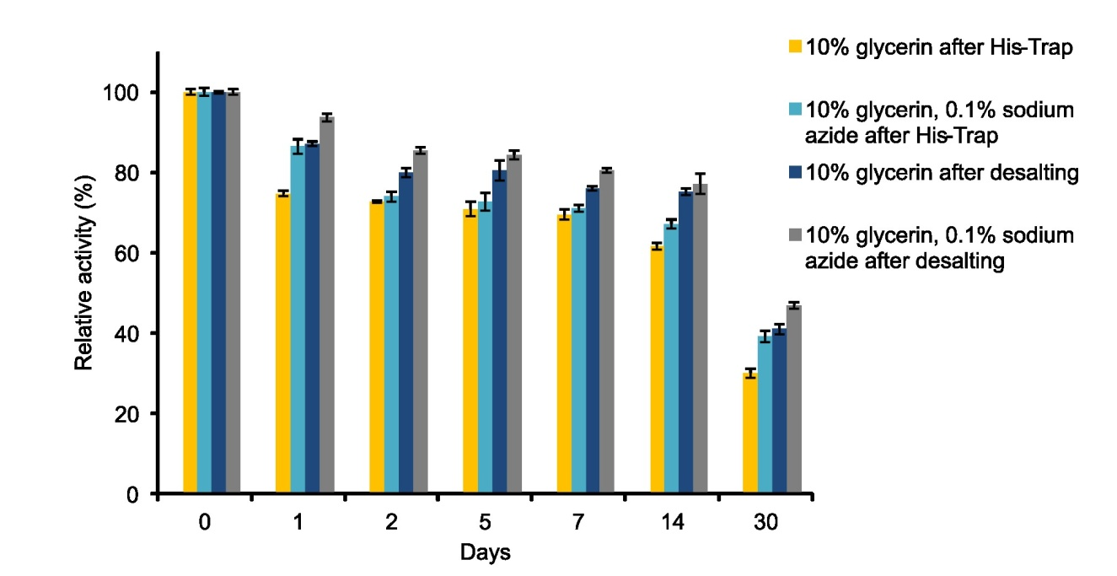

Supplementary Figure S6. Relative enzymatic activity measured for NADPH consumption in reaction with naringenin after storage at -20 °C purified or desalted protein fraction with 10% glycerol addition and 0.1% addition of sodium azide.
a.I
a.II
b.I
b.II
c.I
c.II
d.I
d.II
e.I
e.II
f.I
f.II
g.I
g.II
h.I
h.II
i.I
i.II
j.I
j.II
k.I
k.II
l.I
l.II
m.I
m.II
n.I
n.II
o.I
o.II
p.I
p.II
r.I
r.II

Supplementary Figure S7. LC-MS analysis of hydroxyl products. Mass spectrum of (a) naringenin, (b) hesperetin, (c) 7-hydroxyflavanone, (d) pinocembrin, (e) eriodictyol, (f) chrysin, (g) baicalein, (h) diosmetin, (i) apigenin, (j) luteolin, (k) 4’,7-dihydroxyflavone, (l) fisetin, (m) quercetin, (n) myricetin, (o) morin, (p) genistein, (r) biochanin A; (I) – substrate, (II) – hydroxy product.

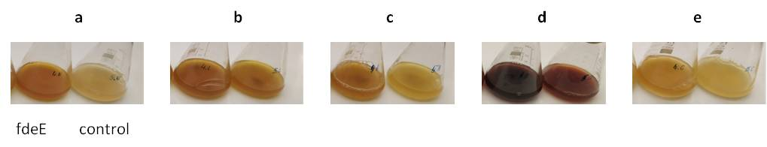

Supplementary Figure S8. Degradation of C-8 hydroxylation products over time in vivo reaction – culture colour after 24 hours. a – naringenin, b – luteolin, c – apigenin, d – quercetin, e – chrysin; left flask – fdeE, right flask– control.

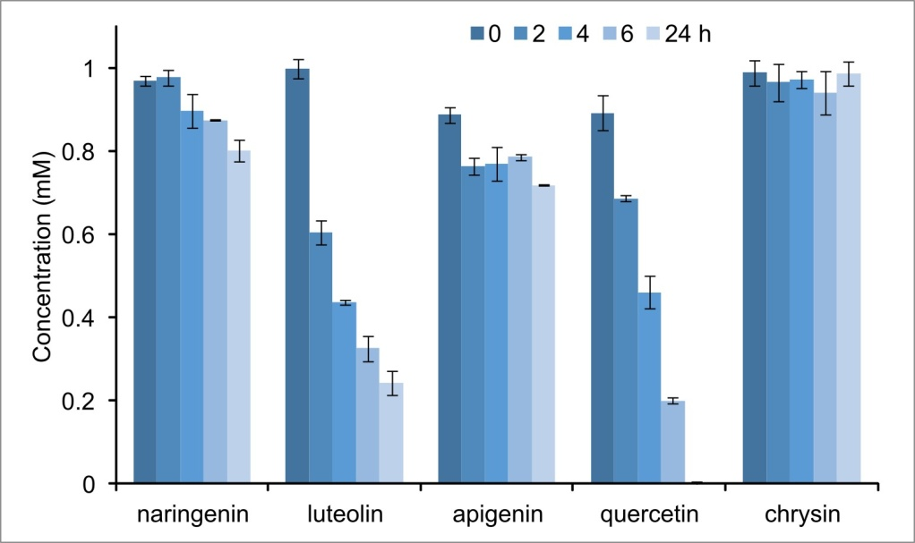

Supplementary Figure S9. Level of degradation of substrates over time in vivo reaction.
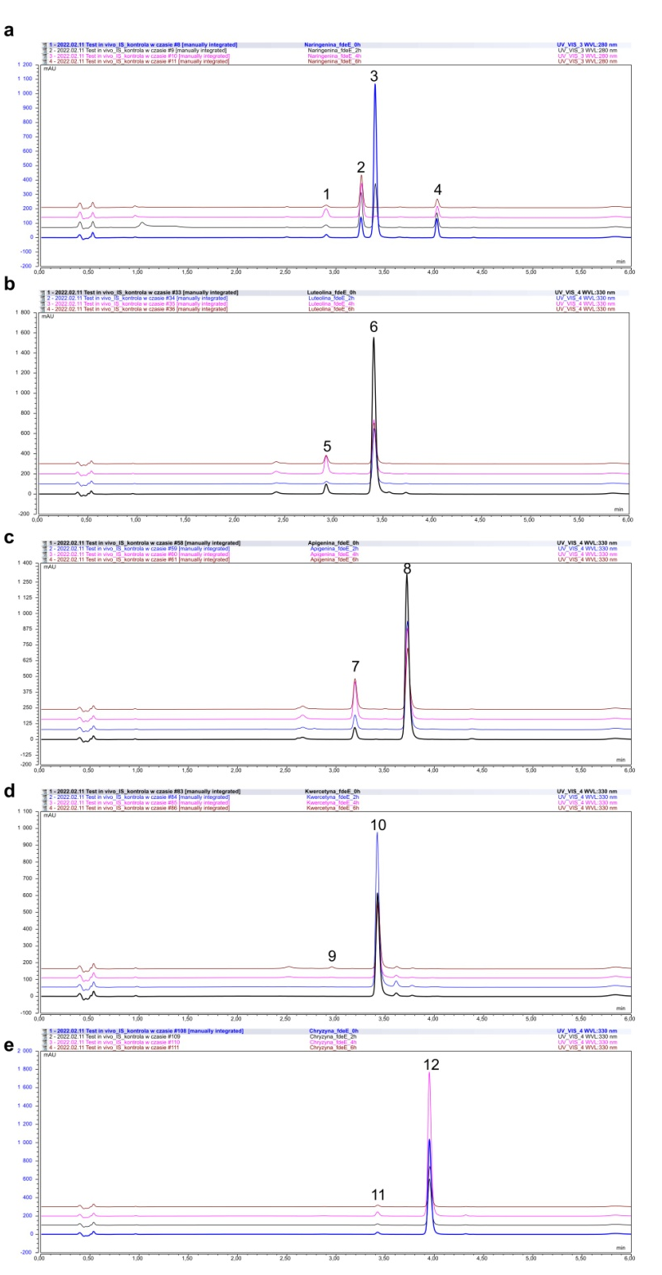

Supplementary Figure S10. Formation and degradation of C-8 hydroxylation products over time in vivo reaction: a – naringenin (λ = 280 nm), b – luteolin (λ = 330 nm), c – apigenin (λ = 330 nm), d – quercetin (λ = 330 nm), e – chrysin (λ = 330 nm); 1 – 8-hydroxynaringenin, 2 – indol (tryptophane degradation product from medium), 3 – naringenin, 4 – dibenzofuran (IS, can be observed at λ = 280 nm, but not at λ = 330 nm), 5 – 8-hydroxyluteolin, 6 – luteolin, 7 – 8-hydroxyapigenin, 8 – apigenin, 9 – 8-hydroxyquercetin, 10 – quercetin, 11 – 8-hydroxychrysin, 12 – chrysin.

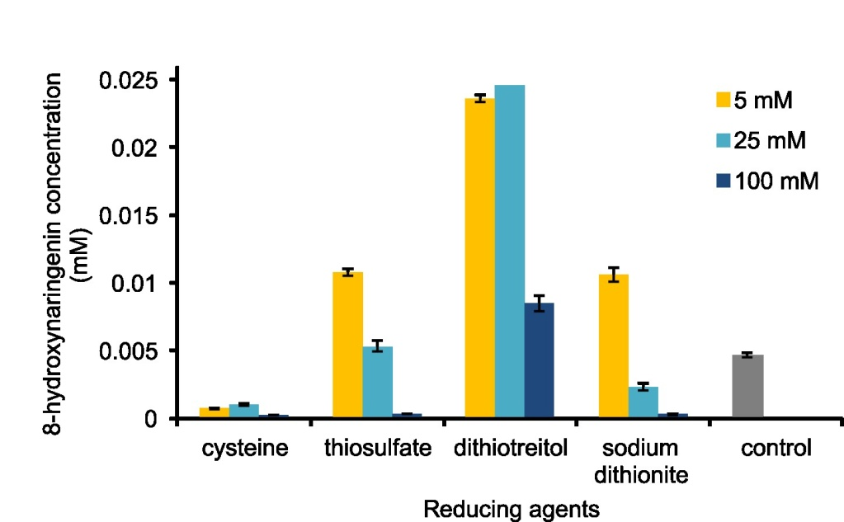

Supplementary Figure S11. Effect of reducing agents (cysteine, thiosulfate, dithiotreitol, sodium ditionite) on the stability of hydroxy derivatives obtained by fdeE in vitro reactions. Naringenin was used as a substrate at an initial concentration of 0.025 mM.

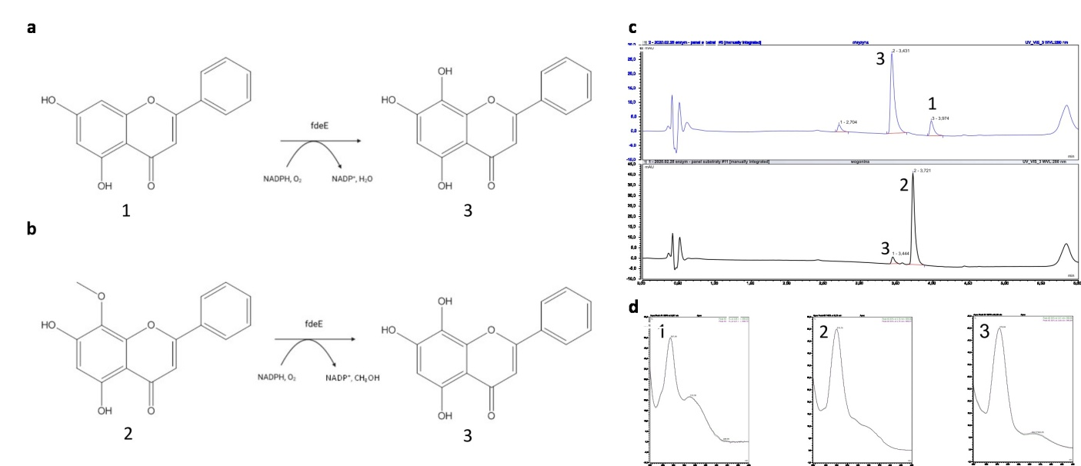

Supplementary Figure S12. (a) Scheme of the chrysin hydroxylation reaction. (b) Scheme of the wogonin demethylation reaction. (c) UPLC-DAD analysis of samples carried out for chrysin (upper chromatogram) and wogonin (lower chromatogram) using fdeE. (d) UV-Vis absorption spectrum: 1 - chrysin, 2 - wogonin, 3 – 8-hydroxychrysin.
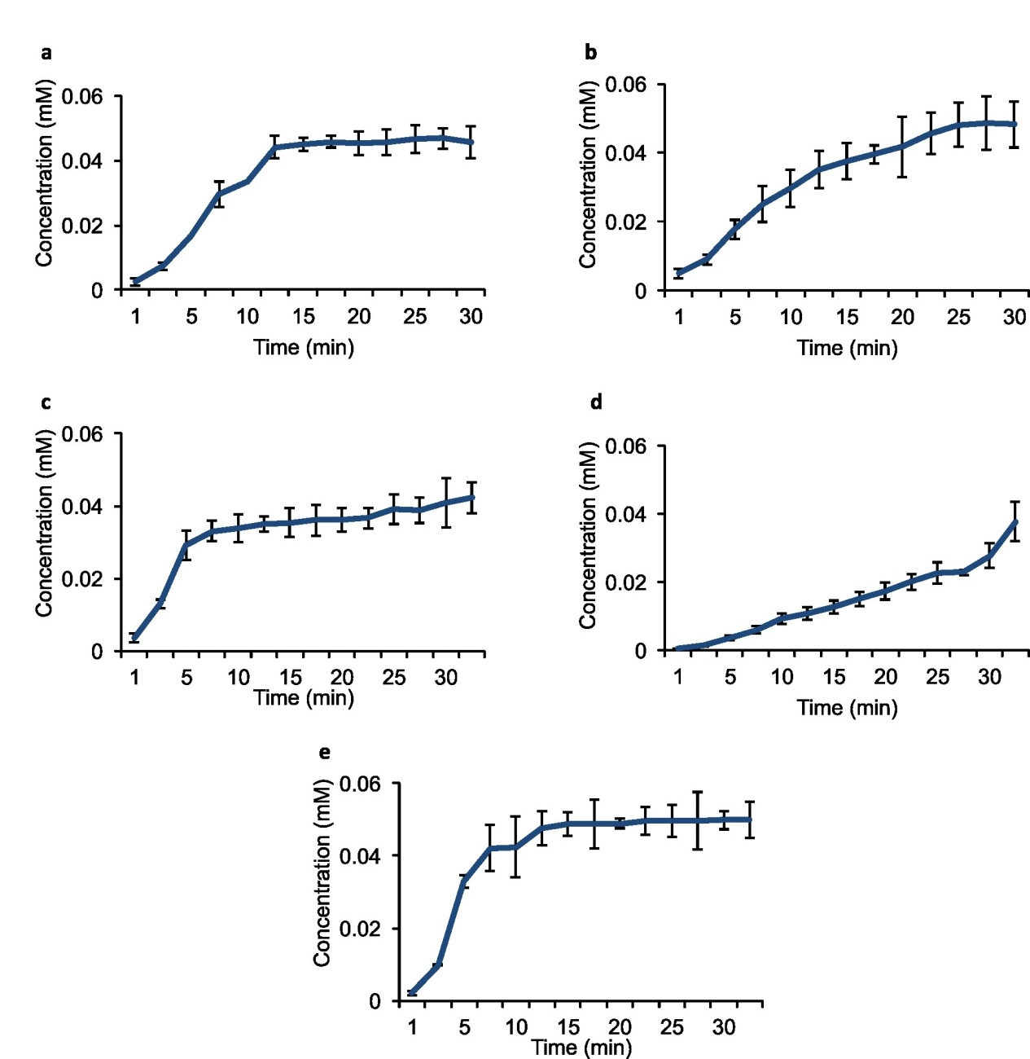

Supplementary Figure S13. Formation curve of 8-hydroxy derivatives of (a) naringenin, (b) luteolin, (c) apigenin, (d) quercetin, (e) chrysin. The initial substrate concentration was 0.05 mM.
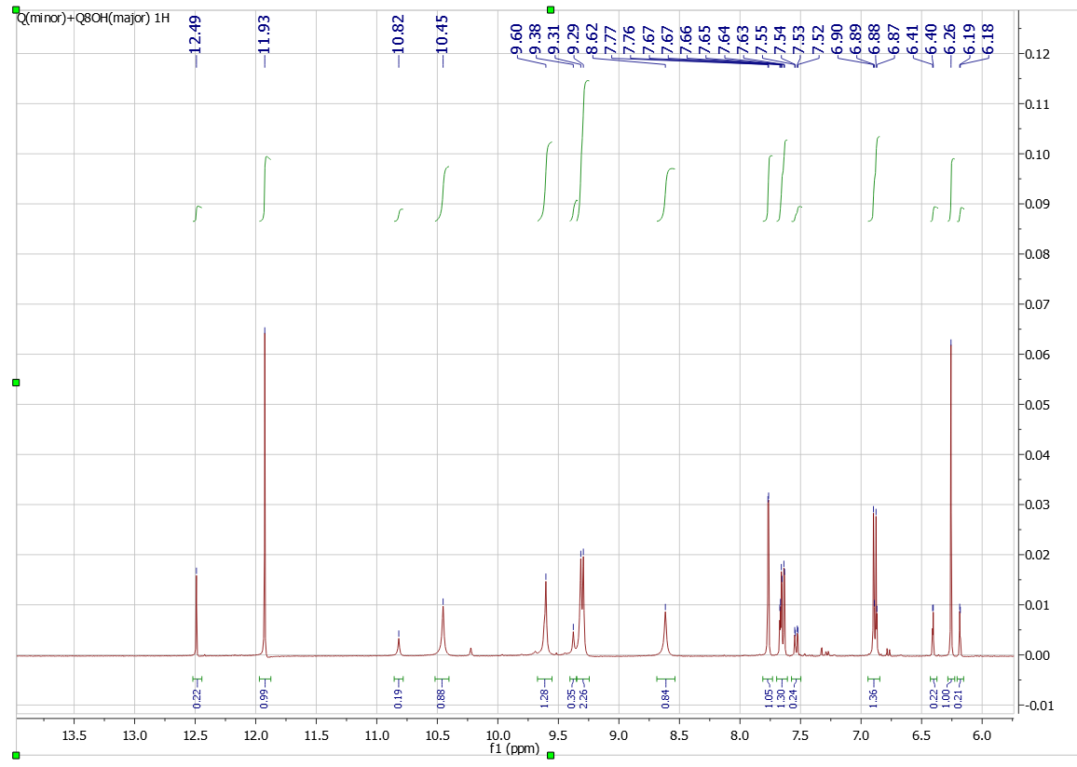

Supplementary Figure S14. ¹H-NMR (600 MHz, DMSO-d₆) spectrum of 8-hydroxyquercetin.
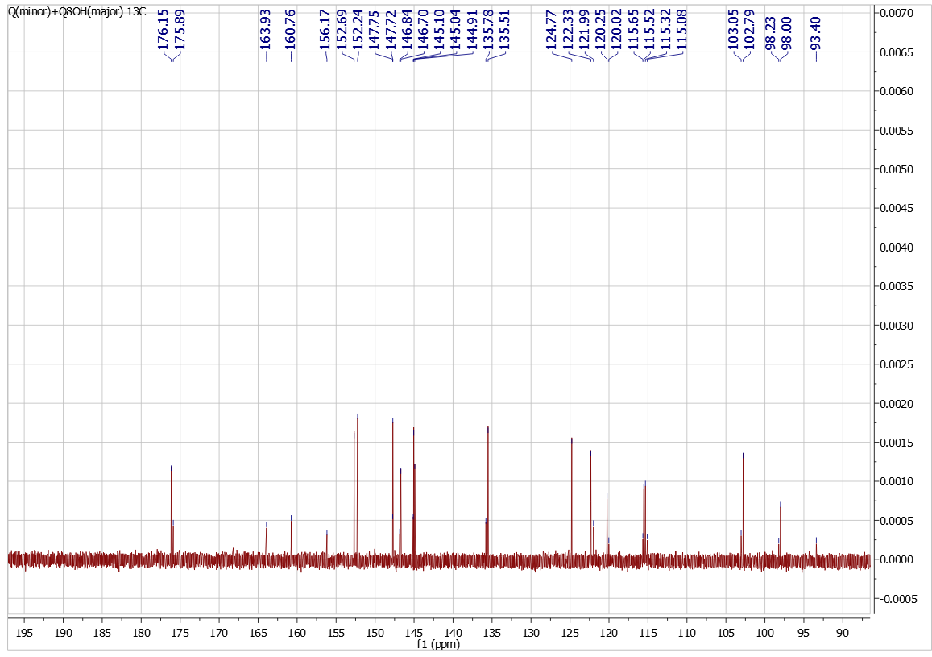

Supplementary Figure S15. ¹³C-NMR (600 MHz, DMSO-d₆) spectrum of 8-hydroxyquercetin.
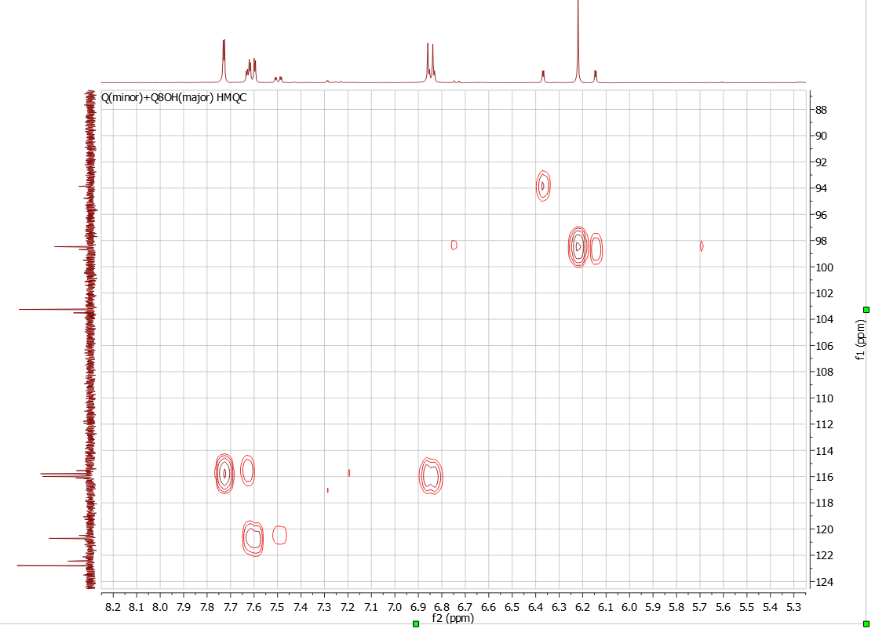
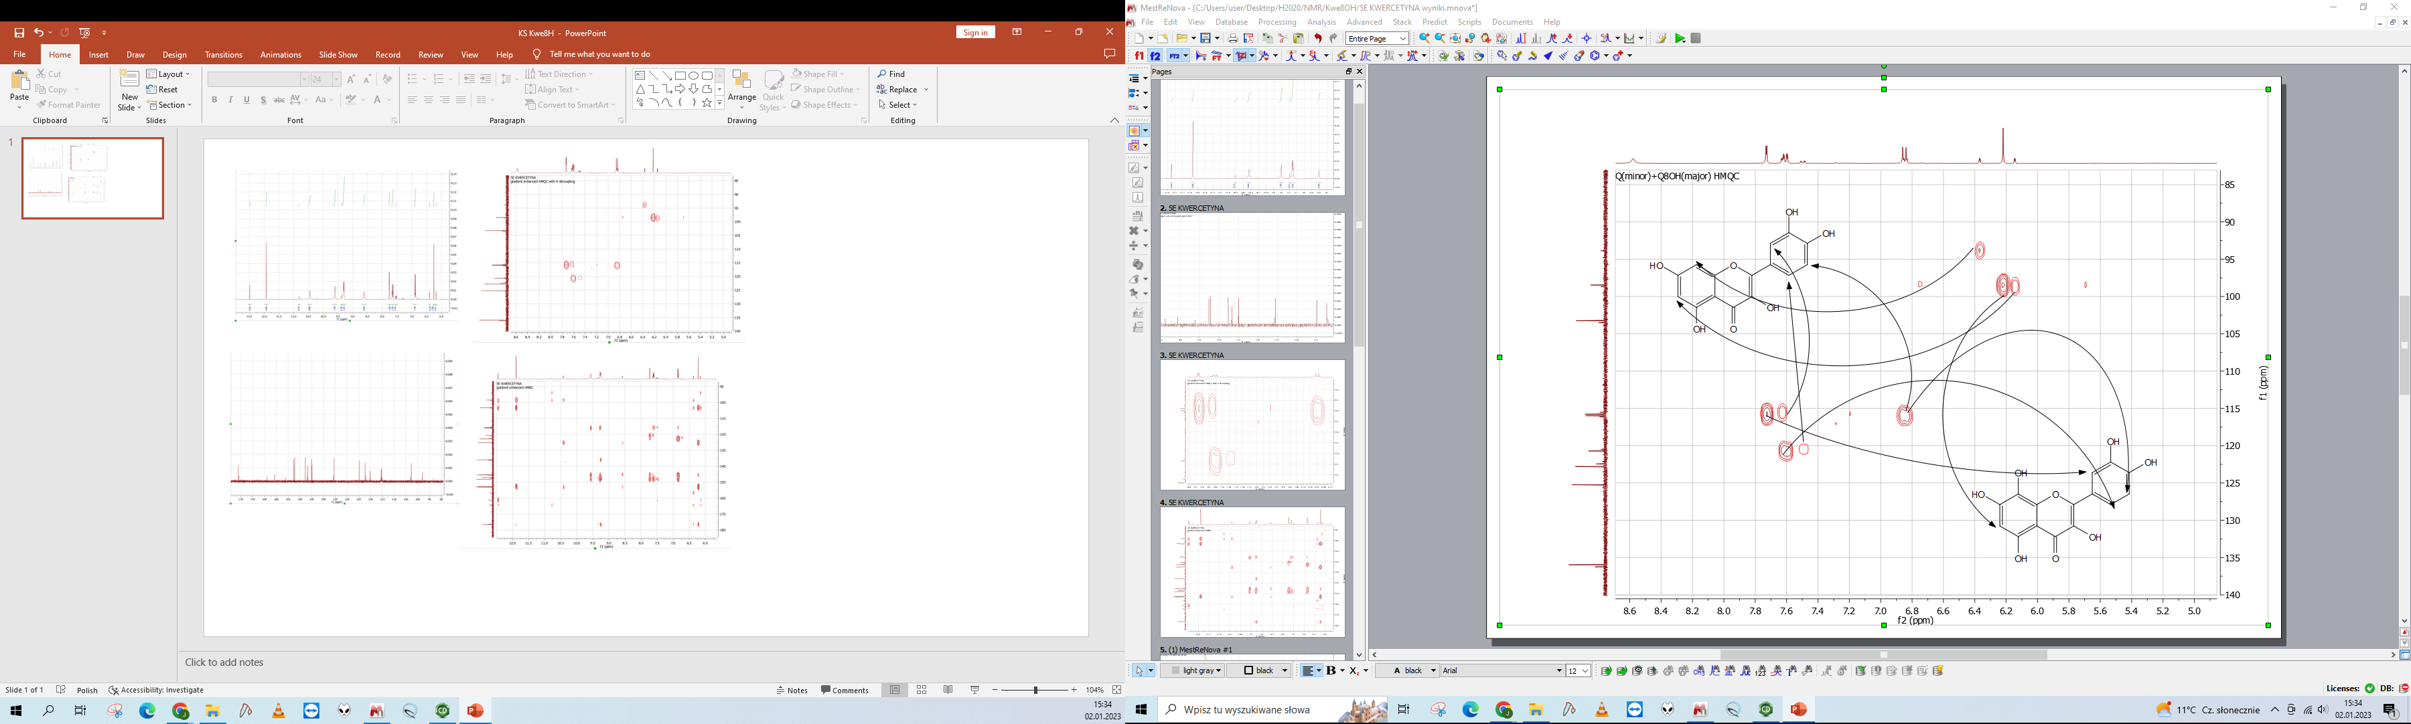

Supplementary Figure S16. ¹H-¹³C NMR (HSQC) (600 MHz, DMSO-d₆) spectrum of 8-hydroxyquercetin.

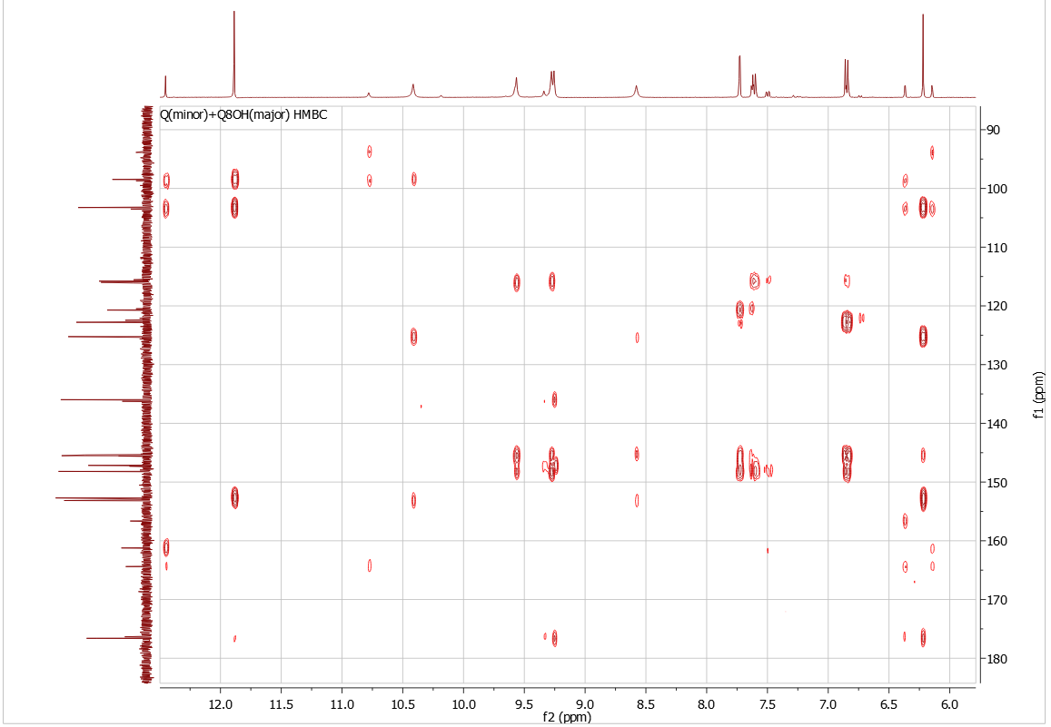

Supplementary Figure S17. ¹H-¹³C NMR (HMBC) (600 MHz, DMSO-d₆) spectrum of 8-hydroxyquercetin.

Supplementary Table S1. Accession numbers and origin of amino acid sequences used in the phylogenetic analysis. A phylogenetic tree was constructed among known flavonoid 6-hydroxylases (F6H)^{2–6}, flavonoid 8-hydroxylases (F8H)^{5,7–10} and plant-derived oxygenases capable of flavonoid hydroxylation^{10–13}.
Name | Origin | Acc. Number
AtF3’H | Arabidopsis thaliana | Q9SD85
AtFLS | Arabidopsis thaliana | NP_001190266.1
At1g12130 | Arabidopsis thaliana | NP_172677.1
At1g12160 | Arabidopsis thaliana | NP_172680.1
At1g12200 | Arabidopsis thaliana | NP_172684.1
At1g62600 | Arabidopsis thaliana | NP_176448.1
CaF6H | Chrysosplenium americanum | AAU04696.1
CsF3Ha | Camellia sinensis | ASU87419
CsF3Hb | Camellia sinensis | ASU87420
CsF8H | Camellia sinensis | AAT68774
GhF3’5’H1 | Gossypium hirsutum | AAP31058
GmF3’5’H | Gossypium hirsutum | AAP31058
GmCYP71D9 | Glycine max | NP_001304582.2
GmF3H | Glycine max | NP_001236797.1
GmF3’H | Glycine max | AAO47847
GmANS | Glycine max | ABY51685.1
GmFLS | Glycine max | NP_001237419.1
GeCYP81E1 | Glycyrrhiza echinata L. | BAA22422.1
GeCYP93B1 | Glycyrrhiza echinata L. | BAA22423.1
GS-OX1 | Arabidopsis thaliana | NP_176761.1
GS-OX2 | Arabidopsis thaliana | NP_001320894.1
GS-OX3 | Arabidopsis thaliana | NP_176444.1
fdeE | Herbaspirillum seropedicae SmR1 | OQ808967
ItF3’H | Ipomoea tricolor | BAD00189
LjF8H | Lotus japonicus | BBN79890
MpCYP82D62 | Mentha piperita | AGF30366
ObCYP93B23 | Ocimum basilicum | AGF30365
ObCYP82D33 | Ocimum basilicum | AGF30364
ObF8H-1’ | Ocimum basilicum | AII16849
ObF8H-2 | Ocimum basilicum | AII16848
ObF8H-1 | Ocimum basilicum | AII16850
ObPTC52-1 | Ocimum basilicum | AII16851.1
OsF3’H | Oryza sativa | NP_920627
PhCYP75A1 | Petunia hybryda | AUI38391.1
PhCYP75B | Petunia hybryda | AAD56282.1
PhF3’5’H1 | Petunia hybryda | CAA80265
PhF3’5’H2 | Petunia hybryda | CAA80266
RgF8H | Rhodotorula glutinis KCh735 | OQ808966
Sam5 | Saccharothrix espanaensis | ABC88666
SbCYP71D1 | Scutellaria baicalensis | ASW21048
SbCYP71D2 | Scutellaria baicalensis | ASW21049
SbCYP82D1.1 | Scutellaria baicalensis | ASW21050
SbCYP82D1.2 | Scutellaria baicalensis | ASW21051
SbCYP82D2 | Scutellaria baicalensis | ASW21052
VvF3’H | Vitis vinifera | CAI54277
VvF3’5’H1 | Vitis vinifera | CAI54278
YUCCA | Arabidopsis thaliana | NP_001329230.1
YUCCA4 | Arabidopsis thaliana | NP_196693.1
YUCCA5 | Arabidopsis thaliana | NP_199202.1
YUCCA10 | Arabidopsis thaliana | NP_175321.1

Supplementary Table S2. Primer sequences and description of transcription units.
Primers
Name | Sequence
R24_SEVA182 | AGCGGATAACAATTTCACACAGGA
F24_SEVA182 | CGCCAGGGTTTTCCCAGTCACGAC
rhaB_expression module_Fwd | GGCGCTTTTTAGACTGGTCG
rha S middle F | GGACGGGATGGCTTTCTGCAATAA

Transcription units
Plasmid | Characteristics | Strain | Used for
Lv1 fdeE | Km^{R}, pBBR1, Lv1 pSEVA23g19g1 vector, pJ23100, RBS T7 from pET28, fdeE gene, and T7 terminator from pET28 | E. coli DH5α | In vivo assay
Lv1 N-His-fdeE | Km^{R}, pBBR1, Lv1 pSEVA23g19g1 vector containing RhaS gene, RhaBAD promoter, RBS T7 from pET28, fdeE gene fussion with N-terminal His tag, and T7 terminator from pET28 | E. coli BL21 (DE3) | Overexpression analysis/ Formation rate/ Stabilization assay
Lv1 N-His-RgF8H | Dulak et al., 2022 | E. coli BL21(DE3) | Formation rate
Lv1 N-His-Bm_GDH | Dulak et al., 2022 | E. coli BL21 (DE3) | Stabilization assay

Supplementary Table S3. Structures of substrates used in this work. The shaded boxes in colour represent compounds transformed by fdeE.
Compounds related to this work | Structure | Compounds related to this work | Structure
Naringenin |  | Hesperetin
2’-hydroxyflavanone |  | 3’-hydroxyflavanone
4’-hydroxyflavanone |  | 6-hydroxyflavanone
7-hydroxyflavanone |  | Isoxanthohumol
Pinocembrin |  | Eriodictyol
Chrysin |  | Baicalein
Diosmetin |  | Apigenin
Luteolin |  | 3-hydroxyflavone
4’,7-dihydroxyflavone |  | Wogonin
Quercetin |  | Myricetin
Morin |  | Fisetin
Epicatechin |  | Dihydromyricetin
Biochanin A |  | Daidzein
Genistein |  | α,β-dihydroxanthohumol
Phloretin |  | Resveratrol
Xanthohumol |  | 4’-hydroxychalcone
Mequinol |  | 4-phenylphenol
4-hydroxybenzaldehyde |  | Rezorcin
4-isopropylphenol |  | Pirocatechin
o-cresol |  | 1-naphthal
2,4-dinitrophenol |  | p-hydroxyacetophenone
Vanillin |  | o-nitrophenol
m-nitrophenol |  | Phenol
Hydroquinone |  | Guaiacol
4-ethylphenol |  | 2,4-dihydroxyacetophenone

Supplementary Table S4. Calculated parameters of substrate binding pocket volume for the predicted 3D models of fdeE, RgF8H and LjF8H.
Enzyme | Volume | Samples
RgF8H | 2159.7 | 40100
LjF8H | 1102.8 | 40100
fdeE | 3031.4 | 40100

Supplementary Table S5. Reaction yield and purification efficiencies. The yield of the isolated product following the best purification method is 16%. Theoretical total amount calculated for the entire reaction mixture (17.1 mg) based on conversion percentage and then divided into 3 fractions.
 | 8-hydroxyquercetin (mg) | Isolated reaction yield  (%) | Purification efficiency (%)
Theoretical Total Amount | 5.7 | - | -
Ethyl Acetate | 5.16 | 16.33 | 90.58
1-Buthanol | 2.6 | 8.23 | 45.61
Liophilization | 0.48 | 1.52 | 8.42

Products identification
Products were identified by retention time, UV spectrum, and mass analysis.
Flavones: 8-hydroxychrysin (calculated mass for the molecular formula C15H10O5 for [M+H]+ m/z+ ~ 271.24, [M-H]- m/z- ~ 269.24, for which the observed masses are 271 and 269, respectively, λmax: 280 nm, 26.93 U (micromoles of substrate converts per minute per milligram of enzyme)), 8-hydroxybaicalein (calculated mass for the molecular formula C15H10O6 for [M+H]+ m/z+ ~ 287.24, [M-H]- m/z- ~ 285.24, for which the observed masses are 287 and 285, respectively, λmax: 286 nm, 6.18 U), 8-hydroxydiosmetin (calculated mass for the molecular formula C16H12O7 for [M+H]+ m/z+ ~ 317.07, [M-H]- m/z- ~ 315.07, for which the observed masses are 317 and 315, respectively, λmax: 280 and 336 nm, 24.95 U), 8-hydroxyapigenin (calculated mass for the molecular formula C15H10O6 for [M+H]+ m/z+ ~ 289.06, [M-H]- m/z- ~ 287.06, for which the observed masses are 289 and 287, respectively, λmax: 280 and 303 nm, 41.22 U), of 8-hydroxyluteolin (calculated mass for the molecular formula C15H10O7 for [M+H]+ m/z+ ~ 303.24, [M-H]- m/z- ~ 301.24, for which the observed masses are 303 and 301, respectively, λmax: 280 and 337 nm, 15.96 U), 7,8,4’-trihydroxyflavone (calculated mass for the molecular formula C15H10O5 for [M+H]+ m/z+ ~ 271.24, [M-H]- m/z- ~ 269.24, for which the observed masses are 271 and 269, respectively, λmax: 265 and 327 nm, 4.81 U) were obtained using fdeE.
Flavanones: 8-hydroxynaringenin (calculated mass for the molecular formula C15H12O6 for [M+H]+ m/z+ ~ 289.25, [M-H]- m/z- ~ 287.25, for which the observed masses are 289 and 287, respectively, λmax: 295 nm, 38.41 U), 8-hydroxyhesperetin (calculated mass for the molecular formula C16H14O7 for [M+H]+ m/z+ ~ 319.28, [M-H]- m/z- ~ 317.28, for which the observed masses are 319 and 317, respectively, λmax: 292 nm, 38.45 U), 7,8-dihydroxyflavanone (calculated mass for the molecular formula C15H12O4 for [M+H]+ m/z+ ~ 257.25, [M-H]- m/z- ~ 255.25, for which the observed masses are 257 and 255, respectively, λmax: 292 nm, 44.52 U), 8-hydroxypinocembrin (calculated mass for the molecular formula C15H12O5 for [M+H]+ m/z+ ~ 273.25, [M-H]- m/z- ~ 271.25, for which the observed masses are 273 and 271, respectively, λmax: 295 nm, 26.95 U), 8-hydroxyeriodictyol (calculated mass for the molecular formula C15H12O7 for [M+H]+ m/z+ ~ 305.25, [M-H]- m/z- ~ 303.25, for which the observed masses are 305 and 303, respectively, λmax: 292 nm, 35.03 U), using fdeE.
Flavonoles: 8-hydroxyfisetin (calculated mass for the molecular formula C15H10O7 for [M+H]+ m/z+ ~ 303.24, [M-H]- m/z- ~ 301.24, for which the observed masses are 303 and 301, respectively, λmax: 255 and 363 nm, 21.51 U), 8-hydroxyquercetin (calculated mass for the molecular formula C15H10O8 for [M+H]+ m/z+ ~ 319.24, [M-H]- m/z- ~ 317.24, for which the observed masses are 319 and 317, respectively, λmax: 260 and 339 nm, 22.51 U), 8-hydroxymyricetin (calculated mass for the molecular formula C15H10O9 for [M+H]+ m/z+ ~ 335.24, [M-H]- m/z- ~ 333.24, for which the observed masses are 335 and 333, respectively, λmax: 258 and 341 nm, 20.66 U), 8-hydroxymorin (calculated mass for the molecular formula C15H10O8 for [M+H]+ m/z+ ~ 319.24, [M-H]- m/z- ~ 317.24, for which the observed masses are 319 and 317, respectively, λmax: 255 and 354 nm, 45.59 U) obtained with fdeE.
Isoflavones: 8-hydroxygenistein (calculated mass for the molecular formula C15H10O6 for [M+H]+ m/z+ ~ 287.24, [M-H]- m/z- ~ 285.24, for which the observed masses are 287 and 285, respectively, λmax: 267 nm, 7.90 U), and 8-hydroxybiochanin A (calculated mass for the molecular formula C16H12O6 for [M+H]+ m/z+ ~ 301.26, [M-H]- m/z- ~ 299.26, for which the observed masses are 301 and 299, respectively, λmax: 267 nm, 1.88 U) by fdeE.
8-hydroxyquercetin: 1H NMR (600 MHz, DMSO-d6) δ (ppm): 6.22 (1H, s, H-6), 6.89 (1H, d, J = 8.4 Hz, H-5’), 7.65 (1H, dd, J = 2.1; 8.4 Hz, H-2’), 7.77 (1H, d, J = 2.1 Hz, H-6’), 8.62 (1H, s, 8-OH), 9.29 (1H, s, 3-OH), 9.31 (1H, s, 3’-OH), 9.60 (1H, s, 4’-OH), 10.45 (1H, s, 7-OH), 11.93 (1H, s, 5-OH); 13C NMR (150 MHz, DMSO-d6) δ (ppm): 98.0 (C-6), 102.79 (C-10), 115.32 (C-6’), 115.52 (C-5’), 120.25 (C-2’), 122.33 (C-1’), 124.77 (C-8), 135.78 (C-3), 144.91 (C-9), 145.04 (C-3’), 146.7 (C-2), 147.72 (C-4’), 152.24 (C-5), 152.69 (C-7), 176.15 (C-4).
References
1. Jurcik, A. et al. CAVER Analyst 2.0: analysis and visualization of channels and tunnels in protein structures and molecular dynamics trajectories. Bioinformatics 34, 3586–3588 (2018).
2. Anzellotti, D. & Ibrahim, R. K. Novel flavonol 2-oxoglutarate dependent dioxygenase: affinity purification, characterization, and kinetic properties. Archives of Biochemistry and Biophysics 382, 161–172 (2000).
3. Latunde-Dada, A. O. et al. Flavonoid 6-hydroxylase from soybean (Glycine max L.), a novel plant P-450 monooxygenase. Journal of Biological Chemistry 276, 1688–1695 (2001).
4. Anzellotti, D. & Ibrahim, R. K. Molecular characterization and functional expression of flavonol 6-hydroxylase. BMC Plant Biology 4, 20 (2004).
5. Zhao, Q. et al. Two CYP82D enzymes function as flavone hydroxylases in the biosynthesis of root-specific 4′-deoxyflavones in Scutellaria baicalensis. Molecular Plant 11, 135–148 (2018).
6. Berim, A. & Gang, D. R. The roles of a flavone-6-hydroxylase and 7-O-demethylation in the flavone biosynthetic network of sweet basil. Journal of Biological Chemistry 288, 1795–1805 (2013).
7. Dulak, K. et al. Novel flavonoid C-8 hydroxylase from Rhodotorula glutinis: identification, characterization and substrate scope. Microbial Cell Factories 21, 175 (2022).
8. Marin, A. M. et al. Genetic and functional characterization of a novel meta-pathway for degradation of naringenin in Herbaspirillum seropedicae SmR1. Environmental Microbiology 18, 4653–4661 (2016).
9. Hiraga, Y. et al. Identification of a flavin monooxygenase-like flavonoid 8-hydroxylase with gossypetin synthase activity from Lotus japonicus. Plant and Cell Physiology 62, 411–423 (2021).
10. Berim, A., Park, J.-J. & Gang, D. R. Unexpected roles for ancient proteins: flavone 8-hydroxylase in sweet basil trichomes is a Rieske-type, PAO-family oxygenase. Plant Journal 80, 385–395 (2014).
11. Hansen, B. G., Kliebenstein, D. J. & Halkier, B. A. Identification of a flavin-monooxygenase as the S-oxygenating enzyme in aliphatic glucosinolate biosynthesis in Arabidopsis. The Plant Journal 50, 902–910 (2007).
12. Mizutani, M. & Ohta, D. Diversification of P450 genes during land plant evolution. Annual Review of Plant Biology 61, 291–315 (2010).
13. Kawai, Y., Ono, E. & Mizutani, M. Evolution and diversity of the 2–oxoglutarate-dependent dioxygenase superfamily in plants. The Plant Journal 78, 328–343 (2014).

