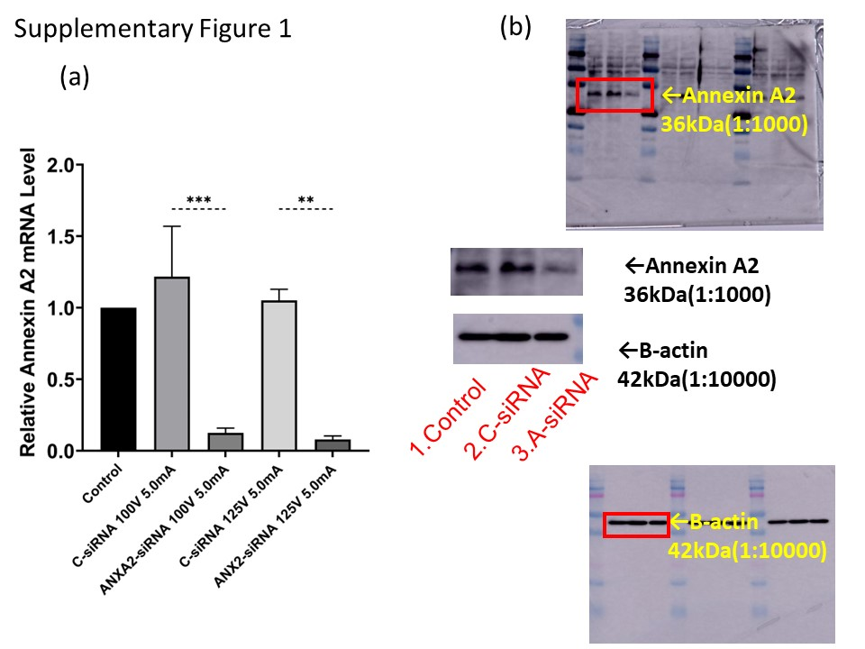

Supplementary Figure 1. Effects of knocking down ANXA2 expression in HepG2 cells. (a) RT-qPCR results of comparison of electroporation under conditions with a single electron pulse of 125 V or 100 V for 5.0 ms. (b) Results of Western blotting analysis of ANXA2 protein expression levels in ANXA2 knockdown HepG2 cells compared to control cells.

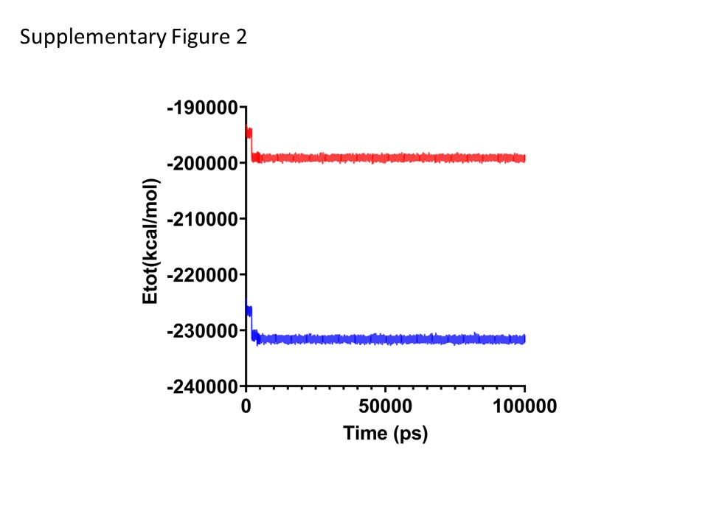

Supplementary Figure 2. Etot plot of 100 ns MD simulation trajectories for baicalin bound to full-length ANXA2 (blue) and ΔN_ANXA2 (red).

