[Supplement material]
Causal Inference Analysis of the Early Progression of Chronic Obstructive Pulmonary Disease

Supplement Figure 1. Comparison of the standardized mean difference before and after matching in the derivation and validation cohorts. The dashed line displays 0.2, which is a common standard for matching.
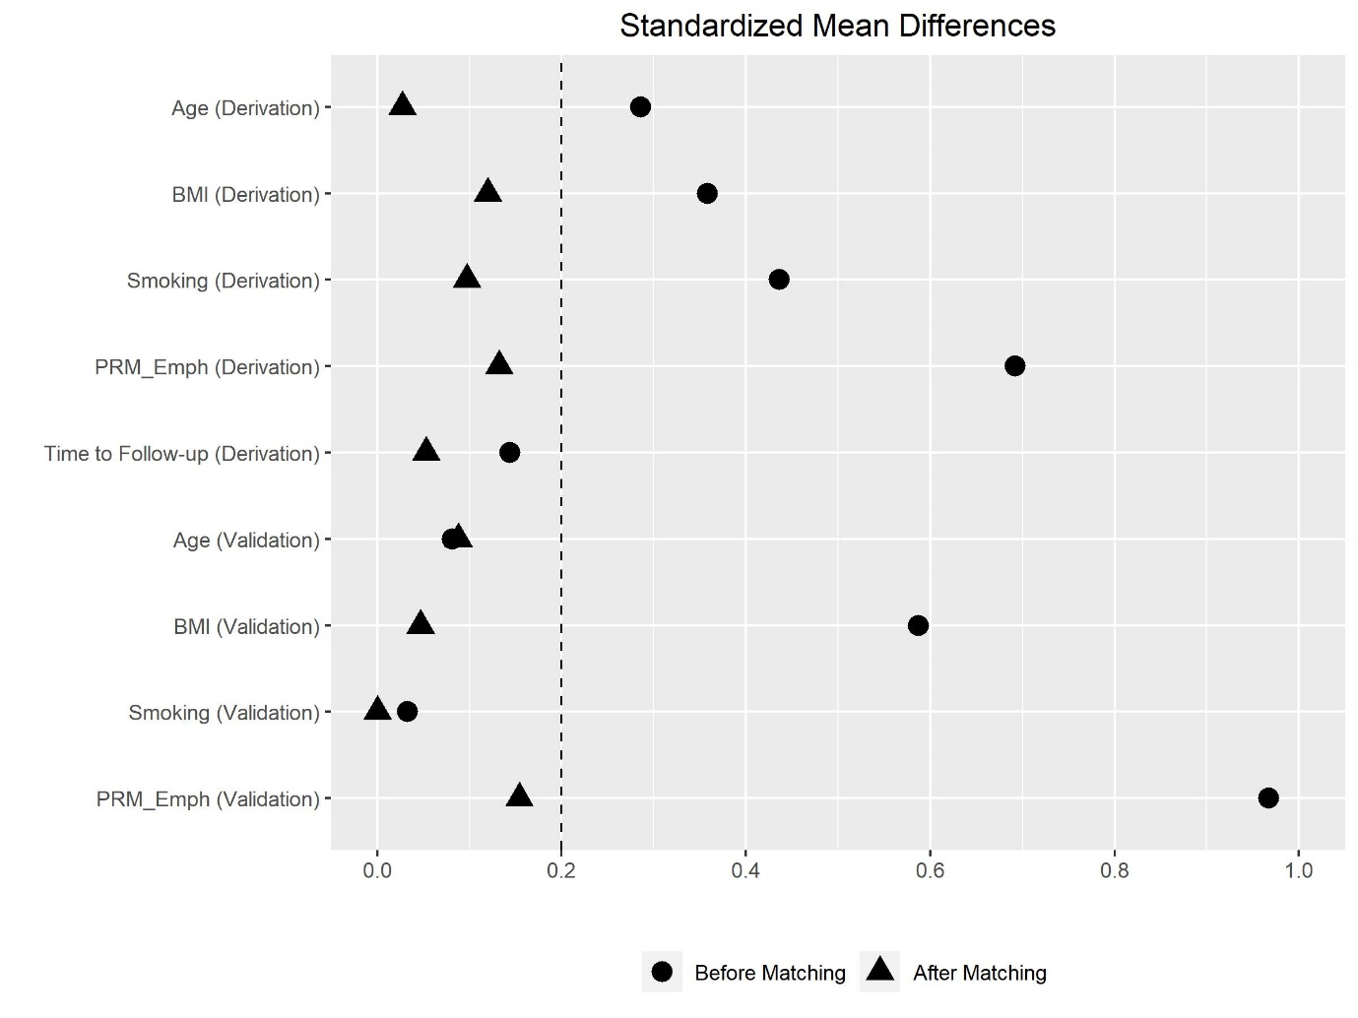

Results

Comparison of changes in PRM^{Emph} on follow-up CT scan between low and high PRM^{fSAD} groups: regression analysis and further matching analysis
To compare, a regression model with the same covariates can be considered. The regression coefficient estimate is 0.46 with a 95% CI of -2.58-3.51 in the derivation cohort. The wide confidence interval is due to the large standard error that occurs common when a model relies on extrapolation. The same regression model can be combined with the above matching method to adjust confounders and remove remaining bias.¹ From, this adjustment method, we obtained the estimate 1.35 with a 95% CI of 0.22-2.64 that is consistent with the results from the M-statistic. Also, an alternative to pair matching is optimal full matching that uses all patients in the cohort by allowing multiple controls to one treated patient.² The matched sets based on full matching can be represented by an approximately equivalent number of matched pairs, and the number was 31.3 that is slightly larger than 26 in the derivation cohort. Also, the p-value was 0.037 that is slightly larger than the p-value from matched pairs.

If the same hypothesis can be tested for both the derivation and validation cohorts simultaneously, combining two sets of matched pairs can strengthen evidence base. From the 42(=26+16) matched pairs, we can obtain the estimate 1.39 with a 95% CI of 0.48-2.30. Furthermore, this conclusion can be assessed by using a sensitivity analysis of unmeasured confounding bias.³ Since we cannot observe all covariates that are needed for valid inferences, we need to examine the robustness of our conclusion. To examine the bias, we consider a sensitivity parameter $Γ≥1$ that represents the maximum discrepancy of the probability of having a high fSAD level between two matched patients within the same pair. Larger $Γ$ means that our conclusion is more robust to bias. This sensitivity parameter is $Γ=1.29$ in the derivation cohort, can be improved to $Γ=1.44$ with regression adjustment. Also, for the combined cohorts, $Γ=1.60$. This means that even if there exists an unmeasured covariate that can change the odds by at most 1.60, the causal conclusion will not be qualitatively changed.

Comparison of changes in PRM^{Emph} on follow-up CT scan between low and high PRM^{fSAD} groups: sensitivity analysis based on cut-off value of PRM^{fSAD}

Further additional analysis was performed to evaluate the changes in the conclusion based on the changes in the cutoff PRM^{fSAD}. Low and high PRM^{fSAD} were defined on the basis of a cut-off value of <10% or <20%, respectively. When the cut-off value used was 10%, there were 17 and 6 matched pairs in the derivation and validation cohorts, respectively. The Huber’s M statistics yielded p-values of 0.005 and 0.036 with 95% CIs of 0.25–3.17 and -0.50–4.50, and the point estimates were 1.32 and 1.84 in the derivation and validation cohorts, respectively. When the cut-off value used was 20%, there were 38 and 40 patients with low and high PRM^{fSAD} in the derivation cohort and 25 and 55 patients with low and high PRM^{fSAD} in the validation cohort, respectively. As the sizes of the two groups in the derivation cohort were almost identical, the covariate balance through matching was not satisfactory. In the validation cohort, the covariate balance was acceptable, with standardized differences in all variables <0.2. The Huber’s M statistics yielded a p-value of 0.017 with a 95% CI of 0.10–2.66 and a point estimate of 1.32.

References
1. Rosenbaum PR. Covariance adjustment in randomized experiments and observational studies. Stat Sci 2002; 17: 286-304.
2. Hansen BB. Full matching in an observational study of coaching for the SAT. J Am Stat Assoc 2004; 99: 609-618.
3. Rosenbaum PR. Design of observational studies. 2nd ed. New York: Springer, 2020.

