Supplementary Files

HIV co-infection increases the risk of post-tuberculosis mortality among persons who initiated treatment for drug-resistant tuberculosis

Argita D. Salindri^{1,2}, Maia Kipiani^{3,4,5}, Nino Lomtadze^{3,4,5}, Nestani Tukvadze^{3,6}, Zaza Avaliani^{3,7}, Henry M. Blumberg^{8,9,10}, Katherine E. Masyn¹, Richard B. Rothenberg¹, Russell R. Kempker⁸, Matthew J. Magee^{8,9,10}

- Department of Population Health Sciences, Georgia State University School of Public Health, Atlanta, GA, USA
- Division of Infectious Diseases and Geographic Medicine, Department of Medicine, Stanford University School of Medicine, Stanford, CA, USA
- National Center for Tuberculosis and Lung Diseases, Tbilisi, Georgia
- David Tvildiani Medical University, Tbilisi, Georgia
- The University of Georgia, Tbilisi, Georgia
- Department of Medicine, Swiss Tropical and Public Health Institute, Allschwil, Switzerland
- European University, Tbilisi, Georgia
- Division of Infectious Diseases, Department of Medicine, Emory University School of Medicine, Atlanta, GA, USA
- Hubert Department of Global Health, Emory University Rollins School of Public Health, Atlanta, Georgia
- Department of Epidemiology, Emory University Rollins School of Public Health, Atlanta, Georgia

SUPPLEMENTARY MATERIALS

 |  | Page
Table S1 | Characteristics of persons who initiated treatment for RR or M/XDR TB according to study inclusion status, Georgia, 2009 – 2017 (N=1416)  This table was constructed to determine whether the demographic and clinical characteristics of individuals excluded from the primary analyses due to missing vital status were different when compared to those included in the primary analyses | iv – v
Table S2 | Multiple multivariable models with different covariate specifications  This table was created to show the range of adjusted hazard rate ratios of post-TB mortality from various multivariable models with different set of predictors to account for systematic errors due to covariates misspecifications. | vi
Table S3 | All-cause post-tuberculosis mortality rates among persons who initiated treatment for RR or M/XDR TB in Georgia, 2009 – 2017 (N=998)  This table is the extension of Table 2. In this table, we reported post-TB mortality rates according to other key factors including other comorbidities, smoking status, and baseline body mass index category. | vii
Table S4 | Crude and adjusted hazard rate ratios of mortality during and after tuberculosis treatment among persons who initiated treatment for RR or M/XDR TB in Georgia, 2009 – 2017 (N=1,032)  This table is the extension of Table 3. In this table, we reported crude and adjusted hazard rate ratios of mortality during and after tuberculosis treatment comparing other key factors including other comorbidities, smoking status, and baseline body mass index category. | viii
Table S5 | Adjusted hazard rate ratios from stratified competing risks models to assess the association between pre-existing comorbidities and mortality post-tuberculosis treatment according to their final TB treatment outcomes among persons who initiated treatment for RR or M/XDR TB in Georgia, 2009 – 2017 (N=980)  To better understand about the high-risk group for post-TB mortality, we also ran an additional test where we stratified our primary analysis according to study participants’ final TB treatment outcomes. | ix
Table S6 | Sensitivity and subgroup analyses to account for potential systematic errors on the association between various comorbidities and all-cause mortality post-tuberculosis among persons who initiated treatment for RR or M/XDR TB in Georgia, 2009 – 2017  We performed a series of sensitivity analyses to quantify the effect of systematic errors on our study estimates. In this table, we reported bias-adjusted estimates from sensitivity analyses to account for errors due to a) model specification, b) misclassification of hyperglycemia/diabetes, and c) effect of unmeasured confounders. | x - xi

Table S1 Characteristics of persons who initiated treatment for RR or M/XDR TB according to study inclusion status, Georgia, 2009 – 2017 (N=1416)
Characteristics | Total  N = 1416 | Included in the analyses |  | p-values*
Characteristics | Total  N = 1416 | No  N (%) = 384# (27.1) | Yes  N (%) = 1032 (72.9)
Median age, years (IQR) | 34 (26 – 48) | 33 (26 – 47) | 35 (26 – 49) | 0.283†
Gender  Female  Male | 375 (26.5)  1041 (73.5) | 96 (25.0)  288 (75.0) | 279 (27.0)  753 (73.0) | 0.440
Nationality  Georgian  Other | 1286 (90.8)  130 (9.2) | 344 (89.6)  40 (10.4) | 942 (91.3)  90 (8.7) | 0.326
BMI at treatment initiation  Median, kg/m² (IQR)  BMI category  Underweight (BMI <18.5 kg/m²)  Normal (BMI 18.5 – 24.9 kg/m²)  Overweight (BMI 25 – 29.9 kg/m²)  Obese (BMI ≥30.0 kg/m²) | 20.8 (19.1 – 22.9)  234 (18.4)  912 (71.7)  101 (7.9)  25 (2.0) | 20.8 (19.1 – 22.9)  64 (17.9)  264 (74.0)  25 (7.0)  4 (1.1) | 20.8 (19.1 – 22.9)  170 (18.6)  648 (70.8)  76 (8.3)  21 (2.3) | 0.962†  0.430
Culture positive | 1213 (99.2) | 337 (99.1) | 876 (99.2) | 1.000‡
Resistance type  RR TB  MDR/pre-XDR  XDR TB | 267 (18.9)  1047 (73.9)  102 (7.2) | 72 (18.8)  286 (74.5)  26 (6.8) | 195 (18.9)  761 (73.7)  76 (7.4) | 0.923
Abnormal X-ray finding | 1352 (97.0) | 377 (99.2) | 975 (96.2) | 0.003
Cavitary disease | 410 (29.0) | 125 (32.6) | 285 (27.6) | 0.069
Infiltrate | 1050 (74.2) | 295 (76.8) | 755 (73.2) | 0.162
Disseminated TB disease | 361 (25.5) | 110 (28.7) | 251 (24.3) | 0.097
Tobacco smoking | 627 (77.4) | 172 (78.5) | 455 (77.0) | 0.639
Excessive alcohol consumption | 80 (5.9) | 21 (5.7) | 59 (5.9) | 0.993
Any main comorbidities¶ | 511 (36.1) | 139§ (36.2) | 372§§ (36.1) | 0.958
HIV co-infection | 49 (3.8) | 10 (3.0) | 39 (4.2) | 0.318
Hyperglycemia^ | 340 (24.0) | 106 (27.6) | 234 (22.7) | 0.089
Diabetes | 162 (14.6) | 47 (15.8) | 115 (14.2) | 0.501
HCV co-infection | 199 (19.9) | 46 (18.6) | 153 (20.4) | 0.527
#384 individuals were not identified after the National Statistics Office of Georgia ran the combinations of first and last name, date of birth, and national ID
*p-values from Chi-square tests unless indicated otherwise
†p-values from Wilcoxon rank sum tests
‡p-values from Fisher’s exact tests
¶Any primary comorbidity was defined as the presence of either HIV co-infection, diabetes/hyperglycemia, or HCV co-infection
§Included 89 individuals with hyperglycemia only, 3 individuals with HIV co-infection only, 26 individuals with HCV co-infection only, 1 individual with hyperglycemia and HIV co-infection, 14 individuals with hyperglycemia and HCV co-infection, 4 individuals with HIV and HCV co-infections, and 2 individuals with hyperglycemia and HIV and HCV co-infections
§§Included 191 individuals with hyperglycemia only, 24 individuals with HIV co-infection only, 105 individuals with HCV co-infection only, 4 individuals with hyperglycemia and HIV co-infection, 37 individuals with hyperglycemia and HCV co-infection, 8 individuals with HIV and HCV co-infections, and 2 individuals with hyperglycemia and HIV and HCV co-infections
^Included individuals with pre-diabetes and diabetes

Abbreviations:
BMI – body mass index; HCV – hepatitis C virus; HIV – human immunodeficiency virus; IQR – interquartile range; MDR – multidrug-resistant; pre-XDR – pre-extensively drug -esistant; RR – rifampicin resistant; TB – tuberculosis; XDR – extensively drug-resistant

Bold indicates that the finding is statistically significant at α=0.05

Table S2 Multiple multivariable models with different covariate specifications
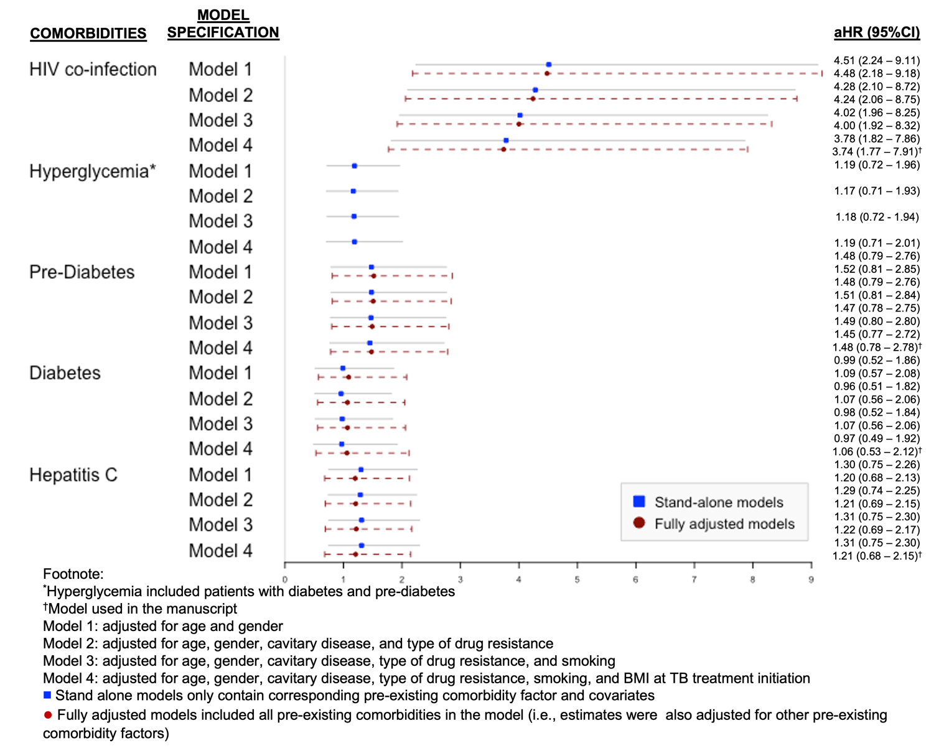

Table S3 All-cause post-tuberculosis mortality rates among persons who initiated treatment for RR or M/XDR TB in Georgia, 2009 – 2017 (N=998)*
Characteristics | All-cause mortality post-tuberculosis treatment
Characteristics | Death/Total (%) | Person time  (Years) | Crude Rates (95%CI)  per 1,000 person-years | Rate Difference (95%CI)  per 1,000 person years | Median time to death post-TB treatment, months (IQR) | Median age at time of death,  years (IQR)
Number of Other Comorbidities†  0  1 – 2  Missing | 60/699 (8.6)  6/52 (11.5)  21/247 (8.5) | 3408  243  1206 | 17.61 (13.67 – 22.67)  24.69 (11.09 – 54.96)  17.41 (11.35 – 26.71) | Reference  7.09 (-13.17, 27.34)  -0.19 (-8.87, 8.49) | 20 (7 – 39)  25 (15 – 28)  28 (7 – 45) | 50 (38 – 63)  58 (50 – 62)  49 (41 – 63)
Other important risk factors
Smoking status  Non-smoker  Smoker  Missing/Unknown | 10/130 (7.7)  37/437 (8.5)  40/431 (9.3) | 620  2127  2110 | 16.13 (8.68 – 29.98)  17.40 (12.60 – 24.01)  18.96 (13.91 – 25.84) | Reference  1.27 (-10.19, 12.73)  2.83 (-8.77, 14.42) | 32 (15 – 43)  22 (10 – 39)  17 (6 – 39) | 57 (53 – 70)  50 (39 – 59)  46 (38 – 64)
Baseline BMI  Underweight (BMI <18.5)  Normal (BMI 18.5 – 24.9)  Overweight/Obese (BMI ≥25.0)  Missing | 16/158 (10.1)  51/633 (8.1)  12/94 (12.8)  8/113 (7.1) | 730  3155  439  533 | 21.92 (13.43 – 35.78)  16.14 (12.29 – 21.27)  27.33 (25.52 – 48.13)  15.01 (7.51 – 30.01) | 5.75 (-5.87, 17.37)  Reference  11.17 (-4.92, 27.26)  -1.16 (-12.46, 10.15) | 20 (5 – 39)  21 (7 – 45)  29 (17 – 36)  7 (4 – 28) | 42 (36 – 73)  50 (39 – 59)  60 (48 – 67)  55 (35 – 64)
*34 individuals who died during treatment were excluded from the post-TB mortality analyses
†Other comorbidities included hepatitis B co-infection, cardiovascular disease, renal disease, ulcer, pancreatitis, and COPD (these were self-reported information and recorded in Georgia’s TB surveillance system). No study participants reported ≥3 other comorbidities.

Abbreviations:
BMI – body mass index; CI – confidence interval; HCV – hepatitis C virus; HIV – human immunodeficiency virus; IQR – interquartile range; TB – tuberculosis

Table S4 Crude and adjusted hazard rate ratios of mortality during and after tuberculosis treatment among persons who initiated treatment for RR or M/XDR TB in Georgia, 2009 – 2017 (N=1,032)
Comorbidities | Study Outcomes
Comorbidities | Tuberculosis mortality during treatment  (n=34) |  | Tuberculosis mortality after treatment  (n=87)
Comorbidities | cHR (95%CI) | aHR* (95%CI) | cHR (95%CI) | aHR* (95%CI)
Number of Other Comorbidities†  0  1 – 2  Missing | Reference  1.13 (0.26 – 4.71)  0.95 (0.43 – 2.11) |  | Reference  1.40 (0.60 – 3.23)  0.99 (0.60 – 1.63)
Smoking status  Non-smoker  Smoker  Missing/Unknown | Reference  0.91 (0.36 – 2.28)  0.51 (0.19 – 1.41) | Reference  0.85 (0.31 – 2.33)  0.46 (0.16 – 1.31) | Reference  1.07 (0.53 – 2.15)  1.15 (0.58 – 2.31) | Reference  1.00 (0.48 – 2.09)  1.34 (0.66 – 2.74)
Baseline BMI  Underweight (BMI <18.5)  Normal (BMI 18.5 – 24.9)  Overweight/Obese (BMI ≥25.0)  Missing | 3.15 (1.48 – 6.73)  Reference  1.35 (0.39 – 4.65)  1.49 (0.49 – 4.48) | 2.87 (0.31 – 2.33)  Reference  1.34 (0.34 – 5.20)  1.36 (0.42 – 4.36) | 1.37 (0.78 – 2.41)  Reference  1.72 (0.92 – 3.23)  0.93 (0.44 – 1.97) | 1.31 (0.72 – 2.38)  Reference  1.20 (0.60 – 2.40)  0.88 (0.40 – 1.95)
*Model was adjusted for HIV-coinfection, diabetes status, HCV co-infection, age, gender, cavitary disease, type of drug resistance, smoking, and BMI at TB treatment initiation (fully-adjusted model)
†Other comorbidities such as cardiovascular disease, renal disease, ulcer, pancreatitis, COPD, silicosis, sarcoidosis were included. No study participants reported ≥3 other comorbidities.

Abbreviations:
aHR – adjusted hazard rate ratios; BMI – body mass index; cHR – crude hazard rate ratios; CI – confidence interval

Bold indicates that the finding is statistically significant at α=0.05

Areas shaded in grey indicate that variables were not included in the final models, and thus, adjusted hazard rate ratios were not obtained.

Table S5 Adjusted hazard rate ratios from stratified competing risks models to assess the association between pre-existing comorbidities and mortality post-tuberculosis treatment according to their final TB treatment outcomes among persons who initiated treatment for RR or M/XDR TB in Georgia, 2009 – 2017 (N=980)#
Pre-existing comorbidities | aHR* (95%CI)
Pre-existing comorbidities | Among those with favorable† treatment outcomes (n=655) | Among those with poor‡ treatment outcomes (n=325)
HIV co-infection
Negative | Reference | Reference
Positive | 3.30 (0.43 – 25.28) | 3.56 (1.66 – 7.65)
Hyperglycemia¶
No | Reference | Reference
Yes | 1.03 (0.42 – 2.50) | 1.05 (0.57 – 1.94)
Diabetes Status
No diabetes | Reference | Reference
Pre-diabetes | 1.10 (0.31 – 3.93) | 1.45 (0.69 – 3.07)
Diabetes | 0.99 (0.35 – 2.80) | 0.78 (0.35 – 1.75)
HCV co-infection
Negative | Reference | Reference
Positive | 2.04 (0.81 – 5.13) | 0.99 (0.49 – 2.01)
#18 patients with missing final TB treatment outcome were excluded
*Model was adjusted for age and gender and estimated with the cause-specific hazard regression with competing risks
†Including patients who were cured or completed the treatment
‡Including 44 patients who failed the treatment, 247 who were lost to follow up, and 34 who died during treatment. Those who died during TB treatment were considered “presented with a competing risk” and were censored when estimating the aHR for post-TB mortality
¶Included individuals with pre-diabetes and diabetes

Abbreviations: aHR – adjusted hazard rate ratios; CI – confidence interval; HCV – hepatitis C virus; HIV – human immunodeficiency virus

Bold indicates that the finding is statistically significant at α=0.05

Notes:
Among those who were successfully treated for TB disease, 9/26 (34.6%, 95%CI 18.4 – 54.1) died during the first year after completing TB treatment. The median time to post-TB death among those who were successfully treated for TB disease was 24 months (IQR 10 – 46) with median age at time of post-TB death of 57 years (IQR 49 – 66). Among those who had poor TB treatment outcomes, 29/59 (49.2%, 95%CI 36.6 – 61.8). The median time to post-TB death among those who had poor TB treatment outcomes was 20 months (IQR 6 – 39) with median age at time of post-TB death of 45 years (IQR 36 – 63).

Table S6 Sensitivity and subgroup analyses to account for potential systematic errors on the association between various comorbidities and all-cause mortality post-tuberculosis among persons who initiated treatment for RR or M/XDR TB in Georgia, 2009 – 2017
No | Various Bias/Sensitivity Analyses | Post-TB treatment Mortality  Measure of Association | Comorbidities | Crude  Estimates | Adjusted  Estimates
1 | Model Specification
1 | Log binomial logistic regression (N=998) | Risk ratios | HIV co-infection | 3.63 (1.99 – 6.61) | 3.12 (1.48 – 6.56)⁺
1 | Log binomial logistic regression (N=998) | Risk ratios | Hyperglycemia† | 1.59 (1.00 – 2.52) | 1.27 (0.76 – 2.14)⁺
1 | Log binomial logistic regression (N=998) | Risk ratios | Prediabetes | 1.49 (0.82 – 2.69) | 1.42 (0.76 – 2.67)⁺
1 | Log binomial logistic regression (N=998) | Risk ratios | Diabetes | 1.70 (0.96 – 3.01) | 1.12 (0.57 – 2.21)⁺
1 | Log binomial logistic regression (N=998) | Risk ratios | HCV co-infection | 1.54 (0.92 – 2.58) | 1.20 (0.67 – 2.14)⁺
3 | Misinformation Bias
3 | Probabilistic (beta distribution) bias analysis to account for plausible non-differential misclassification of hyperglycemia status (1000 iterations) | Median risk ratio  (2.5th – 97.5th percentile) | Systematic Error |  | 1.78 (1.65 – 2.17)
3 |  | Median risk ratio  (2.5th – 97.5th percentile) | Total Error (random+systematic) |  | 1.84 (1.10 – 2.92)
3 | Probabilistic (beta distribution) bias analysis to account for plausible differential misclassification of hyperglycemia status (1000 iterations) | Median risk ratio  (2.5th – 97.5th percentile) | Systematic Error |  | 1.73 (1.21 – 2.37)
3 |  | Median risk ratio  (2.5th – 97.5th percentile) | Total Error (random+systematic) |  | 1.75 (1.01 – 3.00)
4 | Unknown Confounders
4 | Range of plausible true values adjusting for any unknown confounders using the E-value method* | Range of risk ratios | HIV co-infection |  | 0.69 – 2.72
4 |  | Range of risk ratios | Hyperglycemia† |  | 0.30 – 1.19
4 |  | Range of risk ratios | Pre-diabetes |  | 0.28 – 1.12
4 |  | Range of risk ratios | Diabetes |  | 0.32 – 1.28
4 |  | Range of risk ratios | HCV co-infection |  | 0.29 – 1.16
4 | E-value (the magnitude of RR_{EU} and RR_{UD}) to explain away the observed estimates | Min (RR_{EU}, RR_{UD}) | HIV co-infection | ≥ 6.72
4 |  | Min (RR_{EU}, RR_{UD}) | Hyperglycemia† | ≥ 2.56
4 |  | Min (RR_{EU}, RR_{UD}) | Pre-diabetes | ≥ 2.34
4 |  | Min (RR_{EU}, RR_{UD}) | Diabetes | ≥ 2.79
4 |  | Min (RR_{EU}, RR_{UD}) | HCV co-infection | ≥ 2.45
Footnote:
⁺Model adjusted for diabetes status, hepatitis C status, HIV-coinfection age, gender, cavitary disease, type of drug resistance, and smoking (fully-adjusted model)
*Simulated with various combination of RR_{EU} 2.00 – 10.00 and RR_{UD} 2.00 – 10.00 resulting in bias factor of 1.3 – 5.3
†Included individuals with pre-diabetes and diabetes

Abbreviations:
HCV – hepatitis C virus; HIV – human immunodeficiency virus; RR_{EU} – risk ratio estimating the relationship between exposure of interest (i.e., pre-existing comorbidities) and any unknown confounders; RR_{UD} – risk rate ratio estimating the relationship between outcome of interest (i.e., post-TB all-cause mortality) and any unknown confounders

Bold indicates that the finding is statistically significant at α=0.05

