Supplementary figures

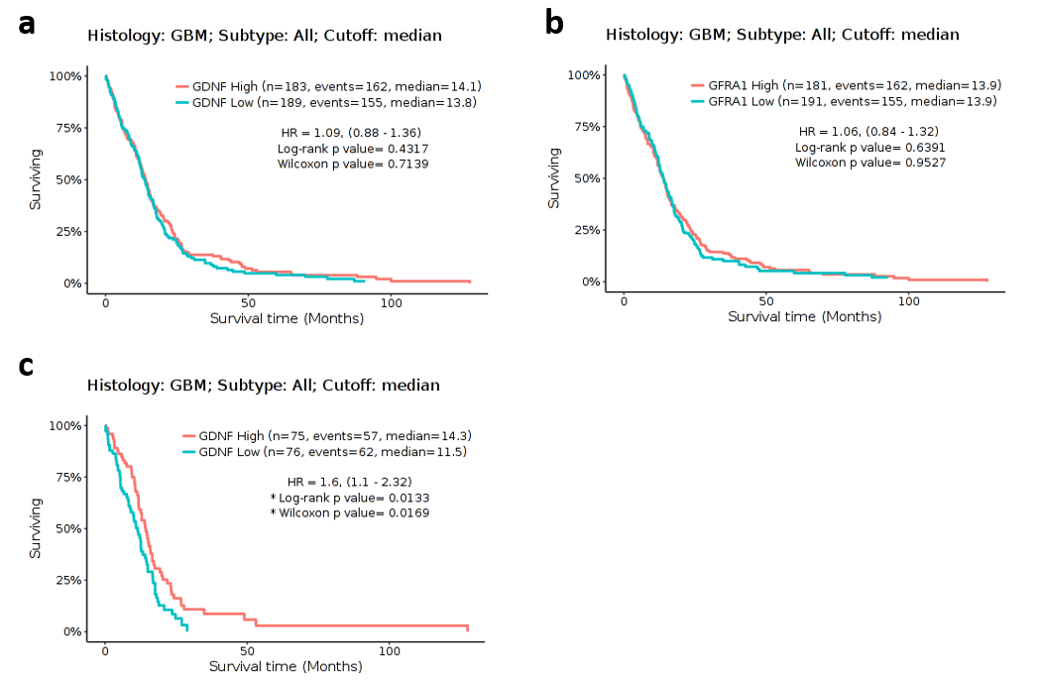
Supplementary figure 1. High GDNF and GFRA1 expression are not associated with increased survival in IDH wildtype GBM, but high GDNF expression confers a survival advantage in MGMT unmethylated IDH WT GBM. (a) Kaplan-Meier survival curves based on TGCA data showing (a) no significant overall survival difference between GDNF-high and GDNF-low IDH WT GBM groups. (b) no significant overall survival difference between GFRA1-high and GFRA1-low IDH WT GBM groups. (c) a significant overall survival difference between GDNF-high and GDNF-low MGMT unmethylated IDH WT GBM groups. * = p≤0.05, with Log-rank K and Wilcoxon tests.

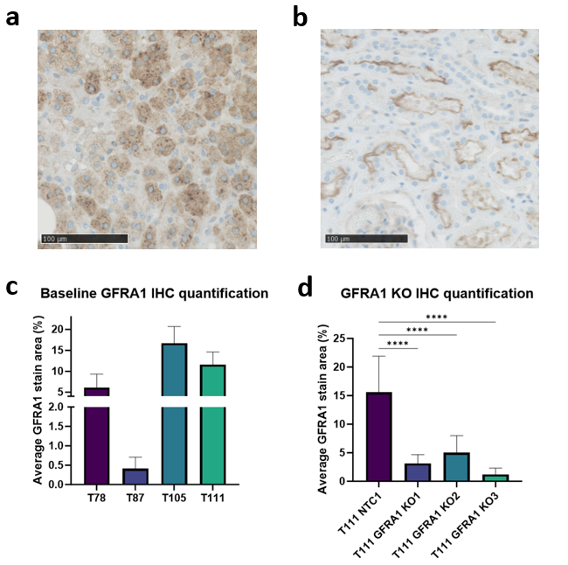

Supplementary figure 2: IHC quantifications of GFRA1 stainings (a) Immunohistochemical (IHC) GFRA1 control staining of adrenal gland tissue. Nuclei counter stained with hematoxylin. Scale bar: 100 µm. (b) Immunohistochemical (IHC) GFRA1 control staining of renal tubuli tissue Nuclei counter stained with hematoxylin. Scale bar: 100 μm. (c) Quantification of the immunohistochemical (IHC) staining of 3D spheroid sections reveals varying expression of GFRA1 across four patient-derived glioblastoma spheroid cultures. (n=12, mean ± SD). (d) Quantification of IHC stainings of 3D spheroid sections reveal statistically significant lower expressions of GFRA1 in the T111 KO cell lines, compared to the GFRA1 expressing NTC1 cell lines. (n=12, mean ± SD). Statistical analysis with one-way ANOVA: * = p ≤ 0,05, ** = p ≤ 0,01, *** = p ≤ 0,001, **** = p ≤ 0,0001.

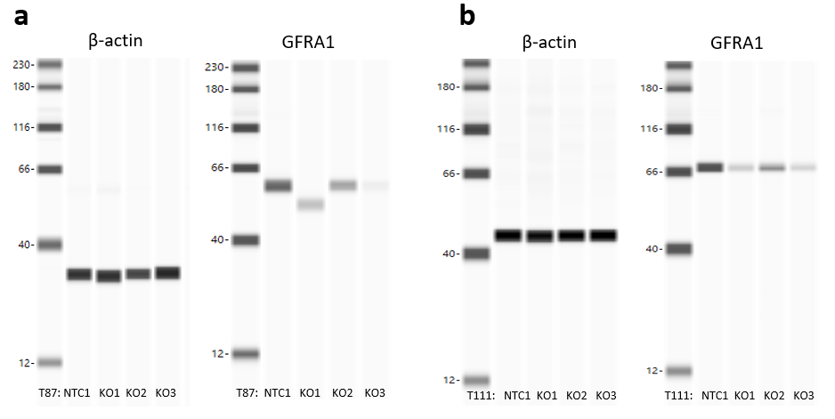
Supplementary figure 3. Western Blot JESS results showing decreased GFRA1 expression in the KO spheroid cell lines. (a) The JESS Biotechne systems does not run the Western Blot assay as a full gel but as multiple individual capillaries. Each capillary corresponds to a sample, the first panel of four capillaries show the β-actin loading control for T87 NTC1, T87 GFRA1 KO1, T87 GFRA1 KO2 and T87 GFRA1 KO3 from left to right. The second panel shows GFRA1 expression in these same samples. (b) The first panel of four capillaries show the β-actin loading control for T111 NTC1, T111 GFRA1 KO1, T111 GFRA1 KO2 and T111 GFRA1 KO3 from left to right. The second panel shows GFRA1 expression in these same samples.

