Early Predictive Values of Clinical Assessments for ARDS Mortality: A Machine-Learning Approach
Ning Ding, MD, PhD^{1,2,*}; Tanmay Nath, PhD^{3,*}; Mahendra Damarla, MD⁴; Li Gao, MD, PhD^{1,#}; and Paul M. Hassoun, MD^{4,#}
¹Division of Allergy and Clinical Immunology, Johns Hopkins University School of Medicine, Baltimore, MD, USA; ²Department of Pulmonary and Critical Care Medicine, The First Affiliated Hospital of Nanjing Medical University, Nanjing, China; ³Department of Biostatistics, Bloomberg School of Public Health, Johns Hopkins University, Baltimore, MD, USA; ⁴Division of Pulmonary and Critical Care Medicine, Johns Hopkins University School of Medicine, Baltimore, MD, USA
*Equal contribution first author
#Co-corresponding authors

Online Data Supplement

Table of contents

Page | Content
1 ……………………………… | Title page
2-6 ……………………………… | Supplementary method
7 ……………………………… | Supplementary table S1
8 ……………………………… | Supplementary table S2
9-10 …………………………… | Supplementary table S3
11 ……………………………… | Supplementary table S4 (A)
12 ……………………………… | Supplementary table S4 (B)
13 …………………………….. | Supplementary figure S1
14 …………………………….. | Supplementary figure S2
15 …………………………….. | Supplementary figure S3
16 …………………………….. Supplementary figure S4
17 …………………………….. | Supplementary figure S5
18 …………………………….. | Supplementary figure S6

Supplementary Methods
Institutional Review Board (IRB) Approval
This study was approved by the Johns Hopkins University Institutional Review Board (approval number: NA_00034898) and all patients gave informed consent at the time of enrollment. All analysis procedures were followed in accordance with the ethical standards of institutional IRB on human experimentation and with the Helsinki Declaration of 1975.
Clinical Data and Variables Selection
During the FACTT trial, clinical parameters were assessed and recorded daily from 4:00-10:00 am using the values closest to 8:00 am on days 1-7. First, we selected 29 parameters based on published studies as well as analysis of ARDS patients enrolled in the FACTT study as potential clinical predictors of 60-day mortality. The 29 clinical parameters were in 5 major categories including (1) baseline characteristics: age, sex and cause of ARDS (trauma, sepsis, multiple transfusion, aspiration, pneumonia, other cause); (2) vital signs and circulatory: heart rate, body temperature, respiratory rate, mean atrial pressure, and vasopressor use; (3) respiratory and ventilatory: FiO₂, PaCO₂, PaO₂, PaO₂/FiO₂, SpO₂, positive end-expiratory pressure (PEEP), peak pressure, plateau pressure and mean airway pressure; (4) blood and coagulation: potassium, sodium, chloride, hemoglobin, glucose, total protein, albumin and platelets; (5) metabolism and renal: bicarbonate, arterial pH, blood urea nitrogen (BUN) and creatinine. Of note, the lowest value of day 0 or day 3 for platelets was utilized instead of the value closest to 8:00 am. We also excluded the following clinical parameters: (1) parameters closely related to fluid strategy (fluid intake last 24h, fluid output last 24h, central venous pressure, pulmonary artery pressure, pulmonary artery occlusion pressure, and cardiac output index); and (2) parameters with data missing rate greater than 30% (tidal volume, bilirubin). Second, we conducted multivariate binary logistic regression (backward) in day 0 and day 3 data separately to select clinical variables as independent predictors for 60-day mortality. Only seven clinical variables (age, sex, cause of ARDS (pneumonia), heart rate, vasopressor use, FiO2 and BUN) from day 0 were selected as independent predictors of 60-day mortality from 29 clinical parameters. In contrast, nine clinical variables (age, sex, cause of ARDS [pneumonia], bicarbonate, glucose, albumin, mean airway pressure, heart rate and platelet count) from day 3 were selected as independent predictors of 60-day mortality from 29 clinical parameters. Last, we performed the ROC analysis with selected clinical predictors. The AUC value generated from day 3 outperformed that from day 0 (0.810 vs. 0.727). Thus, we have chosen to employ the 9 clinical predictors selected from day 3 for the predictive ML modeling.
Statistical Analysis of MAP

A general linear model with repeated measures was utilized to evaluate the trend over time of MAP at baseline, days 1 through 3. The assumption of sphericity was assessed using the Mauchly’s test, and the Greenhouse-Geisser correction was applied to correct deviations from the assumption. The group-by-time interaction term was tested first. If significant, between-group (survivor and non-survivor) differences at each time point were examined. Then within-group changes over time (trend) were tested in both survivor and non-survivor groups independently, with Bonferroni correction applied.
Machine Learning Model Building and Evaluation

We selected 700 patients (after excluding patients with missing information) and converted the raw data into a structured data frame, which was fed into the various machine learning models. In order to train the machine learning model, we randomly split the entire dataset into 70% training and 30% testing dataset. The training set contains a set of known outputs and the algorithm learns on this dataset such that it can generalize on the other dataset. During training, the algorithm never runs on the testing dataset. This is the reason the testing dataset is used to test how well the algorithm generalizes on a new dataset. In this study, we used 6 typically used supervised machine learning algorithms: Random Forest, XGBoost, Support vector classifier (SVC), Logistic regression, Multi-layer perceptron (MLP) and Stacking regression for classifying survivors and non-survivors. We designed the stacking regression model by combining the output of Random Forest, XGBoost and Support vector regression and used Logistic regression to compute the final prediction. Each algorithm needs a set of parameters whose values have to be defined before the algorithms starts learning. These parameters are called as hyper-parameters. The hyper-parameters of each of the machine-learning model were tuned using 5-fold cross validation grid search. Grid search based is a widely used strategy for model selection which allows the researcher to exhaustively search over the specified grid of parameter values. In order to avoid over-fitting which is a situation where the algorithm fails to predict anything informative on an unseen dataset, we performed a 5-fold cross validation on the training dataset on each model to evaluate their cross-validation performance. A k-fold cross-validation strategy (in our case, k = 5) is an approach where the training dataset is split into k smaller sets. For each fold, the algorithm is trained on the k - 1 of the k-folds and the remaining set is used as validation. Finally, we tested our model on the testing dataset to compute a confusion matrix for each model. By definition, a confusion matrix $C$ is such that $C_{ij}$ is equal to the number of observations known to be in group i but predicted to be in group j. Confusion matrix can be summarized using precision, sensitivity/recall and F1 score. Precision is a ratio of the number of true positives to the sum of true positives and false positives. Thus, it describes how good a model is in predicting at positive class. Similarly, sensitivity or recall is a ratio of number of true positives to the sum of true positive and false negative, which attempts to answer what proportion of actual positive were correctly identified. Together, F1 score is a weighted average of precision and sensitivity/recall (https://scikit-learn.org/stable/modules/generated/sklearn.metrics.f1_score.html). We plotted the calibration curve of the models for predicting survival utilizing the sigmoid regressor based on Platt’s logistic model. Our analysis was conducted in python version 3.6 (https://www.python.org) using the library Scikit Learn¹.
Method for Determining Feature Importance
Feature importance is the average of reduction in impurity index over all trees when a particular feature is used at split point¹, we measured feature rankings by using the ‘gini impurity or mean decrease in impurity’ metric in Random Forest (RF). RF is a set of decision trees i.e. at every node, it tries to make a binary decision. Each decision tree is a set of nodes and their corresponding leaves. For classification tasks, the features for internal nodes are selected using gini impurity also known as information gain. The features with the highest decrease in the gini impurity are chosen for internal nodes. Finally, we average across all the nodes to measure the feature importance.
Supplementary Results
Changes of MAP Over Time
The Mauchly's test showed the sphericity assumption of equality was rejected: (P<0.001). The interaction term between groups (survivors and non-survivors) and time indicated significant interaction effects: (F=11.67, P<0.001), thus we further examined the effects of group status and time separately. For between-group differences at each time point, there was no significant difference between survivors and non-survivors at day 0 (15.86±5.14 vs. 16.32±5.73, P=0.597). But from day 1 to day 3, survivors' MAP was much lower than non-survivors (day 1: 16.38±5.52 vs. 15.19±4.67, P<0.01, day 2: 16.47±5.57 vs. 14.33±5.03, P<0.001; and day 3: 16.24±5.83 vs. 13.09±4.48, P<0.001). Furthermore, we assessed changes of MAP over time. Over the course of the three-day follow-up, the trend of MAP among survivors decreased progressively, with day 3 seeing the lowest values (P<0.001). When comparing the MAP between the individual time points, significant differences were found (all Ps<0.001, with the exception of P<0.02 for the comparison between day 1 and day 0; Bonferroni corrections were applied). In contrast, the trend of MAP in non-survivors did not change over time (P=0.926).

References:
E1. Pedregosa F, Varoquaux Ge, Gramfort A, et al. Scikit-learn: Machine Learning in Python. Journal of Machine Learning Research 2011;12:2825-30.

Supplementary table S1. Multivariate binary logistic regression (backward elimination) results of day 3 for predicting 60-day mortality
Predictors | Multivariate (Backward)
Predictors | Adjusted β | 95% CI | P value
Age (yr) | 1.043 | 1.024-1.061 | <0.001
Sex: Male, n (%) | 0.508 | 0.298-0.866 | 0.013
Cause of ARDS (Pneumonia) | 2.429 | 1.304-4.523 | 0.005
Heart rate (bpm) | 1.017 | 1.003-1.031 | 0.015
Mean airway pressure (cmH2O) | 1.094 | 1.032-1.159 | 0.002
Blood glucose (mg/dl) | 1.005 | 1-1.010 | 0.031
Albumin (g/dl) | 0.608 | 0.375-0.984 | 0.043
Platelet count (10⁹/L) | 0.996 | 0.994-0.999 | 0.003
Bicarbonate (mmol/L) | 0.905 | 0.852-0.962 | 0.001

Definition of abbreviations: ARDS = acute respiratory distress syndrome. Age, sex, cause of ARDS (pneumonia), bicarbonate, glucose, albumin, mean airway pressure, heart rate and platelet count were selected as independent predictors of 60-day mortality from 29 clinical parameters.

Supplementary table S2. Comparison of the nine clinical parameters between the training and testing groups at day 0 and day 3

Clinical parameters | Day 0 |  |  | Day 3
 | Training (n=490) | Testing (n=210) | P value | Training (n=415) | Testing (n=178) | P value
Age (yr) | 49.68±0.74 | 50.02±1.11 | 0.687 | 49.32±0.78 | 49.55±1.26 | 0.872
Sex: Male, n (%) | 254 (51.8) | 113 (53.8) | 0.632 | 216 (52) | 91 (51.1) | 0.836
Pneumonia | 323 (65.9) | 135 (64.3) | 0.677 | 273 (65.8) | 114 (64) | 0.684
Heart rate (bpm) | 101.21±0.94 | 102.52±1.53 | 0.455 | 94.83±1 | 95.34±1.54 | 0.780
Mean airway pressure (cmH₂O) | 15.65±0.28 | 15.53±0.4 | 0.811 | 14.01±0.3 | 14.75±0.74 | 0.270
Blood glucose (mg/dl) | 137.06±2.42 | 142.84±6.93 | 0.432 | 139.7±2.91 | 146.71±4.28 | 0.182
Albumin (g/dl) | 2.19±0.03 | 2.2±0.05 | 0.902 | 2.09±0.03 | 2.2±0.05 | 0.074
Platelet count (10⁹/L) | 195.55±5.66 | 233.96±42.97 | 0.193 | 194.41±6.67 | 191.55±10.06 | 0.813
Bicarbonate (mmol/L) | 21.99±0.23 | 22.18±0.35 | 0.674 | 26.58±0.32 | 26.71±0.46 | 0.814

There were no significant differences between the training and testing groups (raw data without imputation) at either day 0 or day 3.
Continuous variables with normal distribution are presented as means ± SE and compared by the Student’s t-test. Continuous variables with non-normal distributions are presented as medians and interquartile ranges and compared by the Mann-Whitney test. Categorical variables are compared by the chi-square test with normal approximation or Fisher’s exact test, as appropriate.

Supplementary table S3. Demographics and clinical characteristics of ARDS patients as a function of mean airway pressure (MAP) at day 0 and day 3
Clinical parameters | Day 0 |  |  | Day 3
Clinical parameters | MAP_{high} (n=357) | MAP_{low} (n=353) | P value | MAP_{high} (n=357) | MAP_{low} (n=353) | P value
Age (yr) § | 48.84±0.82 | 49.23±0.86 | 0.742
Sex: Male, n (%) § | 198 (55.5) | 182 (51.6) | 0.297
Cause of ARDS, n (%)
Pneumonia § | 251 (70.3) | 222 (62.9) | 0.036
Sepsis | 163 (45.7) | 149 (42.2) | 0.355
Aspiration | 47 (13.2) | 89 (25.2) | <0.001
Trauma | 27 (7.6) | 31 (8.8) | 0.553
Multiple transfusion | 9 (2.5) | 10 (2.8) | 0.821
Other | 23 (6.4) | 30 (8.5) | 0.297
Mortality (60-day survival), n (%) | 235 (65.8) | 288 (81.6) | <0.001
Fluid strategy, n (%) |  |  | 0.013
Liberal | 204 (57.1) | 169 (47.6)
Conservative | 153 (42.9) | 184 (52.1)
Vital signs and circulatory
Respiratory rate (bpm) | 26.85±0.39 | 24.58±0.41 | <0.001 | 30.62±0.36 | 24.59±0.37 | <0.001
Heart rate (bpm) § | 103.92±1.02 | 102.03±1.15 | 0.220 | 96.20±1.03 | 93.74±1.03 | 0.092
Body temperature (℃) | 37.53±0.06 | 37.51±0.05 | 0.857 | 37.36±0.05 | 37.45±0.05 | 0.184
Mean arterial pressure (mm Hg) | 74.48±0.71 | 78.34±0.75 | <0.001 | 77.63±0.72 | 83.15±0.71 | <0.001
Respiratory
FiO₂ | 0.72±0.01 | 0.61±0.01 | <0.001 | 0.61±0.01 | 0.42±0.01 | <0.001
PaO₂ (mm Hg) | 86.12±1.96 | 93.38±2.63 | 0.027 | 79.11±1.39 | 85.17±1.58 | 0.004
PaCO₂ (mm Hg) | 40.72±0.51 | 40.64±0.61 | 0.992 | 46.42±0.72 | 42.04±0.55 | <0.001
P/F ratio (mm Hg) | 129.16±3.31 | 162.08±3.82 | <0.001 | 141.27±3.51 | 212.68±4.54 | <0.001
SpO₂ | 93.96±0.26 | 95.23±0.21 | <0.001 | 93.61±0.24 | 95.11±0.17 | <0.001
Mechanical ventilation
PEEP (cm H₂O) | 10.90±0.22 | 8.74±0.20 | <0.001 | 10.58±0.18 | 6.08±0.10 | <0.001
Peak (cm H₂O) | 34.61±0.51 | 30.65±0.46 | <0.001 | 34.63±0.43 | 25.70±0.41 | <0.001
Plateau pressure (cm H₂O) | 28.84±0.47 | 24.52±0.38 | <0.001 | 27.43±0.35 | 19.78±0.28 | <0.001
Mean airway pressure (cm H₂O) § | 17.61±0.31 | 14.18±0.26 | <0.001 | 18.25±0.31 | 9.93±0.11 | <0.001
Blood and coagulation
Potassium (mmol/L) | 4.04±0.03 | 3.97±0.04 | 0.152 | 3.97±0.03 | 3.78±0.03 | <0.001
Sodium (mmol/L) | 138.82±0.30 | 139.08±0.27 | 0.531 | 140.97±0.34 | 141.43±0.29 | 0.304
Chlorine (mmol/L) | 107.89±0.38 | 107.87±0.36 | 0.968 | 106.84±0.40 | 106.28±0.41 | 0.328
Blood glucose (mg/dl) § | 137.54±3.49 | 139.77±3.22 | 0.638 | 144.36±3.21 | 137.68±2.89 | 0.122
Hemoglobin (g/L) | 10.33±0.10 | 10.45±0.10 | 0.371 | 9.75±0.08 | 9.99±0.09 | 0.40
Platelet count (10⁹/L) § | 196.37±6.52 | 200.19±6.67 | 0.682 | 176.56±6.30 | 202.71±7.35 | 0.007
Total protein | 5.01±0.06 | 5.03±0.06 | 0.775 | 4.97±0.06 | 5.18±0.06 | 0.009
Albumin (g/dl) § | 2.10±0.03 | 2.27±0.04 | <0.001 | 1.94±0.03 | 2.15±0.03 | <0.001
Metabolism and renal
Bicarbonate (mmol/L) § | 21.89±0.27 | 22.53±0.28 | 0.097 | 25.82±0.35 | 26.65±0.32 | 0.079
Arterial pH | 7.34±0.005 | 7.37±0.005 | 0.003 | 7.36±0.005 | 7.42±0.004 | <0.001
BUN (mg/dl) | 24.64±0.96 | 23.53±1.00 | 0.424 | 31.94±1.22 | 27.86±1.51 | 0.015
Creatinine (mg/dl) | 1.31±0.05 | 1.22±0.04 | 0.161 | 1.54±0.06 | 1.28±0.06 | 0.004
Definition of abbreviations: ARDS = acute respiratory distress syndrome; PaO₂: partial pressure of oxygen; PaCO₂: partial pressure of carbon dioxide; P/F = PaO₂/FiO₂; SpO₂=pulse oxygen saturation; PEEP = positive end expiratory pressure; peak = peak inspiratory pressure; BUN = blood urea nitrogen.
§ Parameters selected for machine learning.
Patients were dichotomized into MAP_{high} and MAP_{low} subgroups based on their MAP levels using a median split (MAP <14 cm H₂O or ≥14 cm H₂O). Independent-Samples T test was used for continuous variables normally distributed (presented as mean ± standard error). Chi-square test was used for categorical variables (presented as n (%)). Significant P values (P<0.05) were italicized.

Supplementary table S4. The efficacy (precision, sensitivity and F1 score) of six machine-learning classifiers in the training (A) and testing (B) sets (using imputed data)
- In the training set
 |  | Predictive values for survivors  (Day 0=498, Day 3=516) |  |  | Predictive values for non-survivors  (Day 0=202, Day 3=158)
Datasets | Models | Precision  (95% CI) | Sensitivity  ((95% CI) | F1 score  (95% CI) | Precision  (95% CI) | Sensitivity (95% CI) | F1 score  (95% CI)
Day 0  (n=700) | RF | 0.85 (0.83, 0.88) | 0.98 (0.98, 1.0) | 0.91 (0.91, 0.93) | 0.96 (0.93, 0.99) | 0.59 (0.54, 0.66) | 0.73 (0.69, 0.78)
Day 0  (n=700) | XGBoost | 0.87 (0.86, 0.9) | 0.98 (0.98, 0.99) | 0.92 (0.92, 0.94) | 0.95 (0.92, 0.98) | 0.66 (0.61, 0.72) | 0.78 (0.74, 0.82)
Day 0  (n=700) | LR | 0.76 (0.74, 0.79) | 0.94 (0.93, 0.97) | 0.84 (0.83, 0.87) | 0.69 (0.61, 0.78) | 0.28 (0.23, 0.33) | 0.40 (0.34, 0.46)
Day 0  (n=700) | SVM | 0.94 (0.93, 0.97) | 0.98 (0.98, 1.0) | 0.96 (0.96, 0.98) | 0.97 (0.95, 0.99) | 0.87 (0.83, 0.91) | 0.91 (0.89, 0.94)
Day 0  (n=700) | MLP | 0.79 (0.76, 0.82) | 0.85 (0.83, 0.88) | 0.82 (0.8, 0.85) | 0.56 (0.5, 0.63) | 0.44 (0.39, 0.5) | 0.49 (0.44, 0.55)
Day 0  (n=700) | SC | 0.81 (0.79, 0.84) | 0.99 (0.99, 1.0) | 0.89 (0.88, 0.91) | 0.98 (0.97, 1.0) | 0.45 (0.39, 0.51) | 0.61 (0.56, 0.67)
Day 3  (n=674) | RF | 0.90 (0.88, 0.92) | 0.99 (0.98, 1.0) | 0.94 (0.93, 0.96) | 0.95 (0.92, 0.98) | 0.65 (0.6, 0.72) | 0.77 (0.73, 0.82)
Day 3  (n=674) | XGBoost | 0.87 (0.85, 0.89) | 0.95 (0.94, 0.97) | 0.91 (0.9, 0.93) | 0.78 (0.72, 0.85) | 0.53 (0.47, 0.6) | 0.63 (0.58, 0.69)
Day 3  (n=674) | LR | 0.83 (0.81, 0.86) | 0.95 (0.94, 0.97) | 0.89 (0.87, 0.91) | 0.72 (0.64, 0.8) | 0.39 (0.33, 0.46) | 0.50 (0.44, 0.57)
Day 3  (n=674) | SVM | 0.89 (0.87, 0.92) | 0.97 (0.97, 0.99) | 0.93 (0.92, 0.95) | 0.89 (0.84, 0.94) | 0.62 (0.57, 0.69) | 0.73 (0.69, 0.78)
Day 3  (n=674) | MLP | 0.86 (0.84, 0.89) | 0.92 (0.9, 0.94) | 0.89 (0.87, 0.91) | 0.66 (0.6, 0.74) | 0.51 (0.45, 0.59) | 0.58 (0.52, 0.64)
Day 3  (n=674) | SC | 0.89 (0.87, 0.92) | 0.98 (0.98, 1.0) | 0.93 (0.93, 0.95) | 0.94 (0.9, 0.98) | 0.62 (0.56, 0.68) | 0.74 (0.7, 0.8)

- In the testing set

 |  | Predictive values for survivors  (n, Day 0=233, Day 3=215) |  |  | Predictive values for non-survivors  (n, Day 0=67, Day 3=74)
Datasets | Models | Precision  (95% CI) | Sensitivity (95% CI) | F1 score  (95% CI) | Precision  (95% CI) | Sensitivity (95% CI) | F1 score  (95% CI)
Day 0  (n=300) | RF | 0.81 (0.78, 0.85) | 0.91 (0.88, 0.94) | 0.86 (0.83, 0.89) | 0.47 (0.34, 0.61) | 0.28 (0.19, 0.38) | 0.35 (0.25, 0.45)
Day 0  (n=300) | XGBoost | 0.80 (0.77, 0.85) | 0.87 (0.83, 0.9) | 0.83 (0.81, 0.87) | 0.38 (0.27, 0.5) | 0.28 (0.19, 0.38) | 0.32 (0.23, 0.42)
Day 0  (n=300) | LR | 0.80 (0.77, 0.85) | 0.93 (0.9, 0.95) | 0.86 (0.84, 0.89) | 0.48 (0.34, 0.63) | 0.23 (0.16, 0.33) | 0.32 (0.22, 0.42)
Day 0  (n=300) | SVM | 0.78 (0.74, 0.83) | 0.75 (0.7, 0.79) | 0.76 (0.73, 0.8) | 0.25 (0.18, 0.33) | 0.29 (0.21, 0.39) | 0.27 (0.19, 0.35)
Day 0  (n=300) | MLP | 0.84 (0.81, 0.89) | 0.8 (0.76, 0.85) | 0.82 (0.79, 0.85) | 0.41 (0.33, 0.51) | 0.49 (0.39, 0.59) | 0.45 (0.36, 0.53)
Day 0  (n=300) | SC | 0.79 (0.76, 0.84) | 0.95 (0.93, 0.97) | 0.86 (0.84, 0.89) | 0.5 (0.32, 0.68) | 0.16 (0.09, 0.24) | 0.24 (0.14, 0.34)
Day 3  (n=289) | RF | 0.82 (0.78, 0.86) | 0.95 (0.93, 0.98) | 0.88 (0.86, 0.91) | 0.76 (0.65, 0.88) | 0.39 (0.3, 0.49) | 0.51 (0.42, 0.61)
Day 3  (n=289) | XGBoost | 0.82 (0.78, 0.86) | 0.93 (0.91, 0.97) | 0.87 (0.85, 0.9) | 0.69 (0.58, 0.82) | 0.40 (0.31, 0.5) | 0.51 (0.42, 0.6)
Day 3  (n=289) | LR | 0.80 (0.77, 0.85) | 0.95 (0.93, 0.98) | 0.87 (0.85, 0.9) | 0.73 (0.61, 0.86) | 0.33 (0.25, 0.43) | 0.46 (0.36, 0.56)
Day 3  (n=289) | SVM | 0.78 (0.74, 0.82) | 0.92 (0.9, 0.95) | 0.84 (0.82, 0.88) | 0.54 (0.4, 0.69) | 0.25 (0.17, 0.34) | 0.34 (0.25, 0.44)
Day 3  (n=289) | MLP | 0.81 (0.78, 0.86) | 0.93 (0.9, 0.96) | 0.87 (0.84, 0.9) | 0.66 (0.55, 0.78) | 0.40 (0.31, 0.5) | 0.50 (0.41, 0.59)
Day 3  (n=289) | SC | 0.82 (0.78, 0.86) | 0.95 (0.93, 0.98) | 0.88 (0.86, 0.91) | 0.76 (0.65, 0.88) | 0.40 (0.31, 0.5) | 0.53 (0.43, 0.62)
Missing data was imputed using an iterative multivariate imputation technique. RF: random forest, LR: logistic regression, SVM: support vector machine, MLP: multi-layer perceptron, SC: stacking classifier. 95% CI: 95% confidence interval.

Supplementary figure S1. Overview of confusion matrix. Using the confusion matrix, we determined the accuracy, sensitivity (recall), specificity, precision and F1-score (harmonic mean of recall and precision). F1-score = 2 x (precision * recall) / (precision + recall)
Definition of abbreviations: TP = true positive; FP = false positive; TN = true negative; FN = false negative.
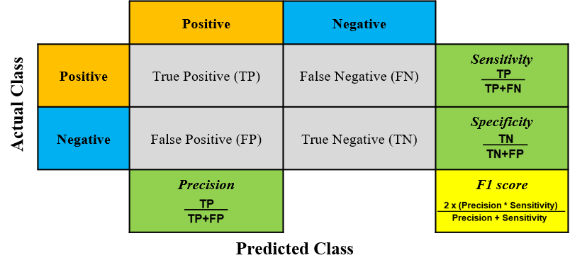

Supplementary figure S2. Comparison of the repeated assessments of mean airway pressure (MAP) between survivors and non-survivors throughout the first three days following the onset of ARDS. *P<0.01; **P<0.001. Error bars: 95% CI.
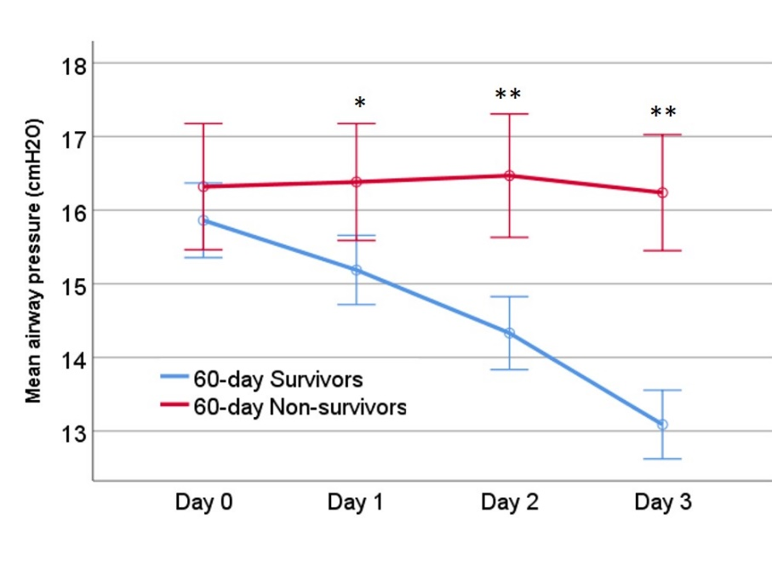

Supplementary figure S3. Confusion matrix for testing sets at day 0 (panel A) and day 3 (panel B). Missing data was imputed using an iterative multivariate imputation technique.
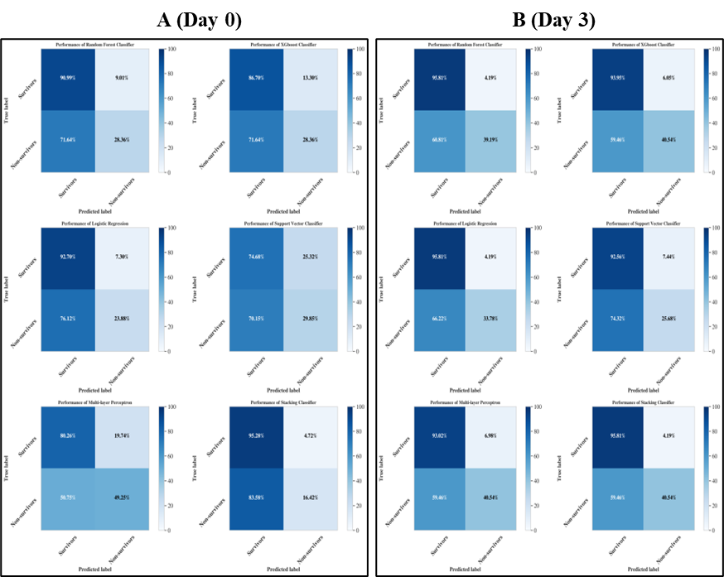

Supplementary figure S4. Calibration curves for the models for predicting survival probability in the testing sets (imputed data) at baseline (A) and day 3 (B).
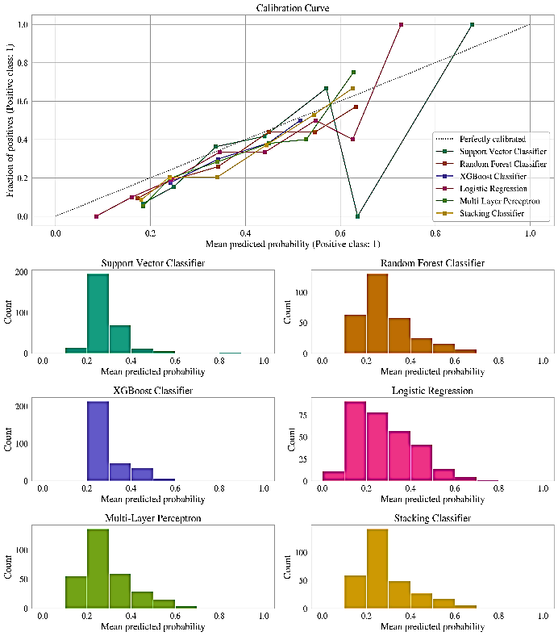
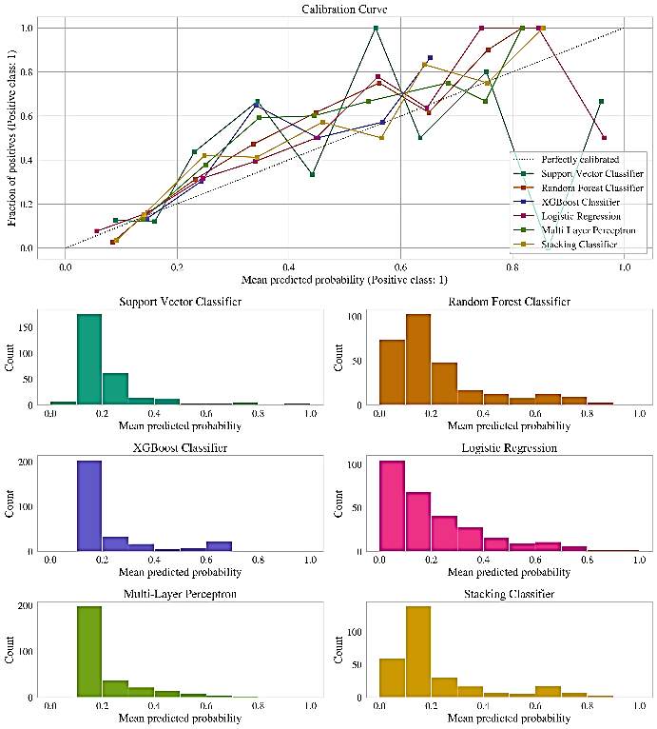
A
B

Supplementary figure S5. Importance of clinical features in the training dataset according to the estimated probability of 60-day mortality in Random Forest models. Normalized values for each single attribute (in a range of 0-100, the most important predictor variable was assigned with the value of 100) were illustrated as relative ranked features (from high to low). The training datasets from day 0 (n=490, Panel A) and day 3 (n=415, Panel B) without imputation were applied.
Definition of abbreviations: ROC = receiver operating characteristics, AUC= area under the curve.
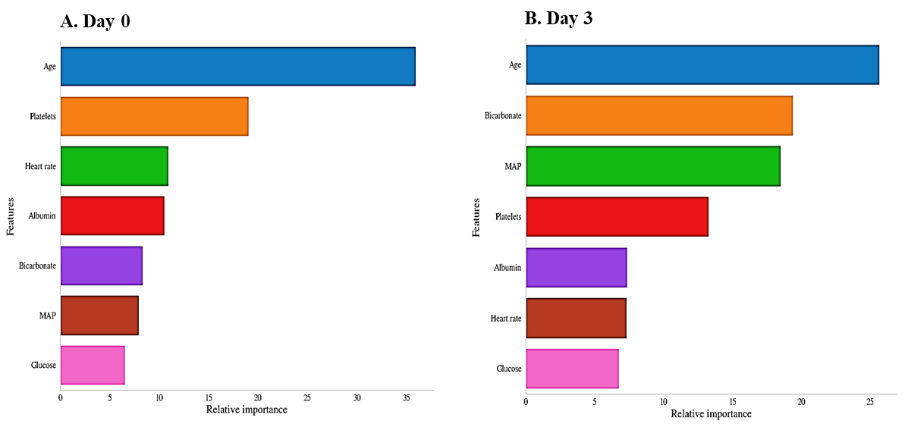
Supplementary figure S6. Screen shot of the ARDS mortality ‘calculator’. The input data (collected at day 3 after ARDS onset) was from a patient who died from ARDS in the FACTT cohort and the predicted survival rate for this patient was 31.53%.
