(a)
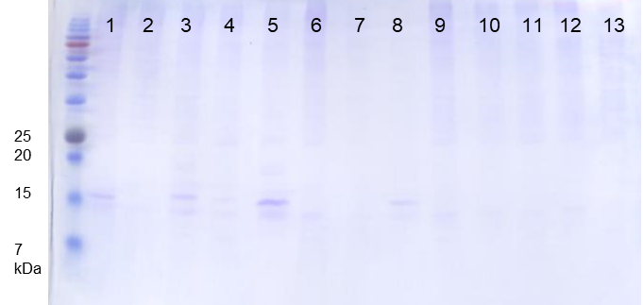
(b)
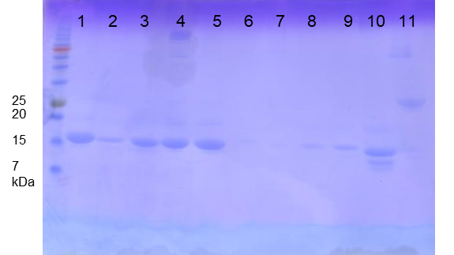
(c)
Clone # | T_{m} (ºC) | Clone # | T_{m} (ºC)
(a)-1 | 49.7 | (b)-1 | 67.7
(a)-3 | Not detected | (b)-2 | 61.1
(a)-4 | Not detected | (b)-3 | 64.0
(a)-5 | Not detected | (b)-4 | 62.0
(a)-8 | Not detected | (b)-5 | 60.0
 |  | (b)-8 | 58.7
 |  | (b)-9 | 60.7
 |  | (b)-10 | 60.0

Supplementary Figure S1. Purification yield and thermal stability of clones before and after 8 rounds of panning against protein A with thermal challenge.
(a) Random sdAb clones from pre-panning FR2 randomized library was purified from 20 mL culture, purified by Ni-NTA, and 10 µL of the purified proteins were analyzed by SDS-PAGE. (b) Ni-NTA purified sdAbs from 8th panning round were analyzed by SDS-PAGE under the same condition as (a). (c) T_{m} values of the sdAbs. Clone #’s are indicated in SDS-PAGE images in (a) and (b). Four clones from the pre-panning library did not exhibit a discrete melting transition, and T_{m} value could not be detected.

(a)
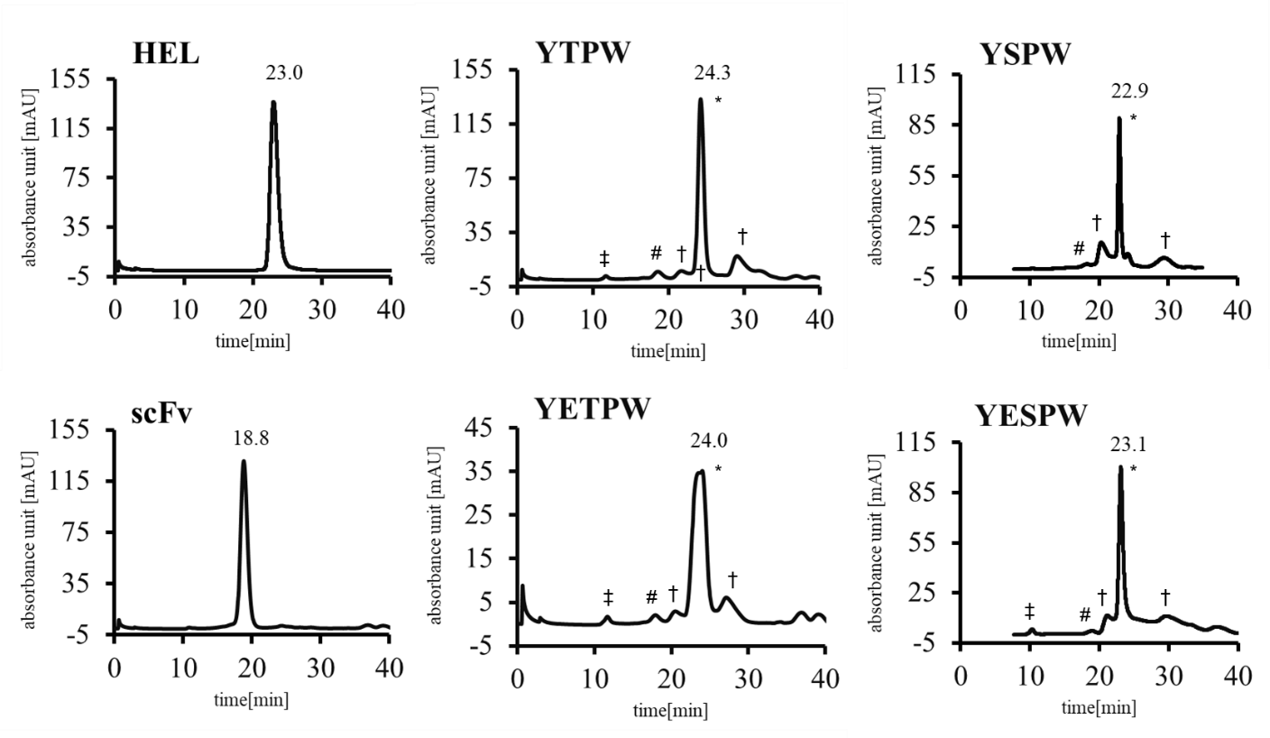
(b)
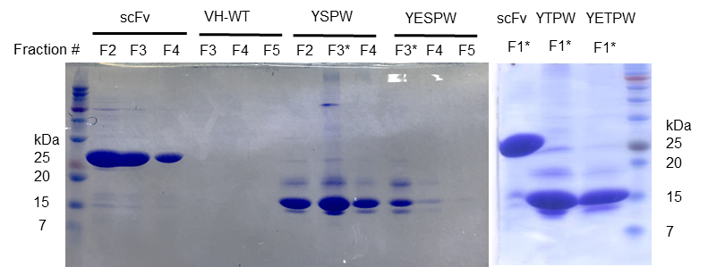
(c)
VH variants | % Monomer
HEL | 92.84
scFv | 83.3
YTPW | 85.33
YSPW | 69.21
YETPW | 88.42
YESPW | 84.12

Supplementary Figure S2. SEC analysis of YQSPW, YESPW, YQTPW, and YETPW variants.
(a) Size exclusion chromatograms for FR2 variants of human VH3-23. The retention time [(min]) of each VH variant is indicated above the peak. Peaks for monomer (*), dimer (#), putative impurities/degradation products (†), and aggregation (‡) are indicated. HEL (14.4 kDa) and scFv (~27 kDa) were used as molecular weight standards. (b) SDS-PAGE of Ni-NTA-purified VH variants and scFv. Fractions analyzed by SEC are marked with an asterisk (*). (c) Monomer percentage estimated from the chromatograms. Peaks eluted at ~21 min are likely to be impurities, therefore “% monomer” should be interpreted as minimum estimated values.

(a)
CDR1: ³¹(DGNS)-(DY)-(DA)-M-(DH)³⁵
CDR2: ⁵⁰(AGLSVW)-I-(SY)-(HPSY)-(DGNS)-(DGNS)-(GS)-(NS)-(IKT)⁵⁷
CDR3 9AA: ⁸⁹VYYCAR- (4 AA)- FDYWGQ¹⁰⁶
CDR3 14AA: ⁸⁹VYYCAR-(9 AA)- FDYWGQ¹⁰⁶
CDR3 20AA: ⁸⁹VYYCAR-(15 AA)- MDVWGQ¹⁰⁶
CDR3 20SS : ⁸⁹VYYCAR-(15 AA with a disulfide)-MDVWGQ¹⁰⁶
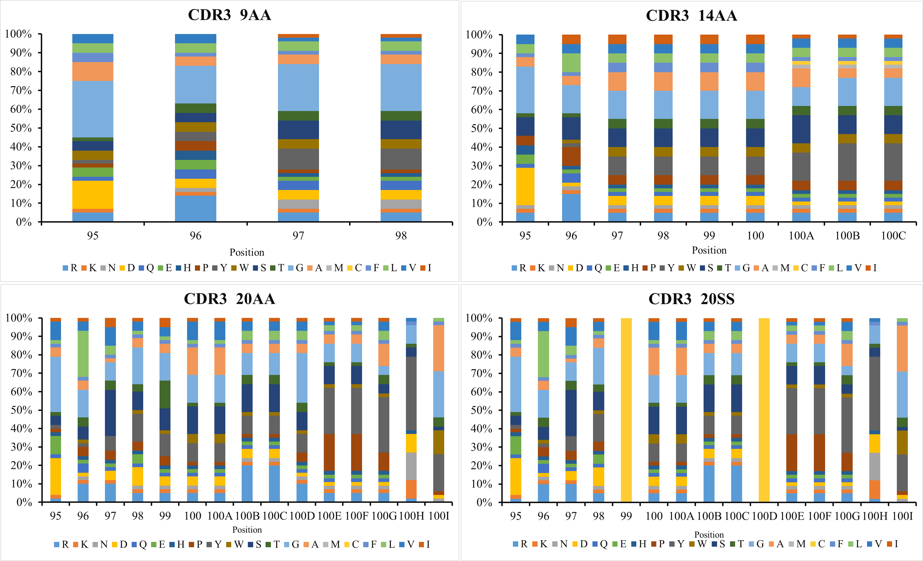
(b)

Supplementary Figure S3. CDR diversity of the final FKS sdAb antibody library.
(a) CDR1 and CDR2 diversity were designed and synthesized using degenerate oligonucleotides to mimic the amino acid usage of human germline CDR-H1 and -H2 sequences. (b) Codon frequency schemes for the synthesis of CDR3 diversity by trinucleotide phosphoramidite chemistry, based on the amino acid usage of human CDR-H3 reported in ref. 29.
(a)
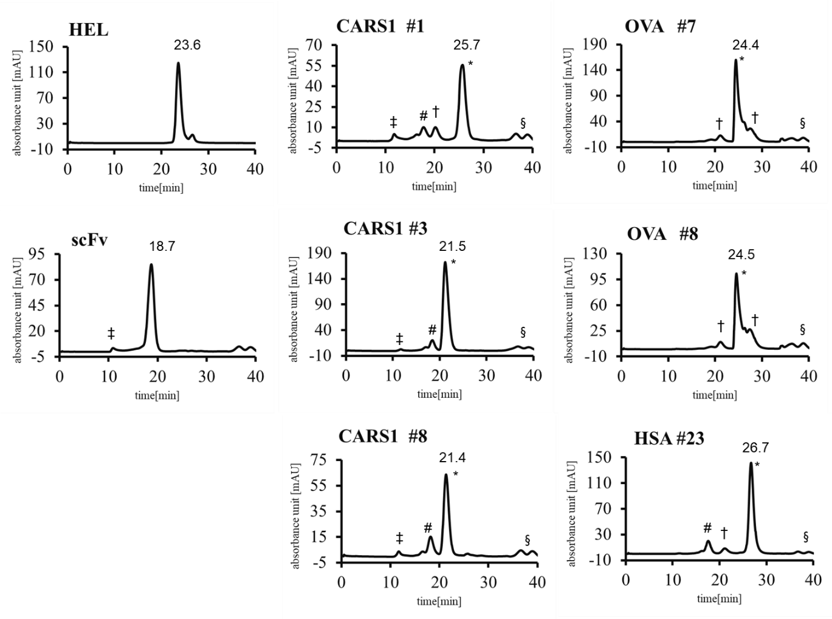
(b)
VH variants | % Monomer
HEL | 99.38
scFv | 96.17
CARS1 #1 | 66.46
CARS1 #3 | 86.32
CARS1 #8 | 73.43
ovalbumin #7 | 87.45
ovalbumin #8 | 83.63
HSA #23 | 76.96

Supplementary Figure S4. SEC analysis of Ag-specific VH binders.
(a) SEC analysis of target-binding sdAbs. The retention time (min) of each VH variant is indicated above the peak. Peaks for monomer (*), dimer (#), putative impurities/degradation products (†), aggregation (‡), and buffer excipients (§) are indicated. HEL (14.4 kDa) and scFv (~27 kDa) were used as molecular weight standards. (b) The monomer contents of target-binding sdAbs estimated from the chromatogram. Peaks eluted at ~21 min are likely to be impurities, therefore “% monomer” should be interpreted as minimum estimated values.

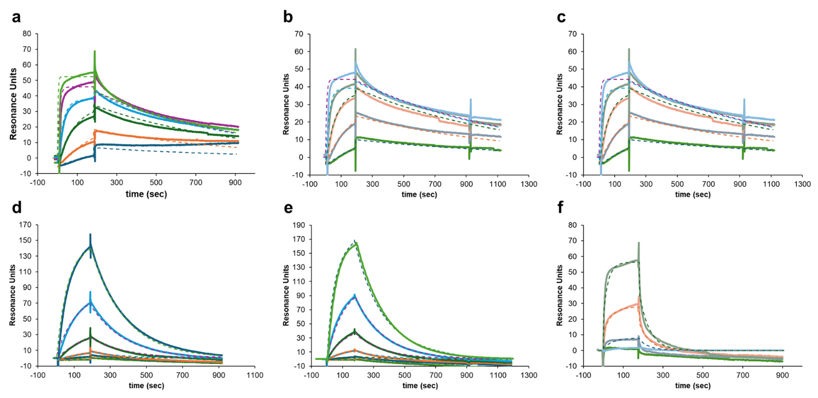

Supplementary Figure S5. SPR sensorgrams of target-specific sdAbs.
SPR sensorgrams for (a) CARS1 #1, (b) CARS1 #3, (c) CARS1 #8, (d) ovalbumin #7, (e) ovalbumin #8, and (f) HSA #23 are shown. Binding kinetics were measured using analyte (sdAb) concentrations of 1000, 300, 100, 30, 10 (except in f), and 3 nM (except in c and f). Solid lines: actual sensorgram. Dashed lines: 1:1 Langmuir binding model fitting results.

Supplementary Table S1. Primer sets for the amplification of FR2-randomized VH library fragments and FKS sdAb library fragments.

Product name | Templates | Primers
FR2-randomized VH library
FR2-randomized 37 | VH3-23 scFv | pC3x-f | DP47-FR2rand-b
FR2-randomized 44, 45, 47 | VH3-23 scFv | DP47-FR2rand-f | pC3x-b
FKS library
FR1-CDR1 | VH3-23 scFv | Pc3x-f | 4thVHlib-FKS-H1rand-b-long
FR2 | VH3-23 scFv | 4thVHlib-FKS-FR2N-f | 4thVHlib-FKS-FR2C-b
CDR2-FR3 (B) | VH3-23 scFv | 4thVHlib-FKS-CDR2T-f-long | 4th-TP-H3-f-rc
FR4-CDR3 9, 14 length (C) | VH3-23 scFv | TH-H3(9, 14)-b-rc | pC3x-b
FR4-CDR3 20, ss length (D) | VH3-23 scFv | TP-H3(20, ss)-b-rc-long | pC3x-b

Supplementary Table S2. Assembly of FR2-randomized VH library and the final FKS VH sdAb library by overlap extension PCR.

Product name | Templates | Primers
FR2-randomized VH library
FR2-randomized VH | FR2-randomized 37  + FR2-randomized 44, 45, 47 | Omp-f | HA-b
Final FKS VH library
A | FR1-CDR1 + FR2 | pC3x-f | 4thVHlib-FKS-FR2C-b
1 | B + TP-H3- 9ª + C | 4thVHlib-FKS-FR2-f | pC3x-b
2 | B + TP-H3- 14^{b} + C | 4thVHlib-FKS-FR2-f | pC3x-b
3 | B + TP-H3- 20^{c} + D | 4thVHlib-FKS-FR2-f | pC3x-b
4 | B + TP-H3- SS^{d} + D | 4thVHlib-FKS-FR2-f | pC3x-b
CDR3 9 aa  sub-library | A + 1 | Omq-f | HA-b
CDR3 14 aa  sub-library | A + 2 | Omq-f | HA-b
CDR3 20 aa  sub-library | A + 3 | Omq-f | HA-b
CDR3 20SS  sub-library | A + 4 | Omq-f | HA-b

^{a,b,c,d} TP-H3-9, -14, -20, and -SS are the names of CDR3 oligonucleotides synthesized by trinucleotide phosphoramidite chemistry.

Supplementary Table S3. Sequences of the primers used in this work.

Primer name | Sequence (5’ → 3’)
FR2-randomized VH library
pC3x-f |  | GCACGACAGGTTTCCCGAC
pC3x-b |  | AACCATCGATAGCAGCACCG
DP47-FR2rand-f |  | CGCCAGGCTCCAGGGAAGNNKNNKGAGNNKGTCTCAGGGATCTATCAT
DP47-FR2rand-b |  | CTTCCCTGGAGCCTGGCGMNNCCAGCTCATAGAATAACT
The final FKS VH library
Pc3x-f |  | GCACGACAGGTTTCCCGAC
Pc3x-b |  | AACCATCGATAGCAGCACCG
4thVHlib-FKS-H1rand-b-long |  | CTCAGGACTCTTCCCTGGAGCCTTGCGATACCAATWCATAKCATMAYYATCAAAGGTGAATCCAGAGGCT
4thVHlib-FKS-FR2N-f |  | TGGTATCGCAAGGCTCCAGG
4thVHlib-FKS-FR2C-b |  | TGAGACCCACTCAGGACTCTTCCCTGG
4thVHlib-FKS-CDR2T-f-long |  | CCAGGGAAGAGTCCTGAGTGGGTCTCAKBGATCTMTYMTRRTRRTRGTARTAHATATTACGCTGATTCTGTAAAAGG
4th-TP-H3-f-rc |  | GCGCGCACAGTAATACACGGC
TH-H3(9, 14)-b-rc |  | TTCGACTACTGGGGCCAG
TP-H3(20, ss)-b-rc-long |  | ATGGACGTCTGGGGCCAGGGTACACTG
Omp-f |  | AAGACAGCTATCGCGATTGCAG
HA-b |  | GAACGTCGTACGGGTATG
Sequencing Primer
Omp-f |  | AAGACAGCTATCGCGATTGCAG

