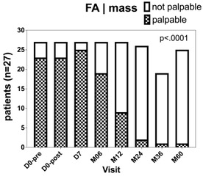

Figure S1. Change in the palpable findings

