Appendix A

The results of the Generalized Additive Mixed Model in modeling physiological parameters of Study (R² less than 0.30)
Response variable | Parametric coefficients | β | Standard Error | Test statistics | P-value | R²
High Frequency of Heart Rate Variability | Time | -10.64 | 31.80 | -0.334 | 0.335 | 0.27
High Frequency of Heart Rate Variability | S (Mental workload) | - | - | 0.182 | 0.671 | 0.27
High Frequency of Heart Rate Variability | S(age) | - | - | 0.170 | 0.681 | 0.27
High Frequency of Heart Rate Variability | S (Work experience) | - | - | 7.342 | <2e⁻¹⁶ | 0.27
High Frequency of Heart Rate Variability | S (Body mass index) | - | - | 1.662 | 0.198 | 0.27
Low Frequency of Heart Rate Variability | Time | 9.18 | 334.23 | 0.029 | 0.977 | 0.11
Low Frequency of Heart Rate Variability | S (Mental workload) | - | - | 0.081 | 0.7792 | 0.11
Low Frequency of Heart Rate Variability | S(age) | - | - | 0.145 | 0.8451 | 0.11
Low Frequency of Heart Rate Variability | S (Work experience) | - | - | 3.111 | 0.0152* | 0.11
Low Frequency of Heart Rate Variability | S (Body mass index) | - | - | 1.816 | 0.1789 | 0.11
Respiration Rate (breaths/min) | Time | 5.8267 | 2.5646 | 2.272 | 0.0239 * | 0.20
Respiration Rate (breaths/min) | S (Mental workload) | - | - | 0.012 | 0.9121 | 0.20
Respiration Rate (breaths/min) | S (Work experience) | - | - | 3.375 | 0.0673 | 0.20
Respiration Rate (breaths/min) | S (Body mass index) | - | - | 0.200 | 0.6595 | 0.20
Number of false answers in divided attention test | Time | -0.2531 | 0.0538 | -4.704 | <0.001*** | 0.25
Number of false answers in divided attention test | S (Mental workload) | - | - | 12.214 | <0.001* | 0.25
Number of false answers in divided attention test | S (Body mass index) | - | - | 26.315 | <0.001*** | 0.25
Number of no answers in divided attention test | Time | -0.38241 | 0.08359 | -4.575 | <0.001*** | 0.17
Number of no answers in divided attention test | S (age) | - | - | 22.523 | <0.001** | 0.17
Number of no answers in divided attention test | S (Body mass index) | - | - | 18.425 | 0.003 ** | 0.17
Percentage of correct answers in divided attention test | Time | 3.0925 | 0.6131 | 5.044 | <0.001*** | 0.25
Percentage of correct answers in divided attention test | S (Mental workload) | - | - | 3.048 | 0.009 ** | 0.25
Percentage of correct answers in divided attention test | S (Body mass index) | - | - | 5.162 | <0.001*** | 0.25

Appendix B

The functional form of the continuous variables in the fitted generalized additive mixed model in predicting physiological, cognitive outcomes (not significant associations)
Low Frequency of Heart Rate Variability | 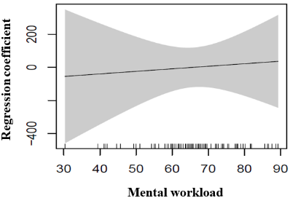 | 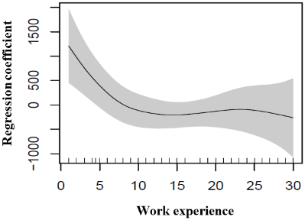 | 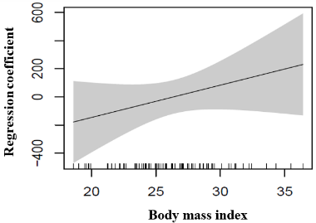
P-value | 0.78 | 0.01 | 0.18
High Frequency of Heart Rate Variability | 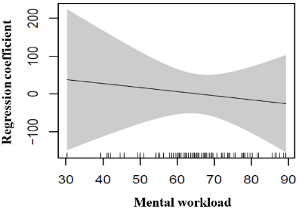 | 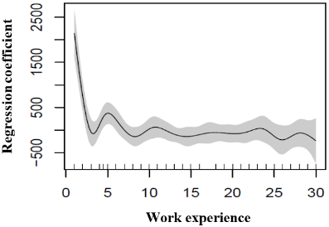 | 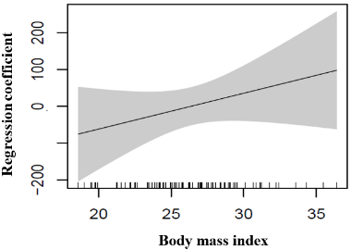  Regression coefficient
P-value | 0.68 | <0.001 | 0.2
Respiration Rate (breaths/min) | 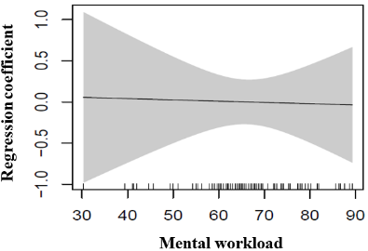 | 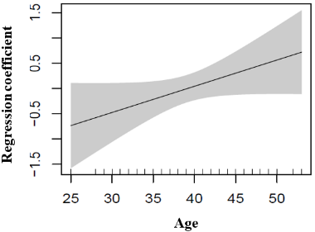 | 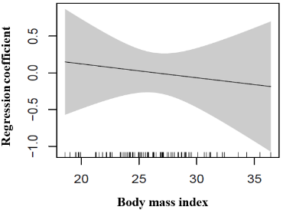
P-value | 0.91 | 0.07 | 0.66

Appendix C

The functional form of the continuous variables in the fitted generalized additive mixed model in predicting cognitive outcomes (not significant associations)
Number of false answers in divided attention test | 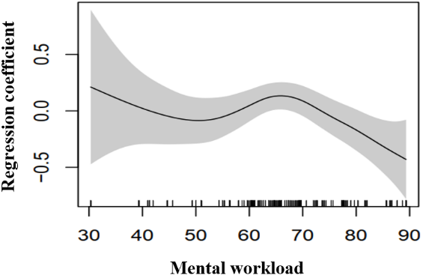 | 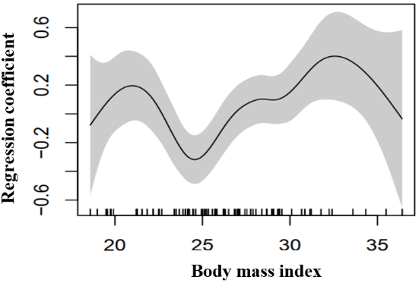
P-value | <0.001 | <0.001
Number of no answers in divided attention test | 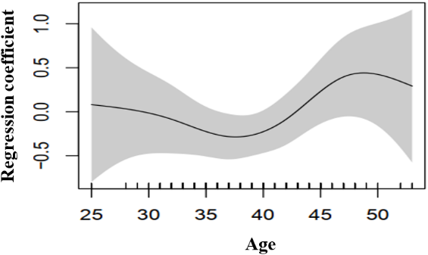 | 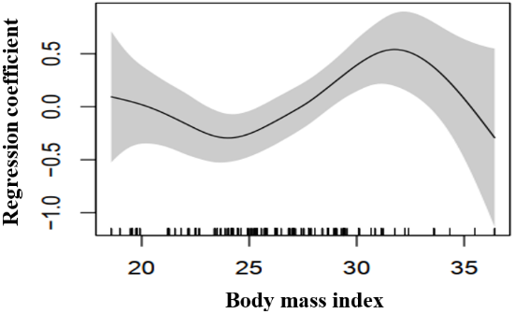
P-value | <0.001 | <0.001
Percentage of correct answers in divided attention test | 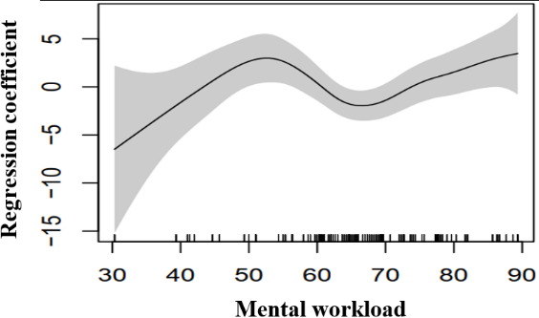 | 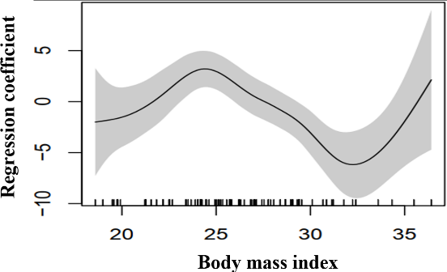
P-value | <0.001 | <0.001

