Supplementary materials

Table S2: The number of base substitutions per site from averaging over all sequence pairs among clusters detected by Geneland are shown.

 | Congo | Western central Africa+Gabon | Central Africa | Western Africa+Ghana+Dahomey Gap
Congo
Western central Africa+Gabon | 0.0265
Central Africa | 0.0189 | 0.0280
Western Africa+Ghana+Dahomey Gap | 0.0333 | 0.0269 | 0.0307

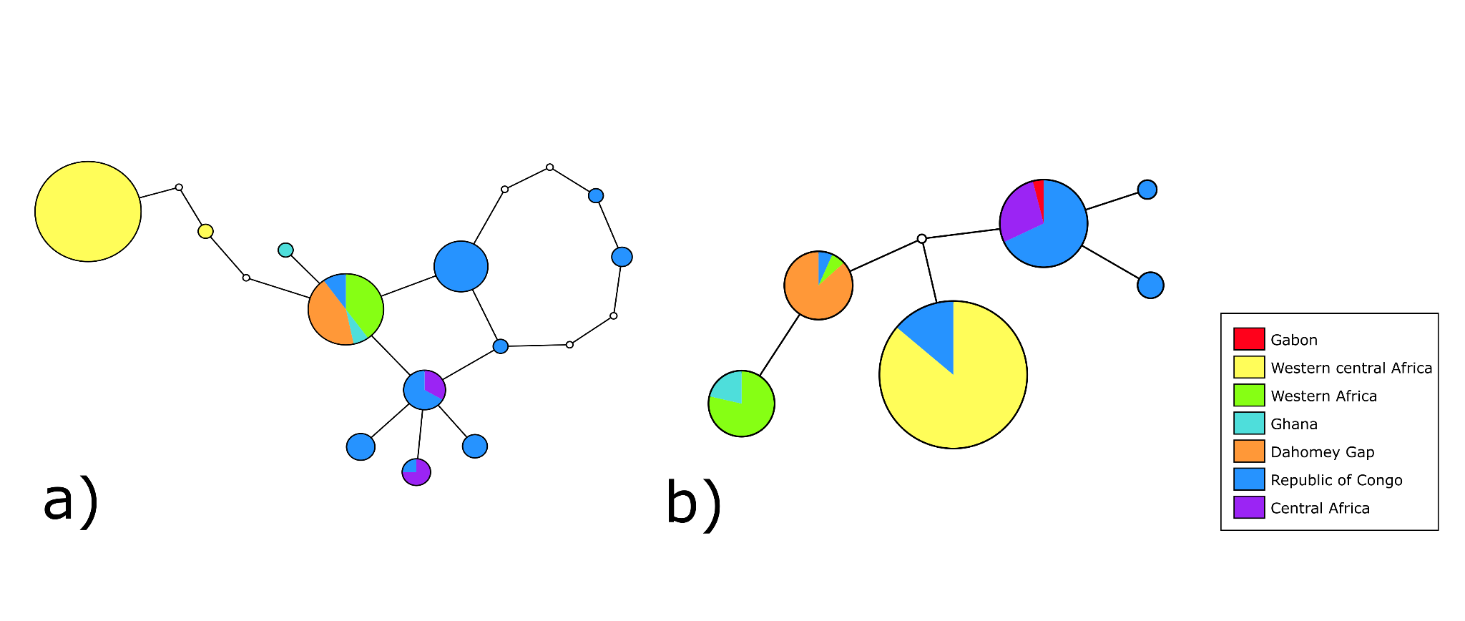
Figure S1: TCS haplotype network of the fibrinogen intron 7 (a) and coding region of titin gene (b) of the white-bellied pangolin (Phataginus tricuspis), including samples collected for this study (Republic of Congo) and georeferenced samples from GenBank (other regions). Haplotypes are represented by circles, which are proportional to haplotype frequency. Colour codes are used based on the phylogeographic lineages from Gaubert et al. ^{[31]}; samples from the RoC are in dark blue. Empty circles between haplotypes represent mutation steps.

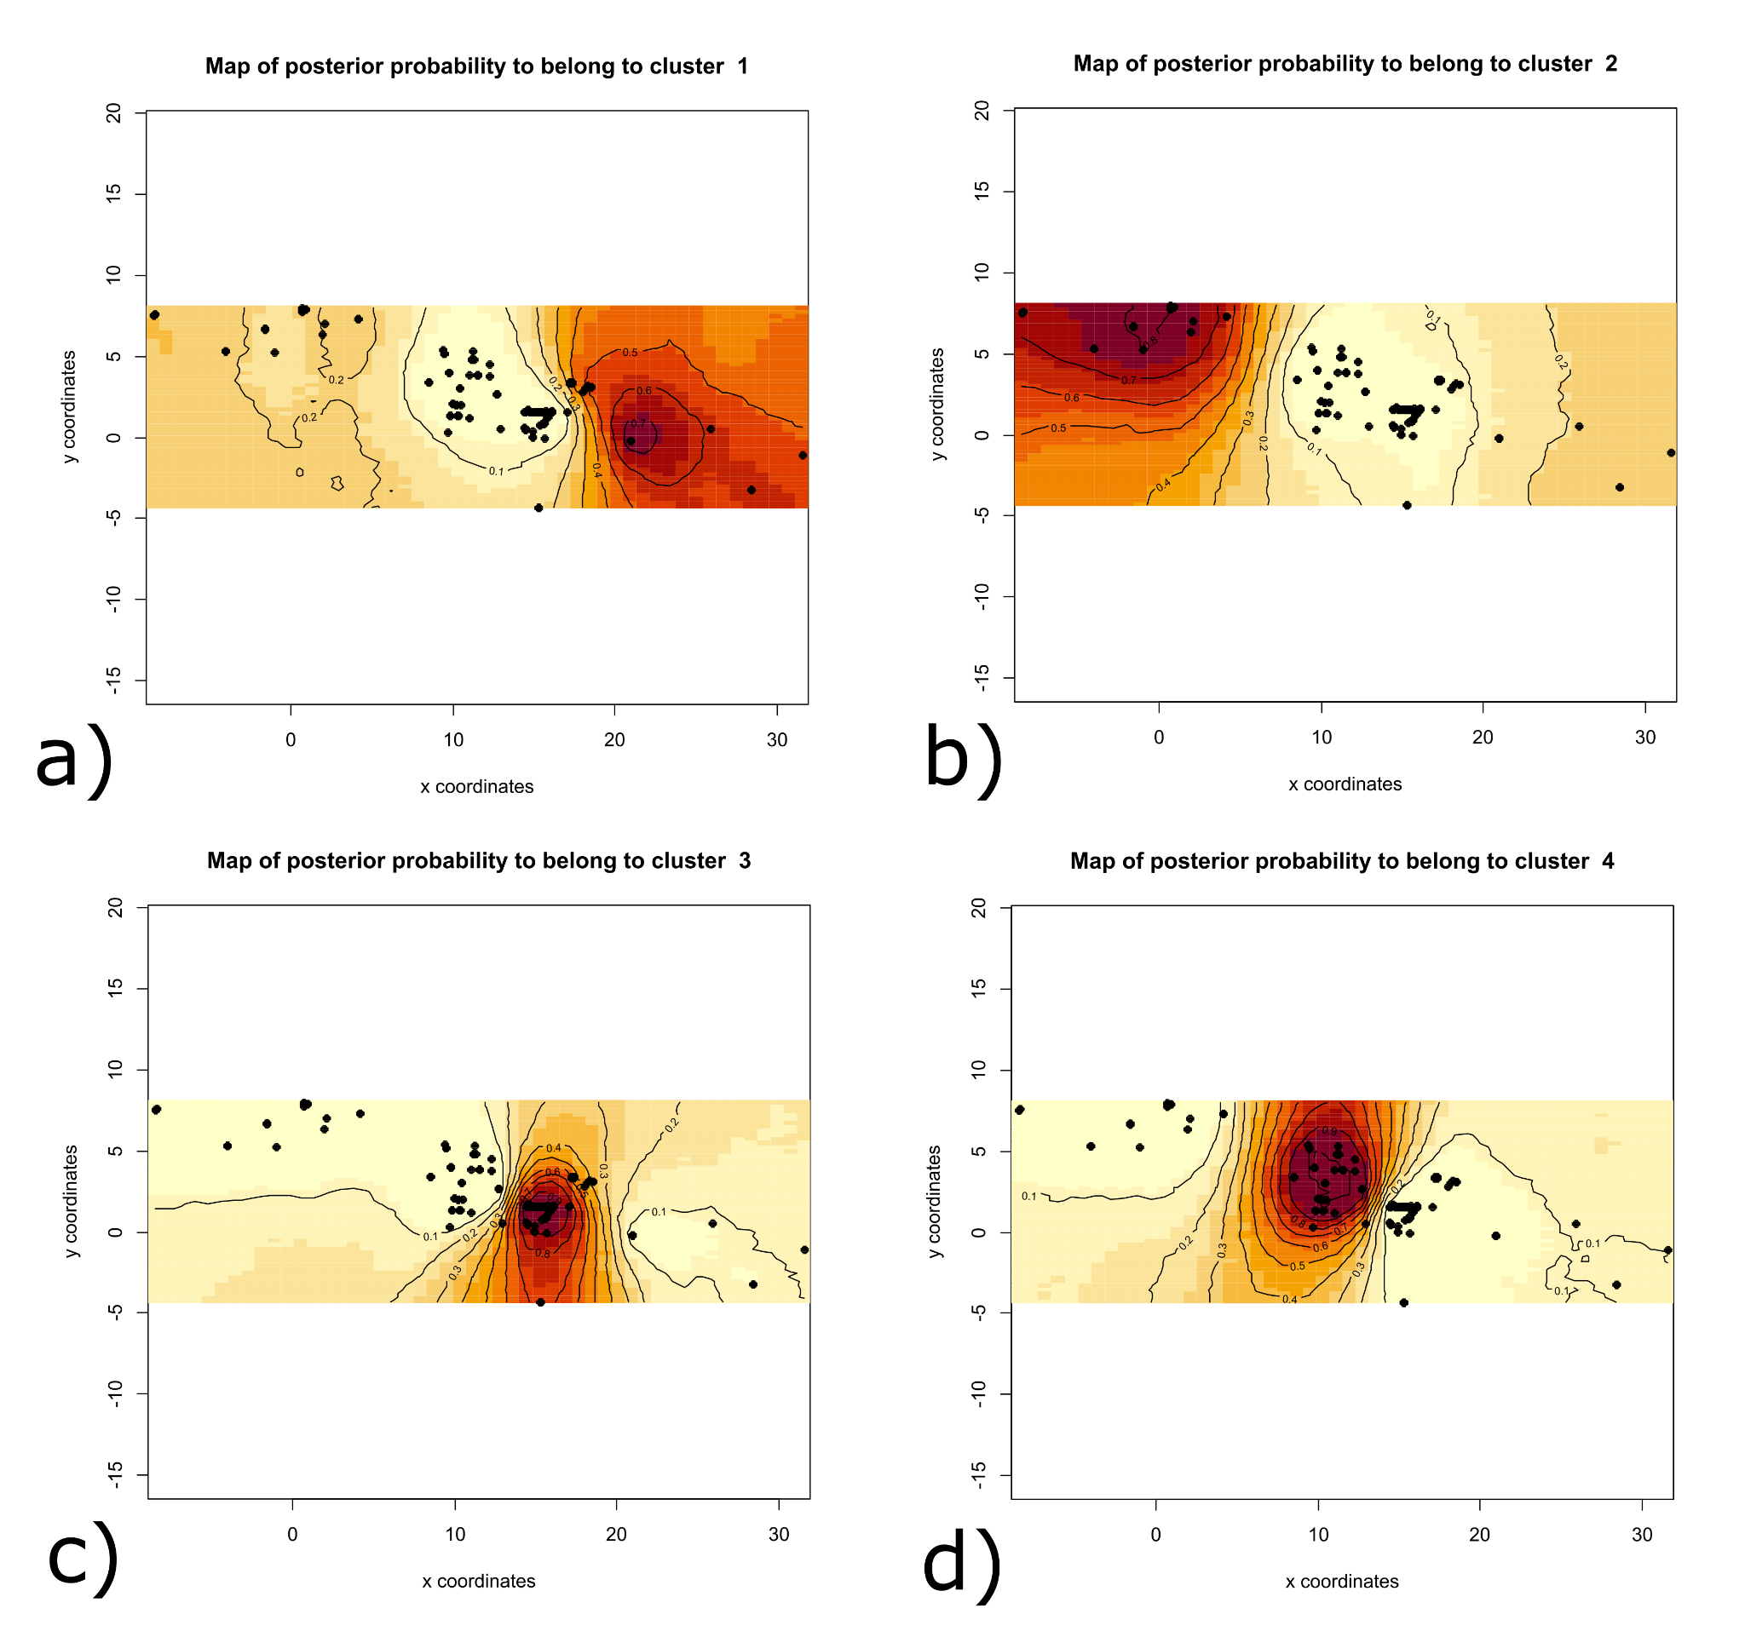

Figure S2: The posterior probability isoclines for each cluster denoted by analysis in Geneland. a) Central African lineage, b) Western, Ghana and Dahomey Gap lineages, c) Congo lineage, d) Gabon and Western central lineages

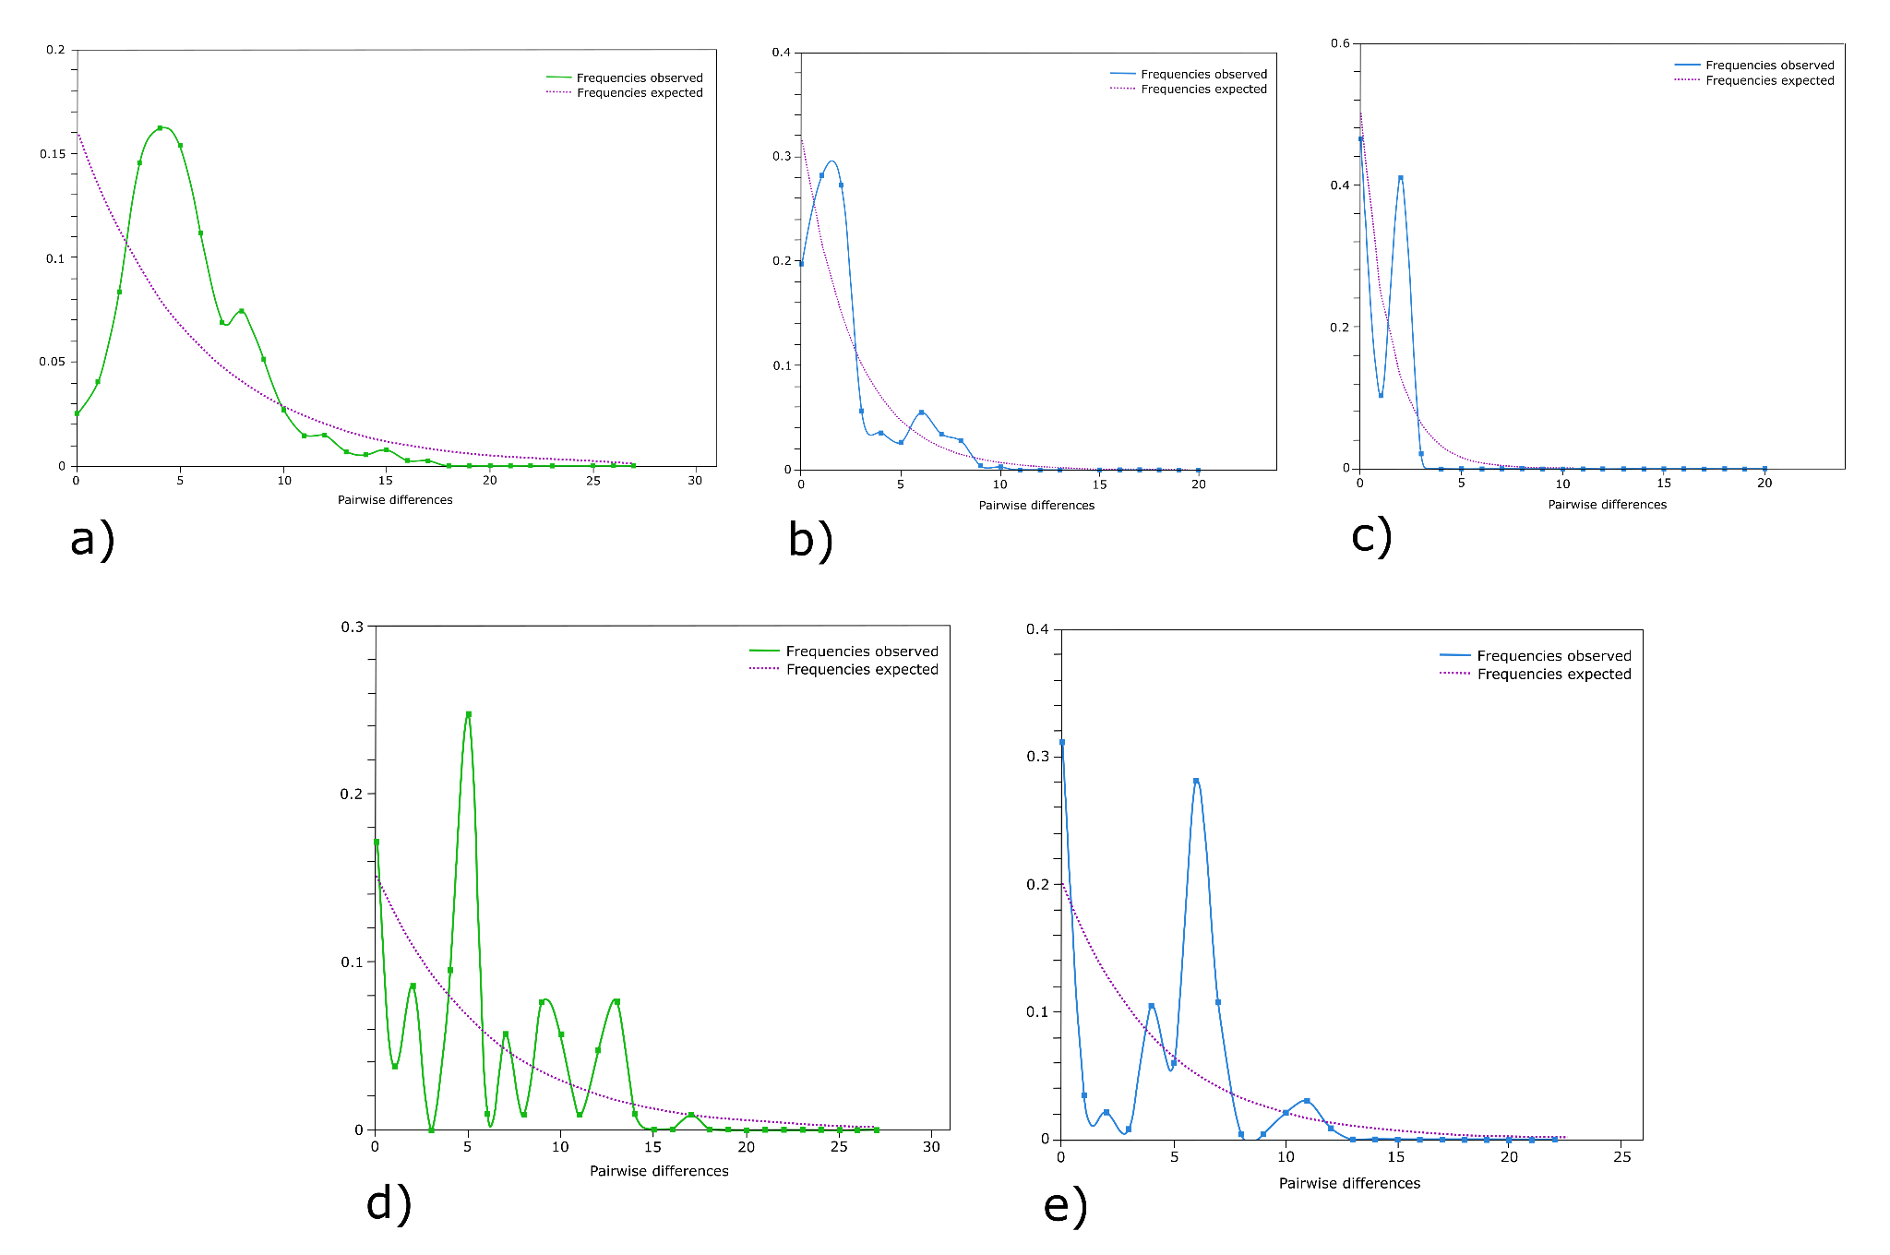

Figure S3: Mismatch distribution analysis graphs based on: control region in Phataginus tricuspis (a), beta-fibrinogen gene (FBG) in Phataginus tricuspis (b), coding region of titin in Phataginus tricuspis (c), control region in Smutsia gigantea (d) and beta-fibrinogen gene in Smutsia gigantea, (e). The pink line represents expected allele frequencies, the green or blue line represents observed allele frequencies.

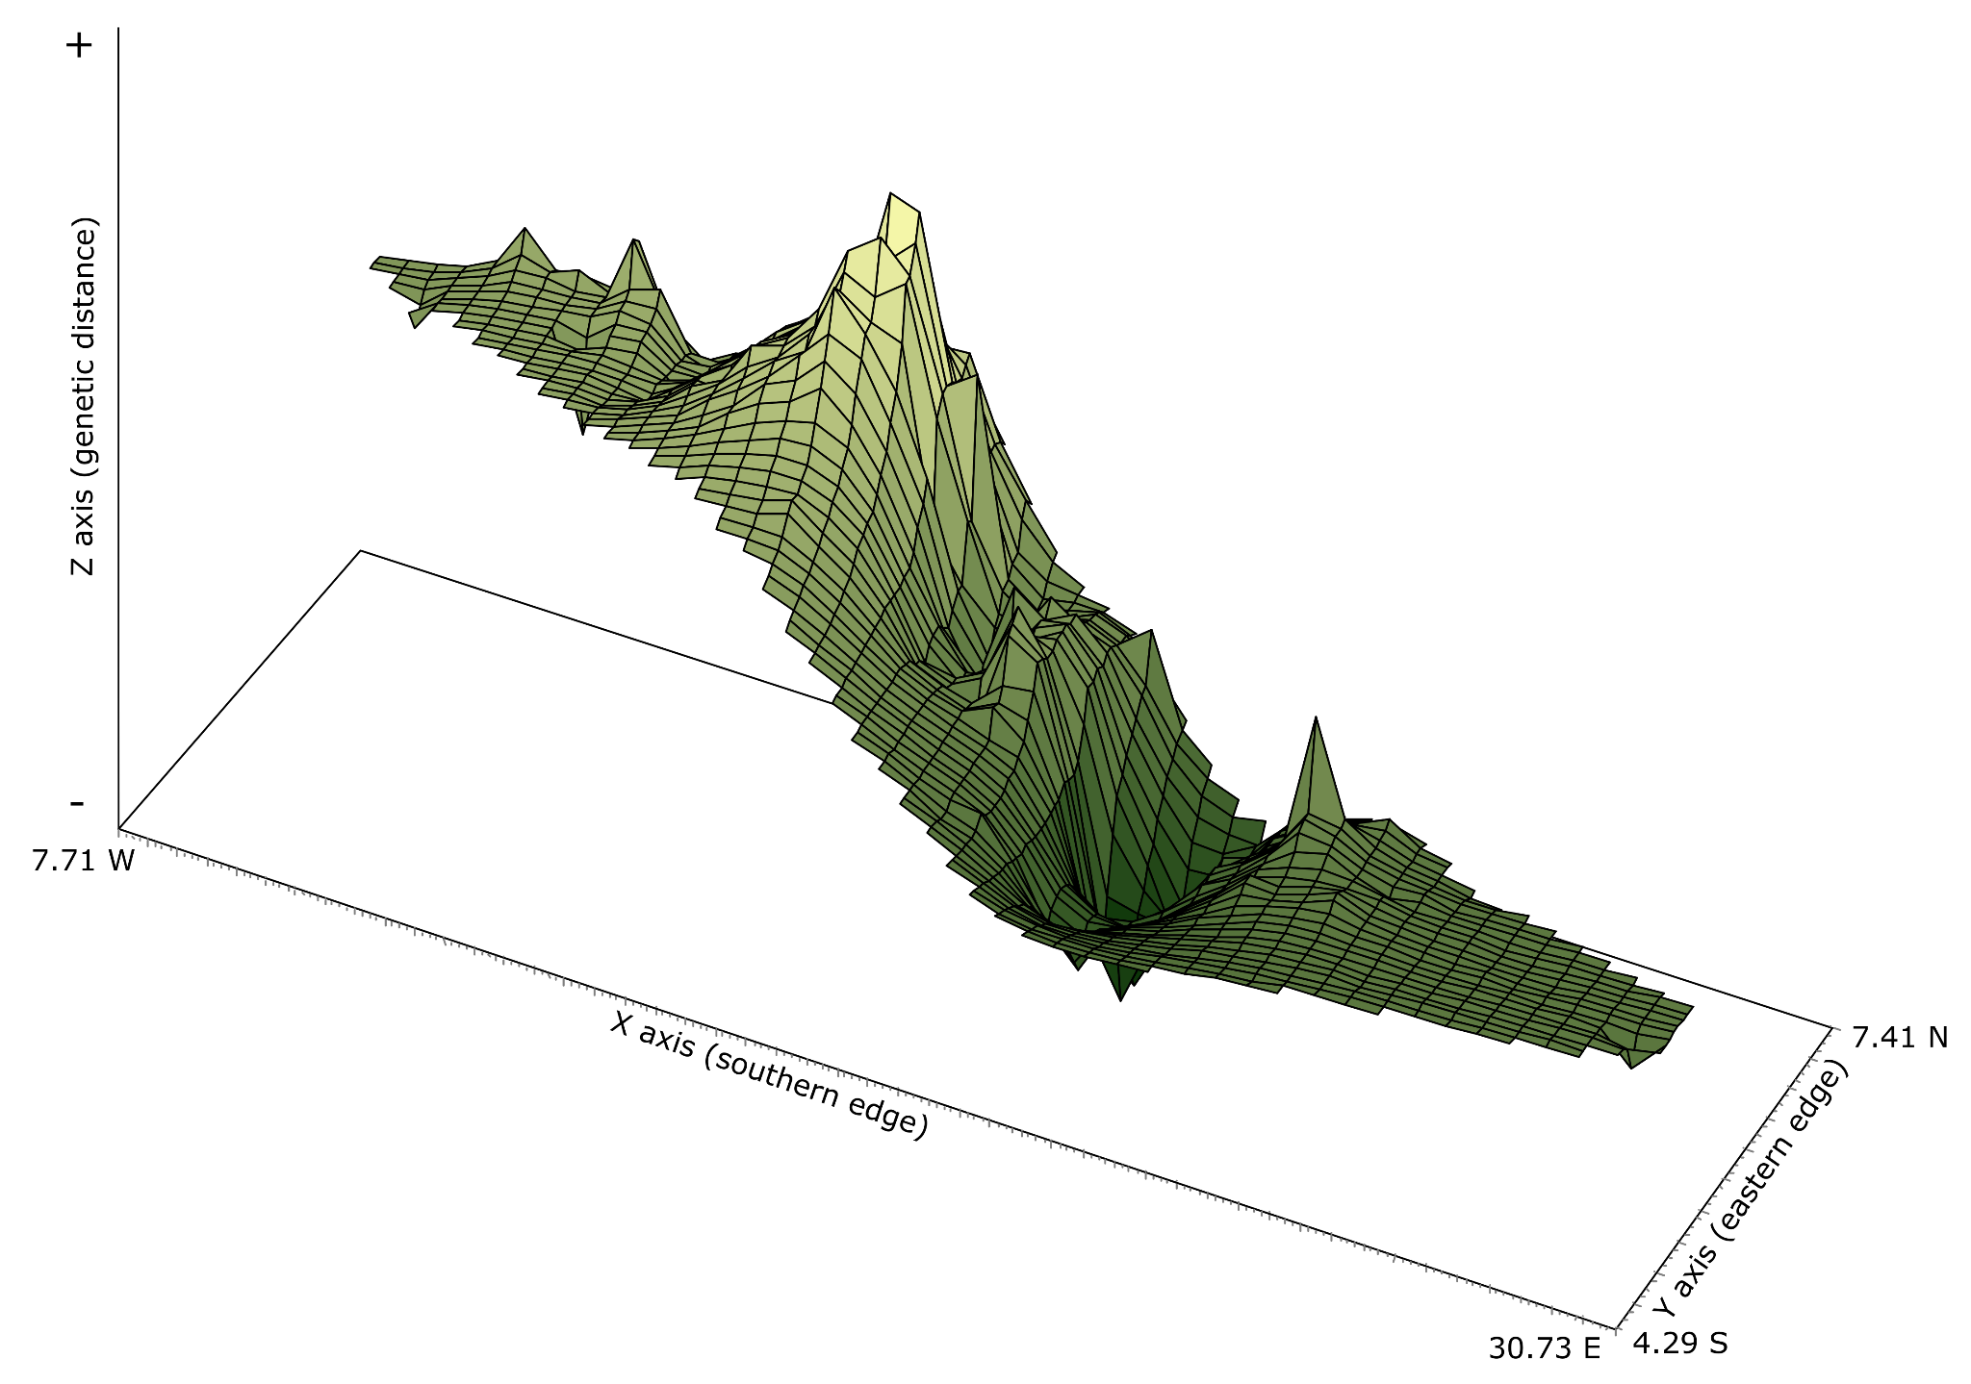

Figure S4: Genetic landscape shape interpolation analysis based on variation in the mitochondrial control region of white-bellied pangolins (Phataginus tricuspis) collected for this study (Republic of Congo) and georeferenced samples from GenBank (other regions). The X and Y axes reflect the geographic coordinates, and the Z axis represents the average genetic distances between analysed individuals.

