Supplementary data

Low nail fold capillary density in patients with precapillary pulmonary hypertension: biomarker of clinical outcome in PAH, but not CTEPH
A.J. Smits¹, K. Isebia, C. Combee-Duffy, S. van der Wal, E.J. Nossent, A. Boonstra, A. Vonk-Noordegraaf, H.J. Bogaard, E. Serné

Table S1 Auto-immune serology
Auto-immune serology | PAH | CTEPH | Control | P-value
ANA, n positive (%) | 3 (10%) | 0 (0%) | - | 0.185
dsDNA, n positive (%) | 0 (0%) | 0 (0%) | - | 1.000
ENA, n positive (%) | 0 (0%) | 0 (0%) | - | 1.000
ANCA, n positive (%) | 0 (0%) | 0 (0%) | - | 1.000
β2 glycoproteïne, n positive (%) | 0 (0%) | 0 (0%) | - | 1.000
Anticardiolipins, n positive (%) | 0 (0%) | 0 (0%) | - | 1.000
Anti-CCP, n positive (%) | 0 (0%) | 0 (0%) |  | 1.000
Reumafactor, n positive (%) | 0 (0%) | 0 (0%) | - | 1.000
Table S1 Auto-immune serology of patients with PAH (iPAH and hPAH), CTEPH and control subjects. Significance is indicated as $ p < 0.001, &p < 0.01, #p < 0.05 compared to ∙. One-way ANOVA, post-hoc t-tests with bonferroni correction

Table S2 Nailfold capillary density in patients with iPAH compared to hPAH
 | iPAH | hPAH | p-value
Measurements
Mean (capillaries/mm) | 7.5 ± 1.1 | 7.6 ± 1.0 | 0.915
L4 (capillaries/mm) | 7.8 ± 1.5 | 7.5 ± 1.1 | 0.564
L3 (capillaries/mm) | 7.5 ± 1.5 | 7.9 ± 1.4 | 0.546
R4 (capillaries/mm) | 7.3 ± 1.2 | 7.2 ± 1.3 | 0.889
R3 (capillaries/mm) | 7.4 ± 1.4 | 7.7 ± 1.3 | 0.618

Table S1 No difference in nailfold capillary density is observed among patients with iPAH and hPAH. Significance is indicated by * p ≤ 0.001, & p ≤ 0.01, # p ≤ 0.05 compared to ∙. Student-t test is employed. Right; R, Left; L, nailfold capillary density was measured in the third; 3, and fourth; 4 finger.

Table S3 Capillary measurements
 | PAH | CTEPH | Control
Capillary density
Mean (capillaries/mm) | 7.5 ± 1.1 ∙ ∙ | 8.4 ± 1.5 ∙ # | 10.3 ± 1.0 *
L4 (capillaries/mm) | 7.8 ± 1.3 ∙ | 8.7 ± 1.4 ∙ | 10.7 ± 2.0 *
L3 (capillaries/mm) | 7.6 ± 1.5 ∙ | 8.2 ± 2.2 ∙ | 10.3 ± 1.6 *
R4 (capillaries/mm) | 7.3 ± 1.2 ∙ ∙ | 8.6 ± 1.7 ∙ & | 10.0 ± 1.2 *
R3 (capillaries/mm) | 7.4 ± 1.4 ∙ | 7.8 ± 1.3 ∙ | 10.3 ± 1.4 *
Capillary dimensions
Total capillary width, mean (μm) | 37.9 ± 9.4 ∙ | 34.5 ± 8.7 ∙ | 28.8 ± 6.1 *
L4 (μm) | 38.8 ± 9.6 ∙ | 34.8 ± 9.5 ∙ | 27.8 ± 5.6 *
R4 (μm) | 37.3 ± 8.9 | 34.2 ± 7.9 ∙ | 30.0 ± 6.5 #
Apex width, mean (μm) | 17.4 ± 4.8 ∙ | 15.9 ± 4.3 ∙ | 13.0 ± 3.2 *
L4 (μm) | 17.9 ± 4.8 ∙ | 16.5 ± 4.8 ∙ | 12.2 ± 3.1 *
R4 (μm) | 16.9 ± 4.7 ∙ | 15.3 ± 3.7 | 13.9 ± 3.1 *
Arterial width, mean (μm) | 11.5 ± 3.4 ∙ | 11.5 ± 3.2 ∙ | 9.2 ± 2.2 *
L4 (μm) | 11.9 ± 3.3 ∙ | 11.0 ± 3.0 ∙ | 8.7 ± 2.0 *
R4 (μm) | 11.1 ± 3.5 ∙ | 11.7 ± 3.4 ∙ | 9.9 ± 2.2 #
Venous width, mean (μm) | 14.5 ± 3.6 ∙ | 13.4 ± 3.9 ∙ | 11.3 ± 2.6 *
L4 (μm) | 14.9 ± 3.8 ∙ | 14.0 ± 4.3 ∙ | 10.8 ± 2.4 *
R4 (μm) | 14.2 ± 3.2 ∙ | 12.6 ± 3.4 ∙ | 12.0 ± 2.6 #
Table S3 Capillary density measurements and capillary dimensions (total capillary diameter, apex, arterial and venous width) in patients with PAH (iPAH and hPAH), CTEPH and control subjects. Significance is indicated as * p < 0.001, &p < 0.01, #p < 0.05 compared to ∙. Two-way ANOVA, post-hoc t-tests with bonferroni correction.

Table S4 NC pattern analysis
Pattern |  |  | n.s.
0 (normal) | 24 (77%) | 14 (87%) | 48 (100%)
1 (aspecific) | 6 (19%) | 2 (13%) | 0 (0%)
2 (early) | 1 (3%) | 0 (0%) | 0 (0%)
3 (active) | 0 (0%) | 0 (0%) | 0 (0%)
4 (late) | 0 (0%) | 0 (0%) | 0 (0%)
Table S4 SSc patterns in patients with iPAH and hPAH, CTEPH and controls

Table S5 Linear regression analysis of mean capillary density in PAH and CTEPH
 | PAH ( per 1 cap/mm increase) | CTEPH, (per 1 cap/mm increase)
mPAP, mmHg | -2.2 (-8.2, 3.9), R2 0.03, p 0.46 | 2.1 (-3.0, 7.2), R2 0.06, p 0.39
PVR, dynes/sec/cm⁻⁵ | -9.5 (-137, 118), R2 0.00, p 0.88 | 142 (-29, 277), R2 0.19, p 0.10
CO, L/min | 0.1 (-0.5, 0.7), R2 0.00, p 0.78 | -0.6 (-1.1, -0.0), R2 0.26, p 0.04
DLCO, % predicted | -1.9 (-9.1, 5.4), R2 0.02, p 0.60 | 0.2 (-5.1, 5.5), R2 0.00, p 0.93
Lowest SpO2 during exercise, % | 1.4 (-0.9, 3.7), R2 0.06, p 0.24 | -1.4 (-3.7, 0.8), R2 0.14, 0.18
Log(NT-proBNP), ng·L⁻¹ | -0.1 (-0.3, 0.1), R2 0.03, p 0.37 | 0.0 (-0.2, 0.3), R2 0.00, p 0.89
Mean blood pressure (mmHg) | -0.8 (-4.5, 2.8), R2 0.01, p 0.64 | 0.0 (-4.8, 4.9), R2 0.00, p 0.99
Age, yrs | -0.0 (-5.7, 5.7), R2 0.00, p 0.98 | 1.0 (-3.7, 5.7), R2 0.01, p 0.65
BMI | 0.8 (-0.6, 2.1), R2 0.04, p 0.25 | -0.9 (-2.6, 0.7), R2 0.1, p 0.24
Table S5 No significant or relevant association was found between mean capillary density in PAH or CTEPH and mean pulmonary artery pressure; mPAP, pulmonary vascular resistance; PVR, N-terminal pro b-type natriuretic peptide; NT-proBNP, right ventricular ejection fraction; RVEF, age, gender, body mass index; BMI, diffusing capacity for carbon monoxide; DLCO, lowest peripheral measured oxygen saturation (SpO2) during exercise, mean systemic blood pressure. Tested via univariate linear regression analysis. Reported are associated increase per 1 cap/mm) with 95% confidence intervals (95% CI), explained variation; R², and p value of the correlations.

Figure S1 Linear regression analysis of mean capillary density in PAH and CTEPH

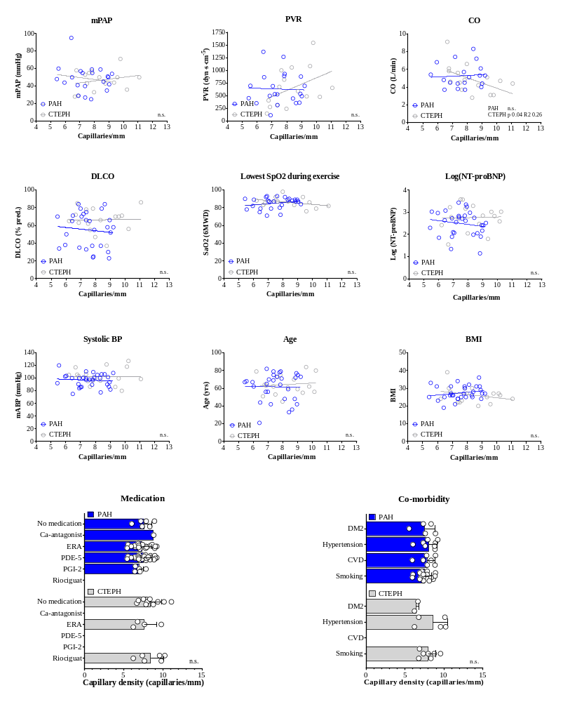

Figure S1 No significant or relevant association was found between mean capillary density in PAH or CTEPH and mean pulmonary artery pressure; mPAP, pulmonary vascular resistance; PVR, cardiac output; CO, diffusing capacity for carbon monoxide; DLCO, lowest SpO2 measured during exercise, NT-proBNP, systolic bloodpressure, age, body mass index; BMI. Neither did capillary density differ between different medication types, or comorbidity.

Figure S2 Cox proportional hazard assumption
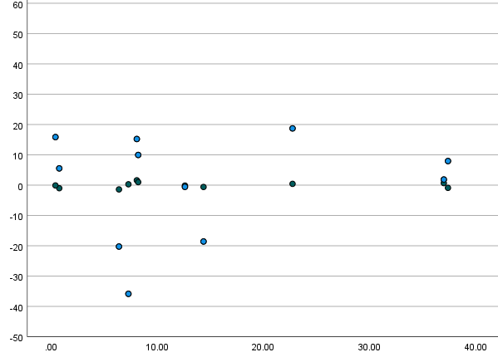
Partial residuals for vascular density (cap./mm, blue), and age (yrs, brown)
Time to clinical worsening (months)

Figure S2 Cox proportional hazards assumption was calculated from partial residuals, as was described by Schoenfeld et al. Indicating the the relation between vascular density and clinical worsening was the same over all time points (b 0.004 (-0.05 – 0.06), p 0.871), same was held true for the confounder, age (b 0.205 ( -0.90, 1.21), p 0.657), y axis; partial residuals, x-axis time to clinical worsening (months). Blue indicates vascular density (cap./mm), and brown dots age (yrs).

