Appendix A
MULTISCALE FEATURES
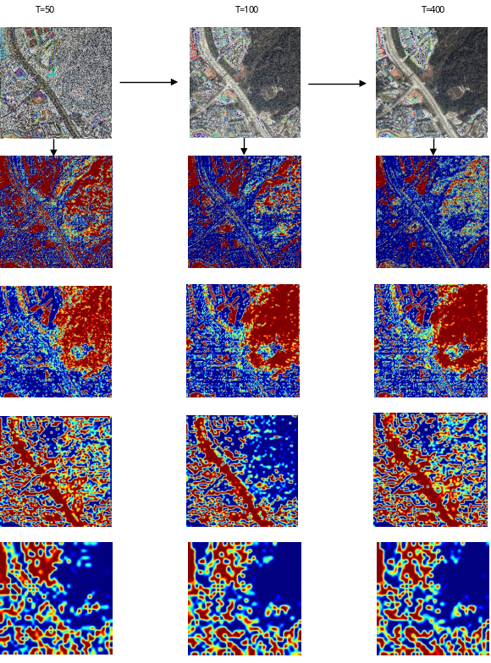
Figure.A1. Multiscale features at different diffusion steps
The images in the first row were generated after different diffusion steps, and the black arrows indicate the order of diffusion. The downward arrows indicate that the following features are extracted from the diffusion images. The size of the original feature is different, from 256 to 16. However, we've upsampled it to the same size for ease of presentation.

