Assessing Surface Water Quality in Hungary’s Danube Basin using Geochemical Modeling, Multivariate Analysis, Irrigation Indices, and Monte Carlo Simulation

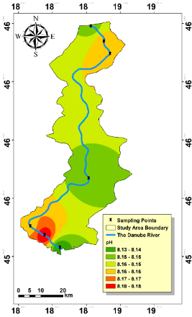  a text here | 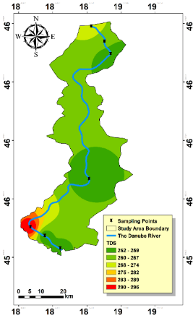  b text here | 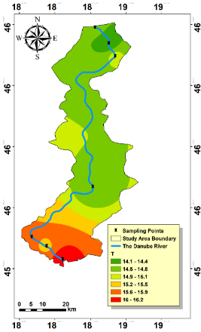  c text here | 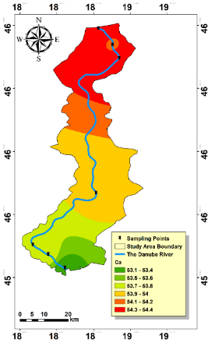  d text here
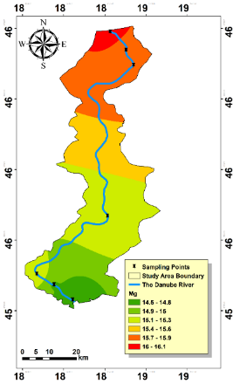  e text here | 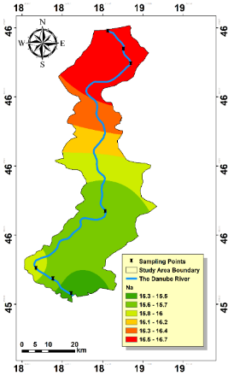  f text here | 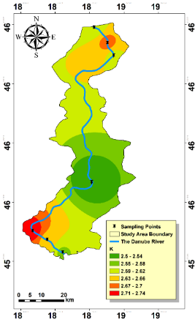  g text here | 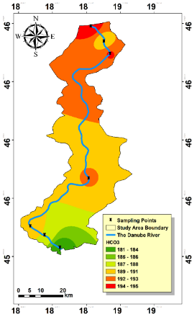  l text here  h text here
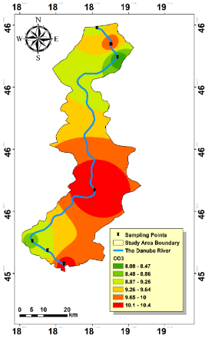  i text here | 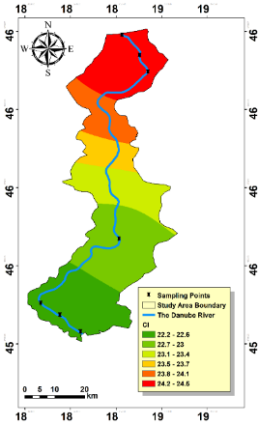  j here | 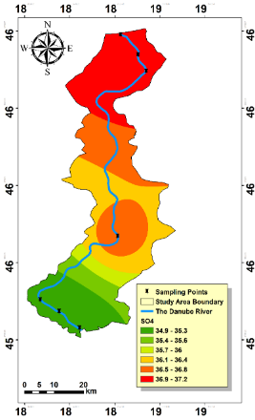  k text here | 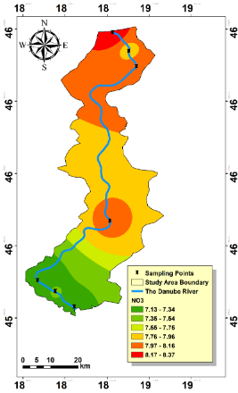
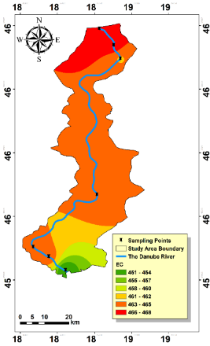  m text here | 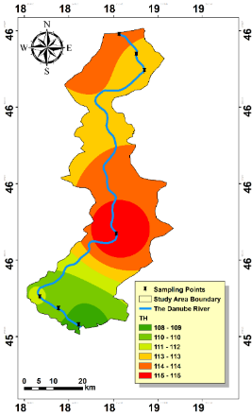  n text here | 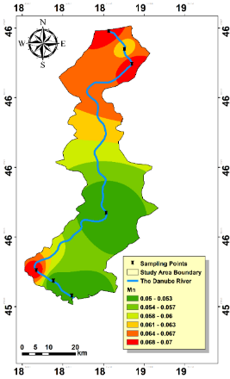  o text here | 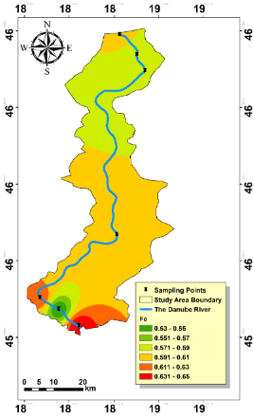  p text here
Figure 1S Distribution map of the HM and physicochemical parameters: (a) pH, (b)TDS, (c) Temperature, (d) Ca2+, (e) Mg2+, (f) Na+, (g) K+, (h) HCO3−, (i) CO3−, (j) Cl−, (k) SO42−, (l) NO3−, (m) EC, (n) TH, (o) Mn and (p) Fe.

Table 1S Classification of water quality based on WQI values (¹)
WQI | Categories | Explanation and Potential Uses
0–25 | Excellent | Drinking, Irrigation and Industrial
26–50 | Good | Domestic, Irrigation and Industrial
51–75 | Poor | Irrigation and Industrial
76–100 | Very Poor | Irrigation
>100 | Unsuitable for drinking | Restricted use for Irrigation

Table 2S Statistical analysis and classes of IWQIs.
Criteria | Min | Max | Mean | Range | Class
IWQI | 99.64 | 107.66 | 104.36 | 85 - 100 | No restriction
IWQI |  |  |  | 70 - 85 | Low restriction
IWQI |  |  |  | 55 - 70 | Moderate restriction
IWQI |  |  |  | 40 - 55 | High restriction
IWQI |  |  |  | 0 - 40 | Severe restriction
SAR | 0.37 | 0.68 | 0.49 | <10 | Excellent
SAR |  |  |  | 10–18 | Good
SAR |  |  |  | 19–26 | Fair Poor
SAR |  |  |  | >26 | Unsuitable
Na% | 13.75 | 18.72 | 16.11 | <20% | Excellent
Na% |  |  |  | 21%–40% | Good
Na% |  |  |  | 41%–60% | Permissible
Na% |  |  |  | 61%–80% | Doubtful
Na% |  |  |  | > 80% | Unsuitable
SSP | 12.52 | 17.59 | 14.88 | <60 | Suitable
SSP |  |  |  | >60 | Unsuitable
PS | 0.73 | 1.66 | 1.04 | PS < 3.0 | Excellent to good
PS |  |  |  | PS = 3.0–5.0 | Good to injurious
PS |  |  |  | PS > 5.0 | Injurious to unsatisfactory
RSC | -1.27 | 0.58 | -0.53 | <1.25 | Good
RSC |  |  |  | 1.25-2.5 | Doubtful
RSC |  |  |  | >2.5 | Unsuitable

Table 3S Mean values of HQ oral of Mn, Fe and NO3 for adults and children
Parameters |  | Minimum | Maximum | Mean
 | Fe | 0.001 | 0.125 | 0.024
HQ Oral for Adult | Mn | 0.025 | 0.439 | 0.074
 | NO₃⁻ | 0.050 | 0.243 | 0.137
 | Fe | 0.002 | 0.477 | 0.092
HQ Oral for Children | Mn | 0.096 | 1.678 | 0.281
 | NO₃⁻ | 0.190 | 0.927 | 0.523
 | HIOral for Adult | 0.096 | 0.577 | 0.235
Non-carcinogenic risk | HIOral for Children | 0.366 | 2.201 | 0.896

Table 4S Non carcinogenic values of Fe, Mn and NO3 for both Adults and Children
Samples | Locations | Date | HQ Fe |  | HQ Mn |  | HQ NO3 |  | HI
 |  |  | Adults | Children | Adults | Children | Adults | Children | Adults | Children
1 | S1 | 1/9/2019 | 0.12 | 0.48 | 0.13 | 0.48 | 0.18 | 0.70 | 0.43 | 1.65
2 | S1 | 2/6/2019 | 0.02 | 0.09 | 0.04 | 0.14 | 0.21 | 0.81 | 0.27 | 1.05
3 | S1 | 3/6/2019 | 0.01 | 0.05 | 0.04 | 0.14 | 0.19 | 0.74 | 0.24 | 0.93
4 | S1 | 4/3/2019 | 0.02 | 0.07 | 0.19 | 0.72 | 0.18 | 0.70 | 0.39 | 1.48
5 | S1 | 5/8/2019 | 0.03 | 0.10 | 0.06 | 0.24 | 0.12 | 0.44 | 0.20 | 0.78
6 | S1 | 6/5/2019 | 0.02 | 0.09 | 0.05 | 0.19 | 0.07 | 0.28 | 0.15 | 0.57
7 | S1 | 7/3/2019 | 0.01 | 0.04 | 0.05 | 0.19 | 0.08 | 0.29 | 0.14 | 0.52
8 | S1 | 8/7/2019 | 0.02 | 0.08 | 0.06 | 0.24 | 0.09 | 0.35 | 0.18 | 0.67
9 | S1 | 9/4/2019 | 0.01 | 0.02 | 0.13 | 0.48 | 0.07 | 0.26 | 0.20 | 0.76
10 | S1 | 10/2/2019 | 0.01 | 0.03 | 0.19 | 0.72 | 0.23 | 0.87 | 0.42 | 1.62
11 | S1 | 11/6/2019 | 0.01 | 0.03 | 0.04 | 0.14 | 0.20 | 0.75 | 0.24 | 0.93
12 | S1 | 12/4/2019 | 0.02 | 0.08 | 0.04 | 0.14 | 0.16 | 0.61 | 0.22 | 0.84
13 | S2 | 1/9/2019 | 0.10 | 0.39 | 0.13 | 0.48 | 0.18 | 0.70 | 0.41 | 1.56
14 | S2 | 2/6/2019 | 0.05 | 0.18 | 0.06 | 0.24 | 0.21 | 0.79 | 0.32 | 1.21
15 | S2 | 3/6/2019 | 0.01 | 0.04 | 0.04 | 0.14 | 0.23 | 0.87 | 0.28 | 1.06
16 | S2 | 4/3/2019 | 0.02 | 0.07 | 0.06 | 0.24 | 0.16 | 0.63 | 0.24 | 0.93
17 | S2 | 5/8/2019 | 0.03 | 0.11 | 0.05 | 0.19 | 0.12 | 0.47 | 0.20 | 0.77
18 | S2 | 6/5/2019 | 0.03 | 0.11 | 0.04 | 0.14 | 0.07 | 0.26 | 0.13 | 0.51
19 | S2 | 7/3/2019 | 0.01 | 0.05 | 0.13 | 0.48 | 0.07 | 0.28 | 0.21 | 0.81
20 | S2 | 8/7/2019 | 0.00 | 0.02 | 0.05 | 0.19 | 0.10 | 0.37 | 0.15 | 0.57
21 | S2 | 9/4/2019 | 0.01 | 0.03 | 0.05 | 0.19 | 0.09 | 0.32 | 0.14 | 0.55
22 | S2 | 10/2/2019 | 0.01 | 0.04 | 0.06 | 0.24 | 0.20 | 0.76 | 0.27 | 1.04
23 | S2 | 11/6/2019 | 0.01 | 0.02 | 0.19 | 0.72 | 0.12 | 0.47 | 0.32 | 1.21
24 | S2 | 12/4/2019 | 0.02 | 0.07 | 0.06 | 0.24 | 0.12 | 0.47 | 0.21 | 0.79
25 | S3 | 1/9/2019 | 0.10 | 0.39 | 0.13 | 0.48 | 0.21 | 0.79 | 0.43 | 1.66
26 | S3 | 2/6/2019 | 0.02 | 0.08 | 0.04 | 0.14 | 0.18 | 0.68 | 0.24 | 0.90
27 | S3 | 3/6/2019 | 0.01 | 0.04 | 0.04 | 0.14 | 0.19 | 0.72 | 0.24 | 0.90
28 | S3 | 4/3/2019 | 0.02 | 0.07 | 0.06 | 0.24 | 0.20 | 0.76 | 0.28 | 1.08
29 | S3 | 5/8/2019 | 0.03 | 0.12 | 0.06 | 0.24 | 0.12 | 0.45 | 0.21 | 0.81
30 | S3 | 6/5/2019 | 0.02 | 0.09 | 0.06 | 0.24 | 0.07 | 0.25 | 0.15 | 0.58
31 | S3 | 7/3/2019 | 0.01 | 0.04 | 0.05 | 0.19 | 0.07 | 0.26 | 0.13 | 0.49
32 | S3 | 8/7/2019 | 0.03 | 0.12 | 0.05 | 0.19 | 0.05 | 0.20 | 0.14 | 0.52
33 | S3 | 9/4/2019 | 0.00 | 0.02 | 0.06 | 0.24 | 0.05 | 0.20 | 0.12 | 0.46
34 | S3 | 10/2/2019 | 0.01 | 0.02 | 0.25 | 0.96 | 0.21 | 0.82 | 0.47 | 1.80
35 | S3 | 11/6/2019 | 0.00 | 0.02 | 0.19 | 0.72 | 0.21 | 0.79 | 0.40 | 1.52
36 | S3 | 12/4/2019 | 0.01 | 0.03 | 0.03 | 0.10 | 0.18 | 0.68 | 0.21 | 0.81
37 | S4 | 1/9/2019 | 0.11 | 0.42 | 0.13 | 0.48 | 0.17 | 0.66 | 0.41 | 1.56
38 | S4 | 2/6/2019 | 0.05 | 0.21 | 0.06 | 0.24 | 0.22 | 0.83 | 0.33 | 1.27
39 | S4 | 3/6/2019 | 0.01 | 0.04 | 0.04 | 0.14 | 0.24 | 0.93 | 0.29 | 1.11
40 | S4 | 4/3/2019 | 0.02 | 0.06 | 0.05 | 0.19 | 0.21 | 0.81 | 0.28 | 1.06
41 | S4 | 5/8/2019 | 0.02 | 0.08 | 0.04 | 0.14 | 0.15 | 0.58 | 0.21 | 0.80
42 | S4 | 6/5/2019 | 0.03 | 0.12 | 0.05 | 0.19 | 0.10 | 0.39 | 0.18 | 0.70
43 | S4 | 7/3/2019 | 0.01 | 0.03 | 0.13 | 0.48 | 0.05 | 0.19 | 0.18 | 0.70
44 | S4 | 8/7/2019 | 0.00 | 0.02 | 0.05 | 0.19 | 0.11 | 0.42 | 0.16 | 0.63
45 | S4 | 9/4/2019 | 0.01 | 0.02 | 0.03 | 0.10 | 0.09 | 0.33 | 0.12 | 0.45
46 | S4 | 10/2/2019 | 0.01 | 0.04 | 0.04 | 0.14 | 0.10 | 0.39 | 0.15 | 0.57
47 | S4 | 11/6/2019 | 0.01 | 0.04 | 0.05 | 0.19 | 0.12 | 0.47 | 0.19 | 0.71
48 | S4 | 12/4/2019 | 0.01 | 0.02 | 0.05 | 0.19 | 0.14 | 0.54 | 0.20 | 0.76
49 | S5 | 1/10/2019 | 0.10 | 0.38 | 0.13 | 0.48 | 0.20 | 0.75 | 0.42 | 1.61
50 | S5 | 2/7/2019 | 0.01 | 0.05 | 0.04 | 0.14 | 0.19 | 0.74 | 0.24 | 0.93
51 | S5 | 3/7/2019 | 0.02 | 0.07 | 0.06 | 0.24 | 0.18 | 0.68 | 0.26 | 0.99
52 | S5 | 4/4/2019 | 0.02 | 0.06 | 0.06 | 0.24 | 0.20 | 0.76 | 0.28 | 1.06
53 | S5 | 5/9/2019 | 0.02 | 0.09 | 0.06 | 0.24 | 0.09 | 0.33 | 0.17 | 0.66
54 | S5 | 6/6/2019 | 0.07 | 0.26 | 0.05 | 0.19 | 0.08 | 0.30 | 0.20 | 0.75
55 | S5 | 7/4/2019 | 0.01 | 0.03 | 0.04 | 0.14 | 0.05 | 0.19 | 0.10 | 0.37
56 | S5 | 8/1/2019 | 0.02 | 0.07 | 0.04 | 0.14 | 0.09 | 0.32 | 0.14 | 0.53
57 | S5 | 9/5/2019 | 0.01 | 0.04 | 0.04 | 0.14 | 0.08 | 0.32 | 0.13 | 0.50
58 | S5 | 10/3/2019 | 0.01 | 0.04 | 0.06 | 0.24 | 0.12 | 0.45 | 0.19 | 0.73
59 | S5 | 11/7/2019 | 0.01 | 0.05 | 0.44 | 1.68 | 0.12 | 0.47 | 0.58 | 2.20
60 | S5 | 12/5/2019 | 0.00 | 0.00 | 0.03 | 0.10 | 0.12 | 0.47 | 0.15 | 0.57
61 | S6 | 1/10/2019 | 0.02 | 0.09 | 0.04 | 0.14 | 0.18 | 0.70 | 0.25 | 0.94
62 | S6 | 2/7/2019 | 0.01 | 0.04 | 0.06 | 0.24 | 0.19 | 0.74 | 0.27 | 1.02
63 | S6 | 3/7/2019 | 0.02 | 0.06 | 0.06 | 0.24 | 0.19 | 0.72 | 0.27 | 1.01
64 | S6 | 4/4/2019 | 0.03 | 0.12 | 0.06 | 0.24 | 0.10 | 0.38 | 0.19 | 0.73
65 | S6 | 5/9/2019 | 0.02 | 0.07 | 0.06 | 0.24 | 0.08 | 0.29 | 0.16 | 0.60
66 | S6 | 6/6/2019 | 0.06 | 0.23 | 0.05 | 0.19 | 0.07 | 0.26 | 0.18 | 0.69
67 | S6 | 7/4/2019 | 0.02 | 0.07 | 0.04 | 0.14 | 0.05 | 0.20 | 0.11 | 0.41
68 | S6 | 8/1/2019 | 0.03 | 0.11 | 0.04 | 0.14 | 0.05 | 0.20 | 0.12 | 0.45
69 | S6 | 9/5/2019 | 0.01 | 0.04 | 0.04 | 0.14 | 0.09 | 0.36 | 0.14 | 0.54
70 | S6 | 10/3/2019 | 0.01 | 0.05 | 0.25 | 0.96 | 0.20 | 0.76 | 0.46 | 1.77
71 | S6 | 11/7/2019 | 0.01 | 0.02 | 0.03 | 0.10 | 0.21 | 0.81 | 0.24 | 0.93
72 | S6 | 12/5/2019 | 0.00 | 0.01 | 0.06 | 0.24 | 0.14 | 0.54 | 0.21 | 0.79
73 | S7 | 1/10/2019 | 0.12 | 0.45 | 0.13 | 0.48 | 0.19 | 0.74 | 0.44 | 1.67
74 | S7 | 2/7/2019 | 0.03 | 0.12 | 0.04 | 0.14 | 0.18 | 0.70 | 0.25 | 0.96
75 | S7 | 3/7/2019 | 0.01 | 0.05 | 0.06 | 0.24 | 0.24 | 0.90 | 0.31 | 1.19
76 | S7 | 4/4/2019 | 0.02 | 0.06 | 0.05 | 0.19 | 0.20 | 0.78 | 0.27 | 1.03
77 | S7 | 5/9/2019 | 0.03 | 0.11 | 0.05 | 0.19 | 0.08 | 0.29 | 0.15 | 0.59
78 | S7 | 6/6/2019 | 0.06 | 0.23 | 0.04 | 0.14 | 0.07 | 0.28 | 0.17 | 0.66
79 | S7 | 7/4/2019 | 0.01 | 0.02 | 0.13 | 0.48 | 0.05 | 0.20 | 0.19 | 0.71
80 | S7 | 8/1/2019 | 0.02 | 0.07 | 0.04 | 0.14 | 0.09 | 0.35 | 0.15 | 0.55
81 | S7 | 9/5/2019 | 0.01 | 0.03 | 0.03 | 0.10 | 0.08 | 0.32 | 0.12 | 0.45
82 | S7 | 9/12/2019 | 0.01 | 0.03 | 0.04 | 0.14 | 0.09 | 0.33 | 0.13 | 0.51
83 | S7 | 10/3/2019 | 0.02 | 0.06 | 0.04 | 0.14 | 0.12 | 0.47 | 0.18 | 0.68
84 | S7 | 11/7/2019 | 0.01 | 0.04 | 0.13 | 0.48 | 0.12 | 0.44 | 0.25 | 0.96
85 | S7 | 12/5/2019 | 0.01 | 0.03 | 0.03 | 0.10 | 0.16 | 0.61 | 0.19 | 0.74

