Supplementary Information
Amyloid Transformations of Phenol Soluble Modulin α1 in Staphylococcus aureus and Their Modulation Deploying a Prenylated Chalcone
Nikita Admane¹, Ram Kothandan² and Sumit Biswas^{*,1}

Figures:
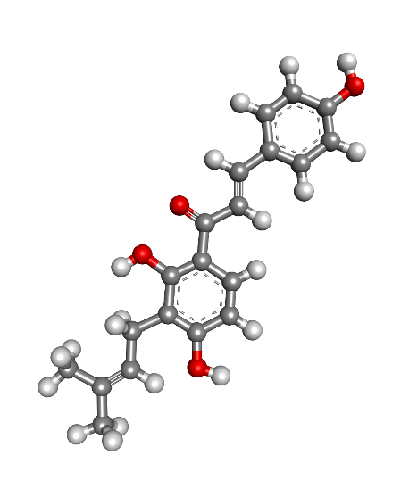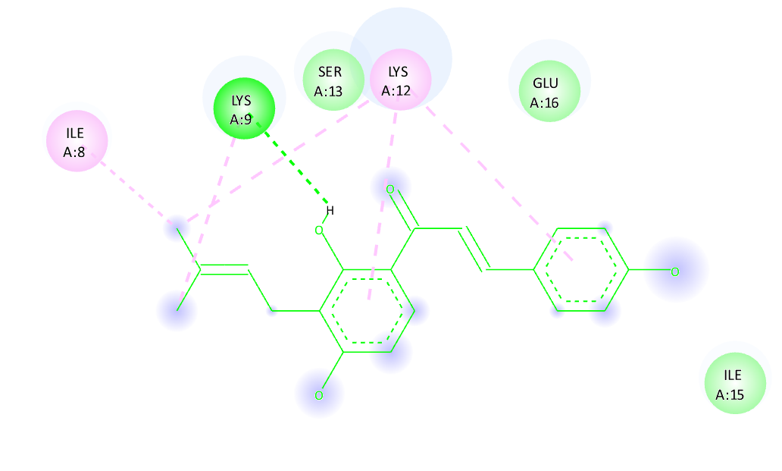
A.
B.

Figure S1: A. Structure of Isobavachalcone (IBC). B. 2D plot of the heteromolecular interactions of PSM-IBC docked complex. The interactions can be visualized as colored traces where dark green traces denote hydrogen bonding and pink traces denote alkyl interactions.
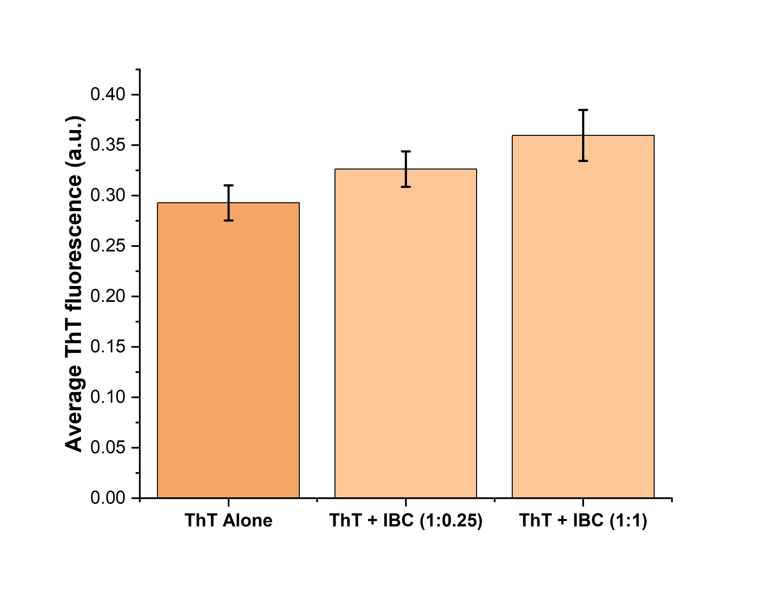
Figure S2: ThT fluorescence in the presence and absence of the lowest and highest concentration of IBC (No quenching of ThT fluorescence is observed in the presence of IBC).

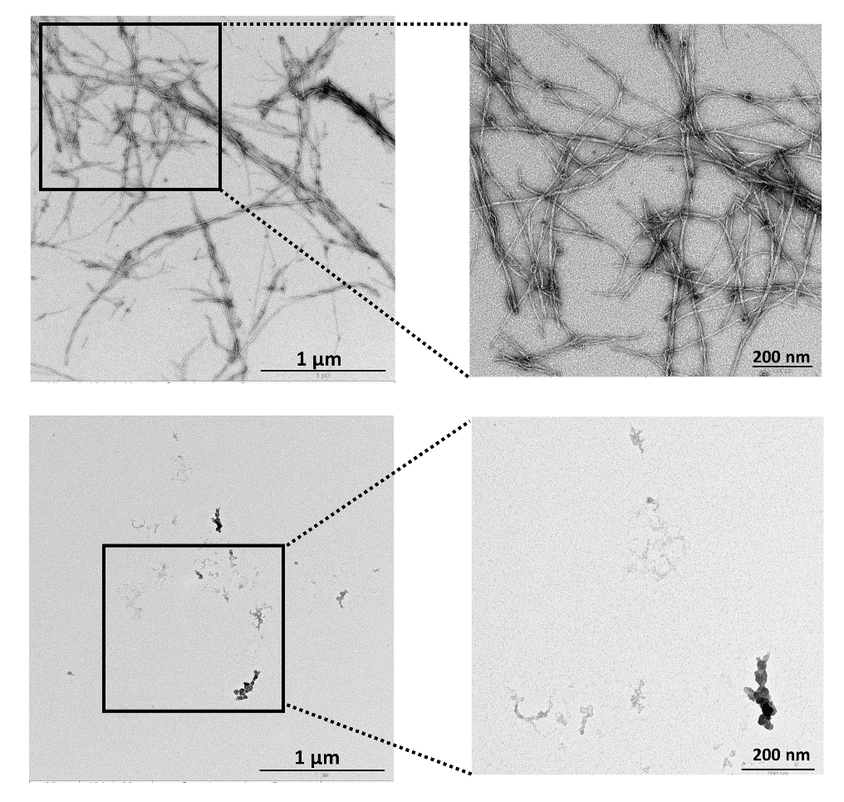
B
A
Figure S3: TEM micrograph showing a decrease in PSM α1 fibrillar load in presence of IBC (200 µM). A. PSM α1 fibrillar aggregates obtained at the end-stage of amyloid transformation. B. PSM α1 aggregates obtained in presence of IBC at the end-stage of aggregation kinetics.

Table S1: Kinetic parameters of PSM α1amyloid transformation.

 | Lag Time | ThT Maxima
PSM alone | 28.22 ±4.5 | 80.34 ±1.92
PSM+IBC (1:0.25) | 31.035 ± 1.7 | 8.91 ±1.5
PSM+IBC (1:0.5) | 42.55 ± 0.5 | 5.45 ±0.18
PSM+IBC (1:1) | N.D.** | 0.59 ±0.01

** N.D. Not determined. Lag time could not be calculated at the highest concentration as there was no significant rise in the ThT fluorescence.

