Supplementary materials
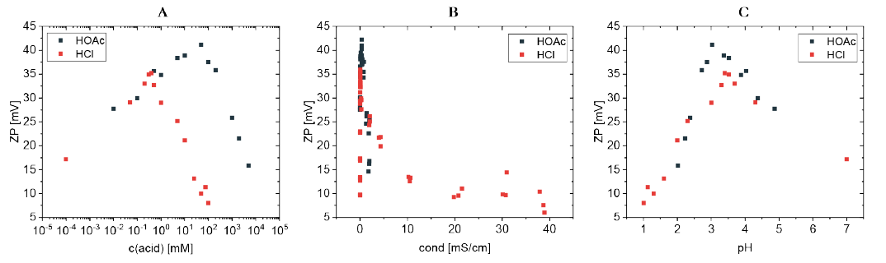
Figure S1. Titration curve for cationic CNC with acetic (HOAc) or hydrochloric acid (HCl). Equivalence point at pH ca. 3 for HOAc and ca. 3,5 for HCl.

Thermal properties
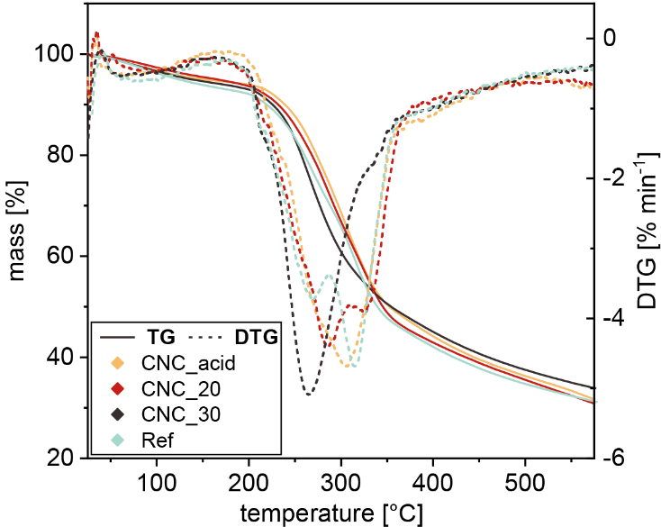
TGA reveals no significant differences in the thermal stability of most of the investigated fibers. The mass loss peak of CNC_30 appears shifted towards lower temperature. The lower degradation point could be related to a lower density and higher specific surface area, promoting the evaporation of volatile fragments (compare Table 1).
Figure S 2. TGA and DTG curves of the fabricated fibers

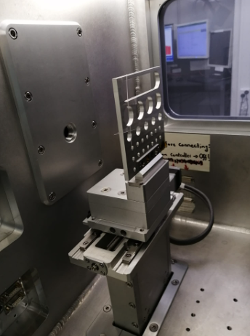
Figure S 3. Setup for the WAXS measurements

