Fig. S1. Histogram of NR distribution of predicted proteins from P. longispora.
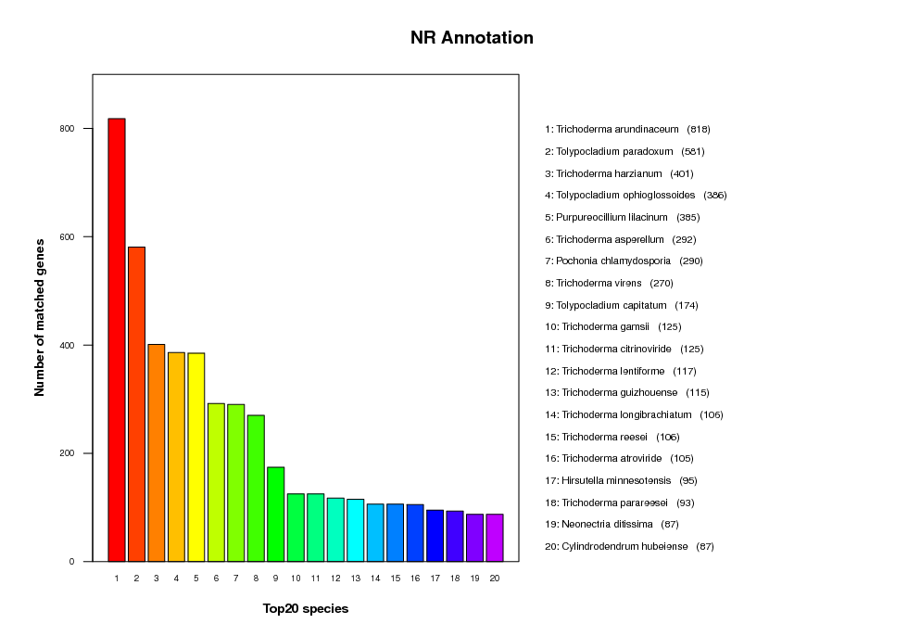
Fig. S2. Histogram of KOG distribution of predicted proteins from P. longispora.
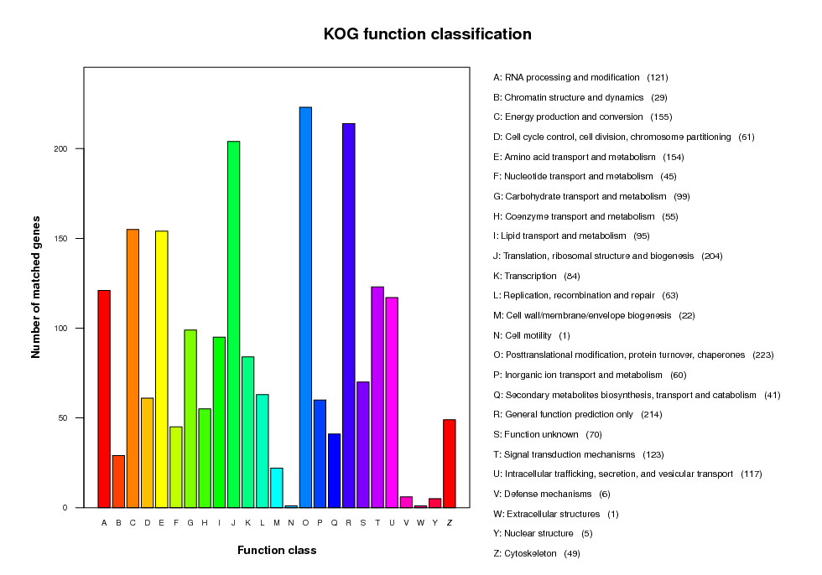

Fig. S3. Histogram of TCDB distribution of predicted proteins from P. longispora.
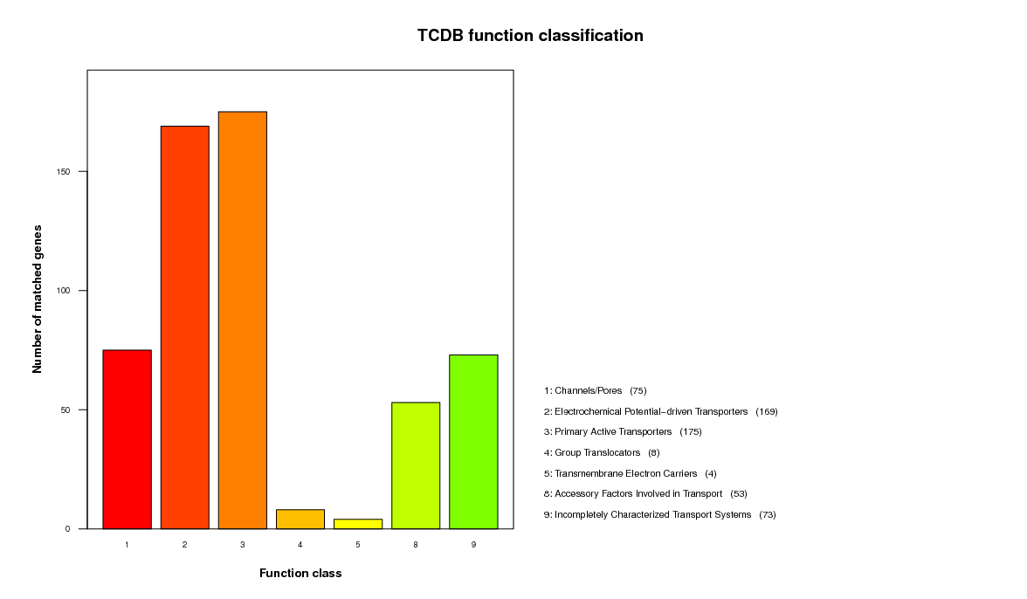
Fig. S4. Histogram of PHI distribution of predicted proteins from P. longispora.

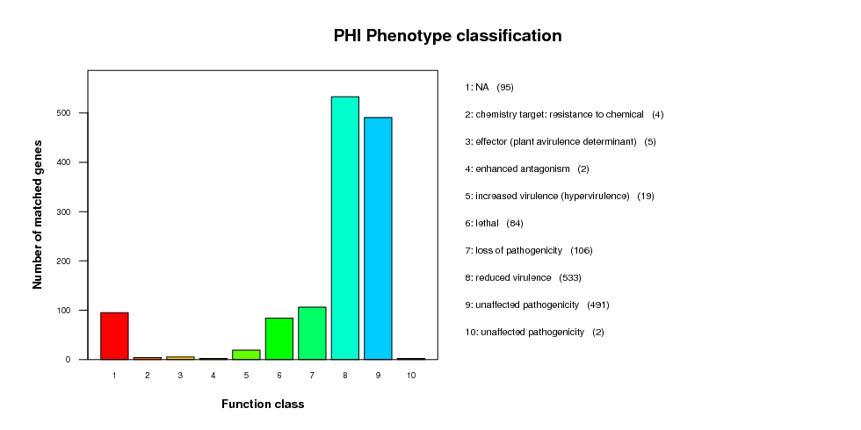
Fig. S5. Histogram of P450 distribution of predicted proteins from P. longispora.
