Peritumoral Edema Enhances MRI-based Deep Learning Radiomic Model for Axillary Lymph Node Metastasis Burden Prediction in Breast Cancer
Author list: Hongbing Luo^{1#*}, Zhe Chen ^{1#}, Hao Xu¹, Jing Ren¹, Peng Zhou^{1*}
Supplementary Materials
- Methods
1.1 TRIPOD checklist
TRIPOD checklist of this study was presented in Appendix.
1.2 Parameters of T2WI and two DCE-MRI protocols in this study
Turbo-Inversion Recovery-Magnitude sequences (TIRM): repetition time (TR), 3570 ms; echo time (TE), 70 ms; inversion time, 230 ms; number of excitations (NEX), 2; field of view (FOV), 340 × 340 mm; matrix, 358 × 448 mm; slice thickness, 4 mm; total acquisition time, 3 min 29 s.
DCE-MRI Protocol 1 (September 2017 - December 2018) was utilized for model development. It included 26 consecutive phases using the commercially available CAIPIRINHA-Dixon-TWIST-VIBE sequence (Siemens Healthcare): TR, 5.64 ms; TE, 2.46 ms; echo train length (ETL), 32; NEX, 1; FOV, 360 × 360 mm; slice thickness, 2.5 mm; no gap; matrix, 269 × 384; flip angle, 10°; acquisition type, 3D; temporal resolution, 12.0 s/phase; and total acquisition time (TA), 5 min 12 s. The images were reconstructed from the k-space using the inverse fourier transform with interleaved stochastic trajectories method.
DCE-MRI Protocol 2 (February 2019 - January 2020) was used for model validation. It included 20 consecutive phases using the homemade sequence: TR, 5.06 ms; TE, 1.83 ms; ETL, 32; NEX, 1; FOV, 340 × 255 mm; slice thickness, 2.5 mm; no gap; matrix, 320 × 240; flip angle, 10°; acquisition type, 3D; temporal resolution, 16.6 s/phase; and TA, 5 min 33 s. The images were reconstructed from the k-space using the inverse fourier transform with linear filling method.
1.3 Interpreting T2WI findings
The examples of peritumoral edema (PE) types in the ipsilateral breast were showed in Figure S1, and the examples of PE degree with corresponding definitions were provided in Figure S2
1.4 Radiomic workflow
1.4.1 Image processing, segmentation, and extraction of radiomic features
Image preprocessing, conducted using the Artificial Intelligence Kit (A.K., version 3.2.0, GE Healthcare) software, involved resampling to 1 × 1 × 1 mm³ isotropic voxels, Gaussian anti-aliasing, and bias-field correction. Voxel intensity values were then normalized using z-score. Manual delineation of the MRI-visible tumor (index tumor) was performed using ITK-SNAP (version 3.8.0, http://www.itksnap.org). Peritumoral regions were obtained through 3-dimensional dilation with a 4 mm radius using A.K. software ^{1,2}. These segmentations were carried out by a radiologist (X.H) with 5 years of experience. For inter-observer agreement assessment, 30 randomly selected cases were re-segmented by radiologist (L.H.B). Reliability was evaluated using intraclass correlation coefficient (ICC), retaining features with ICC values >0.75 for further analysis. The process of radiomic features was utilized PyRadiomics (version 3.0, https://pyradiomics.readthedocs.io), aligning with the image biomarker standardization initiative (IBSI) standard ³.
1.4.2 Original features description
The 104 original radiomic features including shape, first order, and texture features are listed in Table S1. Most features are in compliance with feature definitions as described by the Imaging Biomarker Standardisation Initiative (IBSI). The parameters to compute the texture features are summarized in Table S2. The detailed definitions of all these features are available online (https://pyradiomics.readthedocs.io/en/latest/features.html).
1.5 The workflow for developing and optimizing deep learning models
The loss and accuracy trends during the development and optimization of deep learning in this study were presented in Figure S4-S5.
1.6 The R packages used in this study
The "vcd" package (version 1.4.11) was utilized to evaluate inter- and intra-observer agreement of MRI findings.
The "glmnet" package (version 4.1.7) was use to select the most predictive features associated with ALNM-high burden by the least absolute shrinkage and selection operator (LASSO).
The "keras_model_sequential" function from the "keras" package (version 2.11.1) was utilized to develop and optimize deep learning models in the training cohort. The TensorFlow version used was 2.11.0.
The "glm" function in R was utilized to construct the MRI model in the training cohort, and stepAIC from the "MASS" package (version 7.3.60) was employed for stepwise regression analysis.
The "plotROC" package (version 2.3.0) and "ggplot2" package (version 3.4.2) was utilized to plot melted ROC of three models.
The "ggpubr" package (version 0.6.0) was utilized to generate boxplots for the training and validation cohort. The "patchwork" package (version 1.1.2) in R was employed to combine the plots of the training and validation cohort.
The discrimination metrics, including the area under the curve (AUC), accuracy, sensitivity, specificity, positive predictive value (PPV), negative predictive value (NPV) and F1 score of the model, were computed using the "pROC" package (version 1.18.2) and the "confusionMatrix" function in the "caret" package (version 6.0.94). These metrics were computed in both the training and validation cohorts using the cut-off value identified by the Youden index.
The "rmda" package (version 1.6) was used to perform decision curve analysis (DCA) of combined model. The "rms" package (version 6.7.0) was utilized to construct and visualize the nomogram and the calibration of combined model. The "ResourceSelection" package (version 0.3.5) was used to perform the Hosmer-Lemeshow test in both the primary and validation cohorts.
The "PredictABEL" package (version 1.2.4) was utilized to calculate the net reclassification improvement (NRI), and integrated discrimination improvement (IDI) of peritumoral edema in the validation cohort.
2. Results
2.1 ALNM burden predictor from radiomic features
2.1.1 Feature selection
For the training cohort, the process of LASSO analysis was presented in Figure S3.
2.1.2 Multicollinearity of selected radiomic features
The Spearman correlations among the selected radiomic feature were presented in Table S3.
2.2 Developing and optimizing deep learning models in this study
The validation loss values during the optimization process of the deep learning model, achieved by tuning its hyperparameters, were visualized in Figure S6. The hyperparameters and performance in the train and validation cohorts during training and optimizing deep learning models were presented in Table S4.
2.3 Performance metric in the training set
The final deep learning combined model achieved a higher AUC of 0.953 in the training cohort, compared to the MRI model (AUC = 0.849, p = 0.004) and DLR model (AUC = 0.867, p < 0.001). Categorical NRI values were 0.551 (95% CI: 0.357 to 0.745; p < 0.001), while IDI values were 0.343 (95% CI: 0.230 to 0.436; p < 0.001) in the training cohorts.
3. Discussion
3.1 Comparation between our study with prior similar research and cohorts were provided in Table S5.

Table S1. Overview of 104 original radiomic features.
Category | Features | Counts
Shape | Elongation, Flatness, Least axis length, Major axis length, Maximum 2D diameter (column), Maximum 2D diameter (row), Maximum 2D diameter (slice), Maximum 3D diameter, Mesh volume, Minor axis length, Sphericity, Surface area, Surface area to volume ratio, Voxel volume | 14
First order | 10 Percentile, 90 Percentile, Energy, Entropy, Interquartile range, Kurtosisª, Maximum, Mean absolute deviation, Mean, Median, Minimum, Range, Robust mean absolute deviation, Root mean squared, Skewness, Total energy^{b}, Uniformity, Variance | 18
Texture
GLCM | Autocorrelation, Cluster prominence, Cluster shade, Cluster tendency, Contrast, Correlation, Difference average, Difference entropy, Difference variance, Inverse difference normalized (Idn), Inverse difference (Id), Inverse difference moment normalized (Idmn), Inverse difference moment (Idm), Informational measure of correlation 1 (Imc1), Informational measure of correlation 2 (Imc2), Inverse variance, Joint average, Joint energy, Joint entropy, Maximum probability, Sum entropy | 21
GLRLM | Gray level non-uniformity (GLN), Gray level non-uniformity normalized (GLNN), Gray level variance (GLV), High gray level run emphasis (HGLRE), Long run emphasis (LRE), Long run high gray level emphasis (LRHGLE), Long run low gray level emphasis (LRLGLE), Low gray level run emphasis (LGLRE), Run entropy (RE), Run length non-uniformity (RLN), Run length non-uniformity normalized (RLNN), Run percentage (RP), Run variance (RV), Short run emphasis (SRE), Short run high gray level emphasis (SRHGLE), Short run low gray level emphasis (SRLGLE) | 16
GLSZM | Gray level non-uniformity (GLN), Gray level non-uniformity normalized (GLNN), Gray level variance (GLV), High gray level zone emphasis (HGLZE), Large area emphasis (LAE), Large area high gray level emphasis (LAHGLE), Large area low gray level emphasis (LALGLE), Low gray level zone emphasis (LGLZE), Size zone non-uniformity (SZN), Size zone non-uniformity normalized (SZNN), Small area emphasis (SAE), Small area high gray level emphasis (SAHGLE), Small area low gray level emphasis (SALGLE), Zone entropy (ZE), Zone percentage (ZP), Zone variance (ZV) | 16
GLDM | Dependence entropy (DE), Dependence non-uniformity (DN), Dependence non-uniformity normalized (DNN), Dependence variance (DV), Gray level non-uniformity (GLN), Gray level variance (GLV), High gray level emphasis (HGLE), Large dependence emphasis (LDE), Large dependence high gray level emphasis (LDHGLE), Large dependence low gray level emphasis (LDLGLE), Low gray level emphasis (LGLE), Small dependence emphasis (SDE), Small dependence high gray level emphasis (SDHGLE), Small dependence low gray level emphasis (SDLGLE) | 14
NGTDM | Busyness, Coarseness, Complexity, Contrast, Strength | 5
GLCM, gray-level cooccurrence matrix; GLRLM, gray-level run length matrix; GLSZM, gray level size zone matrix; GLDM, gray level dependence matrix; NGTDM, neighbouring gray tone difference matrix; IBSI, Imaging Biomarker Standardisation Initiative.
ª The kurtosis is not corrected by -3, yielding a value 3 higher than the IBSI kurtosis.
^{b} Total energy is not present in IBSI feature definitions.

Table S2. Computation parameters of texture features.
Category | Matrix aggregation | Distance weighting | Chebyshev distance | Other
GLCM | ITBBª | no weighting | 1 | symmetric matrix
GLRLM | ITBBª | no weighting | - | -
GLSZM | KOBO^{b} | - | 1 | -
GLDM | KOBO^{b} | no weighting | 1 | coarseness parameter α =0
NGTDM | KOBO^{b} | no weighting | 1 | -
GLCM, gray-level cooccurrence matrix; GLRLM, gray-level run length matrix; GLSZM, gray level size zone matrix; GLDM, gray level dependence matrix; NGTDM, neighbouring gray tone difference matrix; IBSI, Imaging Biomarker Standardisation Initiative.
ª Features are computed from each 3D directional matrix and averaged over the 3D directions (IBSI code ITBB)
^{b} The feature is computed from a 3D matrix (IBSI code KOBO).

Table S3. Multicollinearity of selected features in the training cohort.
 | GLCM_Correlation | firstorder_InterquartileRange | GLCM_ClusterShade
GLCM_Correlation | 1.000 (NA) | -0.027 (0.721) | -0.131 (0.082)
firstorder_InterquartileRange | -0.027 (0.721) | 1.000 (NA) | -0.001 (0.994)
GLCM_ClusterShade | -0.131 (0.082) | -0.001 (0.994) | 1.000 (NA)
Statistics P values are included in brackets. GLCM, gray-level cooccurrence matrix.

Table S4. The hyperparameters and performance in the train and validation cohorts during training and optimizing deep learning models
 | Hyperparameters and performance | Baseline model | Model 2 | Model3 | DLR model
Sequential model building | Dense layers of each hidden layers | 64 per units | 128 per units | 128 per units | 128 per units
Sequential model building | L2 regularizer | none | 0.001 | 0.001 | 0.001
Sequential model building | Dropout rate of hidden layers | 0.5 | 0.2 | 0.2 | 0.2
Sequential model building | Activation in hidden layers | ReLU | ReLU | ReLU | ReLU
Sequential model building | Activation in final layers | Sigmoid | Sigmoid | Sigmoid | Sigmoid
Model compiling | Loss | binary-crossentropy | binary-crossentropy | binary-crossentropy | binary-crossentropy
Model compiling | Optimizer | adam | adam | adam | adam
Model compiling | Metrics | accuracy | accuracy | accuracy | accuracy
Model compiling | Batch_size | 32 | 32 | 32 | 32
Model compiling | Epochs | 10 | 20 | 30 | 20
Model's performance monitoring | Loss in the training cohort | 0.419 | 0.300 | 0.327 | 0.448
Model's performance monitoring | Accuracy in the training cohort | 0.785 | 0.915 | 0.927 | 0.831
Model's performance monitoring | Loss in the validation cohort | 0.413 | 0.310 | 0.384 | 0.557
Model's performance monitoring | Accuracy in validation cohort | 0.829 | 0.946 | 0.928 | 0.802
DLR, deep learning radiomic; ReLU, Rectified Linear Unit

Table S5 Comparation between our study with prior similar research and cohorts.
Study | Task | Sample Size | Modalities | Protocols | Models | Performance
Jing Zhang.et al⁴ | ALNM prediction | 1618 | MRI | DCE-MRI | Machine learning-based Radiomic | AUC 0.89
Josip Vrdoljak.et al⁵ | ALNM prediction | NA | MRI and ultrasound | NA | Machine learning (ML) /Deep learning (DL) | AUC 0.82-94
Lu Han.et al⁶ | ANNM prediction | 411 | MRI | T1-DCE | SVM | AUC 0.76-0.78
Lu Han.et al | ANNM burden prediction | 411 | MRI | T1-DCE | SVM-based Radiomic | AUC 0.79
Zeyan Xu.et al⁷ | ANNM burden prediction | 1092 | MRI | T2WI | Logistic regression model | AUC 0.71 in training cohort, 0.69 in validation cohort
Yunfang Yu. et al⁸ | ANNM prediction | 1214 | MRI | T1-DCE, T2WI, and DWI-ADC | Least absolute shrinkage and selection operator (LASSO)–logistic regression model | AUC 0.92 in training cohort, 0.90 in validation cohort
Yunfang Yu. et al | ANNM burden prediction | 1214 | MRI | T1-DCE, T2WI, and DWI-ADC | Least absolute shrinkage and selection operator (LASSO)–logistic regression model | AUC 0.96 in training cohort, 0.90 in validation cohort
Su Jeong Hyun. et al⁹ | ANNM burden prediction | 425 | MRI |  | No models | The NPV of negative MRI findings for exclusion of pN2-pN3 was 99.6 for the no-NAC group and 94% for the neoadjuvant chemotherapy (NAC) group
Colleen H Neal. et al¹⁰ | ANNM burden prediction | 435 | Ultrasonography |  | No models | The NPV of negative MRI findings for exclusion of pN2-pN3 was 93.3%
Xueyi Zheng. et al¹¹ | ANNM burden prediction | 1342 | Ultrasonography |  | Deep learning radiomics (DLR) | AUC 0.956 in the training cohort and 0.905 in the test cohort

Figure S1. Example of peritumoral edema types in the ipsilateral breast, A1-E1 was the fat-suppressed T2-weighted axial breast MRI imaging (T2WI), and A2-E2 represents the early phase of the fat-suppressed T1-weighted axial contrast-enhanced image (DCE-MRI) in the corresponding same patient, showing a clear enhancement of the index tumor as a reference: (A1-A2) Type 0 (no edema), there was no high signal intensity around the index tumor (white arrow). (B1-B2) Type 1 (peritumoral edema), showed the presence of the hyperintensity regions similar to water around the index tumor (white arrow). (C1-C2) Type 2 (pre-pectoral edema), exhibited the presence of water-like hyperintensity extended to the anterior space of the pectoralis major muscle (white arrow). (D1-D2) Type 3 (subcutaneous edema), showed hyperintensity in the skin and subcutaneous fat (white arrow). (E1-E2) Type 4 (diffuse edema), showed diffuse hyperintensity in the ipsilateral breast.
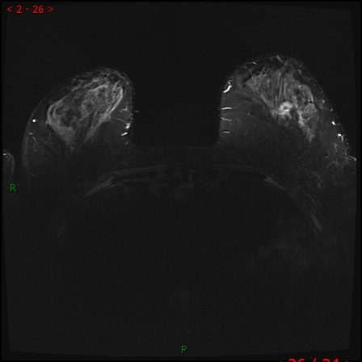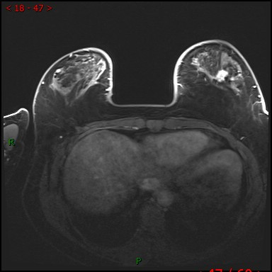
A1 A2
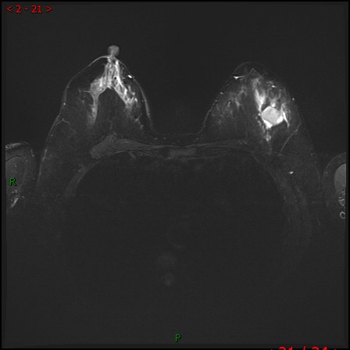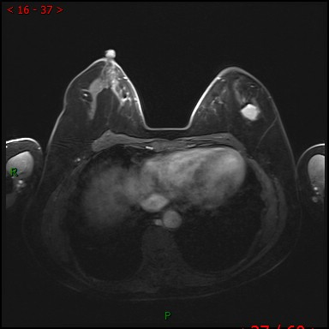
B1 B2
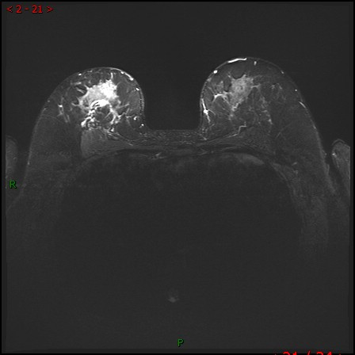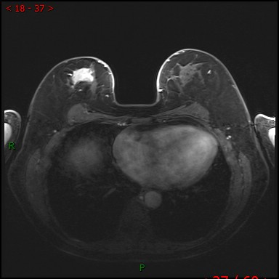
C1 C2
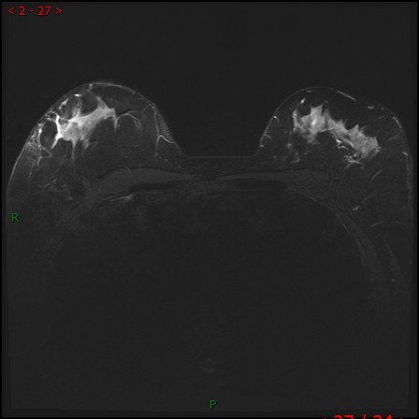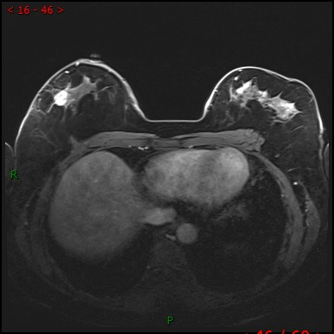
D1 D2
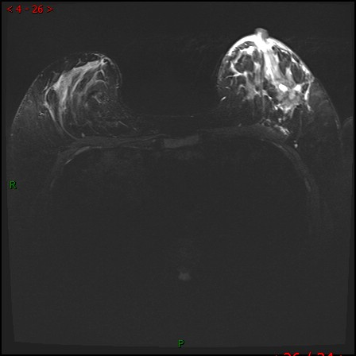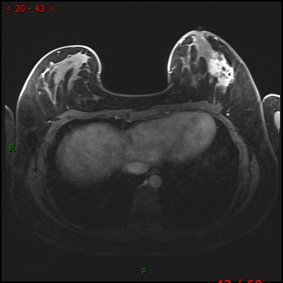
E1 E2
Figure S2. Example of peritumoral edema degrees in the ipsilateral breast, A1-D1 was the fat-suppressed T2-weighted axial breast MRI imaging (T2WI), and A2-D2 represents the early phase of the fat-suppressed T1-weighted axial contrast-enhanced image (DCE-MRI) in the corresponding same patient, showing a clear enhancement of the index tumor as a reference: (A1-A2) Grade 0 (no edema). (B1-B2) Grade 1 (mild edema) was defined as the extent of edema (white arrow) that was much smaller than that of the index tumor (white arrow head). (C1-C2) Grade 2 (moderate edema) was defined as the extent of edema (white arrow) that was almost equal to the index tumor (white arrow head). (D1-D2) Grade 3 (marked edema) was defined as the extent of edema (white arrow) that was much larger than that of the index tumor (white arrow head).
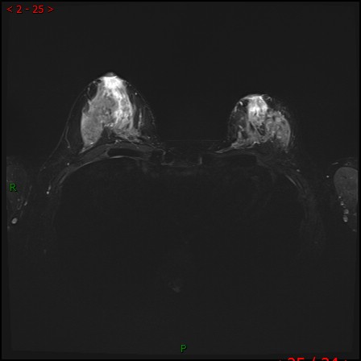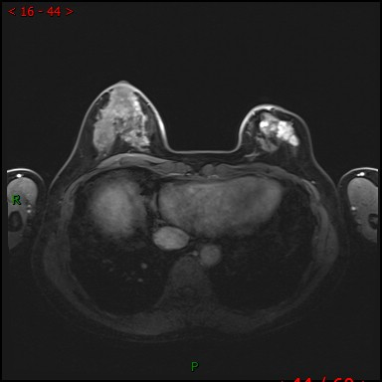
A1 A2
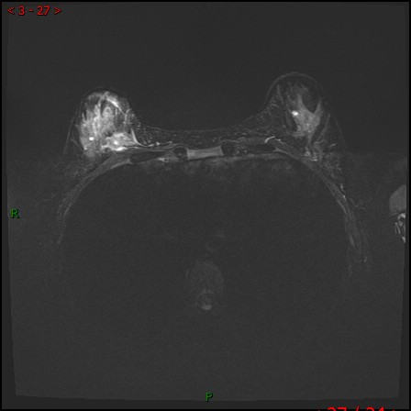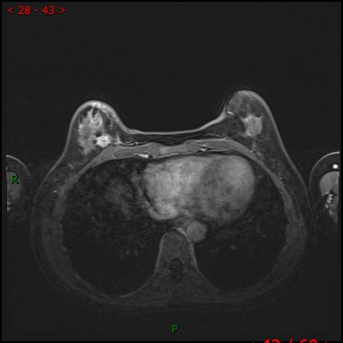
B1 B2
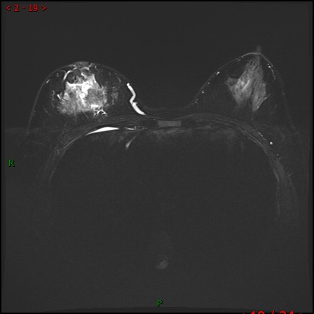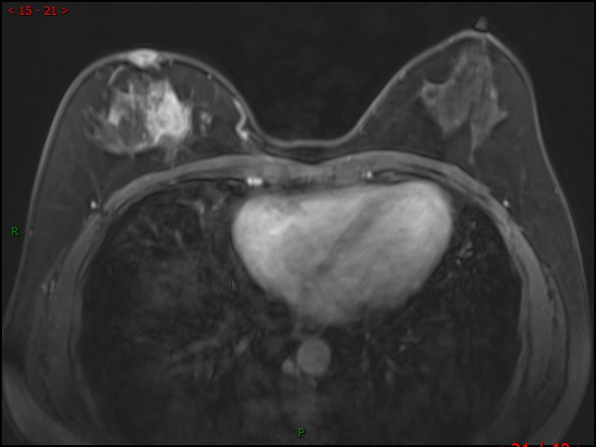
C1 C2
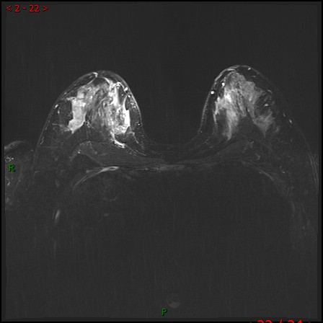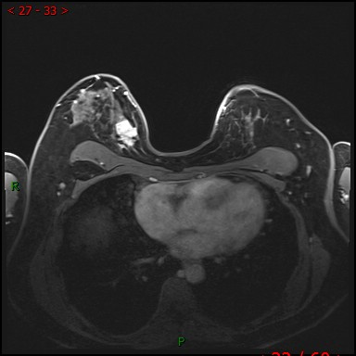
D1 D2
Figure S3. Radiomic feature selection based on LASSO binary logistic regression model in the training cohort. (a) 10-fold cross-validation via 1 standard error of the minimum criteria (1-SE criteria) in the lasso model was used to select feature by tuning parameter lambda (λ). Binomial deviances from the LASSO regression cross-validation procedure are plotted as a function of log (λ). (b) The optimal λ obtains 3 nonzero coefficients. LASSO, least absolute shrinkage and selection operator.
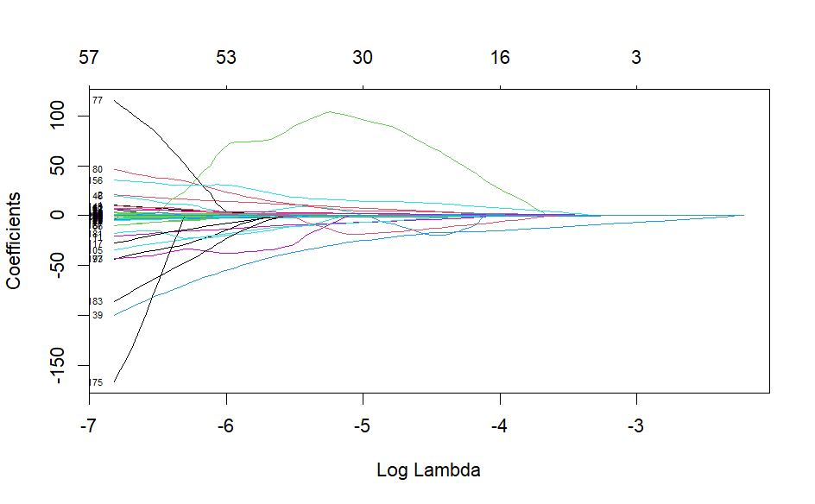
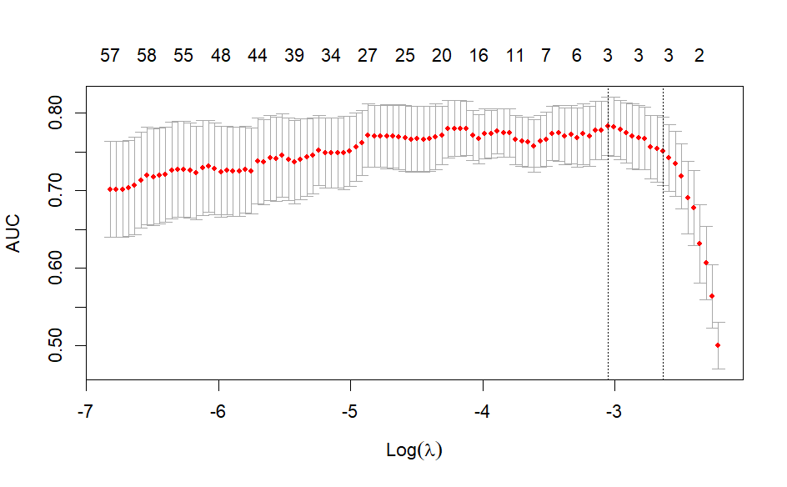
A B
Figure S4. The development and optimization of the deep learning combined model. (a) The loss and accuracy of the baseline deep learning model across epochs in the training and validation cohorts. (b) The loss and accuracy of the deep learning model 2 in the training and validation cohorts. (c) The loss and accuracy of the deep learning model 3 in the training and validation cohorts.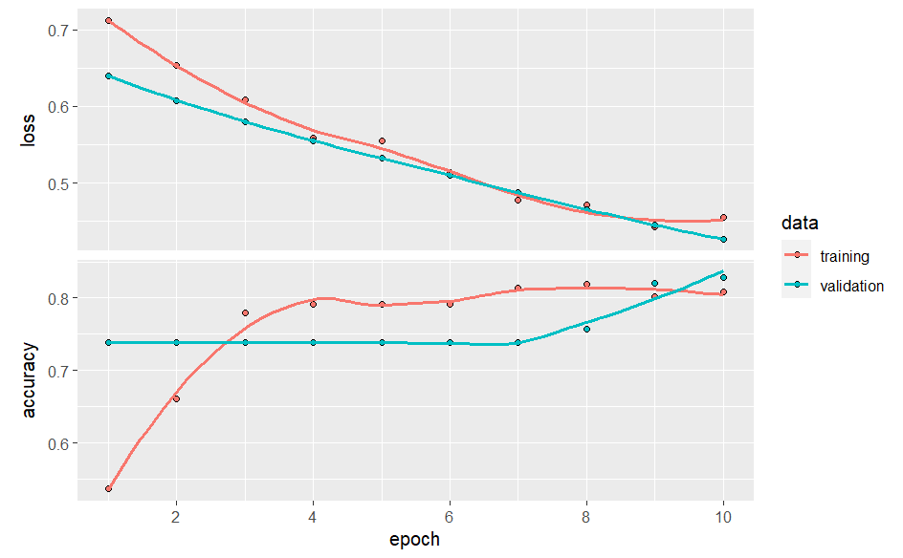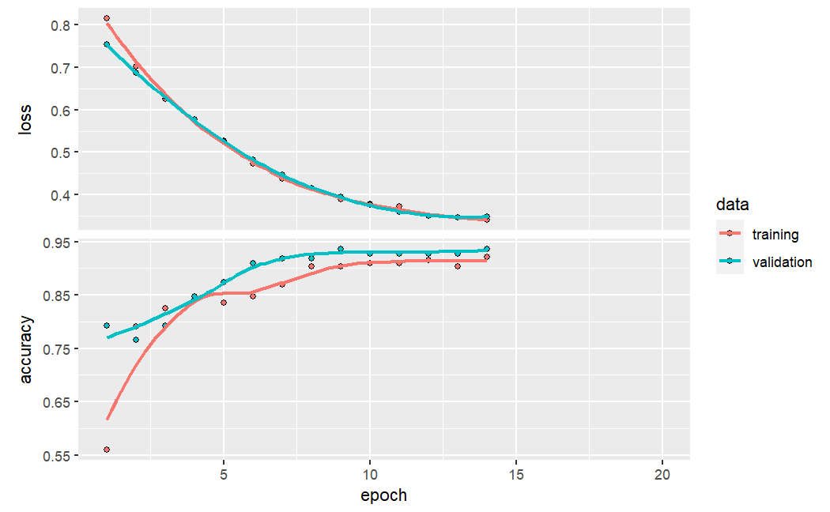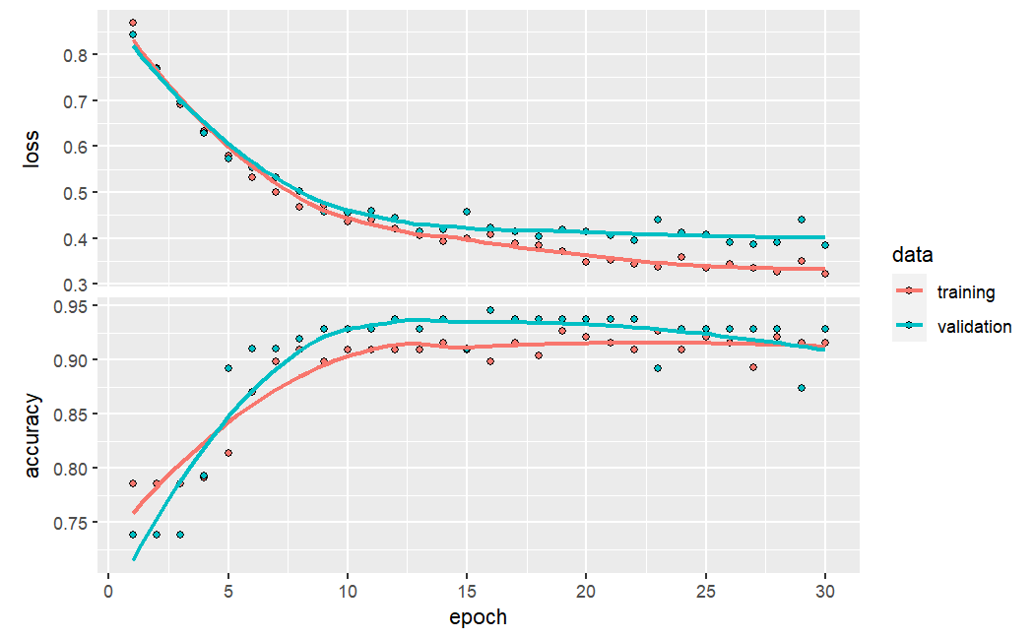
A B C
Figure S5. The loss and accuracy of the deep learning radiomic model in the training and validation cohorts.
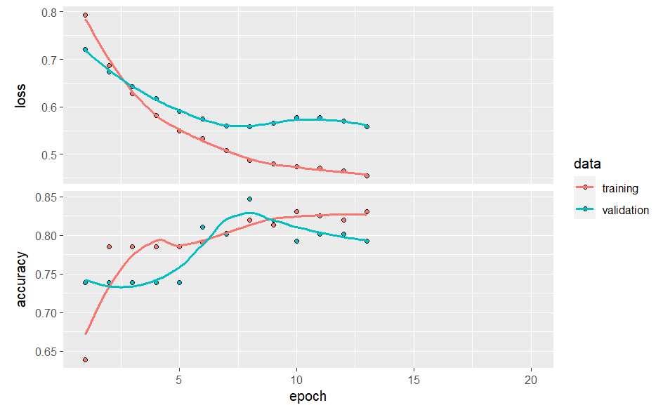
Figure S6. The figure illustrates the validation loss values in the validation cohort during the optimization process of the deep learning model by tuning its hyperparameters. The x-axis represents the number of epochs, while the y-axis represents the corresponding validation loss. Each curve corresponds to a deep learning model, distinguished by color. Model 2 (red curve) exhibited lower validation loss values, suggesting superior model performance and enhanced generalization ability.
Figure S7. The calibration curve of the nomogram depicting the relationship between predicted probability of high burden axillary lymph nodes metastasis (ALNM) from the nomogram and the actual rate of high burden ALNM, as obtained using the calibration method with bootstrapping (B = 1000). The x-axis represents the predicted probability of ALNM high burden from the nomogram, while the y-axis represents the actual rate of ALNM high burden. The mean absolute error (MAE) values are both 0.04 in the training and validation cohort, indicating minimal prediction errors for ALNM burden by the nomogram in both cohorts.
Figure S8. The decision curve analysis (DCA) was performed to compare the net benefit of three models in predicting axillary lymph nodes metastasis (ALNM) burden. The combined model showed higher net benefit compared to the MRI and radiomic based model. The y-axis represents the net benefit, while the x-axis represents the threshold probability. The red line represents the combined model, the blue line represents the radiomic-based model, and the green line represents the MRI model. The thin grey line represents the assumption that all patients have high burden ALNM, and the black line represents the assumption that none of the patients have high burden ALNM.

Appendix. TRIPOD Checklist for prediction model development and validation with explanation and elaboration in form of text excerpts and responses. Some of the items were not applicable (NA) to the current study.
Section/Topic | Item |  | Checklist Item | Page | Explanation and Elaboration in form of Text Excerpts
Title and abstract
Title | 1 | D;V | Peritumoral Edema Enhances MRI-based Deep Learning Radiomic Model for Axillary Lymph Node Metastasis Burden Prediction in Breast Cancer | 1 | “Development and External Validation of Deep Learning Prediction Models for ALNM Burden in Breast Cancer Patients;  A retrospective, single-institution, deep learning radiomic analysis”
Abstract | 2 | D;V | Provide a summary of objectives, study design, setting, participants, sample size, predictors, outcome, statistical analysis, results, and conclusions. | 1 | Objectives, Study design: “To develop and external validate deep learning model by combining PE with intra and peritumoral radiomic to predict ALNM burden, based on MRI.”  Participants / Outcome: “Invasive breast cancer proved by surgery/ ALNM burden.”  Sample size: “N total=288”  Predictors: PE and intra- and peritumoral radiomic features.  Statistical analysis: “Deep learning models were developed in the training cohort and validated in an independent cohort. […] using the net reclassification improvement (NRI) and integrated discrimination improvement (IDI) metrics.”  Results: “The deep learning combined model, incorporating PE with selected radiomic features, demonstrated significantly higher AUC values compared to the MRI model and the DLR model […] These results were confirmed in the validation cohort (Categorical NRI: 0.539, p < 0.001; IDI =0.387, p < 0.001).”  Conclusions: “PE improved […] in breast cancer patients”.
Introduction
Background and objectives | 3a | D;V | Explain the medical context (including whether diagnostic or prognostic) and rationale for developing or validating the multivariable prediction model, including references to existing models. | 4-6 | Explain the medical context: “Axillary lymph node metastasis (ALNM) is an important predictor […] Thus, accurate assessment of ALNM burden by preoperative imaging is now considered to be critical to guide individualized axillary management for patients with breast cancer”.  Explain the rationale for developing and validating the prediction model, including references to existing models: “The commonly used imaging modalities for staging ALNM in breast cancer patients include Ultrasonography (US), magnetic resonance imaging (MRI), mammography, and positron emission tomography/computed tomography (PET/CT). […] Hence, it is imperative to establish novel imaging techniques that can accurately predict ALNM burden for such patients.”  References to existing researches: “Recent advancements and integrations in the fields of artificial intelligence technology and radiomics […] However, the potential advantage of integrating PE with intra- and peri-tumoral radiomic features for preoperative prediction of ALNM burden in breast cancer patients has not been thoroughly explored.”
Background and objectives | 3b | D;V | Specify the objectives, including whether the study describes the development or validation of the model or both. | 6 | “Therefore, we aimed to develop and validate a non-invasive deep learning imaging model for preoperative prediction of ALNM burden, according to the cut-off values for axillary surgery specified by the ACOSOG Z0011 trial.”
Methods
Source of data | 4a | D;V | Describe the study design or source of data (e.g., randomized trial, cohort, or registry data), separately for the development and validation data sets, if applicable. | 7 | “The participants in this study were previously described in our prior study, which had a different research focus […] Further information regarding inclusion and exclusion criteria, as well as patient details, can be found in the Supplementary Materials.”
Source of data | 4b | D;V | Specify the key study dates, including start of accrual; end of accrual; and, if applicable, end of follow-up. | 7/13 | “In summary, a total of 374 consecutive female patients were retrospectively enrolled between September 2017 and January 2020.” and “They were split into a training cohort (n=177, Sep 2017 - Dec 2018) and an independent validation cohort (n=111, Feb 2019 - Jan 2020) based on different DCE-MRI acquisition protocols.”
Participants | 5a | D;V | Specify key elements of the study setting (e.g., primary care, secondary care, general population) including number and location of centres. | 7 | “In summary, a total of 374 consecutive female patients were retrospectively enrolled”.
Participants | 5b | D;V | Describe eligibility criteria for participants. | 7 | “Further information regarding inclusion and exclusion criteria, as well as patient details, can be found in the Supplementary Materials.”  ”
Participants | 5c | D;V | Give details of treatments received, if relevant. |  | NA
Outcome | 6a | D;V | Clearly define the outcome that is predicted by the prediction model, including how and when assessed. | 7 | ALNM burden proved by either SLNB alone, ALND after SLNB, or ALND directly was the prediction outcome.
Outcome | 6b | D;V | Report any actions to blind assessment of the outcome to be predicted. |  | NA
Predictors | 7a | D;V | Clearly define all predictors used in developing or validating the multivariable prediction model, including how and when they were measured. | 8/9/10 | “Radiologist 1 (L.H.B., 15 years of experience) assessed findings on T2WI. […] To prevent overfitting, we employed 10-fold cross-validation and utilized the penalty parameter lambda.1se as the criteria. The process of radiomic features selection were presented in Supplementary Materials (Figure S3 and Table S4).”
Predictors | 7b | D;V | Report any actions to blind assessment of predictors for the outcome and other predictors. | 9 | Both radiologists were blinded to the pathological information when evaluating the PE on T2WI
Sample size | 8 | D;V | Explain how the study size was arrived at. | 11-12 | The sample size was determined by the availability of patients during the study period, given the retrospective nature of this study.
Missing data | 9 | D;V | Describe how missing data were handled (e.g., complete-case analysis, single imputation, multiple imputation) with details of any imputation method. | 7 | To ensure the reliability of our data, we conducted a complete-case analysis.
Statistical analysis methods | 10a | D | Describe how predictors were handled in the analyses. | 8/9/10 | In “Materials and methods” section, the handling of predictors was reported in the "MRI Interpretation on T2WI" and "Radiomic Workflow" subsections. These subsections provide a comprehensive explanation of how predictors were processed and selected before the model-building.
 | 10b | D | Specify type of model, all model-building procedures (including any predictor selection), and method for internal validation. | 10/11 | The type of model developed in this study was a deep learning model.  In the "Model developing and validating" section, we provided a detailed description of the type of model used, as well as all the model-building procedures.
 | 10c | V | For validation, describe how the predictions were calculated. |  | The predictions in validation cohort were calculated the same as that in the development cohort.
 | 10d | D;V | Specify all measures used to assess model performance and, if relevant, to compare multiple models. | 12 | The discrimination, Calibration and clinical use  were all evaluated in the study. More details could be found in the “Model evaluation” section.
 | 10e | V | Describe any model updating (e.g., recalibration) arising from the validation, if done. | 12 | The incremental value of PE as an additional candidate predictor for deep learning radiomic model was assessed, using the NRI and IDI metrics.
Risk groups | 11 | D;V | Provide details on how risk groups were created, if done. |  | Our prediction model was used for prediction a dichotomous ALNM burden (high burden VS. low burden)
Development vs. validation | 12 | V | For validation, identify any differences from the development data in setting, eligibility criteria, outcome, and predictors. |  | NA
Results
Participants | 1 3a | D;V | Describe the flow of participants through the study, including the number of participants with and without the outcome and, if applicable, a summary of the follow-up time. A diagram may be helpful. | 13 | A total of 288 patients, including 67 with ALNM-high burden, were included. They were split into a training cohort (n=177, Sep 2017 - Dec 2018) and an independent validation cohort (n=111, Feb 2019 - Jan 2020) based on different DCE-MRI acquisition protocols.
Participants | 1 3b | D;V | Describe the characteristics of the participants (basic demographics, clinical features, available predictors), including the number of participants with missing data for predictors and outcome. | Table1/13 | The baseline characteristics of the participants in this study was present in Table 1.
Participants | 1 3c | V | For validation, show a comparison with the development data of the distribution of important variables (demographics, predictors and outcome). | Table1/13 | Compared with the developing data, the characteristics of the participants in validation cohort was also present in Table1.
Model development | 1 4a | D | Specify the number of participants and outcome events in each analysis. | Table1/13 | A total of 288 patients, including 67 with ALNM-high burden, were included. (Table1).
Model development | 1 4b | D | If done, report the unadjusted association between each candidate predictor and outcome. |  | NA
Model specification | 1 5a | D | Present the full prediction model to allow predictions for individuals (i.e., all regression coefficients, and model intercept or baseline survival at a given time point). | 15/Figure6 | In this study, we developed a nomogram for the combined model, which enables personalized predictions of the ALNM burden for individual patients.
Model specification | 1 5b | D | Explain how to use the prediction model. | 26/ Figure 6 legends | Each variable is assigned a specific point value indicated at the top of the graph, and the total points obtained by summing up the individual variable points are represented by a line connecting the total points to the bottom line. This line provides an estimate of the probability of ALNM high burden.
Model performance | 16 | D;V | Report performance measures (with CIs) for the prediction model. | Table3/14 | The performance measures for three prediction models in our study was presented in Table3.
Model-updating | 17 | V | If done, report the results from any model updating (i.e., model specification, model performance). | Table2,3/14-15 | The results regarding model updating and comparisons were reported in the "Model evaluation" and "The adding value of PE" sections.
Discussion
Limitations | 18 | D;V | Discuss any limitations of the study (such as nonrepresentative sample, few events per predictor, missing data). | 18 | “The current study has several limitations.[…] Therefore, further studies involving larger datasets from different scanners are needed to ensure the generalizability of our findings.”
Interpretation | 1 9a | V | For validation, discuss the results with reference to performance in the development data, and any other validation data. |  | NA
Interpretation | 1 9b | D;V | Give an overall interpretation of the results, considering objectives, limitations, results from similar studies, and other relevant evidence. | 16/17/18 | “Our findings revealed that the DLC model, integrating PE on T2WI with DLR model from DCE-MRI, demonstrated a significant improvement in prediction performance. This enhancement was supported by improved discrimination, reliable calibration, higher net benefit, and was further confirmed through NRI and IDI analyses. […] further studies involving larger datasets from different centers and scanners are needed to validate the prediction performance and ensure generalizability of our findings.”
Implications | 20 | D;V | Discuss the potential clinical use of the model and implications for future research. | 16/18-19 | “We conducted this study to create a multiparametric MRI-based imaging model for ALNM burden prediction in breast cancer patients.” In page16. And “further studies involving larger datasets from different centers and scanners are needed to validate the prediction performance and ensure generalizability of our findings” in page 18-19.
Other information
Supplementary information | 21 | D;V | Provide information about the availability of supplementary resources, such as study protocol, Web calculator, and data sets. | Supplementary | We provide the supplementary materials.
Funding | 22 | D;V | Give the source of funding and the role of the funders for the present study. |  | We gave the source of funding and the role of the funders for the present study
We provided the TRIPOD Checklist in conjunction with the TRIPOD Explanation and Elaboration. Items relevant only to the development of a prediction model are denoted by D, items relating solely to a validation of a prediction model are denoted by V, and items relating to both are denoted D;V.

Reference
1. Liu C, Ding J, Spuhler K, et al. Preoperative prediction of sentinel lymph node metastasis in breast cancer by radiomic signatures from dynamic contrast-enhanced MRI: Radiomic SLNM Prediction in Breast Cancer. J Magn Reson Imaging. 2019;49(1):131-140. doi:10.1002/jmri.26224
2. Ding J, Chen S, Serrano Sosa M, et al. Optimizing the Peritumoral Region Size in Radiomics Analysis for Sentinel Lymph Node Status Prediction in Breast Cancer. Acad Radiol. 2022;29 Suppl 1(Suppl 1):S223-S228. doi:10.1016/j.acra.2020.10.015
3. Zwanenburg A, Vallières M, Abdalah MA, et al. The Image Biomarker Standardization Initiative: Standardized Quantitative Radiomics for High-Throughput Image-based Phenotyping. Radiology. 2020;295(2):328-338. doi:10.1148/radiol.2020191145
4. Gong X, Guo Y, Zhu T, Peng X, Xing D, Zhang M. The Diagnostic Performance of Machine Learning-Based Radiomics of DCE-MRI in Predicting Axillary Lymph Node Metastasis in Breast Cancer: A Meta-Analysis. Front Oncol. 2022;12:1046005. doi:10.3389/fonc.2022.1046005
5. Vrdoljak J, Krešo A, Kumrić M, et al. The Role of AI in Breast Cancer Lymph Node Classification: A Comprehensive Review. Cancers (Basel). 2023;15(8):2400. doi:10.3390/cancers15082400
6. Han L, Zhu Y, Liu Z, et al. Radiomic nomogram for prediction of axillary lymph node metastasis in breast cancer. Eur Radiol. 2019;29(7):3820-3829. doi:10.1007/s00330-018-5981-2
7. Xu Z, Ding Y, Zhao K, et al. MRI characteristics of breast edema for assessing axillary lymph node burden in early-stage breast cancer: a retrospective bicentric study. Eur Radiol. 2022;32(12):8213-8225. doi:10.1007/s00330-022-08896-z
8. Yu Y, Tan Y, Xie C, et al. Development and Validation of a Preoperative Magnetic Resonance Imaging Radiomics-Based Signature to Predict Axillary Lymph Node Metastasis and Disease-Free Survival in Patients With Early-Stage Breast Cancer. JAMA Netw Open. 2020;3(12):e2028086. doi:10.1001/jamanetworkopen.2020.28086
9. Hyun SJ, Kim EK, Moon HJ, Yoon JH, Kim MJ. Preoperative axillary lymph node evaluation in breast cancer patients by breast magnetic resonance imaging (MRI): Can breast MRI exclude advanced nodal disease? Eur Radiol. 2016;26(11):3865-3873. doi:10.1007/s00330-016-4235-4
10. Neal CH, Daly CP, Nees AV, Helvie MA. Can preoperative axillary US help exclude N2 and N3 metastatic breast cancer? Radiology. 2010;257(2):335-341. doi:10.1148/radiol.10100296
11. Zheng X, Yao Z, Huang Y, et al. Deep learning radiomics can predict axillary lymph node status in early-stage breast cancer. Nat Commun. 2020;11(1):1236. doi:10.1038/s41467-020-15027-z

