Efficient arsenic removal from water using iron-impregnated low-temperature biochar derived from henequen fibers: Performance, mechanism, and LCA analysis
Xu Liao¹, Raúl Miranda Avilés^{2,3}*, Alma Hortensia Serafin Muñoz⁴, Diana Olivia Rocha Amador⁵, Rebeca Yasmin Perez Rodriguez⁶, Jesús Horacio Hernández Anguiano⁷, Carmen Julia Navarro⁸, Xiaoxiao Zha¹, Daniela Moncada³, María de Jesús Puy Alquiza², Pooja Vinod Kshirsagar², Yanmei Li²*
¹Doctoral Program of Water Science and Technology, Engineering Division, University of Guanajuato, Guanajuato, Guanajuato. 36000, México. (x.liao@ugto.mx, x.zha@ugto.mx)
²Department of Mining, Metallurgy and Geology Engineering, University of Guanajuato, Guanajuato, Guanajuato. 36020, México. (yanmeili@ugto.mx, rmiranda@ugto.mx, yosune.puy155@gmail.com, pv.kshirsagar@ugto.mx)
³Laboratory for Research and Characterization of Minerals and Materials, University of Guanajuato, Guanajuato, Guanajuato. 36020, México. (qmoncadas@gmail.com)
⁴Department of Civil Engineering, University of Guanajuato, Guanajuato, Guanajuato. 36000, México (sermuah@ugto.mx)
⁵Pharmacy Department, University of Guanajuato, Guanajuato, Guanajuato. 36000, México. (drochaa@ugto.mx)
⁶Chemistry Department, University of Guanajuato, Guanajuato, Guanajuato. 36000, México. (rebeca.perez@ugto.mx)
⁷Department of Geomatics and Hydraulic Engineering, University of Guanajuato, Guanajuato, Guanajuato. 36000, México. (horacio.hernandez@ugto.mx)
⁸Faculty of Engineering, University Autonomous of Chihuahua, Chihuahua, Chihuahua, 31000, México. (cjnavarro@uach.mx)
*Corresponding authors: 1. yanmeili@ugto.mx, 2. rmiranda@ugto.mx
Abstract: The present study aims to investigate the low-energy consumption and high-efficiency removal of arsenic from aqueous solutions. The designed adsorbent Fe/TBC was synthesized by impregnating iron on torrefaction henequen fibers. Isothermal adsorption experiments indicated maximum adsorption capacities of 7.30 mg/g and 8.98 mg/g for arsenic(V) at 25.0 °C and 40.0 °C, respectively. The interference testing showed that elevated levels of pH, $HCO_{3}^{-}$ concentration, and humic acid content in the solution could inhibit the adsorption of arsenic by Fe/TBC. Characterization of the adsorbent before and after adsorption using FTIR and SEM-EDS techniques confirmed arsenic adsorption mechanisms, including pore filling, electrostatic interaction, surface complexation, and H-bond adhesion. Column experiments were conducted to treat arsenic-spiked water and natural groundwater, with effective treatment volumes of 550 mL and 8792 mL, respectively. Lastly, the life cycle assessment (LCA) using OpenLCA 2.0.3 software was performed to treat 1 m³ of natural groundwater as the functional unit. The results indicated relatively significant environmental impacts during the Fe/TBC synthesis stage. The global warming potential resulting from the entire life cycle process was determined to be 0.8 kg CO₂-eq. The results from batch and column experiments, regeneration studies, and LCA analysis indicate that Fe/TBC could be a promising adsorbent for arsenic(V).
Key words: Arsenic adsorption, CO₂ emission, Regeneration, Torrefaction biochar, Water treatment
- Fundamental characteristics, specific cations and anions of the natural groundwater sample from a well in Guanajuato.
Items | Value
Coordinates | Latitude 20°48՛24˝  Longitude 101°42՛47˝
Temperature (°C) | 30.5
pH | 7.6
EC (uS/cm) | 502.00
TDS (mg/L) | 321.28
${Ca}^{2+}$ (mg/L) | 36.67
${Mg}^{2+}$ (mg/L) | 5.49
${Na}^{+}$ (mg/L) | 79.12
$K^{+}$ (mg/L) | 4.04
${HCO}_{3}^{-}$ (mg/L) | 290.00
${Cl}^{-}$ (mg/L) | 3.51
${SO}_{4}^{2-}$ (mg/L) | 51.77
As (ug/L) | 24.10

- LCA inventory data for the whole processes of LCA analysis.
Processes | Inventory | Value | Unit | Note
TBC preparation | Input
TBC preparation | Electricity | 1.8 | MJ | low voltage
TBC preparation | Tap water | 2000 | g
TBC preparation | Deionized water | 500 | g
TBC preparation | Transport | 500 | kg*km | freight train
TBC preparation | Biomass | 467 | g | The torrefaction production efficiency of henequen fiber is 73%.
TBC preparation | Output
TBC preparation | Wastewater | 2 | L | CUTOFF Disposal, unspecified to waste water treatment
TBC preparation | Waste heat | 1.8 | MJ | The electrical energy assumed diminished as heat to atmosphere.
TBC preparation | TBC | 341 | g
Fe/TBC synthesis | Input
Fe/TBC synthesis | Electricity | 1.4 | MJ | low voltage
Fe/TBC synthesis | Iron chloride | 818 | g | inorganic chemicals
Fe/TBC synthesis | Nitric acid | 304 | g | with 98% HNO₃
Fe/TBC synthesis | Tap water | 2000 | g
Fe/TBC synthesis | Deionized water | 1500 | g
Fe/TBC synthesis | TBC | 341 | g
Fe/TBC synthesis | Output
Fe/TBC synthesis | Wastewater | 2 | L | CUTOFF Disposal, unspecified to waste water treatment
Fe/TBC synthesis | Waste heat | 1.4 | MJ | The electrical energy assumed diminished as heat to atmosphere.
Fe/TBC synthesis | Fe/TBC | 341 | g
Groundwater treatment | Input
Groundwater treatment | Electricity | 8.71 | MJ | low voltage
Groundwater treatment | Pump & Use Well Water | 1 | m³ | Groundwater from Guanajuato
Groundwater treatment | Fe/TBC | 341 | g
Groundwater treatment | Output
Groundwater treatment | Tap water | 1000 | kg | As-free water
Groundwater treatment | Spent adsorbent | 341 | g | CUTOFF Disposal, carbon black, to residual material landfill
- XRF analysis outcomes of major elemental composition of TBC, Fe/TBC and Fe/TBC after adsorption with As.
Biochars | Mg (mg/kg) | Cl (mg/kg) | Fe (mg/kg) | As (mg/kg) | O (mg/kg) | Na (mg/kg)
TBC after HNO₃ treatment | 789 | 126 | 33.3 | ND | 981000 | 10800
Fe/TBC | 2890 | 18100 | 41600 | ND | 883000 | 44000
Fe/TBC with As loaded | 2090 | 4710 | 48600 | 494 | 905000 | 28300
- BET surface area, average pore diameter and total volume in pores of TBC and Fe/TBC.
Biochars | S_{BET} (m²/g) | Average pore diameter (nm) | V_{total} (cm³/g)
TBC before HNO₃ treatment | 1.3894 | 7.9101 | 0.00177
TBC after HNO₃ treatment | 0.5173 | 13.2754 | 0.00122
Fe/TBC | 2.2317 | 8.9771 | 0.00391
As-loaded Fe/TBC | 1.1056 | 6.7150 | 0.00158
- Adsorption kinetics model parameters obtained from experiments.
Temperature | PFO model |  |  |  | PSO model |  |  |  | Elovich model
Temperature | k₁ | q_{e} | R² | RMSE | k₂ | q_{e} | R² | RMSE | a | b | R² | RMSE
Temperature | min⁻¹ | mg/g | R² | RMSE | g/mg/min | mg/g | R² | RMSE | mg/g/min | g/mg | R² | RMSE
25 °C | 0.080 | 0.361 | 0.719 | 0.054 | 0.312 | 0.384 | 0.853 | 0.039 | 0.256 | 18.7 | 0.977 | 0.016
40 °C | 0.074 | 0.376 | 0.805 | 0.049 | 0.260 | 0.404 | 0.903 | 0.034 | 0.206 | 17.2 | 0.974 | 0.018
- Adsorption isotherm model parameters obtained from experiments.
Temperature | Langmuir model |  |  |  | Freundlich model
Temperature | q_{m} | K_{L} | R² | RMSE | K_{F} | n | R² | RMSE
25 °C | 7.30 | 0.311 | 0.903 | 0.734 | 2.12 | 2.85 | 0.934 | 0.606
40 °C | 8.98 | 0.490 | 0.903 | 1.696 | 2.98 | 2.95 | 0.966 | 0.564
- Thomas model parameters obtained from column experiments.
Influent | Thomas model
Influent | $q_{0}$ (ug/g) | K_{TH} (L/mg) | R²
As-spiked water | 366 | 9.59 | 0.977
Natural groundwater | 10832 | 0.30 | 0.973
- Environmental impact analysis results for 1 m³ As-contaminated groundwater treatment.
Impact category | Result | Reference unit
Fine particulate matter formation | 0.000399002 | kg PM2.5-eq
Fossil resource scarcity | 0.085850958 | kg oil-eq
Freshwater ecotoxicity | 0.002499829 | kg 1,4-DCB-eq
Global warming | 0.860574772 | kg CO₂-eq
Human carcinogenic toxicity | 0.004618957 | kg 1,4-DCB-eq
Human non-carcinogenic toxicity | 0.104753422 | kg 1,4-DCB-eq
Ozone formation, Human health | 0.001060343 | kg NOx-eq
Ozone formation, Terrestrial ecosystems | 0.001069592 | kg NOx-eq
Terrestrial acidification | 0.002005846 | kg SO₂-eq
Terrestrial ecotoxicity | 0.260790247 | kg 1,4-DCB-eq

- Illustration of strategy for preparation of Fe/TBC composites.
- System boundary and inputs/outputs of assembling Fe/TBC to treat 1 m³ of As-contaminated groundwater.

- XRD patterns of TBC.
- XRD patterns of Fe/TBC.

- Zeta potential of Fe/TBC as a function of pH.
- Adsorption mechanism of Fe/TBC for As removal from water bodies.

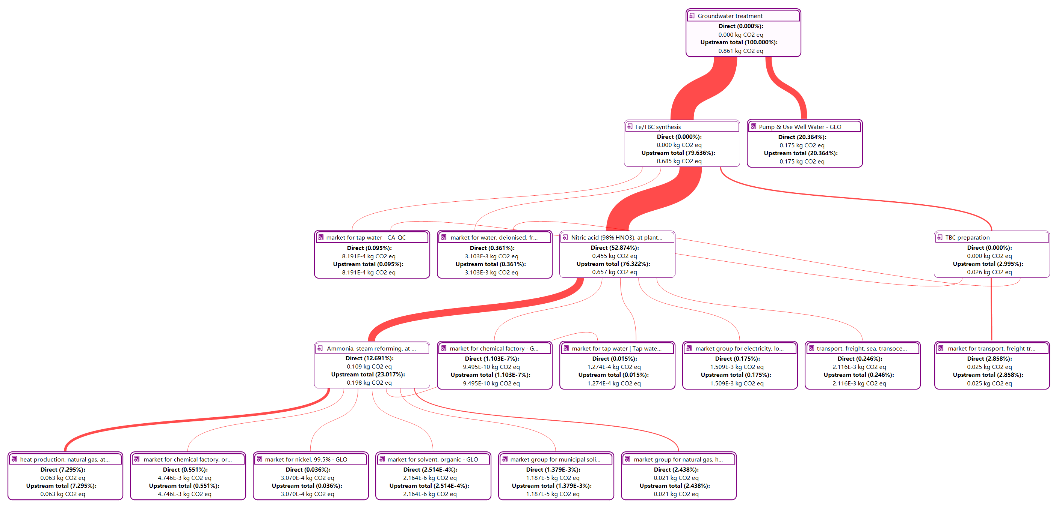
- Sankey diagram of global warming impact across the entire LCA processes.

