Supplementary Figures

Assessing the Causal Relationship between Metabolic Biomarkers and Coronary Artery Disease by Mendelian Randomization Studies
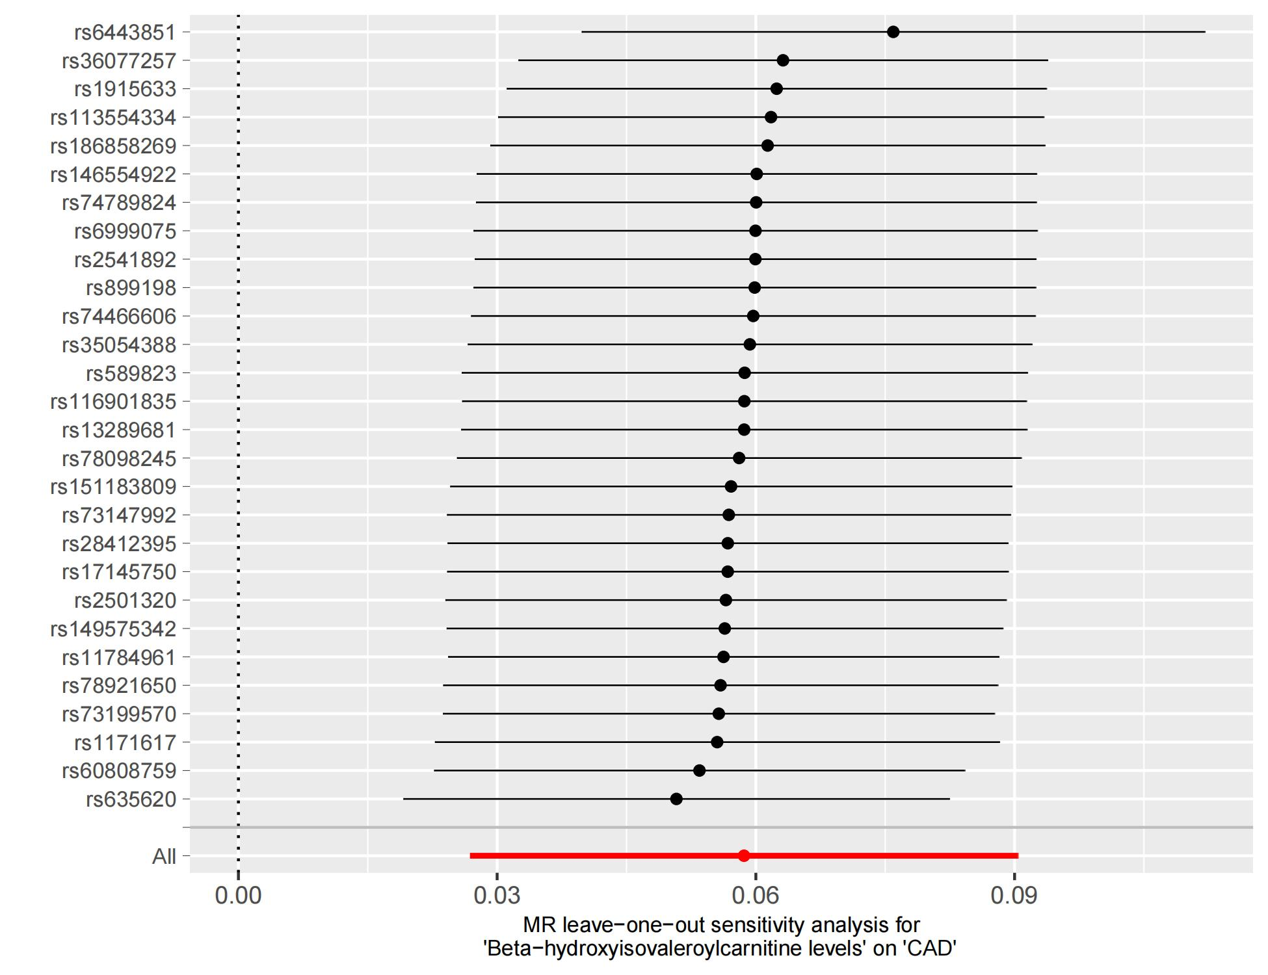

Supplementary Fig 1 Leaving-one-out sensitivity analysis plots for causal linkages between the beta-hydroxyisovaleroylcarnitine levels and the CAD

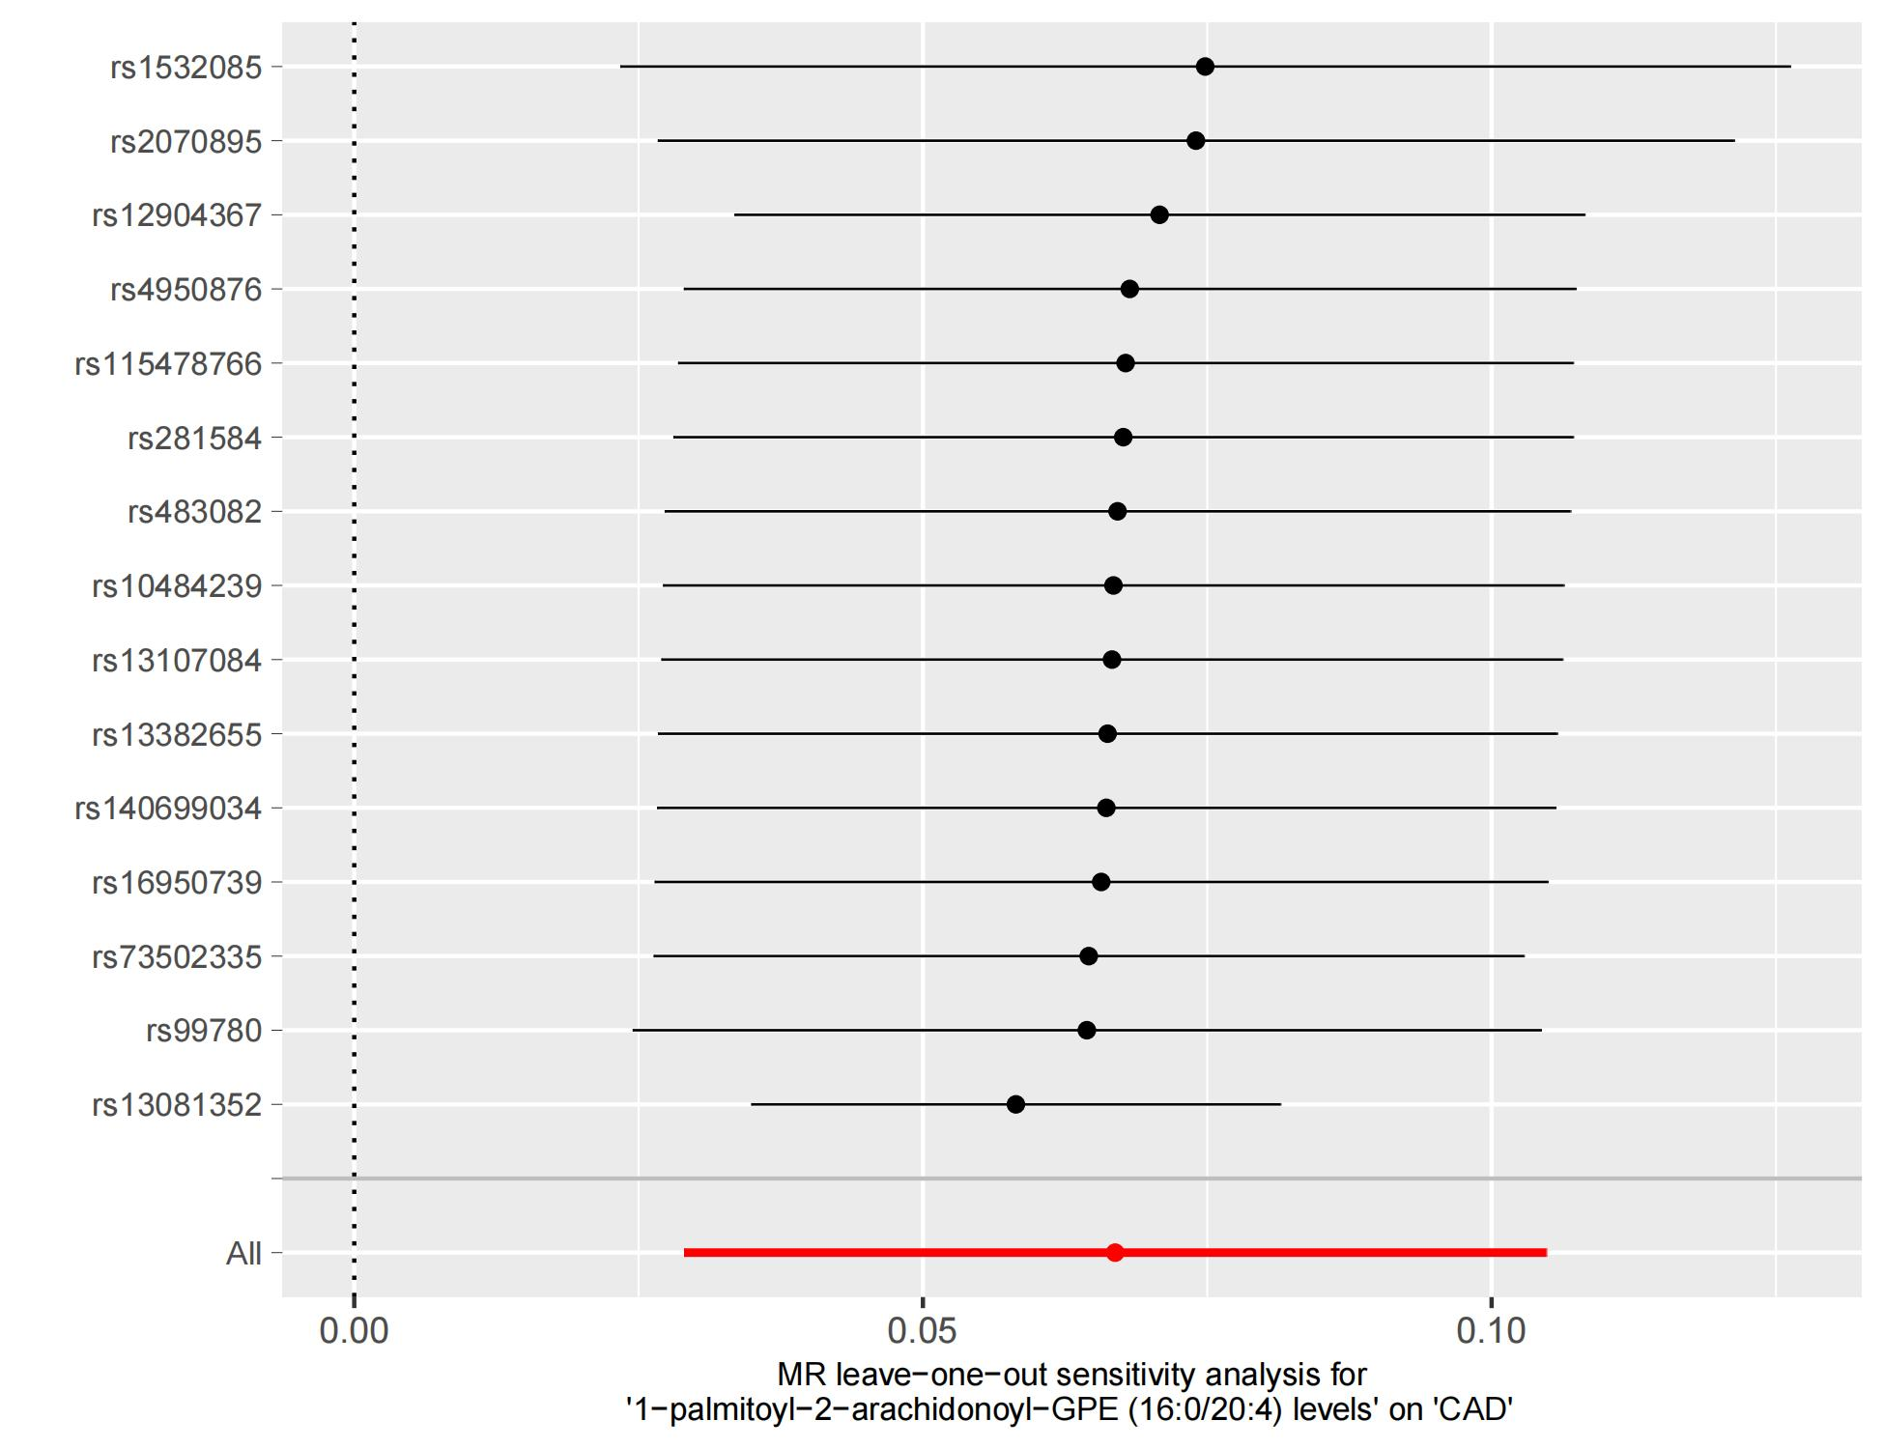
Supplementary Fig 2 Leaving-one-out sensitivity analysis plots for causal linkages between the 1-palmitoyl-2-arachidonoyl-GPE (160204) levels and the CAD
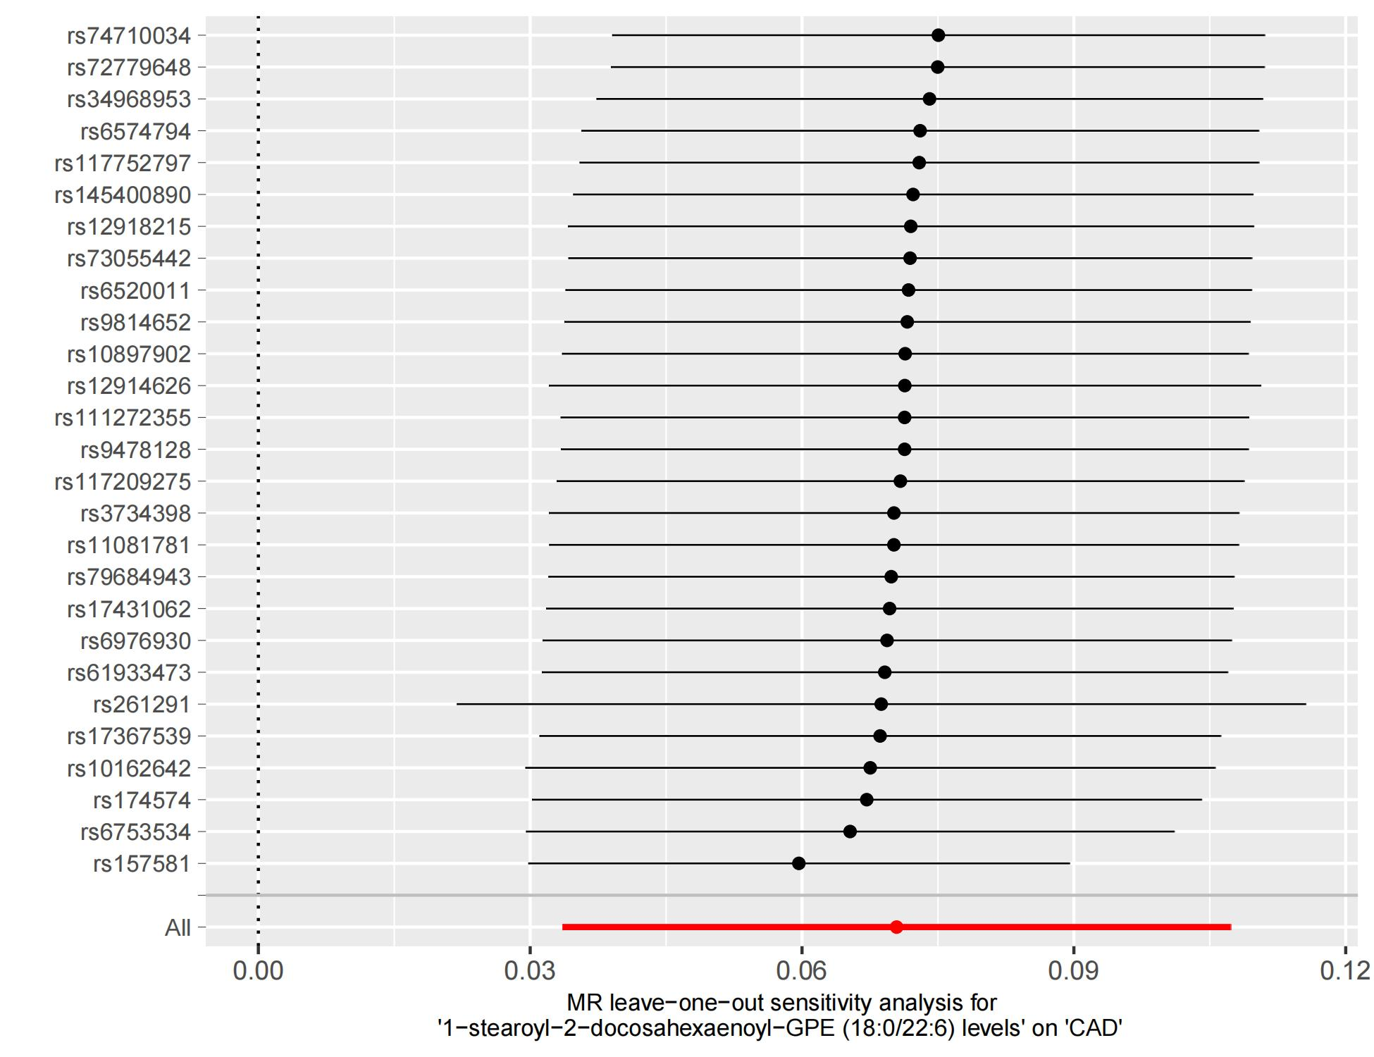
Supplementary Fig 3 Leaving-one-out sensitivity analysis plots for causal linkages between the 1-stearoyl-2-docosahexaenoyl-GPE (180226) levels and the CAD
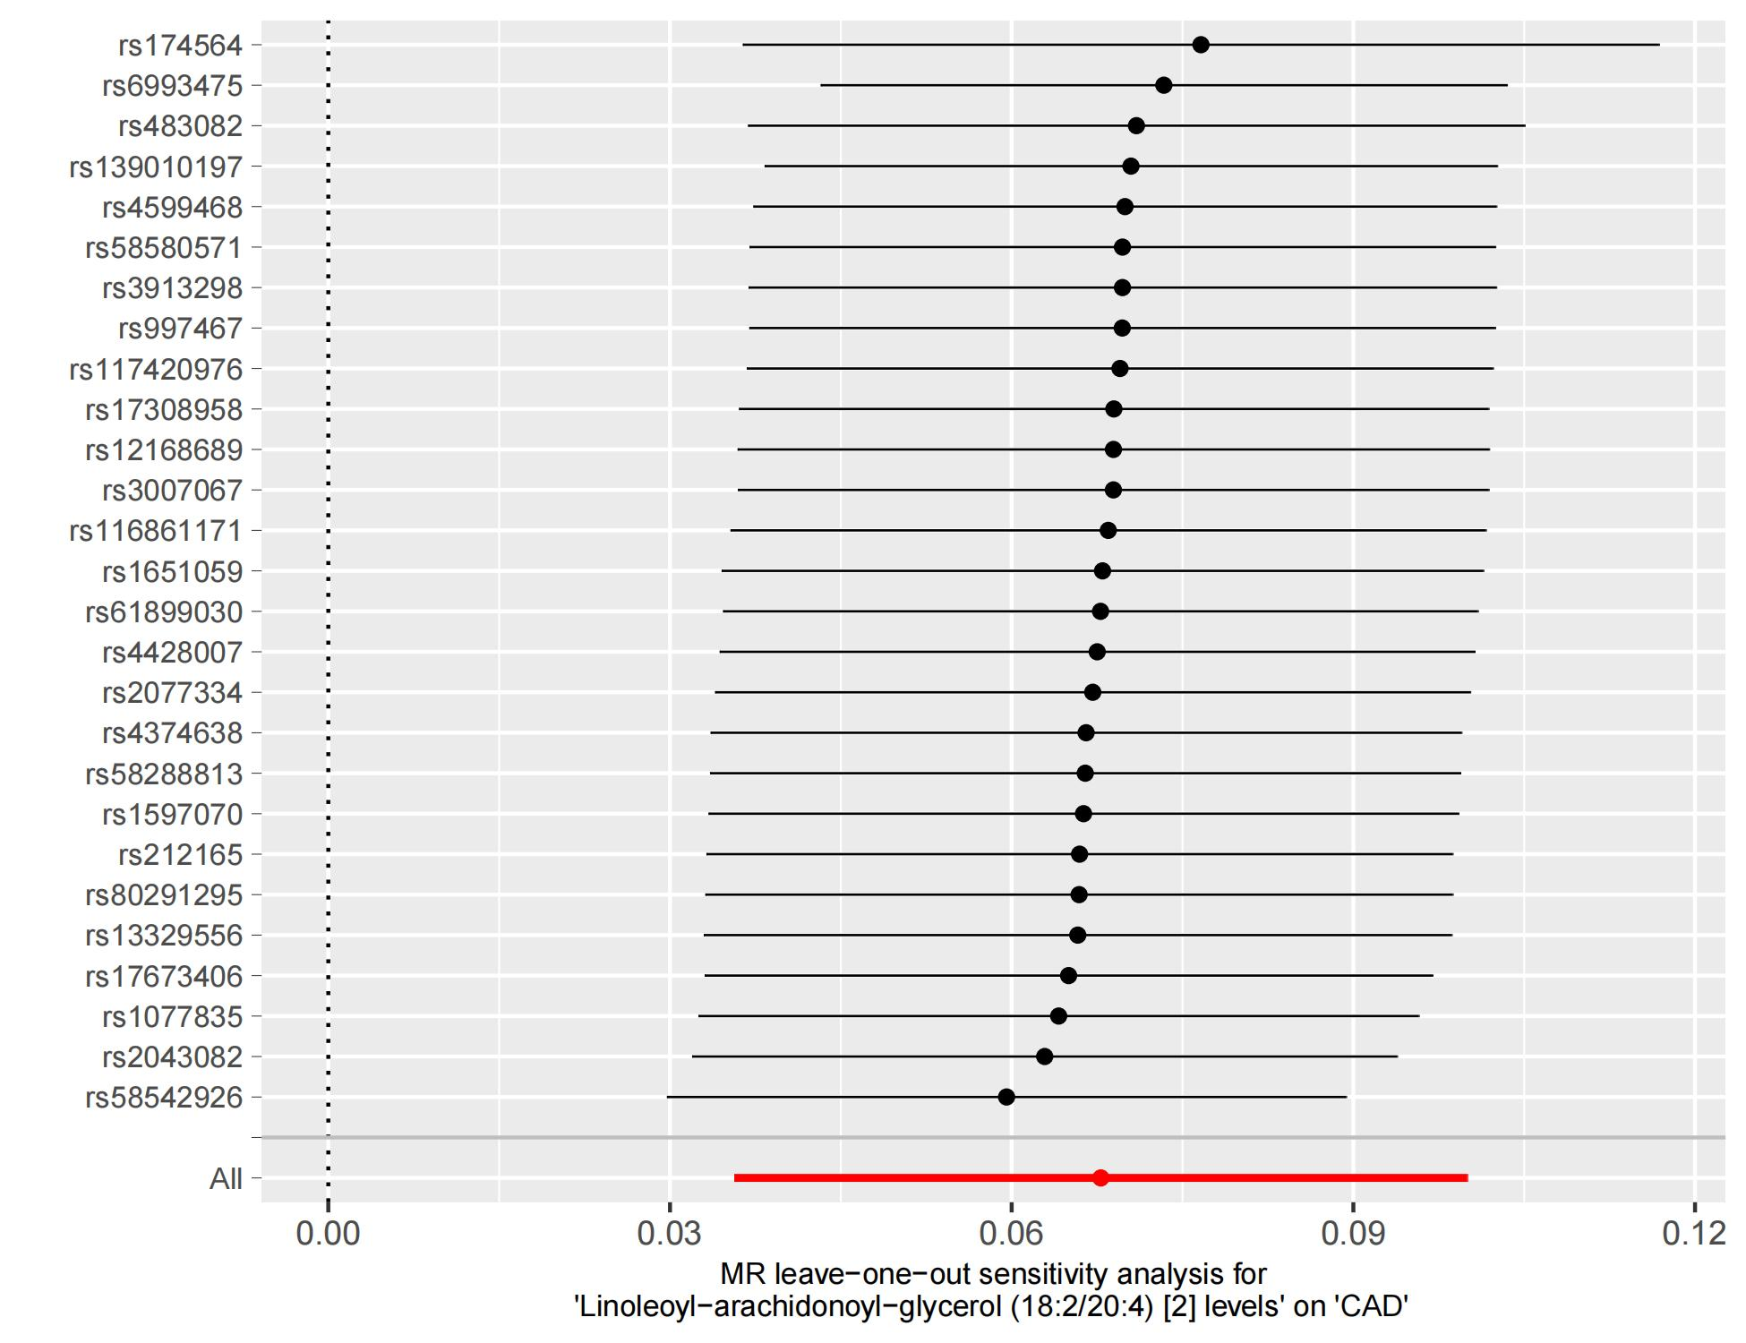
Supplementary Fig 4 Leaving-one-out sensitivity analysis plots for causal linkages between the linoleoyl-arachidonoyl-glycerol (182204) [2] levels and the CAD
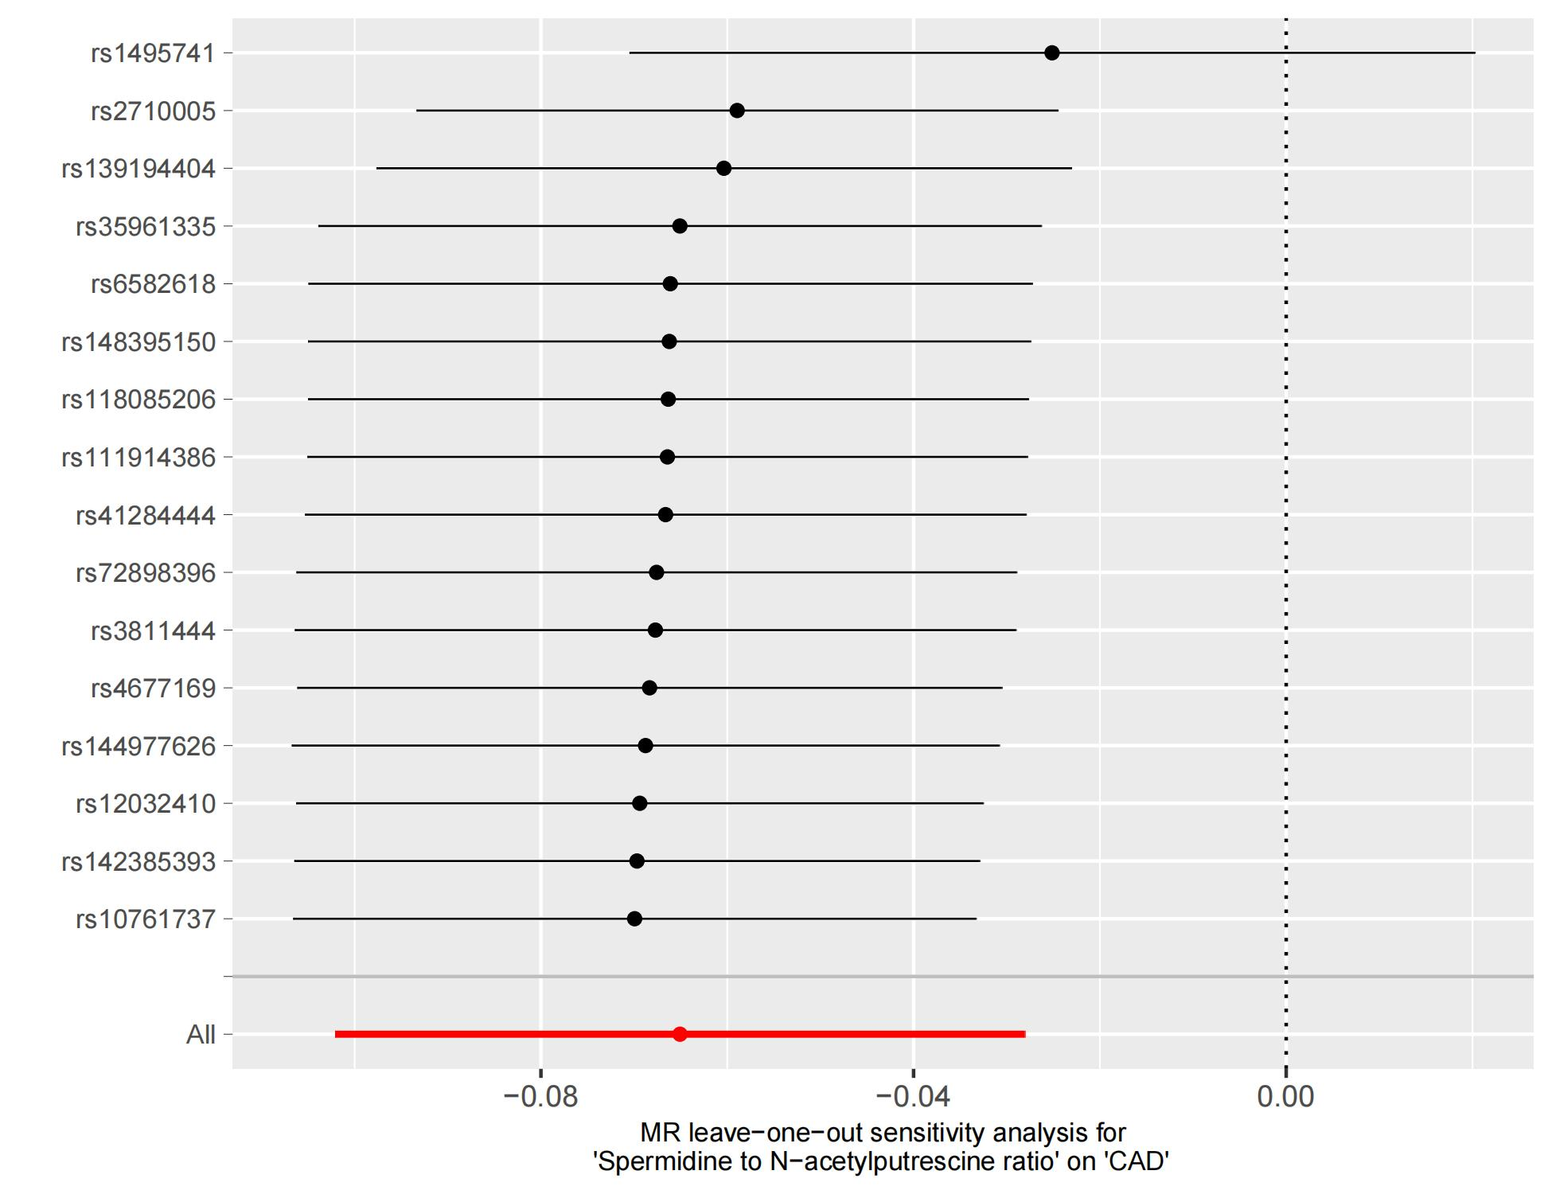
Supplementary Fig 5 Leaving-one-out sensitivity analysis plots for causal linkages between the spermidine to N-acetylputrescine ratio and the CAD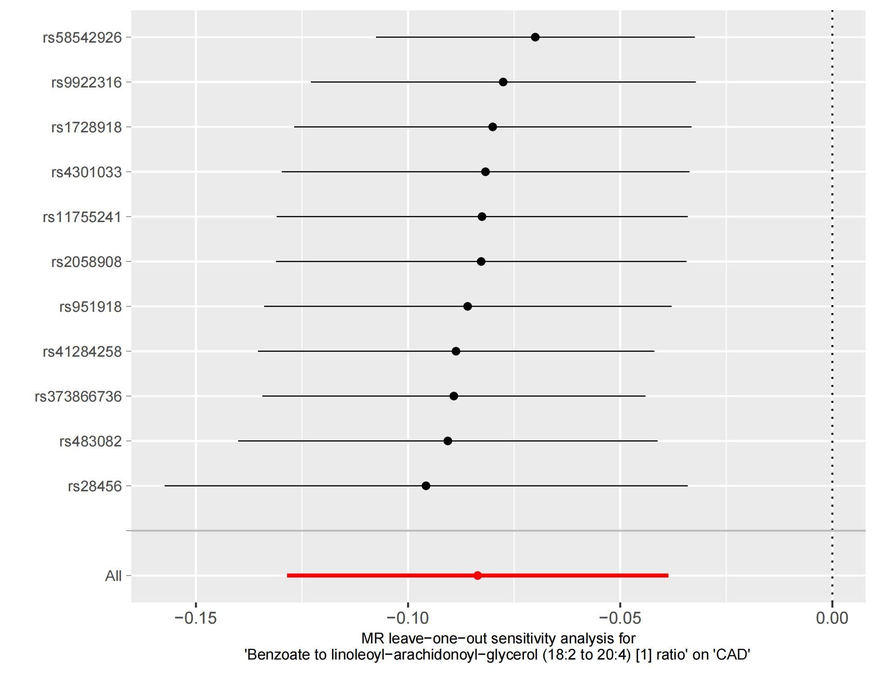
Supplementary Fig 6 Leaving-one-out sensitivity analysis plots for causal linkages between the benzoate to linoleoyl-arachidonoyl-glycerol (182 to 204) [1] ratio and the CAD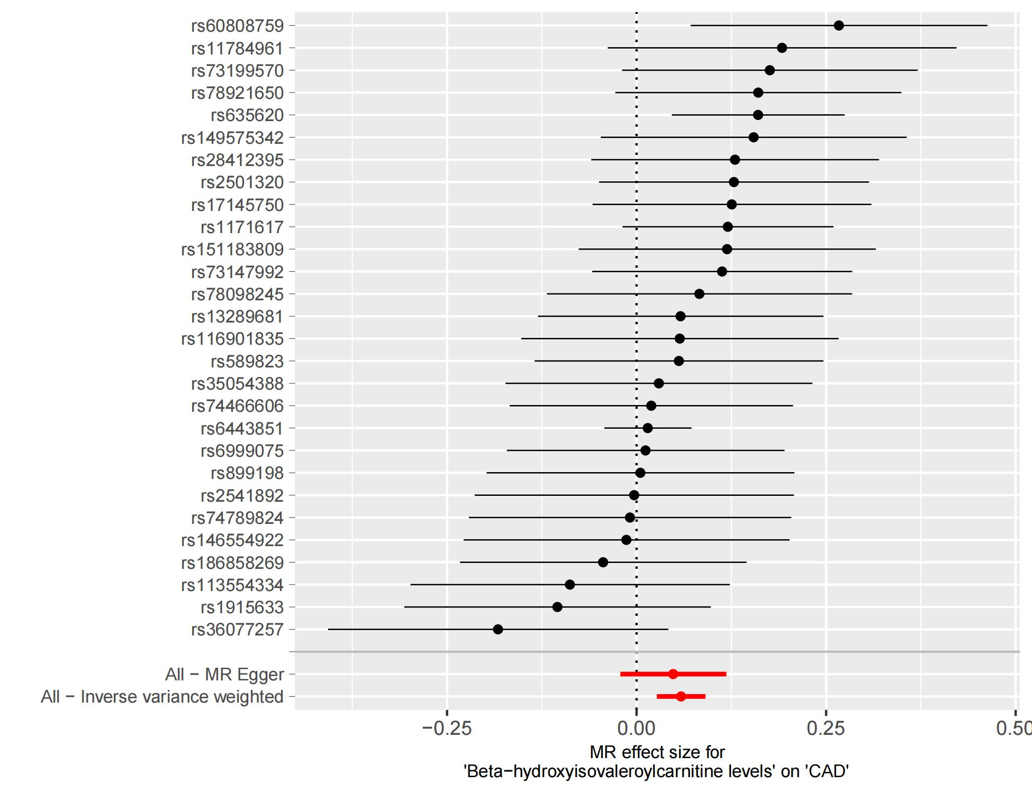
Supplementary Fig 7 Analysis of individual SNP effects for causal linkages between the beta-hydroxyisovaleroylcarnitine and the CAD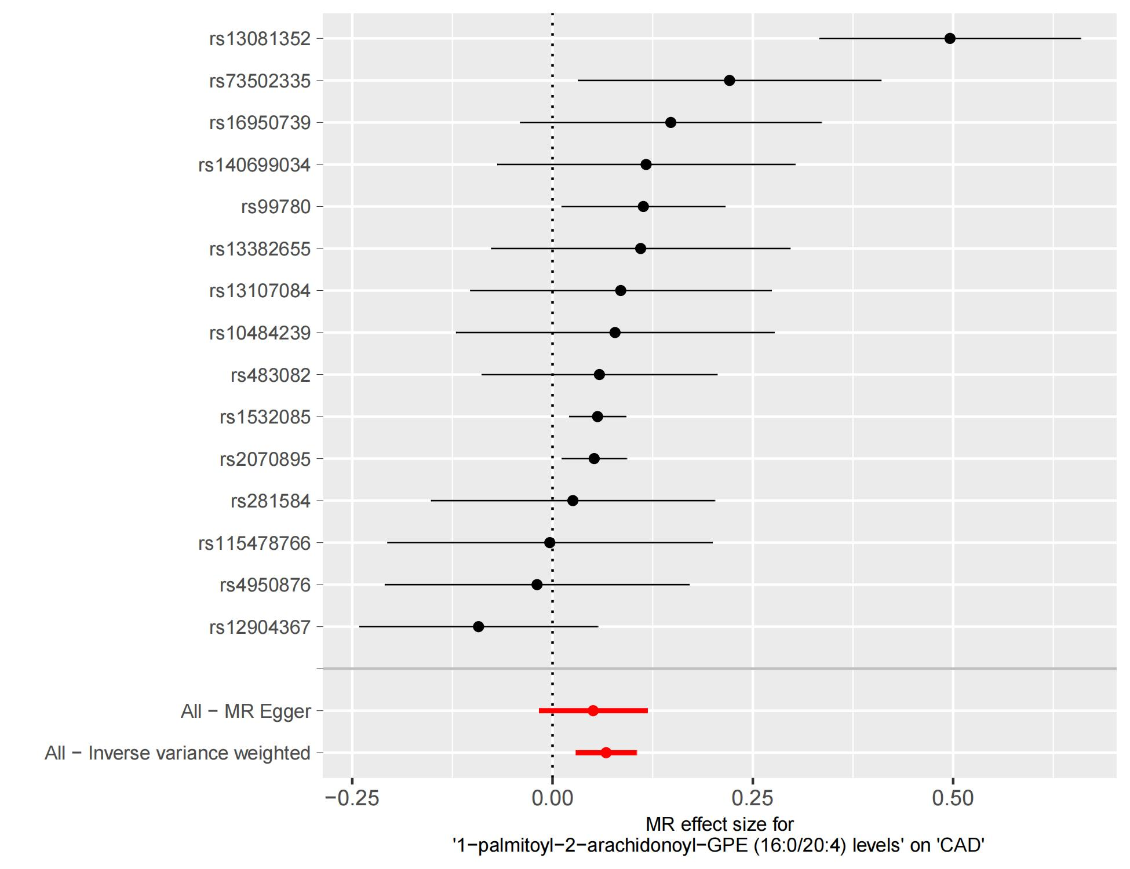
Supplementary Fig 8 Analysis of individual SNP effects for causal linkages between the 1-palmitoyl-2-arachidonoyl-GPE (160204) levels and the CAD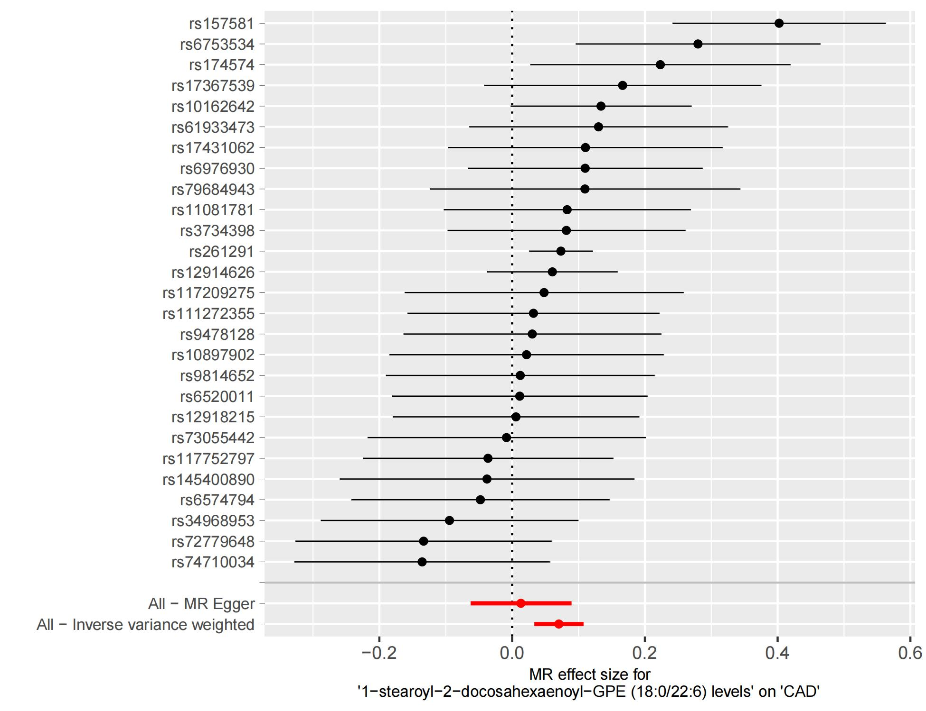
Supplementary Fig 9 Analysis of individual SNP effects for causal linkages between the 1-stearoyl-2-docosahexaenoyl-GPE (180226) levels and the CAD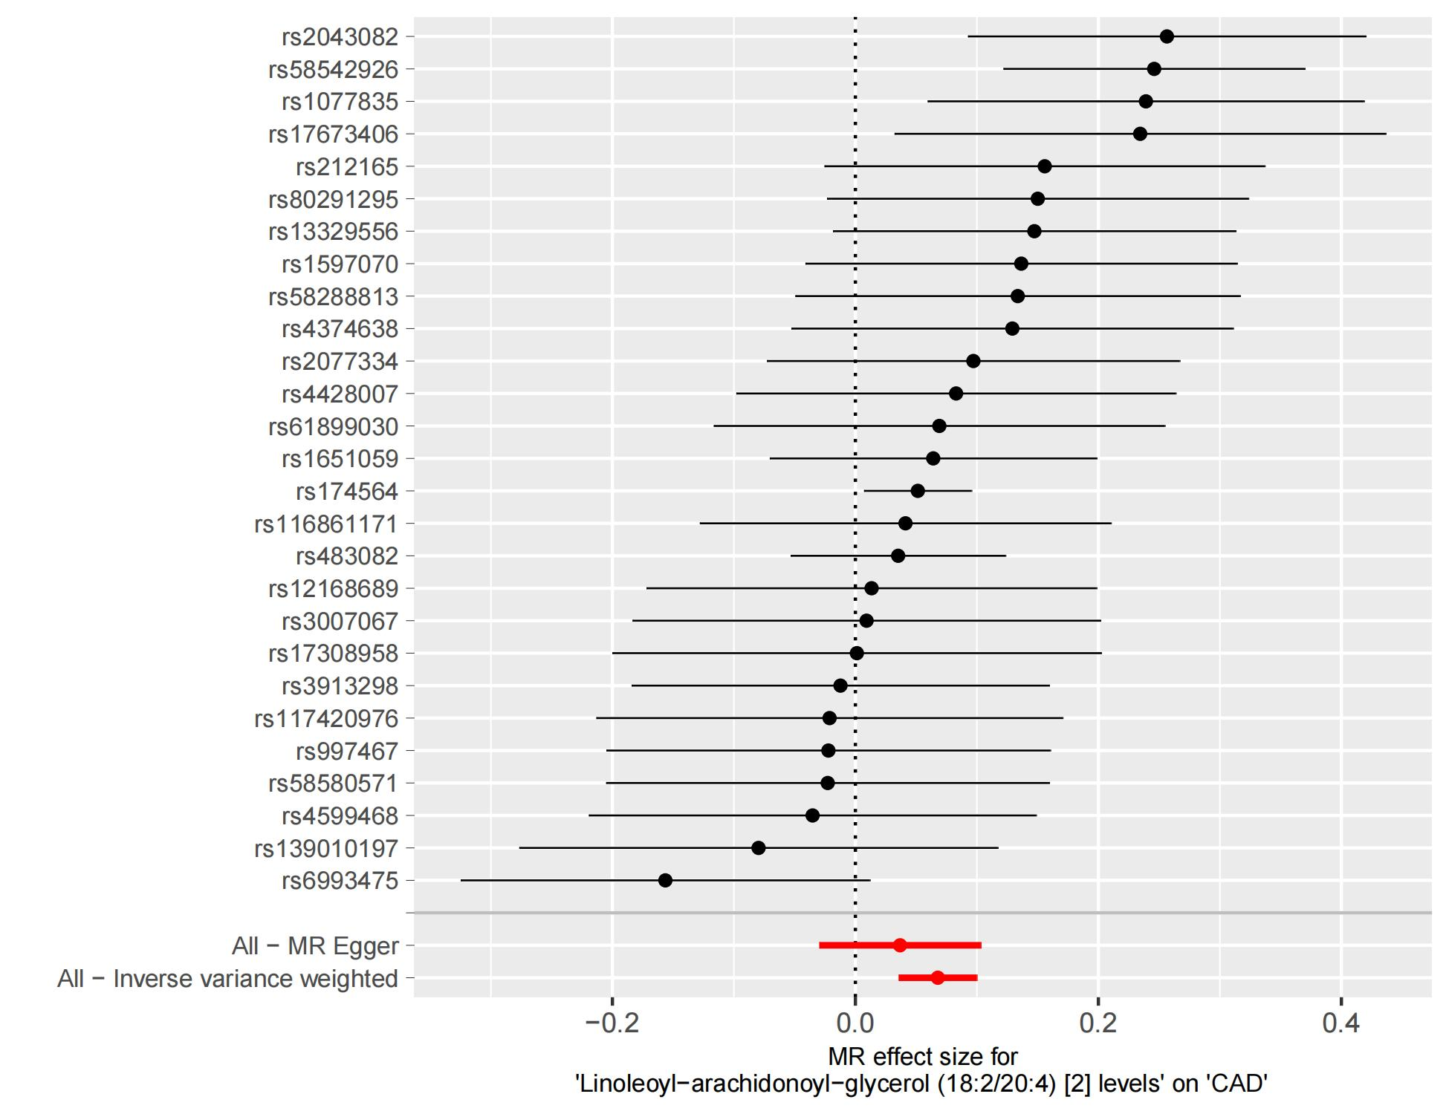
Supplementary Fig 10 Analysis of individual SNP effects for causal linkages between the linoleoyl-arachidonoyl-glycerol (182204) [2] levels and the CAD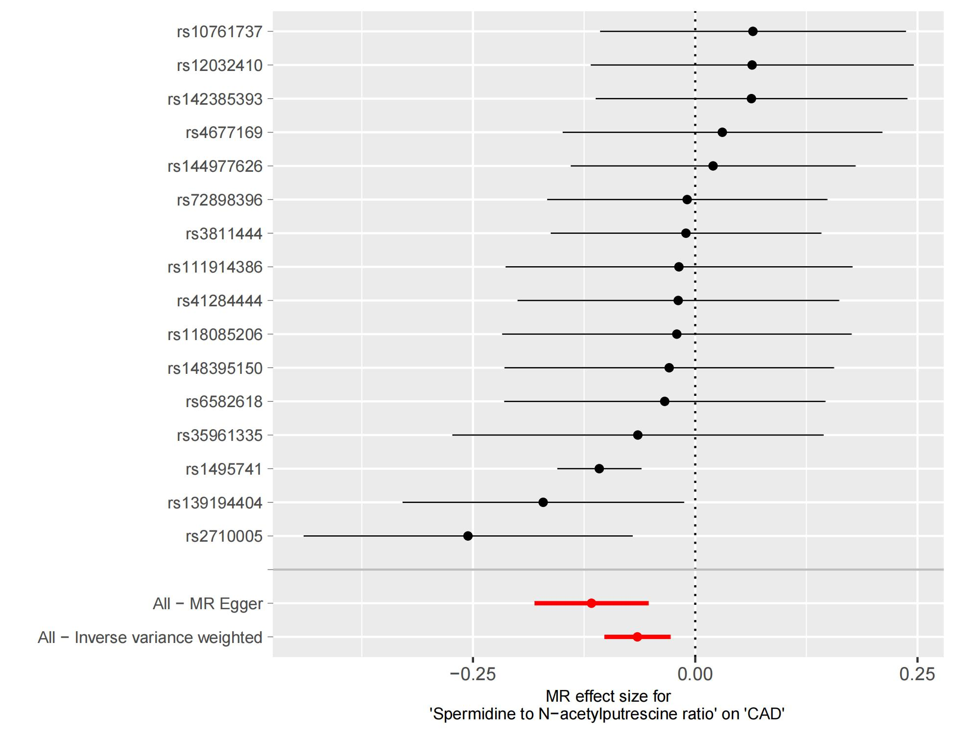
Supplementary Fig 11 Analysis of individual SNP effects for causal linkages between the spermidine to N-acetylputrescine ratio and the CAD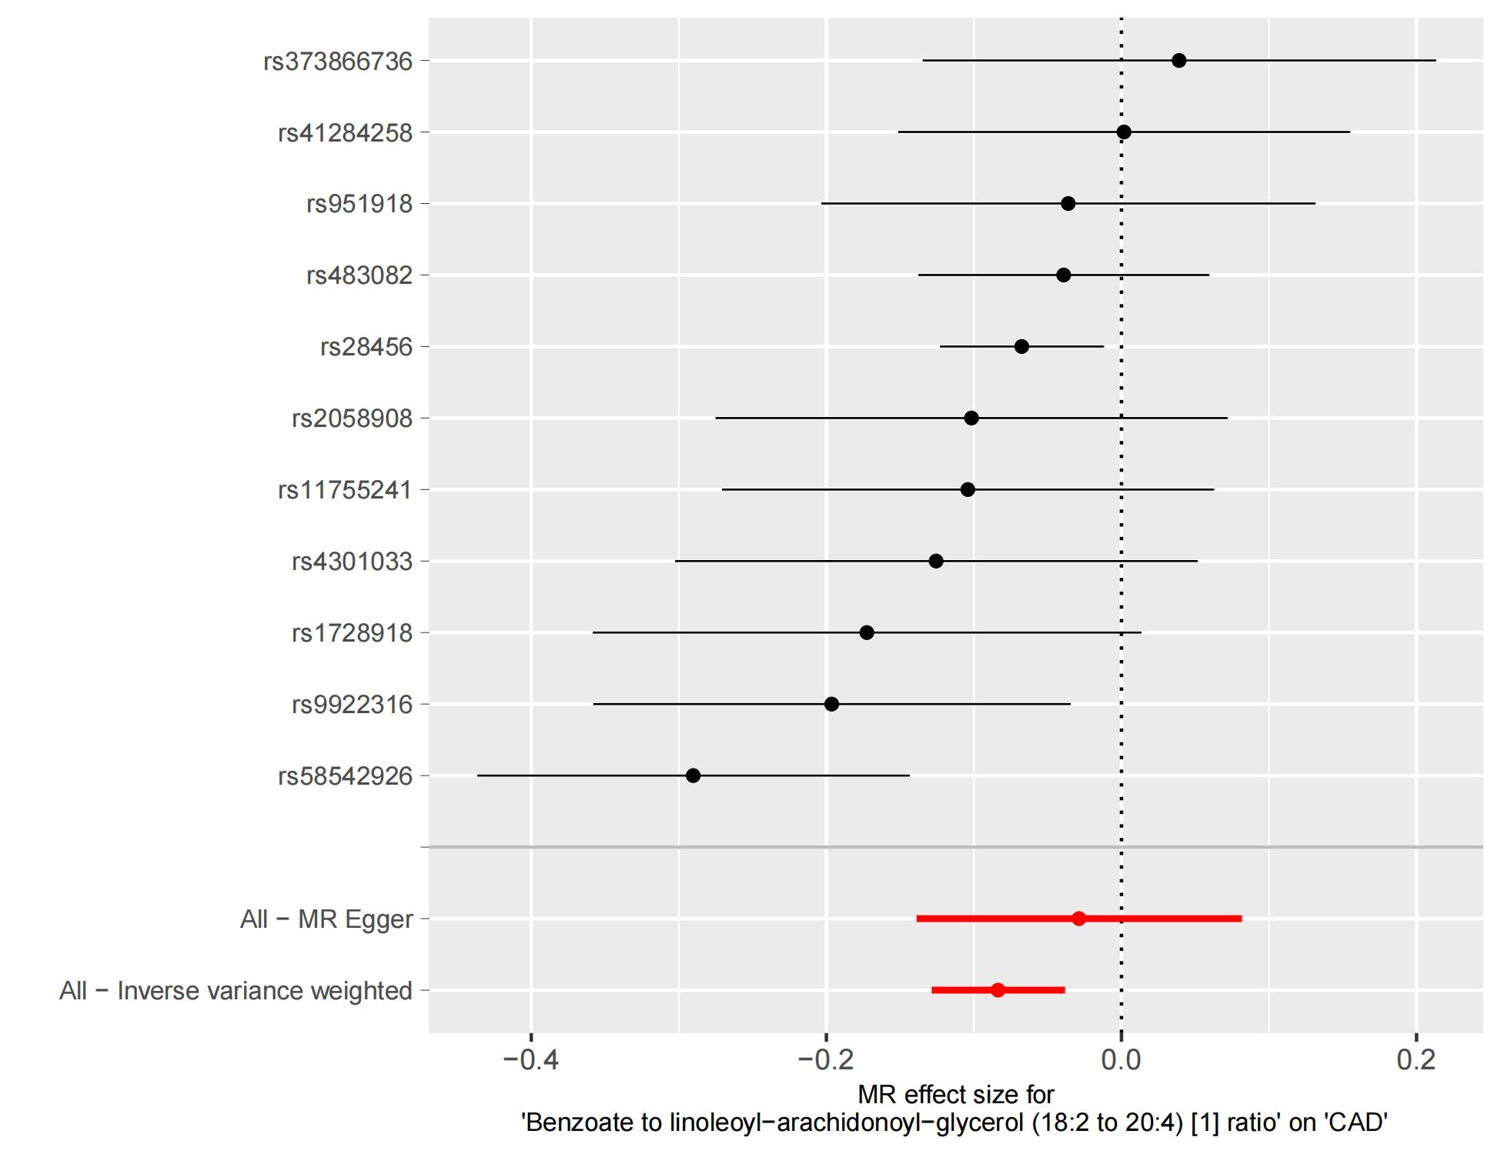
Supplementary Fig 12 Analysis of individual SNP effects for causal linkages between the benzoate to linoleoyl-arachidonoyl-glycerol (182 to 204) [1] ratio and the CAD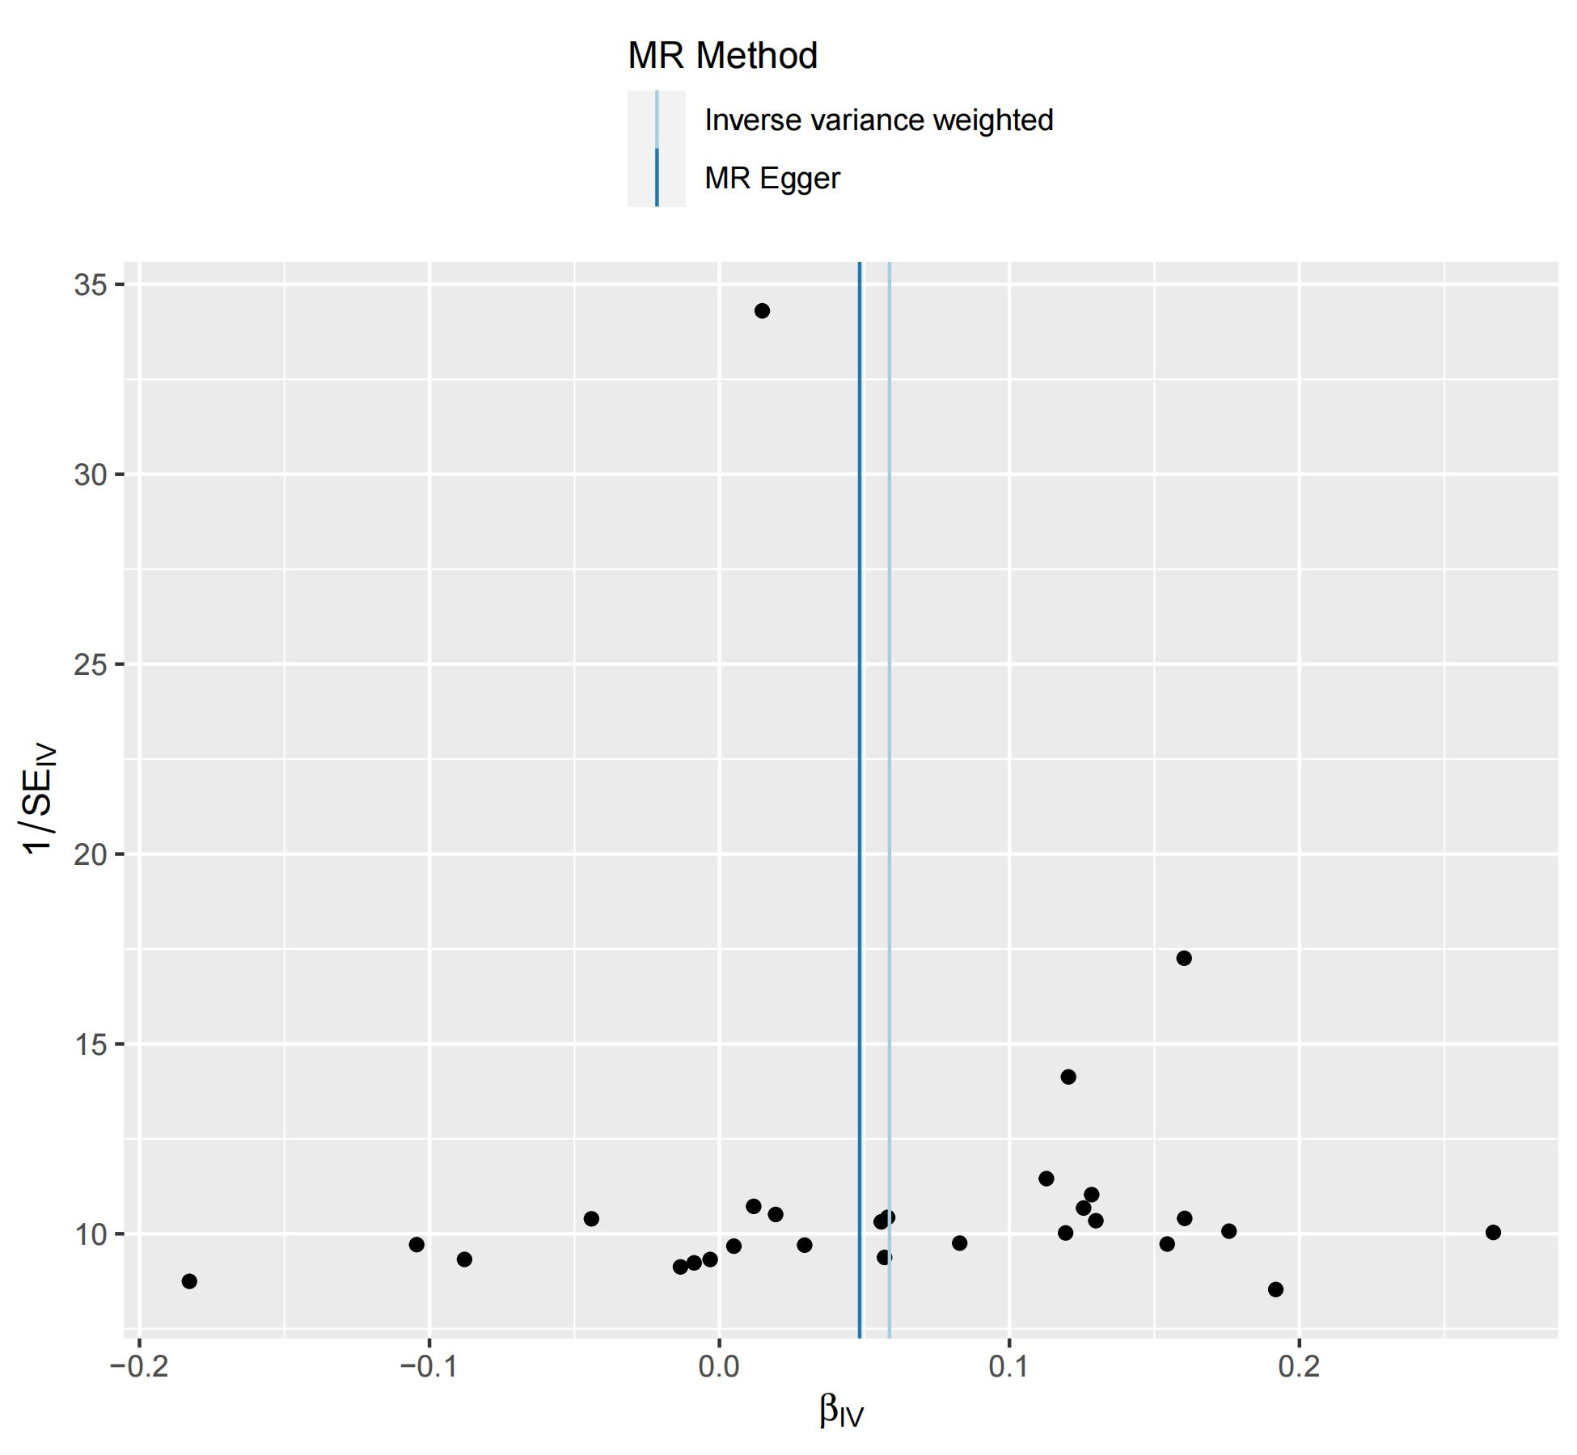
Supplementary Fig 13 Funnel plot for causal linkages between the beta-hydroxyisovaleroylcarnitine and the CAD
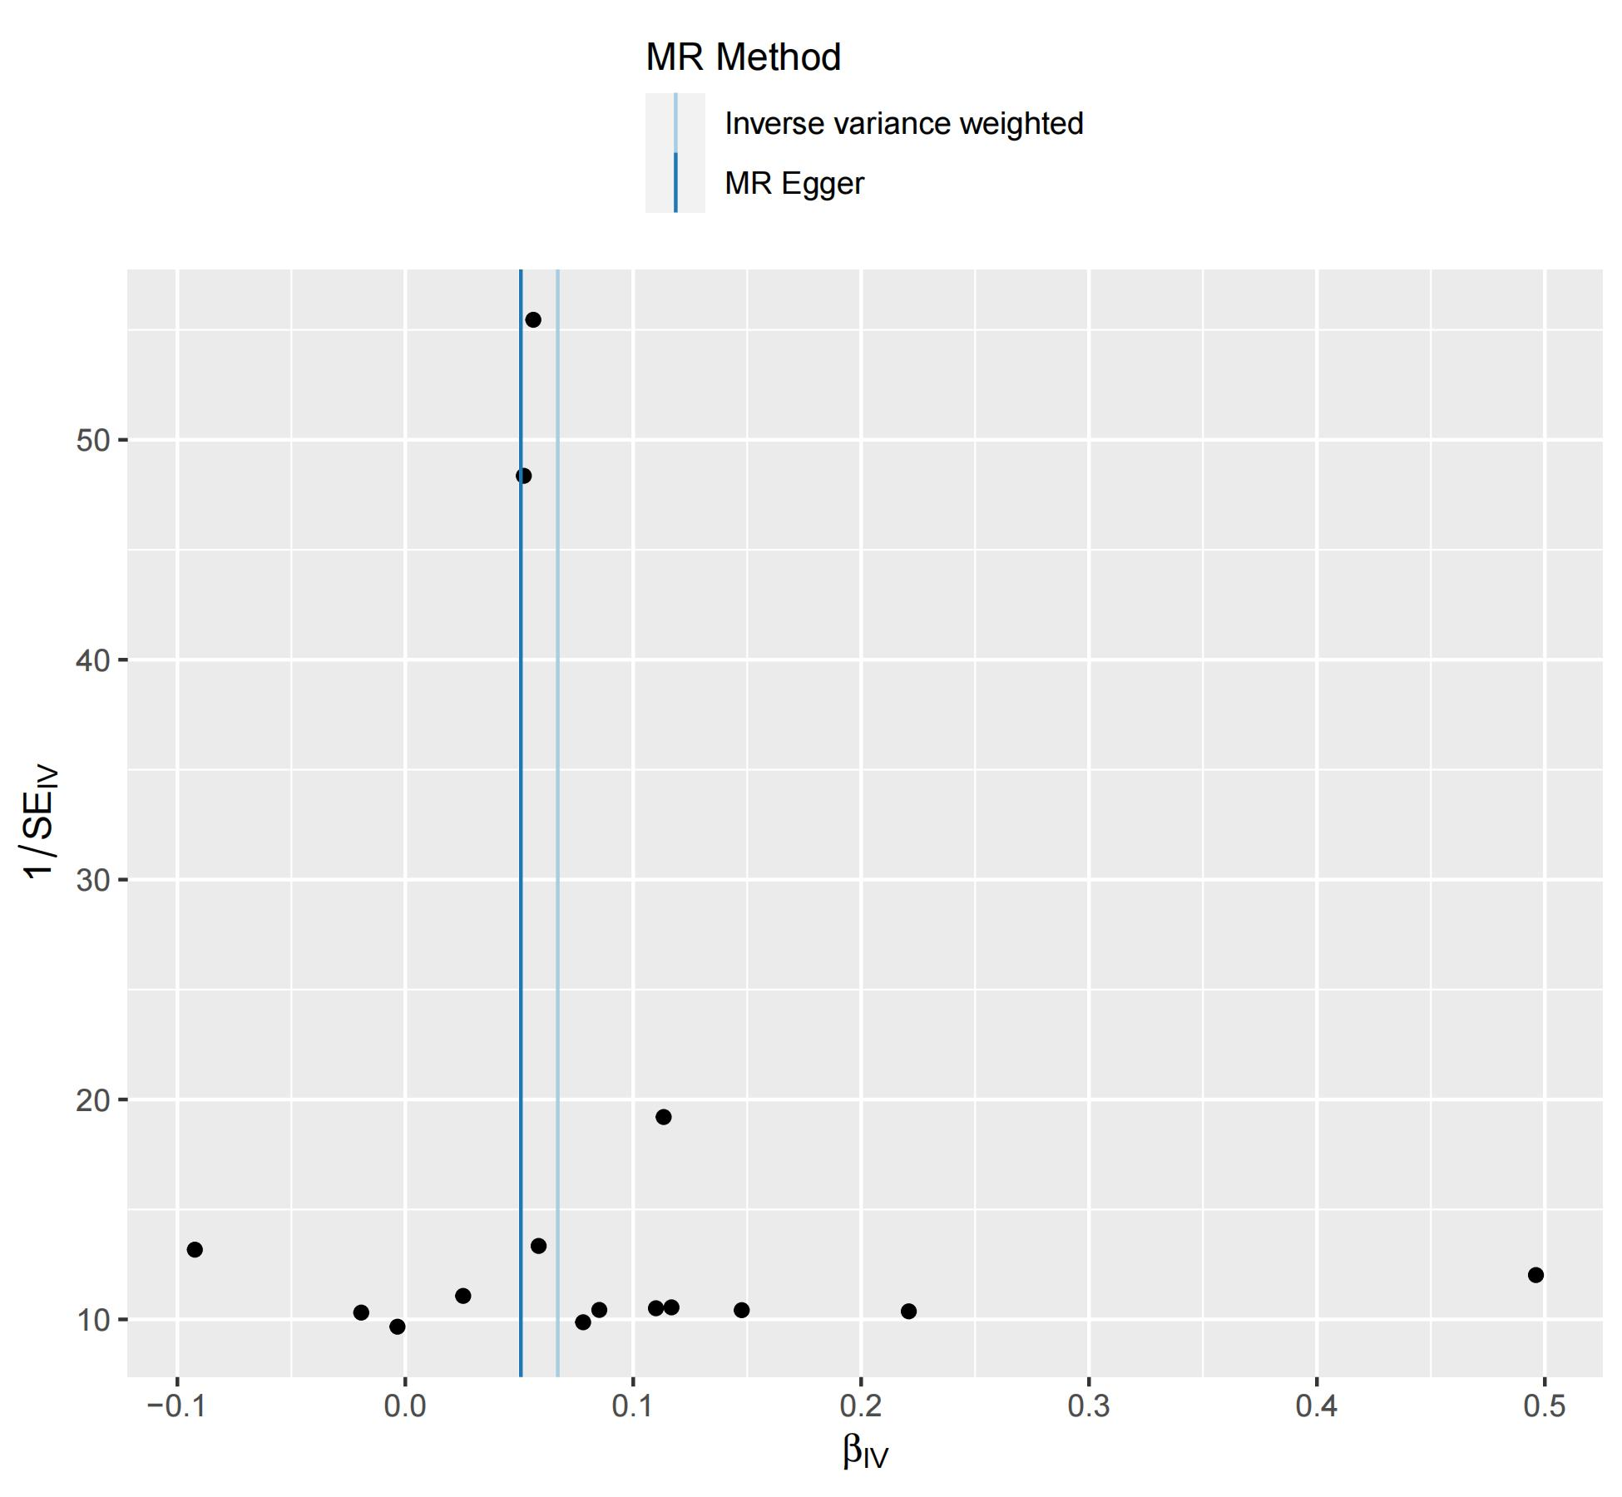
Supplementary Fig 14 Funnel plot for causal linkages between the 1-palmitoyl-2-arachidonoyl-GPE (160204) levels and the CAD
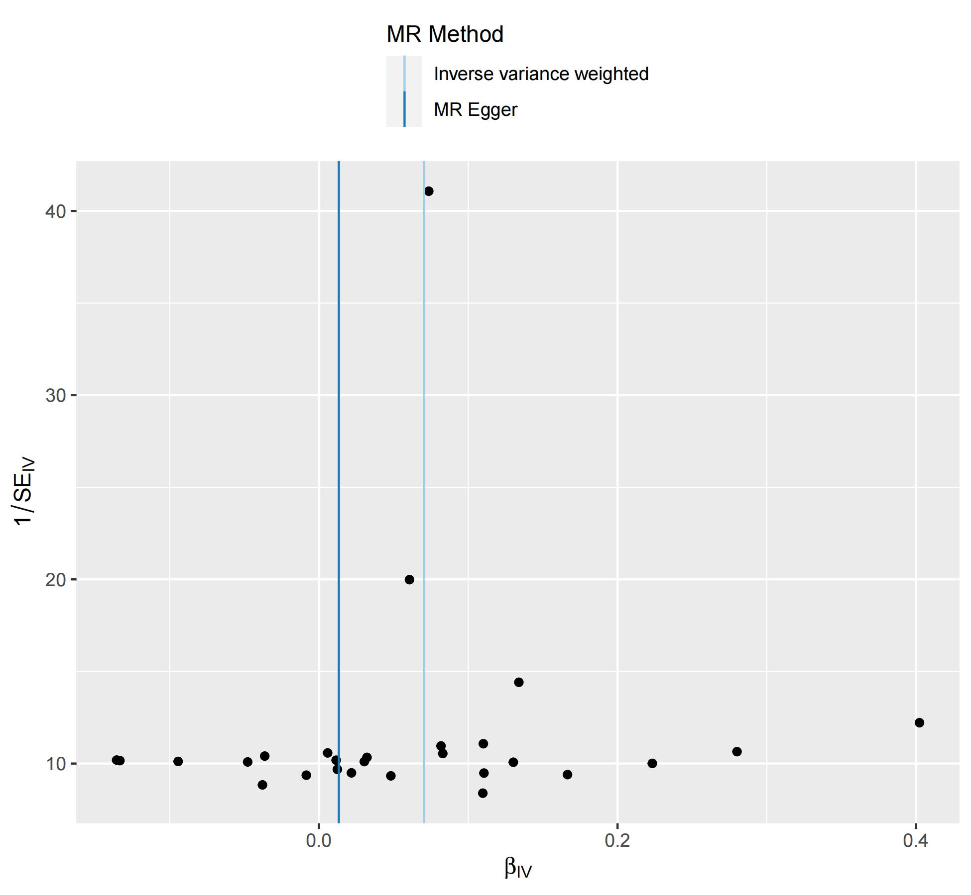
Supplementary Fig 15 Funnel plot for causal linkages between the 1-stearoyl-2-docosahexaenoyl-GPE (180226) levels and the CAD
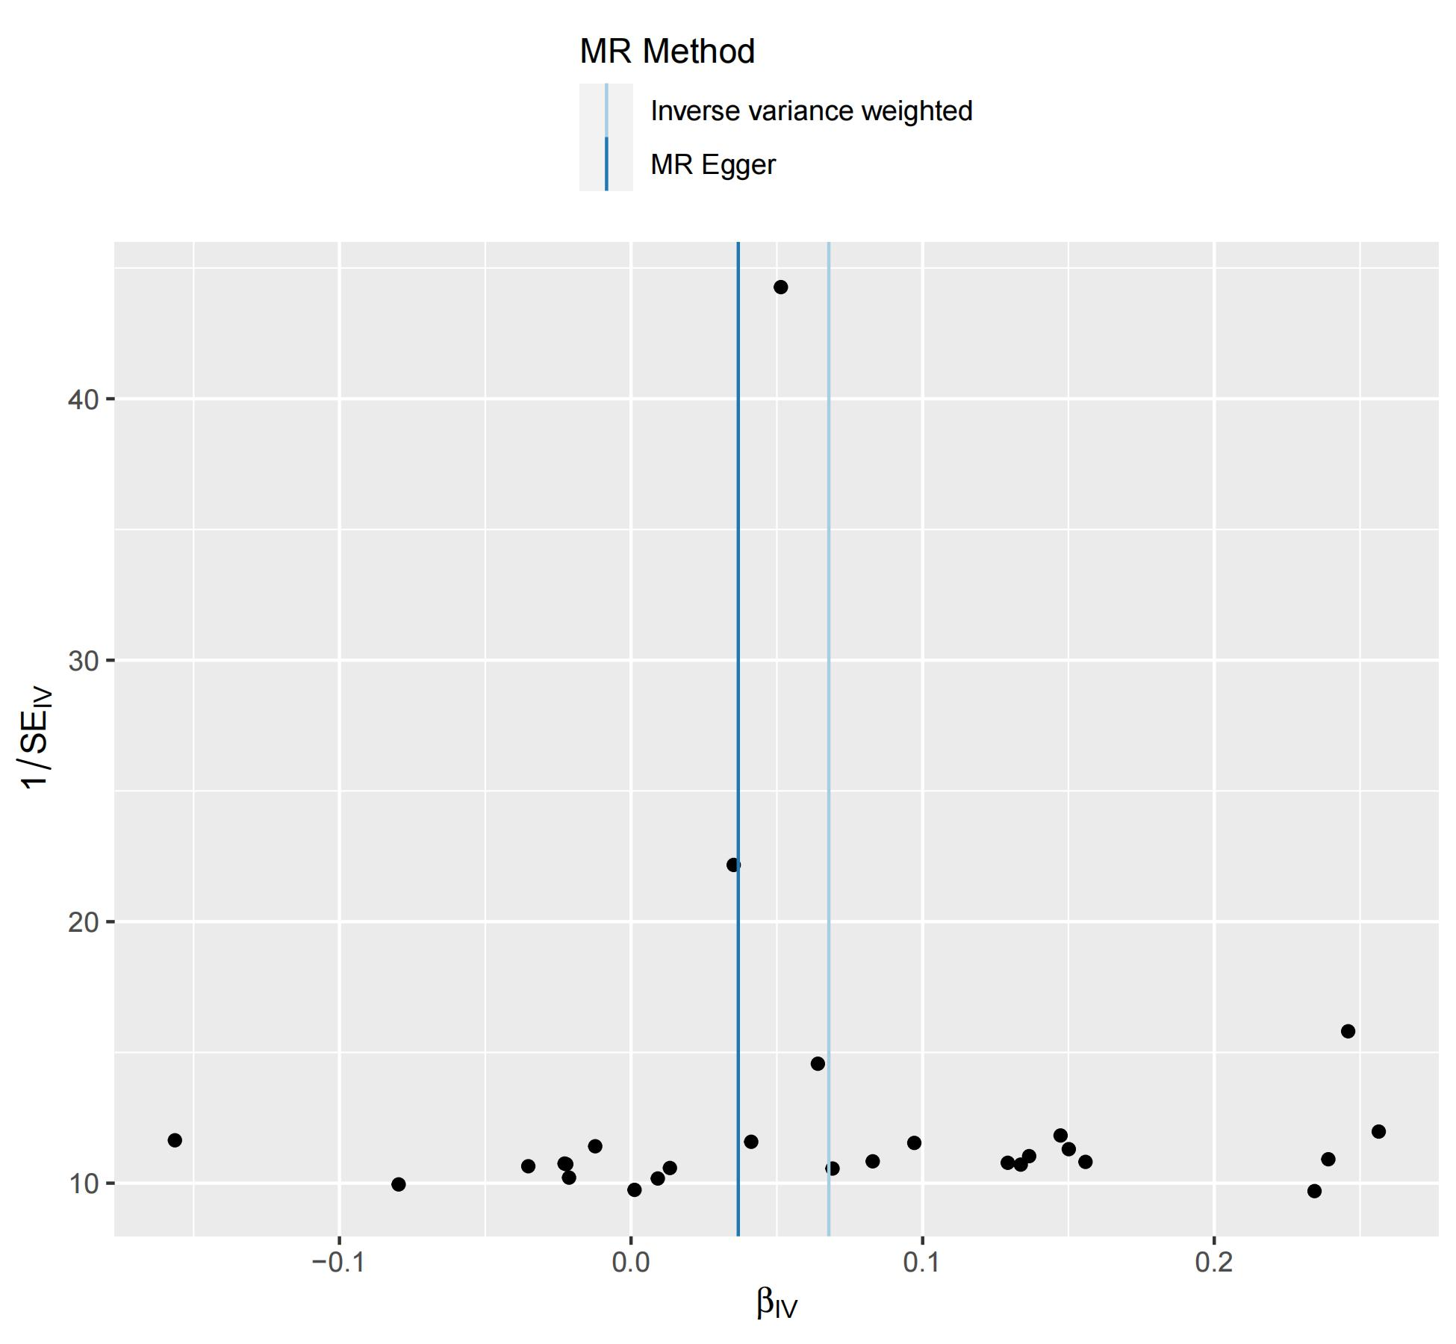
Supplementary Fig 16 Funnel plot for causal linkages between the linoleoyl-arachidonoyl-glycerol (182204) [2] levels and the CAD

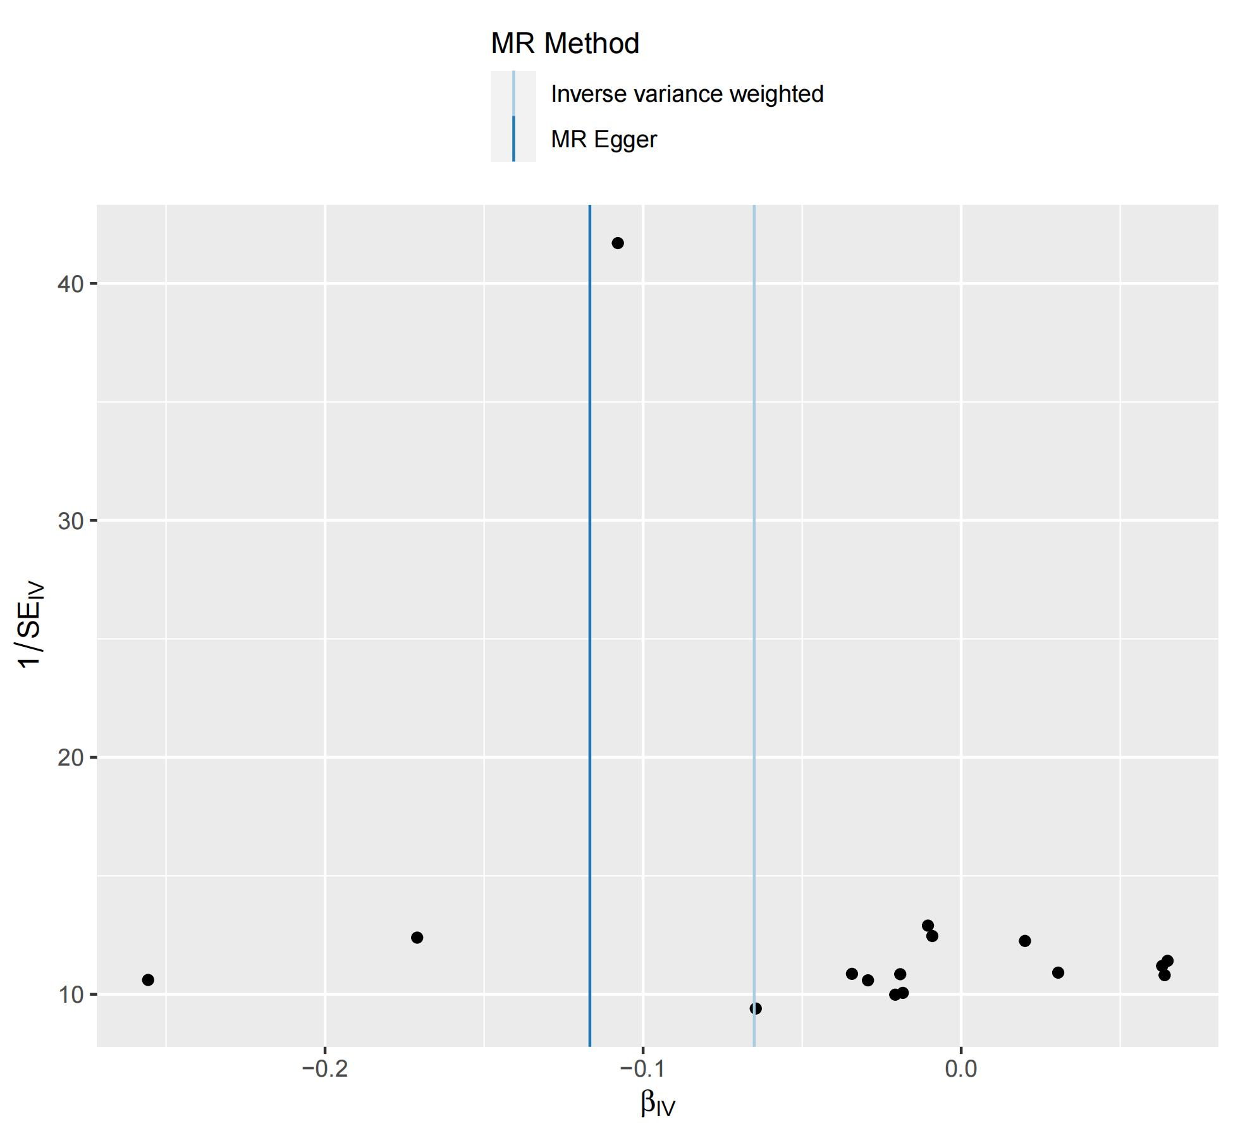
Supplementary Fig 17 Funnel plot for causal linkages between the spermidine to N-acetylputrescine ratio and the CAD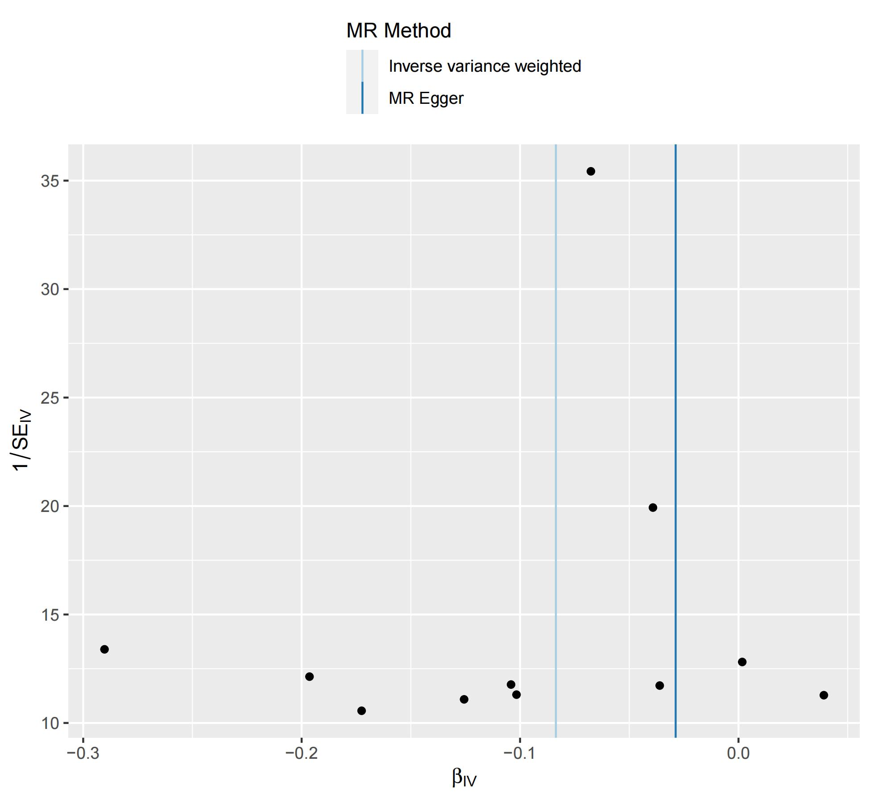
Supplementary Fig 18 Funnel plot for causal linkages between the benzoate to linoleoyl-arachidonoyl-glycerol (182 to 204) [1] ratio and the CAD

