All race/ethnicities
Age group (years) | Men |  |  | Women
Age group (years) | Case (%) | Delayed ASIR (95% CI) | AAPC (95% CI) | Case (%) | Delayed ASIR (95% CI) | AAPC (95% CI)
20+ | 9957 (55.62) | 3.56 (3.49, 3.63) | -1.27 (-2.2, -0.92) | 7946 (44.38) | 2.73 (2.67, 2.79) | -1.11 (-1.75, -0.8)
20-29 | 2243 (12.53) | 3.98 (3.82, 4.15) | -0.48 (-1.01, 0.07) | 2137 (11.94) | 3.96 (3.8, 4.14) | -1.47 (-2.53, -0.99)
30-39 | 1826 (10.20) | 3.4 (3.24, 3.56) | -1.11 (-1.62, -0.62) | 1593 (8.90) | 3 (2.85, 3.15) | -0.75 (-1.22, -0.3)
40-49 | 1409 (7.87) | 2.91 (2.76, 3.07) | -2.23 (-5.97, -1.29) | 1031 (5.76) | 2.09 (1.97, 2.22) | -0.25 (-0.96, 0.45)
50-59 | 1567 (8.75) | 3.15 (2.99, 3.31) | -0.14 (-0.6, 0.34) | 920 (5.14) | 1.79 (1.67, 1.91) | -0.39 (-0.94, 0.19)
60-69 | 1410 (7.88) | 3.63 (3.45, 3.83) | -1.22 (-1.98, -0.37) | 974 (5.44) | 2.27 (2.13, 2.42) | -0.87 (-1.5, -0.19)
70-79 | 1017 (5.68) | 4.85 (4.55, 5.15) | -1.71 (-3.66, -0.87) | 841 (4.70) | 3.29 (3.07, 3.52) | -2.07 (-8.69, -1.12)
80+ | 485 (2.71) | 4.65 (4.25, 5.09) | -1.9 (-6.73, -0.61) | 450 (2.51) | 2.72 (2.47, 2.99) | -2.19 (-7.08, -1.06)
Hispanic
Age groups | Men |  |  | Women
Age groups | Case (%) | Delayed ASIR (95% CI) | AAPC (95% CI) | Case (%) | Delayed ASIR (95% CI) | AAPC (95% CI)
20+ | 1905 (56.36) | 3.36 (3.2, 3.53) | -0.72 (-1.18, -0.21) | 1475 (43.64) | 2.36 (2.24, 2.49) | -1.27 (-4.7, -0.26)
20-29 | 419 (12.40) | 2.52 (2.28, 2.77) | -0.52 (-3.71, 0.78) | 454 (13.43) | 2.92 (2.66, 3.2) | 0.35 (-0.65, 1.44)
30-39 | 353 (10.44) | 2.29 (2.05, 2.54) | -0.5 (-1.63, 0.68) | 290 (8.58) | 2.03 (1.8, 2.28) | 0.5 (-0.51, 1.62)
40-49 | 302 (8.93) | 2.36 (2.1, 2.64) | -1.49 (-2.85, -0.05) | 178 (5.27) | 1.42 (1.22, 1.64) | -0.2 (-2.19, 2.09)
50-59 | 295 (8.73) | 3.04 (2.7, 3.41) | -0.94 (-2.26, 0.61) | 163 (4.82) | 1.65 (1.4, 1.92) | -1.8 (-3.56, 0.2)
60-69 | 267 (7.90) | 4.81 (4.25, 5.43) | 1.62 (-3.87, 10.79) | 172 (5.09) | 2.77 (2.37, 3.21) | -0.78 (-2.54, 1.37)
70-79 | 193 (5.71) | 7.73 (6.66, 8.91) | -0.28 (-1.92, 1.71) | 138 (4.08) | 4.28 (3.59, 5.06) | -3.47 (-9.78, -1.35)
80+ | 76 (2.25) | 6.43 (5.07, 8.05) | -1.76 (-3.51, 0.38) | 80 (2.37) | 4.23 (3.36, 5.27) | -1.05 (-3.11, 1.47)
NHB
Age groups | Men |  |  | Women
Age groups | Case (%) | Delayed ASIR (95% CI) | AAPC (95% CI) | Case (%) | Delayed ASIR (95% CI) | AAPC (95% CI)
20+ | 1219 (53.84) | 3.96 (3.74, 4.2) | 0.17 (-0.58, 0.97) | 1905 (46.16) | 3.01 (2.83, 3.2) | 0.68 (0.08, 1.32)
20-29 | 288 (12.72) | 3.8 (3.37, 4.27) | 0.09 (-1.67, 2.03) | 239 (10.56) | 3.22 (2.82, 3.65) | -1.11 (-2.49, 0.28)
30-39 | 262 (11.57) | 4.28 (3.77, 4.83) | -0.15 (-1.39, 1.11) | 243 (10.73) | 3.66 (3.21, 4.15) | 1.12 (-0.11, 2.44)
40-49 | 231 (10.20) | 4.27 (3.74, 4.86) | 0.22 (-0.86, 1.31) | 192 (8.48) | 3.13 (2.7, 3.6) | 1.59 (-0.31, 3.65)
50-59 | 230 (10.16) | 4.23 (3.7, 4.81) | 0.7 (-0.4, 1.96) | 159 (7.02) | 2.58 (2.19, 3.01) | 1.06 (-0.03, 2.3)
60-69 | 127 (5.61) | 3.38 (2.82, 4.03) | 0.31 (-1.97, 3.11) | 120 (5.30) | 2.55 (2.12, 3.05) | -10.13 (-20.66, 0.58)
70-79 | 62 (2.74) | 3.7 (2.83, 4.76) | -0.09 (-2.07, 2.19) | 70 (3.09) | 2.82 (2.2, 3.57) | 1.78 (-0.11, 4.13)
80+ | 19 (0.84) | 2.58 (1.55, 4.03) | N/A | 22 (0.97) | 1.54 (0.96, 2.34) | -5.71 (-38.94, -0.46)
NHW
Age groups | Men |  |  | Women
Age groups | Case (%) | Delayed ASIR (95% CI) | AAPC (95% CI) | Case (%) | Delayed ASIR (95% CI) | AAPC (95% CI)
20+ | 6239 (55.91) | 4.01 (3.9, 4.11) | -1.29 (-4.02, -0.9) | 4920 (44.09) | 3.15 (3.06, 3.25) | -1.27 (-2.85, -0.89)
20-29 | 1364 (12.22) | 5.17 (4.9, 5.45) | 1.17 (-1, 4.56) | 1258 (11.27) | 5 (4.72, 5.28) | -1.47 (-4.25, -0.94)
30-39 | 1081 (9.69) | 4.12 (3.88, 4.38) | -1.09 (-1.65, -0.57) | 951 (8.52) | 3.71 (3.48, 3.96) | -1 (-1.55, -0.48)
40-49 | 804 (7.20) | 3.22 (3, 3.45) | -1 (-1.54, -0.5) | 595 (5.33) | 2.41 (2.22, 2.61) | -0.17 (-1.01, 0.6)
50-59 | 970 (8.69) | 3.21 (3.01, 3.42) | -0.1 (-0.53, 0.33) | 551 (4.94) | 1.82 (1.67, 1.98) | -0.38 (-1.06, 0.3)
60-69 | 943 (8.45) | 3.61 (3.38, 3.85) | -1.36 (-2.3, -0.34) | 636 (5.70) | 2.27 (2.1, 2.46) | -1.18 (-2.03, -0.28)
70-79 | 714 (6.40) | 4.75 (4.41, 5.12) | -2.25 (-3.23, -1.49) | 599 (5.37) | 3.39 (3.12, 3.68) | -1.11 (-2.24, 0.01)
80+ | 363 (3.25) | 4.76 (4.28, 5.27) | -1.99 (-8.18, -0.67) | 330 (2.96) | 2.78 (2.48, 3.1) | -1.15 (-3.06, 0.64)
Table S1. Counts and age-standardized rate of Hodgkin lymphoma cancer incidence per 100,000 and average annual percent change from 2015 to 2019 in the United States, by age, sex, and race.

Abbreviations: NHW: Non-Hispanic White; NHB: Non-Hispanic Black; ASIR: Age-standardized incidence rate; CI: Confidence interval, AAPC: Average annual percent change.

Table S2. Results of the tests of incidental trends for adult Hodgkin lymphoma incidence rate over 2000-2019 in the United States.
Race/ ethnicities | sex | subtypes | Race/ ethnicities | sex | subtype | P value
Cohort 1 |  |  | Cohort 2 |  |  | P value
Hispanic | Female | CHL-NOS | NHB | Female | CHL-NOS | 0.94
Hispanic | Female | CHL-NOS | NHW | Female | CHL-NOS | 0.86
NHB | Female | CHL-NOS | NHW | Female | CHL-NOS | 0.82
All | Male | CHL-NOS | NHW | Male | CHL-NOS | 0.45
Hispanic | Male | CHL-NOS | NHB | Male | CHL-NOS | 0.45
Hispanic | Both | CHL-NOS | NHB | Both | CHL-NOS | 0.87
Hispanic | Female | CHL | NHB | Female | CHL | 0.37
All | Male | CHL | NHB | Male | CHL | 0.18
Hispanic | Male | CHL | NHB | Male | CHL | 0.07
Hispanic | Both | CHL | NHB | Both | CHL | 0.08
All | Female | LR/MC/LD | NHB | Female | LR/MC/LD | 0.05
Hispanic | Female | LR/MC/LD | NHB | Female | LR/MC/LD | 0.11
All | Male | LR/MC/LD | NHW | Male | LR/MC/LD | 0.62
Hispanic | Male | LR/MC/LD | NHB | Male | LR/MC/LD | 0.38
Hispanic | Female | NLPHL | NHW | Female | NLPHL | 0.25
All | Both | NLPHL | NHW | Both | NLPHL | 0.74
NHW | Female | NLPHL | NHB | Male | NLPHL | 0.16
NHB | Female | NLPHL | NHB | Both | NLPHL | 0.35
NHB | Male | NLPHL | NHB | Both | NLPHL | 0.08
All | Female | NSHL | All | Both | NSHL | 0.05
Hispanic | Female | NSHL | Hispanic | Male | NSHL | 0.07
Hispanic | Female | NSHL | Hispanic | Both | NSHL | 0.21
NHB | Female | NSHL | NHB | Male | NSHL | 0.33
NHB | Female | NSHL | NHB | Both | NSHL | 0.85
NHB | Male | NSHL | NHB | Both | NSHL | 0.08
NHW | Female | NSHL | NHW | Male | NSHL | 0.2
NHW | Female | NSHL | NHW | Both | NSHL | 0.24
NHW | Male | NSHL | NHW | Both | NSHL | 0.06
Abbreviations: NHW: Non-Hispanic White; NHB: Non-Hispanic Black; CHL-NOS: Classical Hodgkin Lymphoma-Not Otherwise Specified; CHL: Classical Hodgkin Lymphoma; LR/MC/LD: Lymphocyte-Rich/ Mixed Cellular/ Lymphocyte depleted; NLPHL: Nodular Lymphocyte Predominant Hodgkin Lymphoma; NSHL: Nodular Sclerosis Hodgkin Lymphoma.

Table S3. Results of the tests of parallelism for adult Hodgkin lymphoma incidence rate over 2000-2019 in the United States.
Race/ ethnicities | sex | subtypes | Race/ ethnicities | sex | subtype | P value
Cohort 1 |  |  | Cohort 2 |  |  | P value
Hispanic | Female | CHL-NOS | Hispanic | Female | NLPHL | 0.38
Hispanic | Female | CHL | Hispanic | Female | HL | 0.13
Hispanic | Female | CHL | Hispanic | Female | NSHL | 0.08
NHB | Female | LR/MC/LD | NHB | Female | NSHL | 0.24
Hispanic | Male | CHL-NOS | Hispanic | Male | NLPHL | 0.62
NHB | Male | LR/MC/LD | NHB | Male | NSHL | 0.18
Hispanic | Both | CHL-NOS | Hispanic | Both | NLPHL | 0.36
All | Female | CHL-NOS | Hispanic | Female | CHL-NOS | 0.76
All | Female | CHL-NOS | NHB | Female | CHL-NOS | 0.65
All | Female | CHL-NOS | NHW | Female | CHL-NOS | 0.26
Hispanic | Female | CHL-NOS | NHB | Female | CHL-NOS | 0.75
Hispanic | Female | CHL-NOS | NHW | Female | CHL-NOS | 0.72
NHB | Female | CHL-NOS | NHW | Female | CHL-NOS | 0.66
All | Male | CHL-NOS | Hispanic | Male | CHL-NOS | 0.18
All | Male | CHL-NOS | NHB | Male | CHL-NOS | 0.6
All | Male | CHL-NOS | NHW | Male | CHL-NOS | 0.78
Hispanic | Male | CHL-NOS | NHB | Male | CHL-NOS | 0.26
Hispanic | Male | CHL-NOS | NHW | Male | CHL-NOS | 0.51
NHB | Male | CHL-NOS | NHW | Male | CHL-NOS | 0.69
All | Both | CHL-NOS | Hispanic | Both | CHL-NOS | 0.85
All | Both | CHL-NOS | NHB | Both | CHL-NOS | 0.5
All | Both | CHL-NOS | NHW | Both | CHL-NOS | 0.75
Hispanic | Both | CHL-NOS | NHB | Both | CHL-NOS | 0.73
Hispanic | Both | CHL-NOS | NHW | Both | CHL-NOS | 0.9
NHB | Both | CHL-NOS | NHW | Both | CHL-NOS | 0.69
All | Female | CHL | Hispanic | Female | CHL | 0.05
All | Female | CHL | NHW | Female | CHL | 0.57
Hispanic | Female | CHL | NHB | Female | CHL | 0.6
Hispanic | Female | CHL | NHW | Female | CHL | 0.08
All | Male | CHL | NHB | Male | CHL | 0.12
All | Male | CHL | NHW | Male | CHL | 0.39
Hispanic | Male | CHL | NHB | Male | CHL | 0.25
Hispanic | Male | CHL | NHW | Male | CHL | 0.14
Hispanic | Both | CHL | NHB | Both | CHL | 0.28
All | Female | HL | Hispanic | Female | HL | 0.08
Hispanic | Female | HL | NHB | Female | HL | 0.07
Hispanic | Female | HL | NHW | Female | HL | 0.07
All | Male | HL | Hispanic | Male | HL | 0.28
All | Male | HL | NHW | Male | HL | 0.19
Hispanic | Male | HL | NHB | Male | HL | 0.09
Hispanic | Male | HL | NHW | Male | HL | 0.35
All | Female | LR/MC/LD | Hispanic | Female | LR/MC/LD | 0.17
All | Female | LR/MC/LD | NHW | Female | LR/MC/LD | 0.68
Hispanic | Female | LR/MC/LD | NHB | Female | LR/MC/LD | 0.36
Hispanic | Female | LR/MC/LD | NHW | Female | LR/MC/LD | 0.42
All | Male | LR/MC/LD | Hispanic | Male | LR/MC/LD | 0.59
All | Male | LR/MC/LD | NHB | Male | LR/MC/LD | 0.29
All | Male | LR/MC/LD | NHW | Male | LR/MC/LD | 0.78
Hispanic | Male | LR/MC/LD | NHB | Male | LR/MC/LD | 0.53
Hispanic | Male | LR/MC/LD | NHW | Male | LR/MC/LD | 0.63
NHB | Male | LR/MC/LD | NHW | Male | LR/MC/LD | 0.39
All | Both | LR/MC/LD | Hispanic | Both | LR/MC/LD | 0.3
All | Both | LR/MC/LD | NHW | Both | LR/MC/LD | 0.84
Hispanic | Both | LR/MC/LD | NHB | Both | LR/MC/LD | 0.16
Hispanic | Both | LR/MC/LD | NHW | Both | LR/MC/LD | 0.5
All | Female | NLPHL | Hispanic | Female | NLPHL | 0.13
All | Female | NLPHL | NHB | Female | NLPHL | 0.82
All | Female | NLPHL | NHW | Female | NLPHL | 0.89
Hispanic | Female | NLPHL | NHB | Female | NLPHL | 0.35
Hispanic | Female | NLPHL | NHW | Female | NLPHL | 0.27
NHB | Female | NLPHL | NHW | Female | NLPHL | 0.94
All | Male | NLPHL | Hispanic | Male | NLPHL | 0.61
All | Male | NLPHL | NHB | Male | NLPHL | 0.42
All | Male | NLPHL | NHW | Male | NLPHL | 0.66
Hispanic | Male | NLPHL | NHB | Male | NLPHL | 0.05
Hispanic | Male | NLPHL | NHW | Male | NLPHL | 0.25
NHB | Male | NLPHL | NHW | Male | NLPHL | 0.18
All | Both | NLPHL | Hispanic | Both | NLPHL | 0.09
All | Both | NLPHL | NHB | Both | NLPHL | 0.25
All | Both | NLPHL | NHW | Both | NLPHL | 0.57
Hispanic | Both | NLPHL | NHW | Both | NLPHL | 0.08
NHB | Both | NLPHL | NHW | Both | NLPHL | 0.12
All | Female | NSHL | Hispanic | Female | NSHL | 0.07
All | Female | NSHL | NHB | Female | NSHL | 0.26
Hispanic | Female | NSHL | NHB | Female | NSHL | 0.25
Hispanic | Female | NSHL | NHW | Female | NSHL | 0.12
NHB | Female | NSHL | NHW | Female | NSHL | 0.49
All | Male | NSHL | Hispanic | Male | NSHL | 0.13
All | Male | NSHL | NHW | Male | NSHL | 0.15
Hispanic | Male | NSHL | NHB | Male | NSHL | 0.36
Hispanic | Male | NSHL | NHW | Male | NSHL | 0.06
Hispanic | Both | NSHL | NHB | Both | NSHL | 0.48
All | Female | CHL-NOS | All | Male | CHL-NOS | 0.2
All | Female | CHL-NOS | All | Both | CHL-NOS | 0.15
All | Male | CHL-NOS | All | Both | CHL-NOS | 0.33
Hispanic | Female | CHL-NOS | Hispanic | Male | CHL-NOS | 0.5
Hispanic | Female | CHL-NOS | Hispanic | Both | CHL-NOS | 0.4
Hispanic | Male | CHL-NOS | Hispanic | Both | CHL-NOS | 0.61
NHB | Female | CHL-NOS | NHB | Male | CHL-NOS | 0.27
NHB | Female | CHL-NOS | NHB | Both | CHL-NOS | 0.25
NHB | Male | CHL-NOS | NHB | Both | CHL-NOS | 0.17
NHW | Female | CHL-NOS | NHW | Male | CHL-NOS | 0.45
NHW | Female | CHL-NOS | NHW | Both | CHL-NOS | 0.44
NHW | Male | CHL-NOS | NHW | Both | CHL-NOS | 0.22
All | Female | CHL | All | Male | CHL | 0.81
All | Female | CHL | All | Both | CHL | 0.51
All | Male | CHL | All | Both | CHL | 0.81
Hispanic | Female | CHL | Hispanic | Male | CHL | 0.42
Hispanic | Female | CHL | Hispanic | Both | CHL | 0.13
Hispanic | Male | CHL | Hispanic | Both | CHL | 0.35
NHB | Female | CHL | NHB | Male | CHL | 0.78
NHB | Female | CHL | NHB | Both | CHL | 0.43
NHB | Male | CHL | NHB | Both | CHL | 0.54
NHW | Female | CHL | NHW | Male | CHL | 0.68
NHW | Female | CHL | NHW | Both | CHL | 0.93
NHW | Male | CHL | NHW | Both | CHL | 0.82
All | Female | HL | All | Male | HL | 0.89
All | Female | HL | All | Both | HL | 0.33
All | Male | HL | All | Both | HL | 0.94
Hispanic | Female | HL | Hispanic | Male | HL | 0.44
Hispanic | Female | HL | Hispanic | Both | HL | 0.16
Hispanic | Male | HL | Hispanic | Both | HL | 0.43
NHB | Female | HL | NHB | Male | HL | 0.74
NHB | Female | HL | NHB | Both | HL | 0.81
NHB | Male | HL | NHB | Both | HL | 0.59
NHW | Female | HL | NHW | Male | HL | 1
NHW | Female | HL | NHW | Both | HL | 0.96
NHW | Male | HL | NHW | Both | HL | 0.99
All | Female | LR/MC/LD | All | Male | LR/MC/LD | 0.14
All | Female | LR/MC/LD | All | Both | LR/MC/LD | 0.32
All | Male | LR/MC/LD | All | Both | LR/MC/LD | 0.06
Hispanic | Female | LR/MC/LD | Hispanic | Male | LR/MC/LD | 0.2
Hispanic | Male | LR/MC/LD | Hispanic | Both | LR/MC/LD | 0.18
NHB | Female | LR/MC/LD | NHB | Male | LR/MC/LD | 0.49
NHB | Female | LR/MC/LD | NHB | Both | LR/MC/LD | 0.51
NHB | Male | LR/MC/LD | NHB | Both | LR/MC/LD | 0.24
NHW | Female | LR/MC/LD | NHW | Male | LR/MC/LD | 0.09
NHW | Male | LR/MC/LD | NHW | Both | LR/MC/LD | 0.37
All | Female | NLPHL | All | Male | NLPHL | 0.41
All | Female | NLPHL | All | Both | NLPHL | 0.33
All | Male | NLPHL | All | Both | NLPHL | 0.3
Hispanic | Female | NLPHL | Hispanic | Male | NLPHL | 0.77
Hispanic | Female | NLPHL | Hispanic | Both | NLPHL | 0.64
Hispanic | Male | NLPHL | Hispanic | Both | NLPHL | 0.85
NHB | Female | NLPHL | NHB | Male | NLPHL | 0.92
NHB | Female | NLPHL | NHB | Both | NLPHL | 0.58
NHB | Male | NLPHL | NHB | Both | NLPHL | 0.5
NHW | Female | NLPHL | NHW | Male | NLPHL | 0.17
NHW | Female | NLPHL | NHW | Both | NLPHL | 0.21
NHW | Male | NLPHL | NHW | Both | NLPHL | 0.53
All | Female | NSHL | All | Male | NSHL | 0.37
All | Female | NSHL | All | Both | NSHL | 0.24
All | Male | NSHL | All | Both | NSHL | 0.46
Hispanic | Female | NSHL | Hispanic | Male | NSHL | 0.21
Hispanic | Female | NSHL | Hispanic | Both | NSHL | 0.27
Hispanic | Male | NSHL | Hispanic | Both | NSHL | 0.41
NHB | Female | NSHL | NHB | Male | NSHL | 0.64
NHB | Female | NSHL | NHB | Both | NSHL | 0.91
NHB | Male | NSHL | NHB | Both | NSHL | 0.33
NHW | Female | NSHL | NHW | Male | NSHL | 0.44
NHW | Female | NSHL | NHW | Both | NSHL | 0.27
NHW | Male | NSHL | NHW | Both | NSHL | 0.44
Abbreviations: NHW: Non-Hispanic White; NHB: Non-Hispanic Black ; CHL-NOS: Classical Hodgkin Lymphoma-Not Otherwise Specified; CHL: Classical Hodgkin Lymphoma; LR/MC/LD: Lymphocyte-Rich/ Mixed Cellular/ Lymphocyte depleted; NLPHL: Nodular Lymphocyte Predominant Hodgkin Lymphoma; NSHL: Nodular Sclerosis Hodgkin Lymphoma.

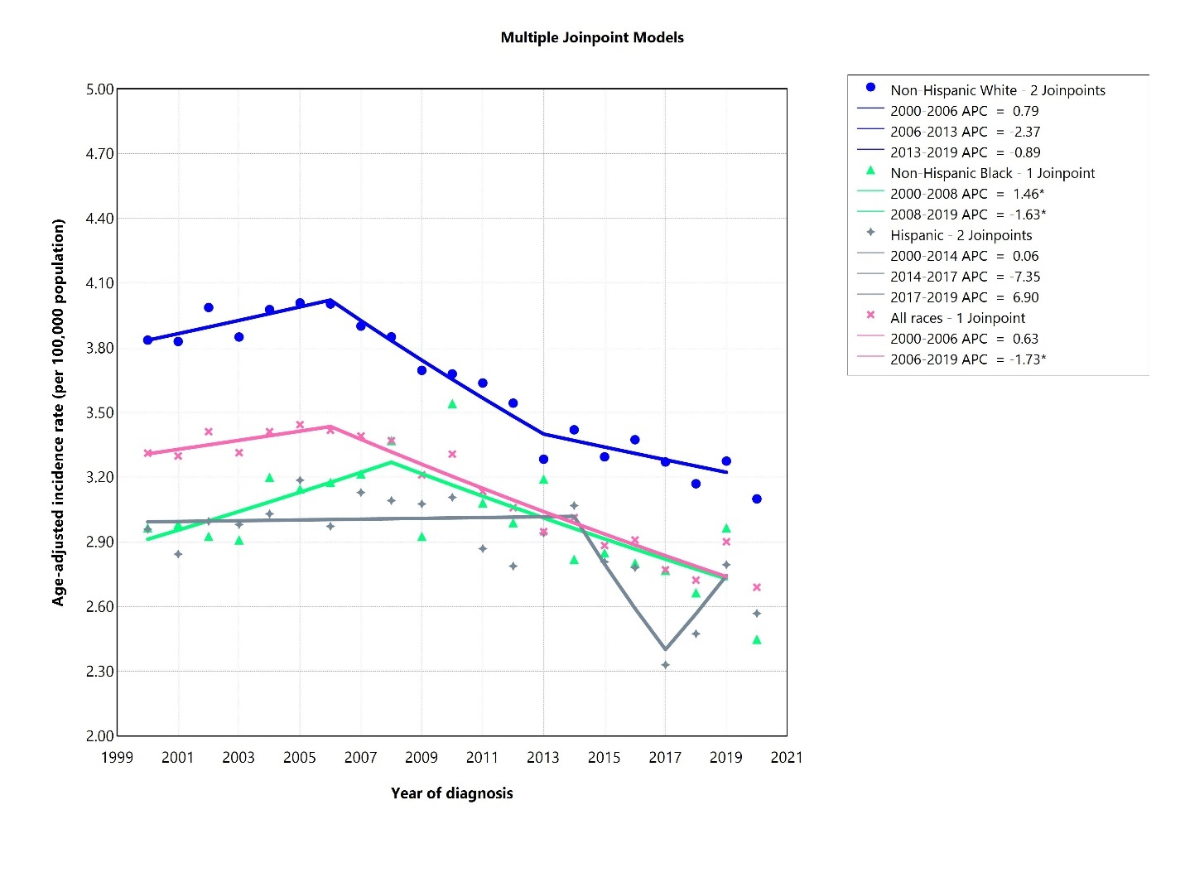Figure S1. Age-adjusted incidence rate of adult classical Hodgkin lymphoma over 2000-2019 and in 2020 in the United States, by race. APC: annual percent change. * Represent p-value less than 0.05.

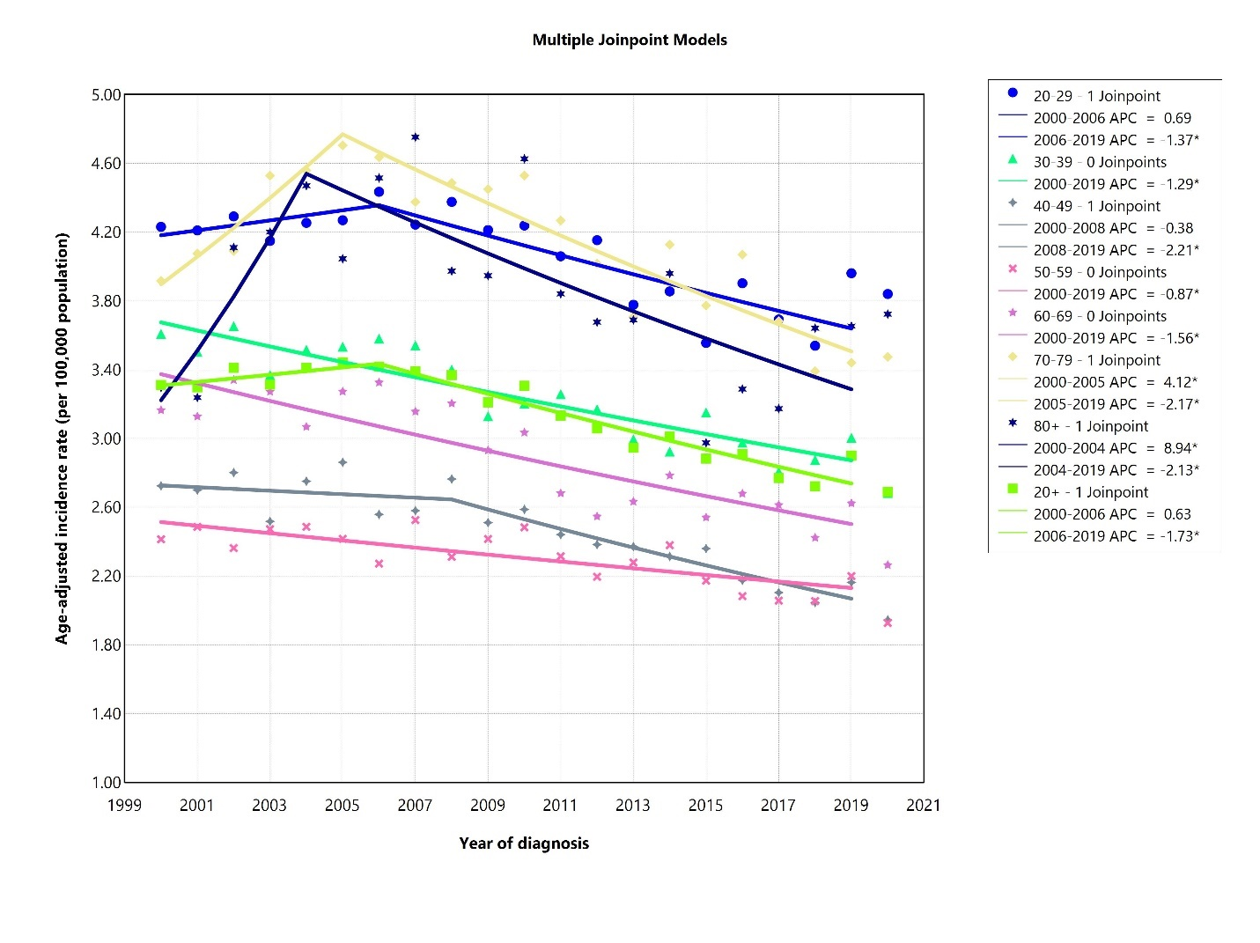
Figure S2. Age-adjusted incidence rate of classical Hodgkin lymphoma over 2000-2019 and in 2020 in the United States, by age. APC: annual percent change. * Represent p-value less than 0.05.
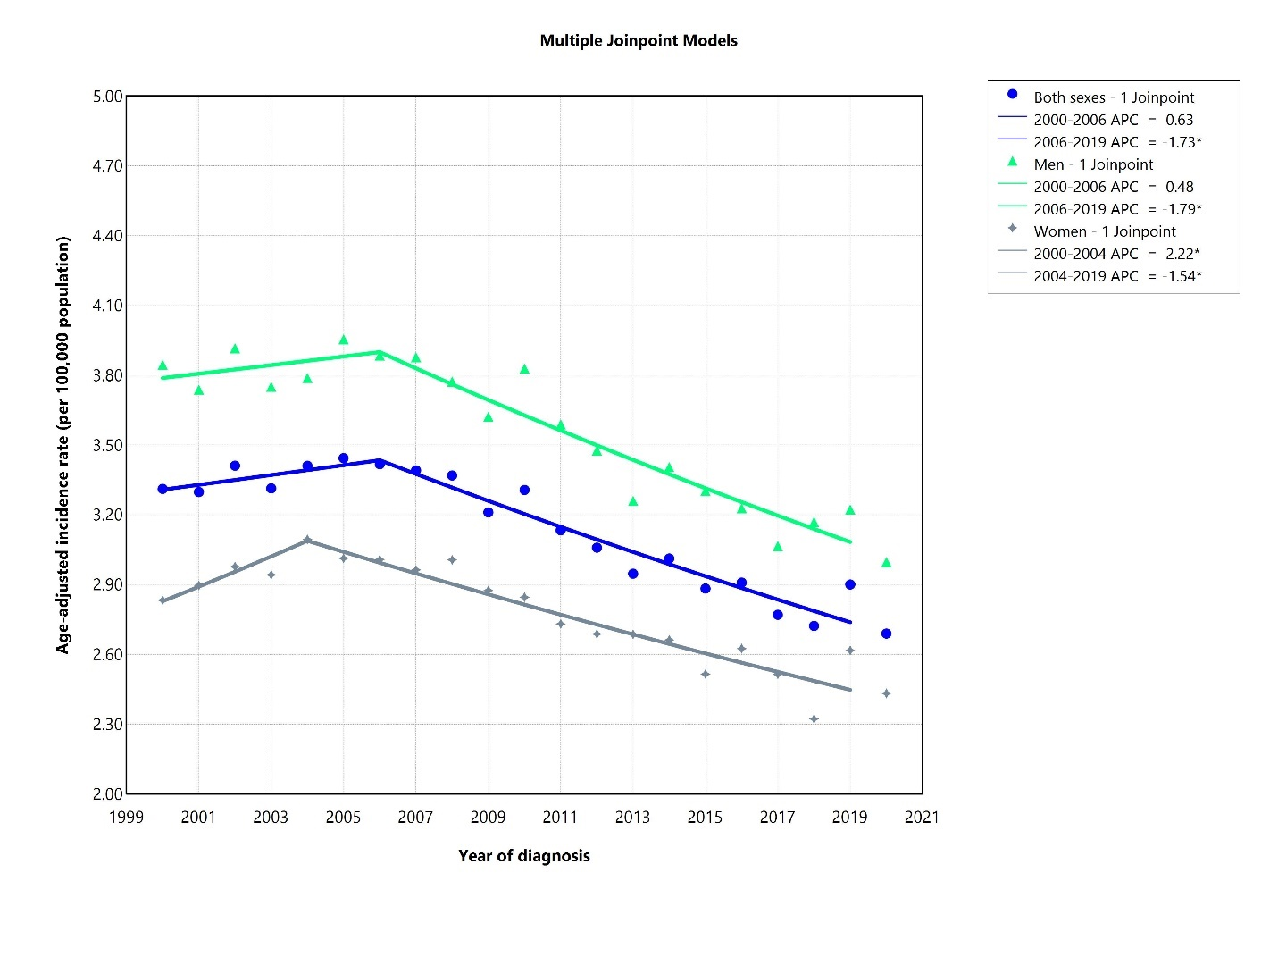
Figure S3. Age-adjusted incidence rate of classical Hodgkin lymphoma over 2000-2019 and in 2020 in the United States, by sex. APC: annual percent change. * Represent p-value less than 0.05.
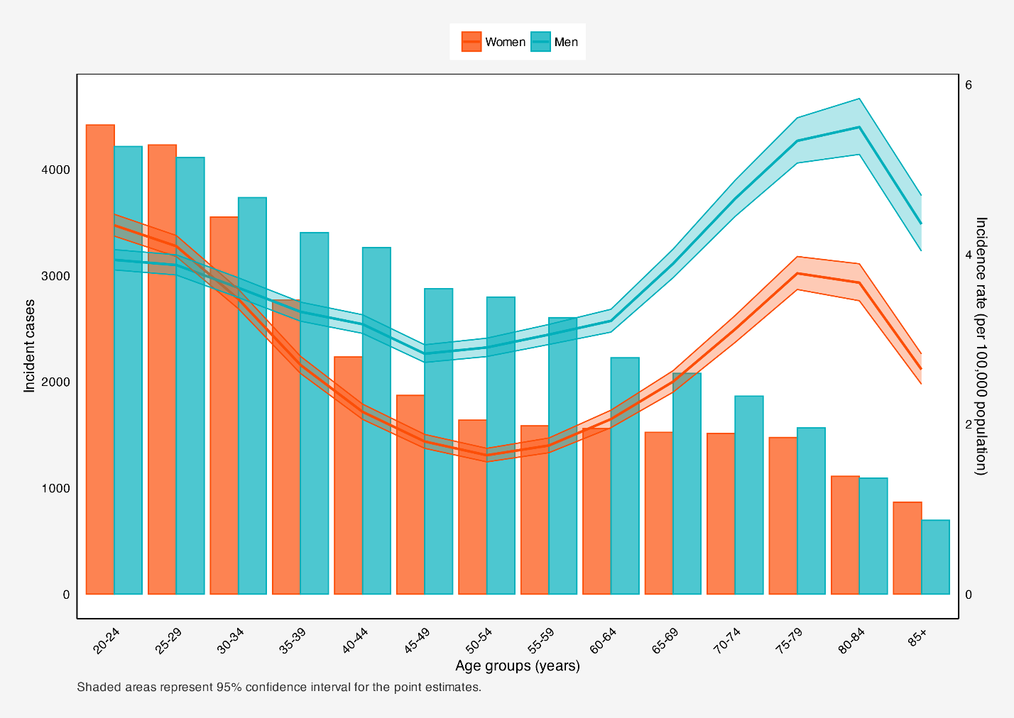
Figure S4. Incident cases and incidence rate of classical Hodgkin lymphoma in the United States among males and females in each age group.
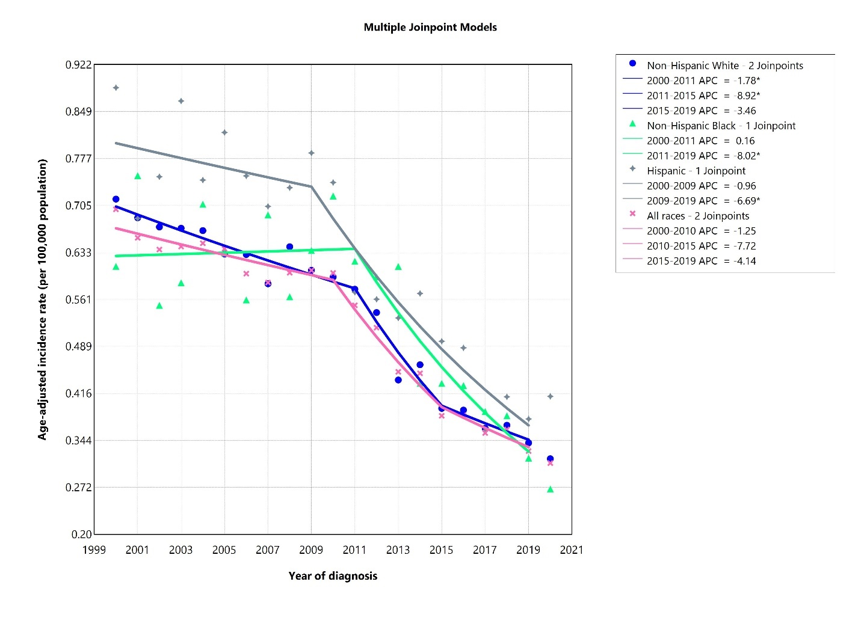
Figure S5. Age-adjusted incidence rate of lymphocyte-rich mixed cell lymphocyte depleted Hodgkin lymphoma over 2000-2019 and in 2020 in the United States, by race. APC: annual percent change. * Represent p-value less than 0.05.
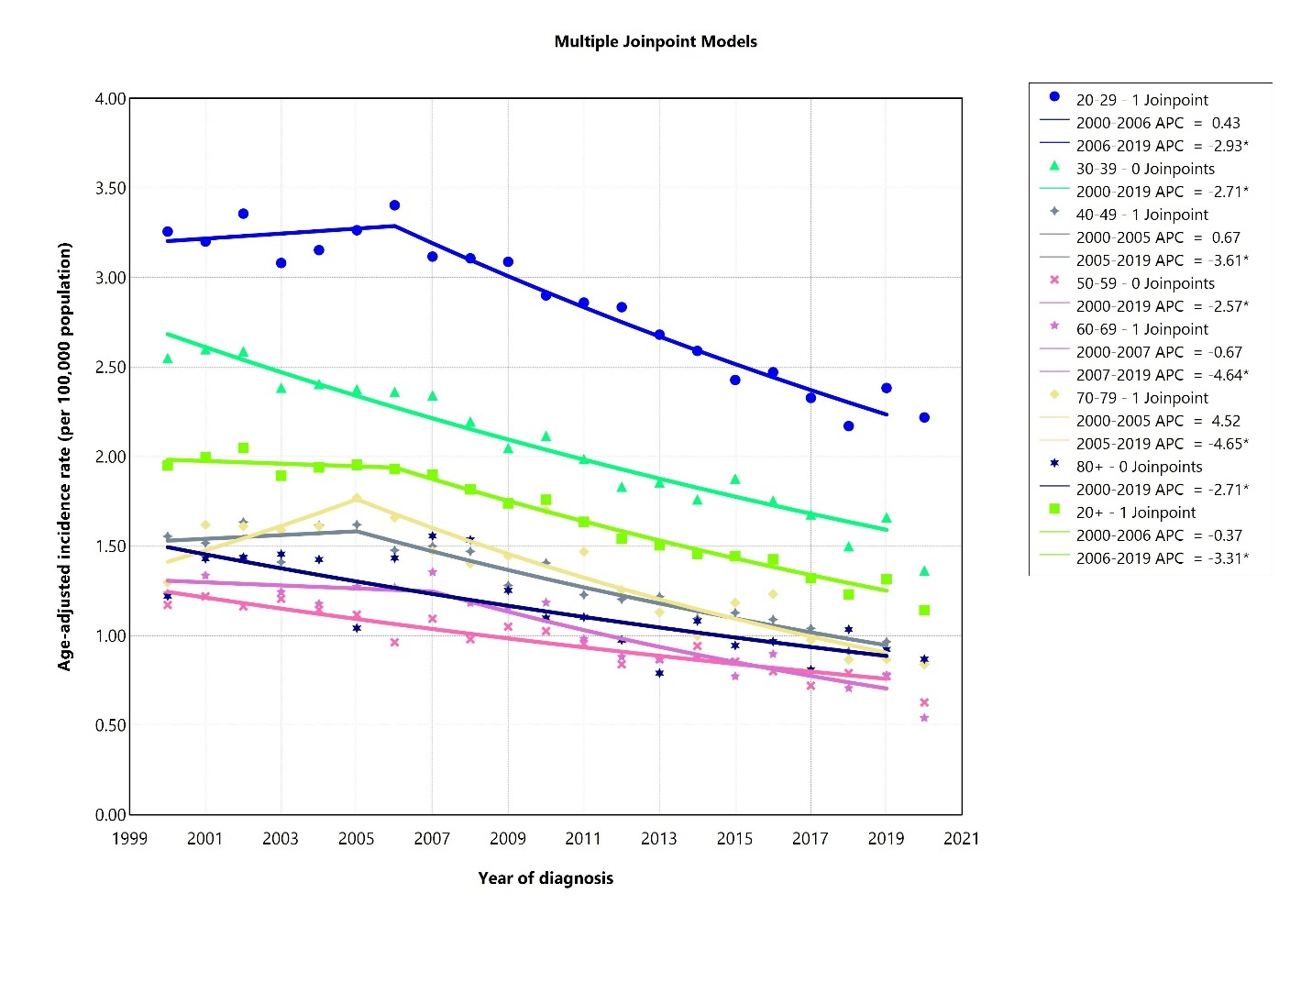
Figure S6. Age-adjusted incidence rate of lymphocyte-rich mixed cell lymphocyte depleted Hodgkin lymphoma over 2000-2019 and in 2020 in the United States, by age. APC: annual percent change. * Represent p-value less than 0.05.
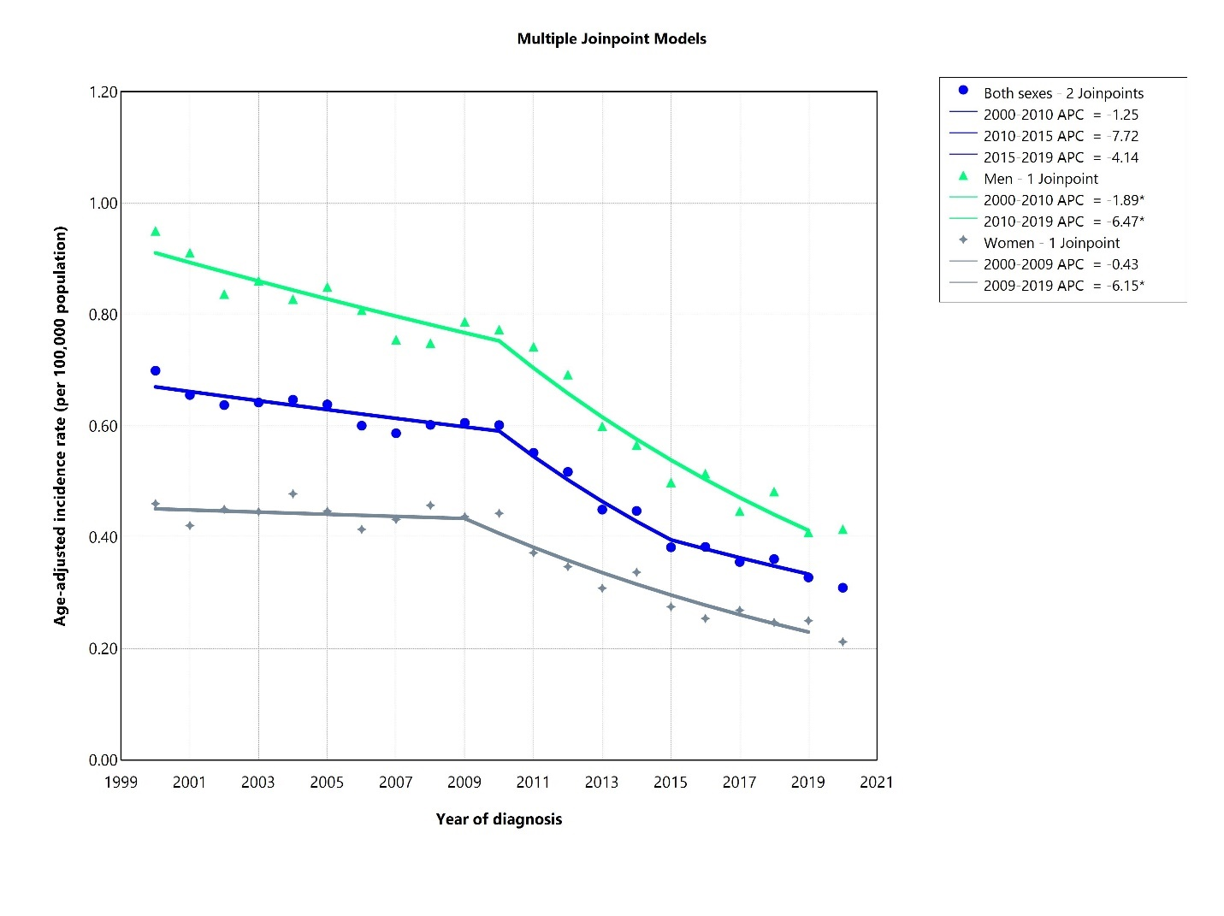
Figure S7. Age-adjusted incidence rate of lymphocyte-rich mixed cell lymphocyte depleted Hodgkin lymphoma over 2000-2019 and in 2020 in the United States, by sex. APC: annual percent change. * Represent p-value less than 0.05.
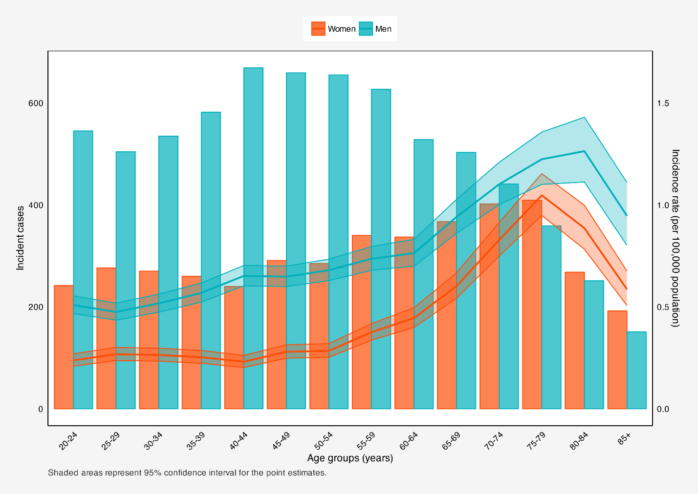
Figure S8. Incident cases and incidence rate of lymphocyte-rich mixed cell lymphocyte depleted Hodgkin lymphoma in the United States among males and females in each age group.
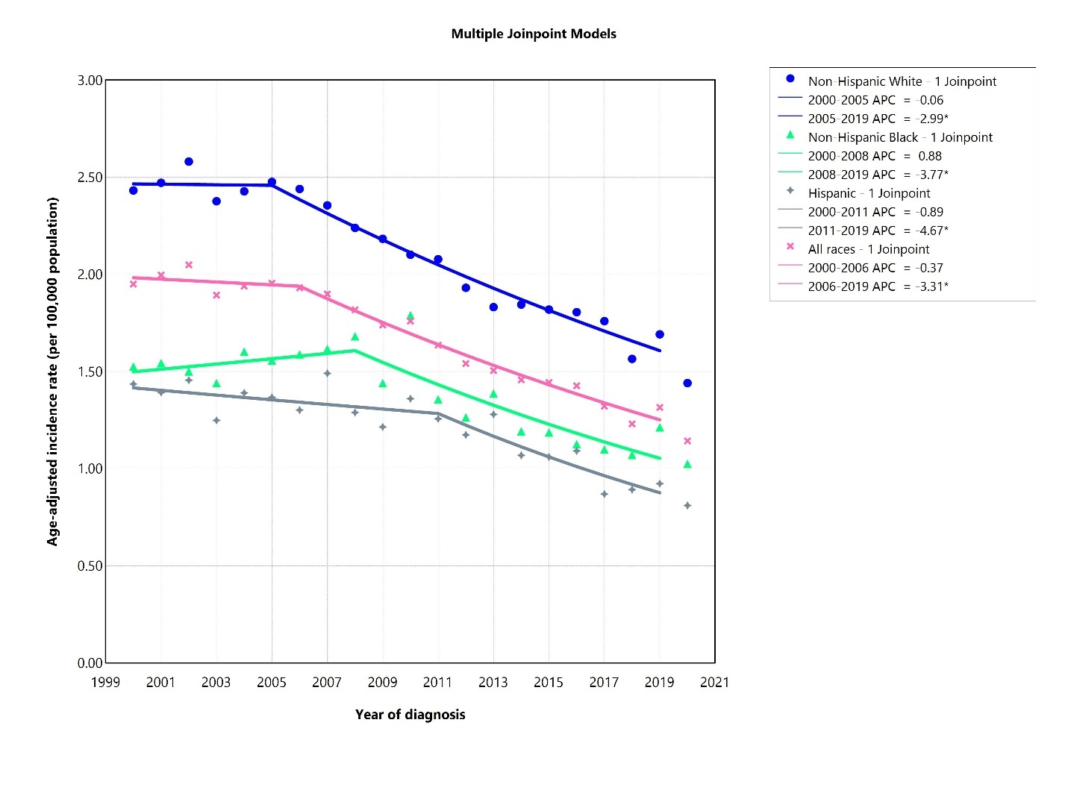
Figure S9. Age-adjusted incidence rate of nodular sclerosis Hodgkin lymphoma over 2000-2019 and in 2020 in the United States, by race. APC: annual percent change. * Represent p-value less than 0.05.
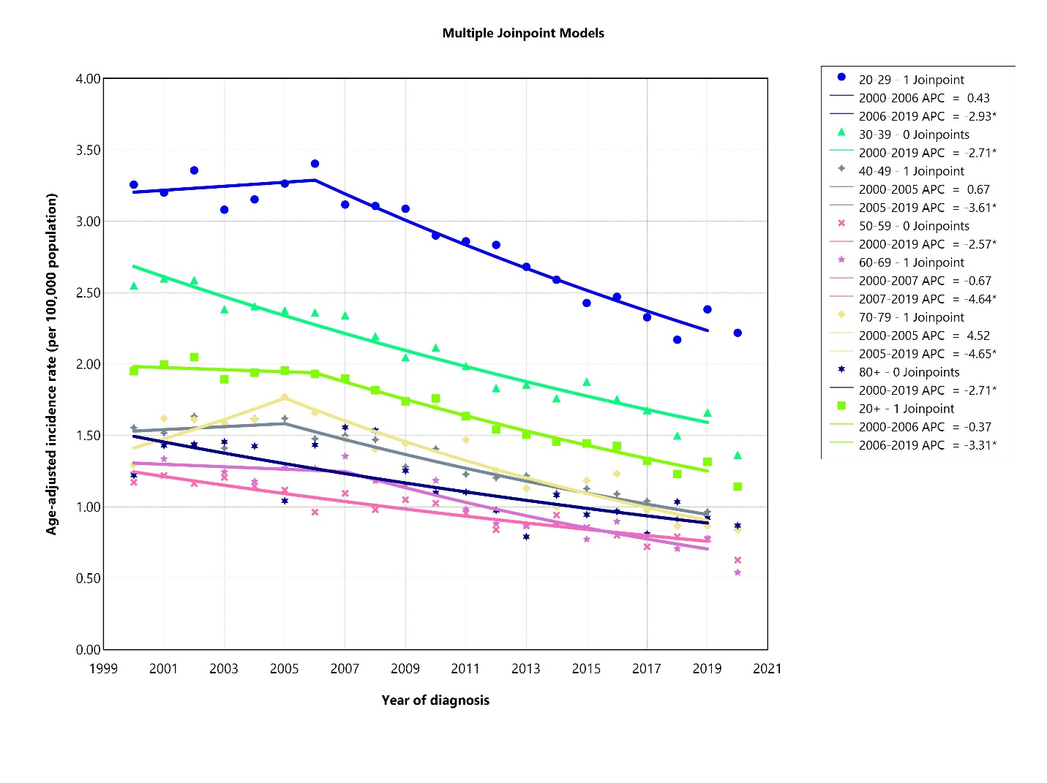
Figure S10. Age-adjusted incidence rate of nodular sclerosis Hodgkin lymphoma over 2000-2019 and in 2020 in the United States, by age. APC: annual percent change. * Represent p-value less than 0.05.
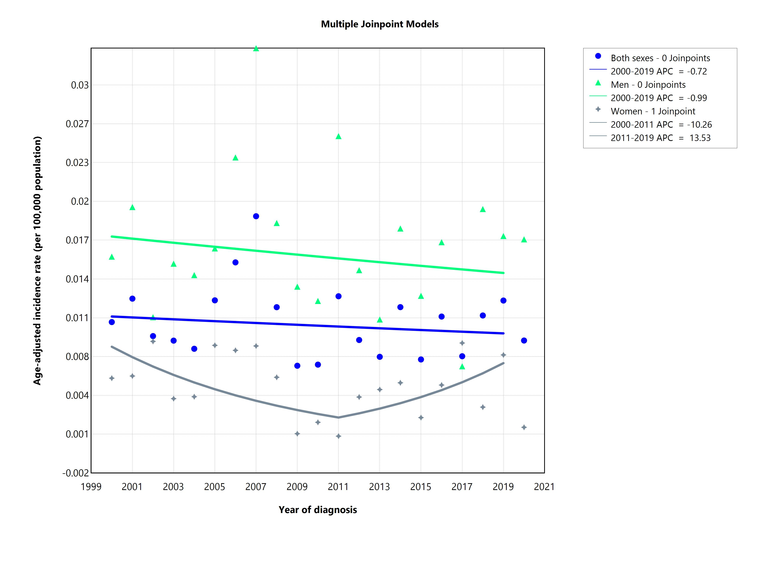
Figure S11. Age-adjusted incidence rate of nodular sclerosis Hodgkin lymphoma over 2000-2019 and in 2020 in the United States, by sex. APC: annual percent change.
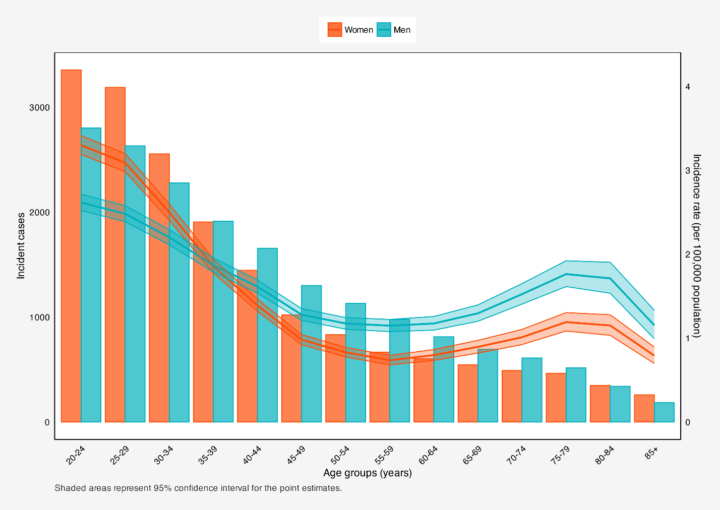
Figure S12. Incident cases and incidence rate of nodular sclerosis Hodgkin lymphoma in the United States among males and females in each age group.

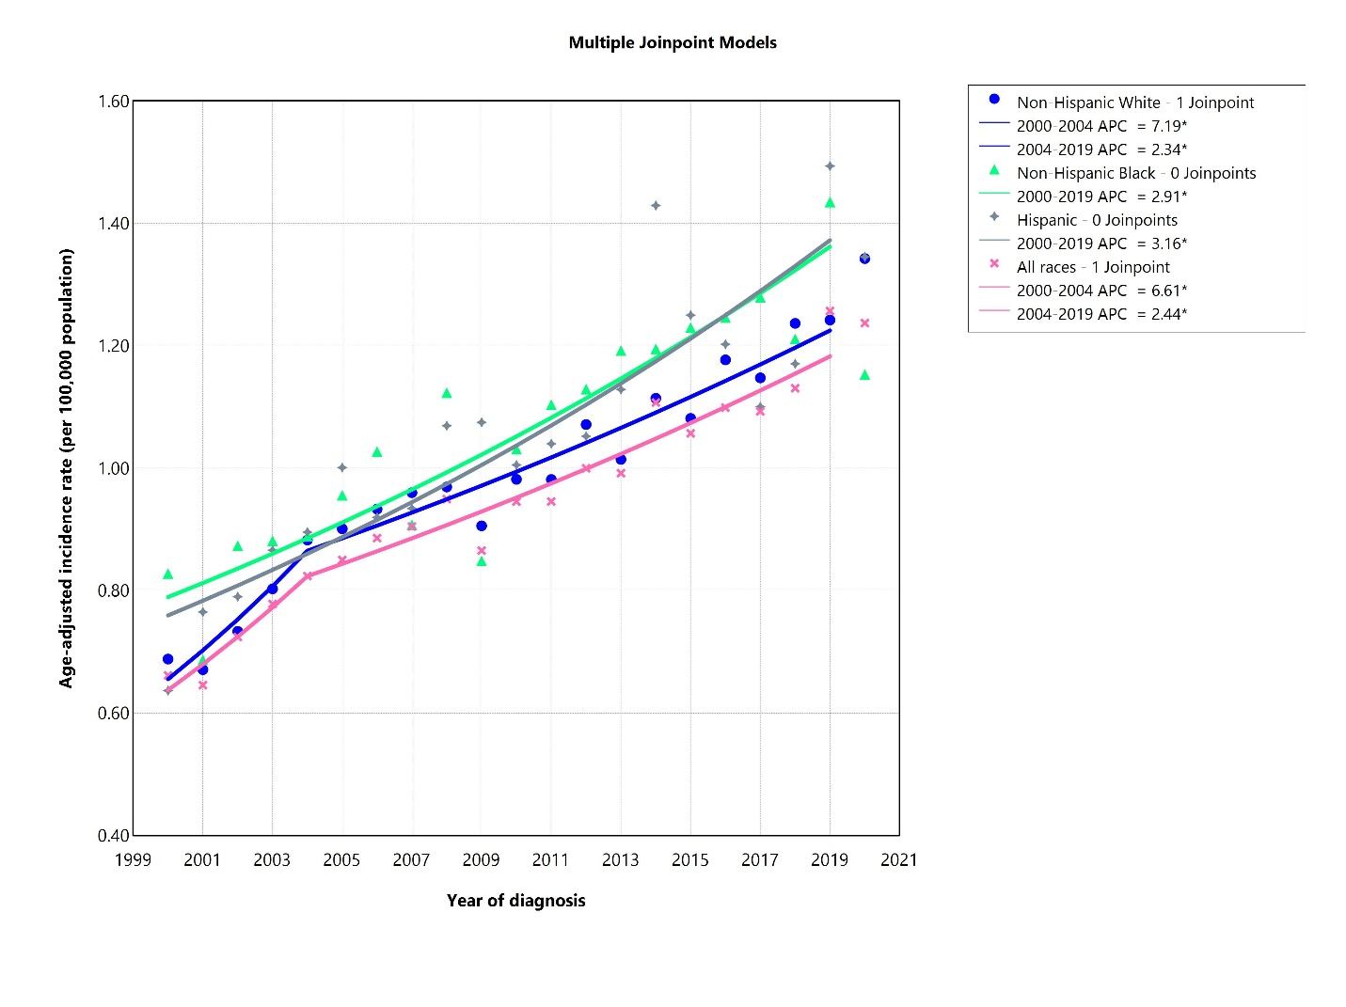
Figure S13. Age-adjusted incidence rate of classical Hodgkin lymphoma not otherwise specified (NOS) over 2000-2019 and in 2020 in the United States, by race. APC: annual percent change. * Represent p-value less than 0.05.
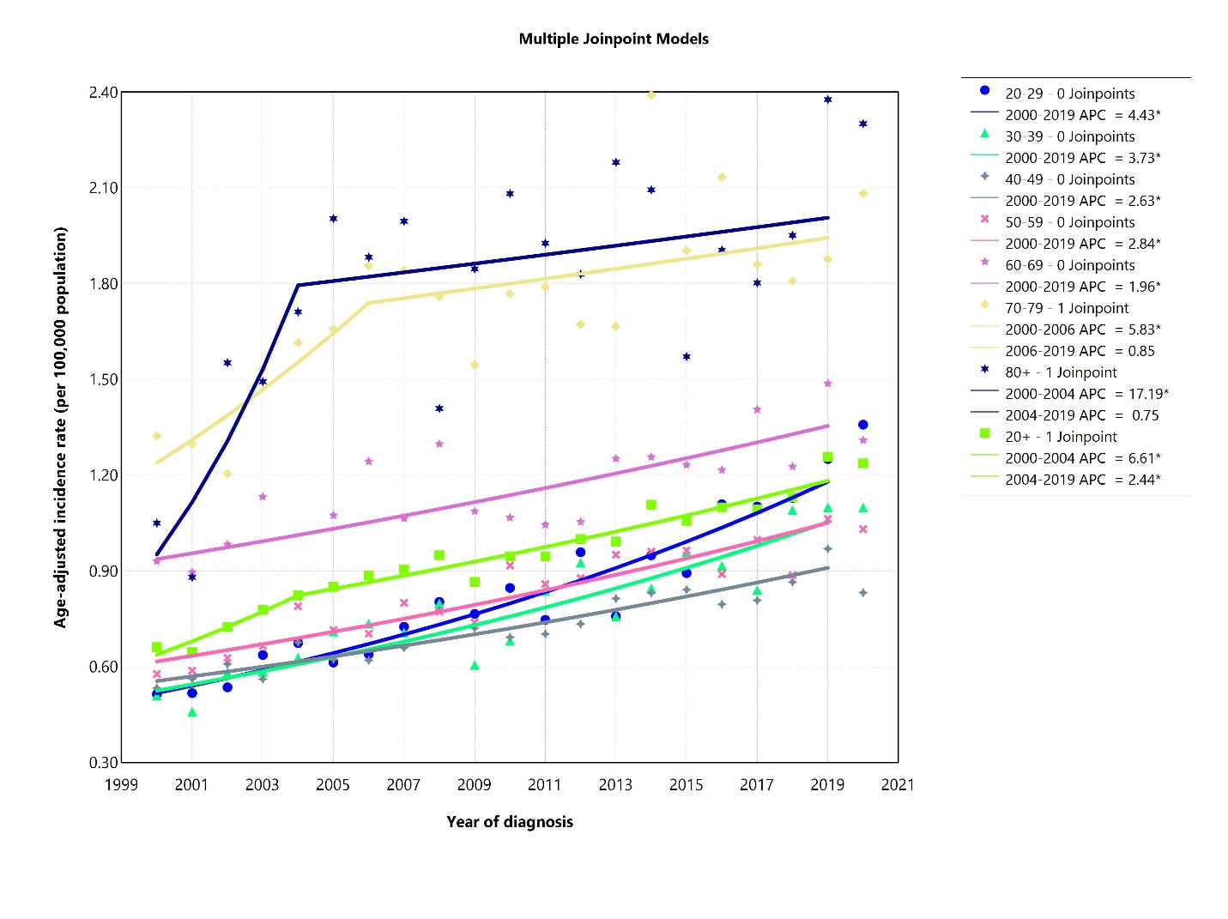
Figure S14. Age-adjusted incidence rate of classical Hodgkin lymphoma not otherwise specified (NOS) over 2000-2019 and in 2020 in the United States, by age. APC: annual percent change. * Represent p-value less than 0.05.
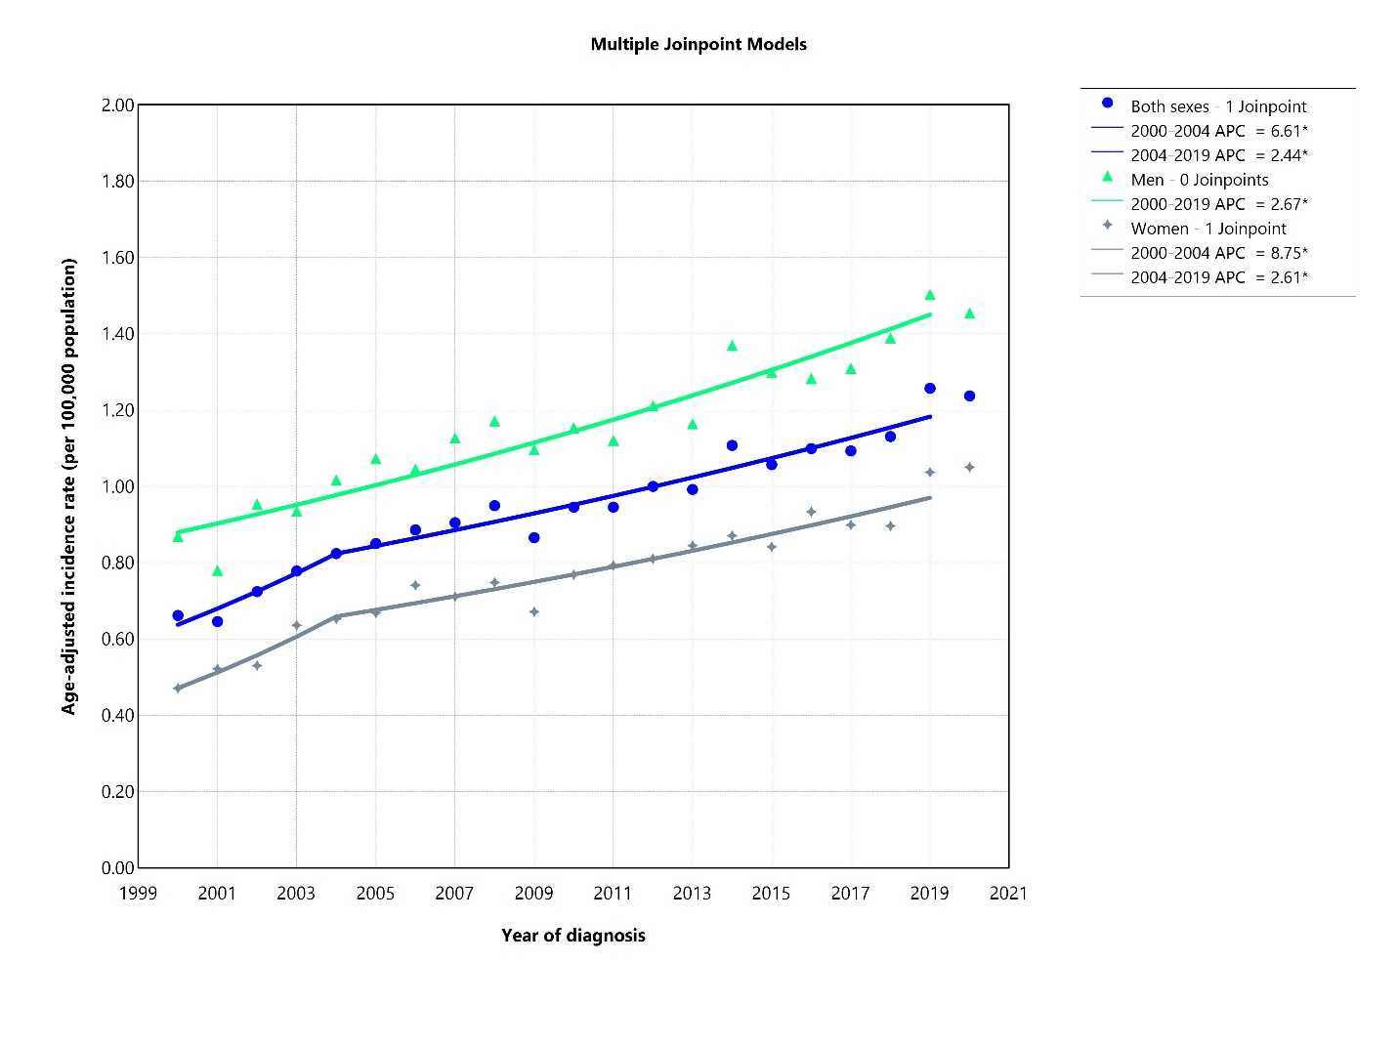
Figure S15. Age-adjusted incidence rate of classical Hodgkin lymphoma not otherwise specified (NOS) over 2000-2019 and in 2020 in the United States, by sex. APC: annual percent change. * Represent p-value less than 0.05.
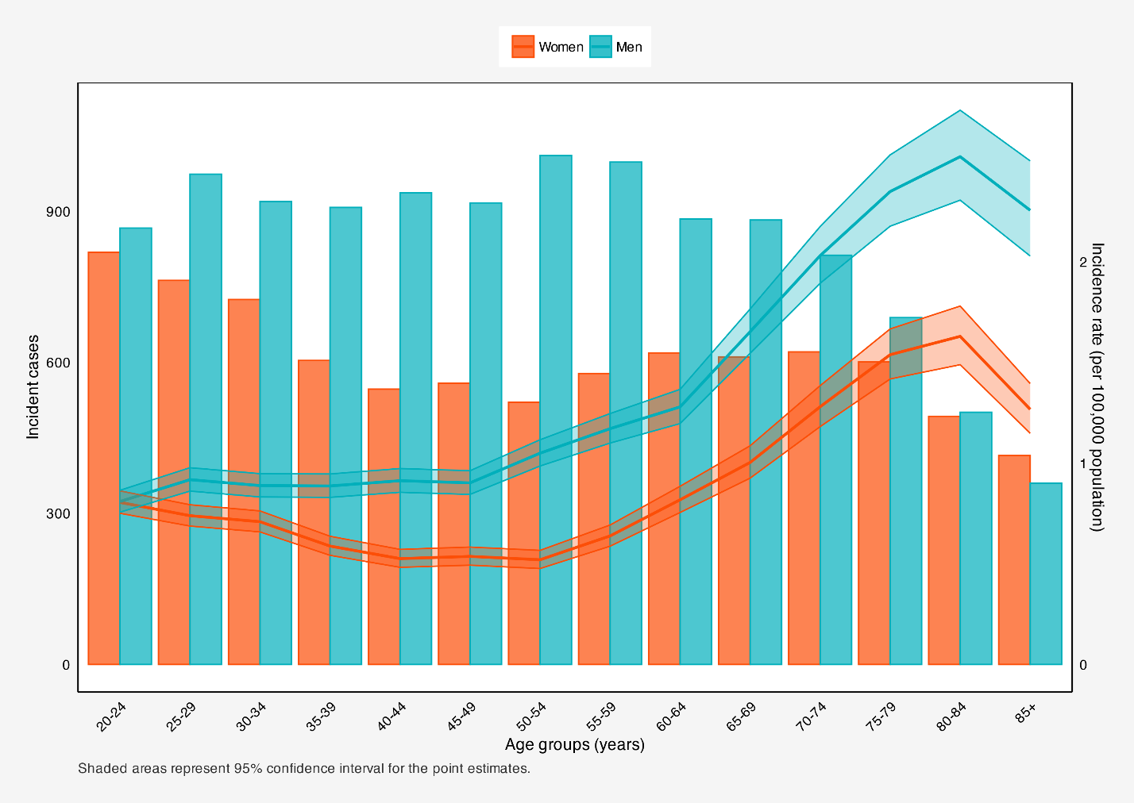
Figure S16. Incident cases and incidence rate of classical Hodgkin lymphoma not otherwise specified (NOS) in the United States among males and females in each age group.

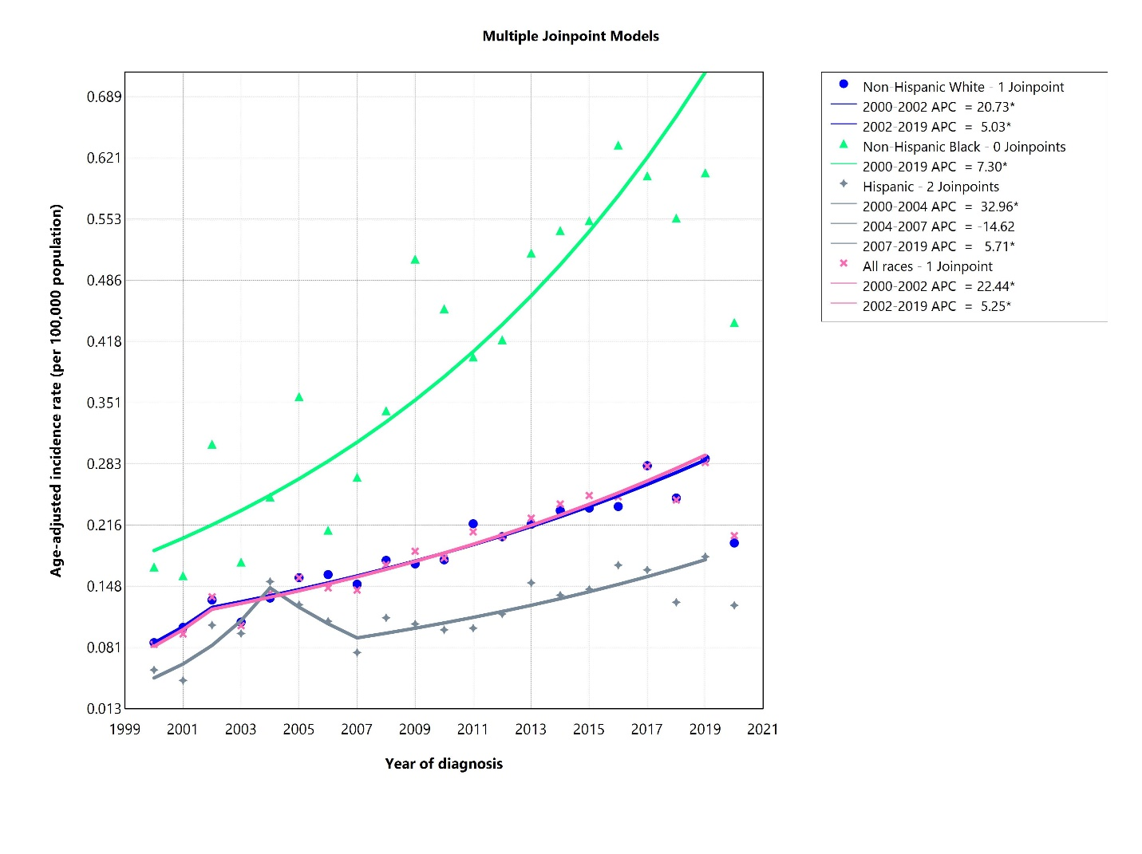
Figure S17. Age-adjusted incidence rate of nodular lymphocyte prominent Hodgkin lymphoma over 2000-2019 and in 2020 in the United States, by race. APC: annual percent change. * Represent p-value less than 0.05.
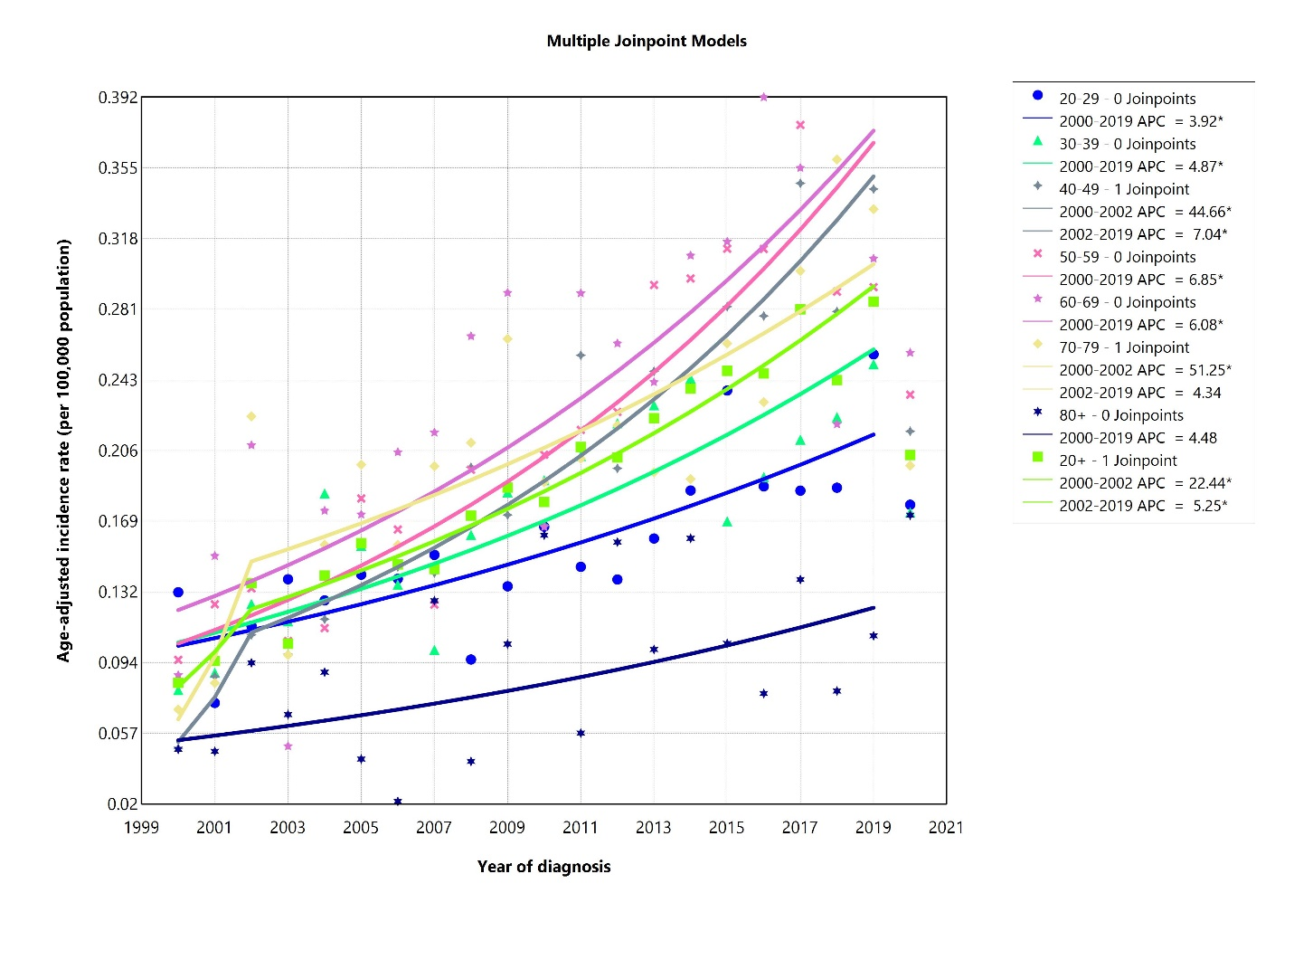
Figure S18. Age-adjusted incidence rate of nodular lymphocyte prominent Hodgkin lymphoma over 2000-2019 and in 2020 in the United States, by age. APC: annual percent change. * Represent p-value less than 0.05.
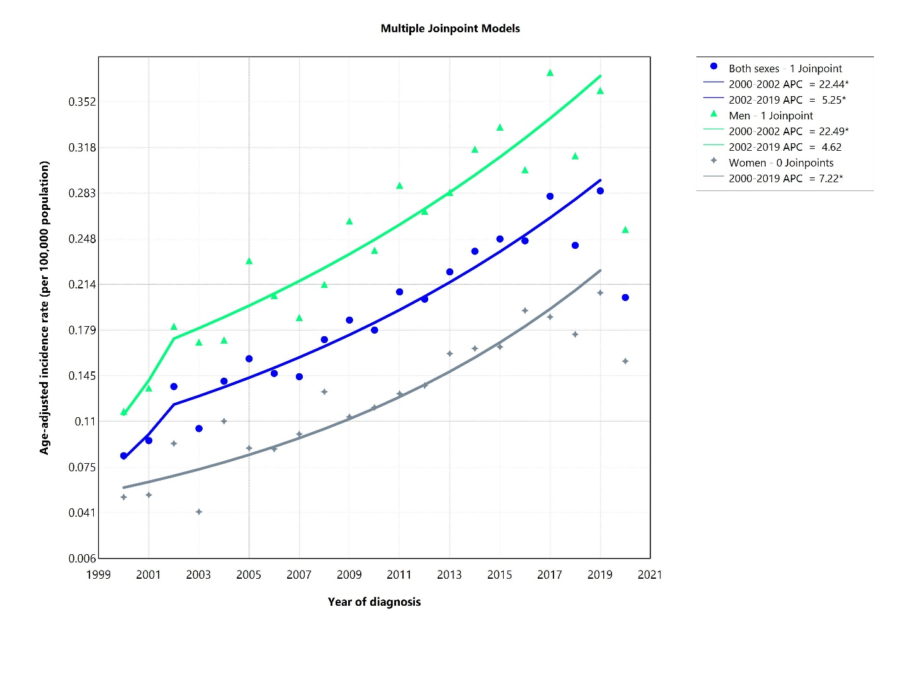
Figure S19. Age-adjusted incidence rate of nodular lymphocyte prominent Hodgkin lymphoma over 2000-2019 and in 2020 in the United States, by sex. APC: annual percent change. * Represent p-value less than 0.05.
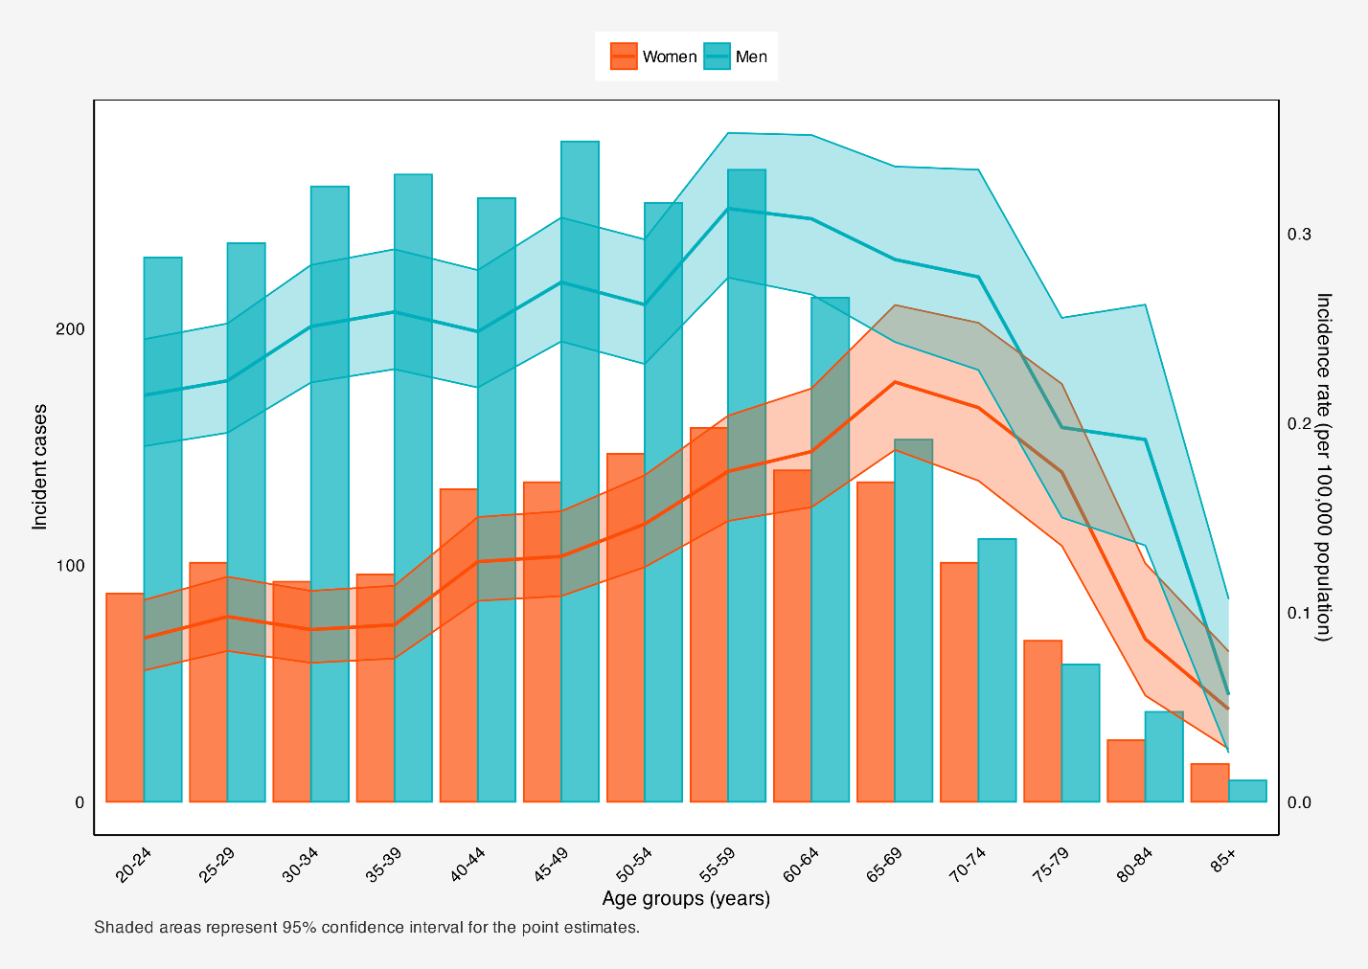
Figure S20. Incident cases and incidence rate of nodular lymphocyte prominent Hodgkin lymphoma in the United States among males and females in each age group.

