ONLINE SUPPLEMENTARY MATERIALS

Sweat lactate sensor for detecting anaerobic threshold in heart failure: a prospective clinical trial (LacS-001)

Yoshinori Katsumata, MD, PhD
Yuki Muramoto
Noriyuki Ishida
Ryo Takemura PhD
Kengo Nagashima PhD
Takenori Ikoma MD, PhD
Naoto Kawamatsu MD, PhD
Masaru Araki MD, PhD
Ayumi Goda MD, PhD
Hiroki Okawara
Tomonori Sawada^{h},
Yumiko Kawakubo Ichihara MD
Osamu Hattori MD,
Koki Yamaoka MD
Yuta Seki MD, PhD
Toshinobu Ryuzaki MD
Hidehiko Ikura MD
Daisuke Nakashima MD, PhD
Takeo Nagura MD, PhD
Masaya Nakamura MD, PhD
Kazuki Sato, MD, PhD
Yasuyuki Shiraishi MD, PhD

SUPPLEMENTARY TABLES

eTable 1. List of reasons for excluded participants

Participant No. | VT | sLT
1002 |  | Discrepant analysis result by three independent investigators due to the presence of several inflection points
1005 |  | No increase in current values due to the absence of sweat lactate production
1007 |  | No increase in current values due to the absence of sweat lactate production
1013 | Inconsistencies among several factors such as the VE/VO₂, the terminal exhaled O₂ concentration, and the VCO₂/VO₂ slope | No increase in current values due to the absence of sweat lactate production
1014 | Inconsistencies among several factors such as the VE/VO₂, the terminal exhaled O₂ concentration, and the VCO₂/VO₂ slope
1015 |  | No increase in current values due to the absence of sweat lactate production
1018 |  | No increase in current values due to the absence of sweat lactate production
1019 |  | No increase in current values due to the absence of sweat lactate production
1020 |  | No increase in current values due to the absence of sweat lactate production
1024 | Inconsistencies among several factors such as the VE/VO₂, the terminal exhaled O₂ concentration, and the VCO₂/VO₂ slope
1025 | Inconsistencies among several factors such as the VE/VO₂, the terminal exhaled O₂ concentration, and the VCO₂/VO₂ slope
1026 |  | No increase in current values due to the absence of sweat lactate production
1030 | Discrepant analysis result by three independent investigators due to the presence of several inflection points
1033 |  | No increase in current values due to the absence of sweat lactate production
1034 | Due to different protocols | Due to different protocols
1039 |  | No increase in current values due to the absence of sweat lactate production
1040 |  | No increase in current values due to the absence of sweat lactate production
1043 | Discrepant analysis result by three independent investigators due to the presence of several inflection points

VT: Ventilatory threshold, sLT: Sweat lactate threshold

eTable 2. Baseline characteristics

 | Analysis for secondary endpoints  (n = 37) | Analysis for primary endpoints  (n = 32)
Age, years (median, IQR) | 62.0 (55.0 - 70.0) | 62.0 (59.0 - 72.0)
Male, n (%) | 33 (89.2) | 29 (90.6)
Height, cm (median, IQR) | 169.3 (165.6 - 173.2) | 168.2 (165.5 - 173.3)
Body weight, kg (median, IQR) | 70.2 (66.0 - 74.5) | 69.6 (65.8 - 74.2)
BMI, kg/m² (median, IQR) | 23.9 (23.4 - 26.2) | 23.9 (23.2 - 26.2)
Hypertension, n (%) | 13 (35.1) | 12 (37.5)
Diabetes, n (%) | 11 (29.7) | 11 (34.4)
Dyslipidemia, n (%) | 21 (56.8) | 20 (62.5)
NYHA ≧ 1, n (%) | 25 (67.6) | 22 (68.8)
Device, n (%) | 5 (13.5) | 5 (15.6)
Laboratory data
Hemoglobin, g/dL (median, IQR) | 14.4 (13.8 - 15.0) | 14.5 (13.9 - 15.2)
Creatinine, mg/dL (median, IQR) | 0.91 (0.81 - 1.04) | 0.92 (0.80 - 1.05)
BNP, pg/mL (median, IQR) | 31.4 (15.5 - 56.6) | 27.6 (15.1 - 55.3)
Missing data, n (%) | 3 (8.1) | 3 (9.4)
Echocardiography data
EF, % (median, IQR) | 59.3 (54.8 - 63.8) | 59.8 (53.8 - 63.9)
Medications
Beta-blocker, n (%) | 29 (78.4) | 26 (81.3)
ACEI or ARB, n (%) | 25 (67.6) | 23 (71.8)
Aldosterone, n (%) | 6 (16.2) | 6 (18.8)
SGLT2i, n (%) | 8 (21.6) | 8 (25.0)
SVSH, n (%) | 3 (8.1) | 3 (9.4)
Ivabradine, n (%) | 2 (5.4) | 2 (6.3)
Cardiopulmonary test data
VO₂ at VT, ml/kg/min (median, IQR) | 12.3 (11.2 - 14.5) | 12.3 (11.2 - 14.5)
Missing data, n (%) | 5 (13.5) | 0 (0.0)
VT, sec (median, IQR) | 251.5 (207.5 - 282.0) | 251.5 (207.5 - 282.0)
Missing data, n (%) | 5 (13.5) | 0 (0.0)
Peak VO_{2,} ml/kg/min (median, IQR) | 21.6 (16.7 - 24.0) | 20.9 (16.7 - 23.7)
% Peak VO₂, % (median, IQR) | 86.7 (79.2 - 101.3) | 86.7 (79.3 - 101.9)
VE/VO₂ slope (median, IQR) | 29.7 (25.9 - 32.5) | 29.1 (25.8 - 32.2)

ACEi angiotensin-converting enzyme inhibitor, ARB angiotensin receptor blocker, BMI body mass index, BNP B-type natriuretic peptide, IQR interquartile range, EF ejection fraction, NYHA New York Heart Association Functional Classification, SGLT2i sodium-glucose cotransporter 2 inhibitor, SVSH Sacubitril Valsartan Sodium Hydrate VE/VCO₂ ventilation-carbon dioxide production, VO2 oxygen uptake, VT Ventiratory threshold

eTable 3. Respiratory gas data during exercise in all participants (n = 50)

 | Rest | Warm-up | VT* | Peak
HR, bpm | 69.0 (61.0–76.0) | 76.5 (71.0–80.0) | 95.0 (88.0–103.0) | 127.5 (115.0–144.0)
SBP, mmHg | 112.0 (102.0–130.0) | 122.5 (113.0–131.0) | 137.0 (122.0–154.0) | 167.5 (151.0–194.0)
DBP, mmHg | 76.5 (66.0–84.0) | 78.5 (71.0–90.0) | 80.0 (69.0–90.0) | 87.0 (78.0–96.0)
RQ | - | - | 0.90 (0.85–0.93) | 1.18 (1.13–1.23)
WR (W) | - | - | 59.0 (46.0–68.0) | 113.0 (100.0–144.0)

All values are presented as medians and interquartile ranges (IQRs). DBP, diastolic blood pressure; HR, heart rate; IQR, interquartile range; RQ, respiratory quotient; SBP, systolic blood pressure; VE/VCO₂, ventilation-carbon dioxide production; VO₂, oxygen uptake; VT, ventilatory threshold; WR, work rate. *The sample size for VT was 43 due to missing data.

eTable 4. Respiratory gas data during exercise in patients with definitely determined sLT (n = 37)

 | Rest | Warm-up | VT* | Peak
HR, bpm | 70.0 (62.0 - 76.0) | 77.0 (70.0 - 80.0) | 95.0 (88.0 - 102.5) | 131.0 (118.0 - 146.0)
SBP, mmHg | 114.0 (103.0 - 128.0) | 123.0 (113.0 - 130.0) | 137.0 (118.5 - 147.5) | 171.0 (151.0 - 194.0)
DBP, mmHg | 77.0 (70.0 - 84.0) | 79.0 (74.0 - 89.0) | 80.5 (70.0 - 88.5) | 87.0 (78.0 - 94.0)
RQ | - | - | 0.90 (0.86 - 0.93) | 1.18 (1.13 - 1.25)
WR (W) | - | - | 59.5 (49.0 - 70.0) | 121.0 (103.0 - 144.0)

All values are presented as medians and IQRs. DBP diastolic blood pressure, HR heart rate, IQR interquartile range, RQ respiratory quotient, SBP systolic blood pressure, VE/VCO2 ventilation-carbon dioxide production, VO₂ oxygen uptake, VT ventilatory threshold, WR work rate. * The sample size for AT was 32 due to missing data.

eTable 5. Respiratory gas data during exercise patients with definitely determined sLT and VT (n = 32)

 | Rest | Warm-up | AT | Peak
HR, bpm | 71.0 (63.0 - 76.0) | 76.5 (70.5 - 81.0) | 95.0 (88.0 - 102.5) | 130.5 (118.0 - 145.0)
SBP, mmHg | 112.0 (102.0 - 126.5) | 122.5 (112.0 - 129.0) | 137.0 (118.5-147.5) | 172.0 (150.5 - 194.0)
DBP, mmHg | 76.5 (67.5 - 81.5) | 78.5 (71.5 - 85.5) | 80.5 (70.0 - 88.5) | 86.0 (77.5 - 93.0)
RQ | - | - | 0.90 (0.86 - 0.93) | 1.19 (1.13 - 1.25)
WR (W) | - | - | 59.5 (49.0 - 70.0) | 118.5 (101.5 - 144.0)

All values are presented as medians and IQRs. DBP diastolic blood pressure, HR heart rate, IQR interquartile range, RQ respiratory quotient, SBP systolic blood pressure, VE/VCO2 ventilation-carbon dioxide production, VO₂ oxygen uptake, VT ventilatory threshold, WR work rate. * The sample size for AT was 32 due to missing data.

eTable 6. (A) Research organization and roles (each team and committee were independently organized and responsible for their own work). (B) Study sites, principal investigators (PI).

A
Role | Investigators and personnel | Institute
Steering Committee
Chairman, Coordinating investigator | Yoshinori Katsumata | Keio University
Medical expert | Yoshinori Katsumata | Keio University
Coordinator | Wakana Seki | Keio University
Biostatistical Committee
Director of biostatistical analysis | Kengo Nagashima | Keio University
Biostatistical analysis | Ryo Takemura | Keio University
Biostatistical analysis | Noriyuki Ishida | Keio University
Data management | Chikara Daimon | CMIC CO.,Ltd.
Clinical Trial Management
Assignment manager | Tsubasa Otsuka | CMIC CO.,Ltd.
Manager, Contact for public queries | Yasuko Ochi | CMIC CO.,Ltd.
Safety information management | Hiroshi Ohashi | CMIC CO.,Ltd.
Data Safety Monitoring Board
Monitoring | Yukiho Ogawa | CMIC CO.,Ltd.
Audit | Noriaki Suzuki | CMIC CO.,Ltd.
Sponsor investigator | Yoshinori Katsumata | Keio University

B
Site, prefecture | Investigator
Keio University, School of medicine. | PI: Yoshinori Katsumata

SUPPLEMENTARY FIGURES

eFigure 1. Imaging of lactate concentration in sweat during incremental exercise in the patients with no increase in sweat lactate sensor
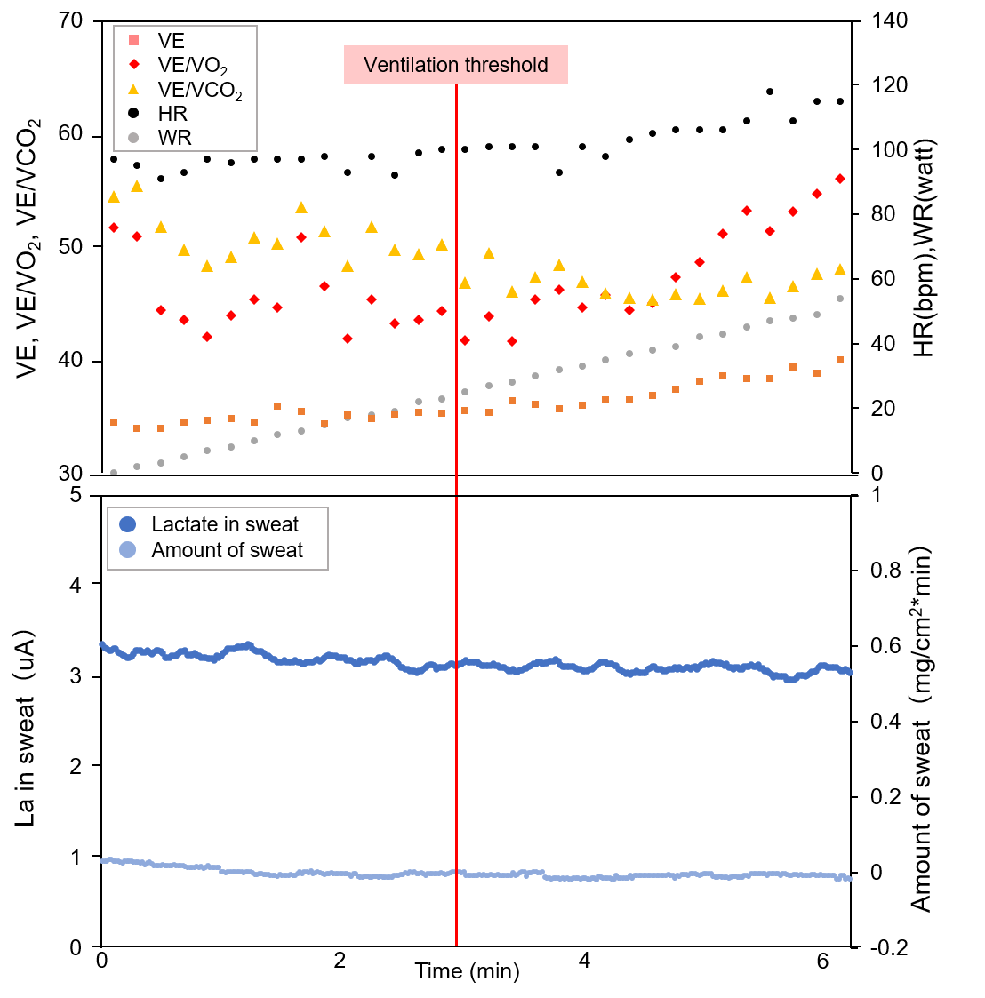
Representative graphs (dots) of the lactate acid in sweat (LA in sweat; dark blue) during exercise with a RAMP (15 W/min) protocol ergometer in patients with no increase in sweat lactate sensor are shown in the lower panel. The respiratory gas data are shown in the upper panel. Abbreviation; HR = heart rate; LA = lactic acid; VE/VCO₂ = ventilation–carbon dioxide production; VE/VO₂ = indicates ventilation-oxygen uptake; WR = work rate.
eFigure 2. Imaging of lactate concentration in sweat during incremental exercise in the patients with several candidate points of sweat lactate threshold
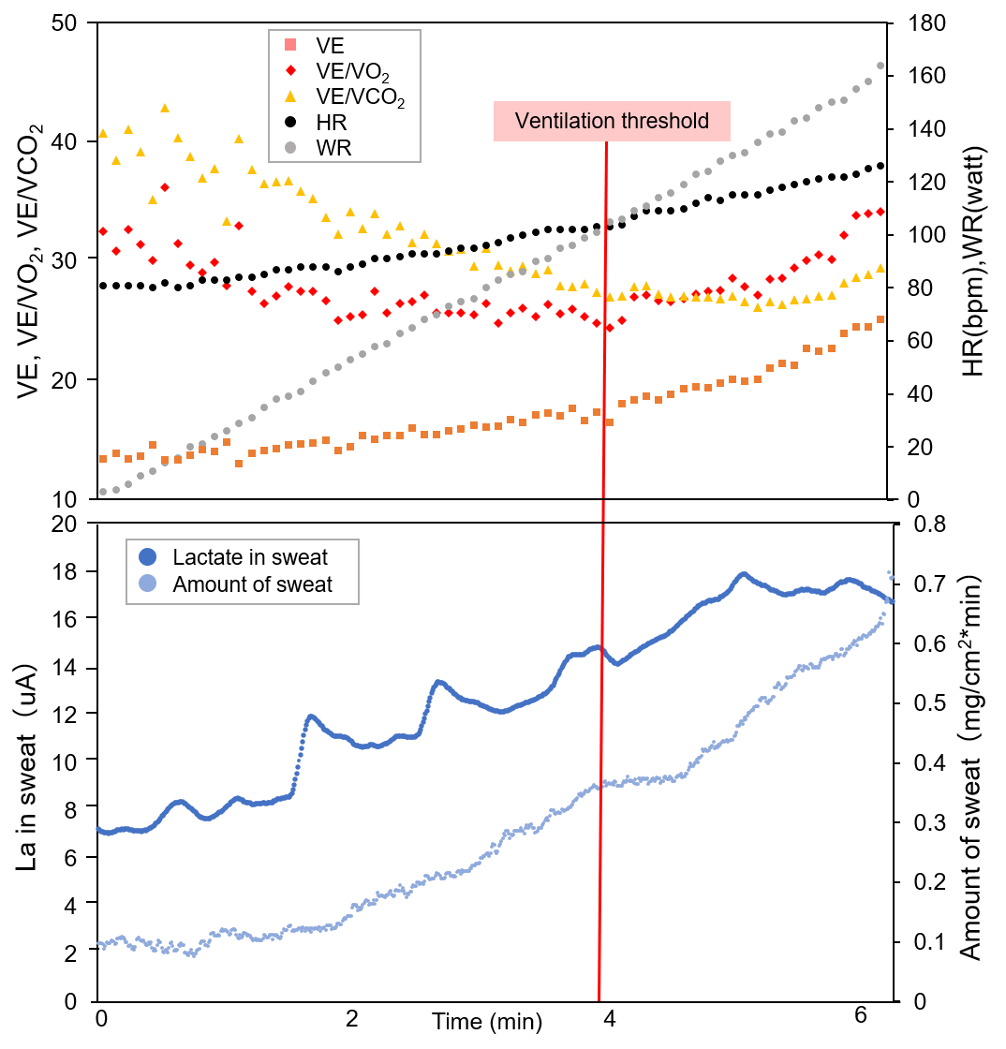
Representative graphs (dots) of the lactate acid in sweat (LA in sweat; dark blue) during exercise with a RAMP (15 W/min) protocol ergometer in patients with several candidate points of sweat lactate threshold are shown in the lower panel. The respiratory gas data are shown in the upper panel. Abbreviation; HR = heart rate; LA = lactic acid; VE/VCO₂ = ventilation–carbon dioxide production; VE/VO₂ = indicates ventilation-oxygen uptake; WR = work rate.

eFigure 3. The scheme to determine a definite VT.
