SUPPLEMENTAL INFORMATION
Figure S1: CGH profiles of duplications from Dup 2, dup 2-9 and DUP 8-9 cells (A-C). Duplicated regions are represented by red dots while black dots represent non duplicated regions. DMD exons are aligned with the duplications in the bottom part of each figure. D) UCSC Genome browser visualization of the duplications and best gRNA used in this study. Duplications (black bars) and gRNAs (small black lines) are aligned with the human genome assembly hg19 and the DMD transcript (in the lower part of the figure). DMD exons are labelled from right to left following the DMD gene orientation on chromosome X.
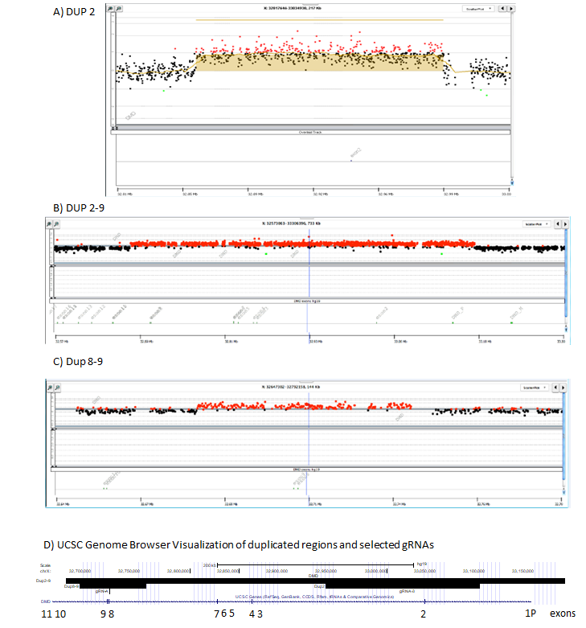

Figure S2: Validation of the sgRNAs for Dup2 and Dup2-9 by CRISPR in tube strategy. A) CRISPR in-tube readout visualized on Agilent Bioanalyzer. The columns labelled 1 and 2 represents replicates. Neg indicates the uncut PCR product. The uncut PCR products are indicated with a star and the cut bands are indicated with a pound key. B) Size of the products and of the fragments and percentage of cutting efficiencies.
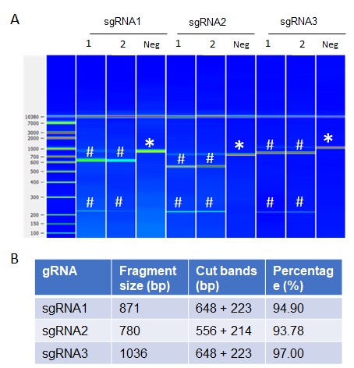
Figure S3: Validation of the sgRNAs for Dup8-9 by transfection in HEK293T cells. A) Schematic workflow of the experiment. B) Results of the transfection experiment. Left images: bright field. Right images: GFP fluorescence. Px458 is the positive control of transfection and UT the untransfected negative control. Size bar = 1 mm. C) Results of the TIDE analysis. The uncropped gel image for Figure S3C was put in Figure S8A.
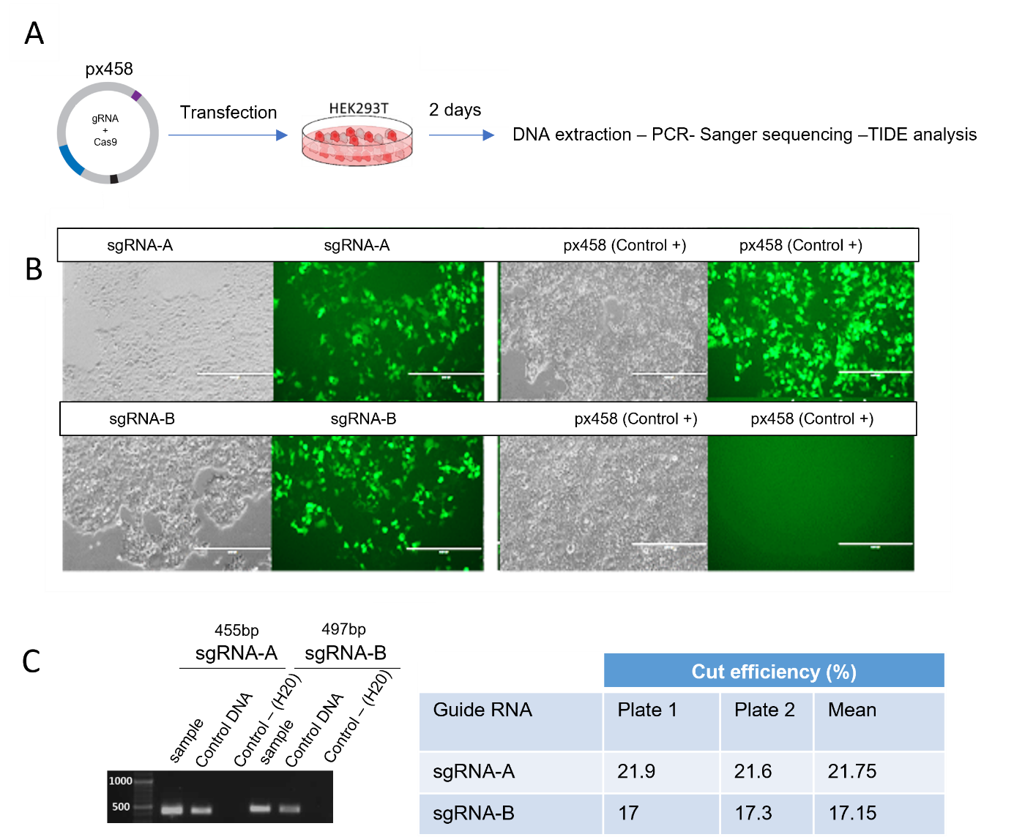

Figure S4: Volcano plots displaying differential gene expression. A) Different gene expression inDup2, Dup2-9, and Dup8-9 cell lines compared to C25 cell line. B) Different gene expression in Dup2 clone 7, Dup2-9 clone 14, and Dup8-9 clone 12 compared to Dup2, Dup2-9, and Dup8-9 cell lines.
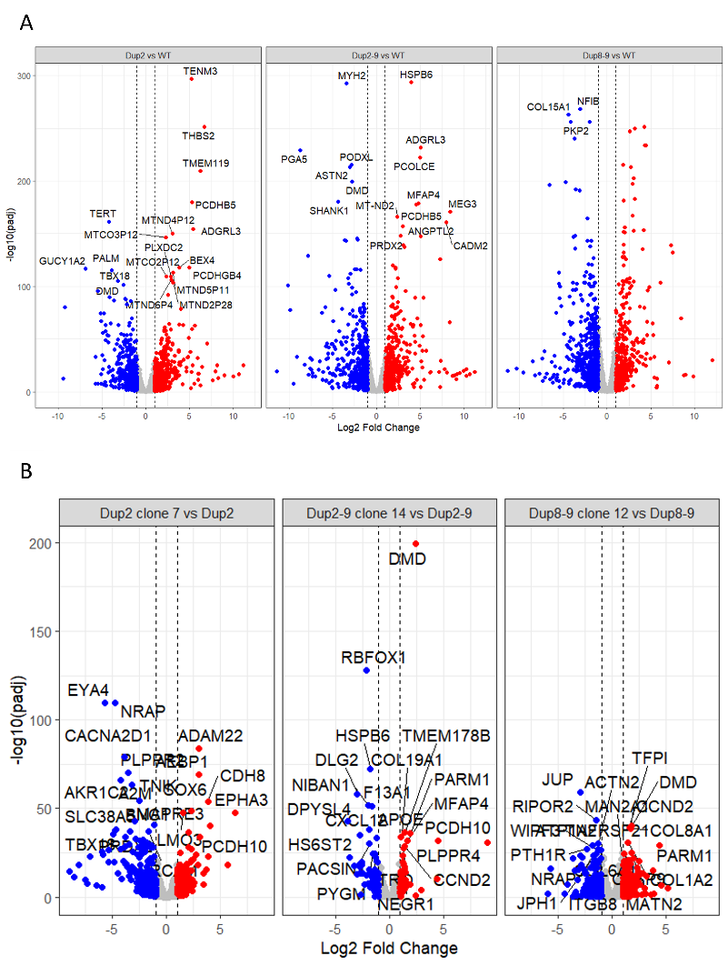

Figure S5: Venn diagrams showing the overlap of differentially expressed genes in common between the different cells. The comparison between Dup2 and C25 is in blue, between Dup2-9 and C25 in yellow and between Dup8-9 and C25 in green.

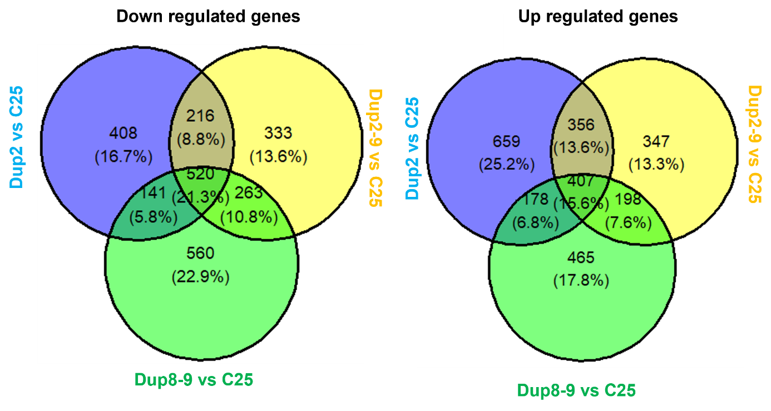

Figure S6: Principal Component Analysis (PCA) scatter plot of gene expression. A) RNAseq data from our study. WT C25 is in black triangle, Dup2 in light blue square, Dup2 clone7 in dark blue square with a cross, Dup2-9 in light yellow circle, Dup2-9 clone14 in dark yellow circle with a cross, Dup8-9 in light green diamont, Dup8-9 clone 12 in dark green diamont with a cross. B) The dataset of GSE262976. WT is in black triangle, DMD1 in light blue square, DMD1_corrected in dark blue square with a cross, DMD2 in light yellow circle, DMD2_corrected in dark yellow circle with a cross.
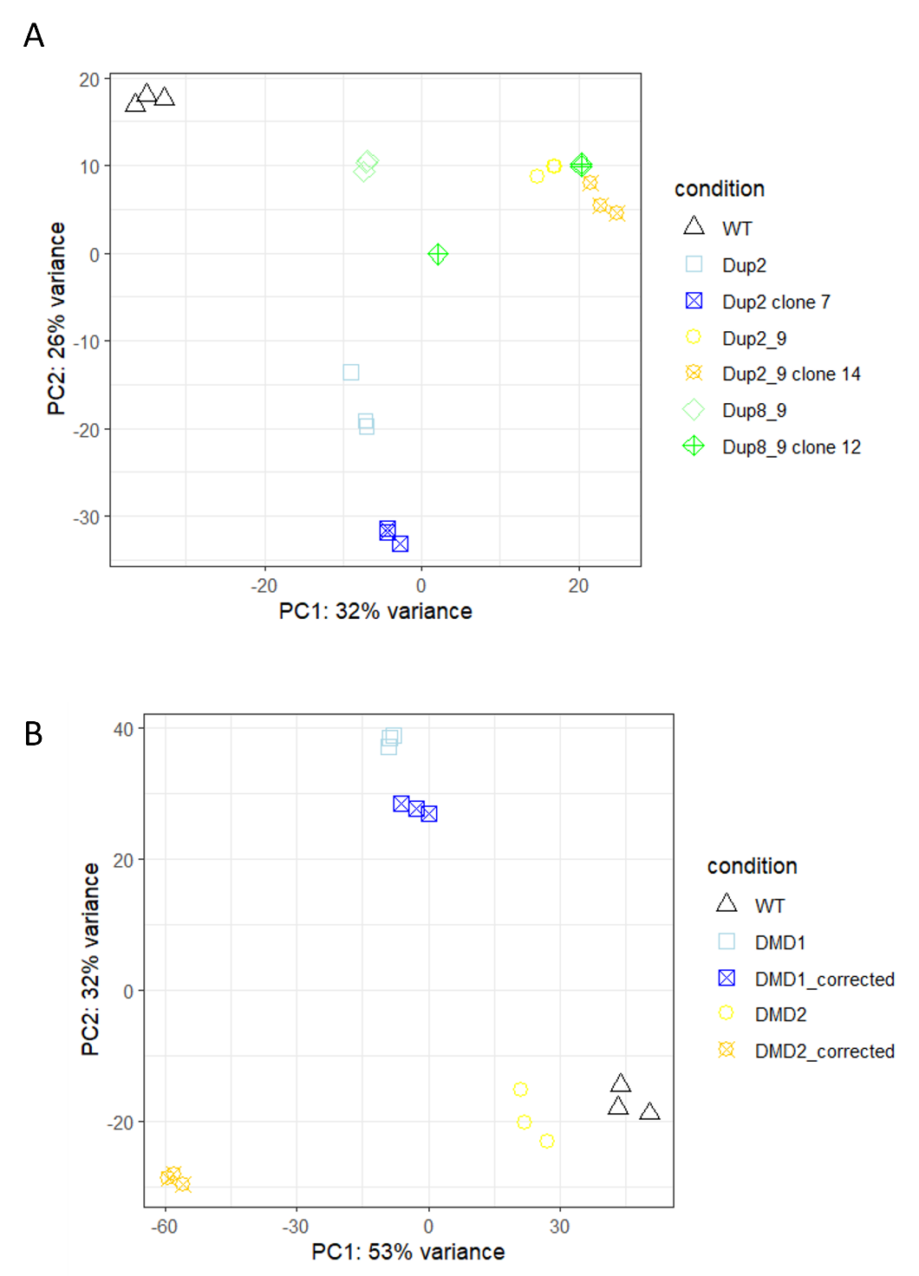

Figure S7: Agarose gels from amplifications of off-target sites directly targeting an exon. A), B), C) Amplification of the off-target sites predicted within an exon for Dup2 and Dup2 clone 7 (A), for Dup2-9 and Dup2-9 clone 14 (B), and for Dup8-9 and Dup8-9 clone 12 (C). D) Amplification of the off-target sites near a dysregulated gene for Dup2 and Dup2 clone 7 (left picture), for Dup2-9 and Dup2-9 clone 14 (middle picture) for Dup8-9 and Dup8-9 clone 12 (right picture). Uncropped versions of the gel images are available in Figure S8C.
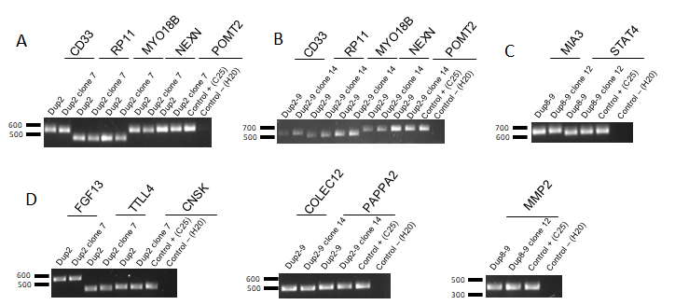

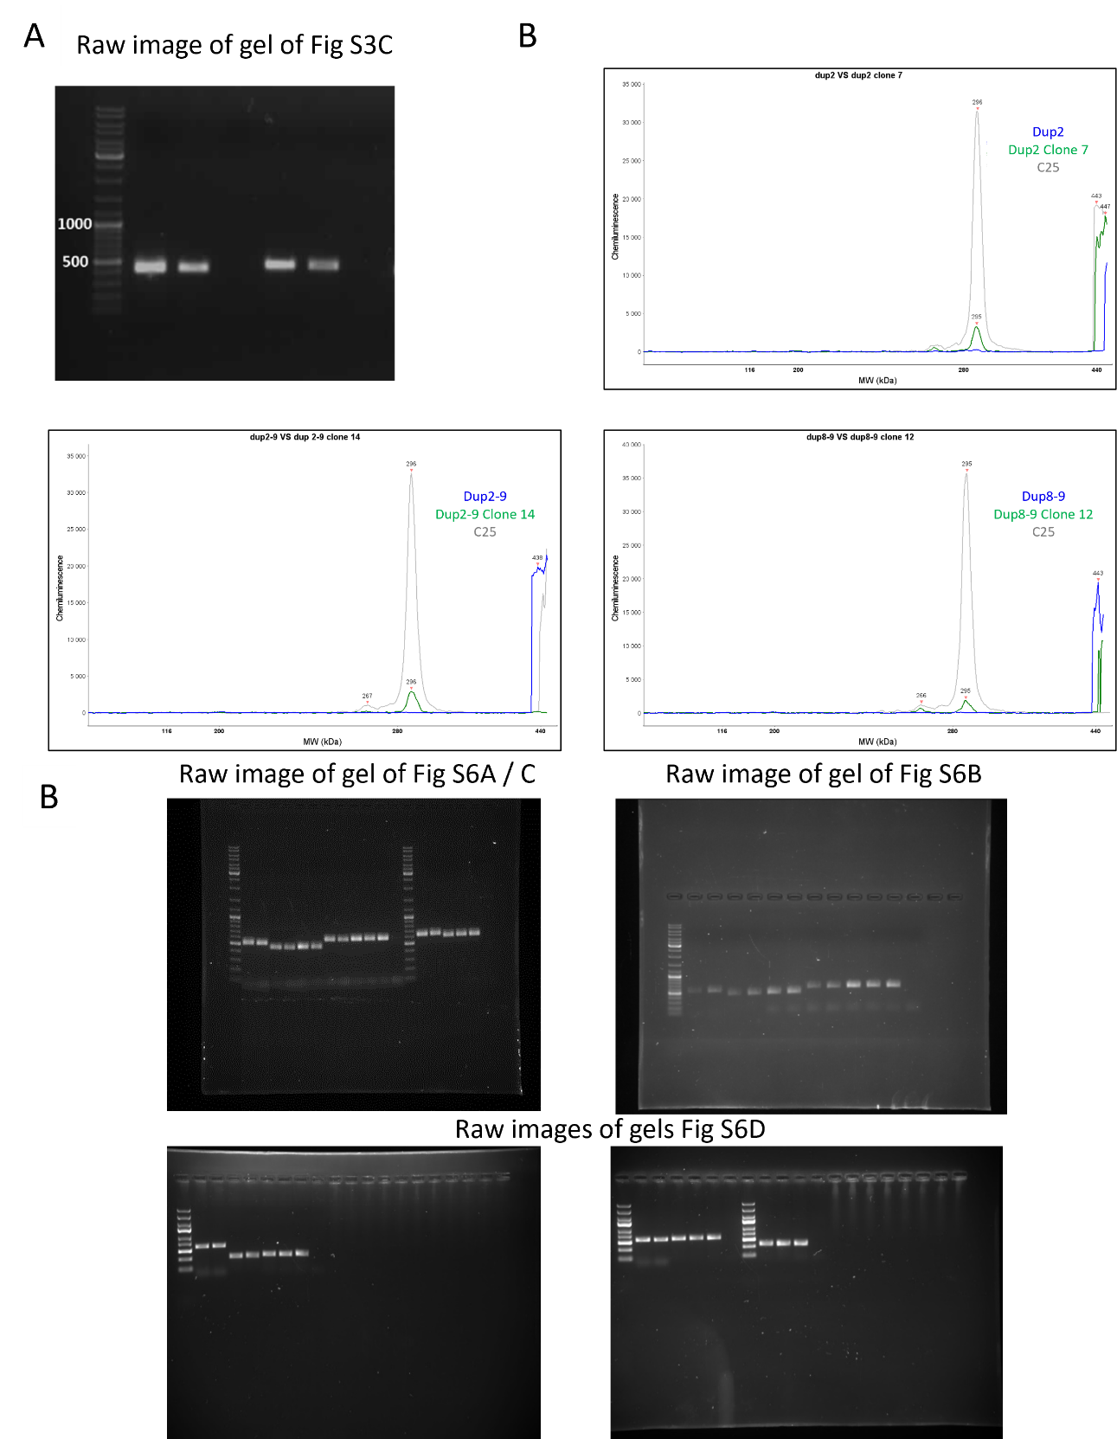
Figure S8: Raw gels for Figure S3C, 2C and S7

SUPPLEMENTAL TABLES
Table S1: List of primers and probes used in ddPCR to validate the DMD exon copy number in mutant and corrected Dup2, Dup2-9 and Dup8-9 patient myoblasts.
Target gene | Sequence
DMD exon 2: Forward | 5’-TTCATAACTCAGTGTGCCCATTCT-3’
DMD exon 2: Reverse | 5’-TGGTTGTATTGAGGACCACAGATG-3’
DMD exon 2: FAM probe | 5’-CCTAATAGGCAGGACCCA-3’
DMD exon 8-9: Forward | 5’-TTGCCGGATTGAAGAGTACCA-3’
DMD exon 8-9: Reverse | 5’-GCTATTTAGCCATGAGGATTCCA-3’
DMD exon 8-9: FAM probe | 5’-CCATATAAATGTTGGAGTTTGTG-3’
DMD exon 30 normalizer: Forward | 5’-TCTTTCAAGGAAAATTGGAGCTTT-3’
DMD exon 30 normalizer: Reverse | 5’-CCCCTTATCACAACCTGTTCAAC-3’
DMD exon 30 normalizer: VIC probe | 5’-AGGGCGAAGCATC-3’

Table S2: List of primers used to amplify HEK293 DNA by PCR across the regions to be edited.
Primers | Sequence
sgRNA-1 Forward  sgRNA-1 Reverse | 5’-TGACCAAACCCATAGTCGTTC-3’  5’-CTTATGTTTTTAAGAGAAGCAACGGAG-3’
sgRNA-2 Forward  sgRNA-2 Reverse | 5’-GGGGATAATTTCCAGGTCTTCTC-3’  5’-TGAAGCCAAATGTGTCTTTGC-3’
sgRNA-3 Forward  sgRNA-3 Reverse | 5’-CCCATCAGCCATAAAGAATTGG-3’  5’-GCCCCTCAACTTGTGTGG-3’
sgRNA-A Forward  sgRNA-A Reverse | 5’-GCATTTCATAGTCAGAACTTATGTG-3’  5’-GCTGATATTAAAGTATGCAGAGAGC-3’
sgRNA-B Forward  sgRNA-B Reverse | 5’-GTCCACAATCCCGCTAACAC-3’  5’-AAAAATTTCATCTTTTATCTCACAAGT-3’

Table S3: A) Primers for off target analysis for sgRNA used for Dup2, Dup 2-9 and Dup8-9 correction. B) Primers for off target for CRISPOR predicted sites located in close proximity to a dysregulated gene seen via RNAseq.
A
Cell lines affected | Off Target | Exon/Intron/  Intergenic | Miss match to target | Primers | PCR Product size (bp)
DUP2 / Dup2 clone 7  DUP2-9 / DUP2-9 cl 14 | CD33 | exon | 4 | F : 5’-TAAGCAAGCTAGGCAGGTTTAG-3’  R : 5’-TGAGGCTGCAGCAGAATAAG-3’ | 528
DUP2 / Dup2 clone 7  DUP2-9 / DUP2-9 cl 14 | RP11-797J4.1 | exon | 4 | F : 5’-CACATGATCCAAGAACACTGAAATAG-3’  R : 5’-GAAGGTAGCAATAAAGATAGGAGGAA-3’ | 452
DUP2 / Dup2 clone 7  DUP2-9 / DUP2-9 cl 14 | MYO18B | exon | 4 | F : 5’-TCCATTCAGAGGCAGCAAATA-3’  R : 5’-GTCAGTCCTACTGAAAGTCATCC-3’ | 467
DUP2 / Dup2 clone 7  DUP2-9 / DUP2-9 cl 14 | NEXN | exon | 4 | F : 5’-CCTGCCATTTCACCATCAATAC-3’  R : 5’-CTCTTGCCTTAGCCATTTGTTC-3’ | 583
DUP2 / Dup2 clone 7  DUP2-9 / DUP2-9 cl 14 | POMT2 | exon | 4 | F : 5’-CAGCTGTCCCTTATGCCTAATA-3’  R : 5’-CATCACCACCATCCTCATTCT-3’ | 583
DUP8-9 / DUP8-9 cl 12 | MIA3 | exon | 4 | F : 5’-GGGTGTAGGCTGATTTGCCA-3’  R : 5’-CATCTGTCTTGACGCCTGCT-3’ | 594
DUP8-9 / DUP8-9 cl 12 | STAT4 | exon | 4 | F : 5’-TGCACTCCAATCCAGTCATTTA-3’  R : 5’-TCTCTCCACTCCTGAGATCATAC-3’ | 626

B
Cell lines affected | Off Target | Exon/Intron/  Intergenic | Miss match to target | Primers | PCR Product size (bp)
DUP2 / Dup2 clone 7 | FGF13-AS1-FGF13 | intergenic | 4 | F : 5’-AGGAAATTGGAGCAAACAGTGC-3’  R : 5’-ATCAAGGCAGTCACATTCATTTC-3’ | 610
DUP2 / Dup2 clone 7 | TTLL4-CYP27A1 | intergenic | 4 | F : 5’-GGGCTTTCTTCTTTCCCATTTC-3’  R : 5’-CCTATGGTGCAACTGTCTCTT-3’ | 301
DUP2 / Dup2 clone 7 | CSNK2A3/RP11-567I13.1-GALNT18 | intergenic | 4 | F : 5’-CCAACGAGACTGATGTCCTTAT-3’  R : 5’-CAGGTTCCAACTTTGGCTTAC-3’ | 342
DUP2-9 / DUP2-9 cl 14 | COLEC12-RP11-720L2.2 | intergenic | 3 | F : 5’-TAATAAATAGTGGCACACATGC-3’  R : 5’-TTGGTCCAACTCATGCCAAT-3’ | 569
DUP2-9 / DUP2-9 cl 14 | PAPPA2 | intron | 3 | F : 5’-GTGGCATATCTCGATCTCCTTC-3’  R : 5’-TCTCCAAGACCTCCTGAACT-3’ | 576
DUP8-9 / DUP8-9 cl 12 | MMP2 | intron | 4 | F : 5’-CTCAACCCAGGCAGCTTTA-3’  R : 5’-ACTGTGTGTCACTTGCTTTATTG-3’ | 344

Table S4: List of antibodies used for immunostaining. A) Primary antibodies. B) Secondary antibodies.
A
Primary antibodies | Target | Reference | Hote/Isotype | Dilution
DysB | N-terminus of dystrophin, exons 10-12 | Leica, NCL-DYSB | Mouse/IgG1, kappa | 1/50
Alpha-actinin2 | Alpha-actinin | Invitrogen 701914 | Rabbit/IgG | 1/100

Secondaryantibodies | Target | Provider | Reference | Dilution
Alexa fluor 594 Goat anti-mouse | Mouse IgG | Life Technologies | A21125 | 1/1000
Alexa fluor 488 Goat anti-rabbit | Rabbit IgG | Life Technologies | A11008 | 1/1000
B

Supplemental-Excel file 1: DMD_exon_usage
Supplemental excel file 2: Dysregulated_gene_list
Supplemental excel file 3: Enriched_pathways
Supplemental excel file 4: Predicted off-targets for sgRNA3 and for sgRNA-A

