Supplemental Information for: “Effects of lignin syringyl to guaiacyl ratio on cottonwood biochar adsorbent properties and performance”

Julie E. Muretta^{a*}, Jade Uriarte^{b}, Dalton Compton^{c}, Richard LaDouceurª, John Kirtley^{d}, Dario Prieto-Centurionª

ª Mechanical Engineering Department, Montana Technological University, Butte, Montana, USA
^{b} Metallurgical and Materials Engineering Department, Montana Technological University, Butte, Montana, USA
^{c} Chemistry and Biochemistry Department, Montana State University, Bozeman, Montana, USA
^{d} Chemistry and Geochemistry Department, Montana Technological University, Butte, Montana, USA
* Corresponding author, E-mail: jmuretta@mtech.edu

Ultimate Analysis of P. trichocarpa Feedstock

Table S1 Ultimate analysis of biomass feedstocks (wt.%)
 | BESC-316 |  | L-BESC-316
 | As-received | Dry Basis | As-received | Dry Basis
Total Moisture | 3.90 |  | 2.72
Ash | 0.45 | 0.46 | 0.21 | 0.21
Carbon | 46.94 | 48.84 | 47.77 | 49.11
Hydrogen | 5.60 | 5.83 | 5.82 | 5.99
Nitrogen | 0.25 | 0.26 | 0.20 | 0.21
Oxygen | 42.87 | 44.61 | 43.27 | 44.48
Sulfur | <0.01 | <0.01 | <0.01 | <0.01
 | CHWH-27-2 |  | L-CHWH-27-2
 | As-received | Dry Basis | As-received | Dry Basis
Total Moisture | 3.67 |  | 2.14
Ash | 0.54 | 0.57 | 0.20 | 0.21
Carbon | 46.62 | 48.39 | 47.47 | 48.51
Hydrogen | 5.50 | 5.71 | 5.65 | 5.77
Nitrogen | 0.22 | 0.22 | 0.16 | 0.16
Oxygen | 43.44 | 45.10 | 44.37 | 45.34
Sulfur | <0.01 | <0.01 | <0.01 | <0.01

Lignin macromolecular structure

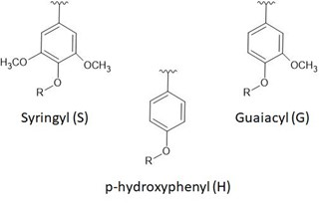
Fig. S1 Syringyl, guaiacyl, and p-hydroxyphenyl groups which form the backbone of the lignin macromolecular structure. The individual types are determined by methoxy (-O-CH₃) group content.

Biomass Ash Composition

Table S2 AAEM content of biomass ash, ppm
 | AAEM concentration (μ ± σ), ppm
 | Ca | K | Mg | Na
BESC-316 | 645 ± 74 | 580 ± 61 | 197 ± 21 | 12 ± 1.0
L-BESC-316 | 502 ± 40 | 63 ± 6.0 | 139 ± 12 | 1 ± 0.0
CHWH-27-2 | 648 ± 65 | 1004 ± 87 | 217 ± 20 | 11 ± 2.0
L-CHWH-27-2 | 393 ± 39 | 83 ± 8.0 | 119 ± 13 | 1 ± 0.0

Biochar Yield Results

Table S3 Biochar Yield and Compositional Data ($\overline{X}$ ± σ where appropriate)
 | Mean Yield (%) | H/C | Moisture (% wt.) | Ash  (% wt.) | H  (% wt.) | C  (% wt.) | Volatile Carbon (% wt.) | Recalcitrant Carbon  (% wt.)
BC-B | 20.35 ± 0.35 | 0.4 ± 0.1 | 0.98 | 1.91 | 1.8 ± 0.5 | 54.6 ± 0.2 | 4.1 | 93.0
BC-BL40 | 18.50 ± 0.65 | 0.4 ± 0.1 | 0.83 | 1.02 | 1.9 ± 0.5 | 54.9 ± 0.2 | 3.9 | 94.3
BC-C | 20.43 ± 0.08 | 0.4 ± 0.1 | 1.03 | 2.44 | 1.7 ± 0.5 | 53.2 ± 0.2 | 3.9 | 92.6
BC-CL40 | 17.74 ± 0.17 | 0.5 ± 0.1 | 0.77 | 0.94 | 2.0 ± 0.5 | 50.1 ± 0.2 | 4.5 | 93.8

Particle Morphology

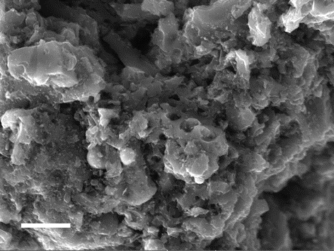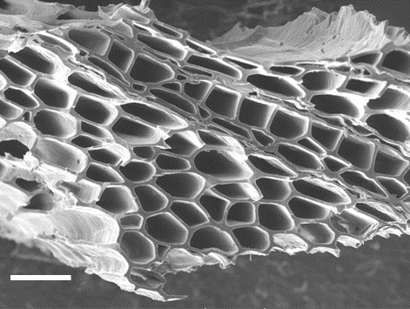
Fig. S2 Secondary electron micrographs of Norit RB3, left, and BC-C, right, at 2kx magnification. The scale bars represent 20 μm in both images.
The morphology of biochar particles reveals that the plant cellular structure was largely preserved during pyrolysis due to limited processing and carbonization. The morphology of the activated carbon, on the other hand, is typical for highly carbonized, granulated material, in which the structure has been heavily damaged by those two processes. The open, honeycomb structure of the biochar has no relation to micropore structure.

Raman Spectrum Fitting Details
The model employed here for Raman spectrum fitting of the first-order region of the spectrum utilizes two peak functions and a linear background, which provides a simple model to adequately account for the complex Raman D and G band structure in biochars [1]. In this work, a single Lorentzian for the D-band and a Breit-Wigner-Fano function for the G-band were applied, along with a linear background function. The asymmetry of the BWF function accounts for the high intensity valley between the D- and G-bands.
The mathematical form for the BWF function used to fit the G-peak in all Raman spectra is
$I\left(ω\right)=\frac{I_{0}{\left[1+2(ω-{ω_{0}}/{QΓ})\right]}^{2}}{1+{[2\left(ω-{ω_{0}}/Γ\right)]}^{2}}$ (1)
where $I_{0}$ is the peak intensity, $ω_{0}$ is the peak position, and $Γ$ is the full width at half the peak maximum (FWHM). Q is known as the BWF coupling coefficient and accounts for a residual intensity in the tail region of the asymmetric line shape. For residual intensity on the lower wavenumber side, Q will be negative. Because of the asymmetry of the BWF line-shape, the position of the peak is not the position of the maximum, $ω_{max}$. The position of the peak maximum is calculated as
$ω_{max}=ω_{0}+Γ/{2Q}$ (2)
A negative value for Q results in the peak maximum occurring at a lower wavenumber than the peak position.
Fig. S3 Vertically-shifted Raman D and G bands for all biochars and Norit RB3. Higher intensity for the D-band in Norit RB3 is consistent with a more highly-carbonized material.
Fig. S4 Sample fitted Raman curve, in this case for BC-B

Three resulting fitting parameters, position of the G peak (Pos(G)), FWHM(G), and ratio of intensity of the D band to that of the G peak (I(D)/I(G)), were used in this present work. It should be noted that this method of comparison is only advisable for Raman measurements collected under identical conditions, including laser power and wavelength.

N₂ Adsorption Isotherms
Adsorption isotherms for the four biochars and the Norit RB3 are shown in Fig. S5. Two of the biochars are considered non-porous, or having closed porosity (BC-B and BC-C – inset), while the other two have significant porosity. Isotherms are of Type I, indicating the materials are microporous.

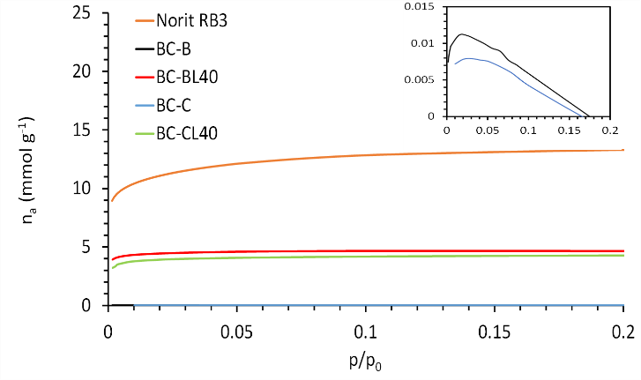
Fig. S5 N₂ adsorption isotherms for all biochars and Norit RB3. The N₂ adsorption for BC-B and BC-C (inset) was very low, indicating those materials were non-porous or with closed porosity.

Dynamic Ammonia Adsorption

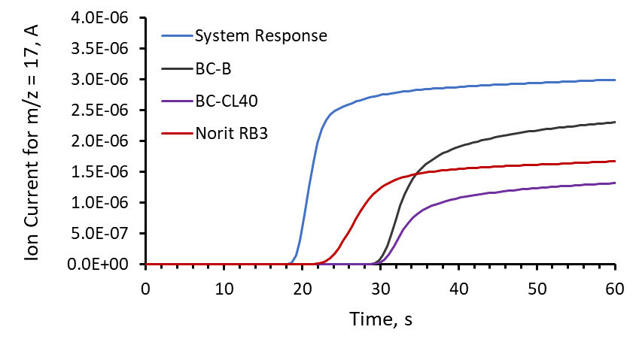
Fig. S6 Raw MS ion current data examples showing system response (all elements of the reactor present except biochar or Norit RB3) compared to breakthrough curves for three representative materials.
References
1. Ferrari, A. C. & Robertson, J. Interpretation of Raman spectra of disordered and amorphous carbon. Phys. Rev. B 61, 14095–14107 (2000).

