Anti-solvent materials enhanced structural and optical properties on ambiently fabricated perovskite thin films

Mohammad Nur-E-Alam^{1,2,3}, Mohammad Aminul Islam^{4,5*}, Yap Boon Kar ^{1,6}, Tiong Sieh Kiong^{1,6}, Halina Misran¹, Mayeen Uddin Khandaker^{7,14}, Yasser Fouad⁸, Manzoore Elahi M. Soudagar^{9,10*}, Erdem Cuce^{11,12,13}*

1 Institute of Sustainable Energy, Universiti Tenaga Nasional, Jalan IKRAM-UNITEN, 43000 Kajang, Selangor, Malaysia
2 School of Science, Edith Cowan University, 270 Joondalup Drive, Joondalup, WA 6027, Australia
3 School of Engineering and Technology, Central Queensland University Australia, Melbourne, VIC 3000, Australia
4 Department of Electrical Engineering, Faculty of Engineering, University of Malaya, Kuala Lumpur 50603, Malaysia
5 Miyan Research Institute. International University of Business Agriculture and Technology (IUBAT), Dhaka, 1230, Bangladesh
6 Department of Electrical and Electronic, College of Engineering, Universiti Tenaga Nasional, Jalan IKRAM-UNITEN, 43000, Kajang, Selangor, Malaysia
7 Applied Physics and Radiation Technologies Group, CCDCU, School of Engineering and Technology, Sunway University, 47500 Bandar Sunway, Selangor, Malaysia
8 Department of Applied Mechanical Engineering, College of Applied Engineering, Muzahimiyah Branch, King Saud University, P.O. Box 800, 11421, Riyadh, Saudi Arabia
9 Faculty of Engineering, Lishui University, Lishui, 323000, Zhejiang, People’s Republic of China
10 Centre of Molecular Medicine and Diagnostics (COMManD), Saveetha Dental College and Hospitals Saveetha Institute of Medical and Technical Sciences, Saveetha University, Chennai, 600077, India
11 Department of Mechanical Engineering, Faculty of Engineering and Architecture, Recep Tayyip Erdogan University, Zihni Derin Campus, 53100 Rize, Turkey
12 College of Engineering, Department of Mechanical Engineering, , Birmingham City University, B4 7XG, Birmingham, UK
13 University Centre for Research and Development, Chandigarh University, Mohali, Punjab, 140413, India
14 Faculty of Graduate Studies, Daffodil International University, Birulia, Savar, Dhaka, 1216, Bangladesh
*Corresponding authors: erdem.cuce@erdogan.edu.tr; aminul.islam@um.edu.my, manzoor@lsu.edu.cn

Supplementary file

Figure S1 schematically presents the sample preparation stages from the spin coating procedure to thermal heat treatment.
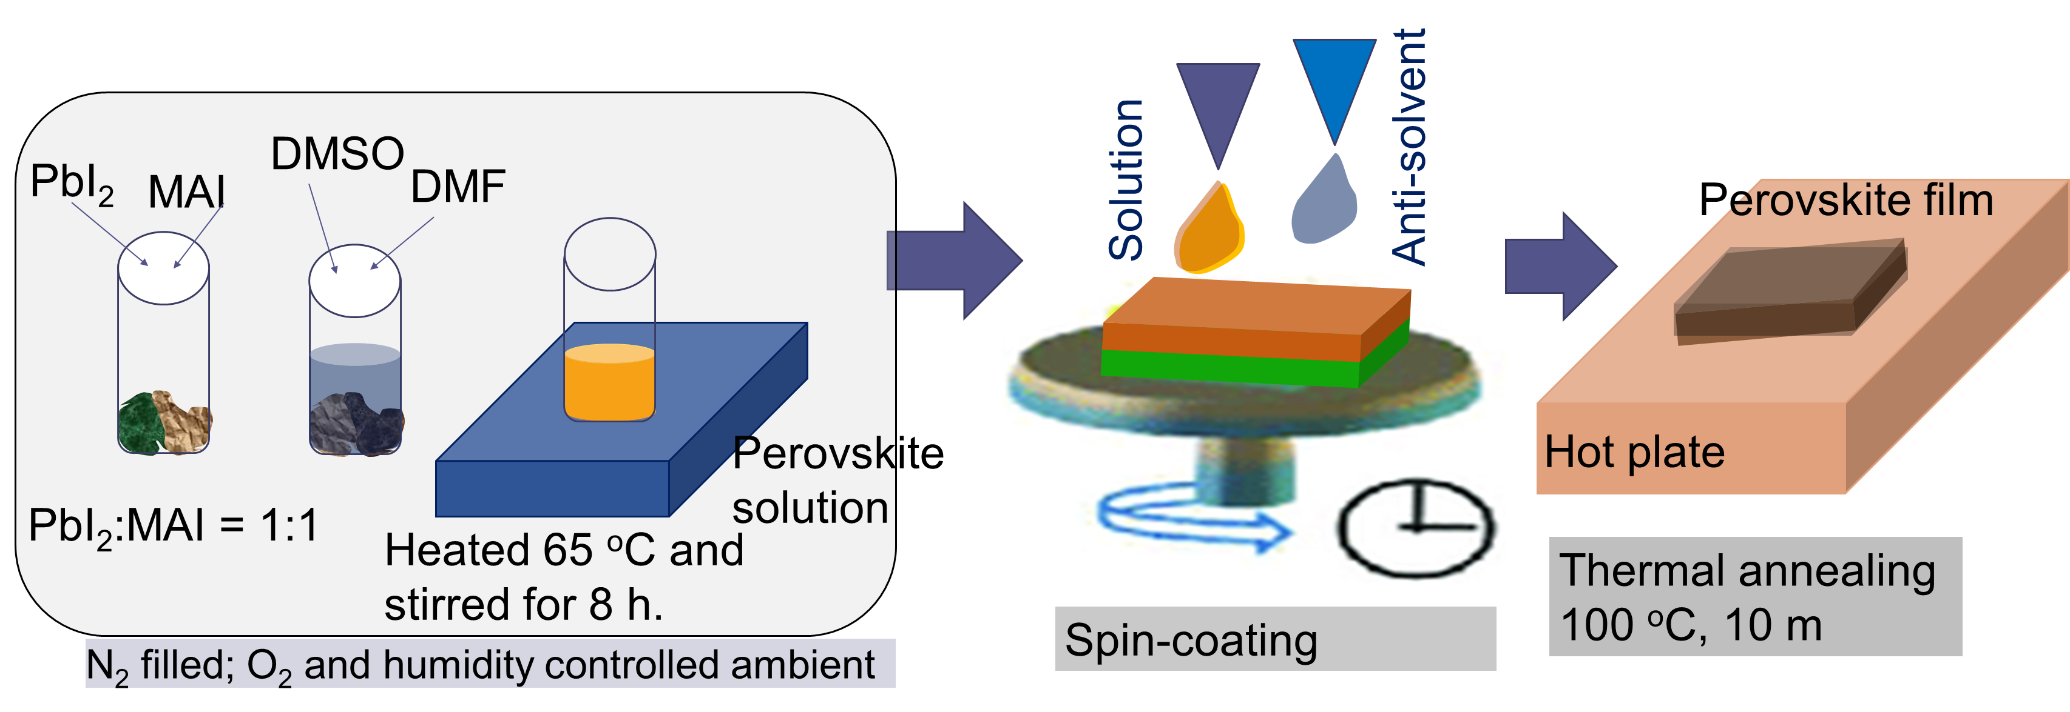
Figure S1. Schematic presentation of sample preparation including the spin-coating and annealing processes.

Figure S2 shows a schematic representation of a workflow that incorporates machine learning into anti-solvent optimization for perovskite solar cells.

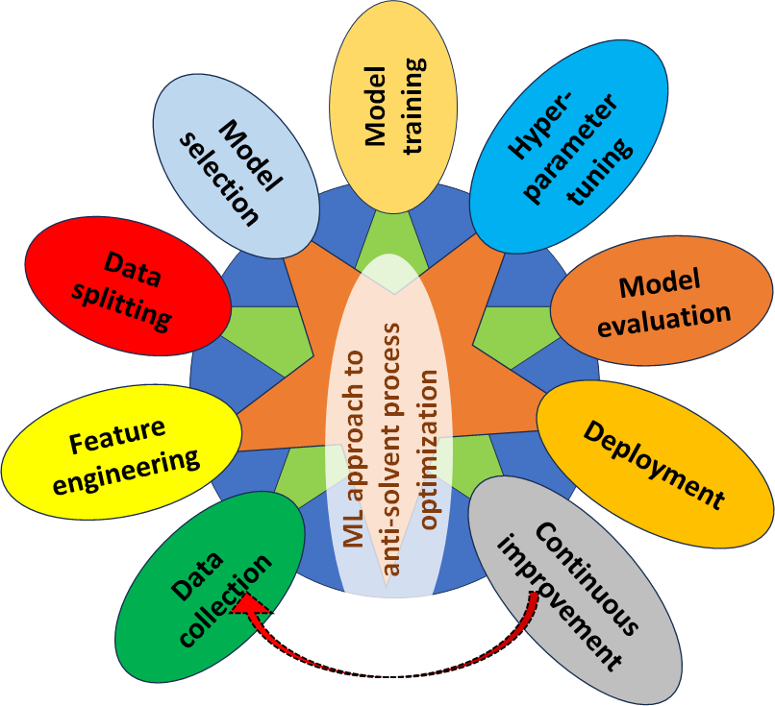
Figure S2. Presentation of a workflow for implementing machine learning in anti-solvent optimization for perovskite.

