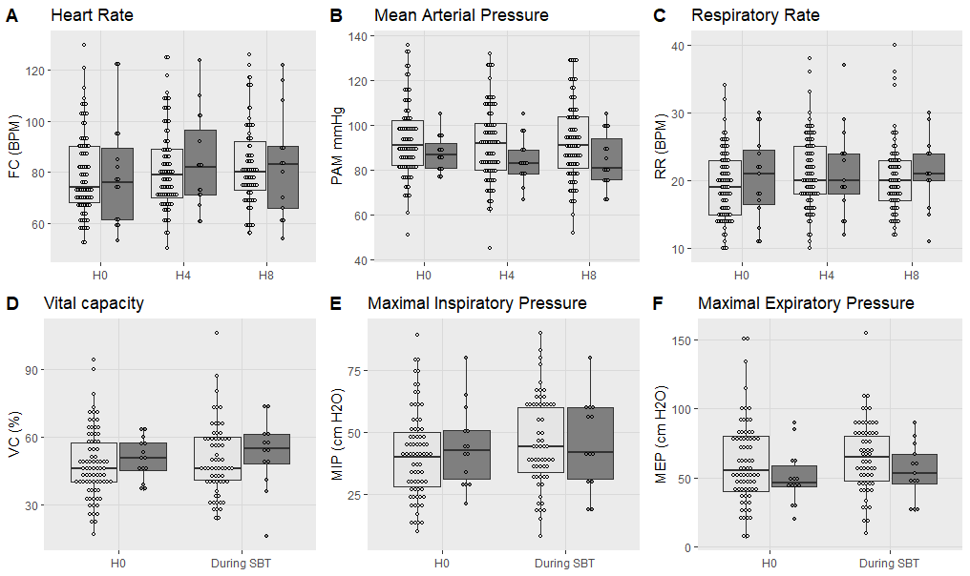
1st attempt failure
1st attempt success
Supplementary Figure 1 Physiological parameters and pulmonary functions tests during SBT compared between successful weaning after 1st extubation or not
HR: Heart Rate; BPM : Beats per minute; MAP: mean arterial pressure; RR: respiratory rate VC: Vital capacity expressed in % of theory; MIP: Maximal inspiratory pressure in cm H₂0; MEP:M aximal expiratory pressure in cm H₂O. H0: at initiation of spontaneous breathing trial; SBT: Spontaneous breathing trial.

 | Successful weaning after 1st extubation | Weaning failure after 1st extubation | Missing
n | 108 | 18 | %
O₂ flow (L/mn) | 2.50 [1, 3] | 2 [2, 3] | 24.6
O₂ flow at 8th hour (L/mn) | 2 [1, 3] | 2 [2, 3] | 31.7
SpO₂ at SBT beginning (%) | 97 [96, 99] | 99 [97, 100] | 27.0
SpO₂ at 4th hour (%) | 97 [96, 99] | 99 [97, 100] | 28.6
SpO₂ at 8th hour (%) | 98 [96, 99] | 99 [97, 99] | 34.9
HR at SBT beginning (bpm) | 74 [68, 90] | 76 [62, 90] | 20.6
HR at 4th hour (bpm) | 79 [70, 89] | 82 [71, 97] | 20.6
HR at 8th hour (bpm) | 80 [73, 92] | 83 [66, 90] | 31.7
MAP at SBT beginning (mmHg) | 91 [82, 102] | 87 [81, 92] | 20.6
MAP at 4th hour (mmHg) | 92 [80, 101] | 83 [79, 89] | 20.6
MAP at 8th hour (mmHg) | 91 [81, 104] | 81 [76, 94] | 20.6
RR at SBT beginning (bpm) | 19 [15, 23] | 21 [17, 25] | 20.6
RR at 4th hour (bpm) | 20 [18, 25] | 20 [18, 24] | 20.6
RR at 8th hour (bpm) | 20 [17, 23] | 21 [20, 24] | 31.7
pH at 8th hour | 7.43 [7.42, 7.46] | 7.42 [7.41, 7.44] | 35.7
paCO₂ at 8th hour (kPa) | 5.21 [4.74, 5.57] | 5.35 [4.88, 5.85] | 35.7
paO₂ at 8th hour (kPa) | 11.95 [10.33, 14.07] | 12.60 [9.88, 15.68] | 63.5

Supp Table 1 Physiological parameters during spontaneous breathing trial in successful weaning and failure groups
SpO2: tissue saturation in O2; HR : Heart Rate; MAP: mean arterial pressure; RR: respiratory rate; SBT: Spontaneous breathing trial; paCO2: arterial partial pressure in CO2; paO2: arterial partial pressure in O2;

 | Odds ratio | 95% Confidence interval | p
Mechanical ventilation duration risk increase per additive day | 1.164 | 1.092-1.241 | 0.0001
Upper respiratory tract infection | 0.072 | 0.009-0.578 | 0.013
Inspiratory pressure upon intubation risk decrease per cm H₂O increase | 0.966 | 0.935-0.997 | 0.035

Supplementary Table 2 Predictors for prolonged weaning according to logistic regression.

