Supplementary Materials
Identifying environmental impacts on planktonic algal proliferation and associated risks: A five-year observation study in Danjiangkou Reservoir, China
Xizhi Nong ^{a, b, *}, Xian Guan ª, Lihua Chen ª, Jiahua Wei ^{b}, Ronghui Li ^{a, *}
ª School of Civil Engineering and Architecture, Guangxi University, Nanning 530004, China
^{b} State Key Laboratory of Hydroscience and Engineering, Tsinghua University, Beijing 100084, China
* Corresponding author:
Xizhi Nong, E-mail address: nongxizhi@gxu.edu.cn
Ronghui Li, E-mail address: lironghui@gxu.edu.cn

Table S1
Sampling Sites | Code | Province/City | Longitude | Latitude | Sub-area of the reservoir field
Madeng | MD | Henan，Nanyang | 111°32′ E | 32°54′ N | Dan Reservoir
Taochaqujie | QJ | Henan，Nanyang | 111°37′ E | 32°41′ N | Dan Reservoir
Taocha | TC | Henan，Nanyang | 111°42′ E | 32°40′ N | Dan Reservoir
Qingshan | QS | Hubei，Shiyan | 110°67′ E | 32°47′ N | Han Reservoir
Longkoulanghe | LK | Hubei，Shiyan | 111°14′ E | 32°39′ N | Han Reservoir
Baqian | BQ | Hubei，Shiyan | 111°28′ E | 32°34′ N | Han Reservoir
Locations of water quality monitoring stations of the Danjiangkou Reservoir in this study.

Table S2
Analytical methods and instruments for water quality indicators in this study.
Items | Analytical methods | Instruments
WT | Thermometer or inverted thermometer method | YSI EXO2 Water Quality Multi-Parameter Monitor
pH | Electrode method | YSI EXO2 Water Quality Multi-Parameter Monitor
DO | Electrochemical probe method | YSI EXO2 Water Quality Multi-Parameter Monitor
COD_{Mn} | Acidometric titration | Acid-type Titer Tube 0167
Tur | Formhydrazine standard | YSI EXO2 Water Quality Multi-Parameter Monitor
NH₃-N | Nessler’s reagent spectrophotometry | UV spectrophotometer (UV 1800)
TP | Ammonium molybdate spectrophotometry | UV spectrophotometer (UV 1800)
TN | Alkaline potassium persulfate digestion by ultraviolet spectrophotometry | UV spectrophotometer (UV 1800)
Chl-a | Spectrophotometry | UV spectrophotometer (UV 1800)

Table S3
Statistical water quality parameters in the DJKR from March 2018 to February 2023 (Avg.: Average; S.D.: Standard deviation).
Parameters |  | WT | DO | pH | Tur | NH₃-N | TP | TN | COD_{Mn} | Chl-a
 |  | °C | mg/L | - | NTU | mg/L | mg/L | mg/L | mg/L | μg/L
Avg. ± S.D. | 2018 | 19.44 ± 7.80 | 9.36 ± 1.25 | 8.11 ± 0.35 | 1.79 ± 1.02 | 0.026 ± 0.007 | 0.013 ± 0.003 | 1.23 ± 0.06 | 1.90 ± 0.10 | 1.80 ± 0.92
Avg. ± S.D. | 2019 | 18.83 ± 6.47 | 9.51 ± 1.15 | 7.95 ± 0.29 | 2.78 ± 3.48 | 0.034 ± 0.014 | 0.017 ± 0.003 | 1.09 ± 0.09 | 1.90 ± 0.12 | 1.51 ± 0.58
Avg. ± S.D. | 2020 | 17.54 ± 5.19 | 9.92 ± 1.12 | 8.07 ± 0.31 | 2.79 ± 1.05 | 0.030 ± 0.009 | 0.015 ± 0.003 | 1.06 ± 0.10 | 1.93 ± 0.12 | 2.28 ± 0.81
Avg. ± S.D. | 2021 | 18.97 ± 6.25 | 9.38 ± 1.29 | 8.15 ± 0.25 | 6.42 ± 5.18 | 0.034 ± 0.006 | 0.014 ± 0.002 | 1.17 ± 0.11 | 2.01 ± 0.18 | 2.52 ± 0.46
Avg. ± S.D. | 2022 | 19.69 ± 7.48 | 9.42 ± 1.38 | 8.32 ± 0.26 | 3.28 ± 2.35 | 0.042 ± 0.022 | 0.013 ± 0.005 | 1.29 ± 0.19 | 1.85 ± 0.26 | 2.81 ± 1.58
Min | 2018 | 4.40 | 6.91 | 7.00 | 0.10 | 0.003 | 0.003 | 0.90 | 1.54 | 0.50
Min | 2019 | 7.50 | 6.10 | 6.90 | 0.20 | 0.014 | 0.008 | 0.79 | 1.64 | 0.21
Min | 2020 | 8.15 | 6.70 | 7.10 | 0.10 | 0.005 | 0.003 | 0.73 | 1.68 | 0.10
Min | 2021 | 7.40 | 6,40 | 7.40 | 0.70 | 0.018 | 0.009 | 0.88 | 1.45 | 1.37
Min | 2022 | 4.88 | 6.10 | 7.35 | 0.00 | 0.005 | 0.004 | 0.64 | 1.08 | 0.48
Max | 2018 | 33.00 | 13.90 | 9.30 | 7.50 | 0.082 | 0.033 | 1.55 | 2.76 | 8.54
Max | 2019 | 31.90 | 13.10 | 8.81 | 35.10 | 0.132 | 0.034 | 1.43 | 2.74 | 5.58
Max | 2020 | 29.00 | 14.40 | 8.80 | 6.70 | 0.094 | 0.034 | 1.44 | 2.71 | 7.40
Max | 2021 | 30.40 | 11.90 | 9.00 | 30.20 | 0.057 | 0.023 | 1.49 | 2.77 | 4.15
Max | 2022 | 33.40 | 12.90 | 9.00 | 20.60 | 0.173 | 0.040 | 1.82 | 2.71 | 11.60
Kruskal-Wallis test |  | P < 0.05 | P < 0.05 | P < 0.05 | P < 0.05 | P < 0.05 | P < 0.05 | P < 0.05 | P < 0.05 | P < 0.05
Note: Since this study divided the seasons into spring (March to May), summer (June to August), autumn (September to November), and winter (December to February of the following year), the annual average was calculated from March of the previous year to February of the following year.

Table S4
Results of stepwise multiple regression analysis of Chl-a concentrations in each water quality monitoring stations and sub-area reservoirs in this study (n=1826).
Stations | Model | Linear model | R² | P-value
MD | 1 | -0.444∗∗∗+2.012∗∗∗lg(COD_{Mn}+1) | 0.111 | < 0.001
MD | 2 | -0.701∗∗∗+2.043∗∗∗lg(COD_{Mn}+1)+0.190∗∗∗lg(WT+1) | 0.158 | < 0.001
MD | 3 | -0.529+1.881∗∗∗lg(COD_{Mn}+1)+0.195∗∗∗lg(WT+1)-16.409∗∗∗lg(TP+1) | 0.188 | < 0.001
MD | 4 | -1.294+1.780∗∗∗lg(COD_{Mn}+1)+0.354∗∗∗lg(WT+1)-20.919∗∗∗lg(TP+1)+0.622∗∗∗lg(DO+1) | 0.216 | < 0.001
MD | 5 | -2.445+1.596∗∗∗lg(COD_{Mn}+1)+0.307∗∗∗lg(WT+1)-20.686∗∗∗lg(TP+1)+0.586∗∗∗lg(DO+1)+1.384∗∗∗lg(pH+1) | 0.235 | < 0.001
QJ | 1 | 0.376∗∗∗+0.195∗∗∗lg(Tur+1) | 0.146 | < 0.001
QJ | 2 | -0.080∗∗∗+0.209∗∗∗lg(Tur+1)+0.441∗∗∗lg(DO+1) | 0.182 | < 0.001
QJ | 3 | -0.256∗∗∗+0.201∗∗∗lg(Tur+1)+0.400∗∗∗lg(DO+1)+0.661∗∗∗lg(TN+1) | 0.206 | < 0.001
QJ | 4 | -0.241∗∗∗+0.204∗∗∗lg(Tur+1)+0.444∗∗∗lg(DO+1)+0.640∗∗∗lg(TN+1)-8.622∗∗∗lg(TP+1) | 0.224 | < 0.001
QJ | 5 | -0.694∗∗∗+0.201∗∗∗lg(Tur+1)+0.739∗∗∗lg(DO+1)+0.658∗∗∗lg(TN+1)-9.191∗∗∗lg(TP+1)+0.120∗∗∗lg(WT+1) | 0.236 | < 0.001
QJ | 6 | -0.674∗∗∗+0.188∗∗∗lg(Tur+1)+0.725∗∗∗lg(DO+1)+0.591∗∗∗lg(TN+1)-11.983∗∗∗lg(TP+1)+0.117∗∗∗lg(WT+1)  +3.365∗∗∗lg(NH₃-N+1) | 0.245 | < 0.001
QJ | 7 | -0.598∗∗∗+0.207∗∗∗lg(Tur+1)+0.758∗∗∗lg(DO+1)+0.738∗∗∗lg(TN+1)-9.947∗∗∗lg(TP+1)+0.123∗∗∗lg(WT+1)  +3.308∗∗∗lg(NH₃-N+1)-0.409∗∗∗lg(COD_{Mn}+1) | 0.252 | < 0.001
TC | 1 | 0.350∗∗∗+0.235∗∗∗lg(Tur+1) | 0.206 | < 0.001
TC | 2 | -1.804∗∗∗+0.193∗∗∗lg(Tur+1)+2.274∗∗∗lg(pH+1) | 0.326 | < 0.001
TC | 3 | -1.426∗∗∗+0.182∗∗∗lg(Tur+1)+1.991∗∗∗lg(pH+1)-17.551∗∗∗lg(TP+1) | 0.383 | < 0.001
TC | 4 | -1.642∗∗∗+0.186∗∗∗lg(Tur+1)+2.361∗∗∗lg(pH+1)-16.311∗∗∗lg(TP+1)-0.117∗∗∗lg(WT+1) | 0.410 | < 0.001
TC | 5 | -1.817∗∗∗+0.179∗∗∗lg(Tur+1)+2.277∗∗∗lg(pH+1)-19.702∗∗∗lg(TP+1)-0.111∗∗∗lg(WT+1)+0.587∗∗∗lg(COD_{Mn}+1) | 0.429 | < 0.001
QS | 1 | -2.215∗∗∗+2.812∗∗∗lg(pH+1) | 0.084 | < 0.001
QS | 2 | -2.300∗∗∗+2.809∗∗∗lg(pH+1)+0.141∗∗∗lg(Tur+1) | 0.147 | < 0.001
QS | 3 | -1.602∗∗∗+2.510∗∗∗lg(pH+1)+0.190∗∗∗lg(Tur+1)-0.950∗∗∗lg(COD_{Mn}+1) | 0.177 | < 0.001
QS | 4 | -1.853∗∗∗+2.381∗∗∗lg(pH+1)+0.209∗∗∗lg(Tur+1)-1.011∗∗∗lg(COD_{Mn}+1)+0.382∗∗∗lg(DO+1) | 0.196 | < 0.001
QS | 5 | -1.738∗∗∗+2.272∗∗∗lg(pH+1)+0.256∗∗∗lg(Tur+1)-1.003∗∗∗lg(COD_{Mn}+1)+0.372∗∗∗lg(DO+1)-2.290∗∗∗lg(NH₃-N+1) | 0.205 | < 0.001
QS | 6 | -1.871∗∗∗+2.369∗∗∗lg(pH+1)+0.243∗∗∗lg(Tur+1)-0.947∗∗∗lg(COD_{Mn}+1)+0.353∗∗∗lg(DO+1)-3.028∗∗∗lg(NH₃-N+1)+7.547∗∗∗lg(TP+1) | 0.213 | < 0.001
LK | 1 | 0.305∗∗∗+0.293∗∗∗lg(Tur+1) | 0.299 | < 0.001
LK | 2 | -0.086∗∗∗+0.299∗∗∗lg(Tur+1)+0.382∗∗∗lg(DO+1) | 0.322 | < 0.001
LK | 3 | -0.061∗∗∗+0.306∗∗∗lg(Tur+1)+0.444∗∗∗lg(DO+1)-14.214∗∗∗lg(TP+1) | 0.349 | < 0.001
LK | 4 | -0.434∗∗∗+0.311∗∗∗lg(Tur+1)+0.661∗∗∗lg(DO+1)-11.807∗∗∗lg(TP+1)+0.106∗∗∗lg(WT+1) | 0.362 | < 0.001
LK | 5 | -0.606∗∗∗+0.300∗∗∗lg(Tur+1)+0.629∗∗∗lg(DO+1)-10.923∗∗∗lg(TP+1)+0.104∗∗∗lg(WT+1)+0.447∗∗∗lg(COD_{Mn}+1) | 0.366 | < 0.001
BQ | 1 | -0.477∗∗∗+0.945∗∗∗lg(DO+1) | 0.146 | < 0.001
BQ | 2 | -0.601∗∗∗+0.942∗∗∗lg(DO+1)+0.222∗∗∗lg(Tur+1) | 0.182 | < 0.001
BQ | 3 | -0.969∗∗∗+0.965∗∗∗lg(DO+1)+0.211∗∗∗lg(Tur+1)+1.059∗∗∗lg(TN+1) | 0.206 | < 0.001
BQ | 4 | -1.223∗∗∗+0.915∗∗∗lg(DO+1)+0.195∗∗∗lg(Tur+1)+0.922∗∗∗lg(TN+1)+0.780∗∗∗lg(COD_{Mn}+1) | 0.224 | < 0.001
BQ | 5 | -2.452∗∗∗+0.965∗∗∗lg(DO+1)+0.205∗∗∗lg(Tur+1)+0.750∗∗∗lg(TN+1)+0.801∗∗∗lg(COD_{Mn}+1)+1.271∗∗∗lg(pH+1) | 0.236 | < 0.001
BQ | 6 | -2.446∗∗∗+0.991∗∗∗lg(DO+1)+0.220∗∗∗lg(Tur+1)+0.976∗∗∗lg(TN+1)+0.710∗∗∗lg(COD_{Mn}+1)+1.243∗∗∗lg(pH+1)-3.155∗∗∗lg(NH₃-N+1) | 0.245 | < 0.001
BQ | 7 | -2.560∗∗∗+1.130∗∗∗lg(DO+1)+0.215∗∗∗lg(Tur+1)+1.057∗∗∗lg(TN+1)+0.741∗∗∗lg(COD_{Mn}+1)+1.054∗∗∗lg(pH+1)-2.889∗∗∗lg(NH₃-N+1)+0.088∗∗∗lg(WT+1) | 0.252 | < 0.001
DR | 1 | -3.456∗∗∗+4.115∗∗∗lg(pH+1) | 0.247 | < 0.001
DR | 2 | -2.880∗∗∗+3.403∗∗∗lg(pH+1)+0.189∗∗∗lg(Tur+1) | 0.369 | < 0.001
DR | 3 | -2.267∗∗∗+2.882∗∗∗lg(pH+1)+0.190∗∗∗lg(Tur+1)-18.606∗∗∗lg(TP+1) | 0.416 | < 0.001
DR | 4 | -2.644∗∗∗+2.879∗∗∗lg(pH+1)+0.149∗∗∗lg(Tur+1)-21.494∗∗∗lg(TP +1)+0.904∗∗∗lg(COD_{Mn}+1) | 0.449 | < 0.001
DR | 5 | -2.927∗∗∗+2.972∗∗∗lg(pH+1)+0.161∗∗∗lg(Tur+1)-21.530∗∗∗lg(TP+1)+0.812∗∗∗lg(COD_{Mn}+1)+0.225∗∗∗lg(DO+1) | 0.460 | < 0.001
DR | 6 | -2.975∗∗∗+2.542∗∗∗lg(pH+1)+0.175∗∗∗lg(Tur+1)-23.512∗∗∗lg(TP+1)+0.734∗∗∗lg(COD_{Mn}+1)+0.563∗∗∗lg(DO+1)+  0.122∗∗∗lg(WT+1) | 0.469 | < 0.001
DR | 7 | -2.921∗∗∗+2.402∗∗∗lg(pH+1)+0.162∗∗∗lg(Tur+1)-24.547∗∗∗lg(TP+1)+0.738∗∗∗lg(COD_{Mn}+1)+0.600∗∗∗lg(DO+1)+  0.135∗∗∗lg(WT+1)+2.897∗∗∗lg(NH₃-N+1) | 0.475 | < 0.001
DR | 8 | -2.919∗∗∗+2.362∗∗∗lg(pH+1)+0.166∗∗∗lg(Tur+1)-22.381∗∗∗lg(TP+1)+0.620∗∗∗lg(COD_{Mn}+1)+0.599∗∗∗lg(DO+1)+  0.137∗∗∗lg(WT+1)+3.026∗∗∗lg(NH₃-N+1)+0.214∗∗∗lg(TN+1) | 0.477 | < 0.01
HR | 1 | 0.349∗∗∗+0.224∗∗∗lg(Tur+1) | 0.167 | < 0.001
HR | 2 | -0.393∗∗∗+0.247∗∗∗lg(Tur+1)+0.717∗∗∗lg(DO+1) | 0.249 | < 0.001
HR | 3 | -3.483∗∗∗+0.249∗∗∗lg(Tur+1)+0.811∗∗∗lg(DO+1)+3.119∗∗∗lg(pH+1) | 0.344 | < 0.001
HR | 4 | -3.150∗∗∗+0.271∗∗∗lg(Tur+1)+0.883∗∗∗lg(DO+1)+2.796∗∗∗lg(pH+1)-16.671∗∗∗lg(TP+1) | 0.371 | < 0.001
HR | 5 | -3.095∗∗∗+0.266∗∗∗lg(Tur+1)+0.871∗∗∗lg(DO+1)+2.585∗∗∗lg(pH+1)-14.818∗∗∗lg(TP+1)+0.448∗∗∗lg(TN+1) | 0.380 | < 0.001
HR | 6 | -2.668∗∗∗+0.286∗∗∗lg(Tur+1)+0.899∗∗∗lg(DO+1)+2.378∗∗∗lg(pH+1)-15.716∗∗∗lg(TP+1)+0.530∗∗∗lg(TN+1)-0.627∗∗∗lg(COD_{Mn}+1) | 0.389 | < 0.001
HR | 7 | -2.728∗∗∗+0.289∗∗∗lg(Tur+1)+1.099∗∗∗lg(DO+1)+2.100∗∗∗lg(pH+1)-15.137∗∗∗lg(TP+1)+0.602∗∗∗lg(TN+1)-0.661∗∗∗lg(COD_{Mn}+1)+0.086∗∗∗lg(WT+1) | 0.396 | < 0.001
HR | 8 | -2.727∗∗∗+0.309∗∗∗lg(Tur+1)+1.066∗∗∗lg(DO+1)+2.143∗∗∗lg(pH+1)-11.891∗∗∗lg(TP+1)+0.736∗∗∗lg(TN+1)-0.763∗∗∗lg(COD_{Mn}+1)+0.074∗∗∗lg(WT+1)-1.712∗∗∗lg(NH₃-N+1) | 0.399 | < 0.01

Table S5
KMO and Bartlete's test of sphericity in this study.
Sub-area of the reservoir field | Sampling Sites/ Sub-area reservoir | Factors | Dimensionality reduction factors | KMO | Bartlete's test of sphericity
Dan Reservoir | MD | Water physicochemical factors | WT, DO, and pH | 0.525 | P < 0.001
Dan Reservoir | QJ | Water physicochemical factors | Tur, DO, and WT | 0.504 | P < 0.001
Dan Reservoir | QJ | Nutrients | TN, TP, and NH₃-N | 0.471 | P < 0.001
Dan Reservoir | TC | Water physicochemical factors | Tur, pH, and WT | 0.523 | P < 0.001
Dan Reservoir | DR | Water physicochemical factors | WT, DO, Tur and pH | 0.438 | P < 0.001
Dan Reservoir | DR | Nutrients | TN, TP, and NH₃-N | 0.509 | P < 0.001
Han Reservoir | QS | Water physicochemical factors | pH, Tur, and DO | 0.519 | P < 0.001
Han Reservoir | QS | Nutrients | NH₃-N, and TP | 0.500 | P < 0.001
Han Reservoir | LK | Water physicochemical factors | Tur, DO, and WT | 0.466 | P < 0.001
Han Reservoir | BQ | Water physicochemical factors | DO, Tur, pH, and WT | 0.531 | P < 0.001
Han Reservoir | BQ | Nutrients | TN and NH₃-N | 0.500 | P < 0.001
Han Reservoir | DR | Water physicochemical factors | WT, DO, Tur and pH | 0.486 | P < 0.001
Han Reservoir | DR | Nutrients | TN, TP, and NH₃-N | 0.343 | P < 0.001

Table S6
Criteria for goodness of fitting indicators of the SEM.
Sampling Sites/ Sub-area reservoir | χ²/df | CFI | GFI | AGFI | RMSEA | SRMR
Sampling Sites/ Sub-area reservoir | ﹤3 | > 0.9 | > 0.9 | > 0.9 | < 0.05 | < 0.05
MD | 0.348 | 1.000 | 1.000 | 0.999 | 0.000 | 0.005
QJ | 1.257 | 0.999 | 0.999 | 0.996 | 0.012 | 0.014
TC | 2.164 | 0.998 | 0.999 | 0.994 | 0.025 | 0.012
DR | 1.160 | 0.999 | 0.999 | 0.996 | 0.009 | 0.012
QS | - | 1.000 | 1.000 | - | - | 0.000
LK | 1.319 | 0.999 | 0.999 | 0.996 | 0.013 | 0.008
BQ | 1.522 | 0.994 | 0.999 | 0.995 | 0.017 | 0.015
HR | 1.765 | 0.995 | 0.999 | 0.993 | 0.020 | 0.013

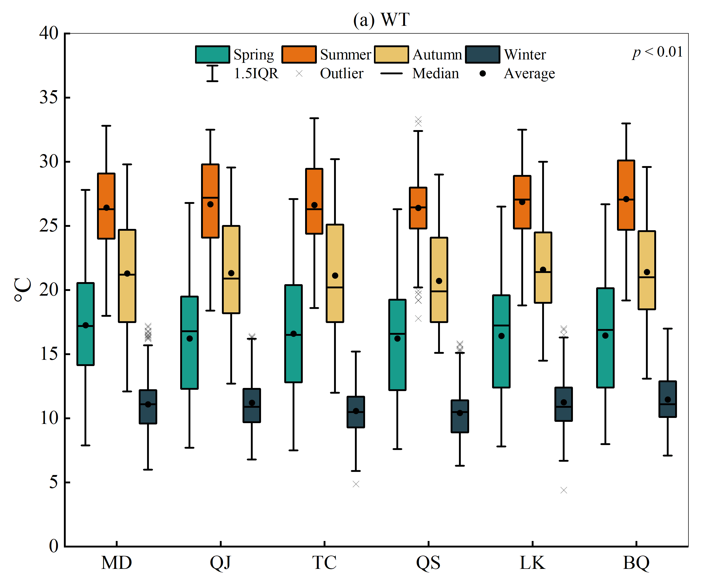 | 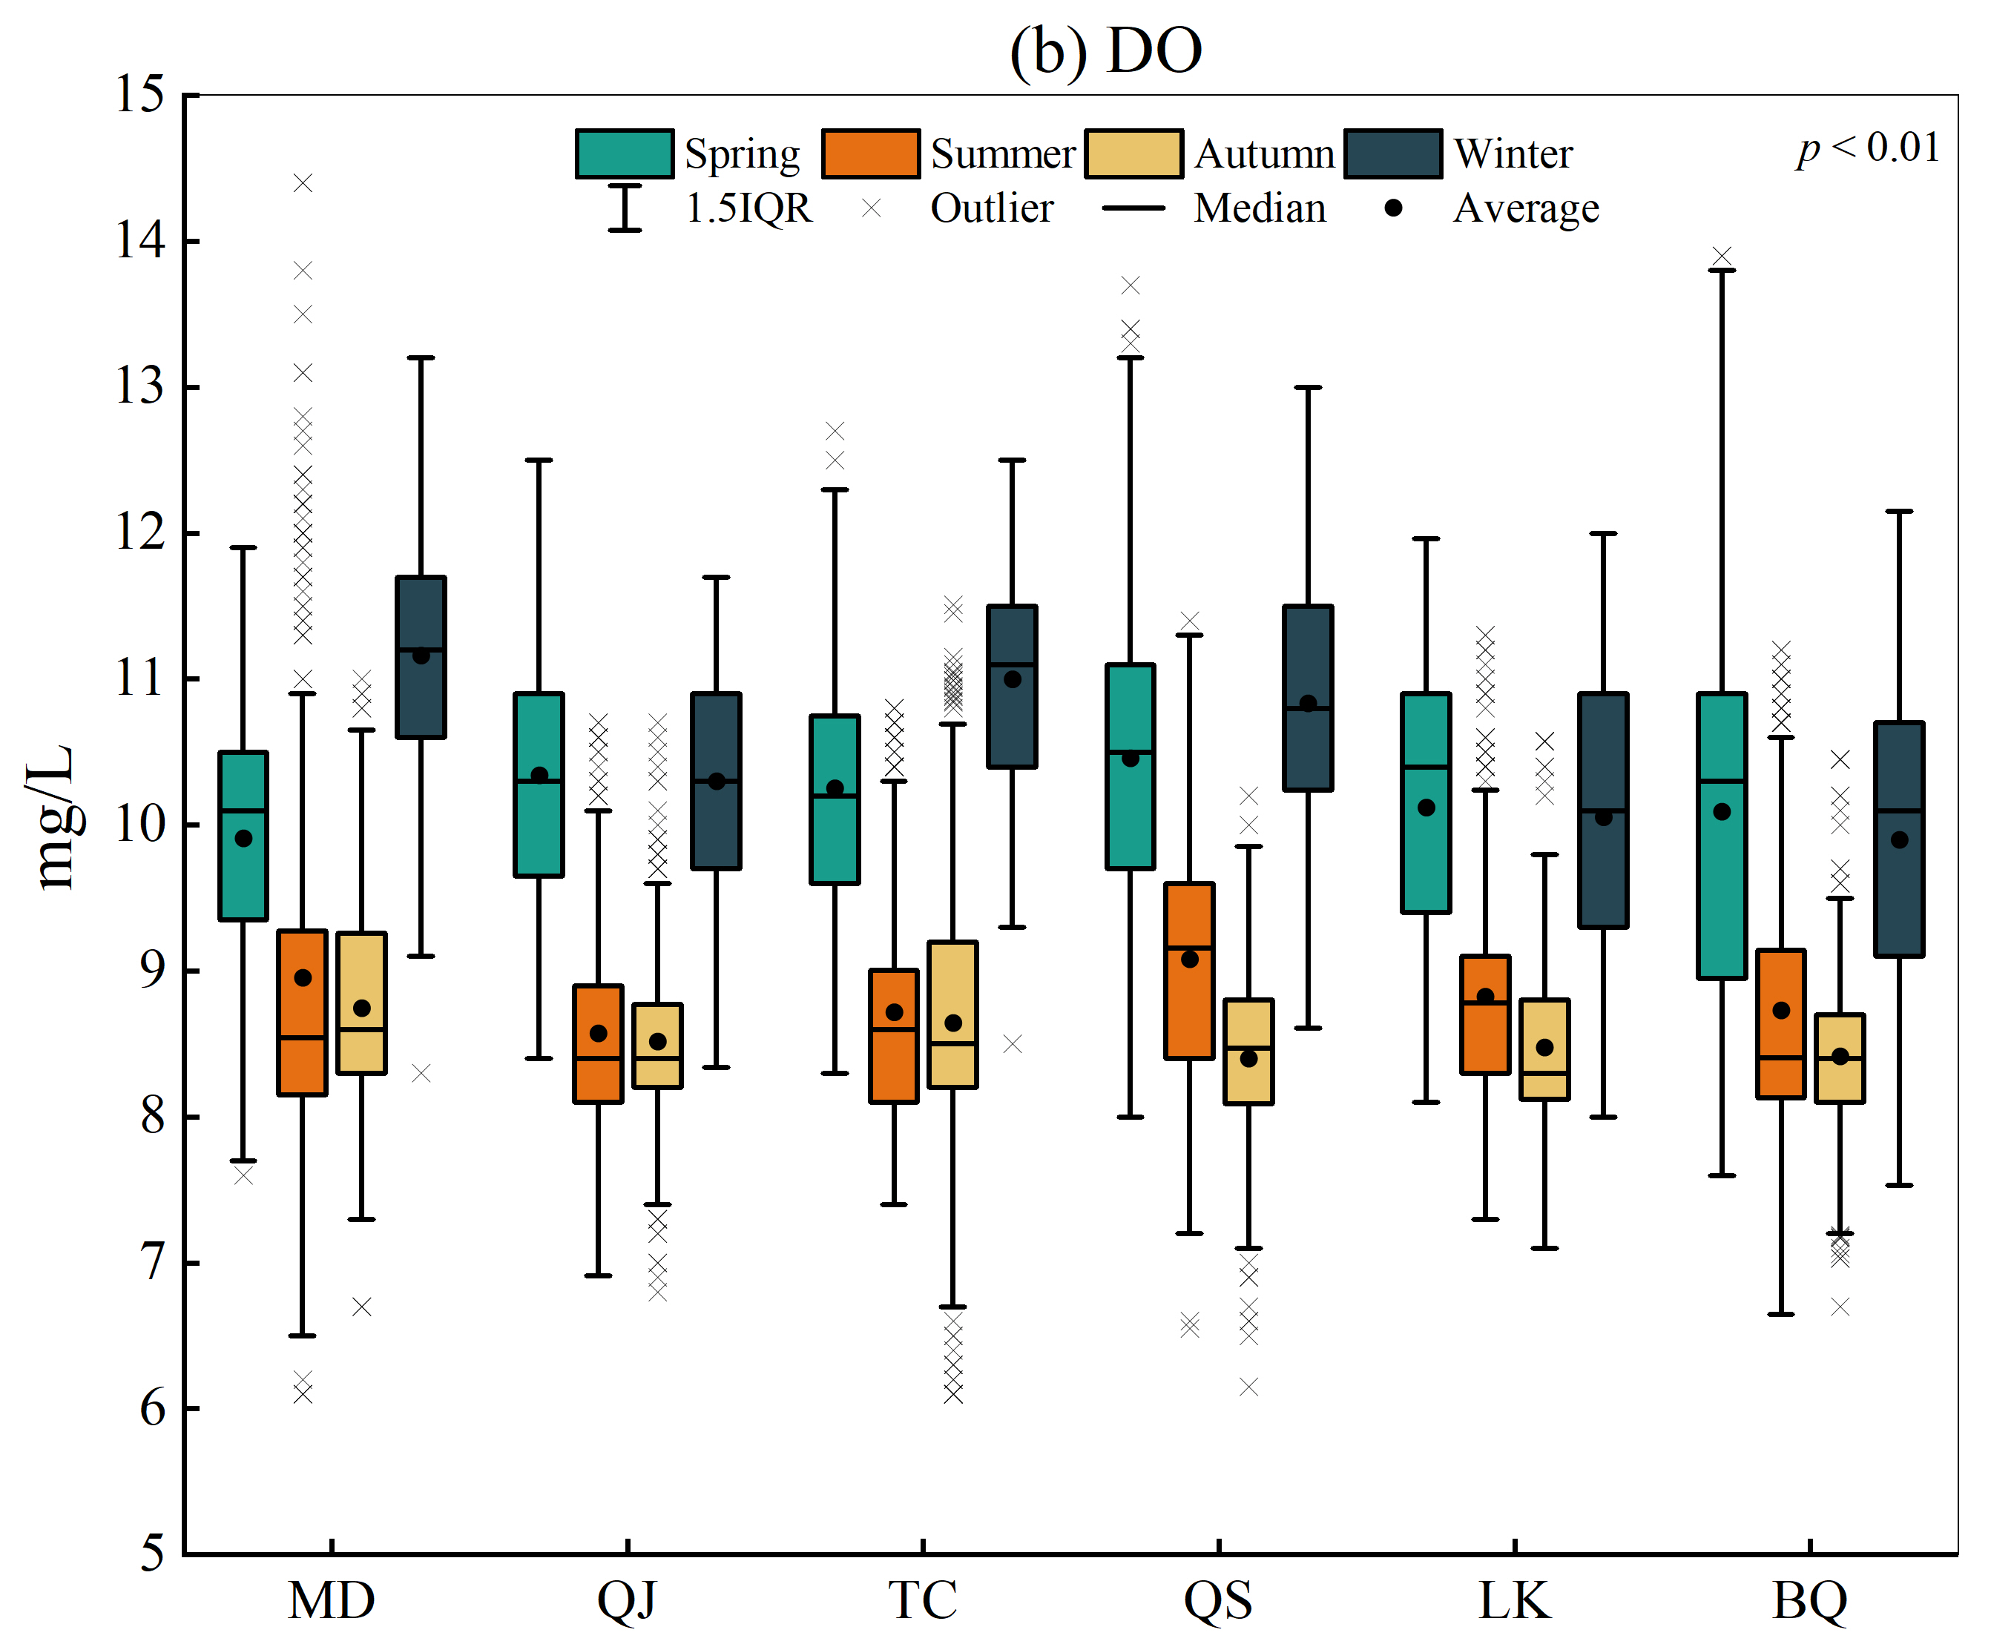
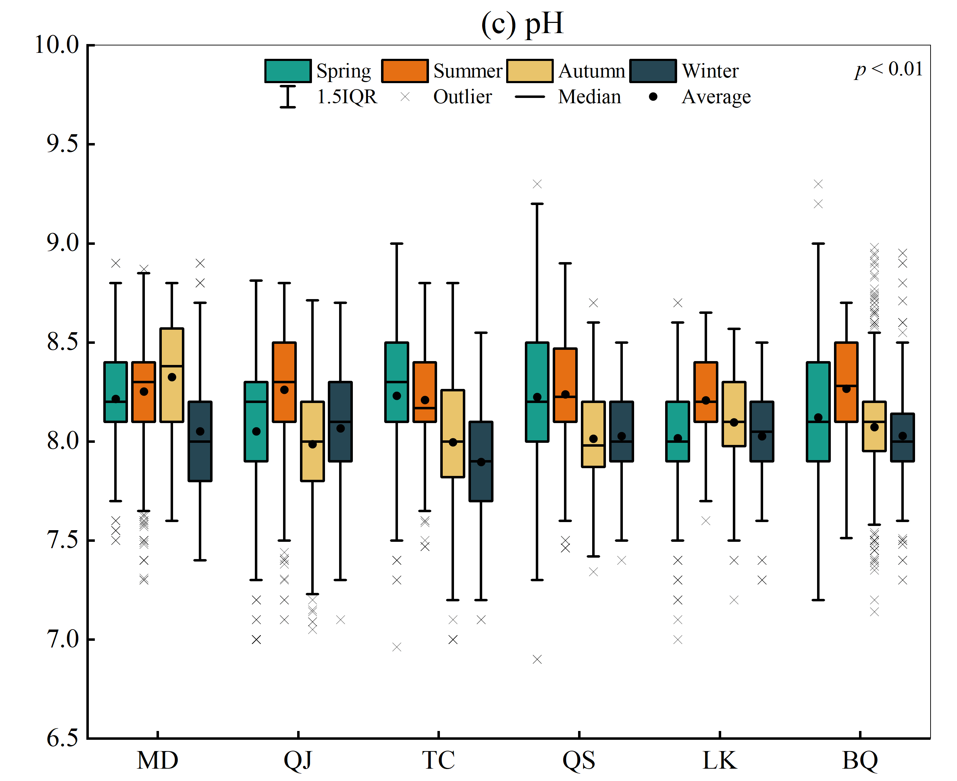 | 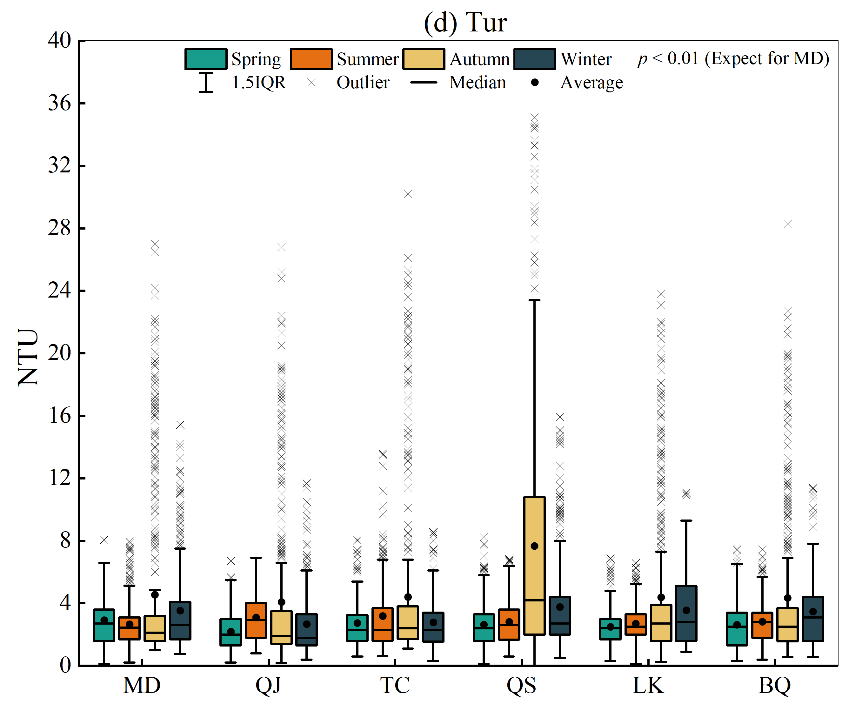
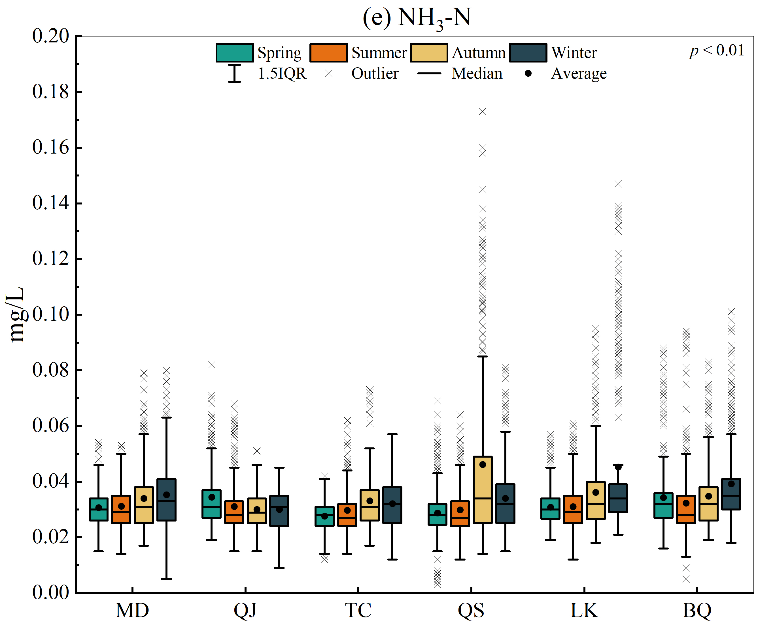 | 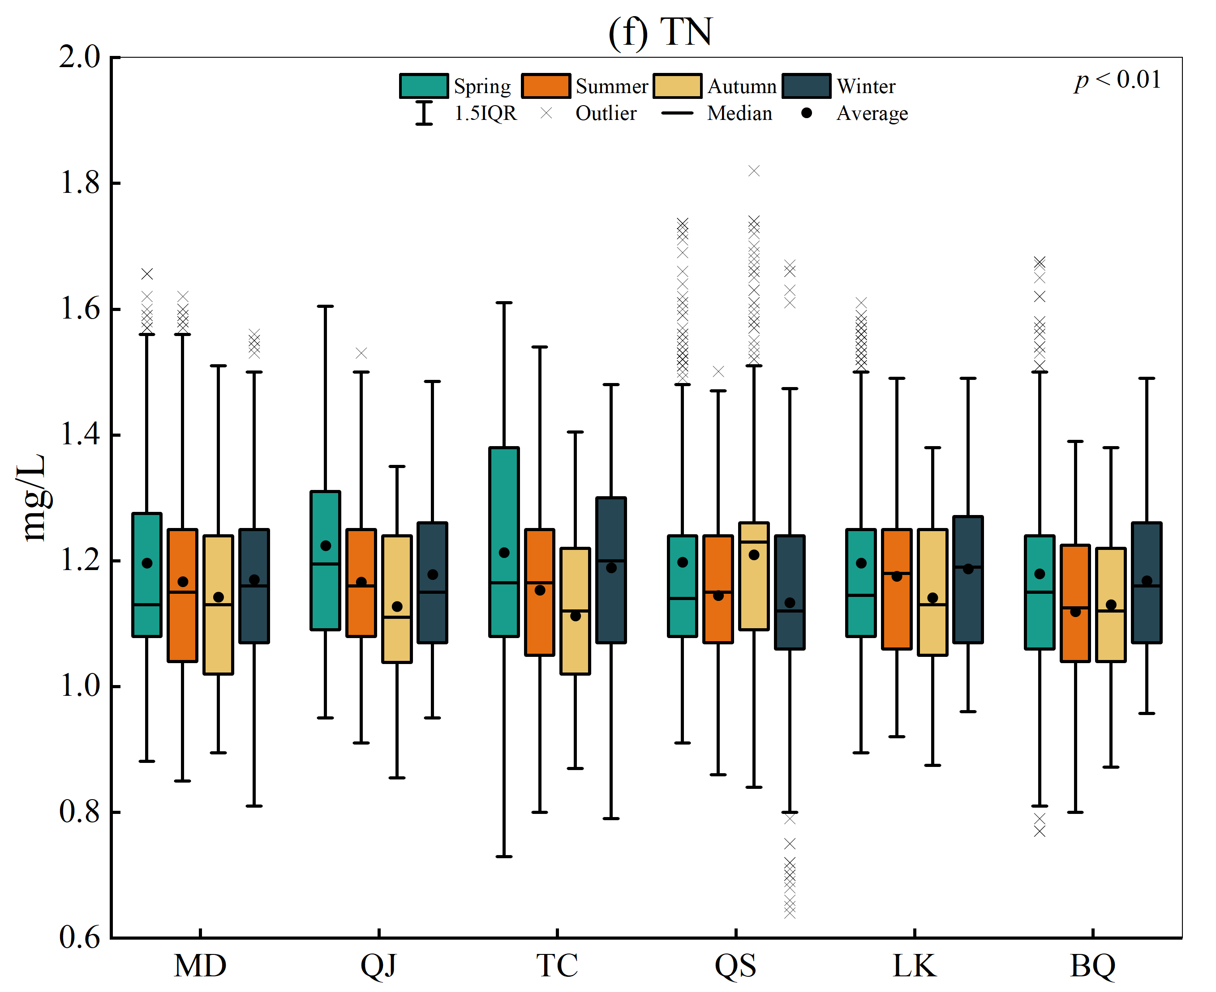
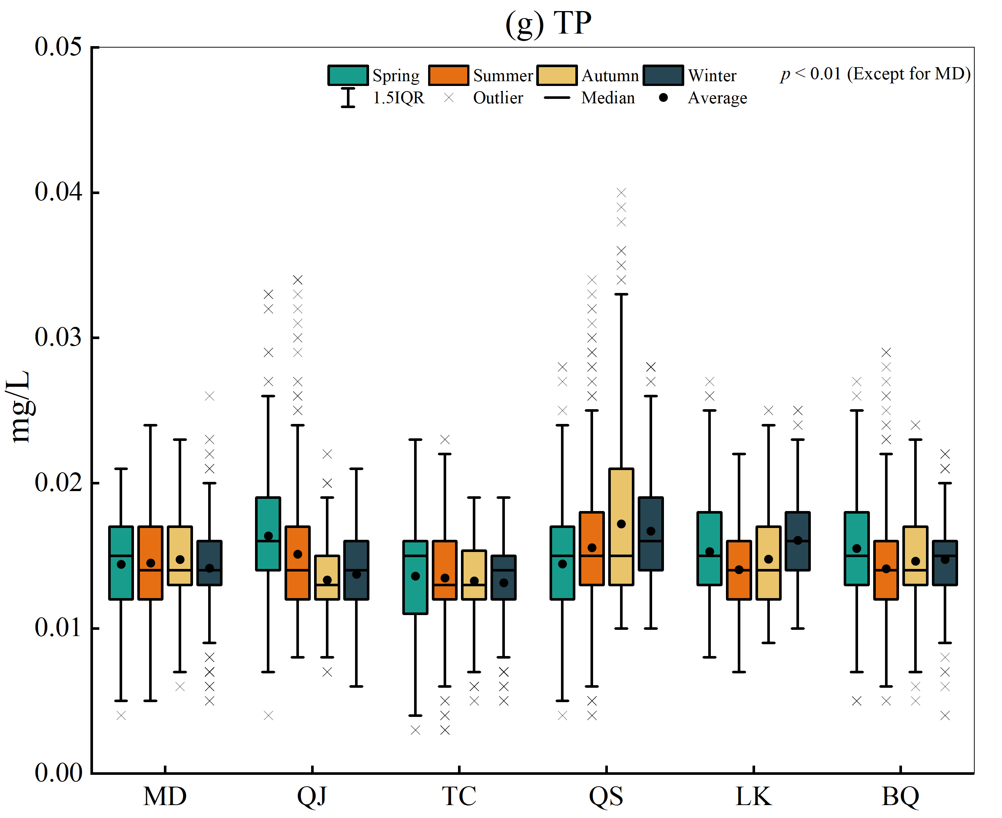 | 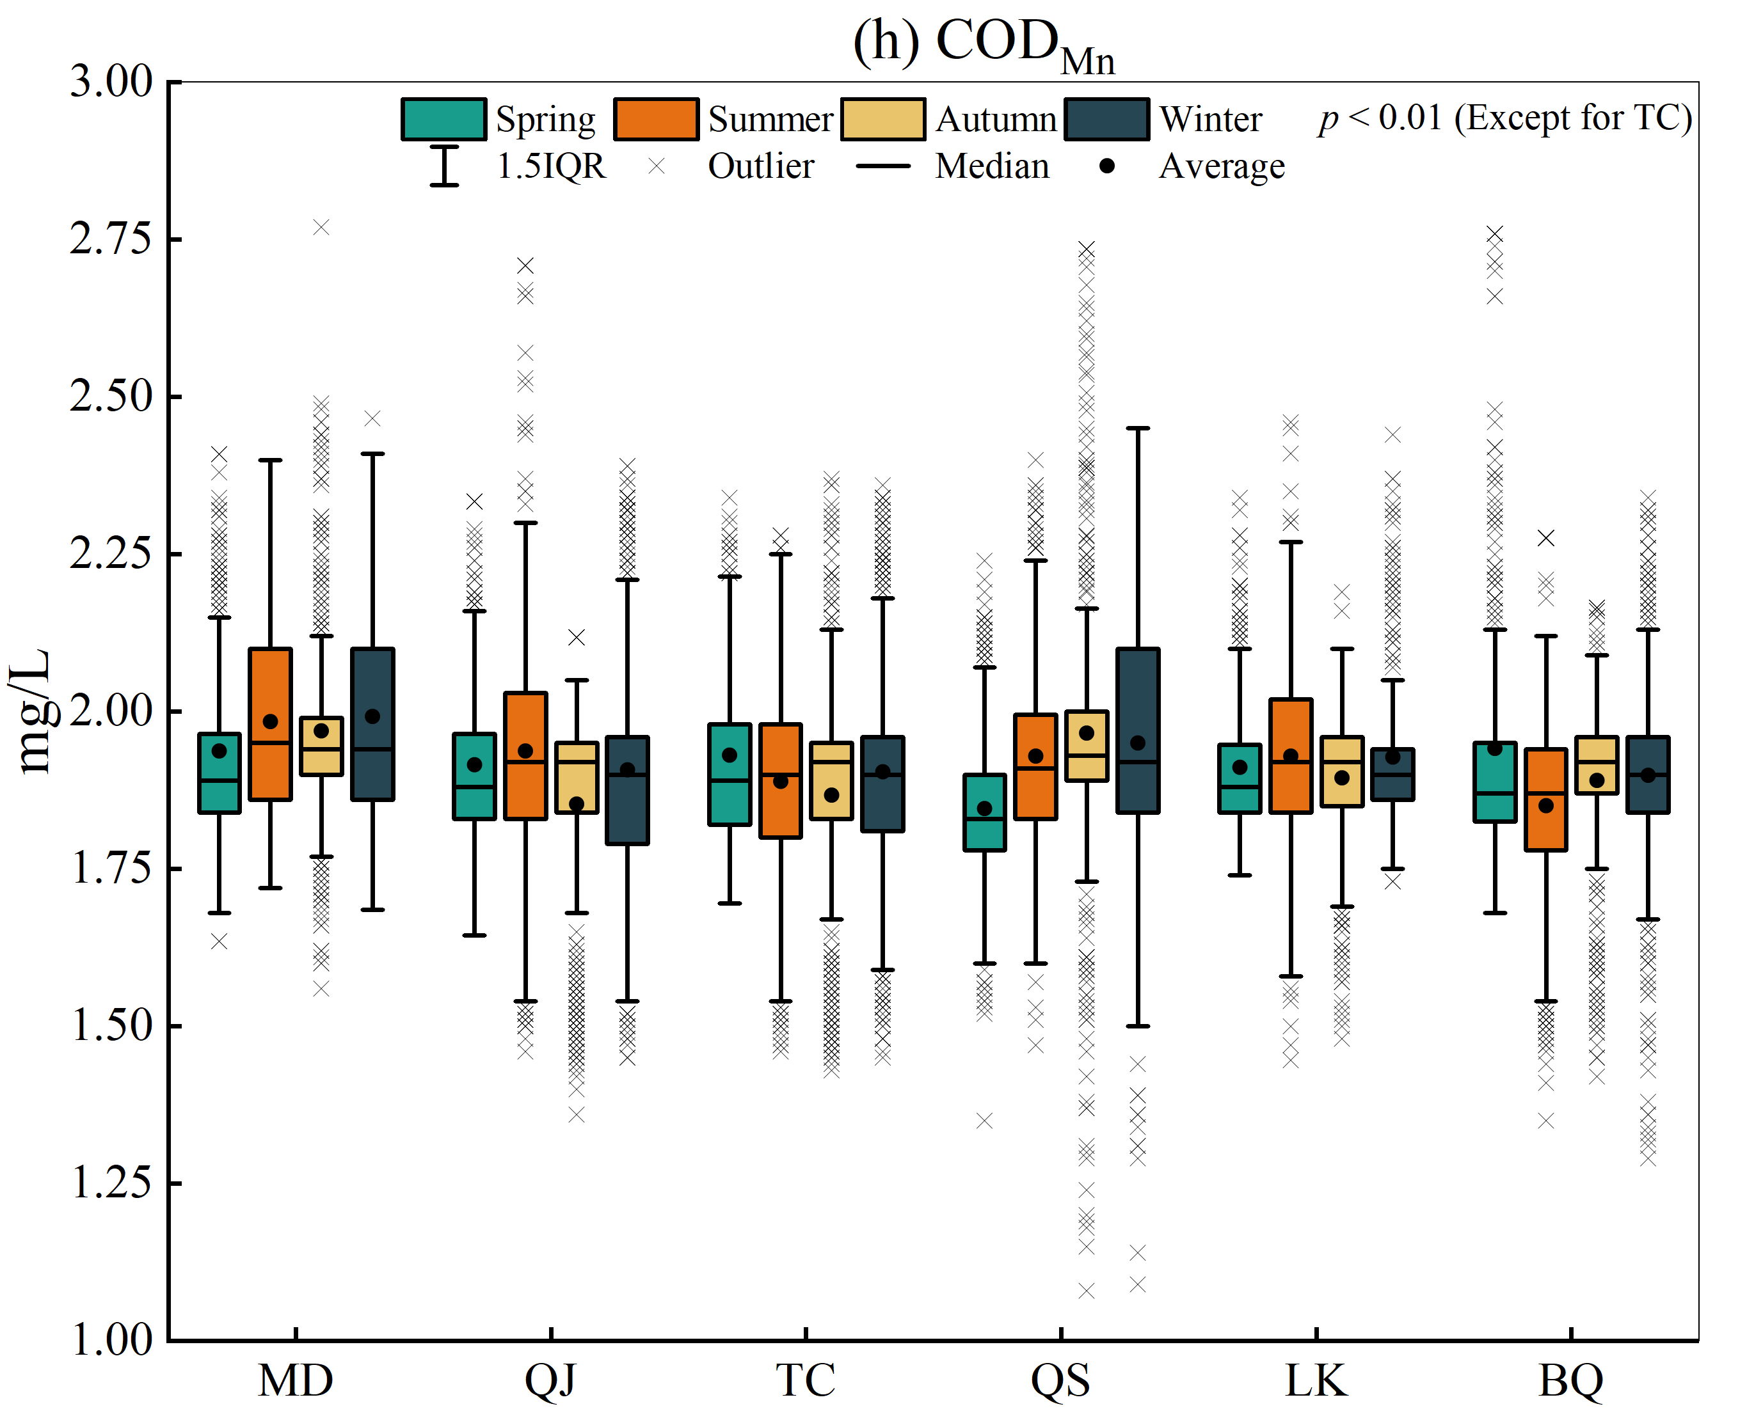

Fig. S1. Seasonal water quality parameter variations in Danjiangkou Reservoir in this study.

