Supplementary Material 1 The burden of primary liver cancer in the Asia-Pacific region by sex
In 2019, the number of primary liver cancer incident cases in females was 100,400 (95% UI 84,000 to 117,900) cases, with 94,300 (95% UI 78,800 to 110,600) deaths and 2.17 million (95% UI 1.81 million to 2.56 million) DALYs in the APAC region. On the other hand, there were 264,300 (95% UI 223,400 to 313,200) cases, 229,800 (95% UI 193,100 to 270,900) deaths, and 6.43 million (95% UI 5.33 million to 7.68 million) DALYs in males (Tables 1–3). In Southeast Asia, ASIR, ASDR, and ASDALYs due to primary liver cancer in females were 2.65 (95% UI 2.23 to 3.14), 2.80 (95% UI 2.31 to 3.34), and 65.43 (95% UI 54.19 to 77.80) per 100,000 population, respectively. In males, ASIR, ASDR, and ASDALYs of primary liver cancer were 5.52 (95% UI 4.72 to 6.39), 5.74 (95% UI 4.90 to 6.72), and 143.52 (95% UI 122.18 to 168.06), respectively. From 2010 to 2019, ASIR in both females (APC: -0.54%, 95% CI: -0.62 to -0.46%), and males (APC: -0.16%, 95% CI: -0.23 to -0.09%) decreased. ASDR in both females (APC: -0.66%, 95% CI: -1.07 to -0.24%), and males (APC: -0.27%, 95% CI: -0.43 to -0.11%) decreased. Similarly, ASDALYs in both females (APC: -0.80%, 95% CI: -1.17 to -0.44%) and males (APC: -0.54%, 95% CI: -0.78 to -0.30%) decreased (Tables 1-3). In the Western Pacific region, ASIR, ASDR, and ASDALYs due to primary liver cancer in females were 5.47 (95% UI 4.57 to 6.41), 4.97 (95% UI 4.17 to 5.79), and 114.37 (95% UI 95.97 to 134.91), respectively. In males, ASIR, ASDR, and ASDALYs of primary liver cancer were 17.05 (95% UI 14.51 to 20.12), 14.51 (95% UI 12.26 to 16.98), and 392.42 (95% UI 325.58 to 469.09), respectively. In females from 2010 to 2019, ASIR (APC: -0.98%, 95% CI: -1.03 to -0.92%), ASDR (APC: -1.12%, 95% CI: -1.25 to -0.98%), and ASDALYs (APC: -1.18%, 95% CI -1.33 to -1.02%) decreased. Meanwhile, in males, ASIR increased (APC: 0.37%, 95% CI: 0.28 to 0.45%) while ASDR and ASDALYs remained stable (Tables 1-3).

Supplementary Table 1 Data quality rating for cause of death data 2010-2019, by country.
Country | Data Quality Rating*
American Samoa | 3
Australia | 5
Austria | 5
Bangladesh | 2
Bhutan | 0
Brunei | 3
Cambodia | 1
China | 3
Cook Islands | 2
Democratic People's Republic of Korea | 0
Fiji | 2
Guam | 3
India | 2
Indonesia | 2
Japan | 5
Kiribati | 2
Laos | 1
Malaysia | 2
Maldives | 2
Marshall Islands | 0
Mauritius | 4
Myanmar | 1
Nauru | 0
Nepal | 1
New Zealand | 5
Niue | 0
Northern Mariana Islands | 2
Pakistan | 2
Palau | 1
Papua New Guinea | 1
Philippines | 3
Republic of Korea | 3
Samoa | 0
Seychelles | 3
Singapore | 5
Solomon Islands | 1
Sri Lanka | 3
Taiwan (province of China) | 4
Thailand | 3
Timor-Leste | 0
Tokelau | 0
Tonga | 1
Tuvalu | 0
Vanuatu | 0
Vietnam | 2
Data obtained from Global Burden of Disease Collaborative Network. Global Burden of Disease Study 2019 (GBD 2019). Seattle, United States of America: Institute for Health Metrics and Evaluation (IHME), 2020.
*Data Quality Rating: 5 for certified data equaling or exceeding 85%; 4 for certified data equaling 65% to less than 85%; 3, certified data equaling 35% to less than 65%; 2, certified data equaling 10% to less than 35%; 1, certified data greater than 0% to less than 10%; 0, certified data equaling 0%.

Supplementary Table 2 Incident cases, age-standardized incidence rates, and time trend from 2010 to 2019 of primary liver cancer in the Asia-Pacific region, stratified by country.
Country | 2010 Incident cases (95% UI) | 2010 Age-standardized  incidence rate per 100,000  (95% UI) | 2019 Incident cases (95% UI) | 2019 Age-standardized  incidence rate per 100,000  (95% UI) | APC from 2010 to 2019  (95% CI) | p
American Samoa | 0 (0 to 0) | 6.86 (6.05 to 7.70) | 0 (0 to 0) | 6.88 (5.69 to 8.35) | 0.07 (0.00 to 0.13) | 0.048
Australia | 1,360 (1,270 to 1,440) | 4.30 (4.03 to 4.56) | 1,800 (1,390 to 2,310) | 4.52 (3.48 to 5.84) | 0.27 (-0.15 to 0.69) | 0.208
Bangladesh | 2,340 (2,010 to 2,820) | 2.61 (2.23 to 3.13) | 3,400 (2,660 to 4,240) | 2.58 (2.03 to 3.21) | -0.03 (-0.16 to 0.11) | 0.702
Bhutan | 10 (10 to 20) | 2.87 (2.02 to 4.12) | 20 (10 to 20) | 3.04 (2.11 to 4.29) | 0.64 (0.62 to 0.67) | <0.001
Brunei Darussalam | 30 (20 to 30) | 12.31 (11.03 to 13.64) | 40 (30 to 50) | 11.75 (9.96 to 13.78) | -0.48 (-0.54 to -0.42) | <0.001
Cambodia | 900 (760 to 1,060) | 9.42 (8.02 to 11.00) | 1,140 (890 to 1,410) | 9.20 (7.26 to 11.26) | -0.27 (-0.29 to -0.25) | <0.001
China | 151,870 (137,020 to 168,530) | 9.68 (8.76 to 10.74) | 210,460 (174,830 to 251,200) | 10.46 (8.74 to 12.42) | 0.93 (0.77 to 1.09) | <0.001
Cook Islands | 0 (0 to 0) | 11.17 (9.56 to 12.92) | 0 (0 to 0) | 11.37 (9.15 to 13.93) | 0.23 (0.07 to 0.39) | 0.004
Democratic People's Republic of Korea | 3,020 (2,270 to 3,860) | 11.00 (8.44 to 14.05) | 3,350 (2,490 to 4,400) | 10.23 (7.66 to 13.36) | -0.81 (-0.85 to -0.78) | <0.001
Fiji | 40 (30 to 40) | 5.56 (5.02 to 6.09) | 50 (40 to 60) | 6.04 (4.67 to 7.62) | 0.96 (0.87 to 1.05) | <0.001
Guam | 10 (10 to 10) | 5.14 (4.41 to 5.97) | 10 (10 to 10) | 5.89 (4.80 to 7.19) | 1.57 (1.45 to 1.70) | <0.001
India | 23,390 (19,820 to 26,030) | 2.71 (2.28 to 3.03) | 29,970 (25,240 to 35,610) | 2.61 (2.20 to 3.10) | -0.47 (-0.54 to -0.40) | <0.001
Indonesia | 3,610 (3,220 to 3,960) | 2.26 (2.02 to 2.46) | 4,500 (3,800 to 5,160) | 2.23 (1.90 to 2.51) | -0.15 (-0.19 to -0.12) | <0.001
Japan | 47,180 (42,190 to 50,050) | 15.53 (14.14 to 16.35) | 46,660 (37,990 to 55,120) | 12.71 (10.51 to 14.98) | -2.34 (-2.66 to -2.02) | <0.001
Kiribati | 10 (10 to 10) | 12.09 (9.57 to 14.81) | 10 (10 to 10) | 11.69 (9.09 to 14.66) | -0.38 (-0.41 to -0.35) | <0.001
Lao People's Democratic Republic | 250 (180 to 320) | 7.14 (5.23 to 9.12) | 300 (220 to 400) | 6.72 (5.06 to 8.54) | -0.66 (-0.70 to -0.63) | <0.001
Malaysia | 1,370 (1,200 to 1,530) | 6.91 (6.01 to 7.75) | 1,640 (1,240 to 2,130) | 6.08 (4.65 to 7.83) | -1.49 (-1.63 to -1.36) | <0.001
Maldives | 10 (10 to 10) | 5.66 (4.89 to 6.45) | 20 (10 to 20) | 5.47 (4.31 to 6.70) | -0.41 (-0.56 to -0.26) | <0.001
Marshall Islands | 0 (0 to 0) | 10.51 (7.85 to 13.97) | 0 (0 to 10) | 10.22 (7.38 to 13.84) | -0.32 (-0.34 to -0.30) | <0.001
Mauritius | 30 (20 to 30) | 1.98 (1.81 to 2.16) | 30 (30 to 40) | 1.93 (1.49 to 2.49) | -0.16 (-0.30 to -0.01) | 0.035
Micronesia (Federated States of) | 10 (0 to 10) | 9.96 (6.81 to 13.25) | 10 (10 to 10) | 10.37 (6.93 to 14.51) | 0.47 (0.43 to 0.51) | <0.001
Myanmar | 1,210 (990 to 1,520) | 3.43 (2.79 to 4.28) | 1,870 (1,540 to 2,240) | 4.11 (3.46 to 4.88) | 2.15 (1.91 to 2.39) | <0.001
Nauru | 0 (0 to 0) | 10.62 (7.50 to 13.69) | 0 (0 to 0) | 9.17 (6.50 to 12.59) | -1.66 (-1.72 to -1.60) | <0.001
Nepal | 320 (260 to 400) | 1.87 (1.55 to 2.37) | 460 (330 to 660) | 2.13 (1.54 to 3.05) | 1.49 (1.27 to 1.70) | <0.001
New Zealand | 270 (250 to 290) | 4.58 (4.30 to 4.84) | 360 (300 to 440) | 4.96 (4.09 to 6.02) | 0.93 (0.88 to 0.98) | <0.001
Niue | 0 (0 to 0) | 7.48 (5.75 to 9.49) | 0 (0 to 0) | 7.37 (5.65 to 9.46) | -0.16 (-0.16 to -0.15) | <0.001
Northern Mariana Islands | 0 (0 to 0) | 7.72 (6.61 to 8.94) | 0 (0 to 10) | 7.97 (6.58 to 9.70) | 0.38 (0.16 to 0.60) | 0.001
Pakistan | 3,160 (2,520 to 3,820) | 3.52 (2.73 to 4.32) | 3,880 (3,100 to 4,740) | 3.27 (2.56 to 4.02) | -0.85 (-0.90 to -0.80) | <0.001
Palau | 0 (0 to 0) | 9.71 (7.57 to 12.36) | 0 (0 to 0) | 9.97 (7.68 to 12.94) | 0.30 (0.27 to 0.33) | <0.001
Papua New Guinea | 50 (30 to 60) | 1.50 (1.16 to 1.93) | 70 (50 to 90) | 1.53 (1.19 to 1.96) | 0.23 (0.21 to 0.25) | <0.001
Philippines | 4,000 (3,620 to 4,410) | 6.34 (5.77 to 7.00) | 5,300 (4,240 to 6,570) | 6.38 (5.16 to 7.84) | 0.04 (-0.09 to 0.18) | 0.542
Republic of Korea | 16,360 (15,370 to 17,670) | 25.44 (23.88 to 27.50) | 20,370 (16,680 to 24,500) | 22.80 (18.72 to 27.32) | -1.30 (-1.47 to -1.12) | <0.001
Samoa | 10 (10 to 10) | 5.03 (3.95 to 6.32) | 10 (10 to 10) | 4.99 (3.82 to 6.29) | -0.08 (-0.16 to 0.01) | 0.074
Seychelles | 0 (0 to 10) | 5.38 (4.79 to 6.03) | 10 (10 to 10) | 5.56 (4.68 to 6.58) | 0.41 (0.36 to 0.46) | <0.001
Singapore | 600 (560 to 640) | 12.20 (11.39 to 12.96) | 880 (710 to 1,110) | 11.50 (9.24 to 14.41) | -0.85 (-1.09 to -0.61) | <0.001
Solomon Islands | 20 (10 to 20) | 5.58 (4.53 to 6.76) | 20 (20 to 20) | 5.37 (4.30 to 6.55) | -0.51 (-0.72 to -0.29) | <0.001
Sri Lanka | 540 (500 to 590) | 2.85 (2.64 to 3.08) | 710 (510 to 950) | 2.80 (2.06 to 3.72) | -0.15 (-0.28 to -0.01) | 0.032
Taiwan (Province of China) | 3,290 (3,080 to 3,480) | 11.02 (10.31 to 11.67) | 3,360 (2,610 to 4,340) | 8.65 (6.73 to 11.15) | -2.86 (-3.09 to -2.63) | <0.001
Thailand | 18,740 (16,350 to 21,560) | 24.78 (21.55 to 28.50) | 24,830 (18,290 to 33,050) | 24.18 (17.89 to 32.01) | -0.28 (-0.44 to -0.12) | 0.001
Timor-Leste | 40 (20 to 60) | 5.85 (3.59 to 8.45) | 50 (30 to 70) | 6.19 (4.18 to 8.57) | 0.64 (0.50 to 0.78) | <0.001
Tokelau | 0 (0 to 0) | 7.45 (5.68 to 9.57) | 0 (0 to 0) | 7.32 (5.29 to 9.90) | -0.19 (-0.21 to -0.18) | <0.001
Tonga | 20 (10 to 20) | 24.90 (18.89 to 31.23) | 20 (10 to 30) | 24.33 (17.65 to 31.90) | -0.26 (-0.28 to -0.24) | <0.001
Tuvalu | 0 (0 to 0) | 8.37 (6.41 to 11.00) | 0 (0 to 0) | 8.47 (6.24 to 11.32) | 0.13 (0.11 to 0.15) | <0.001
Vanuatu | 10 (10 to 20) | 9.23 (6.17 to 13.56) | 20 (10 to 20) | 9.05 (6.21 to 12.85) | -0.23 (-0.27 to -0.20) | <0.001
Viet Nam | 2,280 (1,980 to 2,650) | 3.35 (2.92 to 3.88) | 2,340 (1,790 to 2,950) | 2.61 (2.03 to 3.26) | -2.89 (-3.06 to -2.71) | <0.001
Abbreviation: CI: confidence interval; UI: uncertainty interval

Supplementary Table 3 Death, age-standardized death rates, and time trend from 2010 to 2019 of primary liver cancer in the Asia-Pacific region, stratified by country.
Country | 2010 Death (95% UI) | 2010 Age-standardized  death rate per 100,000  (95% UI) | 2019 Death (95% UI) | 2019 Age-standardized  death rate per 100,000  (95% UI) | APC from 2010 to 2019  (95% CI) | p
American Samoa | 0 (0 to 0) | 7.02 (6.21 to 7.86) | 0 (0 to 0) | 7.02 (5.85 to 8.45) | 0.01 (-0.11 to 0.12) | 0.909
Australia | 1,260 (1,170 to 1,330) | 3.88 (3.64 to 4.10) | 1,730 (1,570 to 1,890) | 4.20 (3.83 to 4.59) | 0.81 (0.47 to 1.15) | <0.001
Bangladesh | 2,390 (2,050 to 2,840) | 2.81 (2.40 to 3.38) | 3,520 (2,770 to 4,400) | 2.75 (2.17 to 3.42) | -0.30 (-0.79 to 0.19) | 0.232
Bhutan | 10 (10 to 20) | 3.09 (2.17 to 4.40) | 20 (10 to 30) | 3.27 (2.29 to 4.61) | 0.69 (0.63 to 0.75) | <0.001
Brunei Darussalam | 20 (20 to 30) | 12.48 (11.12 to 13.91) | 30 (30 to 40) | 11.53 (9.82 to 13.38) | -0.74 (-0.93 to -0.55) | <0.001
Cambodia | 930 (790 to 1,100) | 10.11 (8.66 to 11.73) | 1,180 (920 to 1,460) | 9.86 (7.85 to 12.03) | -0.28 (-0.35 to -0.22) | <0.001
China | 141,710 (128,400 to 157,120) | 9.28 (8.42 to 10.27) | 187,700 (158,260 to 222,770) | 9.41 (7.95 to 11.13) | 0.46 (-0.33 to 1.26) | 0.25
Cook Islands | 0 (0 to 0) | 11.10 (9.54 to 12.76) | 0 (0 to 0) | 11.13 (9.03 to 13.51) | 0.02 (-0.17 to 0.21) | 0.785
Democratic People's Republic of Korea | 2,990 (2,280 to 3,800) | 11.08 (8.50 to 13.99) | 3,310 (2,500 to 4,330) | 10.20 (7.75 to 13.30) | -0.93 (-1.02 to -0.84) | <0.001
Fiji | 40 (30 to 40) | 5.76 (5.21 to 6.30) | 50 (40 to 60) | 6.23 (4.86 to 7.83) | 0.86 (0.55 to 1.17) | <0.001
Guam | 10 (10 to 10) | 5.06 (4.36 to 5.85) | 10 (10 to 10) | 5.79 (4.71 to 7.05) | 1.54 (1.04 to 2.05) | <0.001
India | 23,700 (20,140 to 26,380) | 2.86 (2.40 to 3.21) | 30,710 (25,880 to 36,350) | 2.75 (2.32 to 3.27) | -0.47 (-0.69 to -0.26) | 0.001
Indonesia | 3,780 (3,420 to 4,160) | 2.48 (2.25 to 2.71) | 4,720 (3,970 to 5,400) | 2.45 (2.08 to 2.76) | -0.13 (-0.20 to -0.07) | 0.002
Japan | 34,720 (30,530 to 36,850) | 10.95 (9.84 to 11.52) | 34,510 (29,610 to 37,430) | 8.78 (7.80 to 9.42) | -2.44 (-2.63 to -2.25) | <0.001
Kiribati | 10 (10 to 10) | 12.37 (9.82 to 15.12) | 10 (10 to 10) | 11.95 (9.29 to 15.08) | -0.38 (-0.41 to -0.34) | <0.001
Lao People's Democratic Republic | 250 (180 to 320) | 7.54 (5.53 to 9.63) | 310 (230 to 400) | 7.11 (5.40 to 9.01) | -0.68 (-0.83 to -0.54) | <0.001
Malaysia | 1,360 (1,200 to 1,520) | 7.19 (6.23 to 8.07) | 1,630 (1,240 to 2,100) | 6.22 (4.78 to 7.94) | -1.53 (-2.04 to -1.02) | <0.001
Maldives | 10 (10 to 10) | 6.00 (5.20 to 6.83) | 20 (10 to 20) | 5.63 (4.46 to 6.89) | -0.78 (-0.95 to -0.61) | <0.001
Marshall Islands | 0 (0 to 0) | 10.87 (8.18 to 14.42) | 0 (0 to 10) | 10.57 (7.64 to 14.31) | -0.30 (-0.36 to -0.25) | <0.001
Mauritius | 30 (20 to 30) | 2.08 (1.90 to 2.27) | 30 (30 to 40) | 2.00 (1.55 to 2.57) | -0.32 (-1.07 to 0.45) | 0.413
Micronesia (Federated States of) | 10 (0 to 10) | 10.28 (7.05 to 13.50) | 10 (0 to 10) | 10.70 (7.24 to 14.74) | 0.52 (0.43 to 0.62) | <0.001
Myanmar | 1,280 (1,050 to 1,580) | 3.73 (3.05 to 4.56) | 1,960 (1,630 to 2,320) | 4.44 (3.76 to 5.26) | 2.36 (1.03 to 3.70) | <0.001
Nauru | 0 (0 to 0) | 11.00 (7.86 to 14.02) | 0 (0 to 0) | 9.39 (6.70 to 12.73) | -1.73 (-1.91 to -1.54) | <0.001
Nepal | 340 (280 to 420) | 2.07 (1.73 to 2.60) | 490 (350 to 700) | 2.36 (1.71 to 3.39) | 1.52 (1.36 to 1.67) | <0.001
New Zealand | 210 (200 to 230) | 3.56 (3.35 to 3.72) | 280 (260 to 300) | 3.72 (3.44 to 4.00) | 0.39 (-0.10 to 0.88) | 0.119
Niue | 0 (0 to 0) | 7.51 (5.82 to 9.48) | 0 (0 to 0) | 7.34 (5.67 to 9.36) | -0.24 (-0.28 to -0.20) | <0.001
Northern Mariana Islands | 0 (0 to 0) | 7.61 (6.55 to 8.77) | 0 (0 to 10) | 7.84 (6.50 to 9.45) | 0.41 (0.14 to 0.68) | 0.003
Pakistan | 3,200 (2,540 to 3,860) | 3.72 (2.88 to 4.55) | 3,910 (3,160 to 4,830) | 3.46 (2.75 to 4.30) | -0.79 (-0.87 to -0.71) | <0.001
Palau | 0 (0 to 0) | 9.62 (7.54 to 12.2) | 0 (0 to 0) | 9.79 (7.59 to 12.53) | 0.21 (0.17 to 0.25) | <0.001
Papua New Guinea | 50 (40 to 60) | 1.63 (1.27 to 2.10) | 70 (50 to 90) | 1.67 (1.31 to 2.12) | 0.16 (0.03 to 0.29) | 0.025
Philippines | 3,960 (3,600 to 4,440) | 6.55 (5.97 to 7.33) | 5,280 (4,270 to 6,450) | 6.58 (5.35 to 7.98) | 0.11 (-0.12 to 0.34) | 0.3
Republic of Korea | 12,260 (11,580 to 13,140) | 19.40 (18.20 to 20.80) | 14,480 (12,940 to 16,040) | 16.20 (14.47 to 17.94) | -2.06 (-2.15 to -1.96) | <0.001
Samoa | 10 (10 to 10) | 5.12 (4.04 to 6.40) | 10 (10 to 10) | 5.06 (3.91 to 6.33) | -0.04 (-0.11 to 0.03) | 0.194
Seychelles | 0 (0 to 10) | 5.57 (4.96 to 6.21) | 10 (10 to 10) | 5.70 (4.81 to 6.72) | 0.29 (0.20 to 0.38) | <0.001
Singapore | 470 (440 to 490) | 9.79 (9.14 to 10.28) | 660 (590 to 730) | 8.68 (7.67 to 9.66) | -1.46 (-1.64 to -1.29) | <0.001
Solomon Islands | 20 (10 to 20) | 5.76 (4.71 to 6.96) | 20 (10 to 20) | 5.52 (4.46 to 6.68) | -0.72 (-1.30 to -0.13) | 0.017
Sri Lanka | 550 (510 to 590) | 2.97 (2.74 to 3.21) | 710 (510 to 940) | 2.84 (2.11 to 3.77) | -0.54 (-0.69 to -0.39) | <0.001
Taiwan (Province of China) | 2,670 (2,500 to 2,820) | 8.99 (8.42 to 9.47) | 2,850 (2,230 to 3,660) | 7.27 (5.69 to 9.32) | -2.80 (-3.59 to -2.00) | <0.001
Thailand | 18,550 (16,170 to 21,290) | 25.00 (21.69 to 28.69) | 24,530 (18,170 to 32,510) | 24.01 (17.88 to 31.65) | -0.55 (-1.10 to 0.01) | 0.055
Timor-Leste | 40 (20 to 60) | 6.28 (3.96 to 8.96) | 50 (40 to 70) | 6.60 (4.53 to 9.09) | 0.51 (0.35 to 0.67) | <0.001
Tokelau | 0 (0 to 0) | 7.65 (5.92 to 9.74) | 0 (0 to 0) | 7.48 (5.46 to 10.06) | -0.25 (-0.27 to -0.22) | <0.001
Tonga | 20 (10 to 20) | 25.36 (19.37 to 31.44) | 20 (10 to 30) | 24.74 (18.09 to 32.04) | -0.26 (-0.32 to -0.20) | <0.001
Tuvalu | 0 (0 to 0) | 8.61 (6.59 to 11.19) | 0 (0 to 0) | 8.72 (6.51 to 11.52) | 0.14 (0.11 to 0.16) | <0.001
Vanuatu | 10 (10 to 20) | 9.58 (6.43 to 14.09) | 20 (10 to 20) | 9.36 (6.41 to 13.20) | -0.28 (-0.38 to -0.17) | <0.001
Viet Nam | 2,380 (2,070 to 2,760) | 3.56 (3.12 to 4.12) | 2,390 (1,840 to 2,980) | 2.75 (2.15 to 3.40) | -2.95 (-3.19 to -2.70) | <0.001
Abbreviation: CI: confidence interval; UI: uncertainty interval

Supplementary Table 4 Incident cases, age-standardized incidence rates, and time trend from 2010 to 2019 of primary liver cancer in patients aged 15-49 in the Asia-Pacific region, stratified by etiology.
 |  | Southeast Asia |  |  |  | Western Pacific
 | 2019 Incident cases (95% UI) | 2019 Age-standardized  incidence rate per 100,000  (95% UI) | APC from 2010 to 2019  (95% CI) | p | 2019 Incident cases (95% UI) | 2019 Age-standardized  incidence rate per 100,000  (95% UI) | APC from 2010 to 2019  (95% CI) | p
Overall | 10,430 (8,830 to 12,180) | 0.95 (0.81 to 1.11) | -0.70 (-0.84 to -0.56) | <0.001 | 50,370 (41,910 to 60,340) | 5.18 (4.31 to 6.20) | 1.69 (1.55 to 1.83) | <0.001
By Etiology
Alcohol | 1,850 (1,230 to 2,650) | 0.17 (0.11 to 0.24) | 0.12 (-0.13 to 0.37) | 0.349 | 3,140 (1,970 to 4,540) | 0.32 (0.20 to 0.47) | 2.33 (2.13 to 2.52) | <0.001
Hepatitis B | 6,280 (5,140 to 7,710) | 0.57 (0.47 to 0.70) | -1.08 (-1.25 to -0.92) | <0.001 | 39,550 (32,120 to 47,970) | 4.07 (3.30 to 4.93) | 1.70 (1.56 to 1.84) | <0.001
Hepatitis C | 870 (580 to 1,250) | 0.08 (0.05 to 0.11) | -0.31 (-0.41 to -0.21) | <0.001 | 2,970 (2,250 to 3,830) | 0.31 (0.23 to 0.39) | 0.76 (0.66 to 0.87) | <0.001
MASH | 860 (640 to 1,150) | 0.08 (0.06 to 0.11) | 0.29 (0.21 to 0.37) | <0.001 | 1,580 (1,200 to 2,030) | 0.16 (0.12 to 0.21) | 2.33 (2.28 to 2.38) | <0.001
Others | 570 (430 to 740) | 0.05 (0.04 to 0.07) | -0.40 (-0.52 to -0.29) | <0.001 | 3,120 (2,380 to 3,990) | 0.32 (0.24 to 0.41) | 1.13 (1.07 to 1.20) | <0.001
Abbreviation: CI: confidence interval, MASH: metabolic dysfunction-associated steatohepatitis, UI: uncertainty interval

Supplementary Table 5 Death, age-standardized death rates, and time trend from 2010 to 2019 of primary liver cancer in patients aged 15-49 in the Asia-Pacific region, stratified by etiology.
 |  | Southeast Asia |  |  |  | Western Pacific
 | 2019 Death (95% UI) | 2019 Age-standardized  death rate per 100,000  (95% UI) | APC from 2010 to 2019  (95% CI) | p | 2019 Death (95% UI) | 2019 Age-standardized  death rate per 100,000  (95% UI) | APC from 2010 to 2019  (95% CI) | p
Overall | 9,070 (7,710 to 10,600) | 0.83 (0.70 to 0.97) | -0.91 (-1.37 to -0.44) | <0.001 | 37,760 (31,320 to 45,040) | 3.88 (3.22 to 4.63) | 1.36 (0.87 to 1.86) | <0.001
By Etiology
Alcohol | 1,650 (1,090 to 2,360) | 0.15 (0.10 to 0.22) | -0.14 (-0.61 to 0.34) | 0.577 | 2,360 (1,520 to 3,440) | 0.24 (0.16 to 0.35) | 2.13 (1.73 to 2.53) | <0.001
Hepatitis B | 5,440 (4,390 to 6,700) | 0.50 (0.40 to 0.61) | -1.42 (-1.68 to -1.15) | <0.001 | 29,730 (23,840 to 36,250) | 3.06 (2.45 to 3.73) | 1.37 (0.87 to 1.88) | <0.001
Hepatitis C | 780 (520 to 1,110) | 0.07 (0.05 to 0.10) | -0.42 (-0.71 to -0.12) | 0.006 | 2,170 (1,600 to 2,840) | 0.22 (0.16 to 0.29) | 0.59 (0.22 to 0.97) | 0.007
MASH | 720 (540 to 960) | 0.07 (0.05 to 0.09) | 0.14 (-0.21 to 0.50) | 0.435 | 1,180 (910 to 1,520) | 0.12 (0.09 to 0.16) | 2.06 (1.65 to 2.47) | <0.001
Others | 470 (360 to 630) | 0.04 (0.03 to 0.06) | -0.50 (-0.88 to -0.12) | 0.009 | 2,320 (1,780 to 2,990) | 0.24 (0.18 to 0.31) | 0.81 (0.35 to 1.28) | 0.004
Abbreviation: CI: confidence interval, MASH: metabolic dysfunction-associated steatohepatitis, UI: uncertainty interval

Supplementary Table 6 Disability-adjusted life years, age-standardized DALYs rates, and progression from 2010 to 2019 of primary liver cancer in patients aged 15-49 in the Asia-Pacific region, stratified by etiology
 |  | Southeast Asia |  |  |  | Western Pacific
 | 2019 DALYs (95% UI) | 2019 Age-standardized  DALYs per 100,000  (95% UI) | APC from 2010 to 2019  (95% CI) | p | 2019 DALYs (95% UI) | 2019 Age-standardized  DALYs per 100,000  (95% UI) | APC from 2010 to 2019  (95% CI) | p
Overall | 439,490 (374,880 to 510,470) | 40.12 (34.22 to 46.59) | -0.90 (-1.36 to -0.45) | <0.001 | 1,788,780 (1,487,660 to 2,127,400) | 183.86 (152.91 to 218.66) | 1.31 (0.79 to 1.83) | <0.001
By Etiology
Alcohol | 76,300 (51,500 to 108,090) | 6.96 (4.70 to 9.87) | -0.12 (-0.58 to 0.35) | 0.616 | 107,340 (70,510 to 154,520) | 11.03 (7.25 to 15.88) | 2.08 (1.68 to 2.49) | <0.001
Hepatitis B | 266,100 (217,210 to 324,390) | 24.29 (19.83 to 29.61) | -1.29 (-1.79 to -0.78) | <0.001 | 1,414,120 (1,141,710 to 1,717,820) | 145.35 (117.35 to 176.56) | 1.32 (0.79 to 1.86) | <0.001
Hepatitis C | 35,780 (24,360 to 51,360) | 3.27 (2.22 to 4.69) | -0.44 (-0.73 to -0.14) | 0.004 | 98,560 (73,020 to 127,970) | 10.13 (7.50 to 13.15) | 0.55 (0.15 to 0.95) | 0.013
MASH | 36,690 (27,770 to 48,220) | 3.35 (2.53 to 4.40) | 0.16 (-0.21 to 0.52) | 0.402 | 56,500 (43,690 to 71,480) | 5.81 (4.49 to 7.35) | 1.98 (1.56 to 2.40) | <0.001
Others | 24,620 (18,600 to 32,400) | 2.25 (1.70 to 2.96) | -0.47 (-0.86 to -0.09) | 0.017 | 112,260 (87,210 to 143,880) | 11.54 (8.96 to 14.79) | 0.55 (-0.25 to 1.35) | 0.176
Abbreviation: CI: confidence interval, DALYs: disability-adjusted life years, MASH: metabolic dysfunction-associated steatohepatitis, UI: uncertainty interval

Supplementary Figure 1 A) Age-standardized incidence rates in patients with primary liver cancer per 100,000 population in Southeast Asia from 2010 to 2019, by etiology
B) Age-standardized death rates in patients with primary liver cancer per 100,000 population in Southeast Asia from 2010 to 2019, by etiology C) Age-standardized disability-adjusted life years in patients with primary liver cancer per 100,000 population in Southeast Asia from 2010 to 2019, by etiology D) Age-standardized incidence rates in patients with primary liver cancer per 100,000 population in Western Pacific from 2010 to 2019, by etiology E) Age-standardized death rates in patients with primary liver cancer per 100,000 population in Western Pacific from 2010 to 2019, by etiology F) Age-standardized disability-adjusted life years in patients with primary liver cancer per 100,000 population in Western Pacific from 2010 to 2019, by etiology
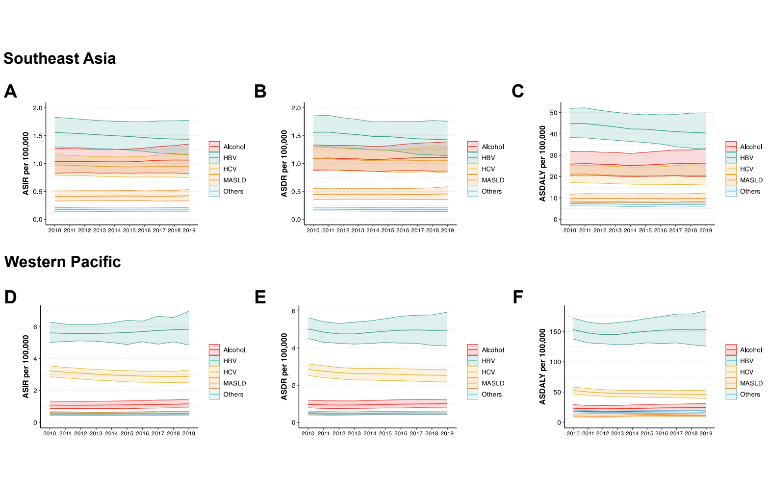
Abbreviation: ASDALYs: age-standardized disability-adjusted life years; ASDR: age-standardized death rates; ASIR: age-standardized incidence rates; HBV: hepatitis B virus; HCV: hepatitis C virus; MASLD: metabolic dysfunction associated steatotic liver disease

Supplementary Figure 2 A) Age-standardized incidence rates in patients with primary liver cancer per 100,000 population in Southeast Asia in 2019, by etiology B) Age-standardized death rates in patients with primary liver cancer per 100,000 population in Southeast Asia in 2019, by etiology C) Age-standardized disability-adjusted life years in patients with primary liver cancer per 100,000 population in Southeast Asia in 2019, by etiology D) Age-standardized incidence rates in patients with primary liver cancer per 100,000 population in Western Pacific in 2019, by etiology E) Age-standardized death rates in patients with primary liver cancer per 100,000 population in Western Pacific in 2019, by etiology F) Age-standardized disability-adjusted life years in patients with primary liver cancer per 100,000 population in Western Pacific in 2019, by etiology
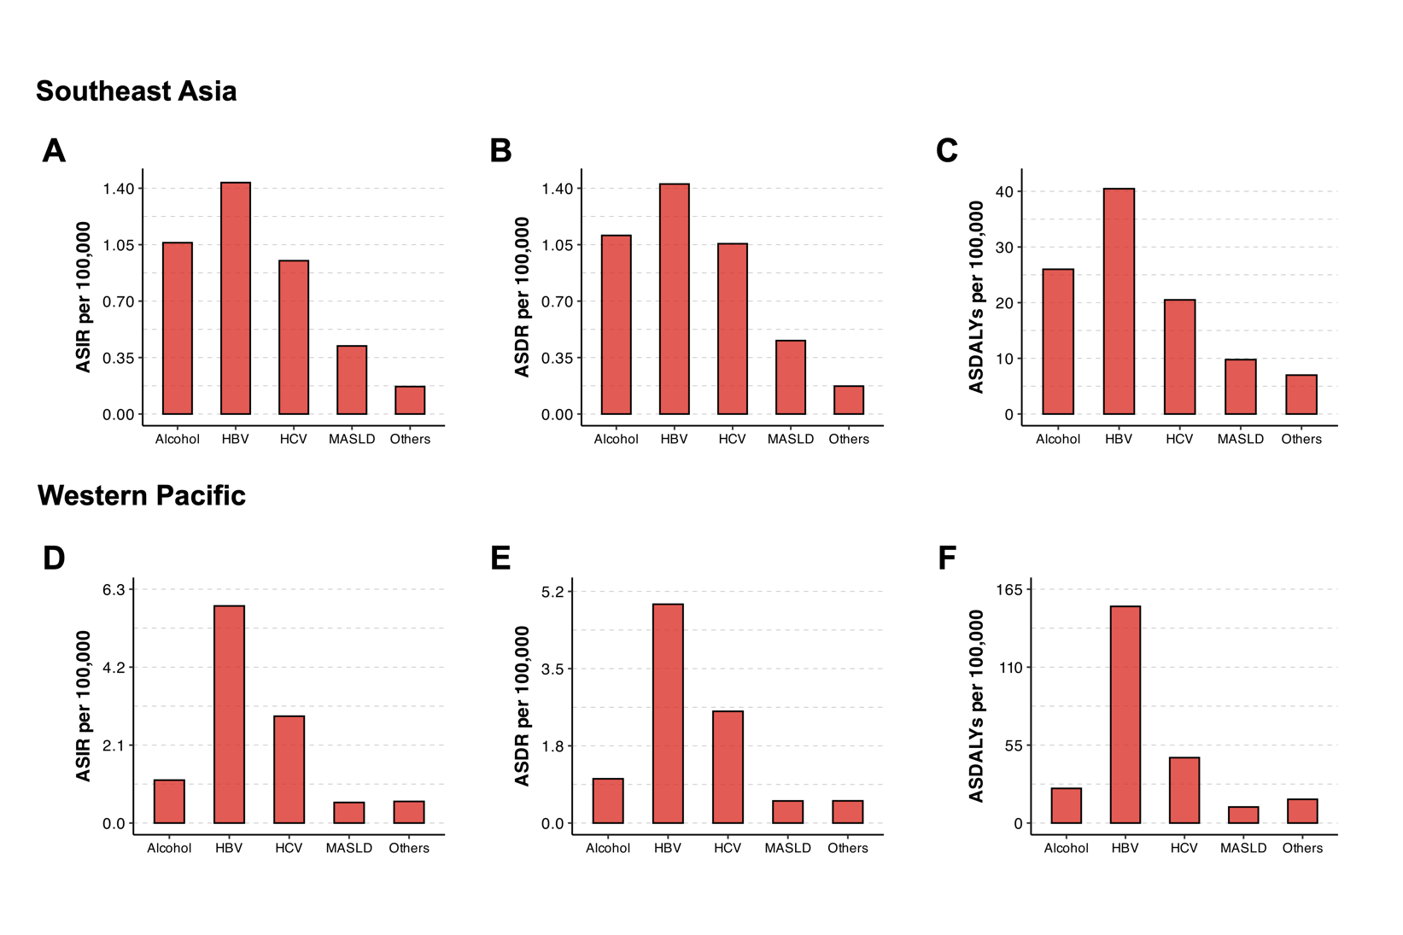
Abbreviation: ASDALYs: age-standardized disability-adjusted life years; ASDR: age-standardized death rates; ASIR: age-standardized incidence rates; HBV: hepatitis B virus; HCV: hepatitis C virus; MASLD: metabolic dysfunction associated steatotic liver disease

