Supplementary Materials: Semantic segmentation in crystal growth process using fake micrograph machine learning

Takamitsu Ishiyama¹, Takashi Suemasu¹, and Kaoru Toko¹

¹ Institute of Applied Physics, University of Tsukuba, 1-1-1 Tennodai, Tsukuba, Ibaraki 305-8573, Japan

Correspondence and requests for materials should be addressed to T.I. (ishiyama.takamits.ta@alumni.tsukuba.ac.jp) and K.T. (toko@bk.tsukuba.ac.jp).

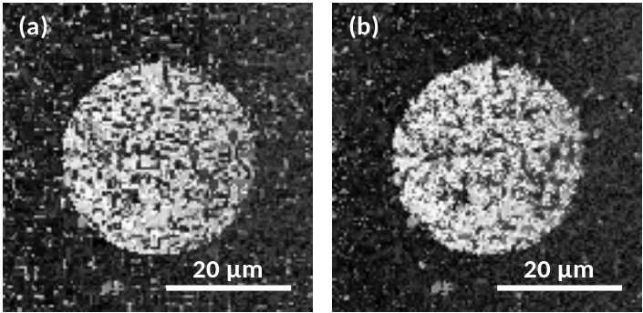

Figure S1. Fake micrographs (a) without and (b) with post-process, where the domain size is set to 30 μm.

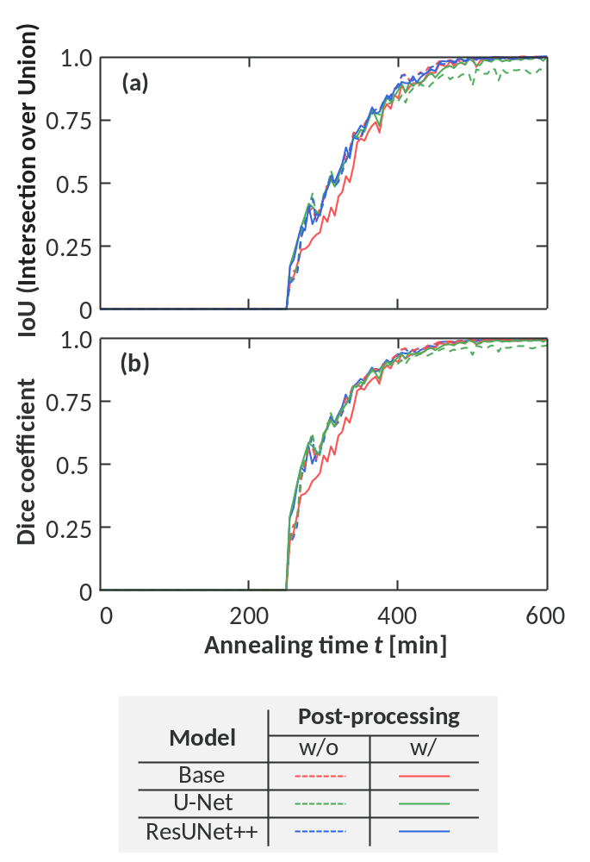

Figure S2. (a) IoU (Intersection over Union) and (b) Dice coefficient as a function of annealing time t, where the base model, U-Net, and ResUNet++ were used with (w/) and without (w/o) post-processing.

