Supplementary Figures
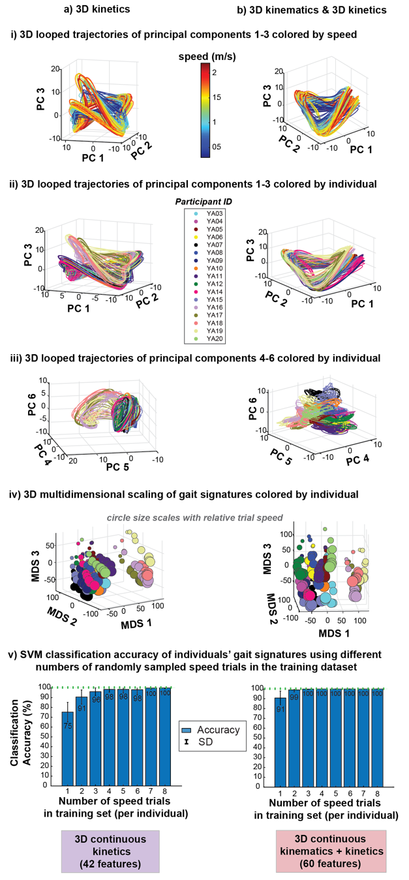
Supplementary Fig. S1: Visualization of kinetic-based gait signatures a) 3D kinetics and b) 3D kinematics & 3D kinetics. i) 3D looped trajectories of the first 3 principal components (PCs 1-3) of the gait signatures colored by speed shows that gait signatures at faster speeds (red) were more expansive than those at slower speeds (blue) ii) 3D looped representations of the first 3 PCs 1-3 of the gait signatures colored by individuals revealed that signatures are individual-specific across speeds. Kinetic signatures (a) appeared to form 2 groups of individuals with differing looped trajectories. iii) 3D looped representations of the second set of PCs 4-6 of the gait signatures colored by individual showcased individual-specific signatures. iv) 3D MDS visualizations of all signatures colored by individual further reveals a splitting of individuals into two groups. v) Individual classification accuracy was relatively high using a) 3D kinetics and b) 3D kinetics & kinematics across varied number of speed trials in the classification model training set.
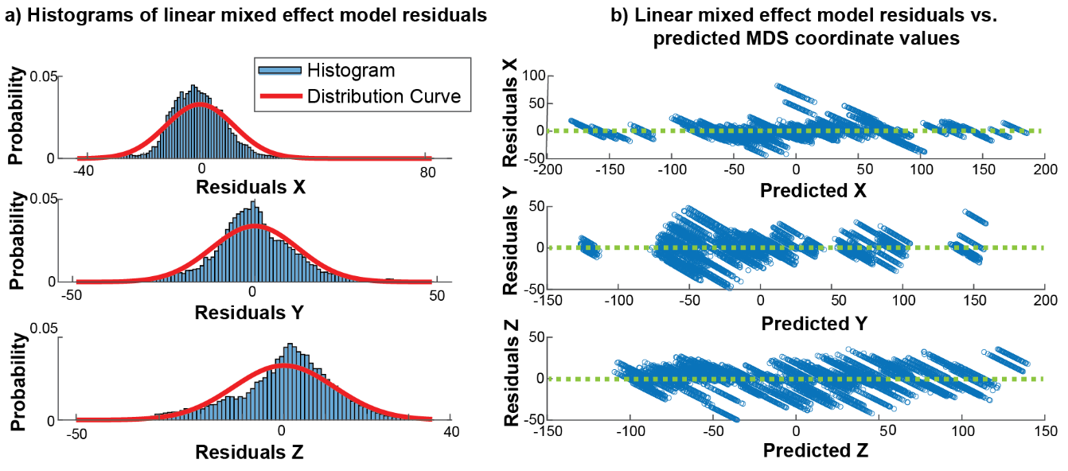
Supplementary Fig. S2: Evaluation of LME model fits. a) Histogram of residuals across 3D coordinate LME models are centered around zero. b) Residuals vs. predicted values reveal homoscedasticity (fluctuation around zero) regardless of prediction value.

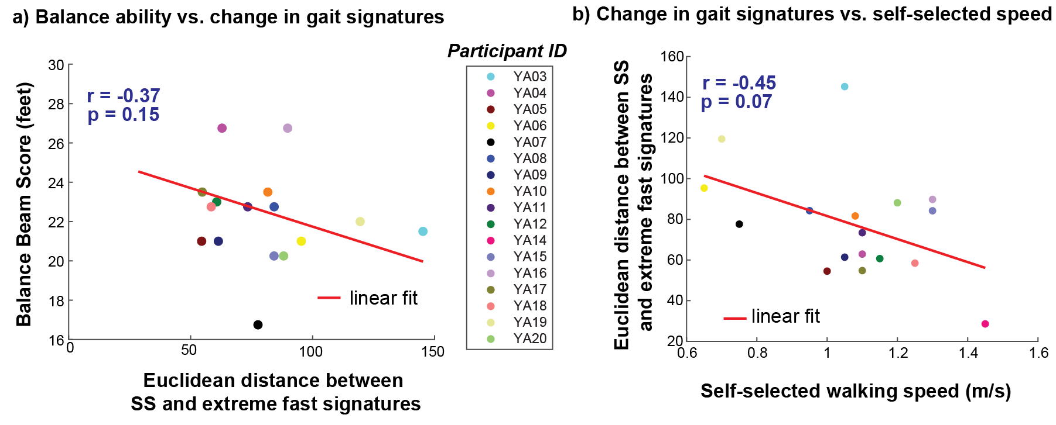Supplementary Fig. S3: Correlation plots showing no significant linear relationships between Euclidean distance between SS and extreme fast (walk to run transition) speed signatures and a) narrowing balance beam score and b) self-selected walking speed.

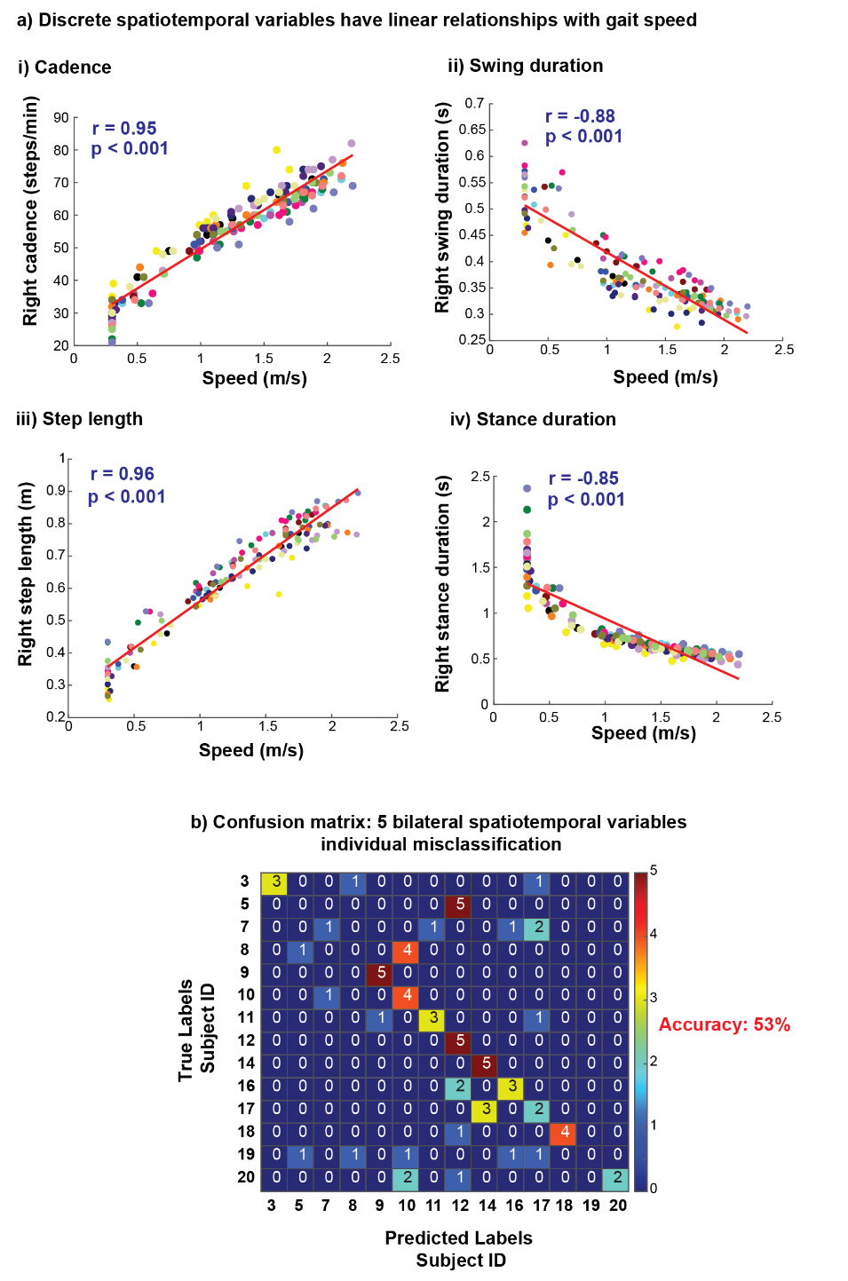
Supplementary Fig. S4: Discrete biomechanical variables show strong, linear relationships with speed. a) Discrete spatiotemporal variables i) cadence and iii) step length show strong positive linear relationships with increasing gait speed and variables ii) swing duration and iv) stance duration show strong negative linear relationships with increasing gait speed. b) Five bilateral spatiotemporal discrete variables (cadence, step length, swing duration, stance duration and step width) were unable to classify individuals with high accuracy (53%). A confusion matrix, derived from a single run of a linear support vector machine classification model, illustrates that multiple individuals were misclassified.
Supplementary Table. T1: Statistics of participants’ speeds across speed conditions
Speed Condition | Mean ± s.d  m/s | Range: [min, max]  m/s
1. Fixed extreme slow | 0.30 ± 0.00 | [0.30, 0.30]
2. Slow OG-derived | 0.48 ± 0.12 | [0.31, 0.71]
3. Self-selected TM-derived | 1.07 ± 0.22 | [0.65, 1.45]
4. Self-selected OG-derived | 1.05 ± 0.16 | [0.78, 1.42]
5. Intermediate calculated | 1.29 ± 0.18 | [1.05, 1.65]
6. Fast TM-derived | 1.53 ± 0.23 | [1.10, 1.88]
7. 92.5% walk-to-run transition | 1.69 ± 0.12 | [1.50, 1.89]
8. Walk-to-run transition | 1.83 ± 0.13 | [1.60, 2.05]
9. 107.5% walk-to-run transition | 1.96 ± 0.15 | [1.70, 2.20]

Supplementary Table. T2: 13 commonly used discrete biomechanical variables assessed bilaterally in gait analysis
Kinematics | Kinetics
Step length | Peak anterior ground reaction force
Peak trailing limb angle | Push off integral
Peak hip hike | Peak ankle moment
Double support duration | Peak ankle power
Stance duration
Swing duration
Ankle angle at heel strike
Ankle angle at toe off
Knee angle at midstance

