Table S1. Proposed symptom changes for the CVS-Q teen© questionnaire
Original symptoms | Teenagers (V1) | Key informants (V2) | Pilot study (V3)
Burning | Not associated with eyes | Delete | Deleted
Itching | Add "eyes” | - | -
Feeling of a foreign body | Confusion of the term  "body"; add "in eye/eyes"; | Change "foreign body" to  "grit" | -
Tearing | - | - | -
Excessive blinking | - | - | -
Eye redness | - | - | -
Eye pain | - | - | -
Heavy eyelids | - | - | -
Dryness | Add "eye" | - | -
Blurred vision | - | - | -
Double vision | - | - | -
Difficulty focusing for near vision | - | Delete "for near vision" | -
Increased sensitivity to light | Not well understood | Add "ambient" behind light | -
Coloured halos around  objects | - | - | Change "coloured halos" to "lights" and add "luminous" behind objects
Feeling that sight is worsening | - | Delete | Deleted
Headache | - | - | -
- No changes

Figure S1: Empirical measure of item category for the CVS-Q teen©
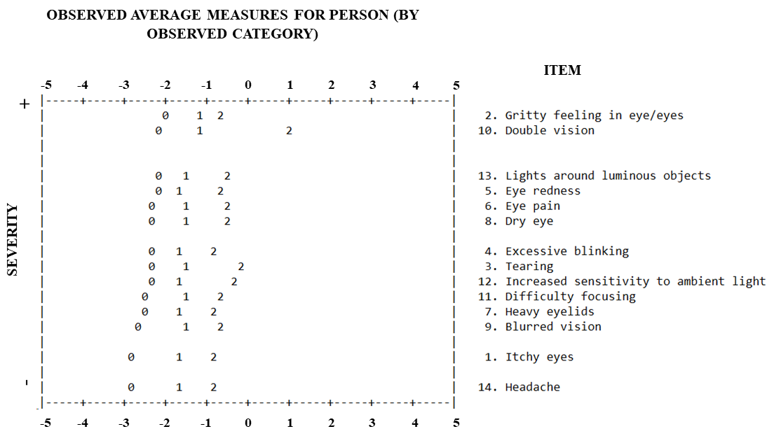
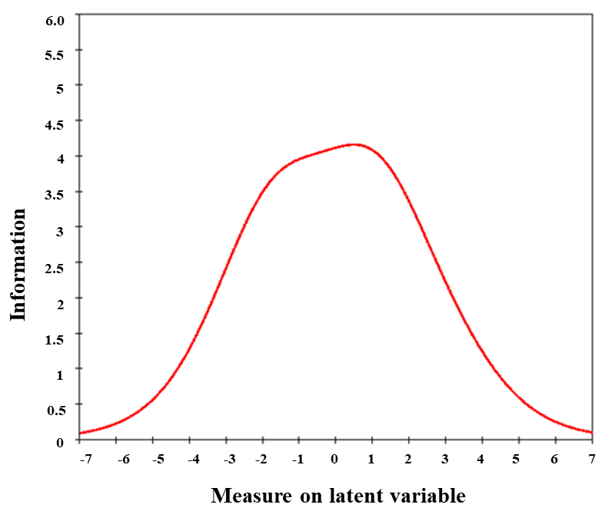
Figure S2: CVS-Q teen© information function

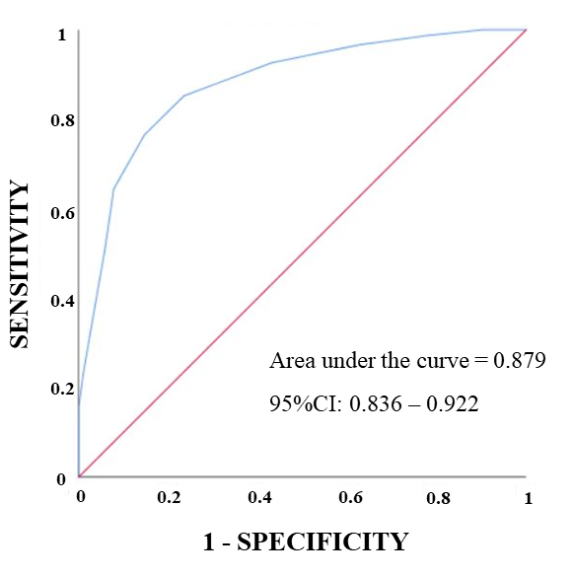
Figure S3: CVS-Q teen© receiver operator characteristic curve

Figure S4: CVS-Q teen©



A rellenar por el adolescente

Indica si percibes alguno de los siguientes síntomas* o molestias, durante o inmediatamente después del uso de dispositivos digitales (móvil, ordenador, e-book, tablet, psp, etc). Para cada síntoma señala con una X:
- Primero, responde a la pregunta: ¿Con qué frecuencia te ocurre?, teniendo en cuenta que:
NUNCA = en ninguna ocasión

OCASIONALMENTE = de forma esporádica o una vez por semana

A MENUDO O SIEMPRE = 2 o 3 veces por semana o casi todos los días

- Segundo, responde a la pregunta: ¿Cuál es la intensidad con que lo sientes?

RECUERDA: si señalas NUNCA en la pregunta de frecuencia, no debes marcar nada en la pregunta de intensidad.
* Si usas habitualmente gafas o lentes de contacto cuando utilizas los dispositivos digitales, debes responder pensando en cómo te sientes cuando las lleva puestas
 | - ¿CON QUÉ FRECUENCIA TE OCURRE? |  |  | b. ¿CUÁL ES LA INTENSIDAD?
 | NUNCA | OCASIONALMENTE | A MENUDO O SIEMPRE | MODERADA | INTENSA
1. Picor en los ojos
2. Sensación de arenilla en los ojos
3. Lagrimeo
4. Parpadeo excesivo
5. Enrojecimiento ocular
6. Dolor ocular
7. Pesadez de párpados
8. Sequedad en los ojos
9. Visión borrosa
10. Visión doble
11. Dificultad al enfocar
12. Aumento de sensibilidad a la luz ambiente
13. Luces alrededor de objetos luminosos
14. Dolor de cabeza
A rellenar por el investigador i

Cálculo de la PUNTUACIÓN TOTAL, considerando que:
- Severidad:
- El resultado de Frecuencia x Intensidad debe ser recodificado como: 0 = 0; 1 o 2 = 1; 4 = 2
- Frecuencia:
  - NUNCA = 0
  - OCASIONALMENTE = 1
  - A MENUDO O SIEMPRE = 2

- Intensidad:
  - MODERADA = 1
  - INTENSA = 2

 | Frecuencia | Intensidad | Frecuencia x Intensidad | Severidad
1. Picor en los ojos
2. Sensación de arenilla en los ojos
3. Lagrimeo
4. Parpadeo excesivo
5. Enrojecimiento ocular
6. Dolor ocular
7. Pesadez de párpados
8. Sequedad en los ojos
9. Visión borrosa
10. Visión doble
11. Dificultad al enfocar
12. Aumento de sensibilidad a la luz ambiente
13. Luces alrededor de objetos luminosos
14. Dolor de cabeza
14
Puntuación total = ∑
i=1

Si la puntuación total es ≥ 6 puntos, el adolescente padece Síndrome Visual Informático (Computer Vision Syndrome).

Figure S5: CVS-Q teen© translated into English



To be completed by adolescent

Indicate whether you experience any of the following symptoms* or discomfort during or immediately after using a digital device (smartphone, computer, e-book, tablet, psp, etc). For each symptom, mark with an X:

- First, answer the question: How often does it occur to you? considering that:
NEVER = the symptom does not occur at all

OCCASIONALLY = sporadic episodes or once a week

OFTEN OR ALWAYS = 2 or 3 times a week to almost every day

- Second, answer the question: What is the intensity with which you experience it?

REMEMBER: if you indicated NEVER in the frequency question, you should not mark anything in the intensity question.
* If you regularly wear glasses or contact lenses when using digital devices, you should answer by thinking about how you feel when you wear them

 | - HOW OFTEN DOES IT OCCUR TO YOU? |  |  | b. WHAT IS THE INTENSITY?
 | NEVER | OCCASIONALLY | OFTEN OR ALWAYS | MODERATE | INTENSE
1. Itchy eyes
2. Gritty feeling in eye/eyes
3. Tearing
4. Excessive blinking
5. Eye redness
6. Eye pain
7. Heavy eyelids
8. Dry eye
9. Blurred vision
10. Double vision
11. Difficulty focusing
12. Increased sensitivity to ambient light
13. Lights around luminous objects
14. Headache
To be completed by investigator i

Calculation of TOTAL SCORE, considering that:
- Severity:
- The result of Frequency x Intensity should be recorded as: 0 = 0; 1 o 2 = 1; 4 = 2
- Frequency:
  - NEVER = 0
  - OCCASIONALLY = 1
  - OFTEN OR ALWAYS = 2

- Intensity:
  - MODERATE = 1
  - INTENSE = 2

 | Frequency | Intensity | Frequency x Intensity | Severity
1. Itchy eyes
2. Gritty feeling in eye/eyes
3. Tearing
4. Excessive blinking
5. Eye redness
6. Eye pain
7. Heavy eyelids
8. Dry eye
9. Blurred vision
10. Double vision
11. Difficulty focusing
12. Increased sensitivity to ambient light
13. Lights around luminous objects
14. Headache
14
Total Score = ∑
i=1

If the total score is ≥ 6 points, the adolescent is considered to suffer Computer Vision Syndrome.

This is NOT the validated English version; it is only an English translation of the original Spanish version.

Table S2. Raw score in the CVS-Q teen© questionnaire and its conversion to logits
Raw Score | Rasch Score (logits) | Raw Score | Rasch Score (logits)
0 | -5.69 | 15 | 0.24
1 | -4.41 | 16 | 0.48
2 | -3.62 | 17 | 0.72
3 | -3.11 | 18 | 0.97
4 | -2.71 | 19 | 1.21
5 | -2.37 | 20 | 1.47
6 | -2.06 | 21 | 1.73
7 | -1.78 | 22 | 2.02
8 | -1.51 | 23 | 2.34
9 | -1.25 | 24 | 2.69
10 | -0.99 | 25 | 3.12
11 | -0.74 | 26 | 3.68
12 | -0.49 | 27 | 4.52
13 | -0.25 | 28 | 5.84
14 | 0.00

