Additional Information on cluster analysis

Hopkin static value = 0.19
Silhouette score for four Swedish replicated clusters = 0.35
Silhouette score for optimal k value clusters = 0.40
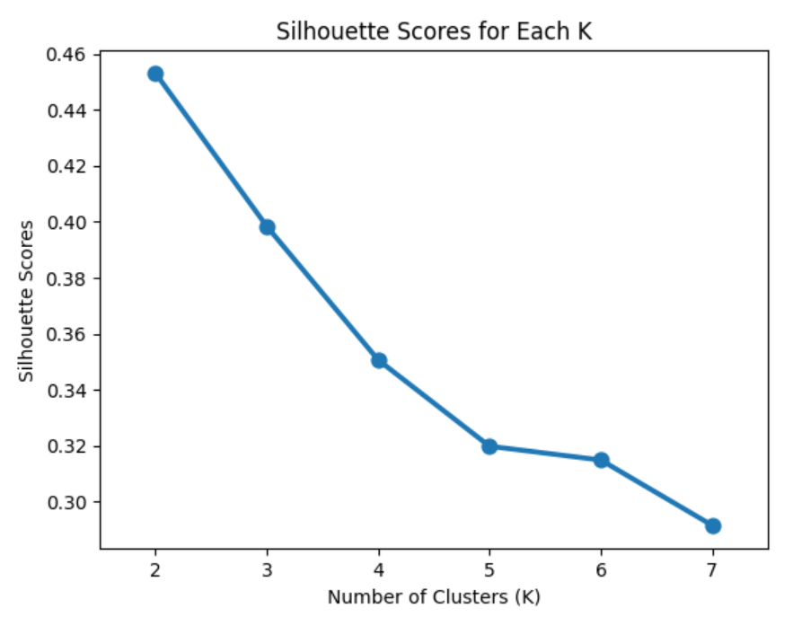
Supplementary Figure S1: Plot of silhouette score with k value to determine optimal number of clusters

Elbow method
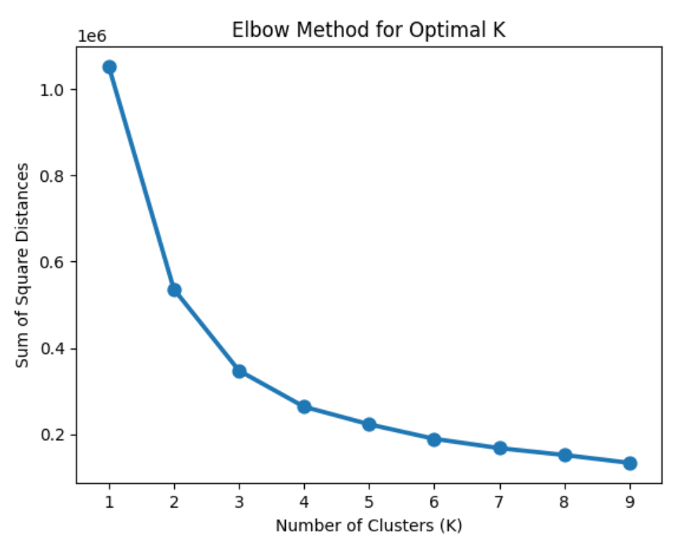
Elbow Point
Supplementary Figure S2: Plot of sum of square distances with k value to determine optimal number of clusters
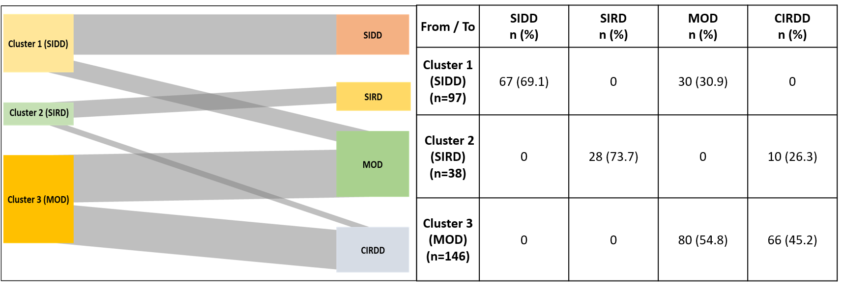
Supplementary Figure S3: the clusters identified using optimal k values and the clusters identified post-replicating the Swedish clusters; SIDD: severe insulin-deficient diabetes; SIRD: severe insulin-resistant diabetes; MOD: mild obesity-related diabetes; CIRDD: combined insulin-resistant and deficient diabetes
Jaccard Similarity and distance Index

Supplementary Table S1: Jaccard similarity and distance index for Optimal k value clusters (3)
Cluster combinations | Jaccard similarity index | Jaccard distance index
Cluster 1 (SIDD) & Cluster 2 (SIRD) | 0 | 1
Cluster 1 (SIDD) & Cluster 3 (MOD) | 0 | 1
Cluster 2 (SIRD) & Cluster 3 (MOD) | 0 | 1

Supplementary Table S2: Jaccard similarity and distance index for four Swedish replicated clusters
Cluster combinations | Jaccard similarity index | Jaccard distance index
Cluster 1 (SIDD) & Cluster 2 (SIRD) | 0 | 1
Cluster 1 (SIDD) & Cluster 3 (MOD) | 0 | 1
Cluster 1 (SIDD) & Cluster 4 (CIRDD) | 0 | 1
Cluster 2 (SIRD) & Cluster 3 (MOD) | 0.1 | 0.9
Cluster 2 (SIRD) & Cluster 4 (CIRDD) | 0.1 | 0.9
Cluster 3 (MOD) & Cluster 4 (CIRDD) | 0 | 1

Supplementary Table S3: Comparison of anthropometric, biochemical, and medical characteristics in the four replicated Swedish clusters
Parameter | SIDD  (n = 67) | SIRD  (n = 28) | MOD  (n = 110) | CIRDD  (n = 76) | P value
Age at onset (years) | 39.7 ± 9.9 | 42.4 ± 13.2 | 43.7 ± 11.3 | 42.4 ± 11.4 | 0.166
Gender: Male | 48 (71.6%) | 13 (46.4%) | 53 (48.2%) | 53 (69.7%) | 0.002
BMI (kg/m²) | 24.9 (17.8-32.0) | 31.7 (22.2-41.2) | 25.3 (18.9-31.7) | 27.8 (19.9-35.7) | <0.001
HbA1C (mmol/mol) | 99.4 (66.5-133.3) | 43.7 (33.3-54.1) | 55.7 (37.9-73.5) | 50.2 (32.8-67.8) | <0.001
HOMA2 %B (%) | 29.8 (12.4-47.2) | 190.4 (144.2-236.6) | 63.8 (38.4-89.2) | 110.2 (85.7-134.7) | <0.001
HOMA2 IR | 2 (0.6-3.4) | 2.8 (1.4-3.2) | 1.6 (0.6-2.6) | 2.2 (1.2-3.2) | <0.001
C peptide (nmol/L) | 0.7 (0.3-1.1) | 1.3 (0.8-1.8) | 0.63 (0.23-1.0) | 0.9 (0.5-1.3) | <0.001
Fasting blood glucose (mmol/L) | 12.2 (7.2-17.2) | 5.1 (4.0-6.2) | 7.3 (5.4-9.2) | 6.1 (5.0-7.2) | <0.001
Total Cholesterol (mg/dL) | 201.5 (147.2-255.8) | 165.6 (101.1-230.1) | 180.4 (119.9-240.9) | 161 (115.5-206.5) | <0.001
HDL (mg/dL) | 39.2 (26.9-51.5) | 39.3 (22.2-56.4) | 43.4 (31.4-55.4) | 37.6 (26.6-48.6) | 0.009
Triglyceride (mg/dL) | 148.0 (39.2-256.8) | 132.5 (49.4-215.6) | 115 (25.4-204.6) | 121.4 (60.4-182.4) | 0.010
LDL (mg/dL) | 130.8 (87.2-174.4) | 105.1 (55.2-158.0) | 110.0 (65.8-154.2) | 99 (59.6-138.4) | <0.001
On statins | 26 (38.8%) | 12 (42.8%) | 41 (37.3%) | 31 (40.8%) | 0.937
On anti-hypertensive medication | 9 (13.4%) | 12 (42.8%) | 21 (19.0%) | 25 (32.9%) | 0.002
On heart medicine | 5 (4.3%) | 3 (6.3%) | - | 1 (1.3%) | 0.117
On OHAs  On both OHAs & insulin  Drug Naïve | 53 (79.1%)  9 (13.4%)  5 (7.5%) | 18 (64.3%)  1 (3.6%)  9 (32.1%) | 63 (57.3%)  9 (8.2%)  38 (34.5%) | 52 (68.4%)  2 (2.6%)  22 (29.0%) | 0.001
Substance use* | 18 (26.9%) | 4 (14.3%) | 17 (15.5%) | 19 (25.0%) | 0.175
Remission rate | 18 (26.9%) | 8 (28.6%) | 40 (36.4%) | 30 (39.5%) | 0.367
Parameters in bold were used for clustering; Data for all parameters are presented as mean ± standard deviation or median (Inter quartile range) or frequency (%); BMI, Body Mass Index; HbA1C, Glycated hemoglobin; HOMA2 IR, Homeostatic Model Assessment of Insulin Resistance; HOMA2 %B, Homeostatic Model Assessment of beta-cell function HDL, High density lipoprotein; LDL, Low density lipoprotein; OHAs, oral hypoglycemic agents; *Smoking or Alcohol or Tobacco or combination of any two; Comparison between groups for continuous variables was done by Kruskal Wallis test and for categorical variables by chi-square test

