Supplementary Information
Evaluating a Novel Method for Vitamin A Analysis in an Observational Study of the UAE's Obese Population
Muhammad Kamran Hakeem¹, Israa El-Konaissi¹, Bashar Alzohily¹, Salah Gariballa², Javed Yasin², Iltaf Shah^{1,}*
- Department of Chemistry, College of Science, United Arab Emirates University (UAEU), Al Ain P.O. Box 15551, United Arab Emirates
- Internal Medicine, Faculty of Medicine & Health Sciences, United Arab Emirates University (UAEU), Al Ain P.O. Box 15551, United Arab Emirates
- Correspondence: altafshah@uaeu.ac.ae

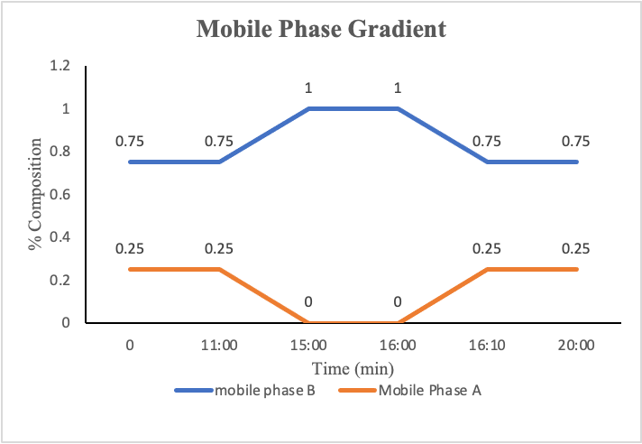
Figure S1: Mobile phase gradient elution profile used for the LC-MS experiments
Figure S2: An overlay of chromatographic peaks showing the specificity of the assay. No interfering co-eluting peaks were found for vitamin A.
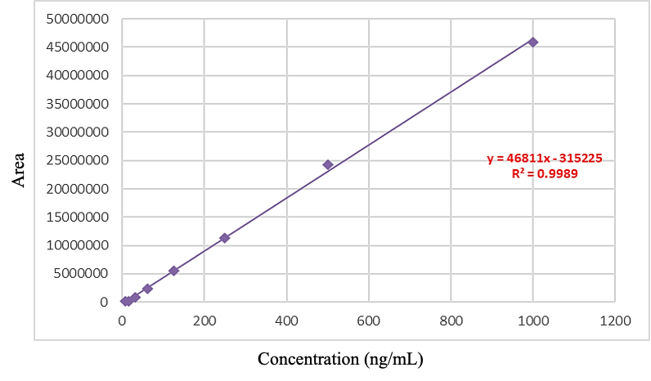
Figure S3: Calibration curve to determine the quality of the samples
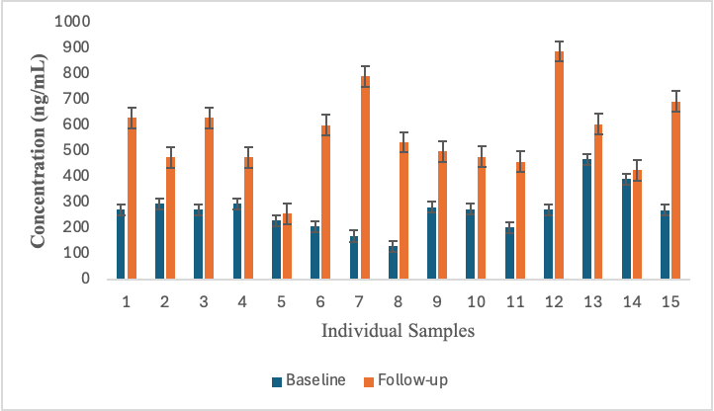
Figure S4: A comparative view of same individuals’ sample on baseline and follow up stage

