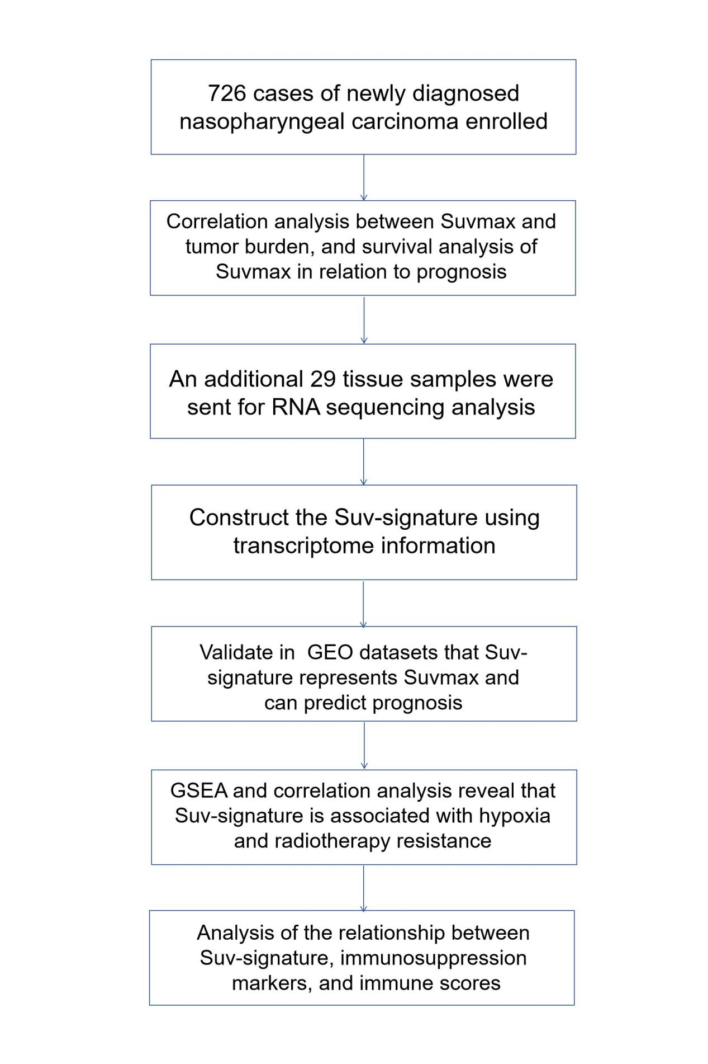
FigureS1 Workflow.

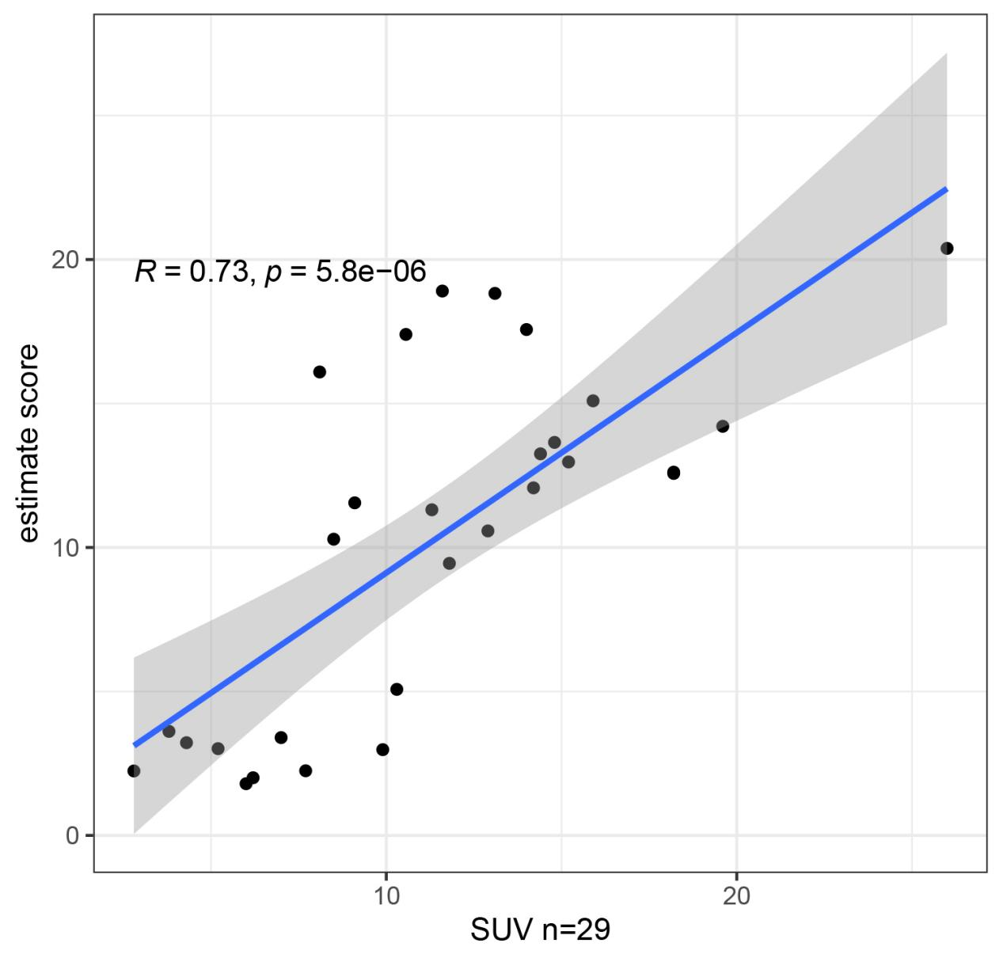
FigureS2 Association between Suv-signature and Suvmax in our 29 patient cohort.

Table S1 Clinical characteristics of sequenced patients
Id | Age | Sex | T-SUVmax | MTV | T-stage | N-stage | TNM-stage
1 | 68 | Males | 2.8 | 2.62 | 1 | 2 | 3
2 | 47 | Males | 3.8 | 3.9 | 1 | 3 | 4
3 | 52 | Males | 4.3 | 3.01 | 2 | 3 | 4
4 | 49 | Males | 5.2 | 2.3 | 3 | 3 | 4
5 | 50 | Males | 6 | 7.74 | 2 | 3 | 4
6 | 53 | Males | 6.2 | 4 | 2 | 3 | 4
7 | 68 | Males | 7 | 40.45 | 3 | 2 | 3
8 | 66 | Males | 7.7 | 15.1 | 3 | 1 | 3
9 | 31 | Females | 8.1 | 55.74 | 4 | 1 | 4
10 | 45 | Females | 8.5 | 11.52 | 3 | 1 | 3
11 | 42 | Females | 9.1 | 21.89 | 3 | 1 | 3
12 | 63 | Males | 9.9 | 6.59 | 2 | 3 | 4
13 | 50 | Males | 10.3 | 10.43 | 3 | 2 | 3
14 | 40 | Females | 10.56 | 52.61 | 3 | 3 | 4
15 | 59 | Males | 11.3 | 10.18 | 3 | 1 | 3
16 | 57 | Females | 11.6 | 87.74 | 4 | 3 | 4
17 | 57 | Males | 11.8 | 14.98 | 3 | 3 | 4
18 | 50 | Males | 12.9 | 7.04 | 1 | 3 | 4
19 | 58 | Males | 13.1 | 23.23 | 4 | 1 | 4
20 | 50 | Females | 14 | 16.7 | 3 | 1 | 3
21 | 57 | Males | 14.2 | 16.7 | 3 | 1 | 3
22 | 41 | Males | 14.4 | 12.35 | 3 | 1 | 3
23 | 54 | Males | 14.8 | 20.03 | 3 | 2 | 3
24 | 54 | Males | 15.2 | 13.38 | 3 | 1 | 3
25 | 55 | Males | 15.9 | 41.09 | 4 | 1 | 4
26 | 15 | Males | 18.2 | 48.64 | 3 | 1 | 3
27 | 26 | Males | 18.2 | 26.3 | 3 | 1 | 3
28 | 62 | Males | 19.6 | 33.6 | 4 | 3 | 4
29 | 69 | Males | 26 | 64.32 | 4 | 2 | 4

Table S2 Gene set of glucose metabolism
id
AKR1A1
PCK1
CLDN9
ERO1A
IGFBP3
KIF2A
TPBG
ALDOA
PPP2R1A
CDK1
PGM2L1
COPB2
CD44
BPNT1
HMMR
G6PC2
B4GALT7
CAPN5
LDHB
ALDH7A1
ADH6
ENO1
TXN
ANG
ACTN3
ARTN
TPI1
QSOX1
ZNF292
SDC2
HDAC4
VLDLR
HK1
MDH1
PRKACB
PAXIP1
HTR2A
PFKFB4
PGAM4
NUP93
GPC4
STMN1
RRAGD
NDUFV3
ALDH3A2
NUP153
PFKFB2
SPAG4
ADH1C
PRPS1
FBP1
GAPDH
ACSS1
ANGPTL4
DLAT
TKTL1
ALDOB
G6PD
HKDC1
AC010618.1
UGP2
ACSS2
PGK1
VCAN
HAX1
B4GALT1
EIF6
ALDH3B1
ANKZF1
POM121
RAE1
GOT2
PKM
COL5A1
TPR
DLD
RARS
SAP30
NDC1
NUP98
OGT
GPR87
TGFBI
SOX9
NSDHL
AC074143.1
AK4
GMPPA
PFKL
PPARGC1A
ADH1A
GPC1
NUP37
KIF20A
B3GALT6
SEC13
PGM1
PPFIA4
NUP188
PRKACA
HSPA5
MLXIPL
GALK2
ALDOC
PAM
CHST12
POLR3K
CHPF2
P2RX7
B4GALT2
MXI1
ALDH3B2
PPIA
GALK1
ENO4
PGP
B3GAT1
EGFR
ME2
ADORA2B
DEPDC1
GNPDA1
NASP
PSMC4
ALDH2
PDHA1
ADH1B
GLRX
VEGFA
SRD5A3
SDC3
GMPPB
ADPGK
NUP107
NT5E
PDHA2
NUP88
CACNA1H
FUT8
PRKAA1
MED24
KDELR3
RPE
GUSB
MYOG
DHTKD1
P4HA1
LDHA
LHX9
AGRN
EXT1
ALDH3A1
LDHAL6B
CHST1
PRKAG1
PFKFB3
GALM
PDK3
P4HA2
PYGL
GYS2
EGLN3
RBCK1
STC1
CHST2
DSC2
GNE
CHST6
ME1
PYGB
G6PC
ISG20
HDLBP
ABCB6
NUP205
CASP6
NUP43
SDC1
MDH2
NUP62
PMM2
MIOX
MPI
OGDHL
NUP58
GPD1
RANBP2
AK3
NUP54
NUP214
IRS2
IGF1
ENO2
HOMER1
ENTPD5
PDHB
PCK2
TALDO1
NUP133
XYLT2
DPYSL4
PPP2CA
CITED2
PC
CTH
CBFA2T3
CLDN3
LDHAL6A
PRKAA2
CENPA
GLCE
SLC25A13
LCT
PHKA2
GCK
GPC3
GCKR
ECD
NUPL2
PKLR
NDST3
PPP2R5D
CHST4
GNPDA2
GFPT1
GOT1
ELF3
SLC16A3
DCN
OGDH
AAAS
HIF1A
ALG1
BPGM
ZBTB20
SLC25A10
EFNA3
PGK2
NUP35
PRKAG2
FBP2
DDIT4
NUP160
MIF
ALDH1A3
AGL
PKP2
BIK
NUP155
CYB5A
POM121C
PGAM1
ADH5
TREX1
TFF3
SLC35A3
SDHC
TGFA
ALDH1B1
HS2ST1
PGAM2
HK2
INS
NUP85
INSR
PFKP
GAPDHS
COG2
CHPF
PLOD1
ADH7
PPP2R1B
PFKFB1
PRKAG3
CXCR4
IDUA
SEH1L
ALDH9A1
AURKA
NUP210
PGM2
PLOD2
ZBTB7A
PFKM
PPP2CB
MERTK
PPARA
B3GNT3
CLN6
SLC37A4
NCOR1
GYS1
ARNT
GCLC
STC2
B4GALT4
ARPP19
HK3
NANP
TPST1
MET
AC016586.1
JMJD8
TSTA3
STAT3
NUP50
EXT2
LHPP
ENO3
LDHC
IER3
ESRRB
TIGAR
PRKACG
FAM162A
ADH4
GAL3ST1
FKBP4
B3GAT3
IL13RA1
HS6ST2
IDH1
GPI
GALE
SOD1
PRXL2C

Table S3 55 genes related to glucose metabolism
gene
ALDH3B1
IGF1
DEPDC1
ME1
PKM
ENO1
ME2
PLOD1
SEH1L
AURKA
PGK1
HTR2A
LHPP
PPARGC1A
NUP155
STC2
PFKFB4
CENPA
LCT
SLC35A3
MXI1
ECD
P4HA1
IDUA
CBFA2T3
LDHA
ALDH1B1
NUP58
PRKACB
PPFIA4
CAPN5
ALDOA
PFKM
STC1
HK2
TFF3
G6PD
HK3
NDST3
PRKACG
CLDN3
ANGPTL4
UGP2
CDK1
PFKFB3
PGAM1
MPI
ZBTB20
CHST6
ADH1A
ADH1B
CLDN9
ANG
PGAM4
EIF6

