Supplementary Material
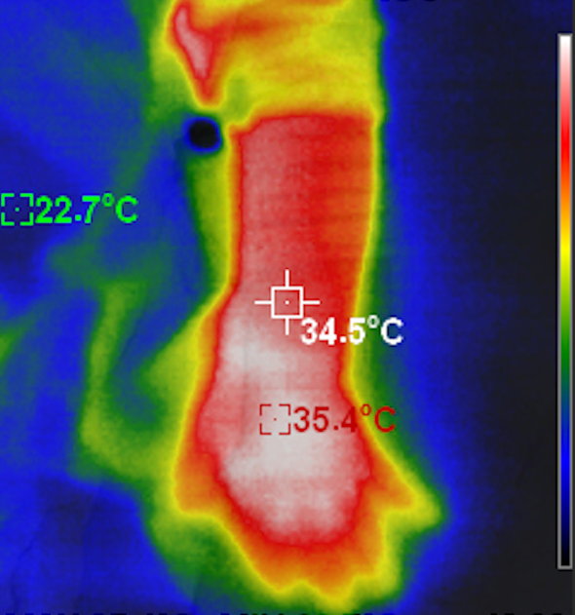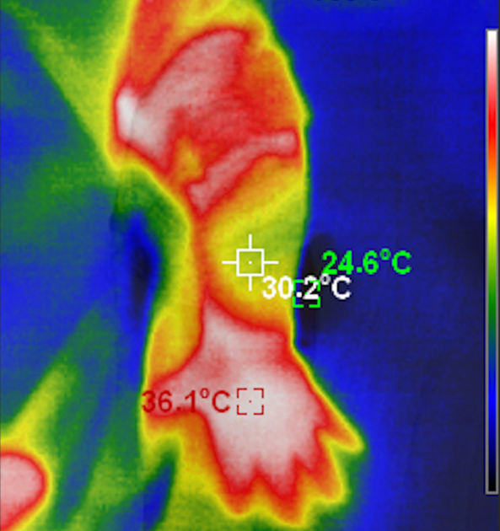
Figure S1 legend: We measured the temperature of the skin site on the upper extremity with the HT-18 infrared thermal imaging camera (Hti-Xintai, China) before and after contact with the "cold swab" in three term-born newborns. Temperatures after contact with the "cold" swab were on average ± SD 4.7°± 0.3°C lower than before (before: 34.3 ± 0.2°C, vs. after: 29.7 ± 0.4°C). At this temperature difference, it is not possible to classify the stimulus as painful; rather, it represents a non-noxious thermal stimulus. The figure shows an exemplary representation of temperature measurement using an infrared thermal imaging camera before (left) and after (right) contact of the skin on the forearm of a term-born newborn with a swab soaked with disinfectant.

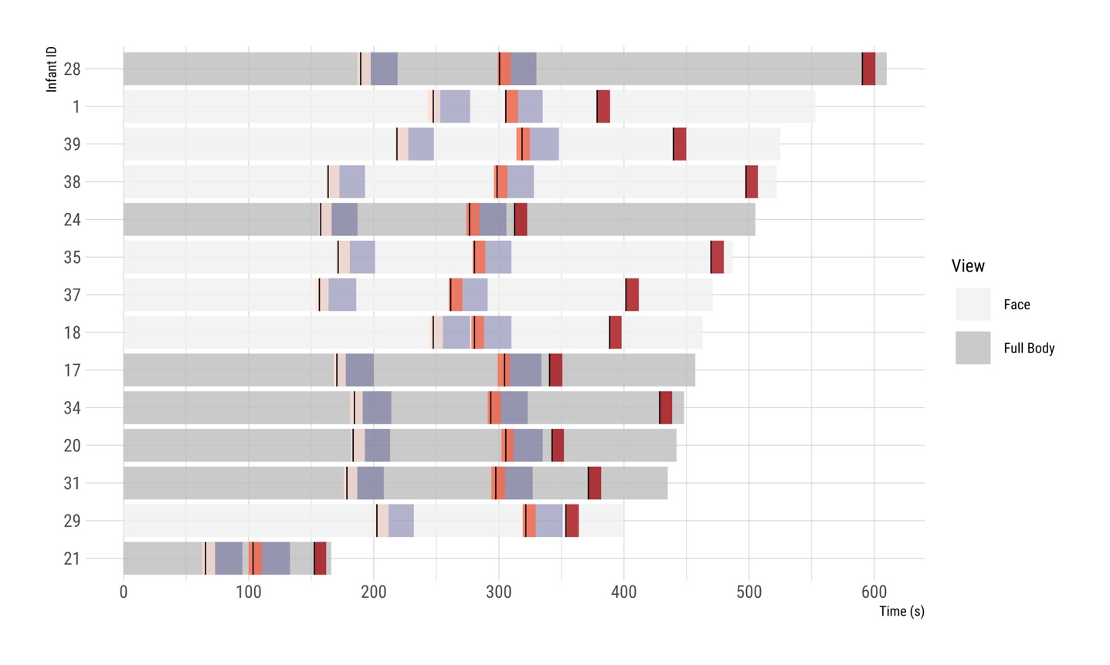
Figure S2 legend: The gray bars represent the total duration of the filmed videos and the context shown (Face View vs. Full Body View) for each patient. The black vertical lines indicate the time points of the stimuli, while the blue bars denote the minimum pause of 30 seconds before the next stimulus. There were no overlaps between the videos. The videos were edited to an average (SD) length of 10.5 (0.37) seconds. The stimuli occurred at an average of 1.85 (0.99) seconds for the non-noxious thermal stimulus (light red bars), 2.23 (1.36) seconds for the short noxious stimulus (medium red bars), and 0 (0) seconds for the prolonged noxious stimulus (dark red bars).

