Supplemental Figure 1. Myo-Inositol Metabolic and Signaling Pathways. This diagram displays the various metabolic and signaling pathways myo-inositol is involved in, including the impact of glucose and insulin activity on its synthesis and enzymatic conversion. As shown, since myo-inositol is synthesized from D-glucose, glycemic dysregulation could contribute to a shared phenotype involving elevated myo-inositol levels as well as elevated natriuretic peptides and alterations in cardiac function. Insulin resistance may also inhibit the conversion of myo-inositol to D-chiro inositol, further increasing systemic levels.

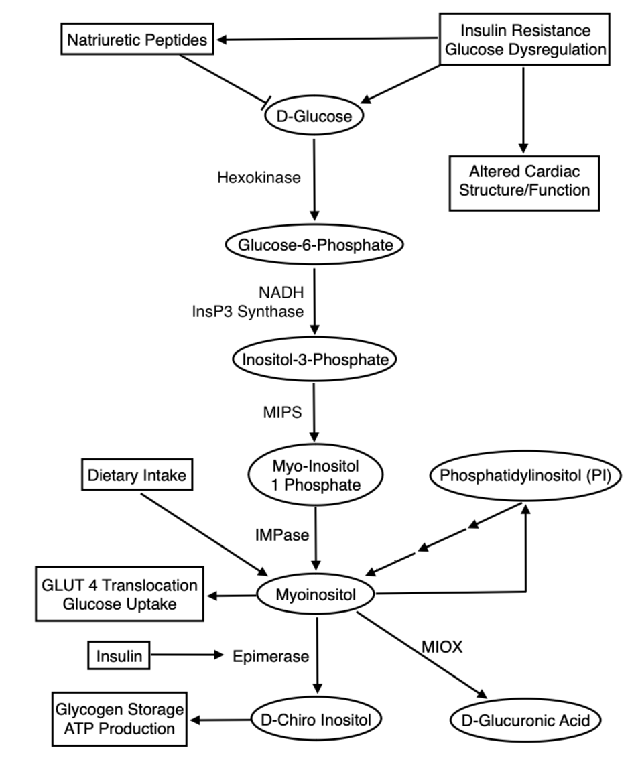

Abbreviations: NADH, nicotinamide adenine dinucleotide. MIPS, myo-inositol-3-phosphate synthase. IMPase, inositol monophosphatase. GLUT4, glucose transporter type 4. MIOX, myo-inositol oxygenase.

