Genetic investigations on singleton school aged children reveal novel variants and new candidate genes for hearing loss
Hina Khan¹, Fariha Muzaffar¹, Midhat Salman¹, Rasheeda Bashir¹, Go Hun Seo², *Sadaf Naz¹
¹School of Biological Sciences, University of the Punjab, Lahore, Pakistan, ²3billion Inc., Seoul, South Korea
Correspondence
*Dr. Sadaf Naz, School of Biological Sciences, University of the Punjab; Email: naz.sbs@pu.edu.pk

Supplementary Table 1 Deleterious variants identified in carrier state in some participants
Case ID | Causative Gene | Carrier State Gene | Variant | Effect | Zygosity | Pathogenicity Scores |  |  |  |  | gnomAD Frequency | First Report
 |  |  |  |  |  | ACMG | REVEL | SIFT | PolyPhen2 | CADD | gnomAD Frequency | First Report
HLMS15 | EYA1  (Heterozygous) | GJB2  NM_004004.6 | c.71G>A  p.Trp24Ter | Nonsense | Heterozygous | LP  PS4, PVS1, PM2 | N/A | N/A | N/A | 40 | 0.0005223 | 9139825
SPK13 | PEX1  (Homozygous)
SPK9 | None | WFS1  NM_006005.3 | c.2104G>A  p.Gly702Ser | Missense | Heterozygous | LP  PS4, PM2, PP3, PM1 | 0.98, D | 0, D | 1, D | 29 | 0.00002488 | - 21446023
LP= Likely Pathogenic, N/A=Not available, D=Deleterious. Although some GJB2 and WFS1 monoallelic variants can cause hearing loss, these particular variants only result in deafness when inherited with a second deleterious variant. However, no second rare or predicted deleterious allele of these genes was identified in the respective individuals’ data.

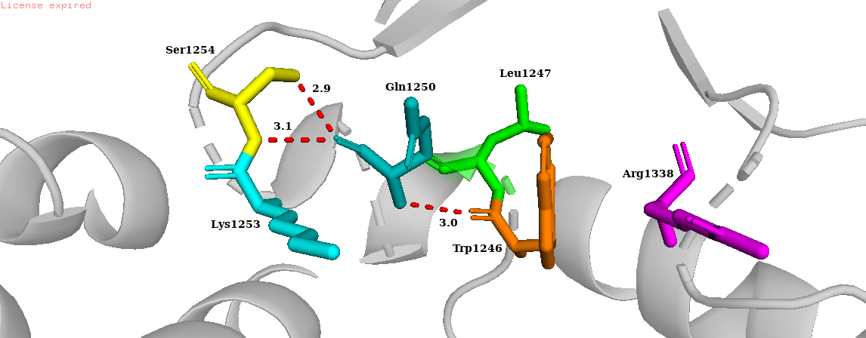  - MYO7A wild-type Gln1250 | - MYO7A variant Arg1250
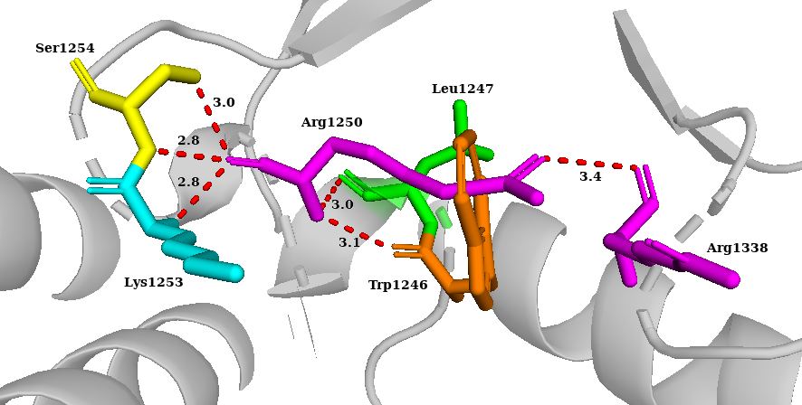
- PEX1 wild-type Pro720 | - PEX1 variant Leu720

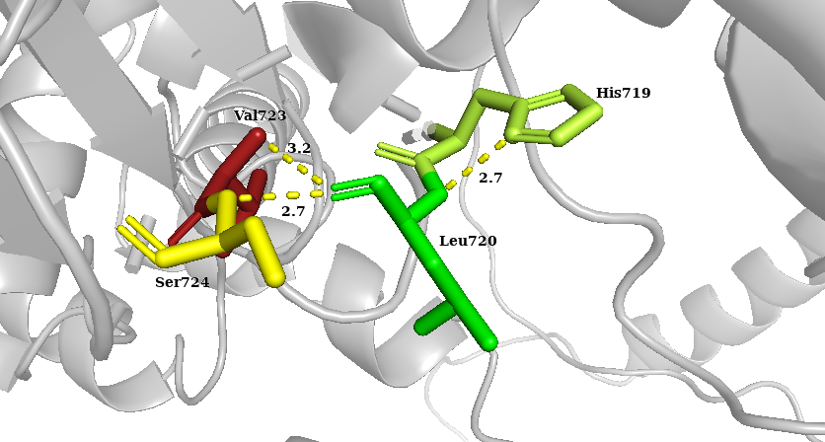
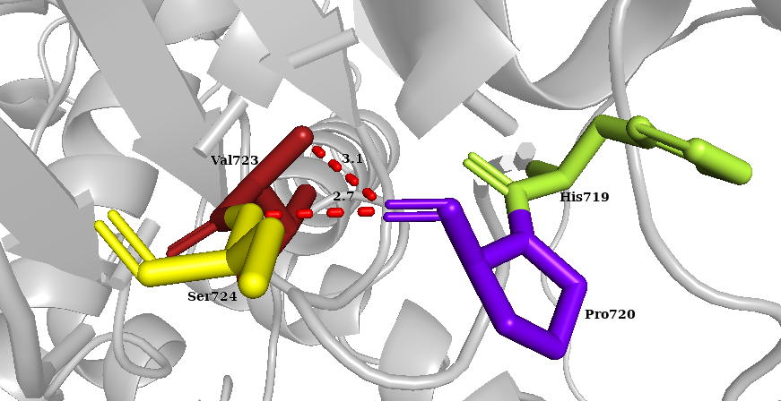

F
E

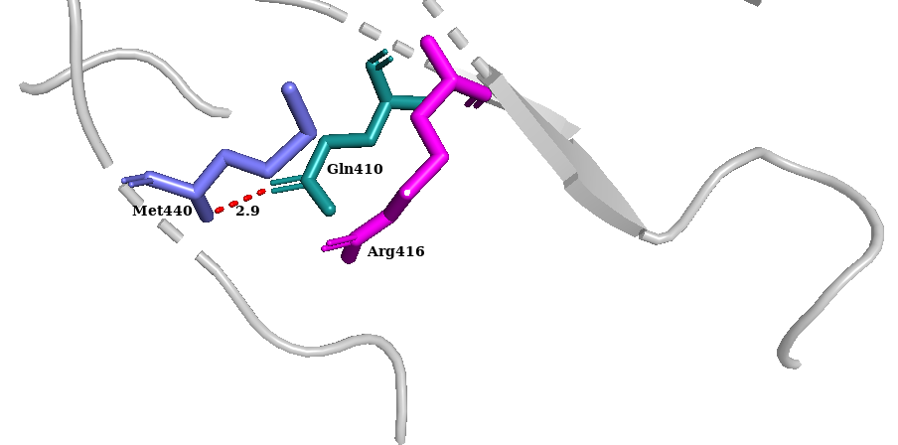  - COCH wild-type Met440 | 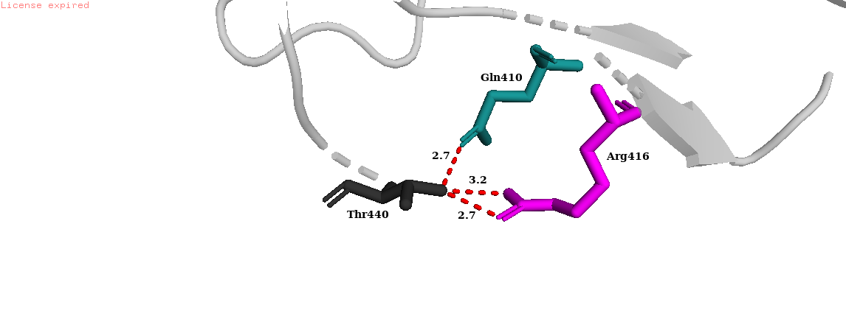  - COCH variantThr440

- ATP6V1B2 wild-type Ala286 | - ATP6V1B2 variant Ser286
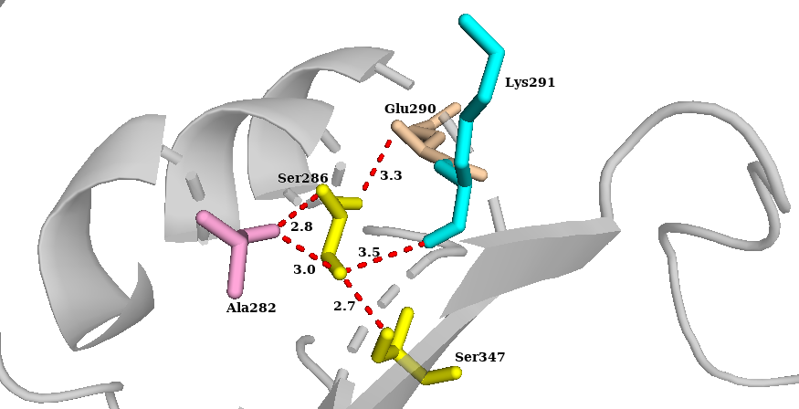
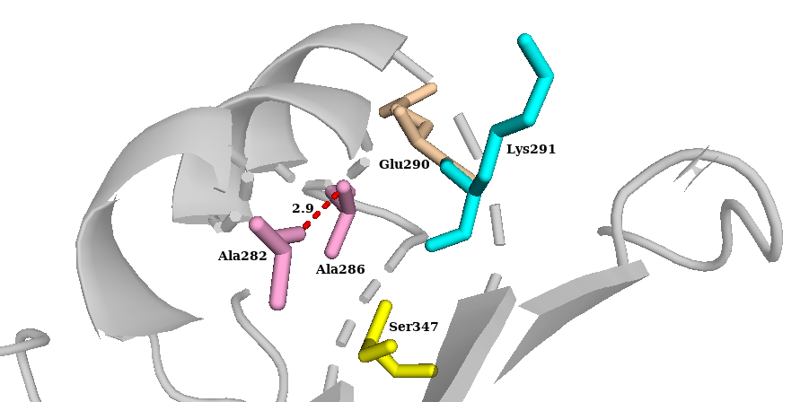

- HGF wild-type Cys679 | - HGF variant Tyr679
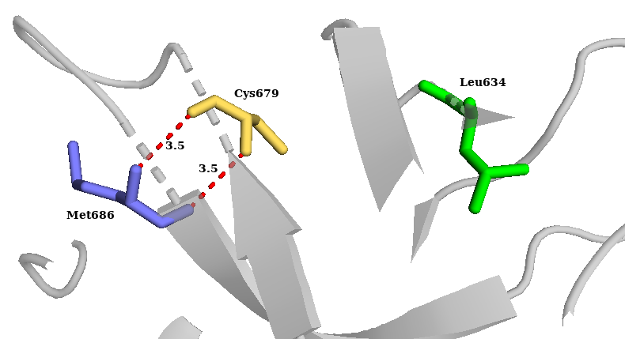
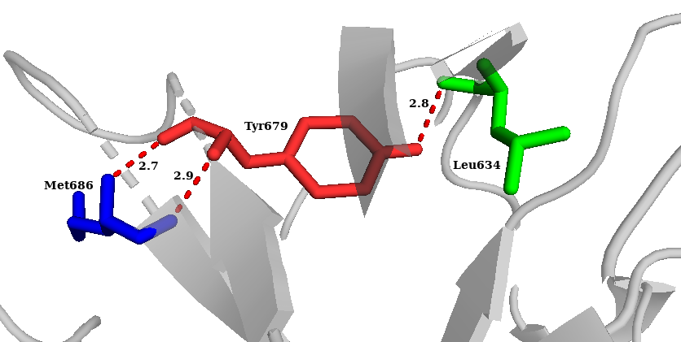

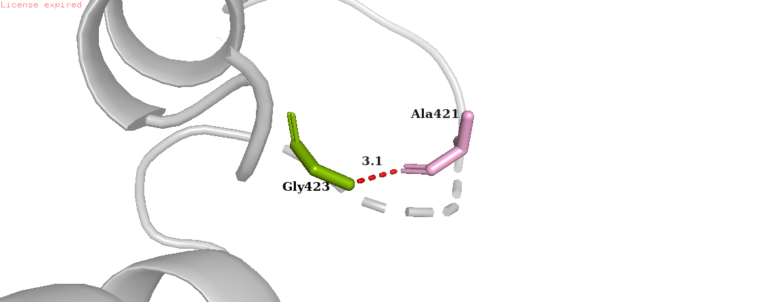  - EYA1 wild-type Gly423 | 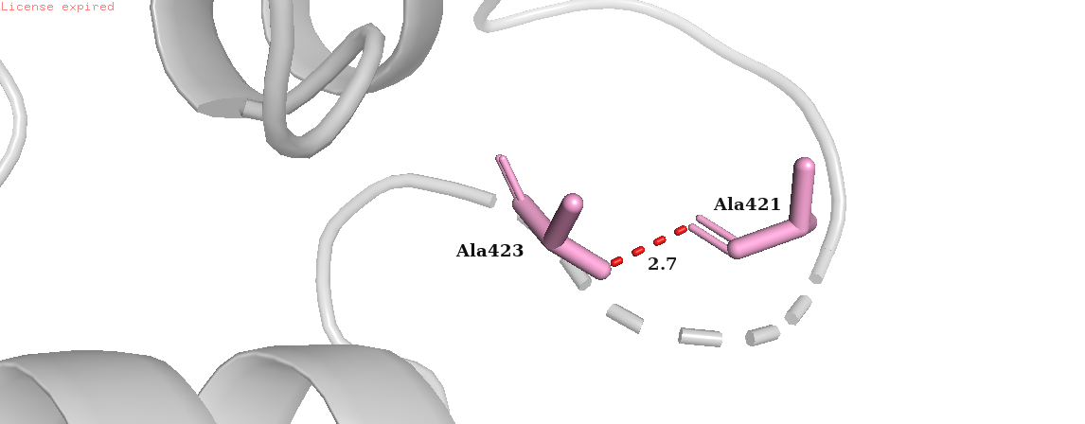  - EYA1 variant Ala423

- SLC12A2 wild-type Ile341 | - SLC12A2 variant Val341
I
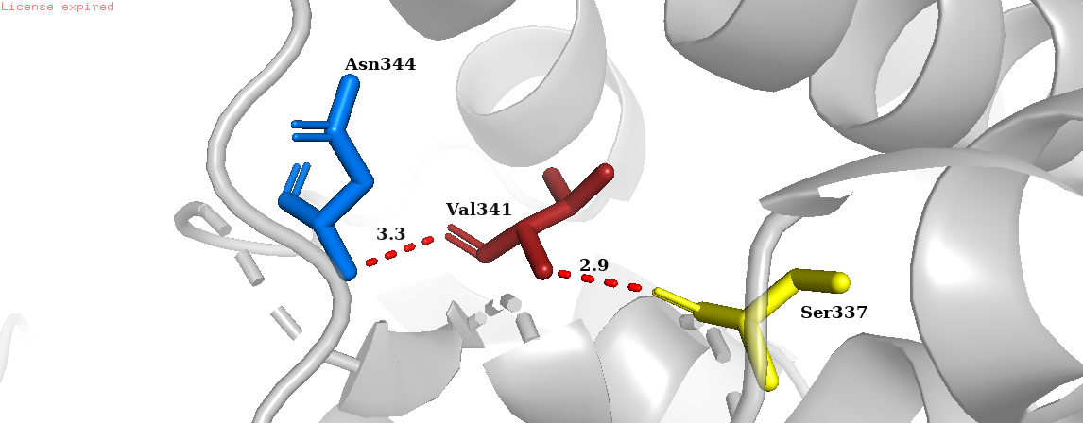
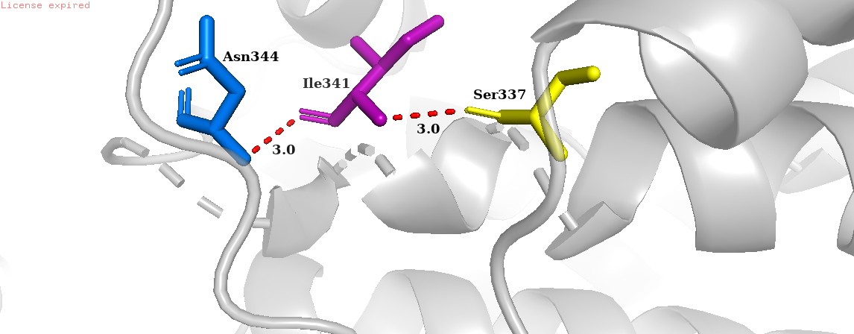

- NCOA3 wild-type Asp1065 | - NCOA3 variant Val1065

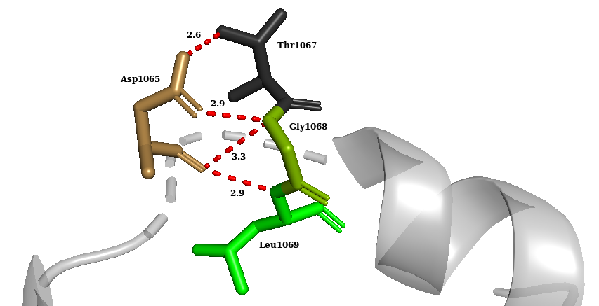
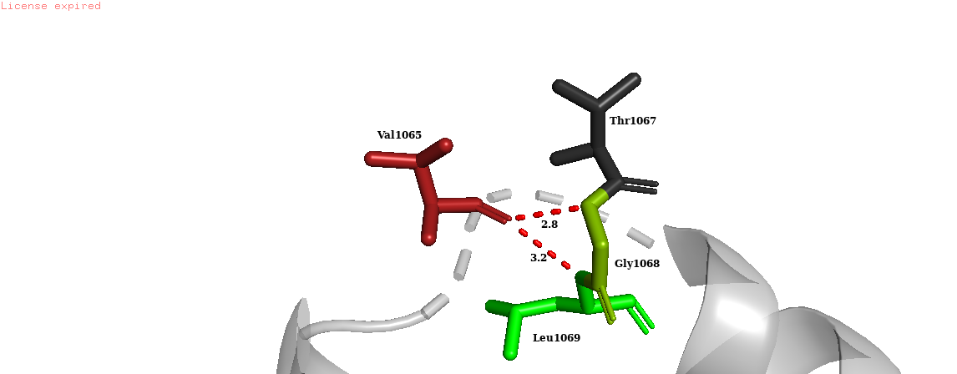

- USH1G wild-type Ala9 | - USH1G variant Pro9
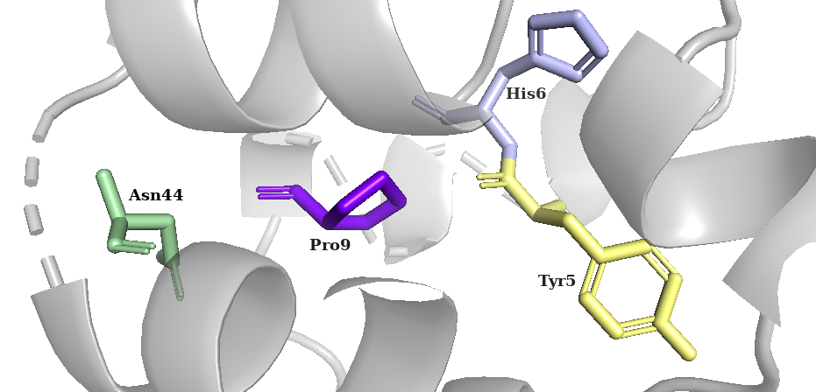
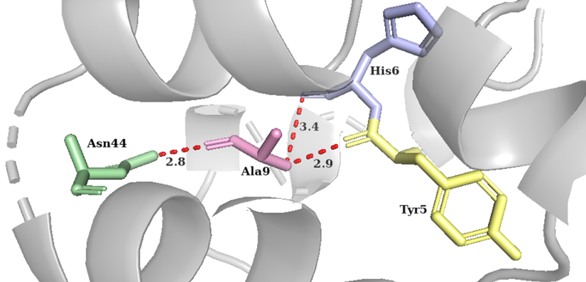

- LHFPL5 wild-type Ala178 | - LHFPL5 variant Val178
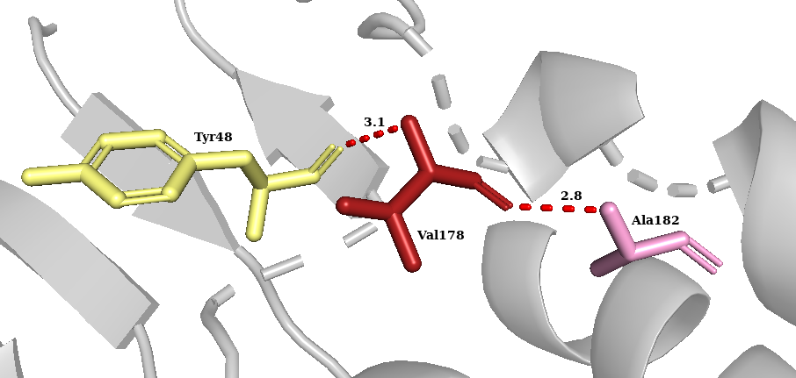
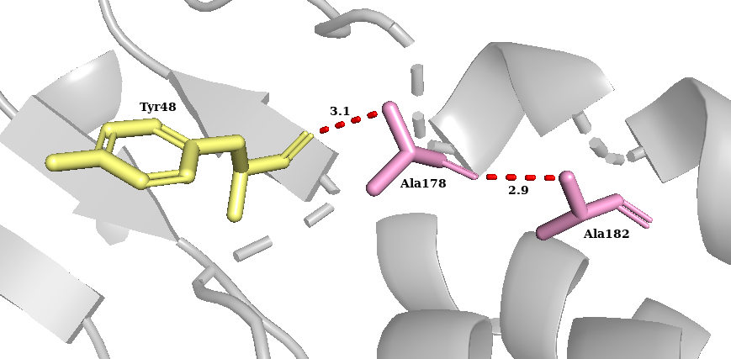

Supplementary Figure 1: Predicted effects of novel homozygous and heterozygous missense variants on protein structures. A. Gln1250 in wild-type MYO7A forms two polar bonds with Ser1254 and a polar contact with Try1246. B. Arg1250 in variant MYO7A creates new polar contacts with neighboring Leu1247, Lys1253 and Arg1338. C. Pro720 in wild-type PEX1 forms bond with Val723 and Ser724. D. The replaced Leu720 in PEX1 forms a new polar contact with His719 which could disrupt the structure. E. Met440 in wild-type COCH forms a bond with Gln410 at single point with 2.9Å distance. F. This bond length is predicted to reduce to 2.7Å along with formation of a new bond with the same amino acid. A new bond is also likely to form with Arg416 on replacement of Met440 with Thr440. G. In the wild-type ATP6V1B2, Ala286 forms a polar contact with Ala282. H. Replacement of Ala286 with Ser in variant ATP6V1B2 might not only alter this bond distance slightly but also form a new bond of around 3 Å. New bonds may also involve Glu290, Ser347 and Lys291. I. Cys679 forms a bond with Met686 with bond length of 3.5Å in the wild-type HGF. J. The substitution to Tyr679in HGF reduces the bond length with Met686 to 2.7Å and 2.9Å. The substituted Tyr679 also forms a bond with Leu634 which may further disrupt the protein. K. In the wild-type EYA1, Gly423 forms a bond with Ala421 with bond distance 3.1Å. L. Variant Ala423 in EYA1 lowers this bond distance to 2.7Å. M. Replacement of Ile341 in the wild-type SLC12A2 with Val in the mutant N. is predicted to increase the bond distance with Asn344 from 3.0Å to 3.3Å and slightly lower the bond distance Ser337. O. Asp1065 in NCOA3 forms a polar contact with Thr1067 and Leu1069. Two bonds are also observed with Gly1068. P. The replacement of negatively charged Asp1065 in NCOA3 with non-polar Val1065 possibly disrupts a bond with Gly1068 and Thr1067. Q. In the wild-type USH1G, Ala9 forms bond with Tyr5, His6 and Asn44. R. Variant Pro9 in USHG1 is anticipated to disrupt all the polar bonds with the neighboring amino acids in the protein. A slight change in the bond distance with the neighboring Ala182 is speculated when Ala178 in S. wild-type is replaced with Val178 in T. variant LHFPL5. The bond distance with Tyr48 remains the same.
# The structures downloaded from UniProt are AlphaFold predictions, and mutations were introduced using PyMOL. Both AlphaFold and PyMOL are open-access and freely available software.

