Association between coffee and tea consumption and the risk of dementia in individuals with hypertension: a prospective cohort study
Supplementary information
Supplemental Text
1.1 Assessment of Hypertension
Table S1. Assessment of coffee and tea consumption in the UK Biobank cohort.
Table S2. ICD-9 and ICD-10 codes used for ascertainment of dementia diagnosis in the UK Biobank cohort.
Table S3. Assessment of covariates in the UK Biobank cohort.
Table S4. After excluding patients with dementia over a two-year period, the effects of coffee and tea consumption, caffeine intake, and coffee type on the risk of dementia in hypertensive patients were examined.
Table S5. After excluding participants with stroke at baseline, the impact of coffee and tea consumption, caffeine intake, and coffee type on the risk of dementia in hypertensive patients was examined.
Table S6. After excluding participants with baseline coffee and tea consumption exceeding 12 cups per day, researchers studied the impact of coffee and tea intake, caffeine consumption, and types of coffee on dementia risk in hypertensive patients.
Table S7. After the final model was further adjusted for frailty variables, the researchers examined the effects of coffee and tea intake, caffeine intake, and type of coffee on the risk of dementia in patients with hypertension.
Supplementary Figure 1. Subgroup analysis of the impact of coffee and tea consumption, type of coffee, and caffeine intake on the risk of all-cause dementia in hypertensive individuals.
Supplementary Figure 2. Subgroup analysis of the impact of coffee, tea consumption, type of coffee, and caffeine intake on the risk of all-cause dementia in normal individuals.

1.1 Assessment of Hypertension
Hypertension was defined as meeting at least one of three criteria:(1) self-reported doctor diagnosis of hypertension; (2) self-reported use of antihypertensive medication; (3) measured systolic blood pressure ≥140 mm of mercury (mmHg) or diastolic blood pressure ≥90 mmHg. The cut-off points for the third criterion were in line with the internationally recommended definition of hypertension at time of blood pressure measurement in UK Biobank in 2006 through 2010¹. Participants who responded “High blood pressure” to the touchscreen question “Has a doctor ever told you that you have had any of the following conditions?” or reported having hypertension during the verbal interview were defined as having doctor-diagnosed hypertension. Participants who responded “Blood pressure medications” to the touchscreen question “Do you regularly take any of the following medications?” or reported an antihypertensive medication (beta blockers, angiotensin-converting enzyme [ACE] inhibitors, angiotensin II receptor blockers, calcium channel blockers, alpha blockers, or diuretics) during the verbal interview were defined as using antihypertensive medication. Two measures of blood pressure were collected, at least 1 minute apart, using an Omron HEM 7015-T automated sphygmomanometer. In the current study, a mean of both measures was used to determine systolic and diastolic blood pressure in mmHg. Hypertensive patients were identified according to hypertension diagnostic criteria of systolic blood pressure ≥140 mm of mercury (mmHg) or diastolic blood pressure ≥90 mmHg. People with hypertension at baseline before the time of enrolment based on the time of diagnosis of primary hypertension.
In this study, the baseline hypertensive population was determined to meet one of the following criteria:(1) self-reported physician diagnosis of hypertension: (2) use of antihypertensive medications; (3) diagnosis based on blood pressure measurements (4) diagnosis of primary hypertension earlier than entry into the cohort.

Table S1. Assessment of coffee and tea consumption in the UK Biobank cohort.
Variables | UK Biobank field code | Definition | Note
coffee intake | 1498 | How many cups of coffee do you drink each DAY? (Include decaffeinated coffee)" | Less than one=0.5 cups, Of these, which are classified according to the number of cups of coffee consumed per day as "none", "0.5-1", "2-3", "4-5", "≥6".
coffee type | 1508 | What type of coffee do you usually drink | 1 "Decaffeinated coffee" 2 "Instant coffee" 3 "Ground coffee" 4 "Other type of coffee"
tea intake | 1488 | How many cups of tea do you drink each DAY | Less than one=0.5 cups, Of these, which are classified according to the number of cups of tea consumed per day as "none", "0.5-1", "2-3", "4-5", "≥6".
Hot drink temperature | 1518 | How do you like your hot drinks? (Such as coffee or tea) | 1 "Very hot" 2 "hot" 3 "Warm"
caffeine | 1498, 1488, 1508 | Caffeine intake (mg/d) was determined using self-reported coffee and tea consumption in the survey, with an assumption of 75 mg of caffeine per cup of coffee and 40 mg of caffeine per cup of tea | coffee type=Decaffeinated coffee, caffeine=tea intake*40  coffee type=caffeinated coffee, caffeine=tea intake*40+coffee_intake*75

Table S2. ICD-9 and ICD-10 codes used for ascertainment of dementia diagnosis in the UK Biobank cohort.
Dementia sub-type | ICD-9 codes | ICD-10 codes
Alzheimer’s | 331.0 | F00, F00.0, F00.1, F00.2, F00.9, G30, G30.0, G30.1, G30.8, G30.9
Vascular dementia | 290.4 | F01, F01.0, F01.1, F01.2, F01.3, F01.8, F01.9, I67.3
Frontotemporal dementia | 331.1 | F02.0, G31.0
Other codes for all-cause dementia | 290.2, 290.3, 291.2, 294.1, 331.2, 331.5 | A81.0, F02, F02.1, F02.2, F02.3, F02.4, F02.8, F03, F05.1, F10.6, G31.1, G31.8

Table S3. Assessment of covariates in the UK Biobank cohort.
Variables | UK Biobank field code | Definition | Note
Townsend Poverty Index (TDI) | 22189 | The Townsend Poverty Index (TDI) is a composite measure of poverty based on postcode residence, using data on unemployment, household crowding, car and house ownership, with higher TDIs indicating higher levels of poverty². | SES was assessed using the TDI and divided into three levels using national cut-off points (high ≤-2.08; medium - 2.08-1.40; low ≥1.40)³.
APOE genotype | rs7412, rs429358 | Therefore, individuals with one or both ε4 alleles were classified as APOE ε4 carriers, while the rest were classified as APOE ε4 non-carriers⁴. | The APOE ε4 allele has been recognized as a genetic risk factor for late-onset Alzheimer's disease⁵.
smoking status | 20116 | never, former, and current | Self-report and hospital registration records
dietary patterns | 1289, 1299,1309, 1319, 1329, 1339,1349,1369,1379,1389,1438,1458 | 1. Fruits: ≥ 3 servings/day;  2. Vegetables: ≥ 3 servings/day;  3. Whole grains: ≥ 3 servings/day;  4. (Shell) Fish: ≥2 servings/week;  5. Refined grains ≤1.5servings/day;  6. Processed meats ≤1 serving/week;  7. Unprocessed meats ≤1.5 serving/week  "0-1 poor dietary pattern", "2-3 medium dietary pattern", ">3 ideal dietary pattern" | In this study, the British Dietetic Survey food frequency questionnaire (FFQ) was used to calculate a healthy eating score, with higher values indicating higher intake. The UKB FFQ has data on the reporting of their daily food intake (https://biobank.ndph.ox.ac.uk/ukb/label.cgi?id=100052). We used the Healthy Diet score. The diet score includes intake of vegetables (cooked vegetables + salads/raw vegetables), fruit (fresh fruit + dried fruit), unprocessed red meat (beef + lamb + pork), fish (fatty fish + non-fatty fish), Whole grains(Cereal intake(Cereal type>=1)),and Refine grain(Bread intake(Bread type>=1)).Frequency categories of meat and fish were recoded: ‘never’= 0, ‘less than once a week’ =0.5, ‘once a week’ = 1, ‘2–4 times a week’=3, ‘5–6 times a week’=5.5 and ‘once or more daily’=7.Amount of per serving was defined as: 1. fresh fruit: 1 piece; 2. dried fruit: 5 pieces; 3. cooked/raw vegetables: 3 heaped tablespoons;4. bran/oat/muesli cereal: 1 bowl/day; 5. wholemeal/wholegrain bread: 1 slice/day⁶
alcohol consumption | 20117，1558，1568, 1578, 1588, 1598, 1608, 4407, 4418, 4429,4440, 4451, 4462, 5364 | UK Biobank Touchscreen questionnaire at baseline; US Dietary guidelines for Americans 2015-2020 of up to 1 drink/day for women and up to 2 drinks/day for men. To calculate drink-equivalents as per guidelines, multiply the volume in ounces by the alcohol content in percent and divide by 0.6 ounces of alcohol per drink-equivalent; then convert to grams: 1 drink-equivalent described as containing 14g of pure alcohol.125ml wine=0.85 drink-equivalents,4% ABV pint beer = 1.28 drink-equivalents,25ml spirits=0.57 drink-equivalents,50ml fortified wine= 0.56 drink-equivalents⁷. | IQRs, Quartiles.
physical activity | 22040 | Total Metabolic Equivalent Task (MET) minutes per week for all activity including walking, moderate and vigorous activity⁸. | measured via the International Physical Activity Questionnaire (IPAQ), (low: MET≤10 h/week, intermediate: 11–50 h/week, and high: > 50 h/week
social relationships | 6160, 709, 1031 | The social contact index used in the UK Biobank was constructed from three questions: question 1, including yourself, how many people are living together in your household (we assigned 1 point for living alone); question 2, how often do you visit friends or family or have them visit you (we assigned 1 point for answering less than once a month); question 3, which of the following (sports club or gym, pub or social club, religious group, adult education class, other group activity) do you engage in once a week or more often (we assigned 1point for answering none of the above)⁹. | Individual scores were summed to obtain an overall score ranging from 0 to 3 and categorized as active (score = 0), moderately active (score = 1), and isolated (scores ≥2), according to a previous UK Biobank study. Being active and moderately active was considered as having frequent social contact.
sedentary behaviour | 1070, 1080, 1090 | Sedentary behavior is defined as any waking behavior while in a sitting, reclining, or lying posture with low energy expenditure (1.5 metabolic equivalents of task [METs] or lower)¹⁰. | Total sedentary behavior time was quantified by summing the time spent on watching TV, using a computer (not at work), and driving. We categorized sedentary behavior time into 4 groups: less than 2 h/d, 2 to 3 h/d, 4 to 5 h/d, and 6 h/d or more
depression | 20,433,130,894 | Age at first episode of depression; Date F32 first reported (depressive episode) | Self-report and hospital registration records
history of cancer | 40005, 20001 | Date of cancer diagnosis | Self-report and hospital registration records
Dyslipidaemia | 30760 | Low high-density lipoprotein (HDL) cholesterol was defined as low HDL (< 1.0 mmol/L (male), < 1.3 mmol/L (female))¹¹. | Self-report and hospital registration records
Hypertriglyceridemia | 30870 | Hypertriglyceridemia was defined as a triglyceride level ≥1.7 mmol/L¹¹. | Self-report and hospital registration records
history of Cardiovascular disease | 131298,131300, 131304, 131306,131354 | myocardial infarction, ischaemic heart disease, heart failure | Self-report and hospital registration records
Vitamin D | 30890 | Given that few participants had serum 25(OH)D ≥ 75 nmol/L in the current study population, serum vitamin D status was categorized into 3 groups: severely deficient (<25 nmol/L), moderately deficient (25 to <50 nmol/L), and insufficient and above (≥50 nmol/L), according to the Endocrine Society Clinical Practice Guidelines¹². | Self-report and hospital registration records

Table S4. After excluding patients with dementia over a two-year period, the effects of coffee and tea consumption, caffeine intake, and coffee type on the risk of dementia in hypertensive patients were examined.
tea consumption, Cups/day | none | 0.5-1 | 2-3 | 4-5 | ≥6 | P-value for trend
All-cause dementia
Total population | Ref. | 0.829(0.722,0.953) | 0.810(0.724,0.907) | 0.766(0.682,0.861) | 0.843(0.746,0.954) | P<0.05
Participants without Hypertension | Ref. |  |  |  |  | P=0.109
Participants with Hypertension | Ref. | 0.833(0.708,0.981) | 0.788(0.689,0.900) | 0.773(0.674,0.887) | 0.828(0.715,0.959) | P<0.05
Alzheimer's disease
Total population | Ref. | 0.729(0.583,0.910) | 0.871(0.734,1.033) | 0.796(0.666,0.951) | 0.840(0.694,1.016) | P<0.05
Participants without Hypertension | Ref. |  |  |  |  | P=0.603
Participants with Hypertension | Ref. |  |  |  |  | P=0.057
Vascular dementia
Total population | Ref. |  |  |  |  | P=0.260
Participants without Hypertension | Ref. |  |  |  |  | P=0.338
Participants with Hypertension | Ref. |  |  |  |  | P=0.174
coffee consumption, Cups/day | none | 0.5-1 | 2-3 | 4-5 | ≥6 | P-value for trend
All-cause dementia
Total population | 0.818(0.695,0.963) | 0.785(0.672,0.916) | 0.799(0.686,0.931) | 0.827(0.698,0.979) | Ref. | P<0.05
Participants without Hypertension |  |  |  |  | Ref. | P=0.962
Participants with Hypertension | 0.762(0.631,0.920) | 0.734(0.613,0.878) | 0.746(0.625,0.890) | 0.766(0.629,0.933) | Ref. | P<0.05
Alzheimer's disease
Total population |  |  |  |  | Ref. | P=0.548
Participants without Hypertension |  |  |  |  | Ref. | P=0.938
Participants with Hypertension |  |  |  |  | Ref. | P=0.367
Vascular dementia
Total population |  |  |  |  | Ref. | P=0.130
Participants without Hypertension |  |  |  |  | Ref. | P=0.557
Participants with Hypertension |  |  |  |  | Ref. | P=0.103
coffeine consumption, mg/day | quintile1 | quintile2 | quintile2 | quintile4 | quintile5 | P-value for trend
All-cause dementia
Total population | Ref. | 0.843(0.756,0.940) | 0.787(0.705,0.879) | 0.772(0.690,0.864) | 0.871(0.779,0.975) | P<0.05
Participants without Hypertension | Ref. | 0.785(0.640,0.961) | 0.828(0.679,1.009) | 0.687(0.557,0.848) | 0.843(0.686,1.034) | P<0.05
Participants with Hypertension | Ref. | 0.870(0.765,0.990) | 0.770(0.674,0.879) | 0.807(0.706,0.923) | 0.881(0.770,1.007) | P<0.05
Alzheimer's disease
Total population | Ref. |  |  |  |  | P=0.271
Participants without Hypertension | Ref. |  |  |  |  | P=0.290
Participants with Hypertension | Ref. |  |  |  |  | P=0.701
Vascular dementia
Total population | Ref. | 0.945(0.750,1.191) | 0.679(0.527,0.874) | 0.811(0.635,1.034) | 0.896(0.703,1.142) | P<0.05
Participants without Hypertension | Ref. |  |  |  |  | P=0.761
Participants with Hypertension | Ref. | 0.980(0.757,1.270) | 0.623(0.465,0.836) | 0.827(0.628,1.089) | 0.850(0.643,1.124) | P<0.05
coffee type | Decaffeinated coffee | Instant coffee | Ground coffee | Other type of coffee |  | P-value for trend
All-cause dementia
Total population | Ref. | 0.863(0.783,0.952) | 0.703(0.622,0.793) | 0.816(0.575,1.160) |  | P<0.05
Participants without Hypertension | Ref. | 0.793(0.663,0.948) | 0.759(0.614,0.937) | 0.945(0.514,1.737) |  | P<0.05
Participants with Hypertension | Ref. | 0.893(0.794,1.004) | 0.680(0.586,0.789) | 0.771(0.502,1.186) |  | P<0.05
Alzheimer's disease
Total population | Ref. | 0.961(0.826,1.117) | 0.761(0.632,0.918) | 0.935(0.554,1.575) |  | P<0.05
Participants without Hypertension | Ref. |  |  |  |  | P=0.554
Participants with Hypertension | Ref. |  |  |  |  | P=0.075
Vascular dementia
Total population | Ref. | 0.832(0.676,1.025) | 0.578(0.439,0.761) | 0.982(0.499,1.932) |  | P<0.05
Participants without Hypertension | Ref. | 0.693(0.466,1.032) | 0.431(0.251,0.740) | 0.000(0.000,1.577^141) |  | P<0.05
Participants with Hypertension | Ref. | 0.914(0.715,1.168) | 0.652(0.474,0.895) | 1.443(0.727,2.864) |  | P<0.05
Model: adjusted for basic socio-demographic characteristics [age; sex; ethnicity (White, Asian, Black, and Other); education level (college or university degree, A level/AS levels or equivalent, O level/GCSEs or equivalent, CSEs or equivalent, NVQ or HND or HNC or equivalent, and other professional qualifications); occupation status (employed, unemployed, and retired); TDI (low, medium, and high); BMI (<18.5, 18.5-24.9, 25-29.9, and ≥30, kg/m²)]; lifestyle [smoking status (never, former, and current); dietary patterns (healthy dietary pattern, intermediate dietary pattern, and poor dietary pattern); alcohol consumption (IQRs, and quartiles); physical activity ((low, moderate, and high); social contact (active, moderately, isolated); duration of sedentary behavior (<2, 2-3.9, 4-5.9, and ≥6, hours/day)]; health-related issues [family history of dementia; APOE genotype; depression; history of cancer; history of cardiovascular disease] and serum markers and drug use [Aspirin use status; lipid-lowering medications use status; dyslipidaemia; hypertriglyceridemia; serum 25(OH)D status (severely deficient, moderately deficient, and insufficient and above)].

Table S5. After excluding participants with stroke at baseline, the impact of coffee and tea consumption, caffeine intake, and coffee type on the risk of dementia in hypertensive patients was examined.
tea consumption, Cups/day | none | 0.5-1 | 2-3 | 4-5 | ≥6 | P-value for trend
All-cause dementia
Total population | Ref. | 0.820(0.711,0.945) | 0.828(0.738,0.928) | 0.770(0.684,0.867) | 0.844(0.744,0.957) | P<0.05
Participants without Hypertension | Ref. |  |  |  |  | P=0.080
Participants with Hypertension | Ref. | 0.824(0.696,0.976) | 0.812(0.708,0.930) | 0.786(0.683,0.905) | 0.842(0.724,0.980) | P<0.05
Alzheimer's disease
Total population | Ref. |  |  |  |  | P=0.067
Participants without Hypertension | Ref. |  |  |  |  | P=0.441
Participants with Hypertension | Ref. |  |  |  |  | P=0.132
Vascular dementia
Total population | Ref. |  |  |  |  | P=0.216
Participants without Hypertension | Ref. |  |  |  |  | P=0.288
Participants with Hypertension | Ref. |  |  |  |  | P=0.245
coffee consumption, Cups/day | none | 0.5-1 | 2-3 | 4-5 | ≥6 | P-value for trend
All-cause dementia
Total population |  |  |  |  | Ref. | P=0.099
Participants without Hypertension |  |  |  |  | Ref. | P=0.909
Participants with Hypertension | 0.804(0.662,0.977) | 0.750(0.623,0.903) | 0.762(0.635,0.915) | 0.759(0.619,0.932) | Ref. | P<0.05
Alzheimer's disease
Total population |  |  |  |  | Ref. | P=0.669
Participants without Hypertension |  |  |  |  | Ref. | P=0.903
Participants with Hypertension |  |  |  |  | Ref. | P=0.519
Vascular dementia
Total population |  |  |  |  | Ref. | P=0.338
Participants without Hypertension |  |  |  |  | Ref. | P=0.430
Participants with Hypertension |  |  |  |  | Ref. | P=0.179
coffeine consumption, mg/day | quintile1 | quintile2 | quintile2 | quintile4 | quintile5 | P-value for trend
All-cause dementia
Total population | Ref. | 0.850(0.761,0.949) | 0.797(0.712,0.892) | 0.770(0.686,0.864) | 0.870(0.776,0.976) | P<0.05
Participants without Hypertension | Ref. | 0.794(0.647,0.974) | 0.856(0.701,1.044) | 0.679(0.548,0.840) | 0.852(0.693,1.049) | P<0.05
Participants with Hypertension | Ref. | 0.875(0.767,0.997) | 0.770(0.672,0.883) | 0.809(0.706,0.927) | 0.879(0.766,1.008) | P<0.05
Alzheimer's disease
Total population | Ref. |  |  |  |  | P-0.359
Participants without Hypertension | Ref. |  |  |  |  | P-0.262
Participants with Hypertension | Ref. |  |  |  |  | P-0.846
Vascular dementia
Total population | Ref. | 0.959(0.753,1.222) | 0.684(0.525,0.892) | 0.826(0.641,1.066) | 0.910(0.705,1.174) | P<0.05
Participants without Hypertension | Ref. |  |  |  |  | P-0.725
Participants with Hypertension | Ref. | 1.002(0.762,1.318) | 0.637(0.467,0.868) | 0.852(0.638,1.138) | 0.877(0.653,1.178) | P<0.05
coffee type | Decaffeinated coffee | Instant coffee | Ground coffee | Other type of coffee |  | P-value for trend
All-cause dementia
Total population | Ref. | 0.877(0.793,0.969) | 0.715(0.631,0.809) | 0.901(0.637,1.275) |  | P<0.05
Participants without Hypertension | Ref. |  |  |  |  | P=0.078
Participants with Hypertension | Ref. | 0.907(0.803,1.023) | 0.696(0.598,0.811) | 0.878(0.576,1.339) |  | P<0.05
Alzheimer's disease
Total population | Ref. |  |  |  |  | P=0.051
Participants without Hypertension | Ref. |  |  |  |  | P=0.747
Participants with Hypertension | Ref. | 0.954(0.794,1.146) | 0.726(0.577,0.914) | 0.921(0.486,1.745) | 0.954(0.794,1.146) | P<0.05
Vascular dementia
Total population | Ref. | 0.874(0.699,1.091) | 0.646(0.484,0.862) | 1.020(0.498,2.092) | 0.874(0.699,1.091) | P<0.05
Participants without Hypertension | Ref. | 0.682(0.456,1.021) | 0.393(0.224,0.689） | 0.000(0.000,4.441^142) | 0.682(0.456,1.021) | P<0.05
Participants with Hypertension | Ref. |  |  |  |  | P=0.192
Model: adjusted for basic socio-demographic characteristics [age; sex; ethnicity (White, Asian, Black, and Other); education level (college or university degree, A level/AS levels or equivalent, O level/GCSEs or equivalent, CSEs or equivalent, NVQ or HND or HNC or equivalent, and other professional qualifications); occupation status (employed, unemployed, and retired); TDI (low, medium, and high); BMI (<18.5, 18.5-24.9, 25-29.9, and ≥30, kg/m²)]; lifestyle [smoking status (never, former, and current); dietary patterns (healthy dietary pattern, intermediate dietary pattern, and poor dietary pattern); alcohol consumption (IQRs, and quartiles); physical activity ((low, moderate, and high); social contact (active, moderately, isolated); duration of sedentary behavior (<2, 2-3.9, 4-5.9, and ≥6, hours/day)]; health-related issues [family history of dementia; APOE genotype; depression; history of cancer; history of cardiovascular disease] and serum markers and drug use [Aspirin use status; lipid-lowering medications use status; dyslipidaemia; hypertriglyceridemia; serum 25(OH)D status (severely deficient, moderately deficient, and insufficient and above)].

Table S6. After excluding participants with baseline coffee and tea consumption exceeding 12 cups per day, researchers studied the impact of coffee and tea intake, caffeine consumption, and types of coffee on dementia risk in hypertensive patients.
tea consumption, Cups/day | none | 0.5-1 | 2-3 | 4-5 | ≥6 | P-value for trend
All-cause dementia
Total population | Ref. | 0.819(0.714,0.940) | 0.809(0.724,0.904) | 0.761(0.678,0.854) | 0.815(0.720,0.923) | P<0.05
Participants without Hypertension | Ref. |  |  |  |  | P=0.057
Participants with Hypertension | Ref. | 0.827(0.702,0.973) | 0.789(0.691,0.900) | 0.774(0.675,0.887) | 0.798(0.688,0.925) | P<0.05
Alzheimer's disease
Total population | Ref. | 0.723(0.579,0.904) | 0.870(0.734,1.032) | 0.801(0.671,0.956) | 0.806(0.664,0.977) | P<0.05
Participants without Hypertension | Ref. |  |  |  |  | P=0.545
Participants with Hypertension | Ref. |  |  |  |  | P=0.075
Vascular dementia
Total population | Ref. |  |  |  |  | P=0.121
Participants without Hypertension | Ref. |  |  |  |  | P=0.282
Participants with Hypertension | Ref. |  |  |  |  | P=0.117
coffee consumption, Cups/day | none | 0.5-1 | 2-3 | 4-5 | ≥6 | P-value for trend
All-cause dementia
Total population |  |  |  |  | Ref. | P=0.071
Participants without Hypertension |  |  |  |  | Ref. | P=0904
Participants with Hypertension | 0.795(0.656,0.964) | 0.753(0.627,0.904) | 0.767(0.640,0.918) | 0.790(0.647,0.965) | Ref. | P<0.05
Alzheimer's disease
Total population |  |  |  |  | Ref. | P=0.725
Participants without Hypertension |  |  |  |  | Ref. | P=0.946
Participants with Hypertension |  |  |  |  | Ref. | P=0.690
Vascular dementia
Total population |  |  |  |  | Ref. | P=0.119
Participants without Hypertension |  |  |  |  | Ref. | P=0.406
Participants with Hypertension |  |  |  |  | Ref. | P=0.114
coffeine consumption, mg/day | quintile1 | quintile2 | quintile2 | quintile4 | quintile5 | P-value for trend
All-cause dementia
Total population | Ref. | 0.843(0.757,0.939) | 0.786(0.705,0.877) | 0.762(0.681,0.852) | 0.856(0.764,0.958) | P<0.05
Participants without Hypertension | Ref. | 0.782(0.639,0.956) | 0.833(0.684,1.013) | 0.674(0.546,0.831) | 0.844(0.687,1.037) | P<0.05
Participants with Hypertension | Ref. | 0.870((0.766,0.988) | 0.764(0.669,0.872) | 0.797(0.698,0.911) | 0.860(0.750,0.984) | P<0.05
Alzheimer's disease
Total population | Ref. |  |  |  |  | P=0.343
Participants without Hypertension | Ref. |  |  |  |  | P=0.269
Participants with Hypertension | Ref. |  |  |  |  | P=0.762
Vascular dementia
Total population | Ref. | 0.916(0.729,1.151) | 0.650(0.506,0.835) | 0.783(0.615,0.996) | 0.844(0.661,1.078) | P<0.05
Participants without Hypertension | Ref. |  |  |  |  | P=0.718
Participants with Hypertension | Ref. | 0.946(0.733,1.221) | 0.596(0.446,0.798) | 0.803(0.612,1.053) | 0.805(0.607,1.066) | P<0.05
coffee type | Decaffeinated coffee | Instant coffee | Ground coffee | Other type of coffee |  | P-value for trend
All-cause dementia
Total population | Ref. | 0.871(0.789,0.961) | 0.706(0.625,0.798) | 0.899(0.641,1.259) |  | P<0.05
Participants without Hypertension | Ref. | 0.794(0.665,0.949) | 0.758(0.614,0.936) | 1.024(0.571,1.836) |  | P<0.05
Participants with Hypertension | Ref. | 0.903(0.803,1.017) | 0.685(0.590,0.795) | 0.856(0.567,1.294) |  | P<0.05
Alzheimer's disease
Total population | Ref. | 0.973(0.836,1.132) | 0.767(0.636,0.926) | 1.014(0.611,1.683) |  | P<0.05
Participants without Hypertension | Ref. |  |  |  |  | P=0.669
Participants with Hypertension | Ref. |  |  |  |  | P=0.082
Vascular dementia
Total population | Ref. | 0.821(0.666,1.012) | 0.592(0.449,0.781) | 0.973(0.495,1.913) |  | P<0.05
Participants without Hypertension | Ref. | 0.655(0.441,0.974) | 0.391(0.226,0.676) | 0.000(0.000,2.280^139) |  | P<0.05
Participants with Hypertension | Ref. | 0.922(0.721,1.179) | 0.656(0.477,0.902) | 1.452(0.731,2.884) |  | P<0.05
Model: adjusted for basic socio-demographic characteristics [age; sex; ethnicity (White, Asian, Black, and Other); education level (college or university degree, A level/AS levels or equivalent, O level/GCSEs or equivalent, CSEs or equivalent, NVQ or HND or HNC or equivalent, and other professional qualifications); occupation status (employed, unemployed, and retired); TDI (low, medium, and high); BMI (<18.5, 18.5-24.9, 25-29.9, and ≥30, kg/m²)]; lifestyle [smoking status (never, former, and current); dietary patterns (healthy dietary pattern, intermediate dietary pattern, and poor dietary pattern); alcohol consumption (IQRs, and quartiles); physical activity ((low, moderate, and high); social contact (active, moderately, isolated); duration of sedentary behavior (<2, 2-3.9, 4-5.9, and ≥6, hours/day)]; health-related issues [family history of dementia; APOE genotype; depression; history of cancer; history of cardiovascular disease] and serum markers and drug use [Aspirin use status; lipid-lowering medications use status; dyslipidaemia; hypertriglyceridemia; serum 25(OH)D status (severely deficient, moderately deficient, and insufficient and above)].

Table S7. After the final model was further adjusted for frailty variables, the researchers examined the effects of coffee and tea intake, caffeine intake, and type of coffee on the risk of dementia in patients with hypertension.
tea consumption, Cups/day | none | 0.5-1 | 2-3 | 4-5 | ≥6 | P-value for trend
All-cause dementia
Total population | Ref. | 0.826(0.719,0.947) | 0.813(0.727,0.908) | 0.765(0.682,0.859) | 0.837(0.741,0.946) | P<0.05
Participants without Hypertension | Ref. |  |  |  |  | P=0.074
Participants with Hypertension | Ref. | 0.832(0.707,0.979) | 0.789(0.692,0.901) | 0.775(0.676,0.888) | 0.822(0.711,0.952) | P<0.05
Alzheimer's disease
Total population | Ref. | 0.726(0.581,0.907) | 0.875(0.737,1.037) | 0.803(0.672,0.958) | 0.834(0.690,1.009) | P<0.05
Participants without Hypertension | Ref. |  |  |  |  | P=0.547
Participants with Hypertension | Ref. |  |  |  |  | P=0.088
Vascular dementia
Total population | Ref. |  |  |  |  | P=0.143
Participants without Hypertension | Ref. |  |  |  |  | P=0.272
Participants with Hypertension | Ref. |  |  |  |  | P=0.136
coffee consumption, Cups/day | none | 0.5-1 | 2-3 | 4-5 | ≥6 | P-value for trend
All-cause dementia
Total population | 0.815(0.693,0.958) | 0.784(0.672,0.915) | 0.803(0.690,0.934) | 0.826(0.698,0.977) | Ref. | P<0.05
Participants without Hypertension |  |  |  |  | Ref. | P=0.954
Participants with Hypertension | 0.759(0.629,0.915) | 0.733(0.614,0.876) | 0.744(0.625,0.887) | 0.761(0.626,0.926) | Ref. | P<0.05
Alzheimer's disease
Total population |  |  |  |  | Ref. | P=0.556
Participants without Hypertension |  |  |  |  | Ref. | P=0.936
Participants with Hypertension |  |  |  |  | Ref. | P=0.349
Vascular dementia
Total population |  |  |  |  | Ref. | P=0.162
Participants without Hypertension |  |  |  |  | Ref. | P=0.518
Participants with Hypertension |  |  |  |  | Ref. | P=0.136
coffeine consumption, mg/day | quintile1 | quintile2 | quintile2 | quintile4 | quintile5 | P-value for trend
All-cause dementia
Total population | Ref. | 0.849(0.762,0.945) | 0.793(0.710,0.884) | 0.771(0.689,0.862) | 0.875(0.783,0.979) | P<0.05
Participants without Hypertension | Ref. | 0.781(0.639,0.956) | 0.836(0.687,1.017) | 0.678(0.550,0.836) | 0.848(0.692,1.040) | P<0.05
Participants with Hypertension | Ref. | 0.877(0.772,0.996) | 0.769(0.674,0.879) | 0.808(0.707,0.923) | 0.885(0.774,1.011) | P<0.05
Alzheimer's disease
Total population | Ref. |  |  |  |  | P=0.345
Participants without Hypertension | Ref. |  |  |  |  | P=0.314
Participants with Hypertension | Ref. |  |  |  |  | P=0.829
Vascular dementia
Total population | Ref. | 0.926(0.737,1.164) | 0.659(0.513,0.847) | 0.795(0.625,1.012) | 0.874(0.687,1.110) | P<0.05
Participants without Hypertension | Ref. |  |  |  |  | P=0.721
Participants with Hypertension | Ref. | 0.953(0.738,1.231) | 0.603(0.451,0.807) | 0.810(0.618,1.063) | 0.828(0.629,1.091) | P<0.05
coffee type | Decaffeinated coffee | Instant coffee | Ground coffee | Other type of coffee |  | P-value for trend
All-cause dementia
Total population | Ref. | 0.869(0.788,0.958) | 0.707(0.626,0.798) | 0.872(0.623,1.222) |  | P<0.05
Participants without Hypertension | Ref. | 0.789(0.661,0.943) | 0.761(0.617,0.939) | 0.999(0.557,1.791) |  | P<0.05
Participants with Hypertension | Ref. | 0.901(0.801,1.013) | 0.682(0.588,0.791) | 0.829(0.548,1.252) |  | P<0.05
Alzheimer's disease
Total population | Ref. | 0.970(0.835,1.128) | 0.770(0.640,0.927) | 0.993(0.598,1.647) |  | P<0.05
Participants without Hypertension | Ref. |  |  |  |  | P=0.696
Participants with Hypertension | Ref. | 0.973(0.812,1.165) | 0.730(0.582,0.916) | 0.959(0.521,1.767) |  | P<0.05
Vascular dementia
Total population | Ref. | 0.834(0.678,1.026) | 0.584(0.445,0.767) | 0.971(0.494,1.908) |  | P<0.05
Participants without Hypertension | Ref. | 0.689(0.465,1.021) | 0.427(0.249,0.731) | 0.000(0.000,3.390^139) |  | P<0.05
Participants with Hypertension | Ref. | 0.911(0.713,1.163) | 0.653(0.477,0.896) | 1.401(0.706,2.781) |  | P<0.05
Model: adjusted for basic socio-demographic characteristics [age; sex; ethnicity (White, Asian, Black, and Other); education level (college or university degree, A level/AS levels or equivalent, O level/GCSEs or equivalent, CSEs or equivalent, NVQ or HND or HNC or equivalent, and other professional qualifications); occupation status (employed, unemployed, and retired); TDI (low, medium, and high); BMI (<18.5, 18.5-24.9, 25-29.9, and ≥30, kg/m²)]; lifestyle [smoking status (never, former, and current); dietary patterns (healthy dietary pattern, intermediate dietary pattern, and poor dietary pattern); alcohol consumption (IQRs, and quartiles); physical activity ((low, moderate, and high); social contact (active, moderately, isolated); duration of sedentary behavior (<2, 2-3.9, 4-5.9, and ≥6, hours/day)]; health-related issues [family history of dementia; APOE genotype; depression; history of cancer; history of cardiovascular disease] and serum markers and drug use [Aspirin use status; lipid-lowering medications use status; dyslipidaemia; hypertriglyceridemia; serum 25(OH)D status (severely deficient, moderately deficient, and insufficient and above)]; and frailty [low grip strength; Weight loss].

Supplementary Figure 1. Subgroup analysis of the impact of coffee and tea consumption, type of coffee, and caffeine intake on the risk of all-cause dementia in hypertensive individuals.
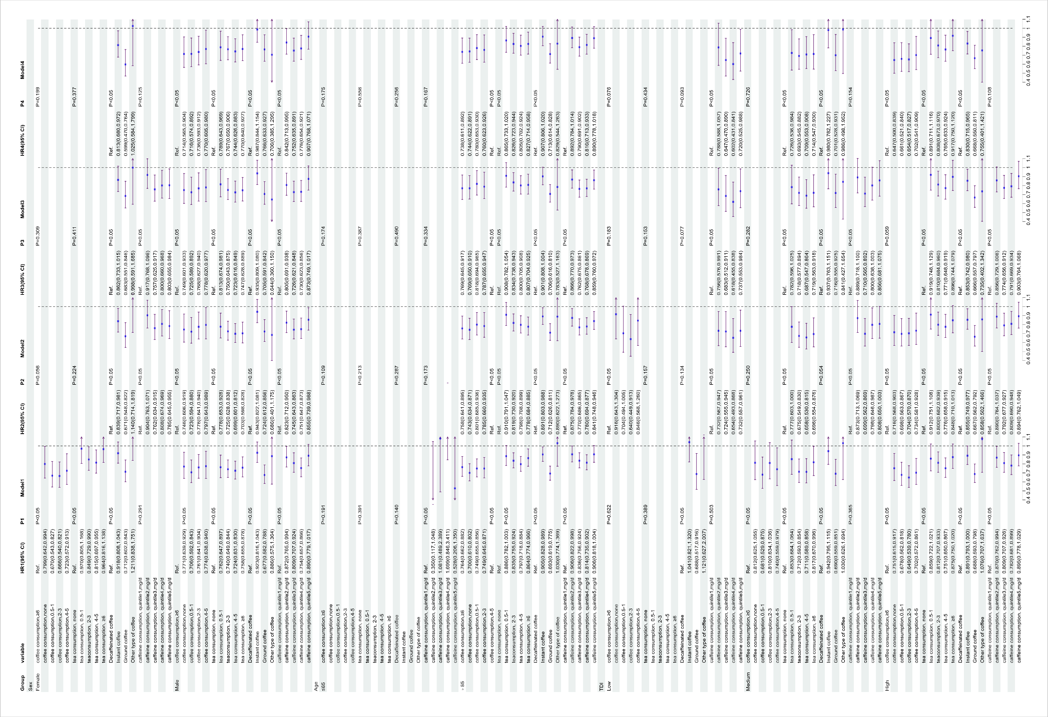

Supplementary Figure 2. Subgroup analysis of the impact of coffee, tea consumption, type of coffee, and caffeine intake on the risk of all-cause dementia in normal individuals.
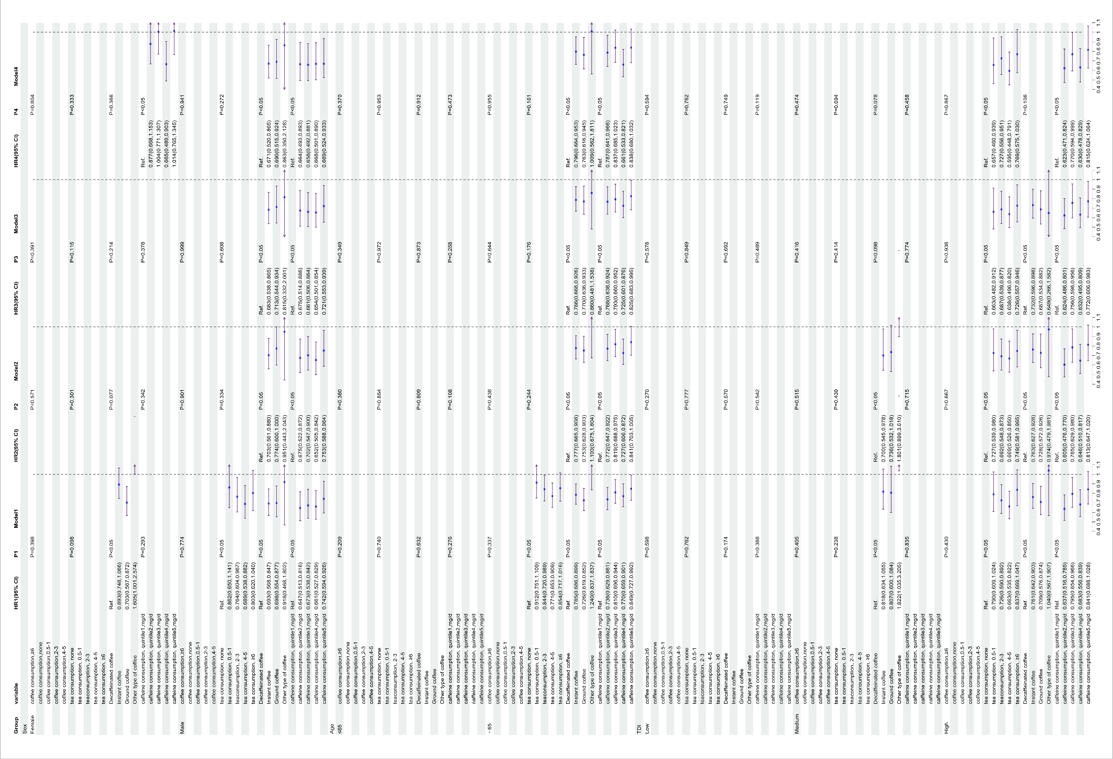

References:
1. Pickering, T. G. et al. Recommendations for Blood Pressure Measurement in Humans and Experimental Animals. Circulation. 111, 697-716 (2005).
2. Townsend P. Deprivation. J Soc Policy. 1987;16(2):125–46. Available From: Http://Journals.Cambridge.Org/Abstract_S0047279400020341.
3. Gong, J., Harris, K., Peters, S. A. E. & Woodward, M. Sex Differences in the Association Between Major Cardiovascular Risk Factors in Midlife and Dementia: A Cohort Study Using Data From the Uk Biobank. Bmc Med. 19, (2021).
4. Bycroft, C. et al. The Uk Biobank Resource with Deep Phenotyping and Genomic Data. Nature. 562, 203-209 (2018).
5. Zhu, J. et al. Physical and Mental Activity, Disease Susceptibility, and Risk of Dementia. Neurology. 99, e799-e813 (2022).
6. Hepsomali, P. & Groeger, J. A. Diet and General Cognitive Ability in the Uk Biobank Dataset. Sci. Rep.-Uk. 11, (2021).
7. Liu, Z. et al. Alcohol Consumption and Hepatocellular Carcinoma: Novel Insights From a Prospective Cohort Study and Nonlinear Mendelian Randomization Analysis. Bmc Med. 20, (2022).
8. Zhang, Y. et al. Association of Coffee and Genetic Risk with Incident Dementia in Middle-Aged and Elderly Adults. Nutr. Neurosci. 25, 2359-2368 (2022).
9. Wang, B. et al. Association of Combined Healthy Lifestyle Factors with Incident Dementia in Patients with Type 2 Diabetes. Neurology. 99, e2336 (2022).
10. Li, X., Ma, H., Zhou, T. & Qi, L. Replacing Sedentary Behavior Time with Physical Activities, Recommended Physical Activity, and Incident Coronary Heart Disease. Mayo Clin. Proc. 98, 111-121 (2023).
11. Liang, Y. Y. et al. Association Between Sleep Duration and Metabolic Syndrome: Linear and Nonlinear Mendelian Randomization Analyses. J. Transl. Med. 21, 90 (2023).
12. Geng, T. et al. Association of Serum 25-Hydroxyvitamin D Concentrations with Risk of Dementia Among Individuals with Type 2 Diabetes: A Cohort Study in the Uk Biobank. Plos Med. 19, e1003906 (2022).

